NAME: K. SARANYA
ROLL NO: A24126552090
BRANCH: CSM
SECTION: B
COURSE NAME: FULL STACK WEB DEVELOPMENT
CODE: 23CM4121
TITLE OF THE EXPERIMENT:
To develop a Student Profile Manager using JavaScript classes and DOM manipulation to collect student details and dynamically display a styled student profile.
DESCRIPTION:-
This experiment demonstrates JavaScript classes and objects, DOM selection, dynamic HTML element creation, event handling, content modification, and CSS styling. The user enters student details and clicks the button to generate the student profile dynamically.
PROGRAM:-
<!-- index.html -->
<!DOCTYPE html>
<html lang="en">
<head>
<meta charset="UTF-8">
<meta name="viewport" content="width=device-width, initial-scale=1.0">
<title>Student Profile Manager</title>
<link rel="stylesheet" href="style.css">
</head>
<body>

<div class="container">

<header>
<h1>🎓 Student Profile Manager</h1>
<p>Create and view a student profile dynamically using JavaScript</p>
</header>

<section class="form-card">
<h2>Enter Student Details</h2>

<label for="name">Student Name</label>
<input type="text" id="name" placeholder="Enter student name">

<label for="roll">Roll Number</label>
<input type="text" id="roll" placeholder="Enter roll number">

<label for="department">Department</label>
<input type="text" id="department" placeholder="Enter department">

<label for="cgpa">CGPA</label>
<input type="number" id="cgpa" step="0.01" placeholder="Enter CGPA">

<button id="createBtn">Create Student Profile</button>
</section>

<section id="profileContainer"></section>

</div>

<script src="script.js"></script>
</body>
</html>

/* ===== style.css ===== */

* {
margin: 0;
padding: 0;
box-sizing: border-box;
}

body {
font-family: Arial, sans-serif;
min-height: 100vh;
background: linear-gradient(135deg, #667eea, #764ba2);
padding: 30px;
}

.container {
width: 100%;
max-width: 850px;
margin: auto;
}

header {
text-align: center;
color: white;
margin-bottom: 25px;
}

header h1 {
font-size: 32px;
margin-bottom: 8px;
}

header p {
font-size: 15px;
}

.form-card {
background: white;
padding: 30px;
border-radius: 18px;
box-shadow: 0 10px 30px rgba(0,0,0,0.2);
margin-bottom: 25px;
}

.form-card h2 {
text-align: center;
margin-bottom: 20px;
}

.form-card label {
display: block;
font-weight: bold;
margin: 12px 0 6px;
}

.form-card input {
width: 100%;
padding: 12px;
border: 1px solid #ccc;
border-radius: 8px;
}

button {
width: 100%;
padding: 13px;
margin-top: 20px;
border: none;
border-radius: 9px;
background: #667eea;
color: white;
font-size: 16px;
font-weight: bold;
cursor: pointer;
}

button:hover {
background: #4f63c7;
transform: translateY(-2px);
}

.profile-card {
background: white;
border-radius: 18px;
overflow: hidden;
box-shadow: 0 10px 30px rgba(0,0,0,0.2);
}

.profile-header {
background: linear-gradient(135deg, #667eea, #764ba2);
color: white;
text-align: center;
padding: 25px;
}

.profile-header .icon {
font-size: 42px;
}

.profile-details {
padding: 25px;
}

.detail {
display: flex;
justify-content: space-between;
padding: 14px 5px;
border-bottom: 1px solid #eee;
}

.label {
font-weight: bold;
color: #555;
}

.value {
color: #333;
}

.cgpa {
color: #667eea;
font-weight: bold;
}

/* ===== script.js ===== */

// Student class acts as a blueprint for student objects.
class Student {

constructor(name, rollNumber, department, cgpa) {
this.name = name;
this.rollNumber = rollNumber;
this.department = department;
this.cgpa = cgpa;
}
}

// Select HTML elements using their IDs.
const nameInput = document.getElementById("name");
const rollInput = document.getElementById("roll");
const departmentInput = document.getElementById("department");
const cgpaInput = document.getElementById("cgpa");

const createButton = document.getElementById("createBtn");
const profileContainer =
document.getElementById("profileContainer");

// Handle the button click using an event listener.
createButton.addEventListener("click", function () {

const name = nameInput.value.trim();
const rollNumber = rollInput.value.trim();
const department = departmentInput.value.trim();
const cgpa = cgpaInput.value.trim();

// Check whether all fields are filled.
if (name === "" || rollNumber === "" ||
department === "" || cgpa === "") {

alert("Please enter all student details.");
return;
}

// Create an object using the Student class.
const student = new Student(
name,
rollNumber,
department,
cgpa
);

// Remove any previously displayed profile.
profileContainer.innerHTML = "";

// Create the profile elements dynamically.
const profileCard =
document.createElement("div");
profileCard.className = "profile-card";

const profileHeader =
document.createElement("div");
profileHeader.className = "profile-header";

const icon = document.createElement("div");
icon.className = "icon";
icon.textContent = "🎓";

const title = document.createElement("h2");
title.textContent = "Student Profile";

profileHeader.appendChild(icon);
profileHeader.appendChild(title);

const profileDetails =
document.createElement("div");
profileDetails.className = "profile-details";

// Create one detail row at a time.
function createDetail(labelText, valueText,
extraClass = "") {

const detail = document.createElement("div");
detail.className = "detail";

const label = document.createElement("span");
label.className = "label";
label.textContent = labelText;

const value = document.createElement("span");
value.className = "value " + extraClass;
value.textContent = valueText;

detail.appendChild(label);
detail.appendChild(value);

return detail;
}

// Add student details from the Student object.
profileDetails.appendChild(
createDetail("Name", student.name)
);

profileDetails.appendChild(
createDetail("Roll No", student.rollNumber)
);

profileDetails.appendChild(
createDetail("Department", student.department)
);

profileDetails.appendChild(
createDetail("CGPA", student.cgpa, "cgpa")
);

// Add the generated profile to the webpage.
profileCard.appendChild(profileHeader);
profileCard.appendChild(profileDetails);
profileContainer.appendChild(profileCard);

});
OUTPUT:-
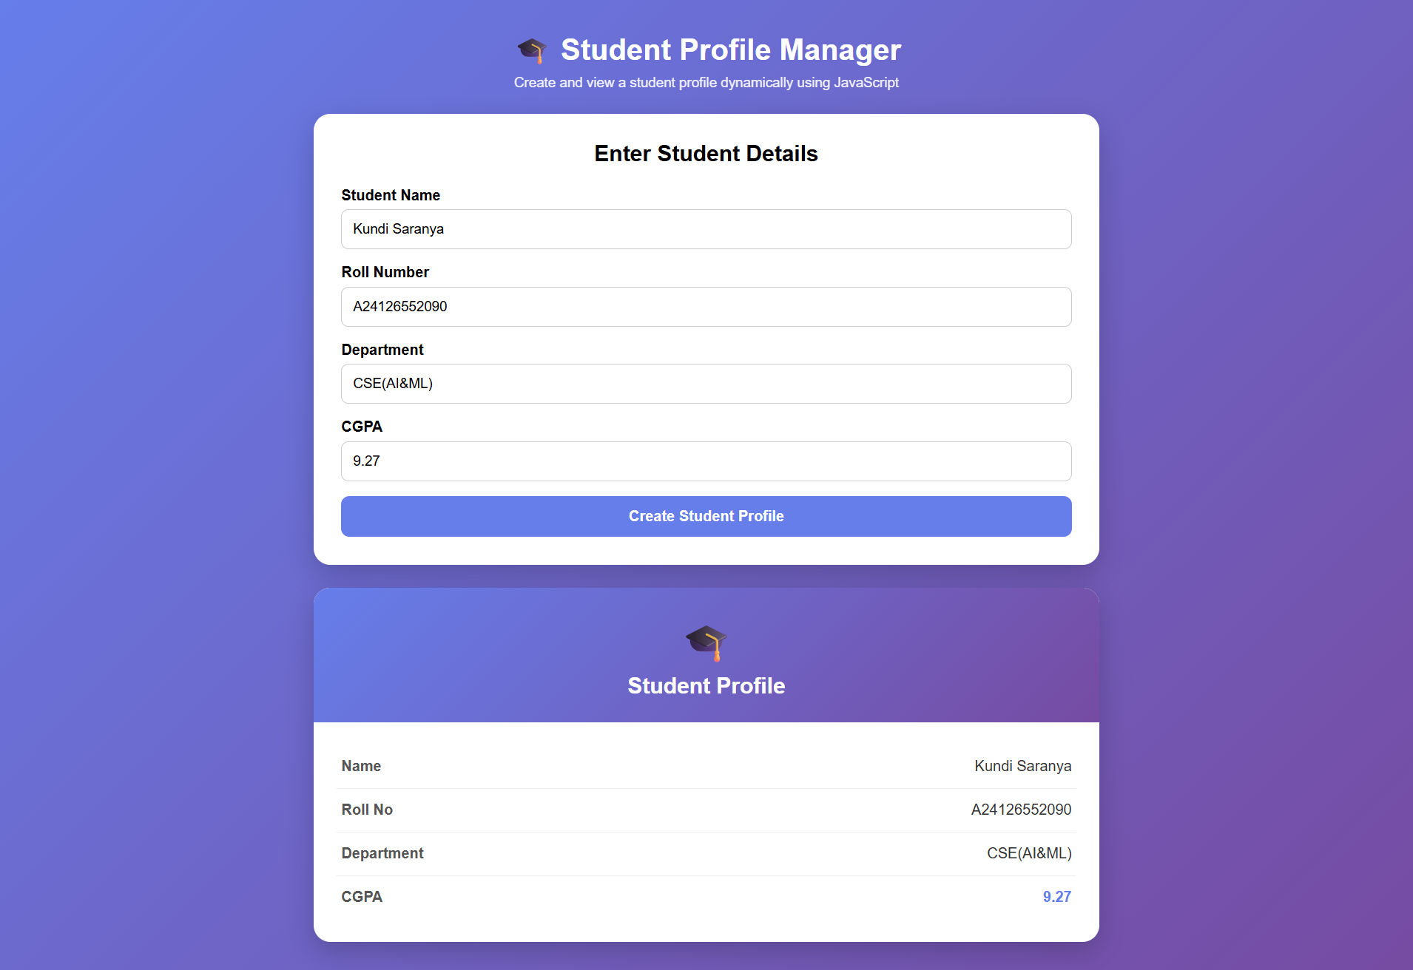
THANK YOU

