LABORATORY OBSERVATION / RECORD
Course: Full Stack Web Development
Course Code: 23CM4121
Branch: CSM
Section: B
Task No.: 5 (PBL - Part 1)
Student Name: K. Saranya
Roll No.: A24126552090
This record contains four experiments carried out under Task 5. Each experiment is documented with its aim, objective, theory, algorithm, program, code explanation, test cases with valid and invalid inputs, output screenshots and result.
Q. No. | Question | CO
1 | Interactive Product Calculator: Create a webpage containing a product name, quantity and price. Using JavaScript functions and event listeners, calculate the total price dynamically whenever the quantity or price changes. Display the result without refreshing the page. | CO-1
2 | Node.js File Management: Create a Node.js application that accepts a filename and content from the user and performs create/write, read, append and display of the final contents using the File System module. | CO-2
3 | Express.js Student Server: Create a basic Express.js server with routes /, /students and /about. The /students route should return a list of at least five students, while /about should display information about the application. | CO-2
4 | Explain the Document Object Model (DOM). Demonstrate how JavaScript can dynamically change the content, style and attributes of an HTML element. | CO-1

EXPERIMENT 1

1. TITLE
Interactive Product Calculator Using JavaScript Functions, Event Listeners and DOM Updates.

2. AIM
To create a webpage with fields for the product name, quantity and price, and to calculate and display the total price dynamically, using JavaScript functions and event listeners, whenever the quantity or price changes, without refreshing the page.

3. OBJECTIVE
The objectives of this experiment are:
- To build an input form in HTML with fields for the product name, quantity and price, and to style it as a card using CSS.
- To select page elements from JavaScript using document.getElementById().
- To read the values typed by the user with the .value property and convert them to numbers using Number().
- To divide the program into small functions: calculateTotal() for the arithmetic, validateInputs() for checking the data and updateCalculator() for changing the page.
- To attach updateCalculator() to the input event of all three fields using addEventListener(), so that the total is recalculated as the user types.
- To validate the data and show an error message for negative values instead of displaying a wrong total.
- To update the page through the DOM using the textContent property and to format the amount with toFixed(2).
- To stop the form from reloading the page by calling event.preventDefault() on its submit event.

4. THEORY
This program is event-driven. The HTML page is loaded only once; after that, every keystroke in the product name, quantity or price field fires an input event and the browser runs a JavaScript function in response. Because the result is written back into the page through the DOM, the document is never reloaded and the total appears to change instantly as the user types.
The script is divided into three functions, each with one job. calculateTotal(quantity, price) is a pure function: it only multiplies its two arguments and returns the answer, and it never touches the page. validateInputs() receives the raw text of the quantity and price fields, converts it with Number() and returns an object that says whether the data is valid, together with either the parsed numbers or an error message. updateCalculator() is the only function that changes the page; it calls the other two and writes the outcome into the result and error elements. Keeping calculation, validation and display separate makes each part easy to read and to test.
The .value property of an input always returns a string, even when the input type is number, so Number() is used to turn the text into a numeric value before it is multiplied. An empty field is detected first with trim() === "", so that a field the user has not filled in yet is not treated as zero; in that case no error is shown and the total simply stays at 0.00. Number.isNaN() detects text that cannot be converted, and the numbers are then compared with 0 to reject negative values.
The submit event of the form is cancelled with preventDefault(). Without this, pressing Enter inside a field would submit the form and reload the page, discarding the calculation.
The key methods and concepts used in this program are:
- document.getElementById("id") returns the element whose id attribute matches, so JavaScript can read from it or write into it.
- element.value reads the text currently typed in an input field; it is always a string.
- Number(text) converts the string read from the input into a number so that arithmetic can be performed.
- addEventListener("input", fn) runs the function on every keystroke or spinner click; unlike "change", it does not wait for the field to lose focus. It is attached to all three fields with a forEach() loop.
- trim() removes leading and trailing spaces, so a blank value is detected as empty; it is also used to show a dash when the product name is blank.
- Number.isNaN(value) detects a value that could not be converted into a number.
- element.textContent writes plain text into an element, replacing what was there before; it is used for the product name, the total and the error message.
- toFixed(2) rounds the total to two decimal places and returns it as a string suitable for displaying an amount of money.
- event.preventDefault() stops the browser's default action, here the submission and reload of the form.
The basic flow of the program is:
The user types in any of the three fields → the input event fires → updateCalculator() runs → the raw values are passed to validateInputs() → if a field is empty, the total is reset to 0.00 without an error; if a value is negative or not a number, an error message is shown and the total is reset to 0.00 → otherwise the error is cleared, calculateTotal() multiplies the quantity by the price and the result is written into the page with two decimal places, along with the product name.

5. ALGORITHM / PROCEDURE
- Create three files, index.html, style.css and script.js, and link style.css in the head and script.js at the end of the body.
- In index.html, add a card containing a heading, a text input for the product name, number inputs for the quantity (min="0", step="1") and the price (min="0", step="0.01"), an empty paragraph with id="error-message", and a result section containing id="result-product" and id="total-price".
- In style.css, style the page background, the card, the labels, the inputs, the red error message and the result box.
- In script.js, select the three inputs and the three output elements using document.getElementById().
- Define calculateTotal(quantity, price) so that it returns quantity * price.
- Define validateInputs(quantityRaw, priceRaw) so that it converts both values with Number() and returns { valid: false, error: "" } when a field is empty, an error message when a value is not a number or is negative, and { valid: true, quantity, price } otherwise.
- Define updateCalculator() to read the three inputs and call validateInputs(); if the data is invalid, show the error and reset the total to 0.00; otherwise clear the error and write the total using toFixed(2).
- Attach updateCalculator() to the input event of the product name, quantity and price fields using forEach() and addEventListener().
- Add a submit listener to the form that calls event.preventDefault().
- Save the files, open index.html in a browser and test the page with valid, empty, zero, negative and decimal values.

6. PROGRAM
index.html
<!DOCTYPE html>
<html lang="en">
<head>
<meta charset="UTF-8" />
<meta name="viewport" content="width=device-width, initial-scale=1.0" />
<title>Interactive Product Calculator</title>
<link rel="stylesheet" href="style.css" />
</head>
<body>

<main class="calculator-card">
<h1>Product Total Calculator</h1>
<p class="subtitle">Total updates instantly as you type — no page refresh needed.</p>

<form id="calculator-form">
<div class="field">
<label for="product-name">Product Name</label>
<input
type="text"
id="product-name"
placeholder="e.g. Wireless Mouse"
autocomplete="off"
/>
</div>

<div class="field-row">
<div class="field">
<label for="quantity">Quantity</label>
<input
type="number"
id="quantity"
min="0"
step="1"
placeholder="0"
/>
</div>

<div class="field">
<label for="price">Price per unit (₹)</label>
<input
type="number"
id="price"
min="0"
step="0.01"
placeholder="0.00"
/>
</div>
</div>

<p id="error-message" class="error-message" aria-live="polite"></p>
</form>

<section class="result" aria-live="polite">
<span class="result-label">Total for <strong id="result-product">—</strong></span>
<span class="result-value">₹<span id="total-price">0.00</span></span>
</section>
</main>

<script src="script.js"></script>
</body>
</html>
style.css
:root {
--ink: #1c2b24;
--paper: #f6f4ee;
--accent: #2f6b4f;
--accent-soft: #e4efe8;
--border: #cdd6cf;
--error: #b3413a;
font-size: 16px;
}

* {
box-sizing: border-box;
}

body {
margin: 0;
min-height: 100vh;
display: flex;
align-items: center;
justify-content: center;
padding: 2rem 1rem;
background: var(--paper);
font-family: "Segoe UI", Roboto, Helvetica, Arial, sans-serif;
color: var(--ink);
}

.calculator-card {
width: 100%;
max-width: 420px;
background: #ffffff;
border: 1px solid var(--border);
border-radius: 10px;
padding: 2rem;
}

h1 {
margin: 0 0 0.4rem;
font-size: 1.5rem;
font-weight: 600;
}

.subtitle {
margin: 0 0 1.5rem;
color: #5b6b62;
font-size: 0.9rem;
line-height: 1.4;
}

.field {
margin-bottom: 1rem;
flex: 1;
}

.field-row {
display: flex;
gap: 1rem;
}

label {
display: block;
margin-bottom: 0.35rem;
font-size: 0.85rem;
font-weight: 600;
color: #3c4a41;
}

input {
width: 100%;
padding: 0.6rem 0.7rem;
border: 1px solid var(--border);
border-radius: 6px;
font-size: 1rem;
font-family: inherit;
color: var(--ink);
background: #fdfdfb;
}

input:focus {
outline: 2px solid var(--accent);
outline-offset: 1px;
border-color: var(--accent);
}

.error-message {
min-height: 1.1rem;
margin: 0.25rem 0 0;
font-size: 0.85rem;
color: var(--error);
}

.result {
margin-top: 1.5rem;
padding: 1rem 1.2rem;
background: var(--accent-soft);
border-radius: 8px;
display: flex;
align-items: baseline;
justify-content: space-between;
gap: 0.5rem;
}

.result-label {
font-size: 0.9rem;
color: #3c4a41;
}

.result-label strong {
color: var(--ink);
}

.result-value {
font-size: 1.4rem;
font-weight: 700;
color: var(--accent);
white-space: nowrap;
}

@media (max-width: 420px) {
.field-row {
flex-direction: column;
gap: 0;
}
}
script.js
// DOM references
const productNameInput = document.getElementById("product-name");
const quantityInput = document.getElementById("quantity");
const priceInput = document.getElementById("price");

const resultProductEl = document.getElementById("result-product");
const totalPriceEl = document.getElementById("total-price");
const errorMessageEl = document.getElementById("error-message");

// Pure calculation logic (no DOM access here)

function calculateTotal(quantity, price) {
return quantity * price;
}

/**
* Validates the raw string inputs and returns parsed numbers,
* or an error message if the inputs are invalid.
*/
function validateInputs(quantityRaw, priceRaw) {
const quantity = Number(quantityRaw);
const price = Number(priceRaw);

if (quantityRaw.trim() === "" || priceRaw.trim() === "") {
return { valid: false, error: "" }; // no error shown yet, just no result
}
if (Number.isNaN(quantity) || Number.isNaN(price)) {
return { valid: false, error: "Quantity and price must be valid numbers." };
}
if (quantity < 0 || price < 0) {
return { valid: false, error: "Quantity and price cannot be negative." };
}
return { valid: true, quantity, price };
}

//DOM update logic
function updateCalculator() {
const productName = productNameInput.value.trim() || "—";
const validation = validateInputs(quantityInput.value, priceInput.value);

if (!validation.valid) {
errorMessageEl.textContent = validation.error;
totalPriceEl.textContent = "0.00";
resultProductEl.textContent = productName;
return;
}

errorMessageEl.textContent = "";
const total = calculateTotal(validation.quantity, validation.price);

resultProductEl.textContent = productName;
totalPriceEl.textContent = total.toFixed(2);
}

//Event listener
[productNameInput, quantityInput, priceInput].forEach((input) => {
input.addEventListener("input", updateCalculator);
});

// Prevent accidental form submission
document.getElementById("calculator-form").addEventListener("submit", (event) => {
event.preventDefault();
});

7. CODE EXPLANATION
Code | Explanation
document.getElementById() | Selects the three input fields and the result, total and error elements by their id.
element.value | Reads the text currently typed into an input field as a string.
calculateTotal(quantity, price) | Pure function that returns quantity * price without touching the page.
validateInputs(quantityRaw, priceRaw) | Converts the raw text to numbers and returns { valid, quantity, price } or an error message.
quantityRaw.trim() === "" | Detects an empty field, so a blank input gives a total of 0.00 without showing an error.
Number.isNaN(quantity) | Detects text that cannot be converted into a number.
quantity < 0 || price < 0 | Rejects negative values with the message "Quantity and price cannot be negative."
updateCalculator() | The only function that changes the page; it validates the input and writes either the error or the total.
productNameInput.value.trim() || "—" | Uses the product name if one has been typed, otherwise shows a dash.
textContent | Writes the product name, the total and the error message into the page without reloading it.
total.toFixed(2) | Rounds the total to two decimal places for currency display.
forEach(... addEventListener("input", updateCalculator)) | Attaches the same function to the input event of all three fields.
event.preventDefault() | Cancels the form submission, which would otherwise reload the page.

8. TEST CASES AND EXECUTION DATA
The page was opened in a browser and tested with valid inputs as well as invalid inputs (empty, zero and negative values). The results were recorded below.
Test Case | Action / Input | Expected Result | Actual Result | Status
TC-01 | Open index.html in a browser | All fields are empty, no error message is shown, and "Total for —" with ₹0.00 is displayed | Default state displayed correctly | Pass
TC-02 | Product: Wireless Mouse, Quantity: 2, Price: 750 | Total updates to ₹1500.00 without reloading the page | Total for Wireless Mouse: ₹1500.00 displayed | Pass
TC-03 | Change the quantity from 2 to 5 (price unchanged) | Total recalculates immediately to ₹3750.00 | Total updated dynamically to ₹3750.00 | Pass
TC-04 | Clear the price field (invalid: empty) | Total resets to ₹0.00; no calculation is done and no wrong value is shown | Total reset to ₹0.00, no error message | Pass
TC-05 | Quantity: 0, Price: 750 (zero quantity) | Zero is not negative, so it is accepted and the total is ₹0.00 | ₹0.00 displayed, no error message | Pass
TC-06 | Quantity: -3, Price: 750 (invalid: negative quantity) | Error "Quantity and price cannot be negative." is shown and the total is ₹0.00 | Error message displayed, total ₹0.00 | Pass
TC-07 | Quantity: 2, Price: -50 (invalid: negative price) | Error "Quantity and price cannot be negative." is shown and the total is ₹0.00 | Error message displayed, total ₹0.00 | Pass
TC-08 | Product: USB Cable, Quantity: 3, Price: 99.99 | Total is ₹299.97, rounded to two decimal places | Total for USB Cable: ₹299.97 displayed | Pass
TC-09 | After the error, enter a valid price of 120 with quantity 3 | Error message disappears and ₹360.00 is displayed | Error cleared, total recalculated to ₹360.00 | Pass
TC-10 | Product name left blank, Quantity: 4, Price: 25 | Total is still calculated and the product name is shown as a dash | "Total for —" with ₹100.00 displayed | Pass

9. OUTPUT
TC-01 – Page loaded with default values
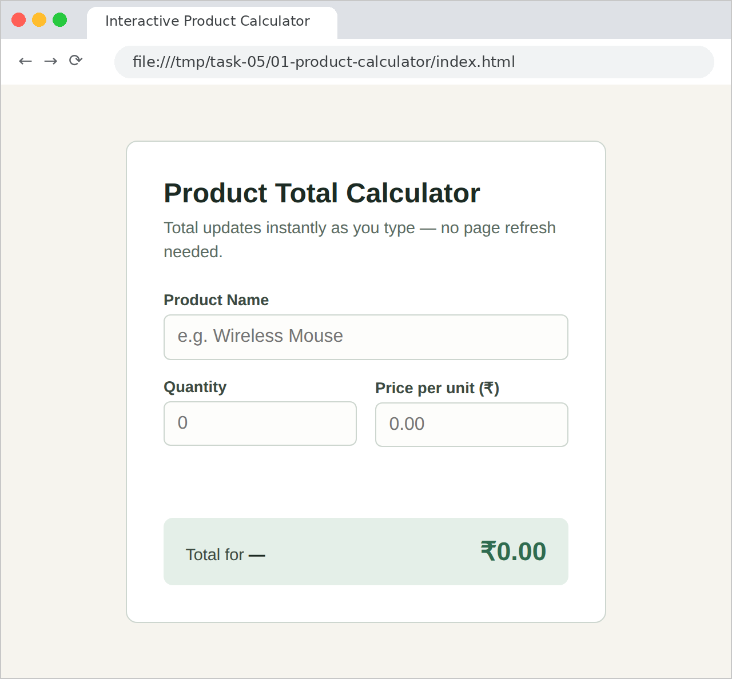
TC-02 – Valid product, quantity and price entered
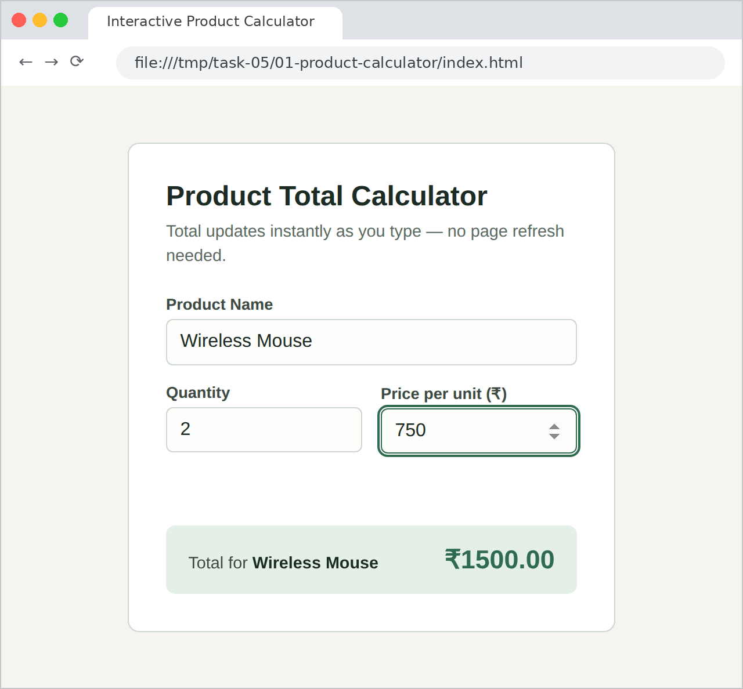
TC-03 – Quantity changed, total recalculated without reload
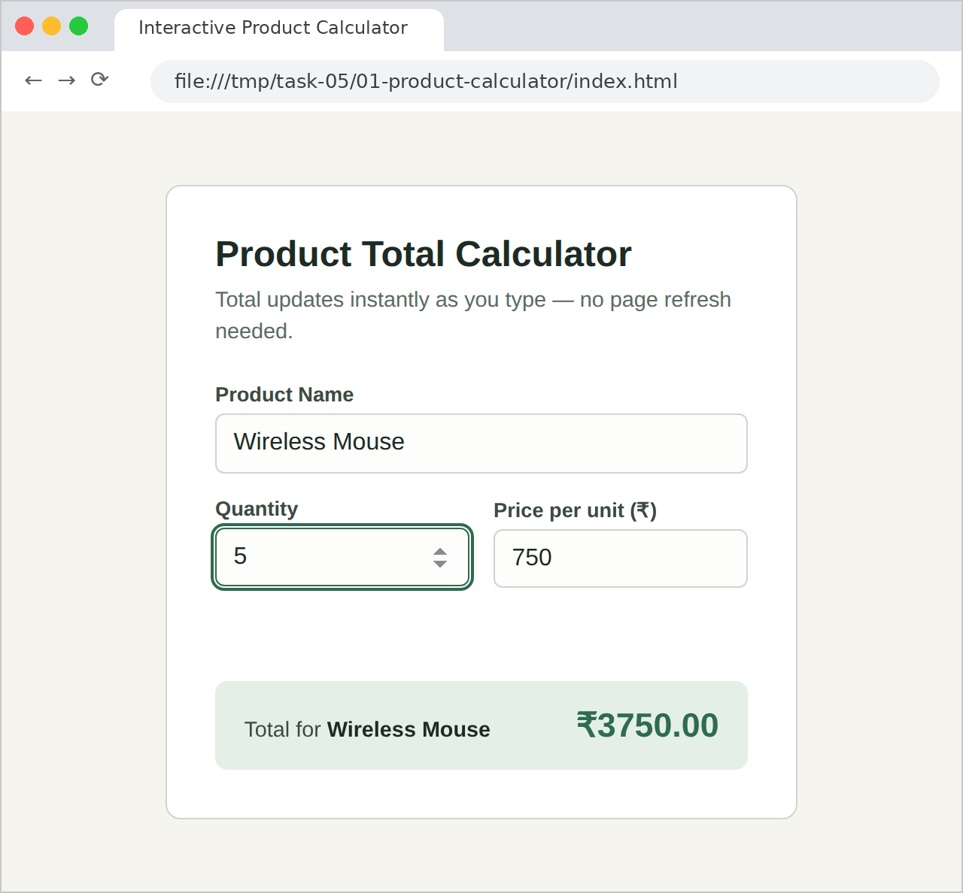
TC-04 – Invalid input: price field cleared
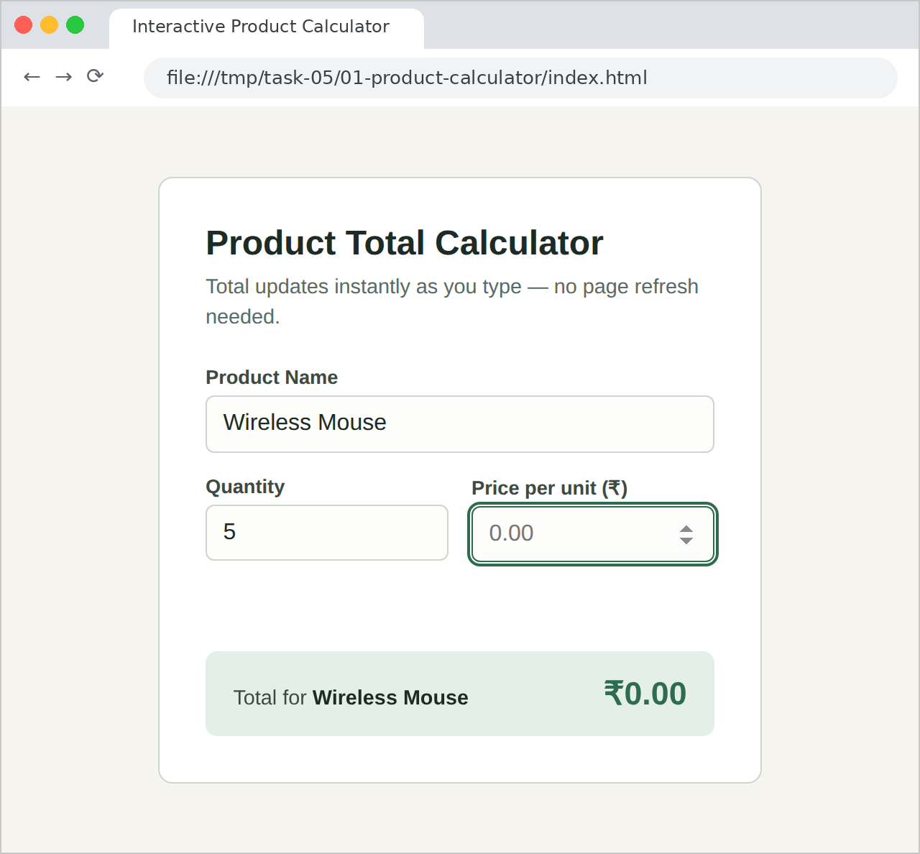
TC-05 – Quantity is zero
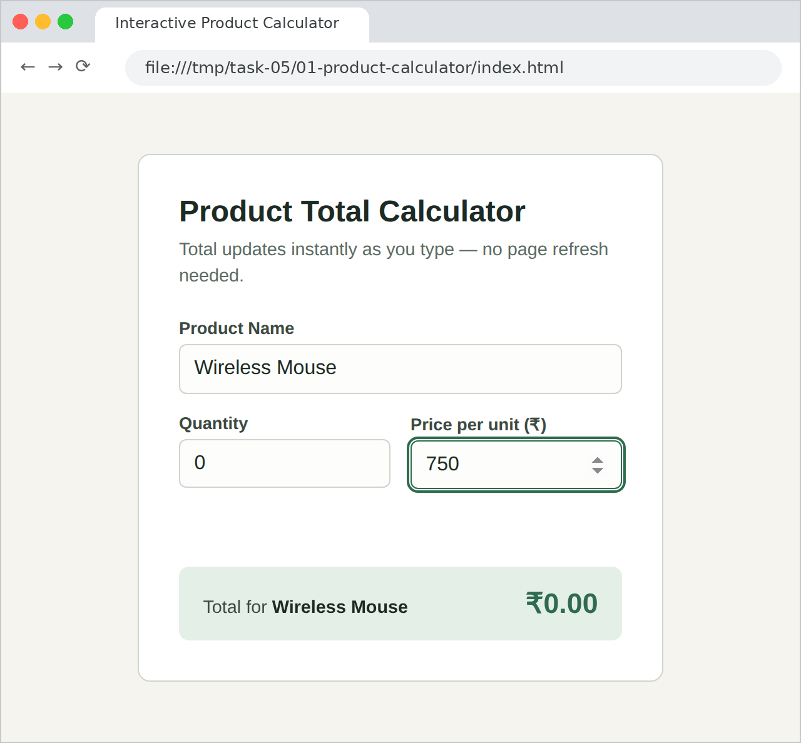
TC-06 – Invalid input: negative quantity
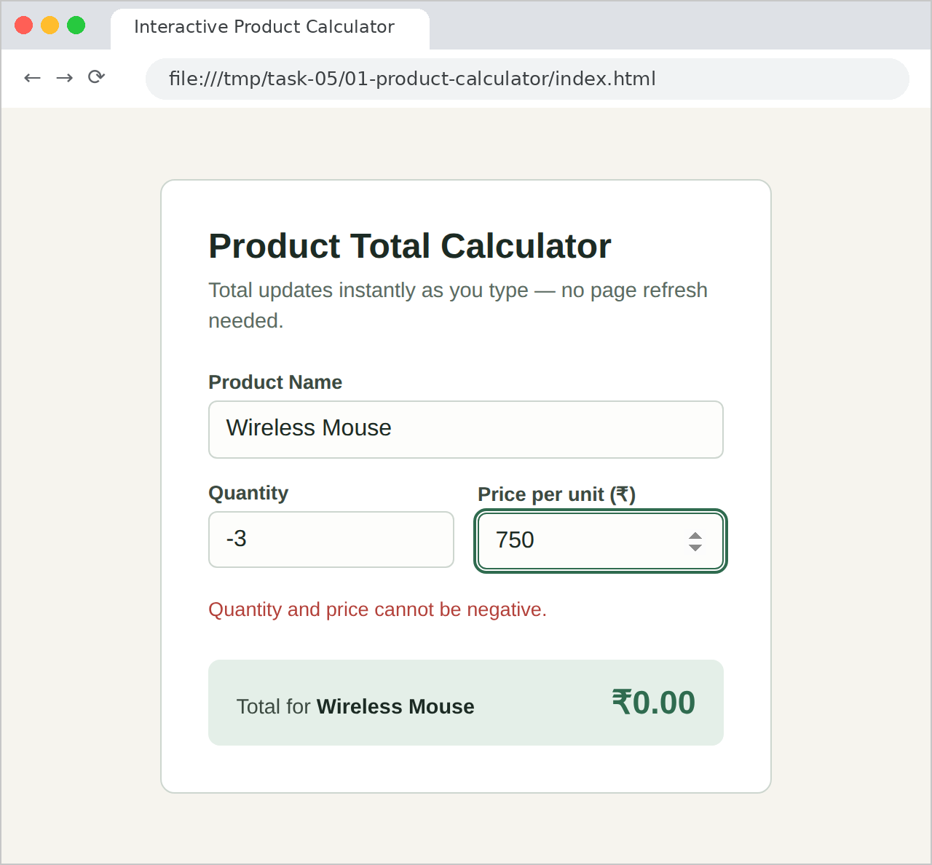
TC-07 – Invalid input: negative price
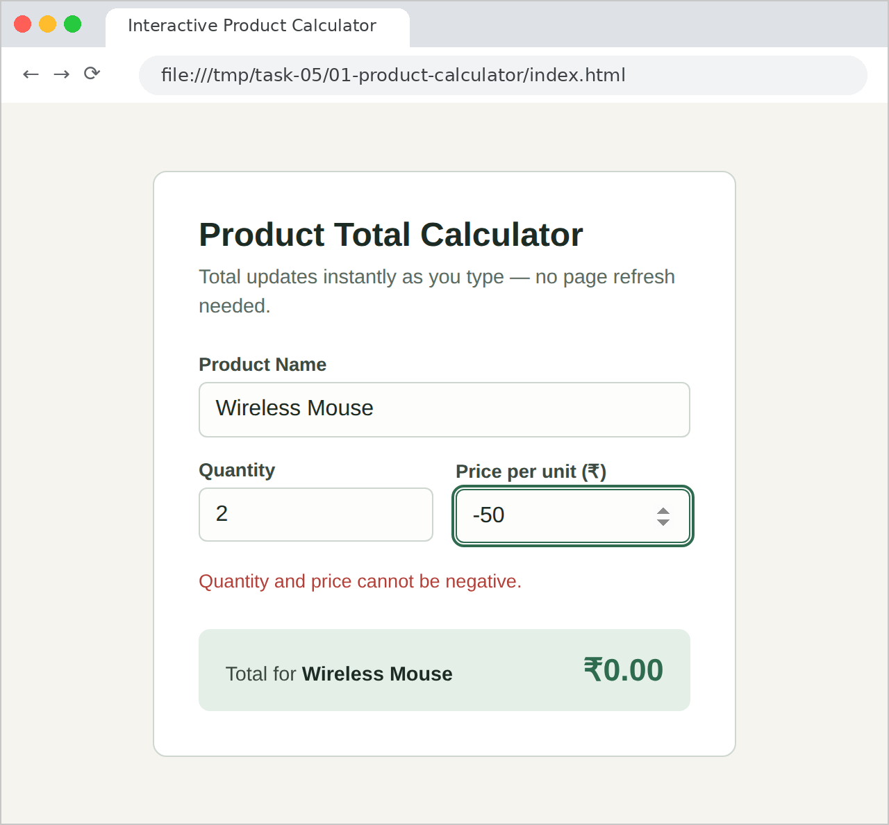
TC-08 – Decimal price rounded to two decimal places
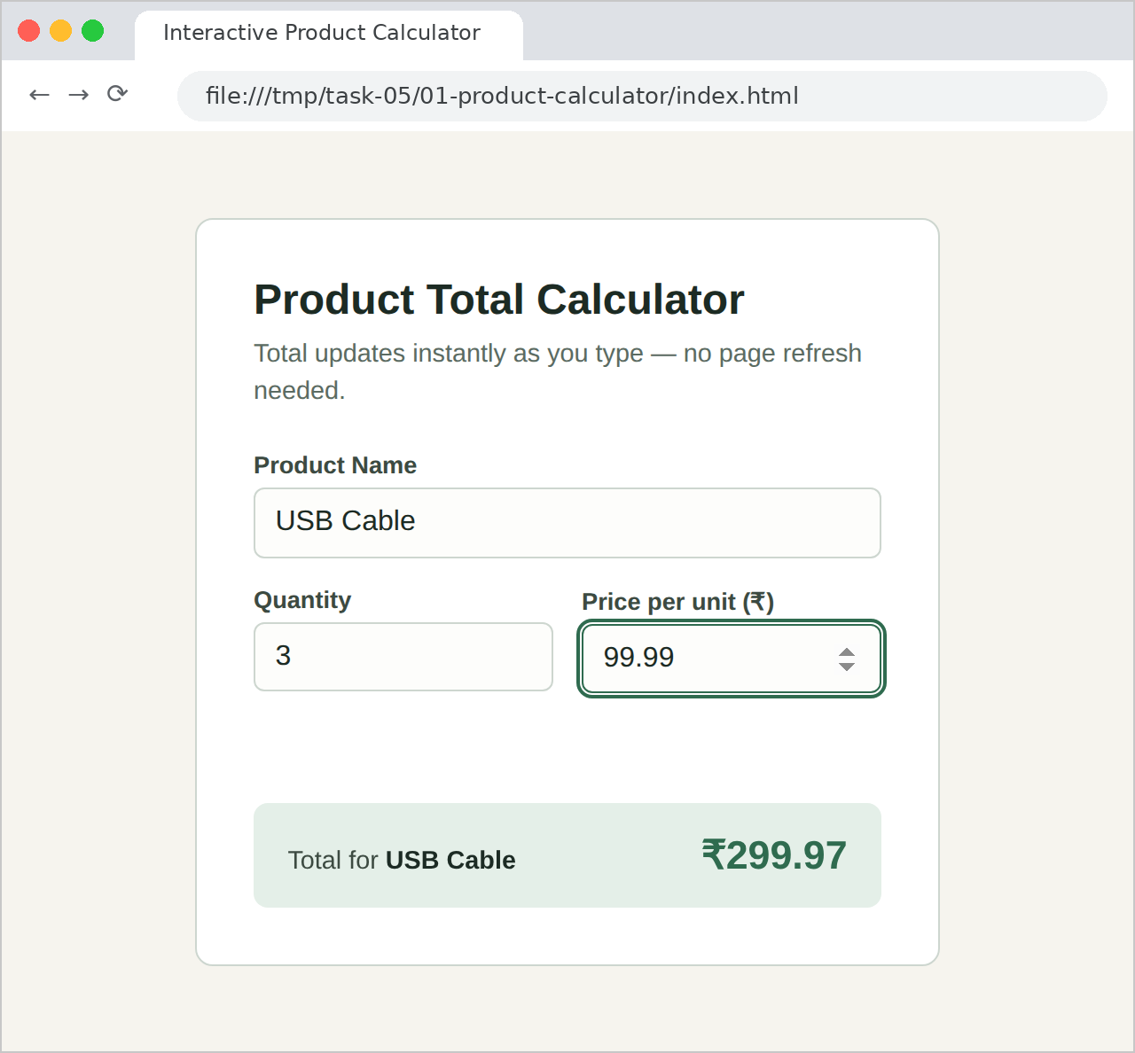
TC-09 – Valid value entered after an error, error message cleared
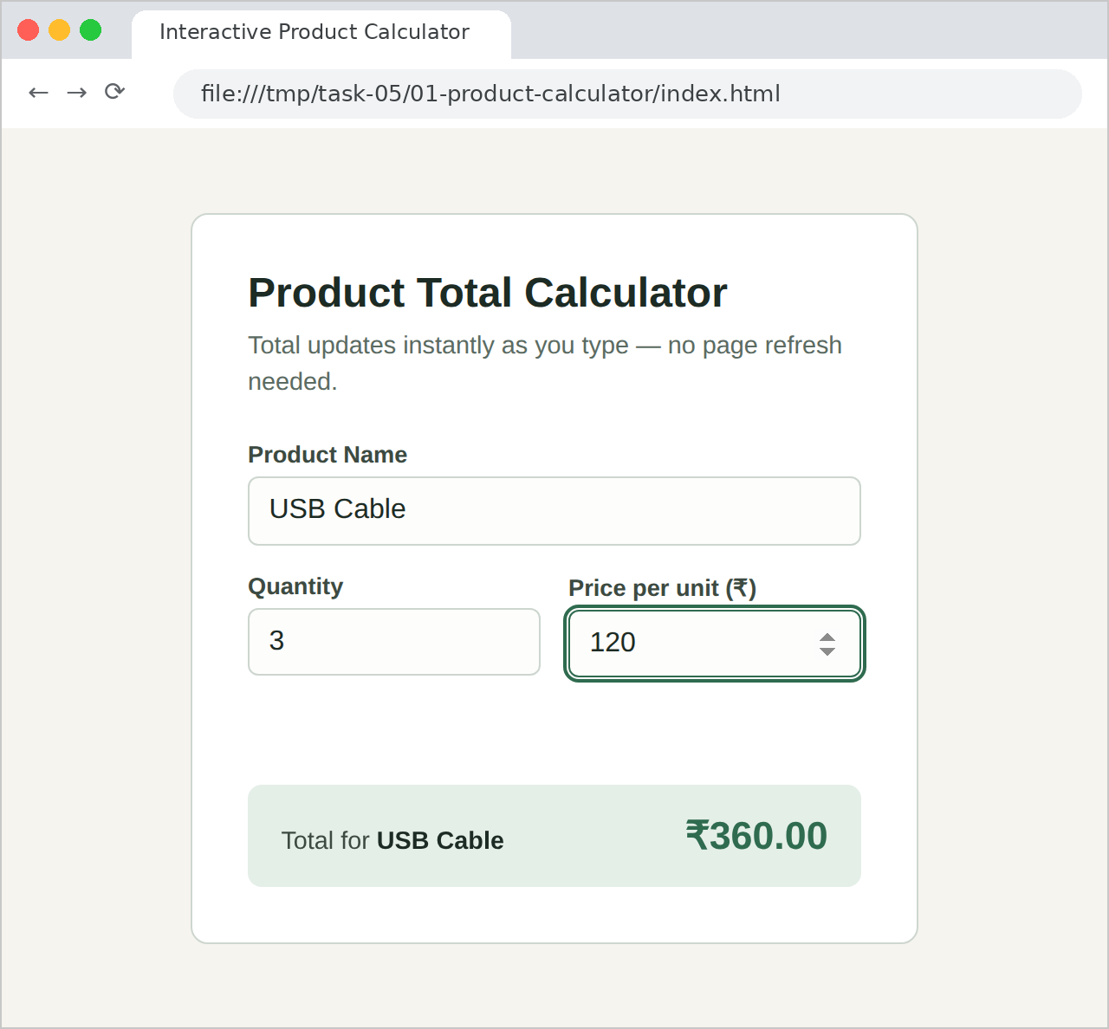
TC-10 – Product name left blank
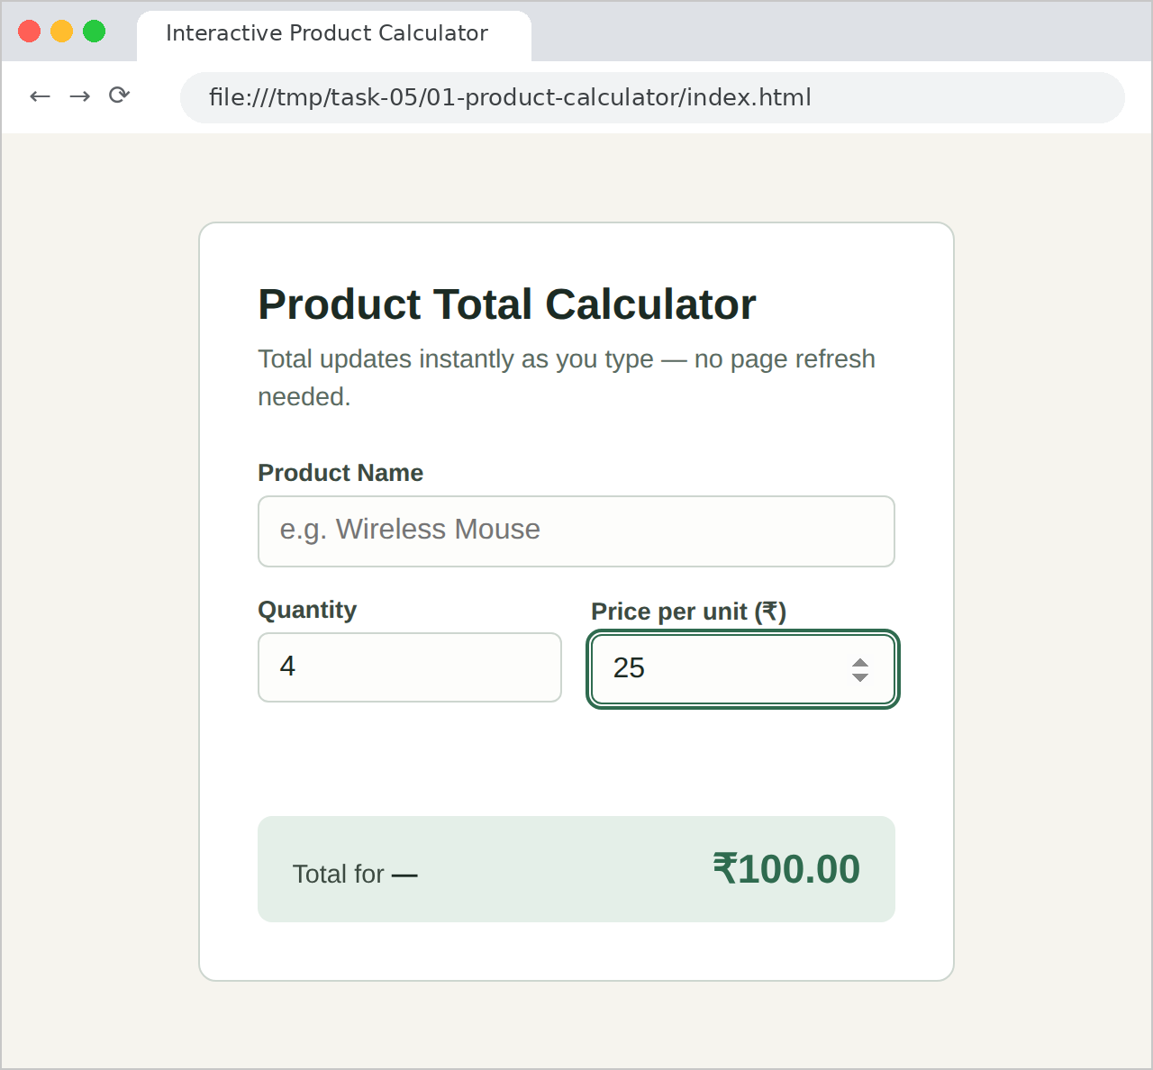

10. RESULT
Thus, an interactive product calculator was successfully built using JavaScript functions, event listeners and DOM updates. The total was calculated and displayed instantly whenever the product name, quantity or price changed, and the page was never reloaded. Negative values were rejected with a red error message and the total was reset to ₹0.00, while an empty field simply left the total at ₹0.00. Two points were noted during testing: a quantity of 0 is accepted and gives ₹0.00 because only negative values are rejected, and the product name is not validated, so a total is still calculated when it is left blank. Checking that the quantity is at least 1 and that the product name is not empty would make the validation stricter.

EXPERIMENT 2

1. TITLE
Node.js File Management Application Using the File System (fs) Module.

2. AIM
To create a Node.js application that accepts a filename and content from the user and, using the File System module, creates and writes the file, reads it, appends more content to it and displays the final contents.

3. OBJECTIVE
The objectives of this experiment are:
- To take input from the terminal using the built-in readline module.
- To read the lines typed by the user with an async iterator and await, so that the questions are asked one after another.
- To create and write a file using fs.writeFileSync().
- To read the contents of a file using fs.readFileSync() with utf8 encoding.
- To add content to the end of an existing file using fs.appendFileSync().
- To display the final contents of the file after the append operation.
- To keep the file operations in a separate module and export them using module.exports.
- To store all files in a dedicated files folder that is created automatically, using fs.existsSync(), fs.mkdirSync(), path.join() and __dirname.
- To catch errors such as an invalid path with a catch block and report them without crashing the program.

4. THEORY
Node.js allows JavaScript to run outside the browser, on the server side. The File System module, imported with require("fs"), gives JavaScript direct access to the files on the machine, which is not possible from a web page.
The fs module offers an asynchronous and a synchronous version of every operation. This program uses the synchronous versions: writeFileSync(), readFileSync() and appendFileSync(). A synchronous method waits until the disk operation has finished and then returns its result, or throws an error if it fails. This lets the steps be written in the order in which they must happen (write, read, append, read again) without nested callbacks, which is suitable here because the files are tiny and the program does only one thing at a time.
Terminal input is handled by the readline module. The interface is created with process.stdin and process.stdout, and rl[Symbol.asyncIterator]() gives an iterator whose next() method resolves with the next line the user types. The helper function ask(question) prints the prompt with process.stdout.write() and awaits lines.next(). Because main() is an async function, each await pauses the program until the user presses Enter, so the prompts appear in sequence.
The program is split into two files. fileoperations.js holds four helper functions, getFilePath(), createAndWrite(), readFile() and appendToFile(), and exports them with module.exports. app.js imports them with require("./fileoperations") and uses them in order. All the files are kept in a folder named files, whose location is built with path.join(__dirname, "files") so that it works whichever directory the program is started from; ensureDataDir() creates the folder the first time it is needed.
The synchronous fs methods throw an exception when something goes wrong, for example ENOENT when a folder in the path does not exist, or EISDIR when the path points to a directory instead of a file. The call main().catch() receives such an error, prints err.message, closes the readline interface and sets process.exitCode to 1 to show that the program ended with a failure.
The key methods and concepts used in this program are:
- require("fs"), require("path") and require("readline") import the built-in File System, Path and readline modules.
- readline.createInterface({ input: process.stdin, output: process.stdout }) connects the program to the keyboard and the screen.
- rl[Symbol.asyncIterator]() and lines.next() wait for the next line typed by the user; value ?? "" returns an empty string if no input is available.
- fs.existsSync(path) and fs.mkdirSync(path) check for the files folder and create it if it is missing.
- fs.writeFileSync(path, content, "utf8") creates the file, or replaces its contents if it already exists.
- fs.readFileSync(path, "utf8") reads the file and returns its contents as a string; without "utf8" a Buffer is returned.
- fs.appendFileSync(path, text, "utf8") adds text to the end of the file without deleting what is already there; "\n" is placed first so that the new content starts on a new line.
- path.join(__dirname, "files", filename) builds a full file path that works on any operating system.
- module.exports exposes the four functions so that app.js can import them.
- async / await lets the asynchronous prompts be written as ordinary top-to-bottom code.
- err.message prints a readable description of a failure, and process.exitCode = 1 marks the program as failed.
- rl.close() ends the readline interface so that the program can exit.
The basic flow of the program is:
The program asks for a filename → asks for the content → the files folder is created if it does not exist → the file is created and written → the file is read and its contents are printed → the program asks for additional content → the content is appended on a new line → the file is read again and the final contents are printed → the readline interface is closed. If any step throws an error, the catch block prints the message and the program ends.

5. ALGORITHM / PROCEDURE
- Create a project folder, initialise it with npm init -y, and create two files, fileoperations.js and app.js.
- In fileoperations.js, import fs and path, and define DATA_DIR as path.join(__dirname, "files").
- Define ensureDataDir() so that it creates the files folder if it does not exist.
- Define getFilePath(filename) that returns the full path of the file inside the files folder.
- Define createAndWrite(filename, content) that calls ensureDataDir() and writes the file using fs.writeFileSync().
- Define readFile(filename) that returns fs.readFileSync(filePath, "utf8").
- Define appendToFile(filename, extraContent) that calls fs.appendFileSync() with "\n" placed before the new text.
- Export getFilePath, createAndWrite, readFile and appendToFile using module.exports.
- In app.js, import readline and the file operations, create the readline interface and its async iterator, and define ask(question) that prints a prompt and waits for the next line.
- In main(), ask for the filename (trimmed) and the content, call createAndWrite() and print the file path.
- Call readFile() and print the contents, ask for the additional content, and call appendToFile().
- Call readFile() once more to print the final contents, then close the readline interface.
- Call main().catch() to print any error message, close readline and set process.exitCode = 1.
- Run the program with node app.js and test it with a valid filename, an empty filename, a folder that does not exist, an existing file and empty content.

6. PROGRAM
fileoperations.js
const fs = require("fs");
const path = require("path");

// All files this app manages are kept inside a dedicated "files" folder.
const DATA_DIR = path.join(__dirname, "files");

/** Makes sure the "files" folder exists before we try to use it. */
function ensureDataDir() {
if (!fs.existsSync(DATA_DIR)) {
fs.mkdirSync(DATA_DIR);
}
}

/** Resolves a filename to its full path inside the data folder. */
function getFilePath(filename) {
return path.join(DATA_DIR, filename);
}

/** Creates the file (or overwrites it) with the given content. */
function createAndWrite(filename, content) {
ensureDataDir();
const filePath = getFilePath(filename);
fs.writeFileSync(filePath, content, "utf8");
return filePath;
}

/** Reads and returns the file's current contents. */
function readFile(filename) {
const filePath = getFilePath(filename);
return fs.readFileSync(filePath, "utf8");
}

/** Appends additional content to the end of the file, on a new line. */
function appendToFile(filename, extraContent) {
const filePath = getFilePath(filename);
fs.appendFileSync(filePath, "\n" + extraContent, "utf8");
return filePath;
}

module.exports = {
getFilePath,
createAndWrite,
readFile,
appendToFile,
};
app.js
const readline = require("readline");
const fileOps = require("./fileoperations");

const rl = readline.createInterface({
input: process.stdin,
output: process.stdout,
});
const lines = rl[Symbol.asyncIterator]();

/** Prompts the user and waits for the next line of input. */
async function ask(question) {
process.stdout.write(question);
const { value } = await lines.next();
return value ?? "";
}

async function main() {
console.log("=== Node.js File Management ===\n");

const filename = (await ask("Enter a filename (e.g. notes.txt): ")).trim();
const initialContent = await ask("Enter the content to write to the file: ");

// 1. Create/write
const filePath = fileOps.createAndWrite(filename, initialContent);
console.log(`\n✅ File created and written: ${filePath}`);

// 2. Read
console.log("\n--- Contents after writing ---");
console.log(fileOps.readFile(filename));
console.log("--- end of file ---");

// 3. Append
const extraContent = await ask("\nEnter additional content to append: ");
fileOps.appendToFile(filename, extraContent);
console.log(`\n✅ Content appended to: ${filePath}`);

// 4. Display final contents
console.log("\n--- Final contents after appending ---");
console.log(fileOps.readFile(filename));
console.log("--- end of file ---");

rl.close();
}

main().catch((err) => {
console.error("Something went wrong:", err.message);
rl.close();
process.exitCode = 1;
});
package.json
{
"name": "node-file-management",
"version": "1.0.0",
"description": "Node.js File System module demo — create/write, read, append (PBL Q2)",
"main": "app.js",
"scripts": {
"start": "node app.js"
}
}

7. CODE EXPLANATION
Code | Explanation
require("fs") / require("path") | Imports the built-in File System and Path modules.
path.join(__dirname, "files") | Builds the location of the files folder next to the program, independent of where the program is started.
fs.existsSync() / fs.mkdirSync() | Checks whether the files folder exists and creates it when it does not.
fs.writeFileSync(filePath, content, "utf8") | Creates the file with the given content, or replaces it if it already exists.
fs.readFileSync(filePath, "utf8") | Reads the file and returns its contents as a readable string instead of a Buffer.
fs.appendFileSync(filePath, "\n" + extraContent, "utf8") | Adds the new content to the end of the file on a new line, keeping the old content.
module.exports | Exports getFilePath, createAndWrite, readFile and appendToFile so that app.js can import them.
readline.createInterface() | Connects the program to the keyboard (process.stdin) and the screen (process.stdout).
rl[Symbol.asyncIterator]() / lines.next() | Provides a way to wait for the next line typed by the user.
async function ask(question) | Prints the prompt and returns the user's answer; value ?? "" gives an empty string if no input is available.
await | Pauses main() until the user has typed an answer, so the prompts appear one after another.
main().catch(...) | Catches any error thrown by the file operations, prints err.message and sets process.exitCode = 1.
rl.close() | Closes the readline interface so that the program ends.

8. TEST CASES AND EXECUTION DATA
The program was run from the terminal using node app.js and tested with valid input as well as invalid input such as an empty filename and a path that does not exist. The results were recorded below.
Test Case | Action / Input | Expected Result | Actual Result | Status
TC-01 | Filename: student.txt; content: "This file is created using Node.js File System module."; append: "This line was appended later to demonstrate the fs.appendFileSync() method." | File is created inside the files folder, read, appended to, and the final contents show both lines | All four operations completed in order; both lines displayed | Pass
TC-02 | Press Enter without typing a filename (invalid: empty); content: "Some content" | No file is created; the error is caught and printed instead of crashing the program | The path resolved to the files folder itself; "Something went wrong: EISDIR ..." displayed and the program ended | Pass
TC-03 | Filename entered as spaces only (invalid) | trim() reduces it to an empty string, so the same error as TC-02 is shown | Same EISDIR error message displayed | Pass
TC-04 | Filename: nofolder/data.txt (invalid: folder does not exist) | An ENOENT error is printed and no file is created | "Something went wrong: ENOENT: no such file or directory ..." displayed | Pass
TC-05 | Re-run with the existing filename student.txt; content: "Overwritten content."; append: "Appended again." | The old content is replaced by the new content, then the appended line is added | File overwritten; final contents are the two new lines | Pass
TC-06 | Filename: empty.txt; content left blank; append: "Now it has content." | An empty file is created and the appended text is added on a new line | Empty file created; final contents show a blank first line followed by the appended text | Pass

9. OUTPUT
TC-01 – Valid filename and content: create, read, append and final display
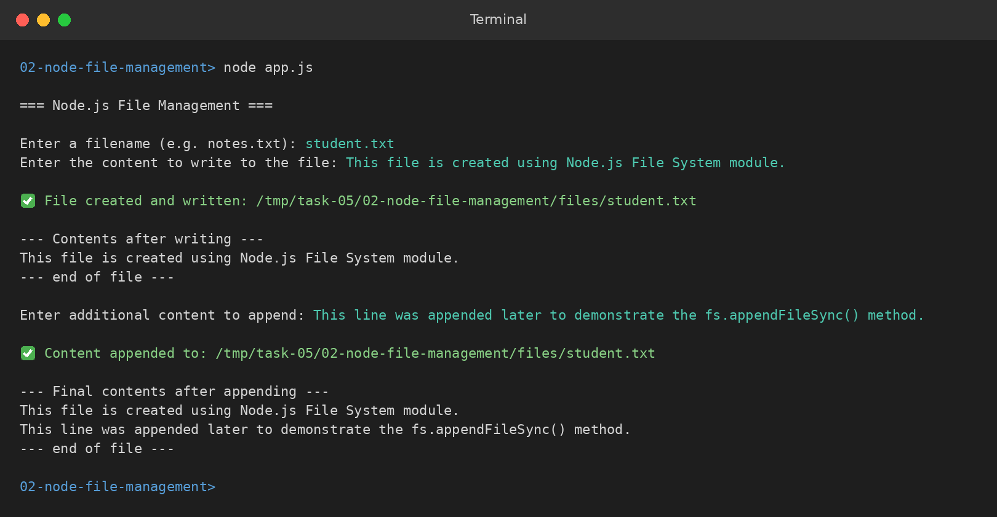
TC-02 – Invalid input: filename left empty
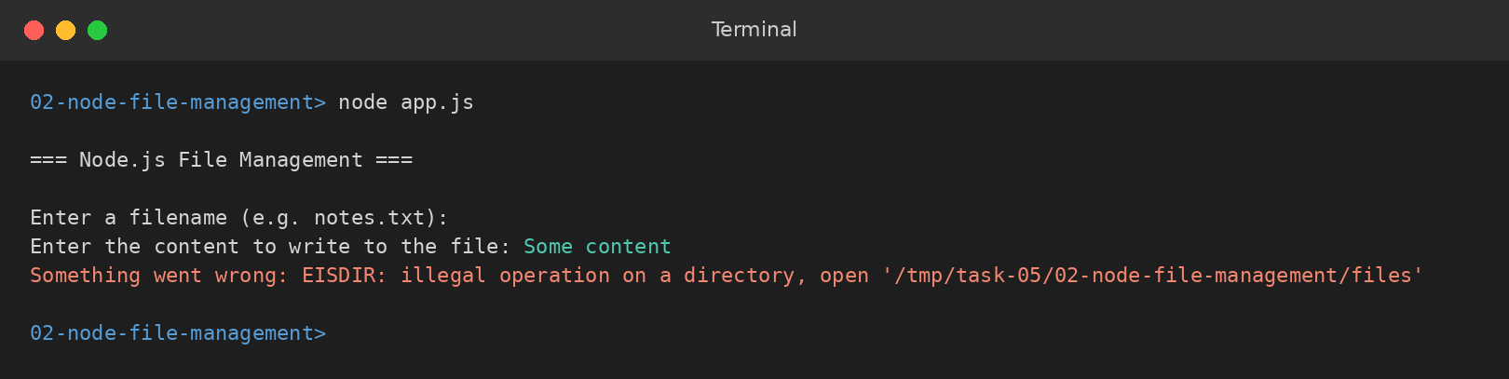
TC-03 – Invalid input: filename containing only spaces
TC-04 – Invalid input: filename inside a folder that does not exist
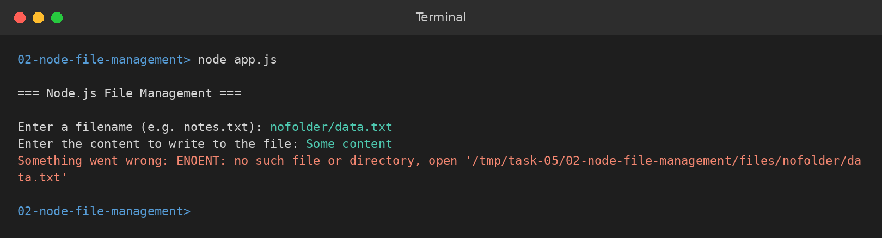
TC-05 – Existing file is overwritten and then appended to
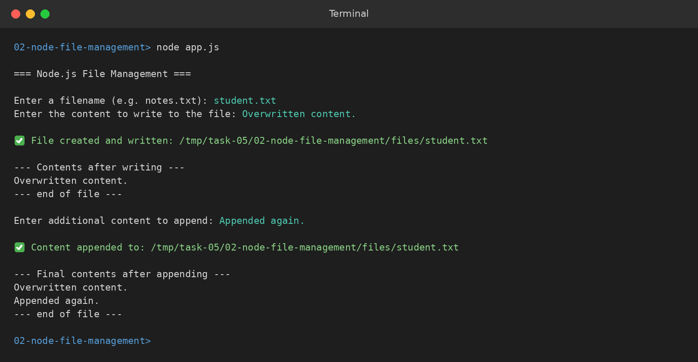
TC-06 – Empty initial content accepted, append adds the first line
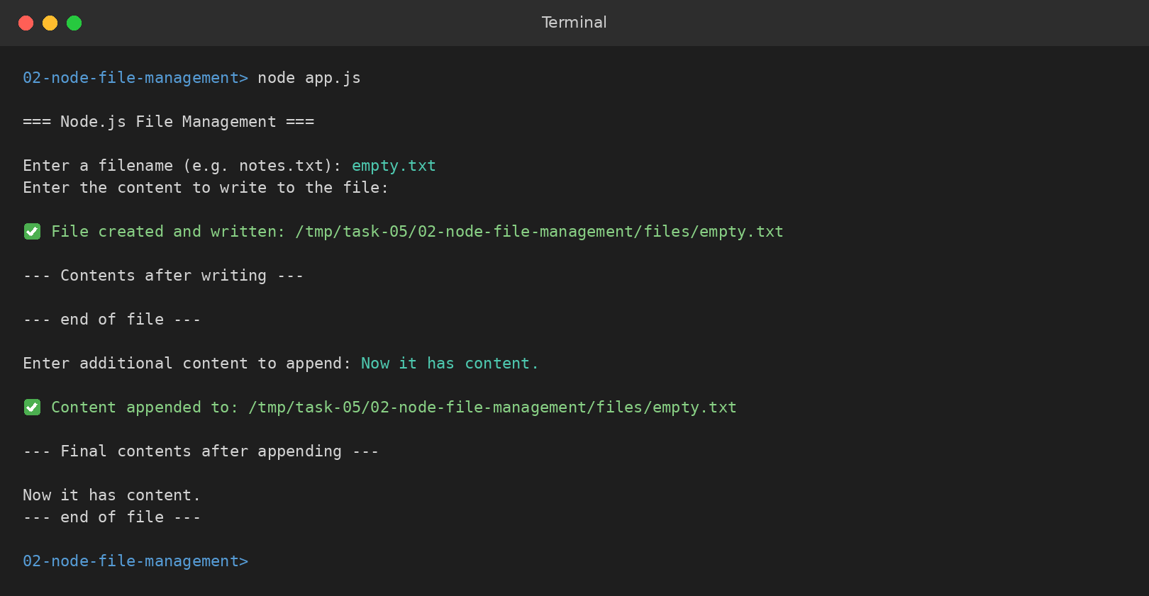

10. RESULT
Thus, a Node.js file management application was successfully created using the File System module. The program accepted a filename and content from the user, created and wrote the file inside the files folder, read and displayed it, appended additional content and displayed the final contents. Errors caused by invalid paths, such as a folder that does not exist, were caught by the catch block and printed instead of crashing the program. Two points were noted during testing: an empty filename is not checked separately, so it fails only when the write is attempted, with an EISDIR error, and writeFileSync() silently replaces an existing file, so running the program twice with the same filename loses the earlier content. Validating the filename before writing and asking for confirmation before overwriting would make the application safer.

EXPERIMENT 3

1. TITLE
Express.js Student Server with Routing and JSON Responses.

2. AIM
To create a basic Express.js server with the routes /, /students and /about, where /students returns a list of five students and /about displays information about the application.

3. OBJECTIVE
The objectives of this experiment are:
- To create a Node.js project and install Express.js using npm.
- To import Express with require("express"), create the application object and start a server on port 3000 with app.listen().
- To keep the student data in an in-memory array of objects.
- To define GET routes for /, /students and /about using app.get().
- To send a plain text response using res.send().
- To send the student list and the application information as JSON using res.json().
- To generate a value dynamically, such as totalStudents, from students.length.
- To test every route in the browser and with curl, including an undefined route and an undefined HTTP method.

4. THEORY
Express.js is a web framework built on top of the Node.js http module. Instead of parsing the URL and the request method by hand, the developer describes the server as a set of routes. A route is a combination of an HTTP method and a path; when a request arrives, Express compares it with the routes in the order in which they were defined and runs the handler of the first one that matches.
Every route handler receives two objects: the request object req, which describes what the client asked for, and the response object res, which is used to send the answer back. Exactly one response must be sent for each request. res.send() sends text or HTML and sets the Content-Type header to text/html, whereas res.json() converts a JavaScript object or array into JSON text and sets the Content-Type header to application/json, which is why it is used for the student list.
The student data is kept in an array of objects inside the program, which acts as a very small in-memory database. Each student has an id, a name, a branch and a section. The /about route returns a JSON object containing the application name, a description, the list of available routes and totalStudents, which is calculated from students.length so that the count stays correct if students are added to the array.
This program does not define a handler for unknown routes. When no route matches a request, Express's built-in final handler answers with the status 404 and a short message such as "Cannot GET /teachers". The same happens when a route exists but not for that HTTP method: only GET is defined for /students, so a POST request to it also receives a 404 response.
The key methods and concepts used in this program are:
- require("express") imports the Express framework, which must first be installed with npm install express.
- const app = express() creates the application object that holds all the routes.
- app.get(path, handler) registers a handler for GET requests to a path, which is the method a browser uses when a URL is typed in the address bar.
- res.send(text) sends a plain text or HTML response to the client.
- res.json(data) sends an array or object as JSON and sets the correct content type automatically.
- students.length gives the number of elements in the array, used for totalStudents.
- app.listen(PORT, callback) starts the server and runs the callback once it is listening; a template literal is used to print the address with the port number.
- package.json records the express dependency and a "start" script so that the server can be started with npm start.
The basic flow of the program is:
The server is started with node server.js → Express listens on port 3000 → a browser or curl sends a GET request → Express compares the path with the registered routes → / returns the welcome text, /students returns the JSON array and /about returns the JSON description → a path or method that matches no route receives Express's default 404 response.

5. ALGORITHM / PROCEDURE
- Create a project folder and run npm init -y to generate package.json.
- Install Express using npm install express.
- Create server.js, import Express with require("express"), create the app object and store the port number 3000 in a constant.
- Define an array named students containing five objects, each with id, name, branch and section.
- Define a GET route for / that sends the welcome message using res.send().
- Define a GET route for /students that returns the students array using res.json().
- Define a GET route for /about that returns a JSON object with appName, description, the list of routes and totalStudents (students.length).
- Call app.listen(PORT, callback) and print the server address from the callback.
- Add a "start" script to package.json and start the server with npm start or node server.js.
- Open http://localhost:3000/, /students and /about in the browser and confirm each response.
- Test an undefined route (/teachers) and use curl to check the status code and headers of GET /students and the response to a POST request to /students.

6. PROGRAM
server.js
const express = require("express");
const app = express();
const PORT = 3000;

// In-memory "database" of students.
const students = [
{ id: 1, name: "Saranya", branch: "CSM", section: "B" },
{ id: 2, name: "Arjun Rao", branch: "CSE", section: "A" },
{ id: 3, name: "Priya Sharma", branch: "CSM", section: "B" },
{ id: 4, name: "Kiran Kumar", branch: "IT", section: "C" },
{ id: 5, name: "Divya Reddy", branch: "CSM", section: "A" },
];

// GET / -> simple welcome route
app.get("/", (req, res) => {
res.send("Welcome to the Student Server. Try /students or /about.");
});

// GET /students -> return the full list of students as JSON
app.get("/students", (req, res) => {
res.json(students);
});

// GET /about -> information about this application
app.get("/about", (req, res) => {
res.json({
appName: "Student Server",
description:
"A basic Express.js REST-style server built for the Full Stack Web Development PBL.",
routes: ["/", "/students", "/about"],
totalStudents: students.length,
});
});

app.listen(PORT, () => {
console.log(`Student server running at http://localhost:${PORT}`);
});
package.json
{
"name": "express-student-server",
"version": "1.0.0",
"description": "Basic Express.js server with /, /students and /about routes (PBL Q3)",
"main": "server.js",
"scripts": {
"start": "node server.js"
},
"dependencies": {
"express": "^4.19.2"
}
}

7. CODE EXPLANATION
Code | Explanation
require("express") | Imports the Express framework installed through npm.
const app = express() | Creates the Express application object on which the routes are registered.
const PORT = 3000 | Stores the port number on which the server listens.
const students = [ ... ] | In-memory array of five student objects, each with id, name, branch and section.
app.get("/", handler) | Handles GET requests to the home route.
res.send("...") | Sends a plain text response to the browser.
app.get("/students", handler) | Handles GET requests to /students.
res.json(students) | Converts the array into JSON and sets the Content-Type header to application/json.
app.get("/about", handler) | Handles GET requests to /about and returns a JSON object describing the application.
totalStudents: students.length | Calculates the number of students from the array instead of writing a fixed number.
app.listen(PORT, callback) | Starts the server and prints its address once it is listening.
"start": "node server.js" | npm script that runs the server when npm start is typed (package.json).
"express": "^4.19.2" | Dependency entry that records the Express version the project needs (package.json).

8. TEST CASES AND EXECUTION DATA
The server was started from the terminal and each route was verified in the browser and with curl, including a route that does not exist and an HTTP method that is not defined. The results were recorded below.
Test Case | Action / Input | Expected Result | Actual Result | Status
TC-01 | Run node server.js in the terminal | The message "Student server running at http://localhost:3000" is printed | Server started on port 3000 | Pass
TC-02 | Open http://localhost:3000/ in a browser | The text "Welcome to the Student Server. Try /students or /about." is displayed | Welcome message displayed | Pass
TC-03 | Open http://localhost:3000/students | A JSON array of five students with id, name, branch and section is returned | JSON list of five students displayed | Pass
TC-04 | Open http://localhost:3000/about | A JSON object with appName, description, routes and totalStudents (5) is returned | JSON object displayed; totalStudents is 5 | Pass
TC-05 | Open http://localhost:3000/teachers (invalid route) | No route matches, so Express returns a 404 response "Cannot GET /teachers" | 404 response with "Cannot GET /teachers" displayed | Pass
TC-06 | Run curl -i http://localhost:3000/students | Status 200 OK, Content-Type application/json and the student list in the body | HTTP/1.1 200 OK with JSON body received | Pass
TC-07 | Run curl -i -X POST http://localhost:3000/students (method not defined) | The request matches no route and returns 404 Not Found | HTTP/1.1 404 Not Found with "Cannot POST /students" returned | Pass

9. OUTPUT
TC-01 – Server started from the terminal
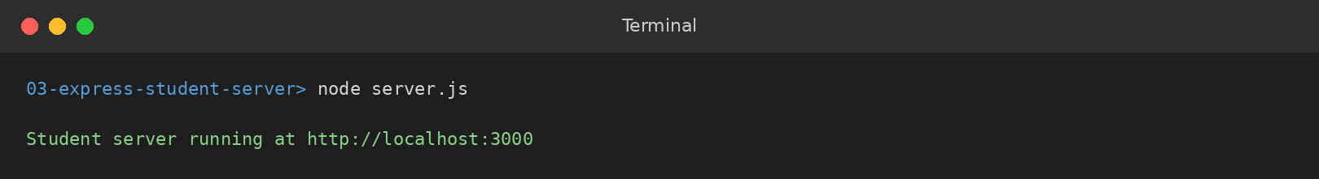
TC-02 – Home route / in the browser
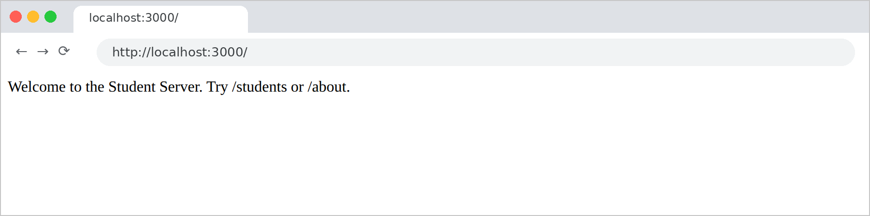
TC-03 – /students route returning the JSON student list
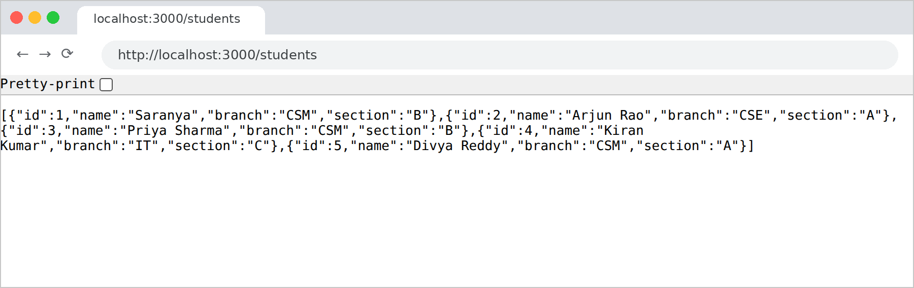
TC-04 – /about route returning the application information
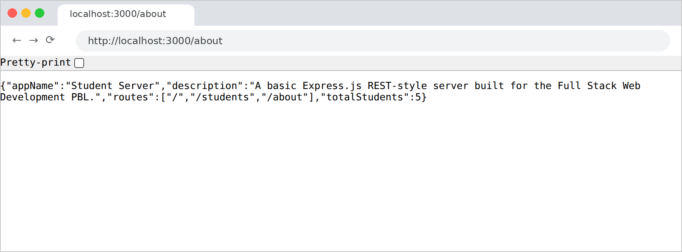
TC-05 – Undefined route /teachers returns Express's default 404
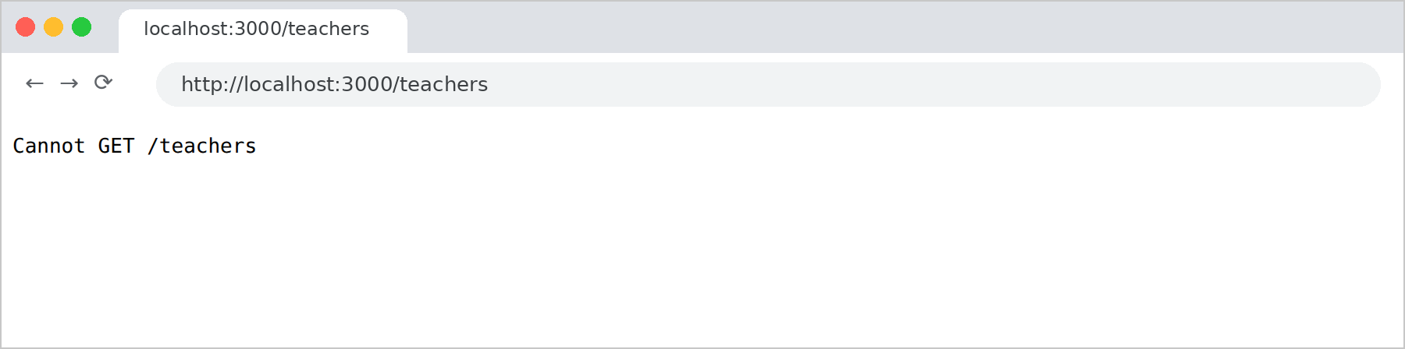
TC-06 – GET /students checked with curl (200 OK)
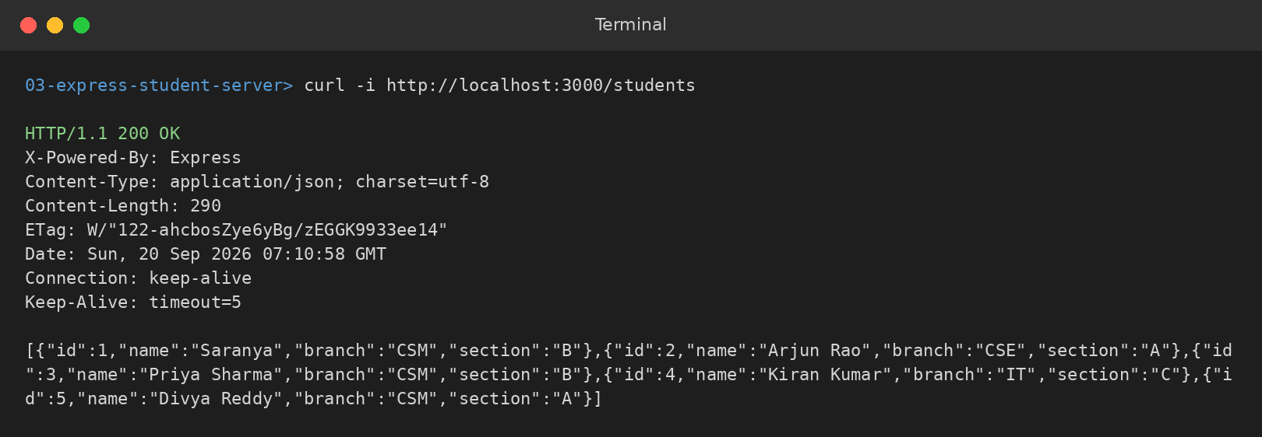
TC-07 – POST /students returns 404 because only GET is defined
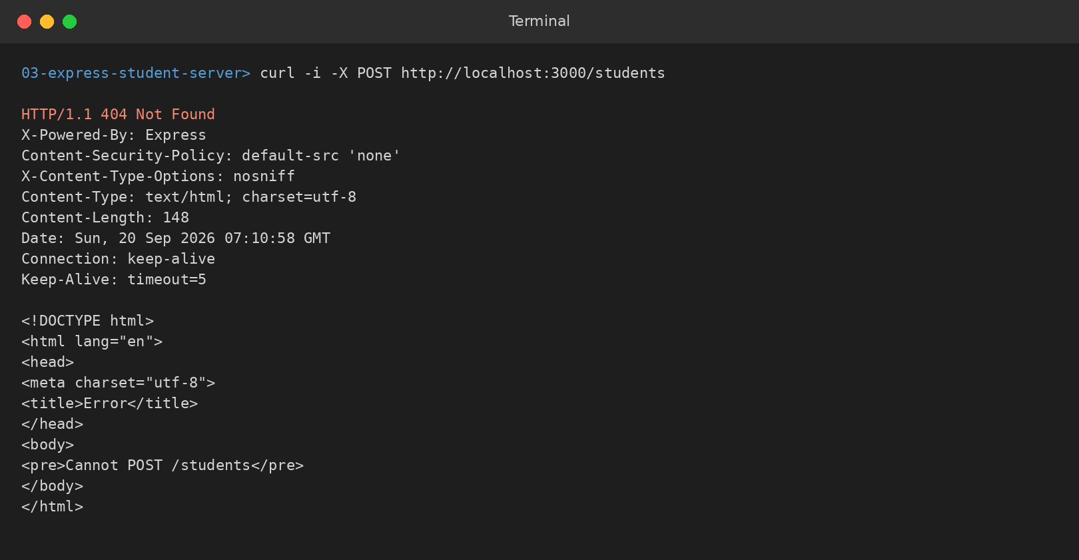

10. RESULT
Thus, a basic Express.js student server was successfully created with the routes /, /students and /about. The home route returned plain text using res.send(), while /students and /about returned JSON using res.json(), and every route was verified in the browser and with curl. Requests to an undefined route, or with an HTTP method that is not defined, received Express's default 404 response. The server keeps its data in memory, so the student list is reset each time the server restarts. Adding a custom 404 handler, POST, PUT and DELETE routes and a database would allow students to be added, updated and removed permanently.

EXPERIMENT 4

1. TITLE
Demonstration of the Document Object Model (DOM): Changing the Content, Style and Attributes of an HTML Element Using JavaScript.

2. AIM
To explain the Document Object Model and to demonstrate how JavaScript can dynamically change the content, the style and the attributes of an HTML element at runtime.

3. OBJECTIVE
The objectives of this experiment are:
- To understand how the browser represents an HTML page as a tree of nodes called the Document Object Model.
- To access elements on the page from JavaScript using document.getElementById().
- To change the visible text of an element using the textContent property.
- To change the appearance of an element at runtime using the style property (color, backgroundColor, padding and borderRadius).
- To add or modify an attribute of an element using setAttribute().
- To run all of these changes from a single click event handler attached with addEventListener().
- To verify the changes visually in the browser and by inspecting the element in the browser console.

4. THEORY
When a browser loads an HTML page it does not keep the file as plain text. It parses the file and builds an object-based model of it in memory called the Document Object Model, or DOM. Every element, attribute and piece of text becomes a node, and the nodes are arranged as a tree: the document object is the root, <html> is below it, then <head> and <body>, and so on down to the individual elements.
The DOM is a live model. It is not a copy of the HTML file but what the browser actually displays: whenever JavaScript changes a node, the browser immediately repaints the page to match, so the page can change without being reloaded and without the HTML file being edited. Reloading the page rebuilds the DOM from the file, so all such changes are lost.
JavaScript can change three different things about an element, and this program demonstrates all three:
- Content – the text inside the element, changed here with the textContent property, which replaces whatever text the element held.
- Style – the appearance of the element, changed here through the style object. CSS properties written with a hyphen become camelCase in JavaScript, so background-color is written as backgroundColor and border-radius as borderRadius.
- Attributes – the extra information carried by the tag, changed here with setAttribute("title", ...), which adds a title attribute that the browser shows as a tooltip when the mouse rests on the heading.
The changes are made inside a function passed to addEventListener("click", ...), so nothing happens until the user clicks the button. This is the event-driven model on which interactive web pages are built.
The key methods and concepts used in this program are:
- document.getElementById("id") returns the node in the DOM tree whose id attribute matches.
- addEventListener("click", fn) registers a function to run when the button is clicked.
- element.textContent replaces the text inside an element; unlike innerHTML it treats the value as plain text and does not interpret HTML tags, which makes it the safer choice.
- element.style.color, style.backgroundColor, style.padding and style.borderRadius set inline CSS on the element, which overrides the styles from a stylesheet.
- element.setAttribute("title", value) adds or updates an attribute on the element.
- The script is placed at the end of the body so that all the elements already exist in the DOM when the script runs.
- The changes exist only in the DOM in memory, so refreshing the page restores the original HTML.
The basic flow of the program is:
The page loads and the browser builds the DOM → the three elements are selected and stored in constants → the user clicks the Update Page button → the click handler runs → the heading text and the paragraph text are replaced → the heading colour, background colour, padding and border radius are set → a title attribute is added to the heading → the browser repaints the page immediately, without reloading it.

5. ALGORITHM / PROCEDURE
- Create the file dom.html with an <h1> having id="title", a <p> having id="description" and a <button> having id="updateBtn".
- Write the JavaScript inside a <script> tag placed at the end of the body, so that the elements already exist when the script runs.
- Select the heading, the paragraph and the button using document.getElementById() and store them in constants.
- Attach a click event listener to the button using addEventListener().
- Inside the handler, change the content by setting title.textContent and description.textContent to their new values.
- Change the style by setting title.style.color to white, backgroundColor to teal, padding to 12px and borderRadius to 6px.
- Change the attribute by calling title.setAttribute("title", "Heading text updated via JavaScript").
- Save the file and open it in a browser; note the original content, then click the button and observe the content and style change.
- Open the browser console and inspect the heading before and after the click to confirm the inline style and the title attribute.
- Click the button a second time and then refresh the page to observe that the DOM is rebuilt from the HTML file.

6. PROGRAM
dom.html
<!DOCTYPE html>
<html lang="en">
<head>
<meta charset="UTF-8">
<title>DOM Manipulation Demo</title>
</head>

<body>

<h1 id="title">Static Heading</h1>

<p id="description">
This paragraph has not been touched by JavaScript yet.
</p>

<button id="updateBtn">
Update Page
</button>

<script>
const title = document.getElementById("title");
const description = document.getElementById("description");
const updateBtn = document.getElementById("updateBtn");

updateBtn.addEventListener("click", function () {

// Change content
title.textContent = "Heading Updated Successfully";

description.textContent =
"JavaScript just changed this text using the DOM.";

// Change style
title.style.color = "white";
title.style.backgroundColor = "teal";
title.style.padding = "12px";
title.style.borderRadius = "6px";

// Change an attribute
title.setAttribute("title", "Heading text updated via JavaScript");
});
</script>

</body>
</html>

7. CODE EXPLANATION
Code | Explanation
document.getElementById("title") | Selects the <h1> node from the DOM so that JavaScript can modify it.
document.getElementById("description") | Selects the paragraph whose text will be replaced.
document.getElementById("updateBtn") | Selects the button that triggers all the changes.
addEventListener("click", function () { ... }) | Runs the given function whenever the button is clicked, instead of when the page loads.
title.textContent = "Heading Updated Successfully" | Changes the content: replaces the text inside the heading.
description.textContent = "..." | Changes the content of the paragraph in the same way.
title.style.color = "white" | Changes the style: applies an inline text colour to the heading.
title.style.backgroundColor = "teal" | Applies a background colour; the CSS property background-color becomes backgroundColor in JavaScript.
title.style.padding / borderRadius | Adds inline spacing inside the heading and rounds its corners.
title.setAttribute("title", "...") | Changes the attributes: adds a title attribute, which the browser shows as a tooltip on hover.

8. TEST CASES AND EXECUTION DATA
The page was opened in a browser and tested before and after the click, including an inspection of the element in the browser console and a check that the change is not permanent. The results were recorded below.
Test Case | Action / Input | Expected Result | Actual Result | Status
TC-01 | Open dom.html in a browser | The heading "Static Heading", the original paragraph and the Update Page button are displayed in the default style | Original page displayed | Pass
TC-02 | Click the "Update Page" button | The heading and paragraph text change, and the heading turns white on a teal background with padding and rounded corners | Content and style changed without reloading the page | Pass
TC-03 | Inspect the heading in the console before and after the click | Before: no title attribute and no inline style. After: the title attribute and the inline style are present on the <h1> | getAttribute("title") returned null before and "Heading text updated via JavaScript" after; inline style present | Pass
TC-04 | Click the button a second time | The same values are set again, so the page stays as it is and no error occurs | Output unchanged, no error | Pass
TC-05 | Refresh the page after clicking | The DOM is rebuilt from the HTML file and the original content returns | Original content restored | Pass

9. OUTPUT
TC-01 – Original page before the button is clicked
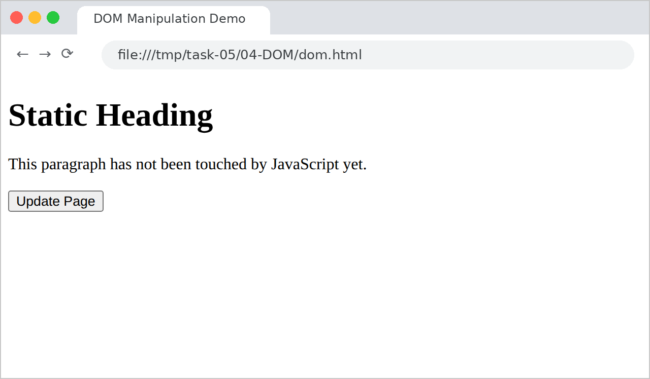
TC-02 – Content and style changed after clicking Update Page
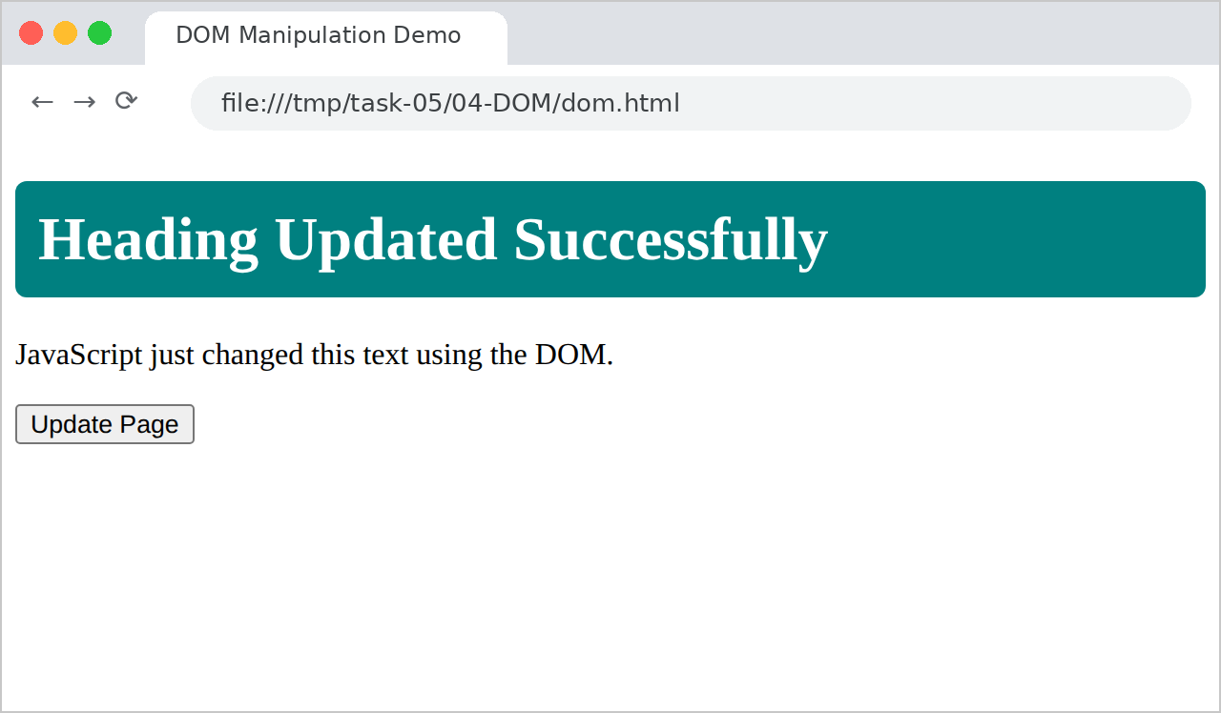
TC-03 – Element inspected in the console before and after the click
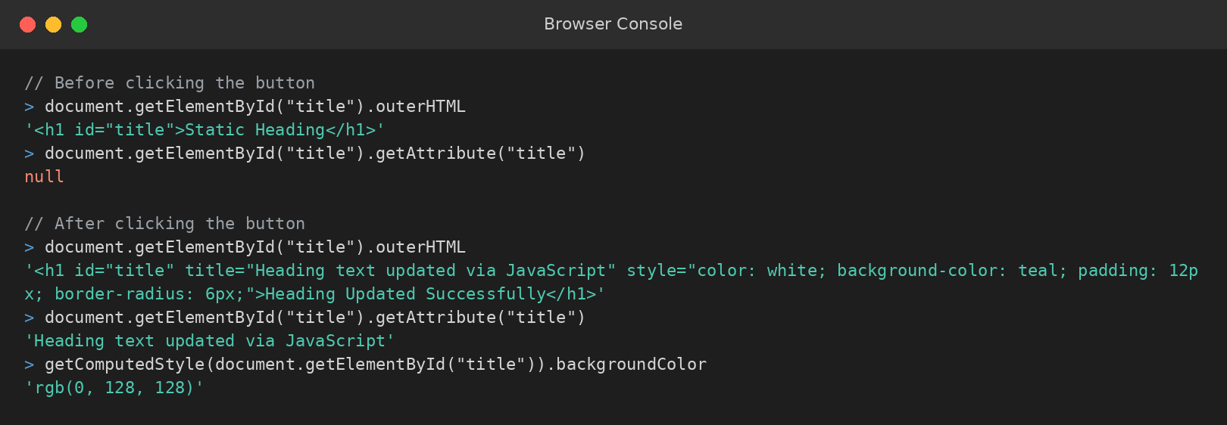
TC-04 – Clicking a second time leaves the output unchanged
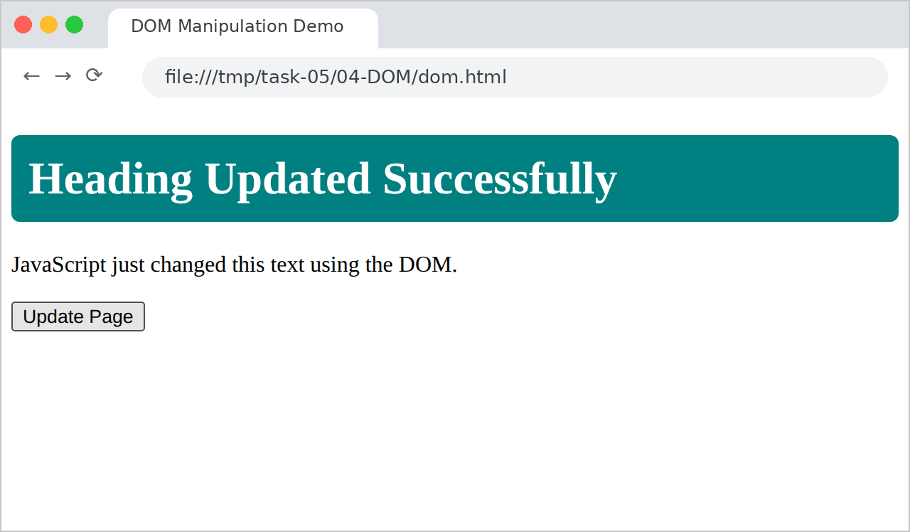
TC-05 – After refreshing, the original page is restored

10. RESULT
Thus, the Document Object Model was explained and demonstrated successfully. On clicking the Update Page button, JavaScript changed the content of the heading and the paragraph using textContent, the style of the heading using the style object and an attribute of the heading using setAttribute(), and the browser repainted the page immediately without reloading it. Inspecting the element confirmed that the inline style and the title attribute had been added in the DOM. Clicking the button again produced no visible change because the same values were set, and refreshing the page restored the original content, because the changes are held only in memory and the DOM is rebuilt from the HTML file on every load.

