NAME: K. SARANYA
ROLL NO: A24126552090
BRANCH: CSM
SECTION: B
COURSE NAME: FULL STACK WEB DEVELOPMENT
CODE: 23CM4121

TITLE OF THE EXPERIMENT:
To understand and implement the fundamental building blocks of HTML and HTML5 for creating structured web pages.
DESCRIPTION:-
This experiment brings a college's digital front door to life through the "College Information Portal" — a single HTML5 page built like a set of building blocks stacked one on top of another. Each block demonstrates a distinct concept: semantic tags (header, nav, section, article, footer) frame the page's skeleton the way corridors and departments frame a real campus; formatted text, ordered and unordered lists, and hyperlinks bring the college's story and offerings to life; a structured table and images showcase student records and campus visuals; and a fully interactive registration form — complete with radio buttons, checkboxes, dropdowns, and the newer HTML5 input types (date, number, color, range) — mirrors the kind of admission form a real student would fill out. Rounding it off, embedded audio and video elements demonstrate how modern browsers handle media natively, without needing any external plugins. Together, these pieces turn a plain page into a working, well-organised digital portal.
PROGRAM:-
<!DOCTYPE html>
<html lang="en">

<head>
<meta charset="UTF-8">
<title>College Information Portal</title>
</head>

<body>

<!-- Part A: Basic HTML -->
<header>
<h1>ANITS Engineering College</h1>
</header>
<nav><a href="#">Home</a> | <a href="#">About</a> | <a href="#">Contact</a></nav>
<section>
<p>Welcome to our college portal. We offer <b>quality education</b>, <i>modern infrastructure</i>, and
<u>excellent placements</u>.
</p>
<p>Established in 2005 | Our college secured 1<sup>st</sup> rank in the state for placements<sub> (2024)</sub>.
</p>
<h2>Courses Offered</h2>
<ol>
<li>CSE</li>
<li>ECE</li>
<li>MECH</li>
</ol>
<h2>Facilities</h2>
<ul>
<li>Library</li>
<li>Sports Complex</li>
<li>Hostel</li>
</ul>
<p><a href="https://www.college-example.edu" target="_blank">College Website</a> | <a
href="https://www.google.com" target="_blank">Google</a></p>
</section>

<!-- Part B: Tables & Images -->
<section>
<h2>Student Details</h2>
<table border="1" cellpadding="8">
<tr>
<th>Roll No</th>
<th>Name</th>
<th>Branch</th>
<th>Email</th>
</tr>
<tr>
<td>101</td>
<td>Saranya</td>
<td>CSE</td>
<td>saranya@example.com</td>
</tr>
<tr>
<td>102</td>
<td>Ravi</td>
<td>ECE</td>
<td>ravi@example.com</td>
</tr>
</table>
<h2>Logo & Campus</h2>
<img src="logo.png" alt="College Logo" width="120">
<img src="campus.jpg" alt="Campus View" width="300">
</section>

<!-- Part C: Registration Form -->
<section>
<h2>Student Registration Form</h2>
<form>
Name: <input type="text" required><br>
Email: <input type="email" required><br>
Password: <input type="password" required><br>
Gender: <input type="radio" name="gender">Male <input type="radio" name="gender">Female<br>
Hobbies: <input type="checkbox">Reading <input type="checkbox">Sports<br>
Branch: <select>
<option>CSE</option>
<option>ECE</option>
<option>MECH</option>
</select><br>
Comments:<br><textarea rows="4" cols="30"></textarea><br>
<input type="submit"><input type="reset">
</form>
</section>

<!-- Part D: Semantic Elements, Media, HTML5 Inputs -->
<section>
<article>
<h3>Latest Notice</h3>
<p>Semester exams start from next month.</p>
</article>
<h2>Media</h2>
<audio controls src="welcome.mp3"></audio>
<video controls width="300" src="campus_tour.mp4"></video>
<h2>HTML5 Input Types</h2>
<form>
Email: <input type="email"><br>
DOB: <input type="date"><br>
Age: <input type="number" min="17" max="30"><br>
Color: <input type="color"><br>
Rating: <input type="range" min="1" max="5">
</form>
</section>

<footer>
<p>&copy; 2026 ANITS Engineering College</p>
</footer>
</body>

</html>

OUTPUT:-
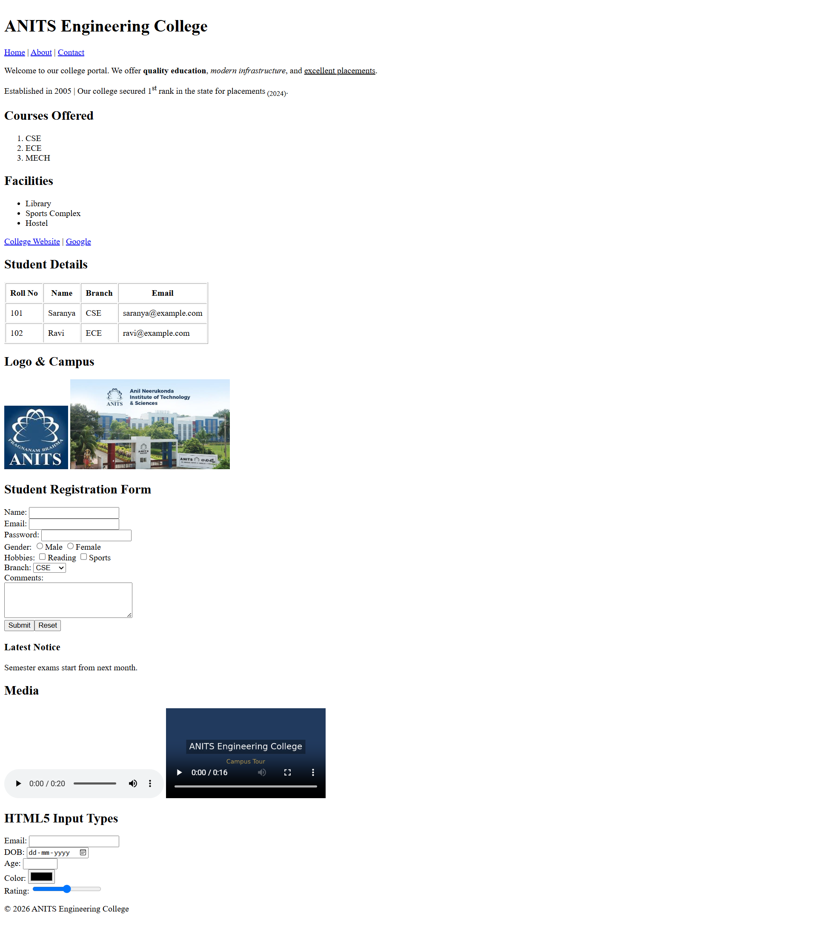
THANK YOU

