NAME: K. SARANYA
ROLL NO: A24126552090
BRANCH: CSM
SECTION: B
COURSE NAME: FULL STACK WEB DEVELOPMENT
CODE: 23CM4121
TITLE OF THE EXPERIMENT:
To develop an interactive To-Do List using JavaScript, DOM manipulation, and event listeners that allows users to add, complete, and delete tasks dynamically.
DESCRIPTION:-
This experiment demonstrates DOM element selection, dynamic element creation, event listeners, click event handling, and adding and removing elements from a webpage. The user can enter a task, add it to the list, mark it as completed, and delete it.
PROGRAM:-
<!-- index.html -->

<!DOCTYPE html>
<html lang="en">
<head>
<meta charset="UTF-8">
<meta name="viewport" content="width=device-width, initial-scale=1.0">
<title>My To-Do List</title>
<link rel="stylesheet" href="style.css">
</head>

<body>

<div class="container">

<!-- Page heading -->
<header>
<h1>📝 My To-Do List</h1>
<p>Organize your tasks and stay productive</p>
</header>

<!-- Task input section -->
<div class="task-input">

<input type="text"
id="taskInput"
placeholder="Enter a task...">

<button id="addTaskBtn">Add Task</button>

</div>

<!-- Tasks are added dynamically here -->
<div id="taskList"></div>

<!-- Message shown when the list is empty -->
<p id="emptyMessage">No tasks available.</p>

</div>

<script src="script.js"></script>
</body>
</html>

/* ================= style.css ================= */

* {
margin: 0;
padding: 0;
box-sizing: border-box;
}

body {
font-family: Arial, sans-serif;
min-height: 100vh;
background: linear-gradient(135deg, #667eea, #764ba2);
padding: 40px 20px;
}

.container {
max-width: 700px;
margin: auto;
}

header {
text-align: center;
color: white;
margin-bottom: 25px;
}

header h1 {
font-size: 34px;
margin-bottom: 8px;
}

header p {
font-size: 15px;
}

.task-input {
display: flex;
gap: 10px;
background: white;
padding: 20px;
border-radius: 16px;
box-shadow: 0 10px 25px rgba(0,0,0,0.2);
margin-bottom: 20px;
}

#taskInput {
flex: 1;
padding: 13px;
border: 1px solid #ccc;
border-radius: 8px;
font-size: 15px;
}

#addTaskBtn {
padding: 13px 22px;
border: none;
border-radius: 8px;
background: #667eea;
color: white;
font-size: 15px;
font-weight: bold;
cursor: pointer;
}

#addTaskBtn:hover {
background: #5369d8;
transform: translateY(-2px);
}

.task-item {
display: flex;
align-items: center;
gap: 12px;
background: white;
padding: 16px;
margin-bottom: 12px;
border-radius: 12px;
box-shadow: 0 5px 15px rgba(0,0,0,0.15);
}

.task-text {
flex: 1;
font-size: 16px;
font-weight: 500;
}

.complete-btn,
.delete-btn {
border: none;
border-radius: 7px;
padding: 9px 13px;
color: white;
font-weight: bold;
cursor: pointer;
}

.complete-btn {
background: #28a745;
}

.delete-btn {
background: #dc3545;
}

.complete-btn:hover {
background: #218838;
}

.delete-btn:hover {
background: #c82333;
}

.completed {
text-decoration: line-through;
opacity: 0.6;
}

#emptyMessage {
text-align: center;
color: white;
font-size: 16px;
margin-top: 25px;
}

/* ================= script.js ================= */

// Select the required HTML elements.
const taskInput = document.getElementById("taskInput");
const addTaskBtn = document.getElementById("addTaskBtn");
const taskList = document.getElementById("taskList");
const emptyMessage = document.getElementById("emptyMessage");

// Update the empty-list message.
function updateEmptyMessage() {
if (taskList.children.length === 0) {
emptyMessage.style.display = "block";
} else {
emptyMessage.style.display = "none";
}
}

// Add a new task when the button is clicked.
addTaskBtn.addEventListener("click", function () {

const taskText = taskInput.value.trim();

// Prevent adding an empty task.
if (taskText === "") {
alert("Please enter a task.");
return;
}

// Create a new task container.
const taskItem = document.createElement("div");
taskItem.className = "task-item";

// Create the task text.
const task = document.createElement("span");
task.className = "task-text";
task.textContent = taskText;

// Create the Complete button.
const completeBtn = document.createElement("button");
completeBtn.className = "complete-btn";
completeBtn.textContent = "Complete";

// Mark or unmark the task as completed.
completeBtn.addEventListener("click", function () {

task.classList.toggle("completed");

if (task.classList.contains("completed")) {
completeBtn.textContent = "Completed";
} else {
completeBtn.textContent = "Complete";
}
});

// Create the Delete button.
const deleteBtn = document.createElement("button");
deleteBtn.className = "delete-btn";
deleteBtn.textContent = "Delete";

// Remove the selected task.
deleteBtn.addEventListener("click", function () {
taskItem.remove();
updateEmptyMessage();
});

// Add all elements to the task container.
taskItem.appendChild(task);
taskItem.appendChild(completeBtn);
taskItem.appendChild(deleteBtn);

// Add the task to the webpage.
taskList.appendChild(taskItem);

// Clear the input field.
taskInput.value = "";

updateEmptyMessage();
});

// Show the message when the page initially has no tasks.
updateEmptyMessage();
OUTPUT:-
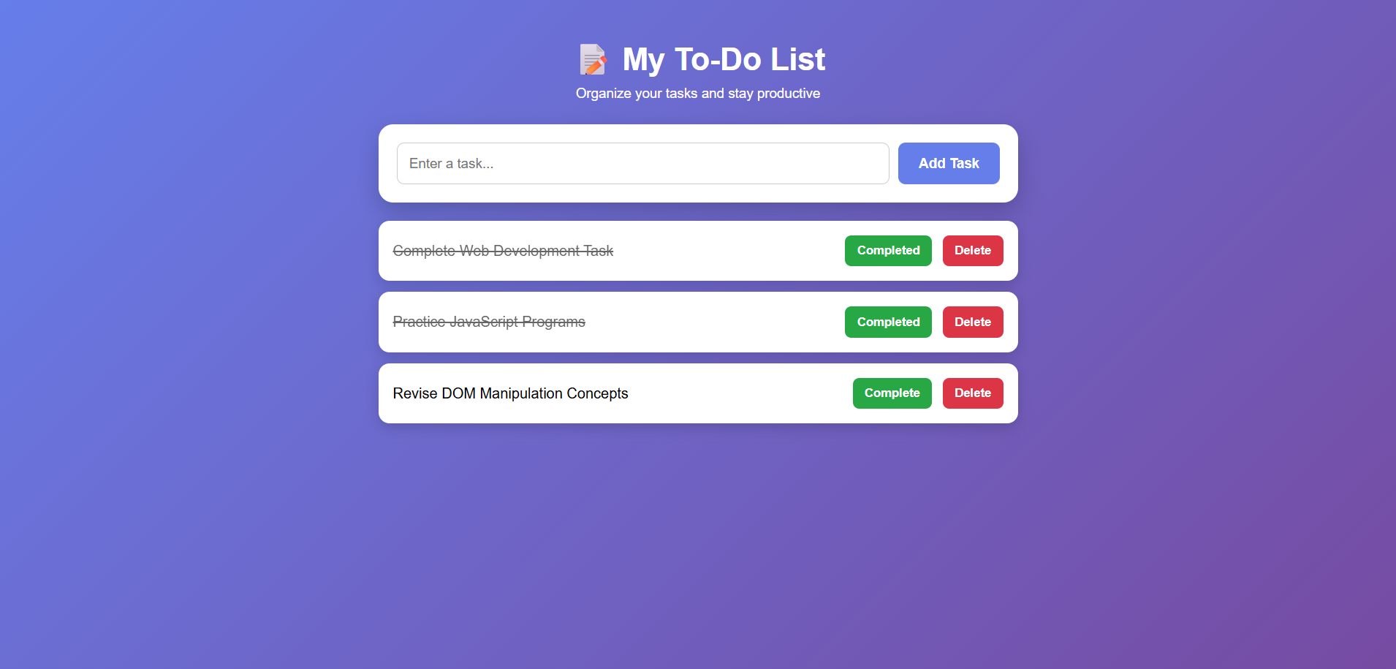
THANK YOU

