Topic : Library Management System

You are going to build a project based on Library Management System. It keeps track of all information about books in the library, their cost, status and total number of books available in the library.

Tables and Attributes:

1. Branch  
  
• Branch_no [Set as PRIMARY KEY  ]  
• Manager_Id    
• Branch_address    
• Contact_no

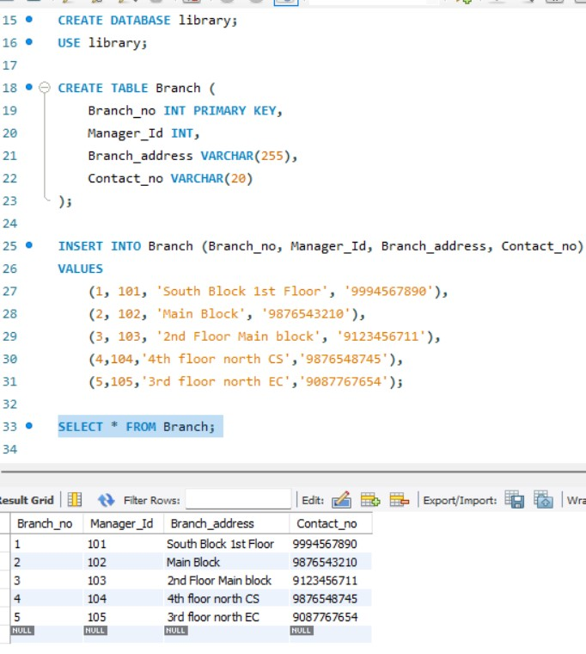

2. Employee    
  
• Emp_Id – Set as PRIMARY KEY    
• Emp_name    
• Position    
• Salary  
• Branch_no [Set as FOREIGN KEY and it refer Branch_no in Branch table]

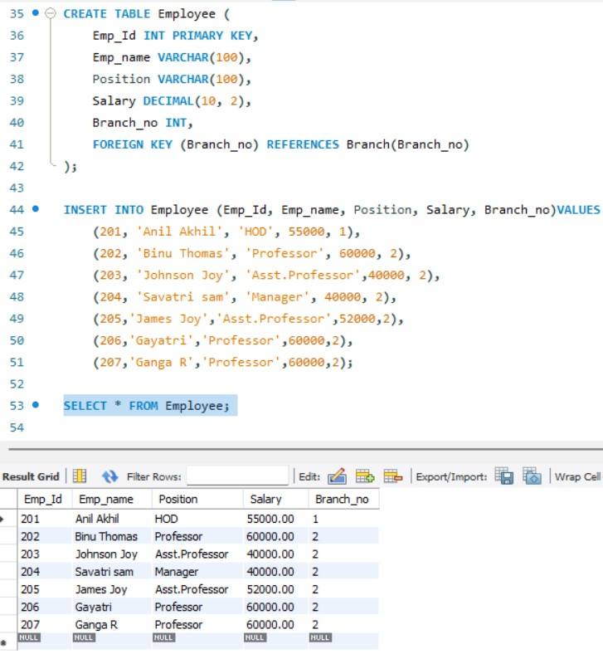

3. Books    
  
• ISBN [Set as PRIMARY KEY ]  
• Book_title    
• Category    
• Rental_Price    
• Status [Give yes if book available and no if book not available]    
• Author    
• Publisher

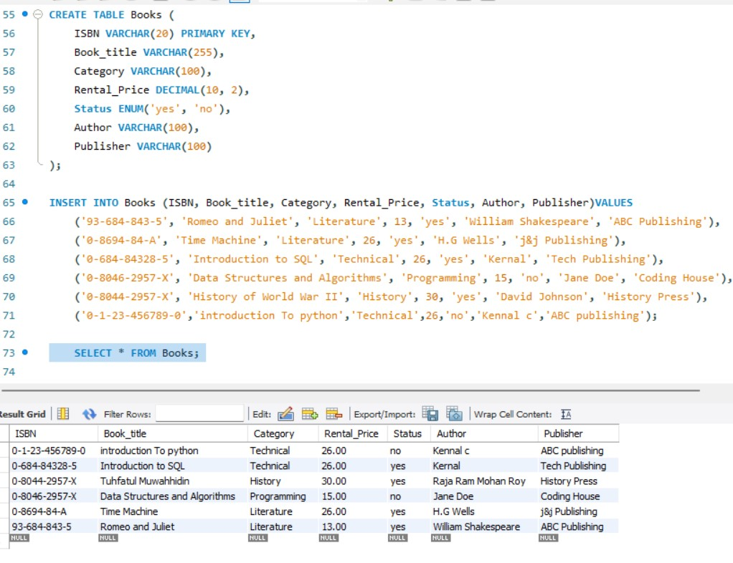

4. Customer    
  
• Customer_Id [Set as PRIMARY KEY]    
• Customer_name    
• Customer_address    
• Reg_date

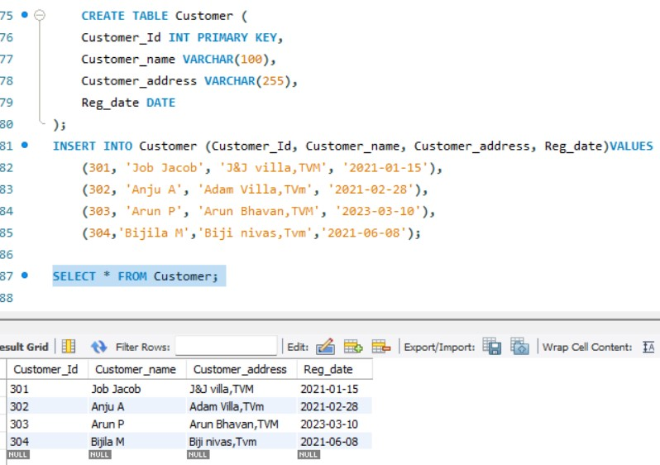

5. IssueStatus    
  
• Issue_Id [Set as PRIMARY KEY]    
• Issued_cust – Set as FOREIGN KEY and it refer customer_id in CUSTOMER table  Issued_book_name   
• Issue_date   
• Isbn_book – Set as FOREIGN KEY and it should refer isbn in BOOKS table

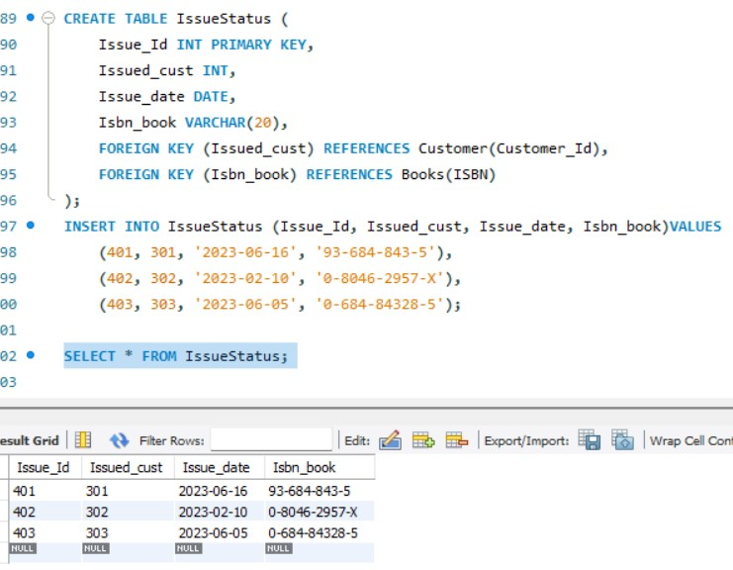

6. ReturnStatus    
  
• Return_Id [Set as PRIMARY KEY]    
• Return_cust    
• Return_book_name    
• Return_date    
• Isbn_book2 [Set as FOREIGN KEY and it should refer isbn in BOOKS table]

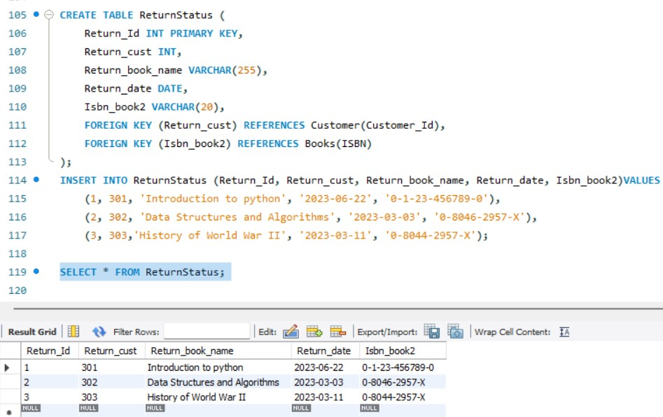

1. Retrieve the book title, category, and rental price of all available books.

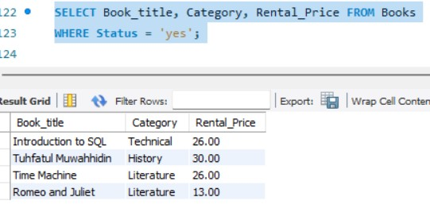

1. List the employee names and their respective salaries in descending order of salary.

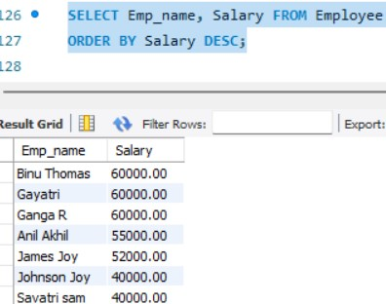

1. Retrieve the book titles and the corresponding customers who have issued those books.

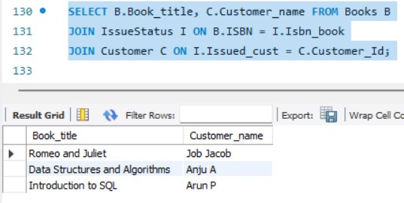

1. Display the total count of books in each category.

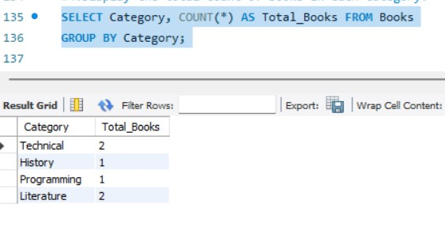

1. Retrieve the employee names and their positions for the employees whose salaries are above Rs.50,000.

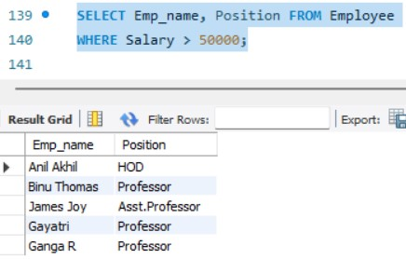

1. List the customer names who registered before 2022-01-01 and have not issued any books yet.

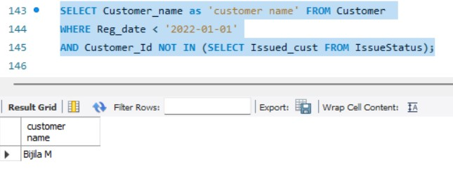

1. Display the branch numbers and the total count of employees in each branch.

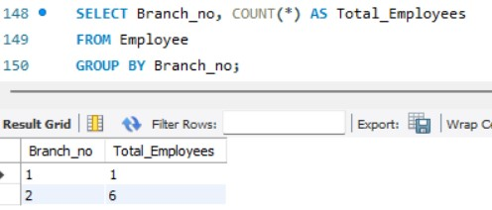

1. Display the names of customers who have issued books in the month of June 2023

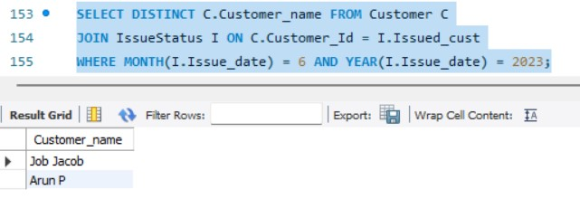

1. Retrieve book_title from book table containing history.

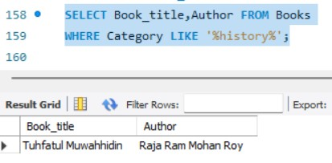

10.Retrieve the branch numbers along with the count of employees for branches having more than 5 employees

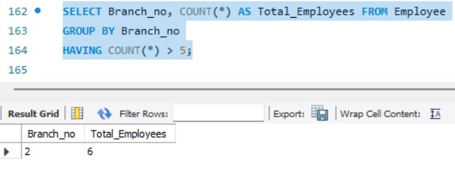

11.Retrieve the names of employees who manage branches and their respective branch addresses.

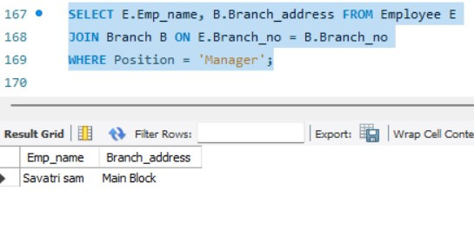

12.  Display the names of customers who have issued books with a rental price higher than Rs. 25.

