Customer 360 Data Integration Project
Azure Synapse Analytics • ADLS Gen2 • Azure SQL Database • GitHub CSV Ingestion
Step-by-step implementation guide with screenshots
Based on 20 screenshots captured on November 1, 2026

Project overview
This project uses Azure SQL Database to maintain file ingestion metadata, Azure Synapse pipelines to orchestrate ingestion, an HTTP linked service to retrieve CSV source files from GitHub, and Azure Data Lake Storage Gen2 to store the files. The screenshots document resource setup and a successful four-row metadata lookup. Subsequent file copy and downstream transformation results are not shown in this screenshot set.

Conceptual data flow
GitHub CSV source files → Synapse HTTP Copy activity → ADLS Gen2 raw folder. Azure SQL Customer360DB.FileConfig → Synapse Lookup → ForEach → parameterized Copy activity. Additional transformation/serving steps can be added after ingestion.

Project resources visible in screenshots
Resource group: rg-customer360
Region: Canada Central
Storage account: adls360demo01
ADLS filesystem: customer360
Synapse workspace: syn-customer360
Azure SQL logical server: sql-customer360
Azure SQL database: Customer360DB
Metadata table: dbo.FileConfig
Pipeline: Customer_360_project3
Lookup activity: File_lookup
HTTP linked service: LS_GitHub_HTTP

Implementation steps

Step 1. Create the Azure resource group
Procedure: Azure Portal → Resource groups → Create. Select Azure subscription 1, enter rg-customer360, and select Canada Central. Review and create.
Purpose / explanation: The resource group organizes all project services and supports cost tracking and resource management.
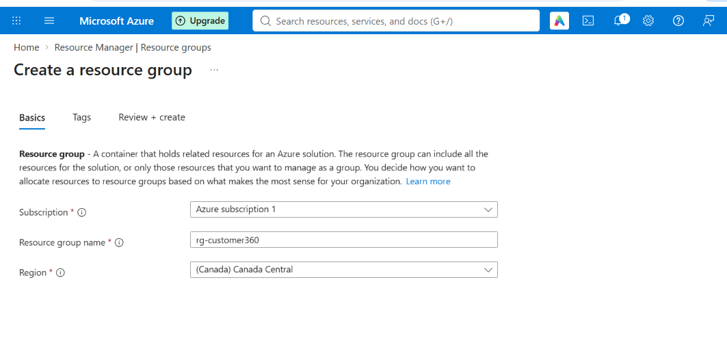
Figure 1. Create the Azure resource group — source screenshot: Screenshot 2026-11-01 170730.png

Step 2. Configure the storage account
Procedure: Azure Portal → Storage accounts → Create. Select rg-customer360, enter the globally unique storage account name adls360demo01, and choose Canada Central.
Purpose / explanation: This storage account provides the persistent data lake for ingested source files and subsequent processing.
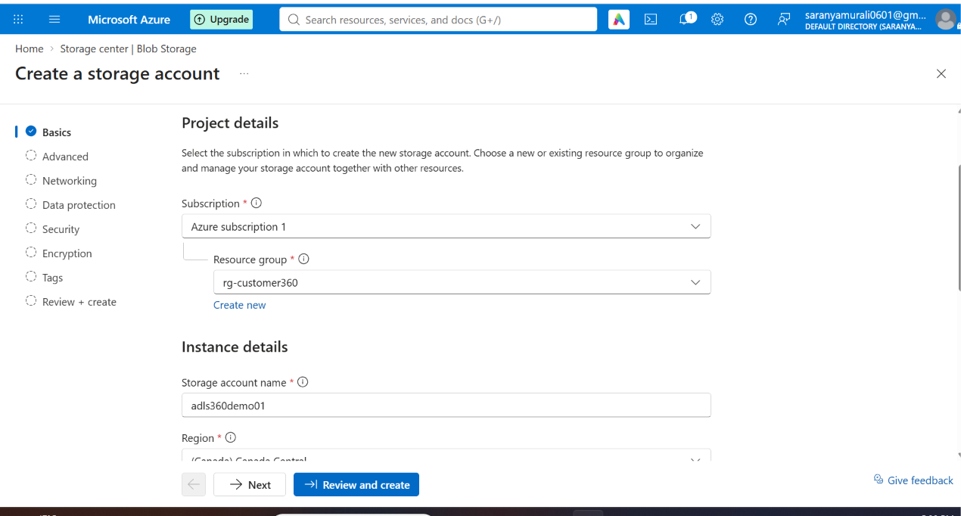
Figure 2. Configure the storage account — source screenshot: Screenshot 2026-11-01 170942.png

Step 3. Choose storage performance and service
Procedure: Under Basics, select Azure Blob Storage or Azure Data Lake Storage as the primary service and Standard performance. Review the workload and redundancy settings as appropriate.
Purpose / explanation: Standard storage is a practical starting point for a learning project; cost depends on capacity, transactions and redundancy.
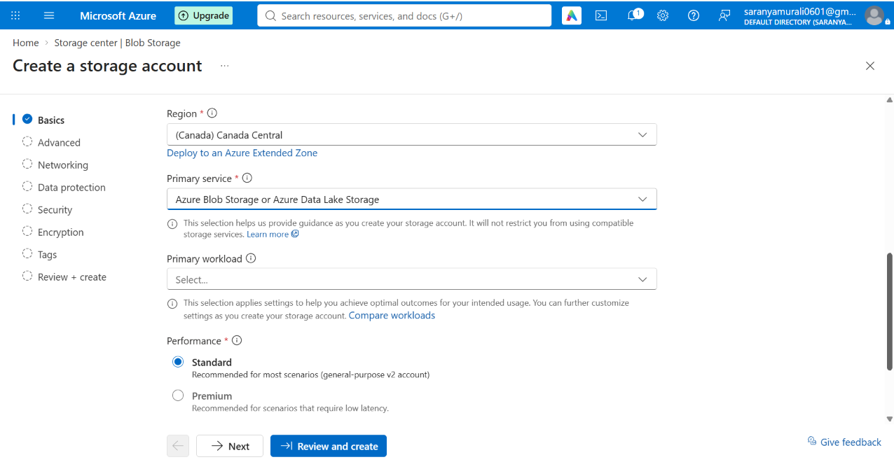
Figure 3. Choose storage performance and service — source screenshot: Screenshot 2026-11-01 171000.png

Step 4. Enable ADLS Gen2 hierarchical namespace
Procedure: Under Advanced, enable Hierarchical namespace. Leave NFS v3 and SFTP off unless specifically required.
Purpose / explanation: Hierarchical namespace enables directory-style organization and ADLS Gen2 semantics needed for analytics workloads.
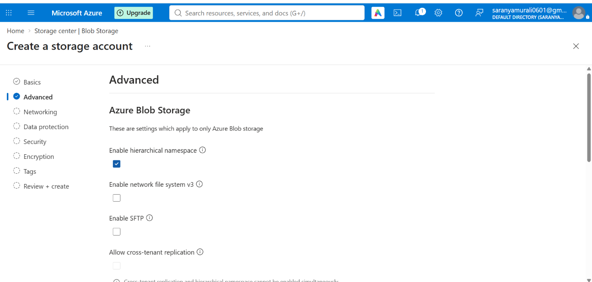
Figure 4. Enable ADLS Gen2 hierarchical namespace — source screenshot: Screenshot 2026-11-01 171035.png

Step 5. Verify storage deployment
Procedure: Select Review + create, validate and create the storage account. Wait until Azure shows Your deployment is complete.
Purpose / explanation: This confirms the resource deployment succeeded; it does not alone verify data access permissions.
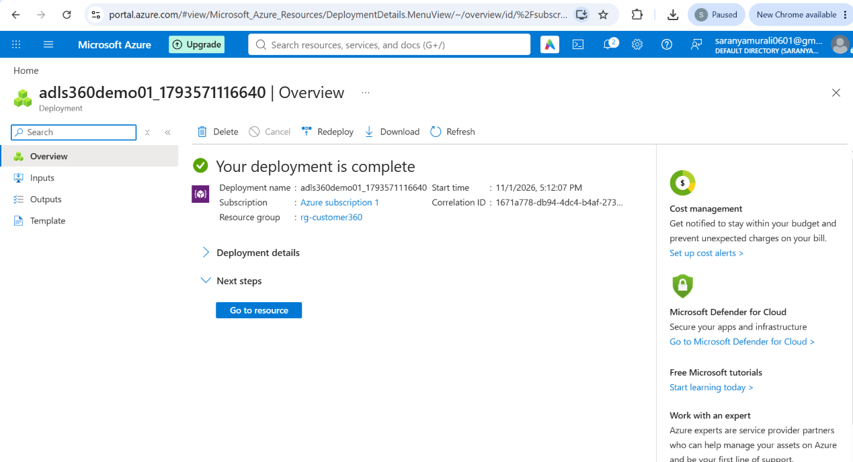
Figure 5. Verify storage deployment — source screenshot: Screenshot 2026-11-01 171244.png

Step 6. Create the Synapse workspace
Procedure: Azure Portal → Azure Synapse Analytics → Create. Choose subscription, rg-customer360, workspace name syn-customer360, and Canada Central.
Purpose / explanation: Synapse provides orchestration, Spark notebooks and serverless SQL querying within the same workspace.
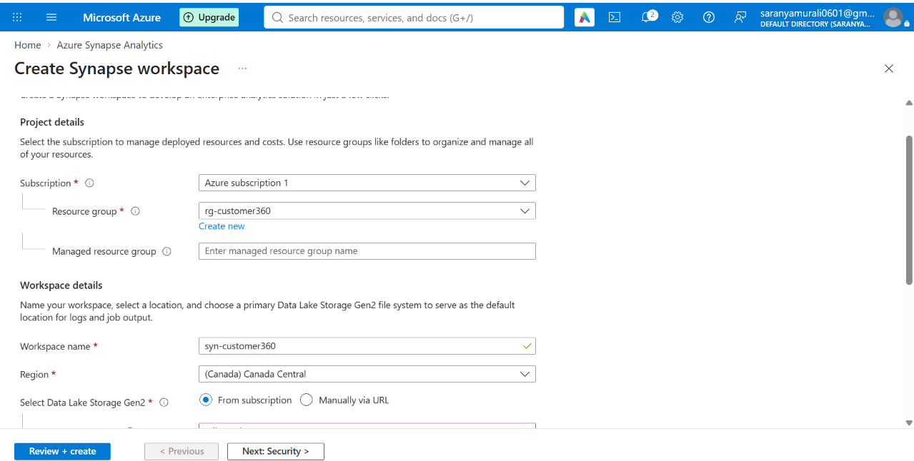
Figure 6. Create the Synapse workspace — source screenshot: Screenshot 2026-11-01 171452.png

Step 7. Associate the primary data lake
Procedure: Choose storage account adls360demo01 and create/select filesystem customer360. The screenshot shows Assign myself the Storage Blob Data Contributor role selected.
Purpose / explanation: The filesystem is the workspace default storage location. The workspace managed identity and human users require appropriate storage permissions.
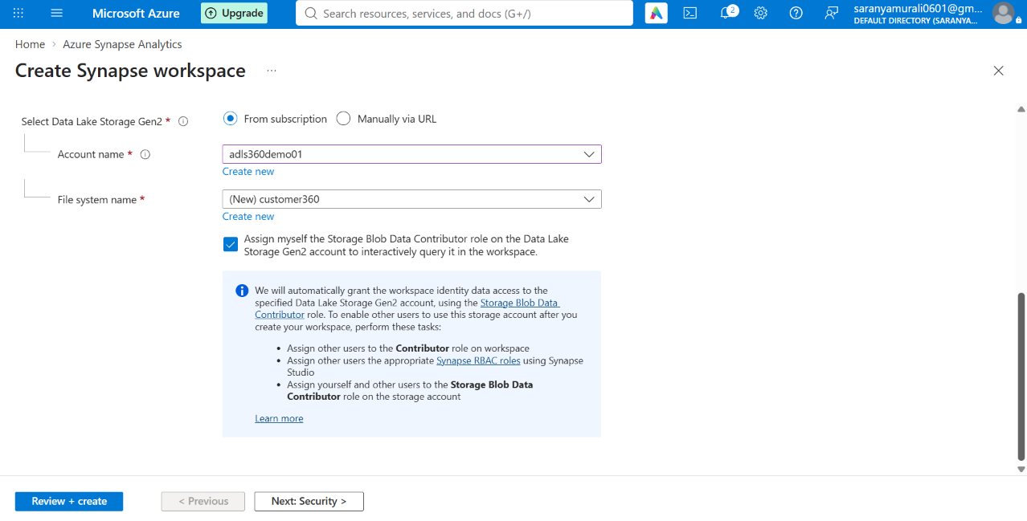
Figure 7. Associate the primary data lake — source screenshot: Screenshot 2026-11-01 171505.png

Step 8. Verify Synapse workspace deployment
Procedure: Review and create the workspace, then confirm the deployment-complete message. Open Synapse Studio from the deployed resource.
Purpose / explanation: Workspace deployment completion establishes the resource; later permissions and network settings still need testing.
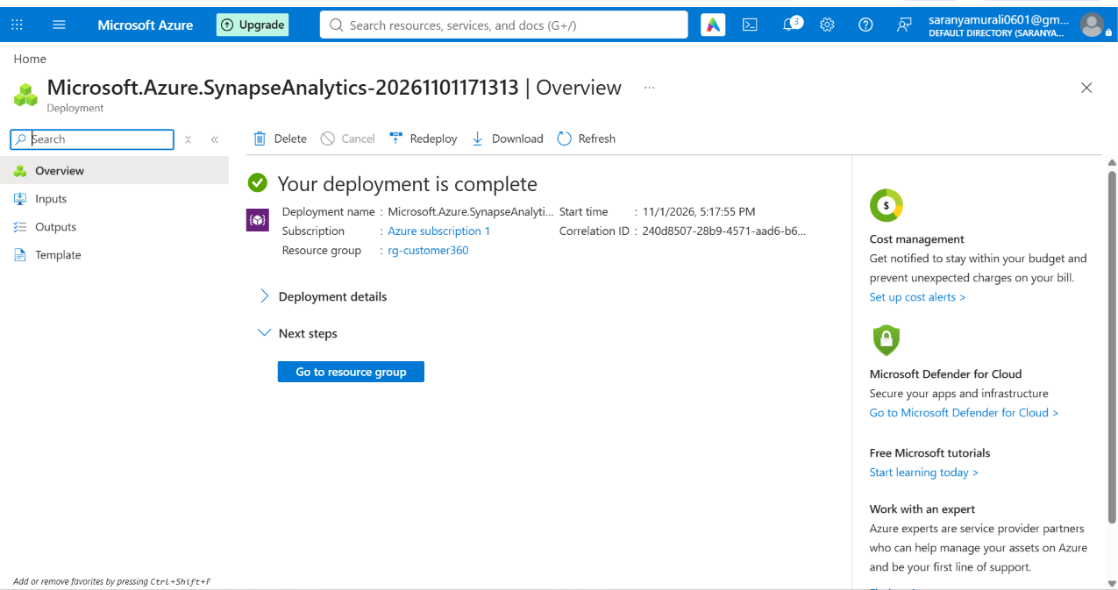
Figure 8. Verify Synapse workspace deployment — source screenshot: Screenshot 2026-11-01 172138.png

Step 9. Create an Azure SQL logical server
Procedure: Azure Portal → SQL servers → Create. Use rg-customer360, server name sql-customer360 and Canada Central.
Purpose / explanation: This server hosts the separate Azure SQL Database used for project metadata and, where designed, target tables.
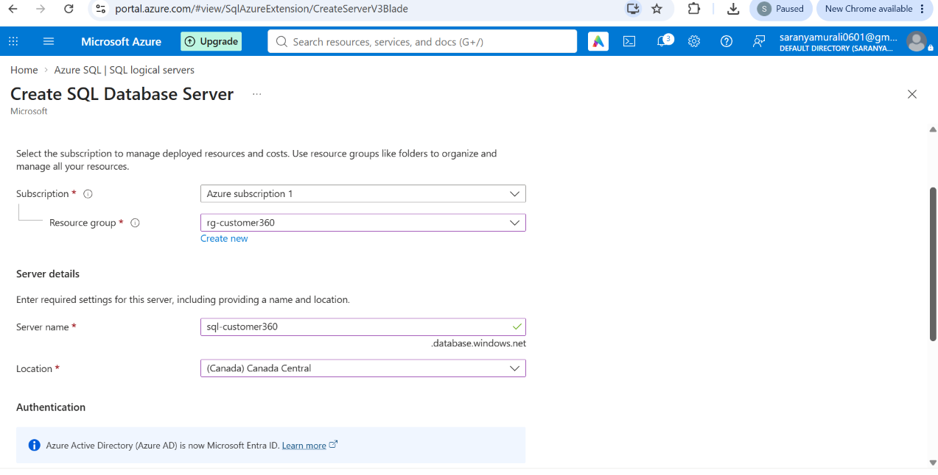
Figure 9. Create an Azure SQL logical server — source screenshot: Screenshot 2026-11-01 172351.png

Step 10. Configure SQL server authentication
Procedure: The screenshot selects SQL authentication and shows the SQL admin login sqladminuser. Set a strong password and store it securely; do not place it in project documentation.
Purpose / explanation: SQL authentication is for the Azure SQL logical server. It is not the same as Microsoft Entra authentication for Synapse serverless SQL.
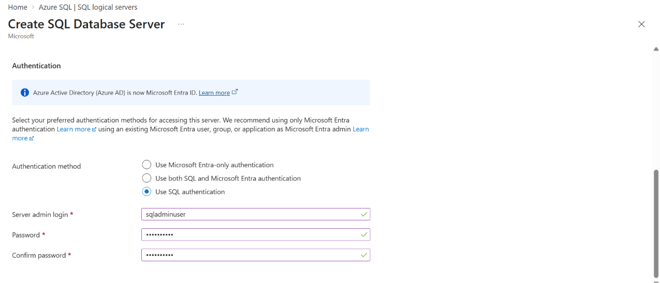
Figure 10. Configure SQL server authentication — source screenshot: Screenshot 2026-11-01 172404.png

Step 11. Verify SQL logical server deployment
Procedure: Complete deployment and confirm Your deployment is complete.
Purpose / explanation: The server must exist before creating the Azure SQL database.
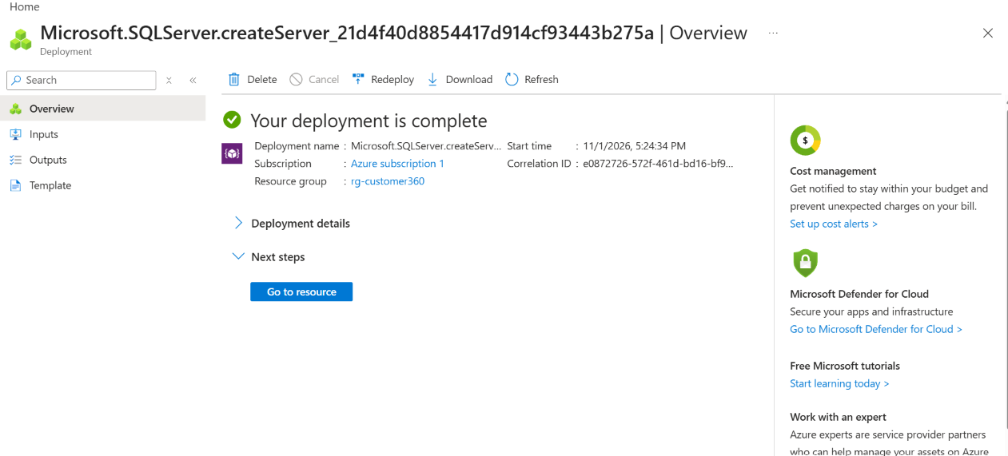
Figure 11. Verify SQL logical server deployment — source screenshot: Screenshot 2026-11-01 172606.png

Step 12. Choose Azure SQL compute tier
Procedure: In the SQL database creation wizard, inspect General Purpose and Serverless compute. Configure auto-pause/minimum capacity and storage to suit the lab budget.
Purpose / explanation: Azure SQL Database serverless is a compute tier for a provisioned SQL database; it is distinct from Synapse Built-in serverless SQL.
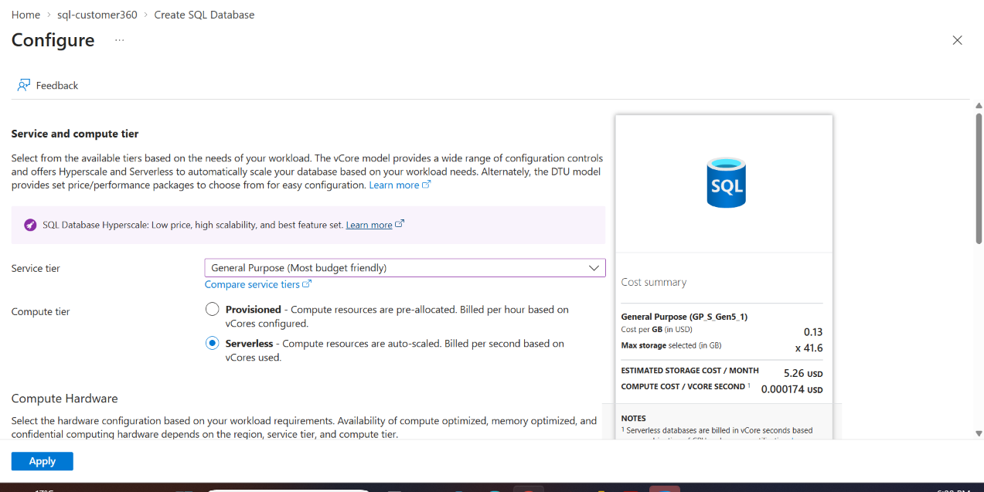
Figure 12. Choose Azure SQL compute tier — source screenshot: Screenshot 2026-11-01 180017.png

Step 13. Create the Customer360DB Azure SQL database
Procedure: Select the sql-customer360 server and enter database name Customer360DB. Choose the appropriate workload environment and compute settings.
Purpose / explanation: Customer360DB is the Azure SQL Database in this screenshot, not automatically a Synapse Built-in SQL database.
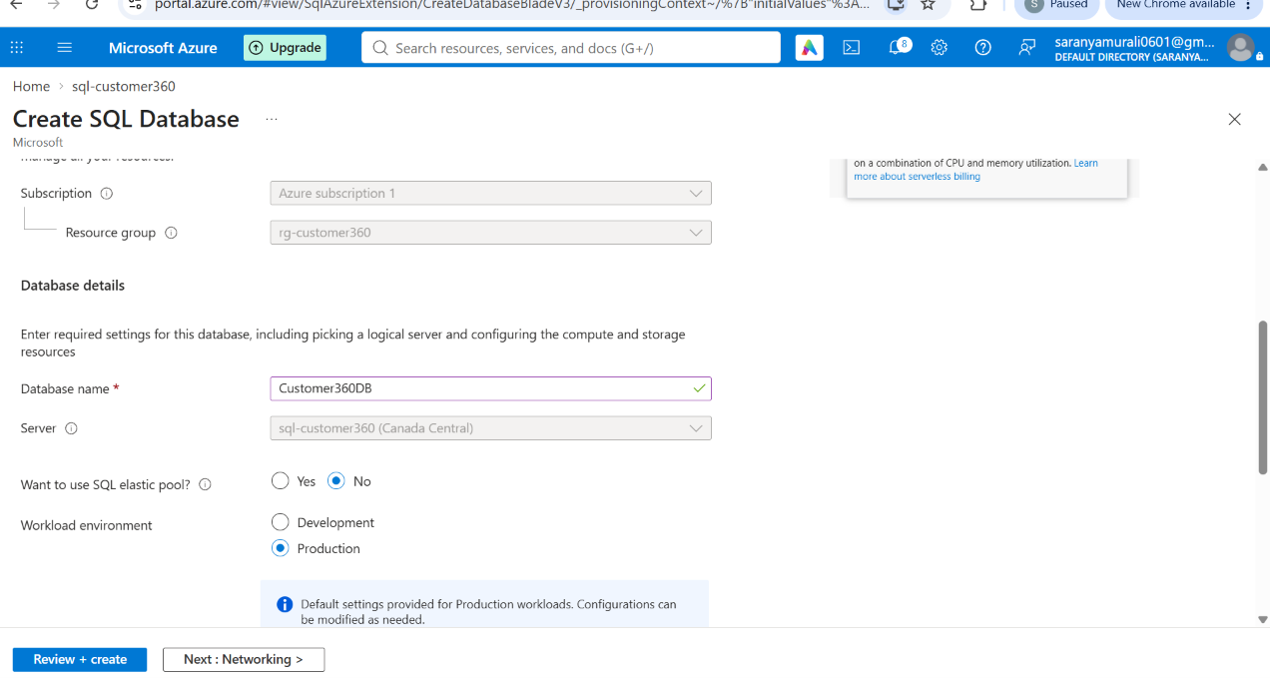
Figure 13. Create the Customer360DB Azure SQL database — source screenshot: Screenshot 2026-11-01 180038.png

Step 14. Verify Azure SQL Database deployment
Procedure: Review and create the database, then wait for the deployment-complete status.
Purpose / explanation: The SQL database is ready for table creation once firewall and login permissions are configured.
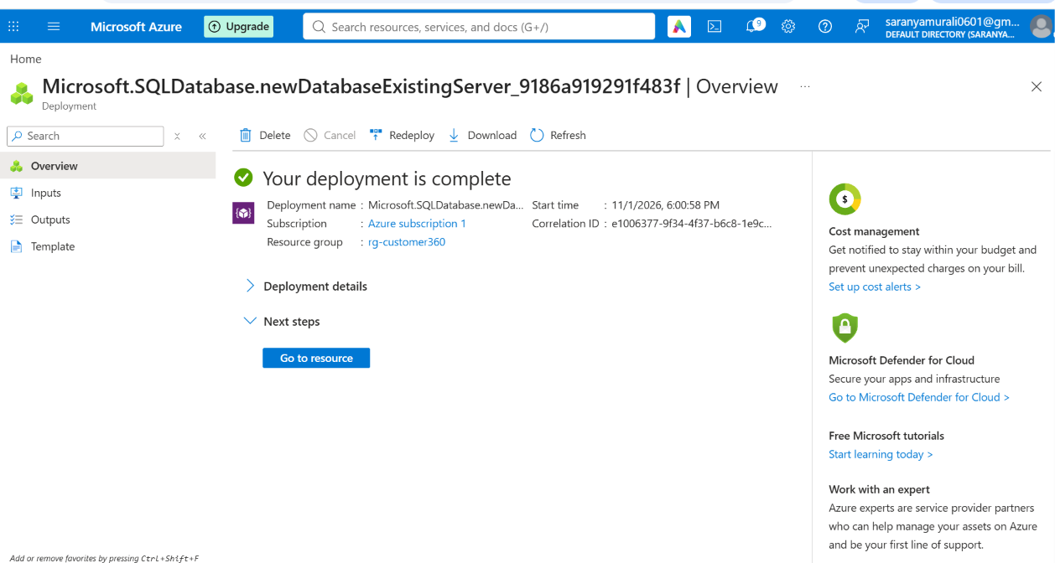
Figure 14. Verify Azure SQL Database deployment — source screenshot: Screenshot 2026-11-01 180227.png

Step 15. Create and populate the FileConfig metadata table
Procedure: Connect SQL Server Management Studio to sql-customer360.database.windows.net, choose Customer360DB and execute the FileConfig DDL. Insert one metadata row for each source file.
Purpose / explanation: FileConfig holds SourceFileName, SourceURL, TargetFolder, TargetFileName and IsActive. The screenshot shows four rows: two credit-bureau and two payment-gateway files.
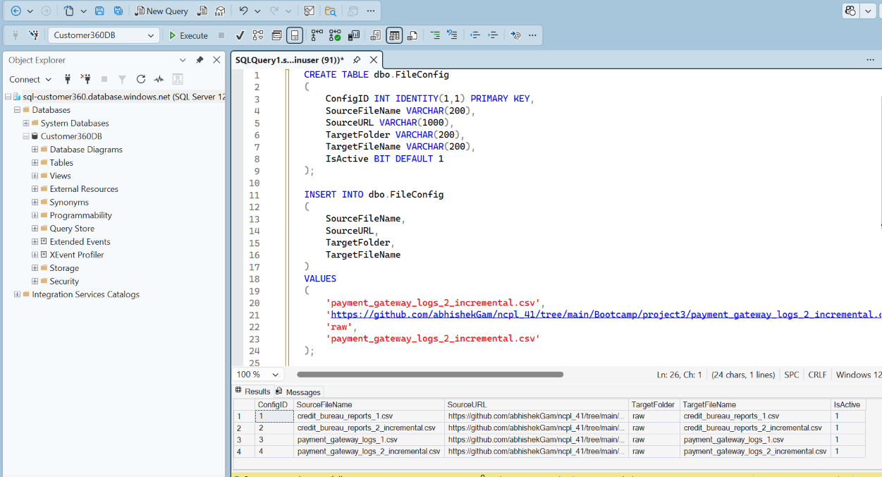
Figure 15. Create and populate the FileConfig metadata table — source screenshot: Screenshot 2026-11-01 181331.png

Step 16. Add a Lookup activity in the Synapse pipeline
Procedure: Open Synapse Studio → Integrate → create/open pipeline Customer_360_project3. Add Lookup named File_lookup. Select a source dataset that reads the Azure SQL FileConfig table, not an HTTP dataset for the metadata lookup.
Purpose / explanation: Lookup retrieves the active file configuration rows so a single pipeline can process multiple files.
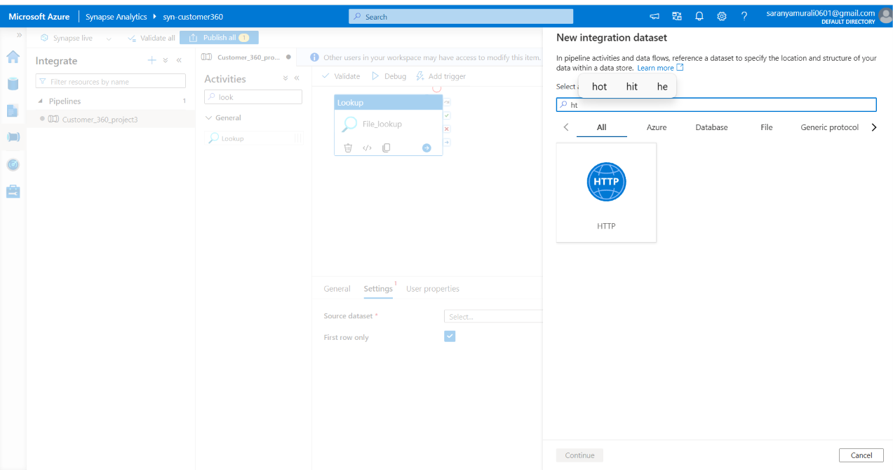
Figure 16. Add a Lookup activity in the Synapse pipeline — source screenshot: Screenshot 2026-11-01 185152.png

Step 17. Select the correct file format
Procedure: When creating a file-based dataset, choose DelimitedText for CSV files. The screenshot shows the format selection screen.
Purpose / explanation: A dataset format determines how Synapse interprets source or destination file contents. The metadata lookup itself should use the SQL dataset.
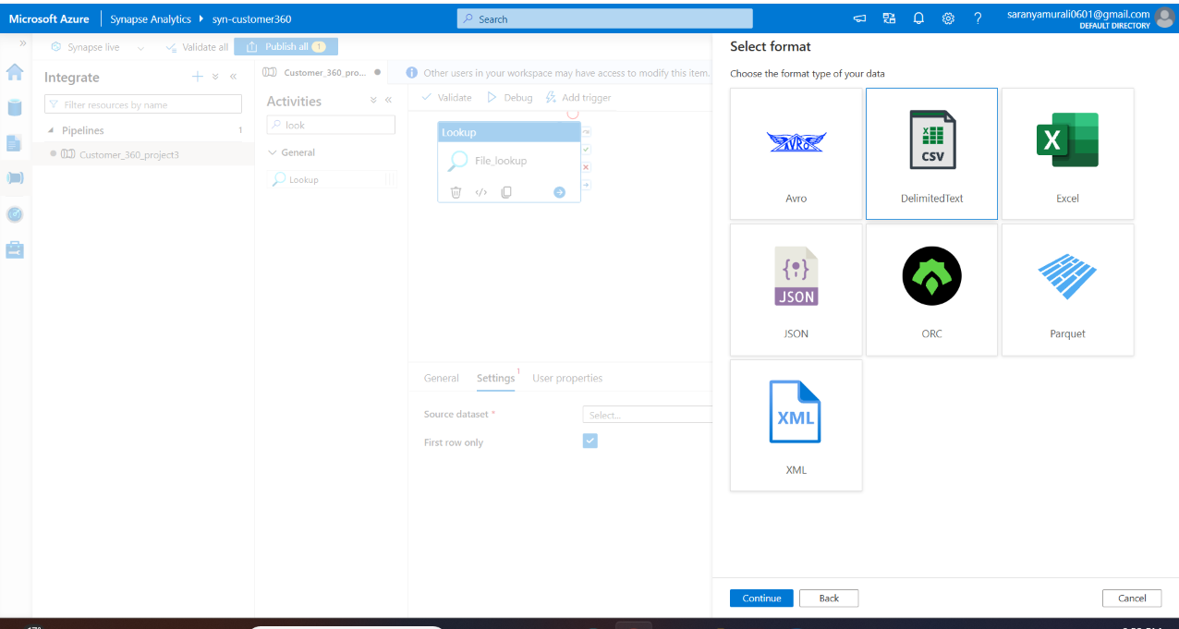
Figure 17. Select the correct file format — source screenshot: Screenshot 2026-11-01 185216.png

Step 18. Create the HTTP linked service
Procedure: Create HTTP linked service LS_GitHub_HTTP using AutoResolveIntegrationRuntime and anonymous authentication for a public raw GitHub URL. The screenshot shows a connection-successful result.
Purpose / explanation: A successful linked-service test checks endpoint connectivity; it does not prove that each individual source file URL returns CSV data.
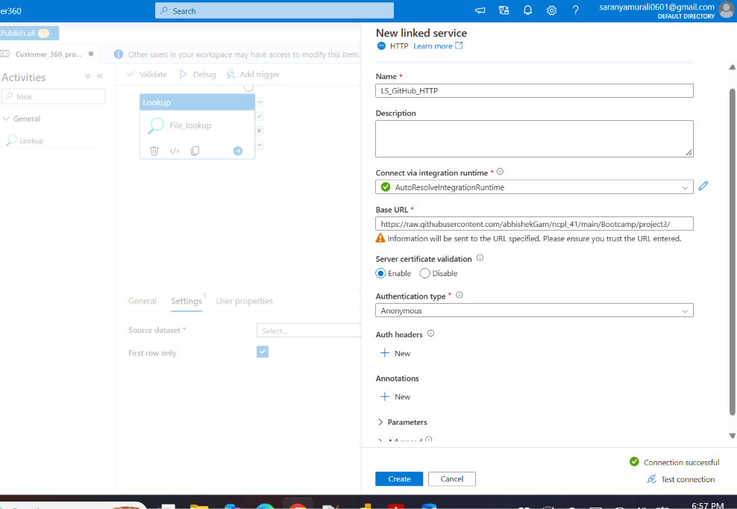
Figure 18. Create the HTTP linked service — source screenshot: Screenshot 2026-11-01 185741.png

Step 19. Configure the dynamic expression
Procedure: In a ForEach activity, set Items to @activity('File_lookup').output.value when Lookup First row only is disabled. Inside ForEach, use @item() fields for source URL and destination file name in a Copy activity.
Purpose / explanation: The expression shown in the screenshot is @activity('File_lookup').output, which is the whole output object. ForEach normally needs the value array, not the entire object.
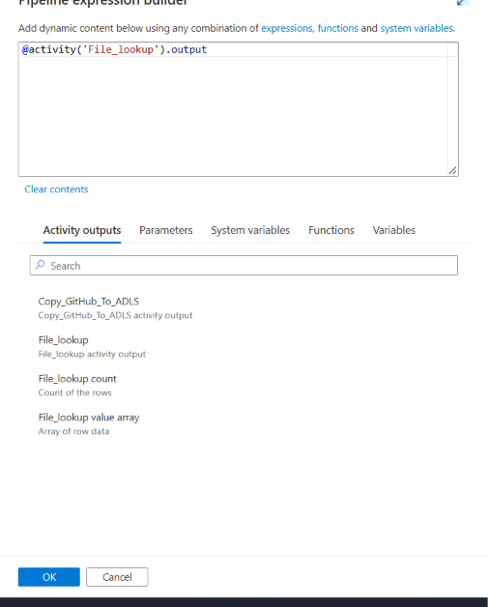
Figure 19. Configure the dynamic expression — source screenshot: Screenshot 2026-11-01 195542.png

Step 20. Validate Lookup output and four configuration rows
Procedure: Debug the pipeline and inspect File_lookup output. The screenshot shows count: 4 and value containing four SourceURL/TargetFolder/TargetFileName objects.
Purpose / explanation: This confirms that Lookup returned four metadata records. It does not by itself confirm that Copy activities succeeded or that all four files reached ADLS.
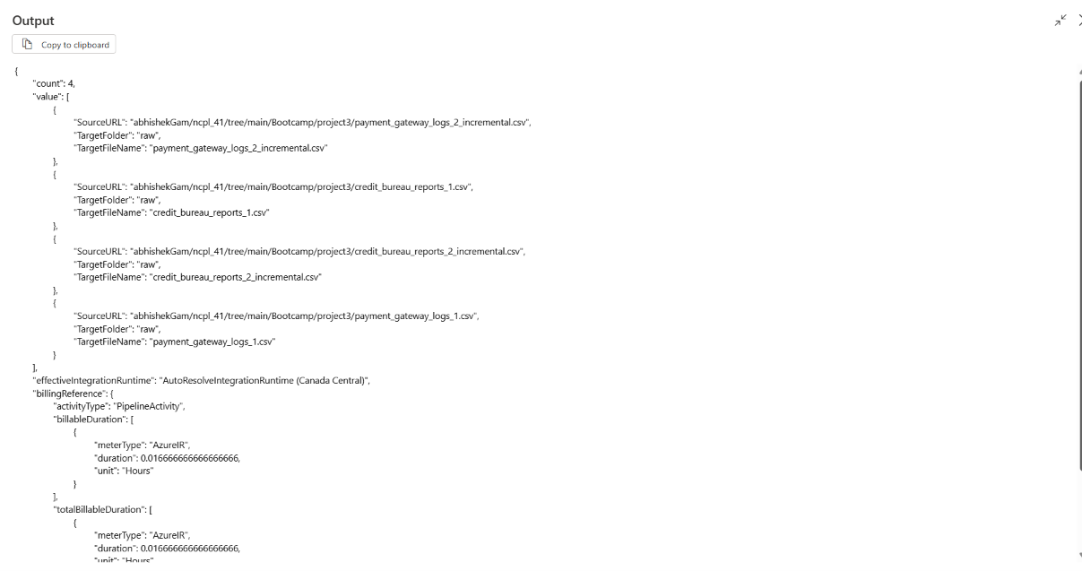
Figure 20. Validate Lookup output and four configuration rows — source screenshot: Screenshot 2026-11-01 195647.png

SQL configuration example
The following is an illustrative reconstruction of the table visible in the SQL screenshot. Execute it only if the table does not already exist.
CREATE TABLE dbo.FileConfig (
ConfigID INT IDENTITY(1,1) PRIMARY KEY,
SourceFileName VARCHAR(200),
SourceURL VARCHAR(1000),
TargetFolder VARCHAR(200),
TargetFileName VARCHAR(200),
IsActive BIT DEFAULT 1
);
SELECT SourceURL, TargetFolder, TargetFileName
FROM dbo.FileConfig
WHERE IsActive = 1;

Pipeline configuration: detailed execution

1. Azure SQL linked service
Create an Azure SQL Database linked service pointing to sql-customer360.database.windows.net and Customer360DB. Use an authorized login and test the connection.

2. Lookup dataset
Create an Azure SQL Database dataset linked to dbo.FileConfig; set Lookup to use a query filtering IsActive = 1. Turn off First row only so output.value is an array.

3. ForEach loop
Connect Lookup success to ForEach. Use @activity('File_lookup').output.value as Items.

4. Parameterized HTTP source
Use a public raw.githubusercontent.com URL. The screenshot’s older GitHub tree URL is not a raw CSV endpoint. A private repository requires authorized access rather than anonymous HTTP.

5. Copy to ADLS
Within ForEach, configure Copy source using @item().SourceURL or a correctly parameterized relative URL; configure destination folder @item().TargetFolder and file name @item().TargetFileName. Ensure the dataset and linked service do not duplicate URL path segments.

6. Debug and verify
Debug, confirm four ForEach iterations, inspect each Copy activity status and bytes copied, and verify actual files under the ADLS customer360 container.

7. Publish and schedule
Publish all changes. After successful debugging, create a trigger if scheduled ingestion is needed. Monitor runs and configure failure alerts as required.

Step 1: Configure GitHub HTTP linked service
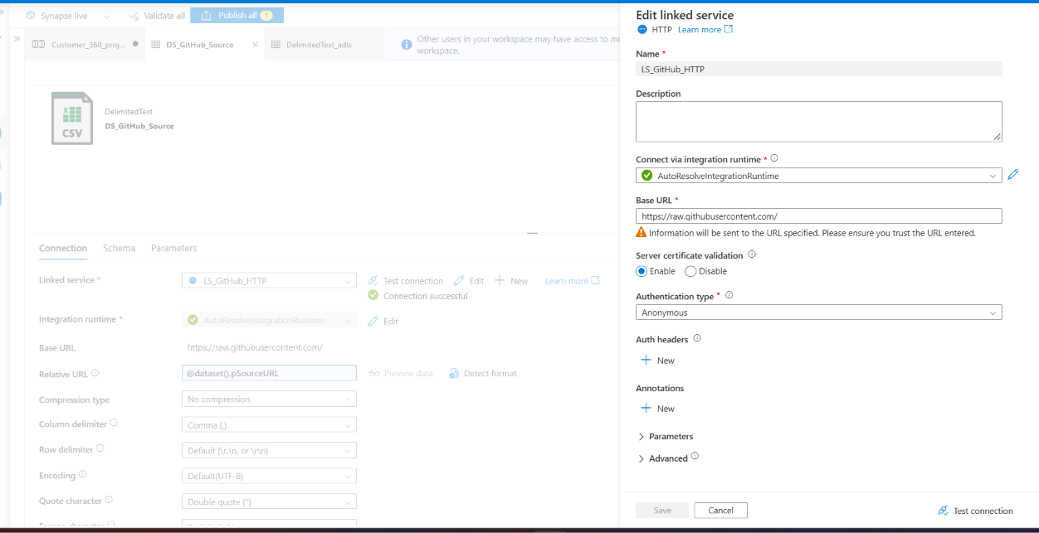
Create LS_GitHub_HTTP using the HTTP connector. Set the base URL to https://raw.githubusercontent.com/, select AutoResolveIntegrationRuntime, enable server certificate validation, and choose Anonymous only for publicly accessible files. Parameterize the dataset relative URL with pSourceURL; confirm the URL resolves to raw CSV content.

Step 2: Create Azure SQL sink dataset
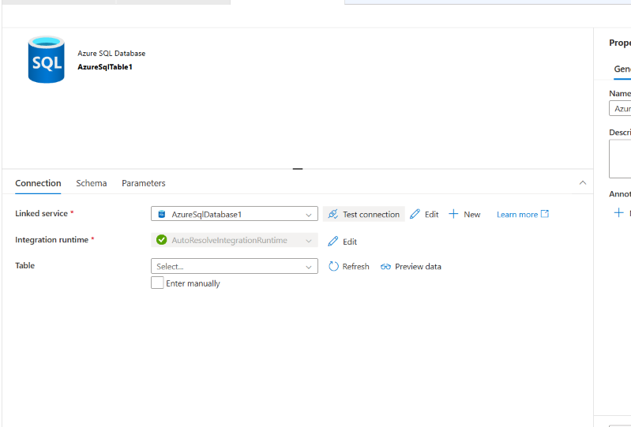
Create an Azure SQL Database dataset and select the AzureSqlDatabase1 linked service. Test the connection. The destination table is selected later using a dataset parameter, allowing a single dataset to load different tables.

Step 3: Configure ADLS delimited-text dataset
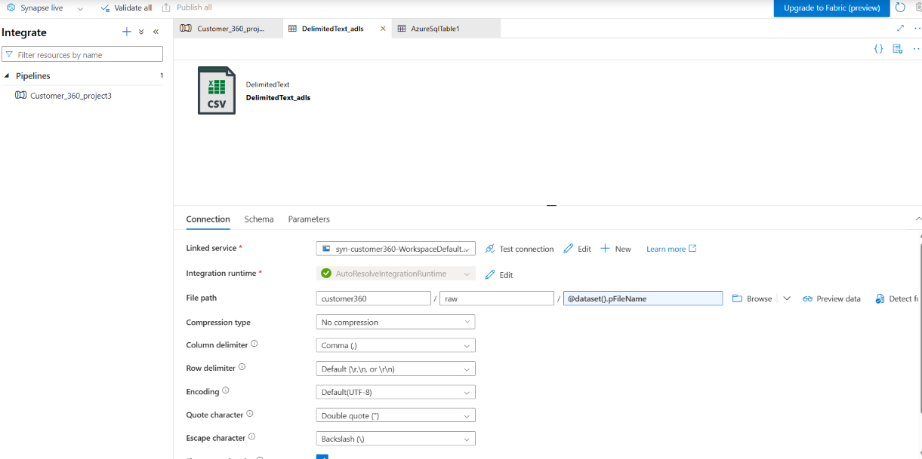
Set the dataset storage container to customer360, folder to raw, and file name to @dataset().pFileName. Keep CSV settings consistent with the source, including comma delimiter, UTF-8 encoding, and quote character.

Step 4: Parameterize SQL sink table
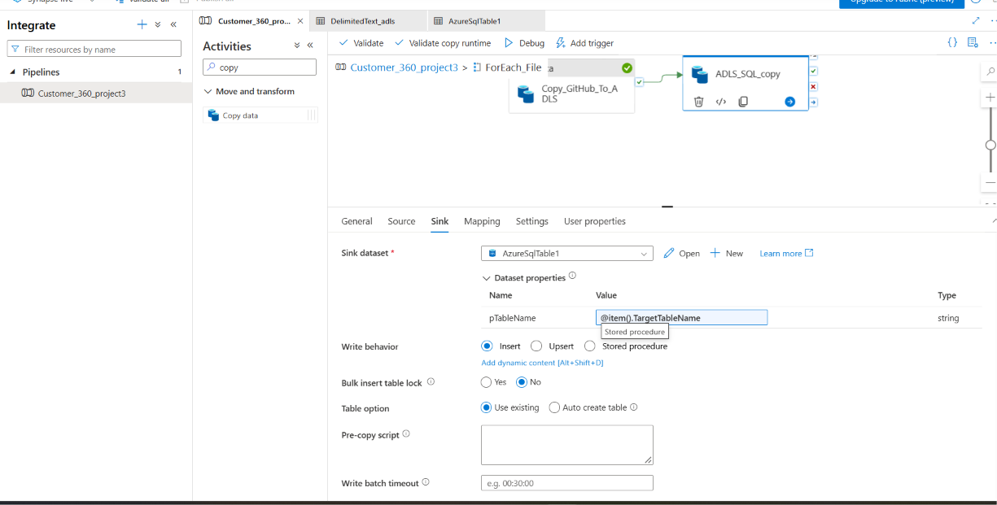
In ADLS_SQL_copy Sink, select AzureSqlTable1 and pass @item().TargetTableName into pTableName. Select Insert and Use existing table; use Upsert instead if the incremental-loading requirement calls for key-based updates.

Step 5: Configure dynamic SQL dataset table
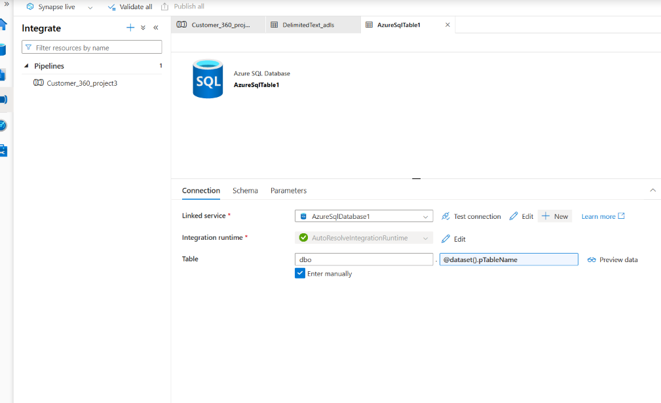
In AzureSqlTable1, select Enter manually, set schema dbo, and set the table-name field to @dataset().pTableName. Verify that FileConfig supplies the intended target table name for every file.

Step 6: Create credit bureau target table
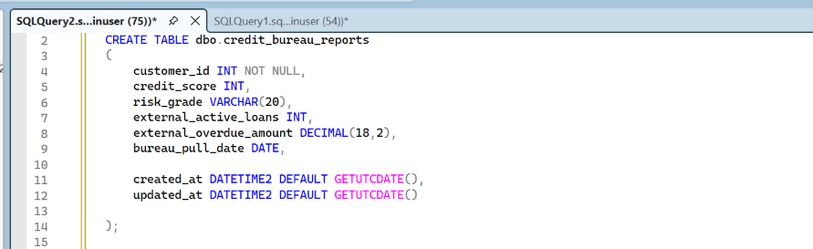
Create dbo.credit_bureau_reports with customer_id, credit_score, risk_grade, external_active_loans, external_overdue_amount, bureau_pull_date, and created_at/updated_at columns. Use DECIMAL(18,2) for amounts and DATE for bureau_pull_date.

Step 7: Create payment gateway target table
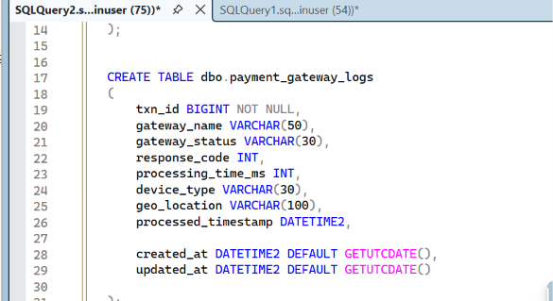
Create dbo.payment_gateway_logs with txn_id, gateway_name, gateway_status, response_code, processing_time_ms, device_type, geo_location, processed_timestamp, and audit timestamps. Match the source CSV column types before copying.

Step 8: Validate Azure SQL row counts
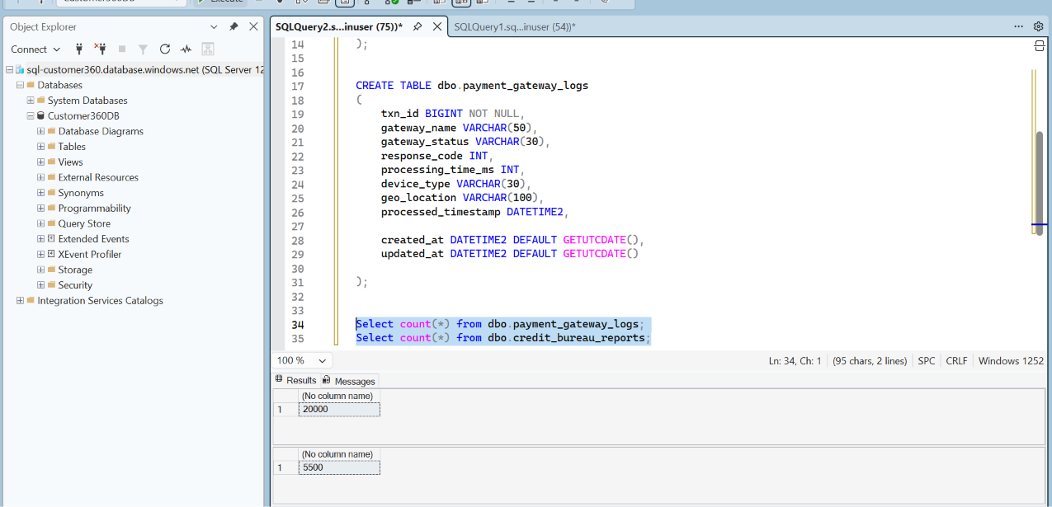
Run SELECT COUNT(*) on dbo.payment_gateway_logs and dbo.credit_bureau_reports. The screenshot shows 20,000 payment gateway rows and 5,500 credit bureau rows. Compare these totals with expected full and incremental file counts and check for duplicate business keys.

Step 9: Configure ForEach activities
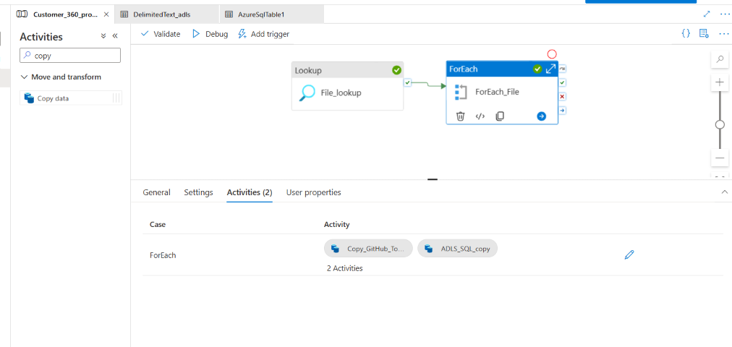
Connect File_lookup success to ForEach_File. Inside ForEach, add Copy_GitHub_To_ADLS followed by ADLS_SQL_copy with a success dependency. The loop processes each configuration row returned by Lookup.

Step 10: Parameterize the ADLS source file
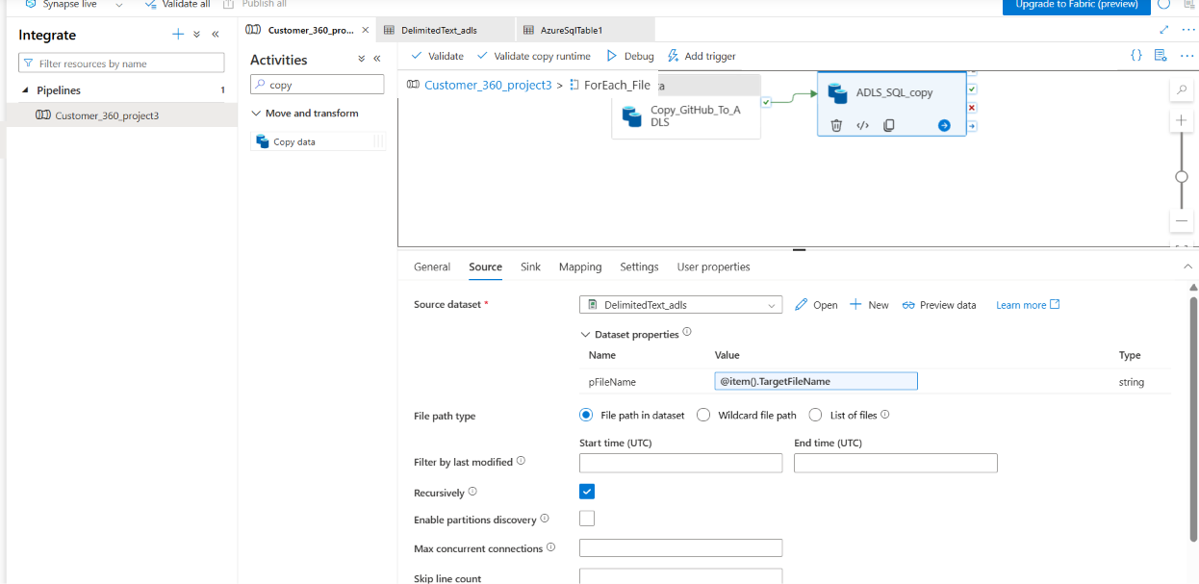
In ADLS_SQL_copy Source, choose DelimitedText_adls and pass @item().TargetFileName to the pFileName dataset parameter. This ensures the file written in the current loop iteration is the file read for SQL loading.

Step 11: Review successful Synapse pipeline execution
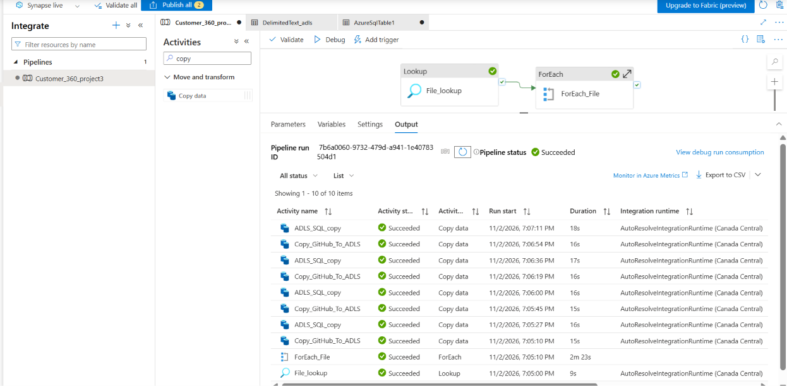
Debug Customer_360_project3. Confirm File_lookup and ForEach_File succeeded, and review the eight successful Copy activity executions (four GitHub-to-ADLS and four ADLS-to-SQL). Inspect each activity’s input/output for rows read, rows written, and errors.

Step 12: Review SQL records after loading
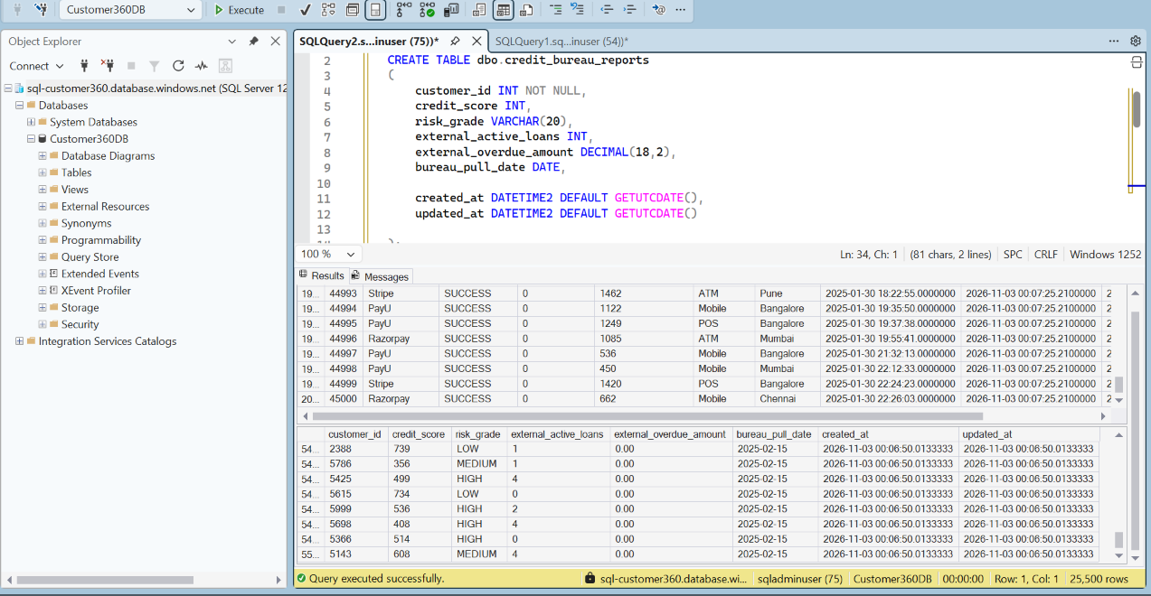
In SQL Server Management Studio connect to Customer360DB and query the destination tables. Inspect loaded payment gateway transactions and credit bureau records, including timestamps, scores, and risk grades, to verify the data reached Azure SQL.

Step 13: Verify taxi source folders in ADLS
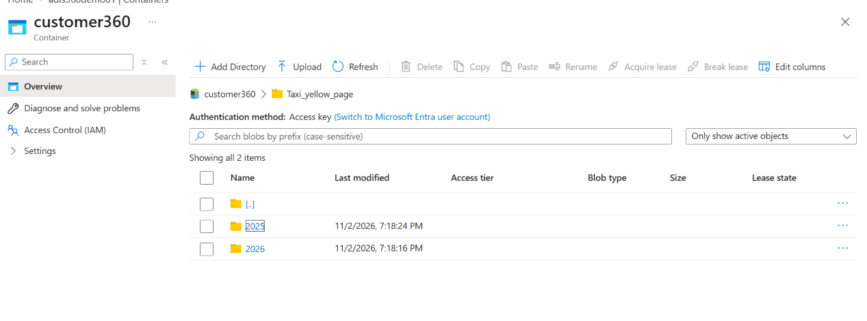
Open the customer360 storage container and navigate to Taxi_yellow_page. Confirm that the 2025 and 2026 folders are present as the landing structure for the downloaded NYC taxi Parquet files.

Step 14: Download NYC taxi Parquet files
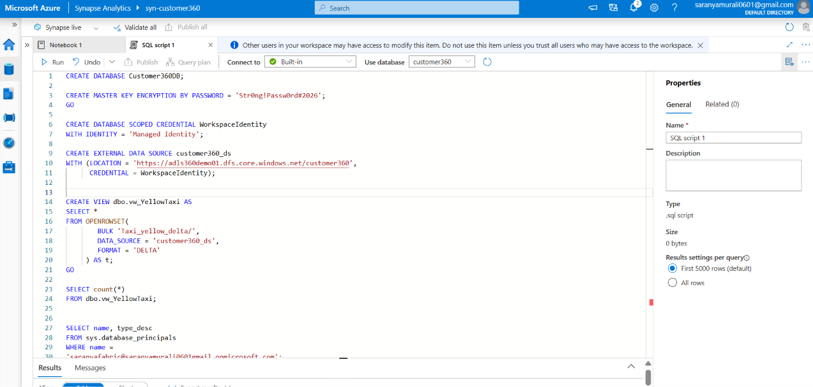
In a Synapse PySpark notebook, use requests and os to loop through years 2025–2026 and months 01–04. Construct each yellow_tripdata_{year}-{month}.parquet URL, stream its response into /tmp/nyc_taxi, and handle HTTP or request exceptions.

Step 15: Upload downloaded Parquet files to ADLS
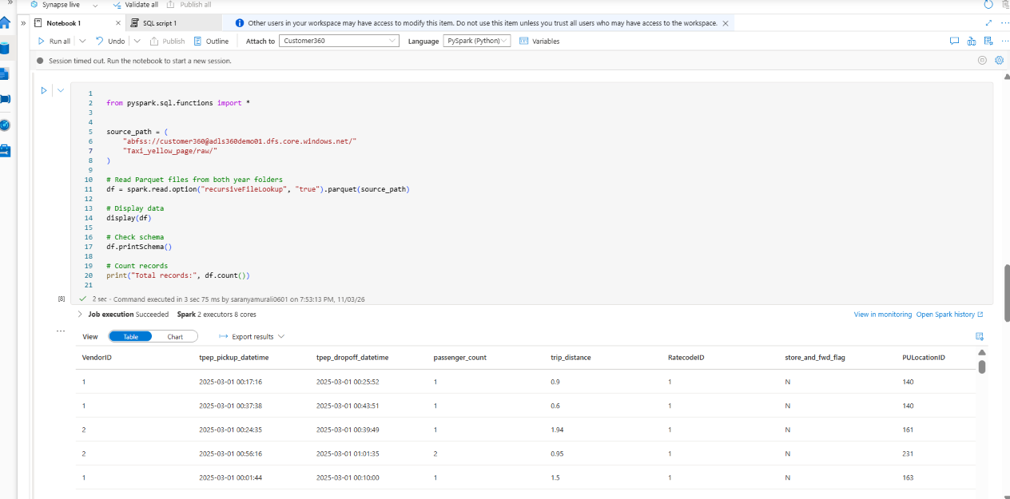
Use notebookutils.mssparkutils.fs to create the raw taxi folder in the customer360 container. Loop over local Parquet files, check whether each exists, and copy it to the ADLS path. Confirm upload messages before proceeding.

Step 16: Read and inspect taxi Parquet data
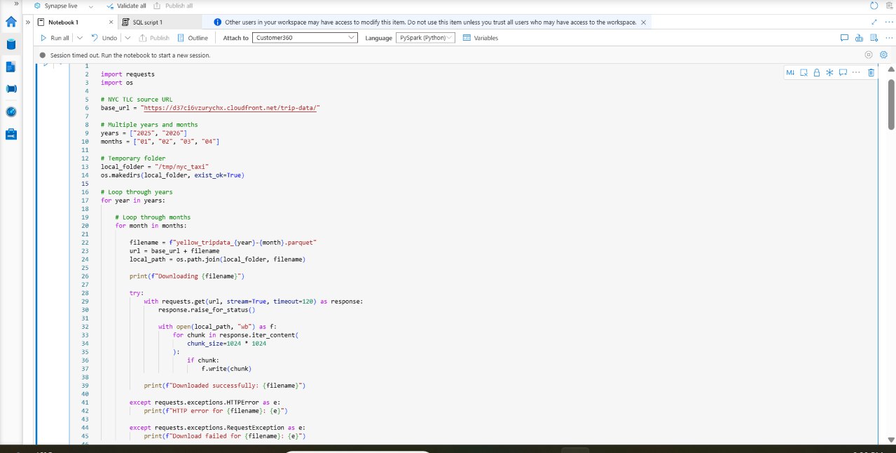
Use spark.read.option("recursiveFileLookup","true").parquet(source_path) to read across folders. Display the DataFrame, call printSchema(), and count the records. The displayed columns include VendorID, pickup/dropoff times, passenger_count, and trip_distance.

Step 17: Transform and write Delta Lake data
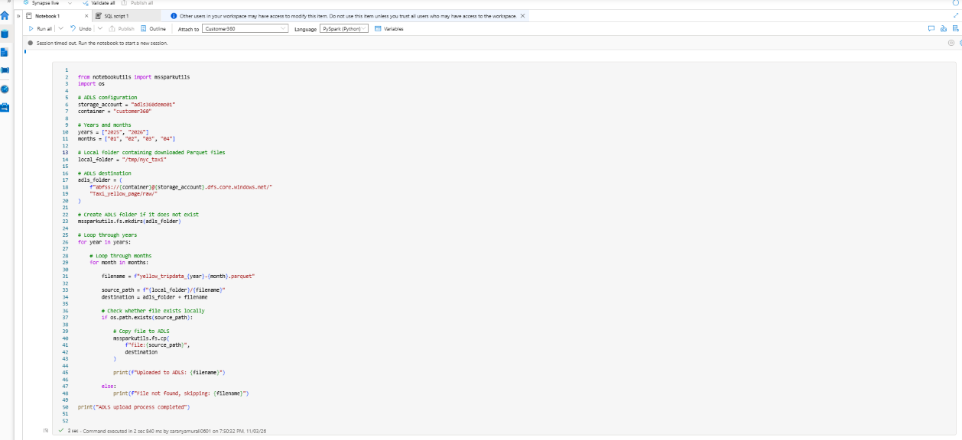
Derive year and month from tpep_pickup_datetime using PySpark functions. Write the transformed DataFrame in Delta format to Taxi_yellow_delta, partitioned by year and month. Read it back and group by year/month to verify partition coverage.

Step 18: Verify Delta folder structure
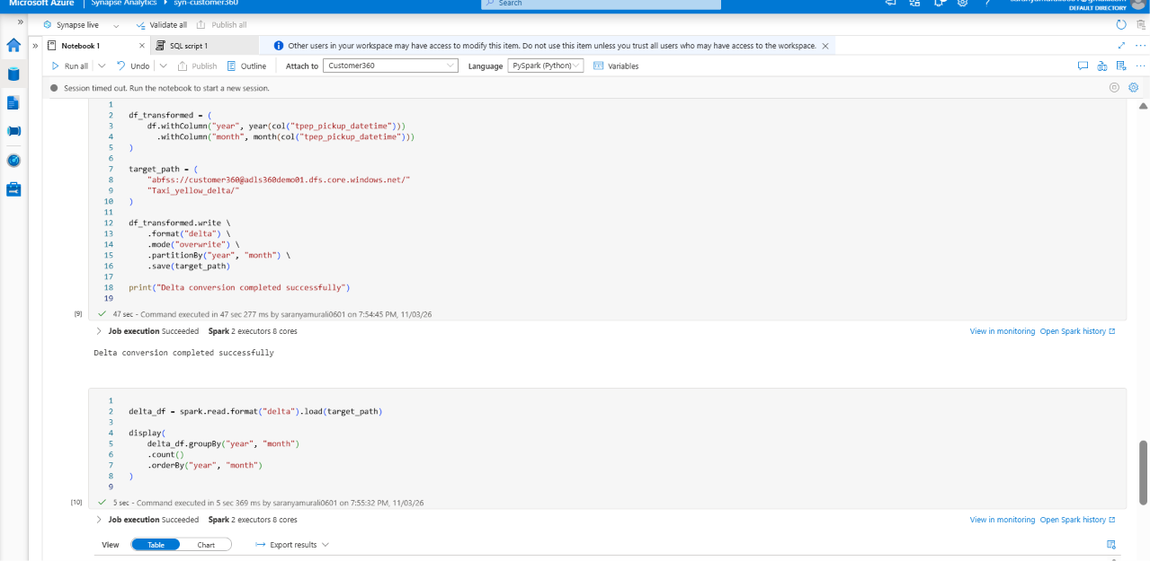
In ADLS, open Taxi_yellow_delta and verify _delta_log and year=... partition folders. The transaction log identifies the directory as a Delta table; partition directories help organize data by pickup year and month.

Step 19: Create Synapse serverless external data source and view
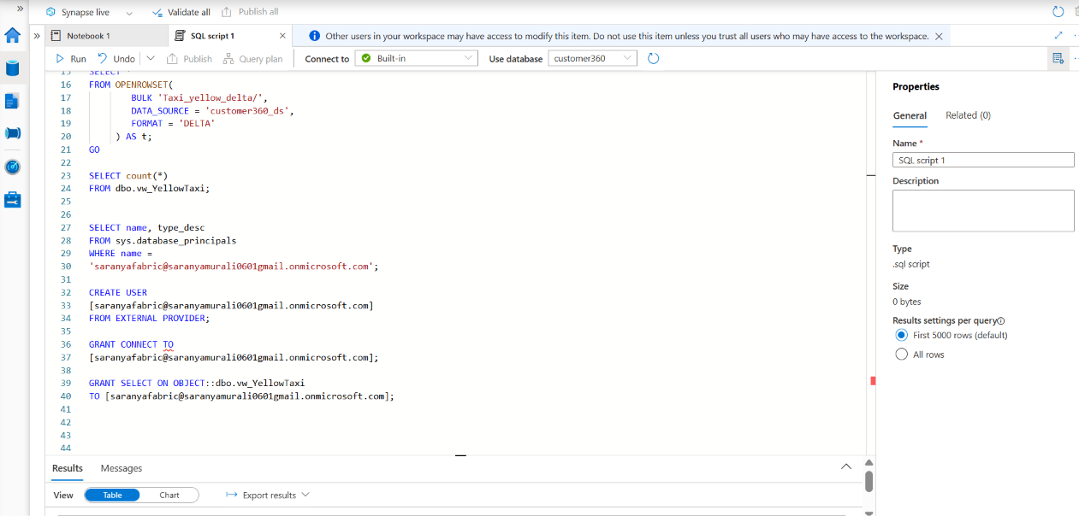
In a Synapse built-in serverless SQL script, create the database, managed-identity database scoped credential, and external data source pointing to the ADLS container. Define dbo.vw_YellowTaxi with OPENROWSET over Taxi_yellow_delta/ and FORMAT = DELTA, then query COUNT(*) to validate access. Use a securely generated master-key password rather than copying one from a screenshot.

Step 20: Grant access to the taxi view
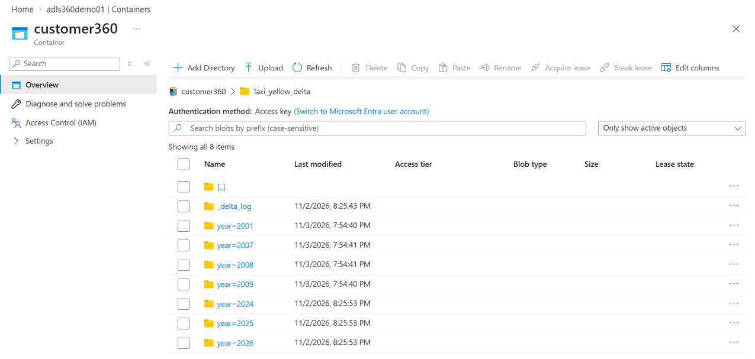
Check sys.database_principals for the intended Microsoft Entra identity, create an external-provider database user if necessary, grant CONNECT and SELECT on dbo.vw_YellowTaxi, and verify the user can query the view. Apply only the permissions needed.

Step 21: Connect Power BI to Synapse SQL view and create a dashboard
This step connects Power BI Desktop to the Synapse serverless SQL view created in Step 19 and uses the imported taxi-trip data to build a report visual.
1. Open Power BI Desktop. Select Home > Get data > Azure > Azure Synapse Analytics SQL (or the corresponding Synapse SQL connector).
2. Enter the Synapse serverless SQL endpoint, such as syn-customer360-ondemand.sql.azuresynapse.net, and database customer360. Use the endpoint and database configured in your own workspace.
3. Choose Import as the connectivity mode, as shown in the screenshot. Import loads a copy of the query results into the Power BI semantic model; it does not continuously query Synapse. Select DirectQuery instead only if live querying is required and supported.
4. Under Data source credentials, choose an authentication method supported by your Synapse environment. The screenshot shows Basic; supply the authorized SQL username and password only when SQL authentication has been configured. Otherwise use the appropriate organizational account authentication. Leave encrypted connection enabled, and set an appropriate privacy level.
Screenshot 21.1 — Power BI connection and credentials
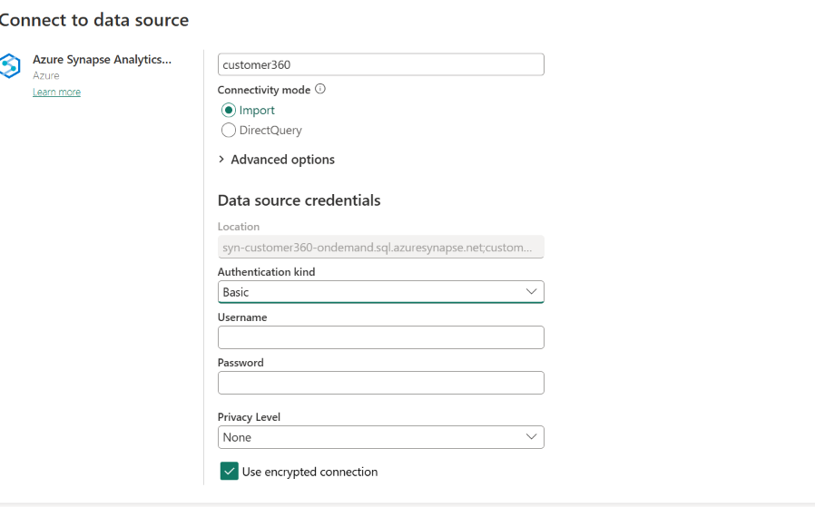
5. Connect and, in the Navigator, expand database customer360 and select the dbo.vw_YellowTaxi view created with OPENROWSET over the Delta Lake folder. Preview the columns, then select Load (or Transform Data if cleaning is required).
6. In Report view, insert a clustered bar chart. The supplied screenshot shows total_amount and trip_distance placed on the Y-axis and Sum of month on the X-axis. This produces a chart, although month should normally be treated as a category rather than summed.
7. For a more meaningful taxi analysis, place year/month on the category axis and Sum of total_amount on the value axis. Use trip_distance as a separate measure or visual, and verify the aggregation settings and data types.
8. Adjust the title, labels, and filters. Save the Power BI report (.pbix). If needed, publish it to a Power BI workspace and configure scheduled refresh for Import mode.
Screenshot 21.2 — Power BI report visual created from Synapse taxi data
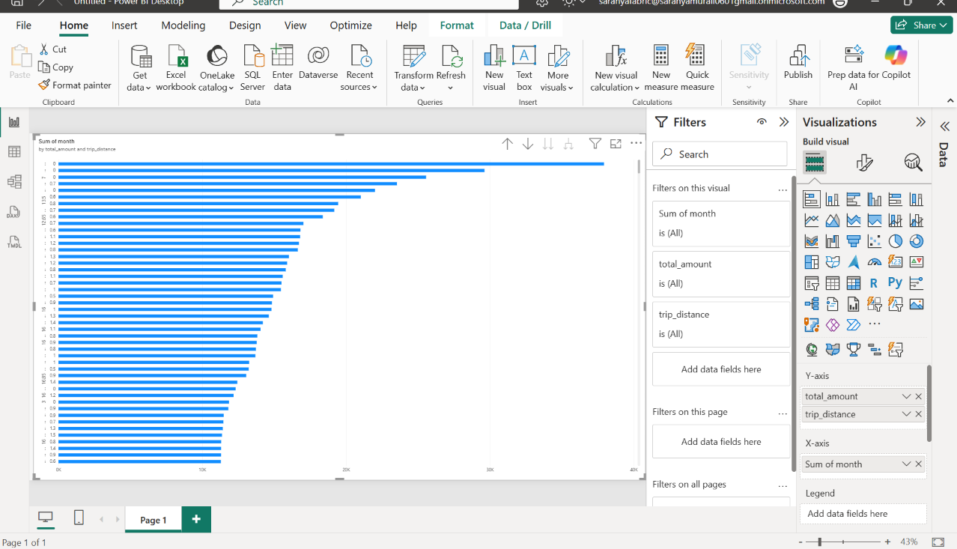
Expected result: The Synapse SQL view is accessible from Power BI and the taxi-trip data is available to create and validate report visuals.

Validation checklist
☐ Resource group, storage, Synapse workspace and SQL database deployed
☐ FileConfig returns four active rows
☐ HTTP URL resolves to actual downloadable CSV files (not a GitHub web page)
☐ Lookup output.value contains four items
☐ ForEach iterates four times
☐ Every Copy activity succeeds and ADLS contains the expected files
☐ No secrets or passwords are stored in documentation or pipeline expressions

Implementation notes and limitations
The provided screenshots show setup screens and a Lookup output, not a completed end-to-end Copy execution. Some SourceURL values visible in the output appear to use a GitHub repository path rather than a direct raw-file URL; these should be checked. The screenshot of the HTTP linked service shows a successful connection test but cannot establish file accessibility. SQL Server Management Studio connects to the Azure SQL logical server, whereas Synapse Studio Built-in uses a separate serverless SQL endpoint and database namespace.

Power BI Connection Issue and Resolution
Issue encountered: While connecting Power BI Desktop to the Azure Synapse Analytics serverless SQL endpoint for the customer360 database, the initial sign-in using the Organizational account authentication option did not establish the connection.
Resolution: The authentication method was changed to Basic. The SQL administrator username sqladminuser was entered along with the SQL administrator password configured when the Azure SQL server was created. The encrypted connection option remained enabled. Using these credentials, the connection succeeded and the Synapse SQL view could be loaded into Power BI.
Connection details used:
- Connector: Azure Synapse Analytics
- Server: syn-customer360-ondemand.sql.azuresynapse.net (serverless SQL endpoint shown in the connection screen)
- Database: customer360
- Connectivity mode: Import
- Authentication kind: Basic
- Username: sqladminuser
- Password: SQL administrator password configured for the server (not documented)
- Object loaded: dbo.vw_YellowTaxi
Result: The taxi data from the Synapse SQL view was imported into Power BI Desktop and used to build the report visual shown in the preceding screenshot.
Note: This records the successful workaround for this project; it does not establish why Organizational account authentication failed. Organizational authentication can require the appropriate Microsoft Entra identity, database permissions, and connection configuration. Do not save or share administrator passwords in project documentation.

