**Scroll Bar related issues**

**Issue 1**

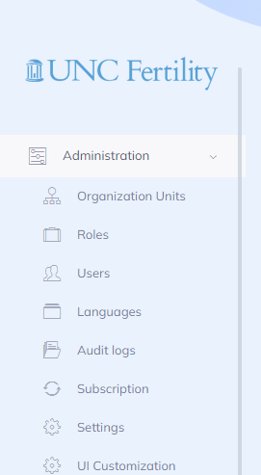

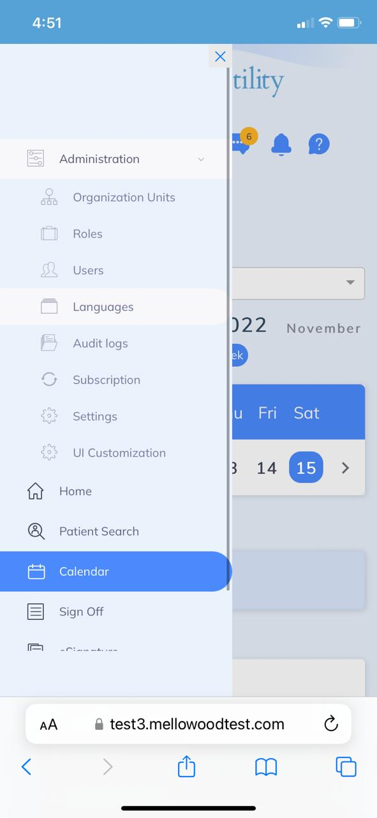

**Issue 2**

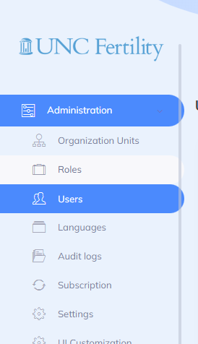

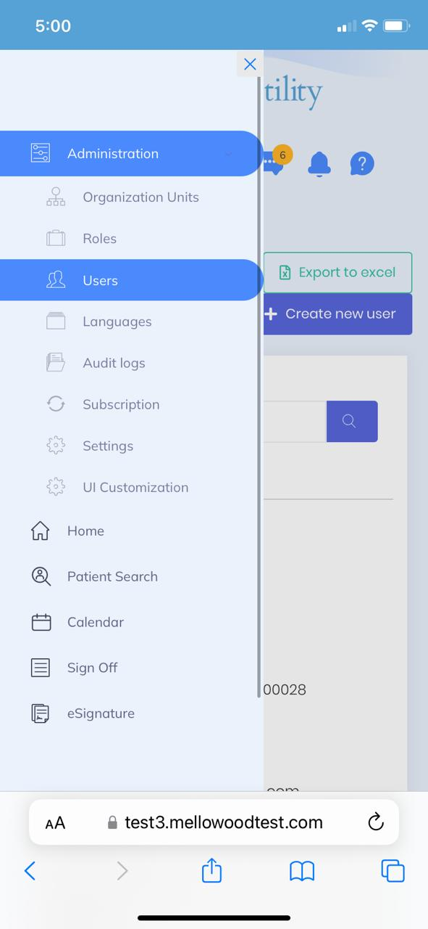

**Issue 3**

**Issue 4**

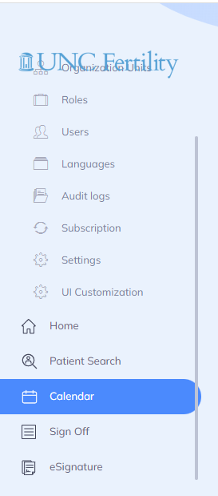

**Issue 5**

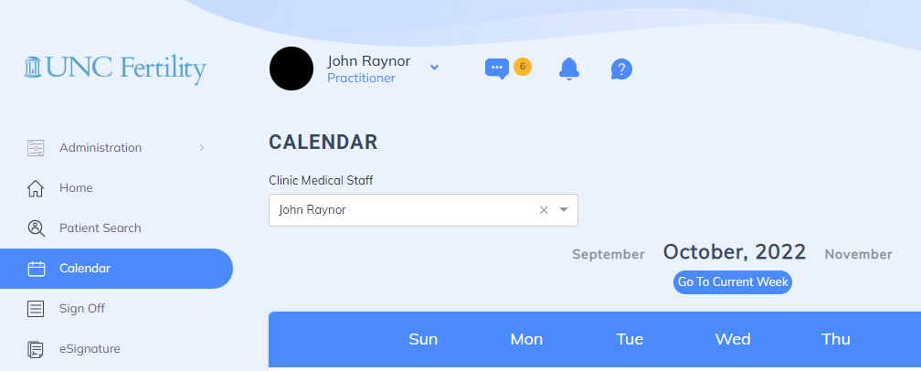

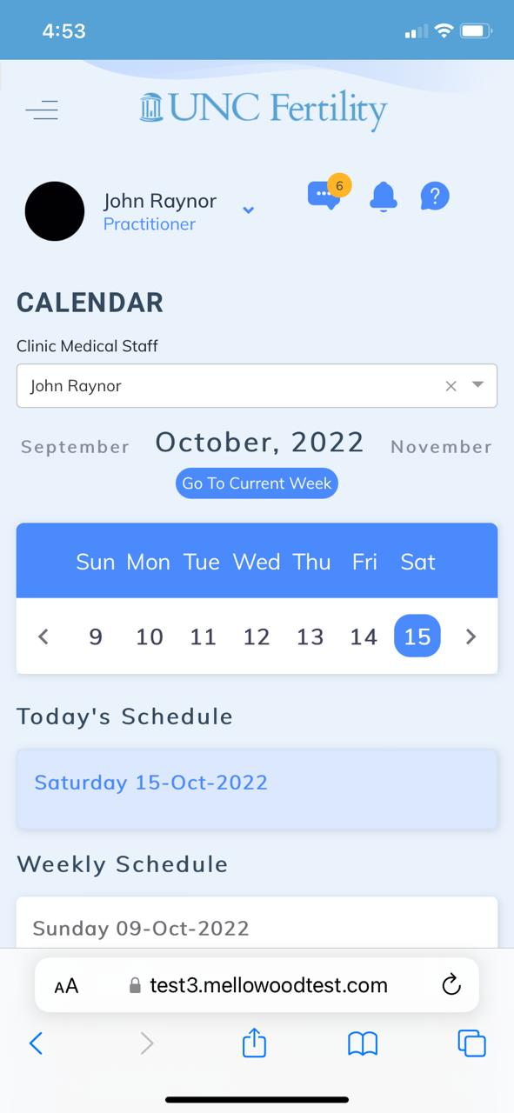

**Issue 6**

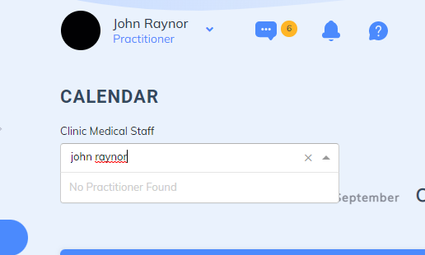

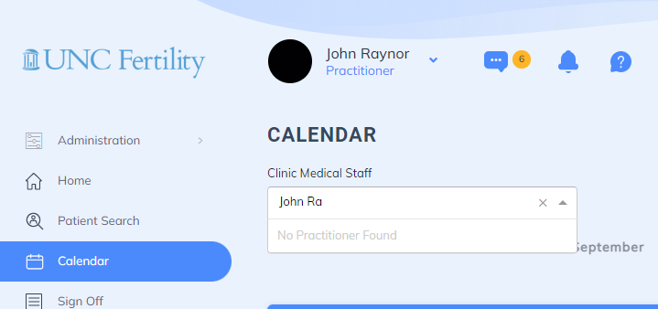

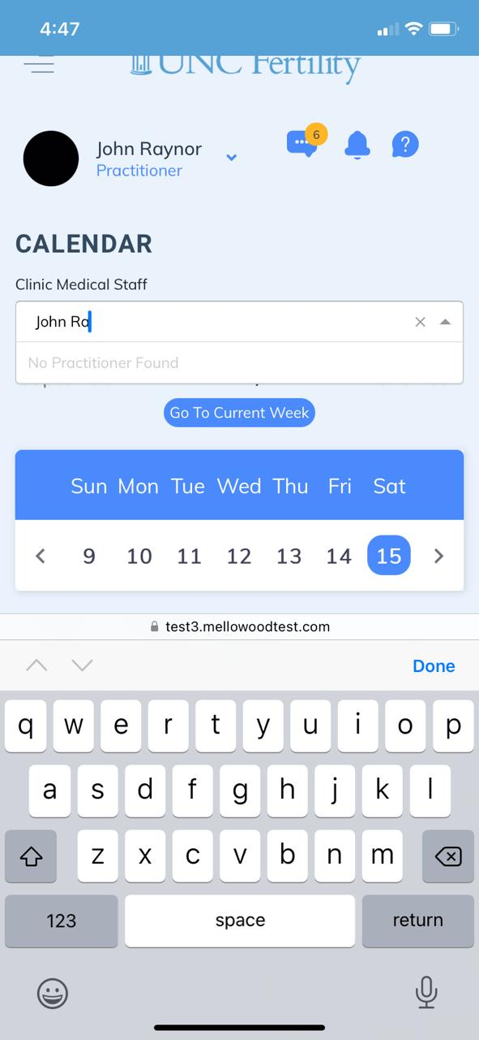

**Issue 7**

When you select a different clinical staff name, nothing is happening with the application, and it is not showing the calendar details of the selected Physician.



**Issue 8**

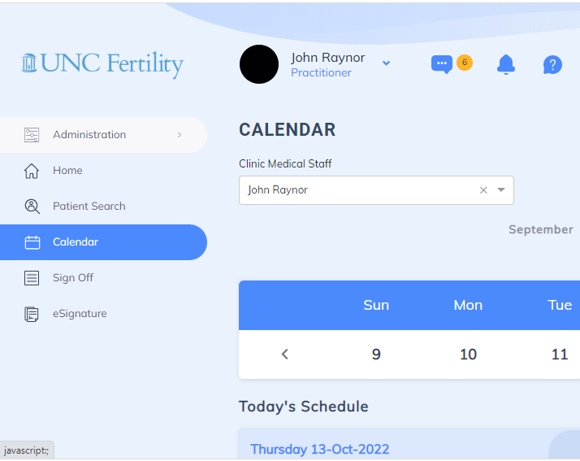

**Issue 9**

**Issue 10**

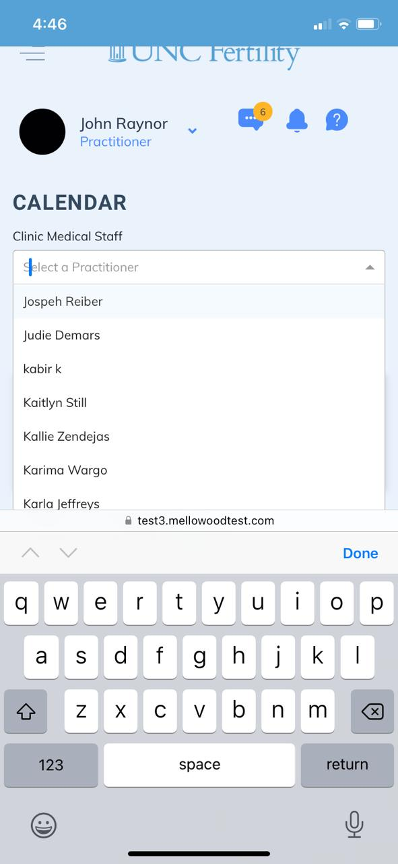

**Improvement 1**

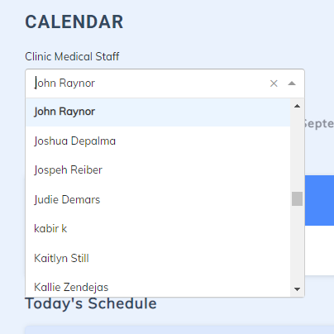

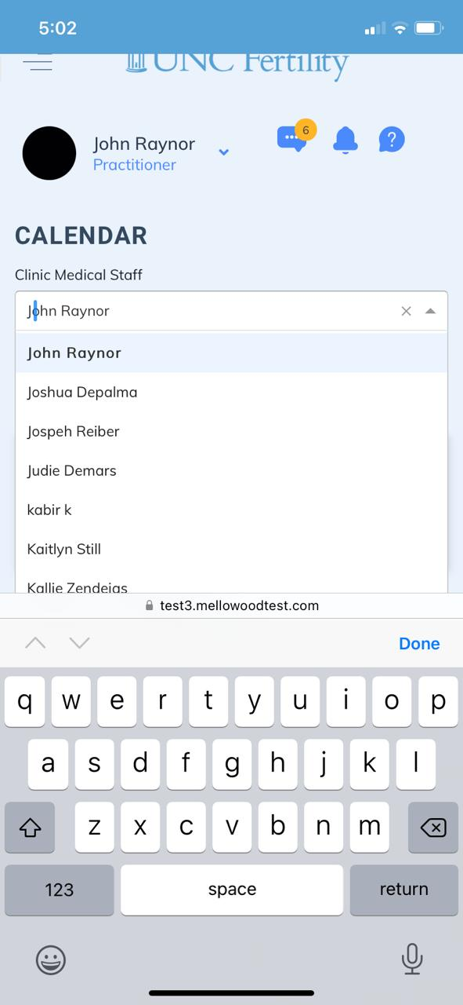

**Improvement 2**

**Improvement 3**



**Improvement 4**

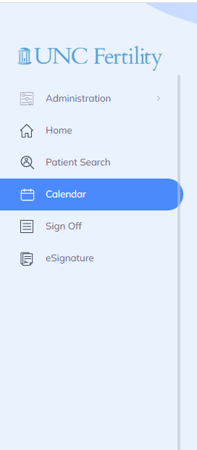

**Improvement 5**

