AbleSpace – Caseload → Take Data
Product Understanding
Full Stack Developer (Fresher) – Technical Assessment

1. Overview
The provided assessment screenshot shows the AbleSpace Caseload screen. The screen presents a list of students in a table and provides a Take Data action for each student. The purpose of this workflow, based on the supplied screen, is to start data collection for a selected student directly from the Caseload.

2. Screen and Workflow Understanding
- Open the Caseload section from the application navigation.
- Review the students displayed in the Caseload table.
- Identify the student for whom data needs to be recorded.
- Use the Take Data button in the Actions column for that student.
- The Take Data action is the entry point to the data-collection workflow for the selected student.
The screenshot clearly shows the relationship between the student row and its corresponding Take Data action. This row-level action helps the user start the workflow for the correct student without needing to leave the Caseload list first.

3. Screenshot – Provided Assessment Reference
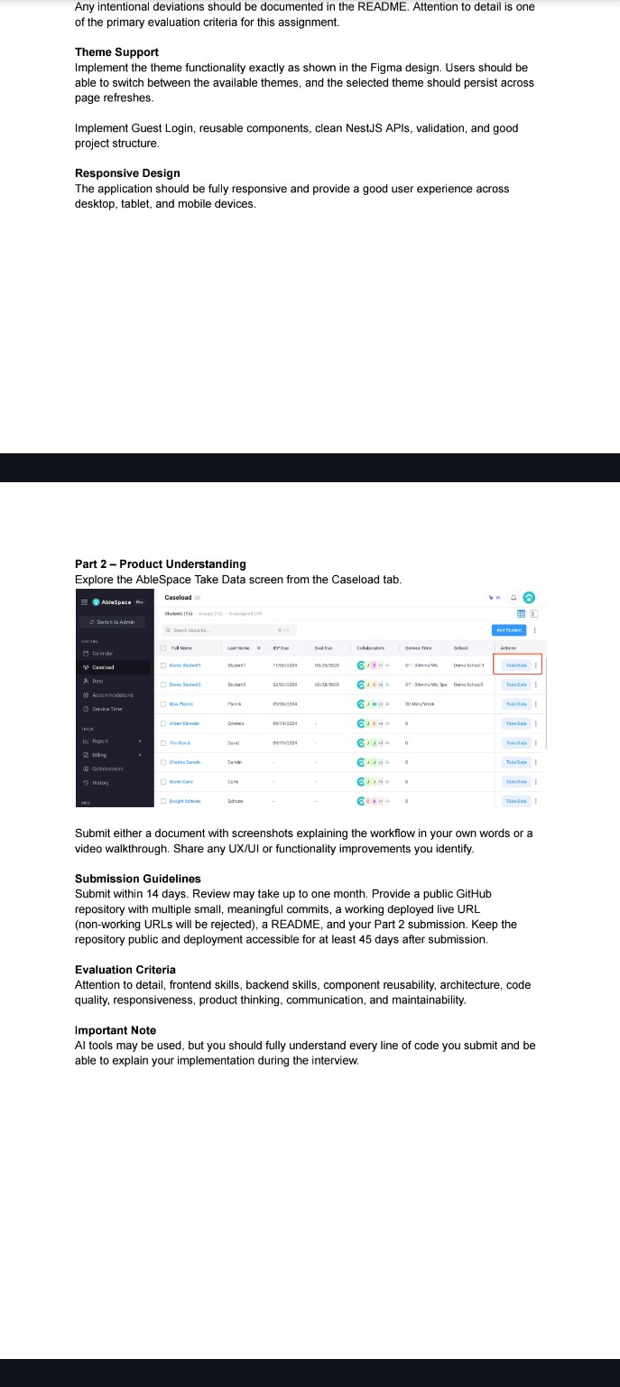
Figure 1: Assessment screenshot showing Caseload students and Take Data actions.

4. UX/UI Improvements
- Make the selected student's name clearly visible after entering Take Data so the user can confirm the correct student.
- Provide a clear loading state while Take Data is opening or data is being saved.
- Show a clear success confirmation after data is saved.
- Provide useful empty and error states when no students or no data are available.
- Keep the Take Data action visually prominent and easy to use on tablet and mobile screens.
- Consider a confirmation or clear context indicator before saving data to reduce the risk of recording data for the wrong student.
- Support keyboard navigation and accessible labels for table actions.

5. Product Thinking
The row-level Take Data action is a useful interaction because it connects the data-collection task directly to the selected student. From a product perspective, the workflow should prioritize accuracy, speed, and context: users should always know which student they are working with, what action they are performing, and whether their data was successfully saved.

6. Scope Note
This explanation is based on the screenshots supplied with the assessment. The screenshots visibly establish the Caseload list and the Take Data action, but they do not show the subsequent Take Data form or save flow. Therefore, details about fields, measurements, or later screens are intentionally not assumed.

