**Anomaly Detection - Univariate Time Series :**

**Usecase 1:**

Fetch stock prices for Facebook, Amazon, Netflix and Google between the time period – 01-01-2016 to 30-06-2018 and identify the anomalies.

**Solution:**

**Package – anomalize**

Anomalies are highlighted in the graph in red colour.

**Facebook**

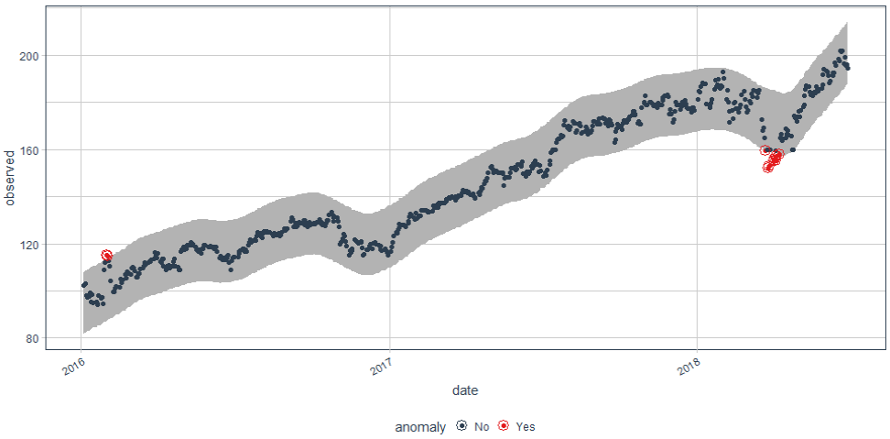

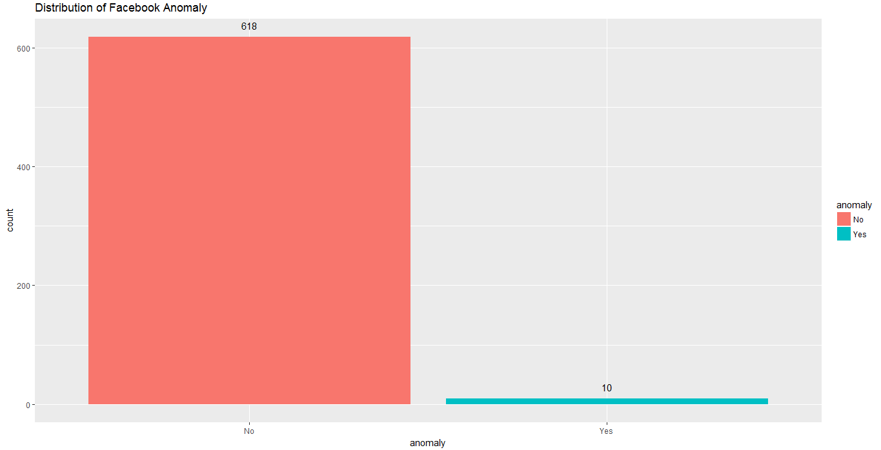

Amazon

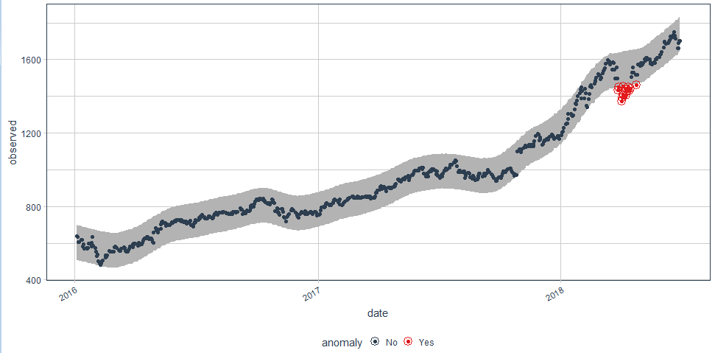

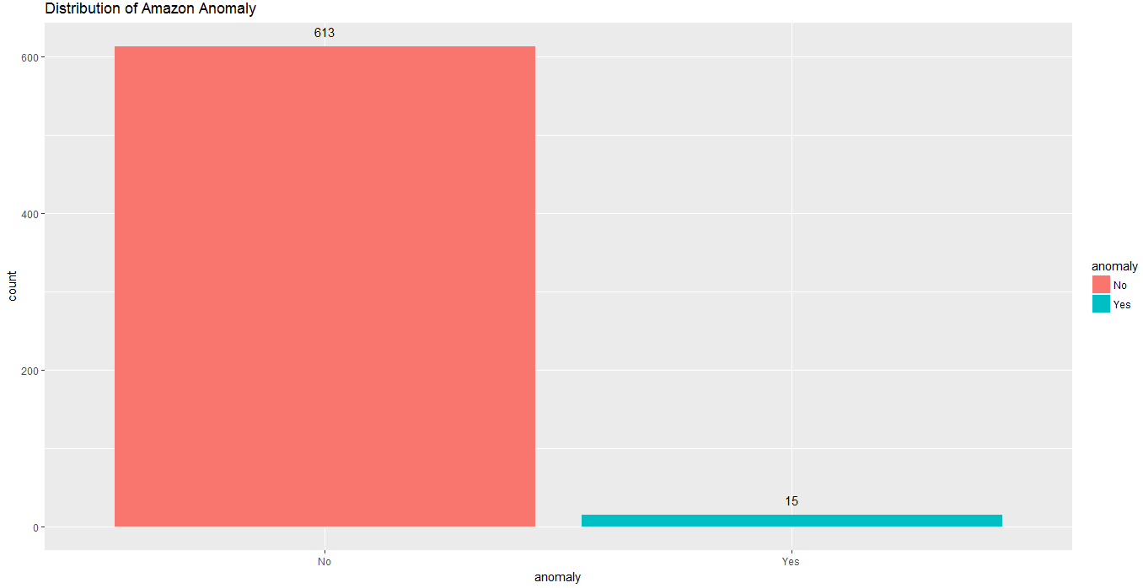

Netflix

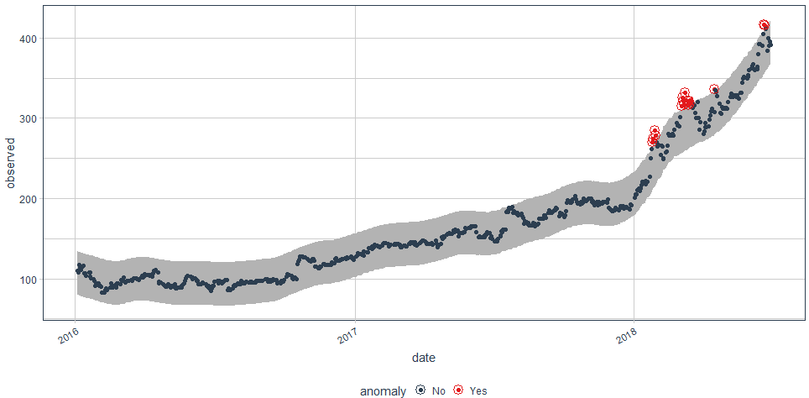

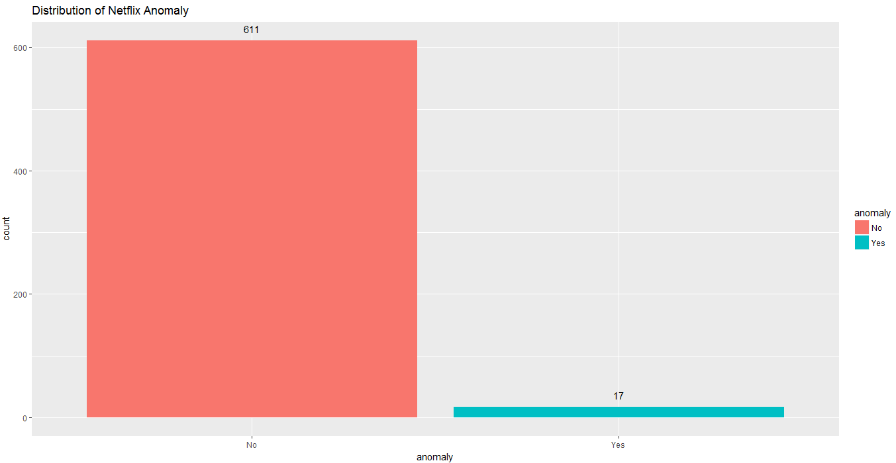

Google

