**NLP:**

**Week 1:**

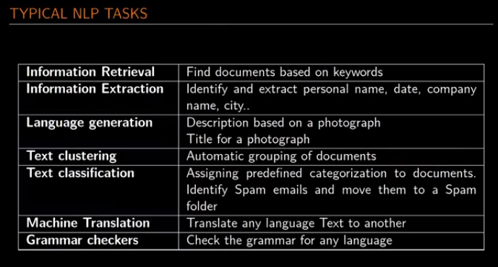

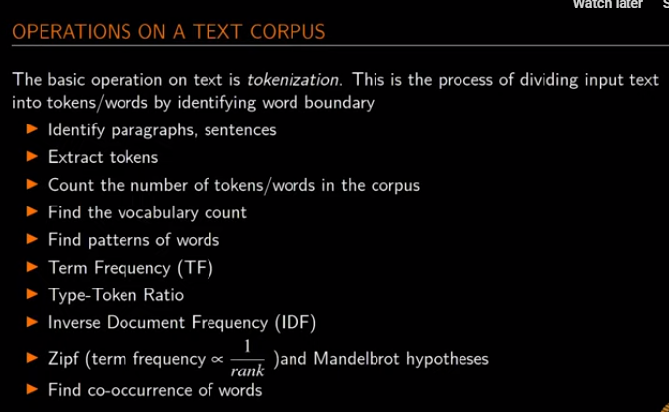

Type –Token Ratio:

A type-token ratio (TTR) is the total number of UNIQUE words (types) divided by the total number of words (tokens) in a given segment of language. For example, that last sentence contains 26 different words (tokens), but several of those words (like ‘a’, ’the’, ‘words’) occur more than once, so there are only 19 UNIQUE words, or types. The TTR of that sentence is 19/26, or .73. The closer the TTR ratio is to 1, the greater the lexical richness of the segment.

