PRODUCT SALES AND PROFITABILITY INSIGHTS ACROSS CUSTOMER SEGMENTS

OBJECTIVE:
The project involves the analysis of category-wise and segment-wise sales, identification of top-performing and low-performing products, and evaluation of regional sales trends. Sales trends over time are analysed to understand seasonal patterns and growth behaviour. In addition, sales forecasting is carried out for the next six months to support the organization in planning future strategies.
The key objectives of the analysis are:
• The study focuses on understanding the overall sales performance of the business.
• The analysis aims to identify top-selling and low-performing products.
• Category-wise and segment-wise profitability is evaluated.
• Sales trends over time are examined to identify growth patterns.
• The impact of discounts on profit is analysed.
• Regional sales performance is assessed.
• Average profit margins are calculated for better financial evaluation.
• Sales forecasting is performed for the next six months.
• Key insights are presented through interactive visual dashboards.

Dataset Description:
The dataset contains detailed transactional records of sales across multiple products, categories, cities, and customer segments. Each row represents an individual order for a product, capturing information about the customer, the product sold, the pricing, discounts applied, revenue generated, and profitability. The dataset is designed to support in-depth analysis of sales performance, revenue trends, profit, and customer behavior.

Sales Table - Column Description

Column Name | Description
Order_ID | Unique identifier for each sales order.
Customer_Name | Name of the customer who placed the order.
Product_Category | Category to which the product belongs.
Product_Name | Name of the product sold.
Product_ID | Unique identifier assigned to each product.
Units_Sold | Number of units sold in a particular order.
Unit_Price | Price per unit of the product.
Discount_% | Discount percentage applied to the product.
Revenue | Total revenue generated from the sale after discount.
Product_cost | Cost incurred to produce or procure the product.
Profit/Loss | Profit or loss earned from the transaction.
Profit Margin% | Profit expressed as a percentage of revenue.
Order_Date | Date on which the order was placed.
City_ID | Unique identifier for the city where the sale occurred.
Segment | Customer segment (B2B or B2C).

Data cleaning & transformation:

Data Import Process
The dataset was imported into the analysis environment using Microsoft Excel’s data import feature. The following steps were followed to load the data:
- Navigate to the Data tab in Excel.
- Select Get Data and choose From File.
- Click on Text/csv and browse to the Snitch Fashion Sales Data Set file.
- Select the required worksheets from the workbook.
- Click Load to import the data into Excel for further processing and analysis.

Data Cleaning & Transformation

Order_ID Standardized
The Order_ID field was reviewed and found to be free of null values and inconsistencies. As a standard data quality measure, CLEAN and TRIM functions were applied to remove any hidden characters or extra spaces, ensuring the Order_ID values are fully standardized and ready for downstream analysis.
Formula used=CLEAN(TRIM([@[Order_ID]]))

Customer_Name Standardized
The Customer_Name column contained inconsistencies due to the use of titles and suffixes such as Mr., Mrs., Ms., Dr., PhD, and DVM. These variations resulted in multiple representations of the same customer and affected data accuracy. To resolve this issue, all prefixes and suffixes were removed and the customer names were standardized into a uniform format. This ensured consistent reporting and improved the overall quality and reliability of the dataset.
Formula Used=CLEAN(TRIM(PROPER(CONCAT([@Column1]," ",[@Column2]," ",[@Column3]))))

Product_Category Standardized
The Category data was reviewed and found to be largely consistent. As part of data standardization, CLEAN and TRIM functions were applied to eliminate hidden characters and extra spaces, ensuring uniformity across Category values. The cleaned results were then converted to values and used for subsequent processing.
Formula Used =CLEAN(TRIM([@[Product_Category]]))

Product_Name Standardized
The Category data was reviewed and found to be largely consistent. As part of data standardization, CLEAN and TRIM functions were applied to eliminate hidden characters and extra spaces, ensuring uniformity across Category values. The cleaned results were then converted to values and used for subsequent processing.
Formula Used=CLEAN(TRIM([@[Product_Name]]))

Unit_Sold Column Standardized
The Unit column contained invalid values such as negative quantities, zero values, and null values. Since sales quantities cannot be negative all negative values were converted to positive values. Zero and missing (null) values were imputed using the average unit quantity to maintain data consistency. This cleaning process ensured logical accuracy and prevented distortion in sales and inventory analysis.
Formula Used
=IF(OR([@[Units_Sold]]="",[@[Units_Sold]]=0),AVERAGEIF([Product_Name],[@[Product_Name]],$E$4:$E$2392),IFS([@[Units_Sold]]=-1,"1",[@[Units_Sold]]=-2,"2",TRUE,[@[Units_Sold]]))

Product_ID Standardized
In the main transactional table, the Product ID was used as a foreign key referencing the Product table to retrieve product-related details for further analysis. This relationship enabled seamless integration of product attributes with sales data, supporting accurate product-level reporting and deeper analytical insights. As part of data standardization, CLEAN and TRIM functions were applied to eliminate hidden characters and extra spaces, ensuring uniformity across Category values. The cleaned results were then converted to values and used for subsequent processing.
Formula Used=CLEAN(TRIM([@[Product_ID]]))

Unit_ Price Standardized
The Unit Price column contained missing (null) values, which could affect the accuracy of revenue and profitability analysis. To address this issue, null values were imputed using the average unit price of the corresponding product, based on the same product name. This approach ensured consistency in pricing across identical products and improved the reliability of financial calculations. As a result, the dataset became completer and more suitable for meaningful analysis.
FormulaUsed=IF(ISBLANK([@[Unit_Price]]),AVERAGEIF([Product_Name],[@[Product_Name]],$F$2:$F$2392),[@[Unit_Price]])

Discount_% Standardized
The Discount column contained missing (null) values, which could impact the accuracy of profit and margin calculations. To maintain consistency in discount-related analysis, all null values were replaced with the average discount value of the dataset. This ensured a complete and uniform discount field and improved the reliability of promotional and profitability insights.
Formula Used= =IF(OR([@[Discount_%]]=0,G1=""),AVERAGEIF([Product_Name],[@[Product_Name]],$G$2:$G$2392),IF([@[Discount_%]]>1,1,[@[Discount_%]]))

Revenue Standardized
The Total Revenue field was derived using relevant sales and pricing attributes and used to replace missing (null) values in the dataset. This ensured that all records contained valid revenue information for accurate financial and performance analysis. By imputing null values with calculated revenue, the dataset became more complete and reliable for reporting purposes.
Formula Used=([@[Unit_Price]]*[@[Units_Sold]])*(1-[@[Discount_%]])

Product_Cost Standardized
The Product Cost column was imputed to address missing values and ensure accurate profit and loss analysis. By completing this field, the dataset enabled reliable calculation of cost, profit, and margin metrics across all transactions. This improved the consistency and validity of financial performance evaluation

Profit/Loss Standardized
Profit and loss calculations were performed to support more accurate and meaningful business analysis. This enabled clear evaluation of financial performance across products, categories, and regions, helping to identify profitable areas and segments requiring improvement.
Formula Used=[@Revenue]-[@[Product_cost]]

Profit Margin Standardized
Profit margin was calculated to determine the exact percentage contribution of profit for each product. This metric enabled effective comparison of product performance by highlighting high-margin and low-margin items. As a result, the organization could identify profitable products and areas requiring cost or pricing optimization.
Formula Used=[@[Profit/Loss]]/[@Revenue]*100

Order Date Standardized
The Order Date column contained missing (null) values, which could affect time-based analysis and reporting. To resolve this issue, appropriate date logic and formulas were applied to populate the null values with valid order dates. This ensured completeness of the date field and enabled accurate trend and period-wise analysis.

City Standardized
The City_ID field was reviewed and found to be free of null values and inconsistencies. As a standard data quality measure, CLEAN and TRIM functions were applied to remove any hidden characters or extra spaces, ensuring the City_ID values are fully standardized and ready for downstream analysis.
Formula used=CLEAN(TRIM([@[City_ID]]))

Segment Standardized
The Segment field was reviewed and found to be free of null values and inconsistencies. As a standard data quality measure, CLEAN and TRIM functions were applied to remove any hidden characters or extra spaces, ensuring the Segment values are fully standardized and ready for downstream analysis.
Formula used=CLEAN(TRIM([@[Segment]]))

Additionally, all columns were formatted in accordance with their respective data types, including text, numeric, and currency formats, to ensure consistency and enable accurate analytical reporting.

Statistics Description:
Revenue Statistics
Mean | ₹ 2,336.45
Standard Error | ₹ 43.48
Median | ₹ 1,857.60
Mode | ₹ 1,533.60
Standard Deviation | ₹ 2,125.87
Sample Variance | ₹ 45,19,330.66
Kurtosis | 24.80
Skewness | 3.47
Range | ₹ 29,165.92
Minimum | ₹ 16.52
Maximum | ₹ 29,182.44
Sum | ₹ 55,86,457.86
Count | 2391.00

- Mean: The average revenue per record.
- Standard Error: The estimated accuracy of the mean; smaller values indicate more reliable average.
- Median: The middle revenue value when all records are ordered.
- Mode: The most frequently occurring revenue value.
- Standard Deviation: Measures how much the revenue values vary from the mean.
- Sample Variance: The squared variation of revenue, indicating overall dispersion.
- Kurtosis: Shows the “peaked ness” of the revenue distribution; higher values indicate heavy tails.
- Skewness: Indicates that the revenue distribution is positively skewed (long tail on the right).
- Range: Difference between the maximum and minimum revenue values.
- Minimum: The smallest revenue value in the dataset.
- Maximum: The largest revenue value in the dataset.
- Sum: Total revenue across all records.
- Count: Total number of revenue records analysed.

Visualization and Insights

• Sales are concentrated in a few high-performing product categories, while several products contribute only marginally to total revenue.
• Dresses lead overall sales, followed by moderate-performing categories, with Jeans and similar items showing weak contribution.
• Revenue is mainly driven by B2C transactions across all product types.
• Regional performance varies significantly, affecting product-wise sales distribution.
• Discount levels differ widely across products, creating uneven profit outcomes.

• High sales in some products do not translate into high profit due to aggressive discounting.
• Certain products show low sales because of weak demand or ineffective positioning.
• Profit margin differences across products indicate inconsistent pricing strategies.
• Regional demand patterns strongly influence product performance.
• Heavy reliance on B2C makes results sensitive to consumer buying behavior.

• High-performing products are likely to continue driving most of the revenue.
• Low-performing products are expected to remain weak without strategy changes.
• Profit variability across products is likely to persist if discounting continues.
• Regions with strong performance will continue supporting overall sales.
• Product mix is expected to remain unbalanced, with limited growth from weaker items.

Focus on improving profit from top-selling products rather than only increasing volume.
• Revise pricing and discount strategies for low-profit products.
• Support weak products using bundling or region-specific promotions.
• Strengthen B2C channel while developing B2B as a stability channel.
• Monitor product-wise profit regularly to prevent margin erosion.

• The forecast shows an overall upward trend in revenue from July to December, indicating expected growth over the next six months.
• Revenue is projected to increase gradually month by month, with higher values observed toward November and December.
• The upper confidence line suggests that revenue has the potential to reach significantly higher levels if demand remains strong.
• The lower confidence line indicates a risk of short-term dips, especially in the middle period, but the general direction still supports growth.
• Seasonal variation is visible, with fluctuations around the trend line, meaning revenue will not rise smoothly but in waves.
• The widening gap between upper and lower bounds toward the later months shows higher uncertainty in long-term forecasts compared to short-term periods.
• Overall, the next six months are expected to show stable to moderate revenue growth, driven mainly by high-performing products and strong consumer demand.
• If current sales patterns continue, December is likely to record the highest forecasted revenue among the upcoming months.
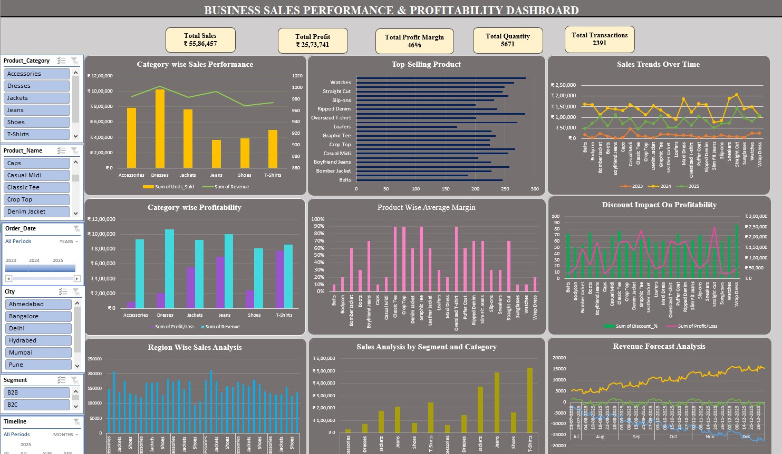
Conclusion:
Overall sales and profit performance demonstrate that the organization maintains strong revenue generation with healthy margins, reflecting stable operational efficiency. Category analysis indicates Dresses as the primary contributor, whereas Jeans and Shoes underperform, suggesting the need for a balanced product strategy. Discount policies significantly influence profitability, and regional sales are concentrated in select cities such as Hyderabad and Mumbai. B2C transactions dominate the market, highlighting an underutilized B2B segment. Forecasting suggests moderate revenue growth over the next six months; however, long-term profitability will require optimized product mix, regional strategies, and pricing adjustments.

