**Create Facebook Database:**

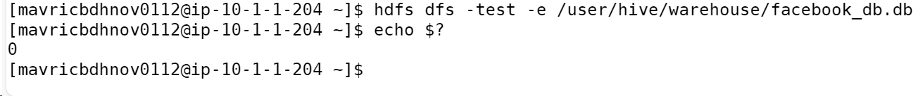

**Create table facebook:**

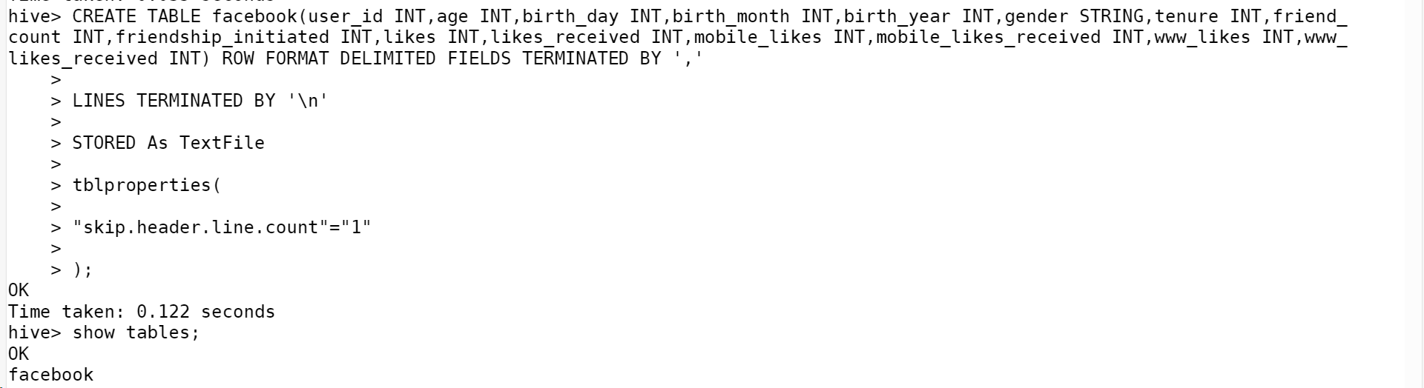



**Q1:** Find out the total no of users in the dataset - **99003**

Q2: Find out the no of users above the age of 25 – **56676**

Q3: Do male face book users tend to have more friends or female users – **Male Users**

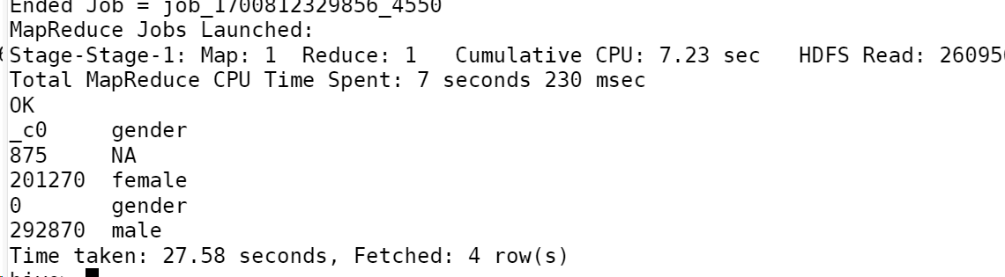

Q4: How many likes do young people receive on facebook as opposed to old people – **47367700**

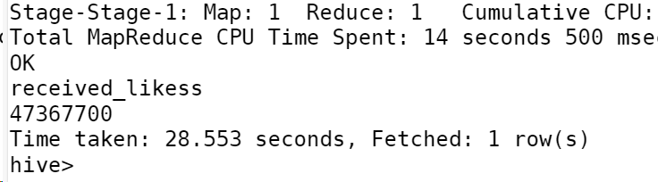

**Q5: Find out the count of facebook users for each birthday month**

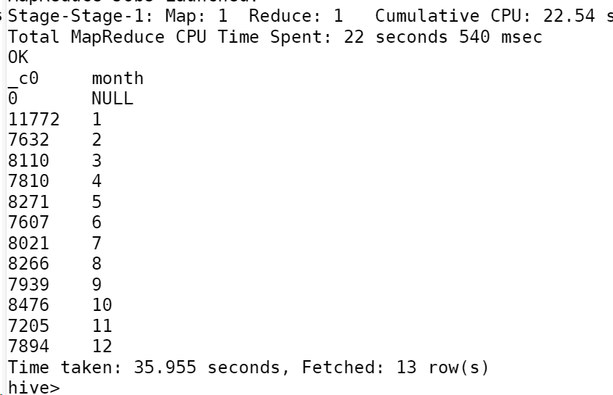

Q6: Do young members use mobile phones or computers for facebook browsing -**Mobile Phones**

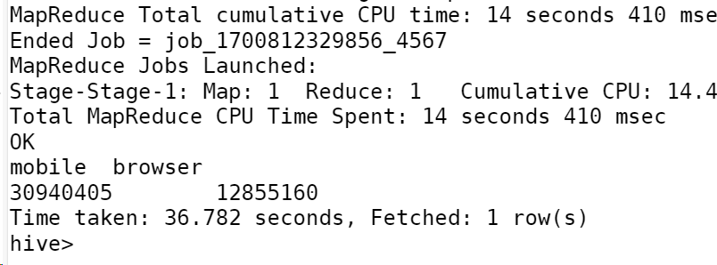

Q7: Do adult members use mobile phones or computers for facebook browsing- **Mobile Phones**

