**Create external tables for drivers and timesheet data**:

**Query: How many total hours and miles logged by each driver?**

Select d.driver_id,sum(t.hours_logged) as total_hours ,sum(t.miles_logged) as total_miles from drivers d join timesheet t on t.driver_id=d.driver_id group by d.driver_id;

**Query: Print the name of the driver in the above query**

Select d.driver_id,d.driver_name,sum(t.hours_logged) as total_hours ,sum(t.miles_logged) as total_miles from drivers d join timesheet t on t.driver_id=d.driver_id group by d.driver_id,d.driver_name;

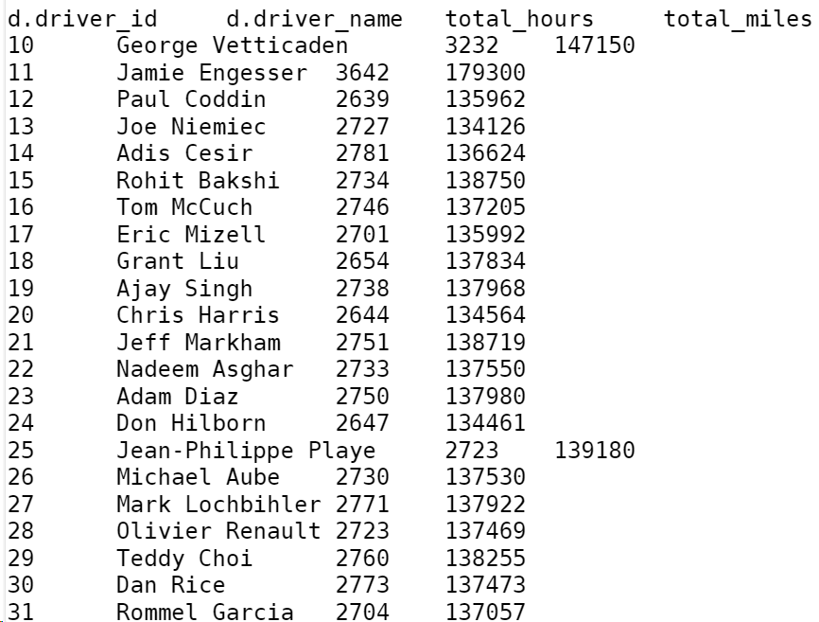

**Query: Write the above query output in to hdfs directory**

INSERT OVERWRITE DIRECTORY "/user/mavricbdhnov0112/driver_out/" ROW FORMAT DELIMITED FIELDS TERMINATED BY '|'

Select d.driver_id,d.driver_name,sum(t.hours_logged) as total_hours ,sum(t.miles_logged) as total_miles from drivers d join timesheet t on t.driver_id=d.driver_id group by d.driver_id,d.driver_name;

