**Data Setup in HDFS:**

1. Copy the provided csv files in a directory named AirlinesOntimeAnalysis:

2.Unzip the contents for the bz2 files:

3.Create the directories in hdfs where your data will reside:

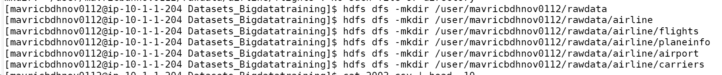

Step 4: copy the respective files to the above created hdfs structure.

1. **Create tables using Hive**

Create the required tables as External (flights, airports, carriers, plane_info) in the staging area. The schema of each of the tables is provided above. Also point these tables to the hdfs locations already created above Note: Name every table name at the end with _stg. Create all the tables in a different database in Hive(airline_db

**Create database airline_db;**

Create external table airports_stg(

IATA String, Name String,City String,State String,Country String,Lat Decimal,Long Decimal)

Row format delimited fields terminated by “,”

Lines terminated by “\n”

Stored as textfile

Location ‘/user/mavricbdhnov0112/airline/airport’

Tblproperties(“skip.header.line.count”=”1”);

Create external table carrier_stg(

code String, description String)

Row format delimited fields terminated by ","

Lines terminated by "\n"

Stored as textfile

Location '/user/mavricbdhnov0112/airline/carriers'

Tblproperties("skip.header.line.count"="1");

Create external table planeinfo_stg(

tailnum String, type String,manufacturer String,issue_date String,model String, status String,aircraft_type String,engine_type String,year Int)

Row format delimited fields terminated by ","

Lines terminated by "\n"

Stored as textfile

Location '/user/mavricbdhnov0112/airline/planeinfo'

Tblproperties("skip.header.line.count"="1");

Create external table flight_stg(

year Int, month Int,dayofmonth Int,dayofweek Int,deptime Int,crsdeptime Int,arrtime Int,crsarrtime Int,uniquecarrier String,flightnum String,tailnum String,actualelapsedtime Int,crselapsedtime Int,airtime Int, arrdelay Int,depdelay Int,origin String,dest String,distance Int,taxiin String,taxiout String,cancelled String,cancellationcode String,diverted String,carrierdelay Int,weatherdelay Int,nasdelay Int,securitydelay Int,lateaircraftdelay Int)

Row format delimited fields terminated by ","

Lines terminated by "\n"

Stored as textfile

Location '/user/mavricbdhnov0112/airline/flights'

Tblproperties("skip.header.line.count"="1");

Create tables for flights , plane_info, carriers and airports in the staging area.

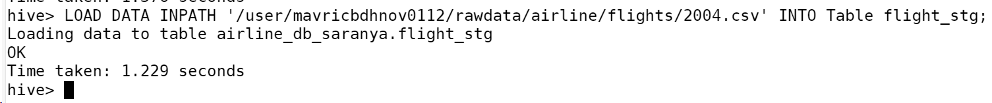

Check if the tables have data.

What is the average arrival delay and average departure delay in each month of the year 2004?

**Select avg(arrdelay) as avg_arrival_delay ,avg(depdelay) as avg_departure_delay from flight_stg group by month;**

1. **Improving the performance of Hive tables** - Parquet format

Create the parquet table as external tables for flights from the above staging table. Name the new table with _pq as a suffix: Ex : flights_pq Point all the table location output/airline/pq_flights

Create external table flight_stg_pq(

year Int, month Int,dayofmonth Int,dayofweek Int,deptime Int,crsdeptime Int,arrtime Int,crsarrtime Int,uniquecarrier String,flightnum String,tailnum String,actualelapsedtime Int,crselapsedtime Int,airtime Int, arrdelay Int,depdelay Int,origin String,dest String,distance Int,taxiin String,taxiout String,cancelled String,cancellationcode String,diverted String,carrierdelay Int,weatherdelay Int,nasdelay Int,securitydelay Int,lateaircraftdelay Int)

Row format delimited fields terminated by ","

Lines terminated by "\n"

Stored as parquet

Location '/user/mavricbdhnov0112/output/airline/pq_flights'

Tblproperties("skip.header.line.count"="1");



Run the same query as above to check if data is loaded properly Is there a difference between the response times for the queries(2 and 3)

There is difference of 7.38 seconds for query 2 and 3.

