Econ HW 2

Maddie Berger & Sara Orofino

4/25/2019

### 1. Aggregate Demand, Supply, and Surplus

**High income demand curve: $Price=(23.3914418)−(1.2966378×{10}^{−4})Q$**

**Low income demand curve: $Price=(21.9908534)−(1.3551741×{10}^{−4})Q$**

#### a. Find aggregate demand

**Aggregate demand curve: $Price=(22.7066059)−(6.6262994×{10}^{−5})Q$**

#### b. Find the supply curve

**Supply curve: $Price=(1.8711376×{10}^{−5})*Q$**

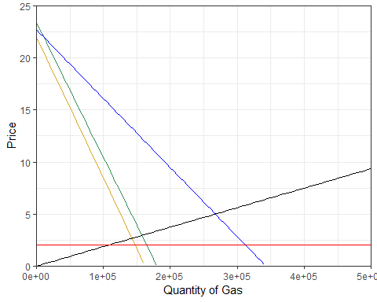

#### c. Surplus under the status quo

**Consumers: $CS=(2.3694528×{10}^{6})$**

**Producers: $PS=(6.6804279×{10}^{5})$**

#### d. Environmental Cost under the Status Quo

$Environmental Cost=(5.3443423×{10}^{5})$

### 2. Division of Consumer Benefit

**Consumer Surplus for High Income $CS_{High}=(1.3043162×{10}^{6})$**

**Consumer Surplus for Low Income $CS_{Low}=(1.0651366×{10}^{6})$**

### 3. Implement a Gas Tax of $0.50/gallon

#### a. New quantity of gasoline

$Q_{Tax}=(2.6133299×{10}^{5})$

#### b. New price of gasoline

$P_{Tax}=(5.3898999)$

#### c. Surplus to high income consumers

$CS_{High}=(1.2495992×{10}^{6})$

#### d. Surplus to low income consumers

$CS_{Low}=(1.0168127×{10}^{6})$

#### e. Producer surplus

$PS_{Tax}=(6.3894607×{10}^{5})$

#### f. Environmental damage

$TEC_{Tax}=(5.2266597×{10}^{5})$

#### g. Tax revenue

$Tax Revenue=(1.3066649×{10}^{5})$

### 4. Tax Revenues for Infrastructure Repairs

#### a. Surplus to high income consumers

Tax Amount

High Income Consumer Welfare

0.25

1311895

0.50

1319015

0.75

1325677

1.00

1331880

1.25

1337625

1.50

1342910

1.75

1347737

2.00

1352106

2.25

1356016

2.50

1359467

2.75

1362459

3.00

1364993

3.25

1367068

3.50

1368685

3.75

1369843

4.00

1370542

4.25

1370783

4.50

1370565

4.75

1369888

5.00

1368753

#### b. Surplus to low income consumers

Tax Amount

Low Income Consumer Welfare

0.25

543269.1

0.50

555397.0

0.75

567086.1

1.00

578336.4

1.25

589147.8

1.50

599520.4

1.75

609454.2

2.00

618949.1

2.25

628005.2

2.50

636622.4

2.75

644800.9

3.00

652540.5

3.25

659841.2

3.50

666703.2

3.75

673126.3

4.00

679110.5

4.25

684656.0

4.50

689762.6

4.75

694430.3

5.00

698659.3

#### c. Surplus to producers

Tax Amount

Producer Welfare

0.25

653413.4

0.50

638946.1

0.75

624640.7

1.00

610497.2

1.25

596515.7

1.50

582696.2

1.75

569038.6

2.00

555543.0

2.25

542209.3

2.50

529037.6

2.75

516027.9

3.00

503180.1

3.25

490494.3

3.50

477970.5

3.75

465608.6

4.00

453408.7

4.25

441370.7

4.50

429494.7

4.75

417780.7

5.00

406228.6

Tax Amount (USD)

Tax Revenue (USD)

Welfare Change Low Income (%)

Welfare Change High Income (%)

Welfare Change Producers (%)

0.25

66068.76

-0.490

0.006

-0.022

1.75

431589.67

-0.428

0.033

-0.148

3.25

744153.44

-0.381

0.048

-0.266

5.00

1041879.21

-0.344

0.049

-0.392

### 5. Electric cars lower demand for each group by one half (vertically)

#### a. & b. Gas consumption by High/Low income Consumers

#### c. New price of gasoline with higher EV use and lower gas demand

#### d. Environmental Cost

### 6. Compare a 2.00 per gal tax to the influence of EV