# 

# Question 1

## Mean Adult Density Graphs

Tasks:  
- Graph mean adult density for each species at each lagoon, separate by years

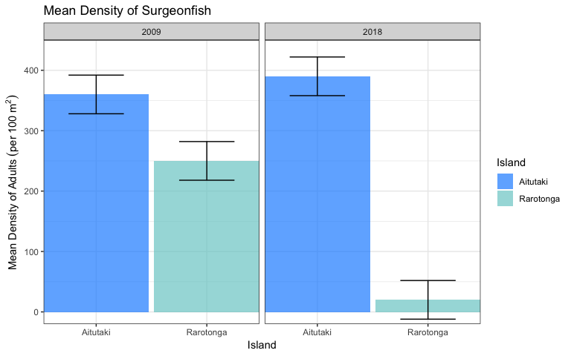

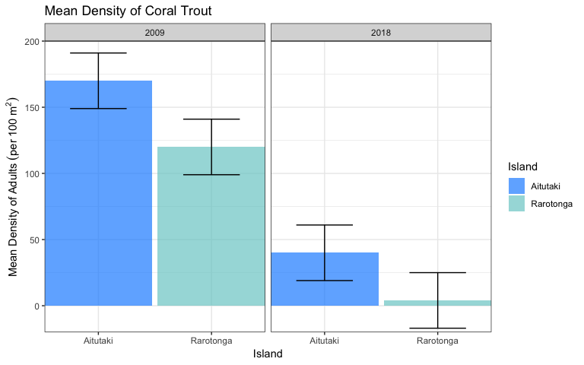

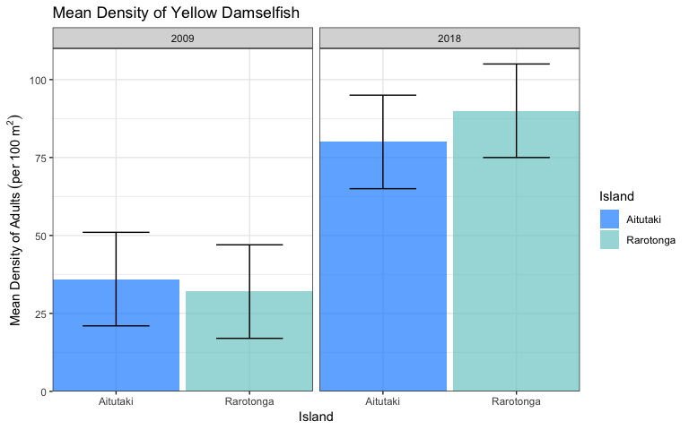

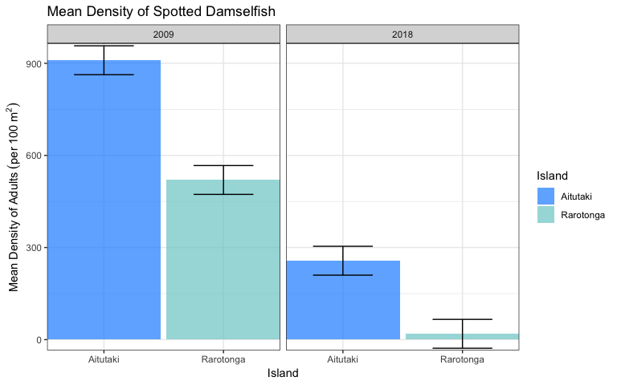

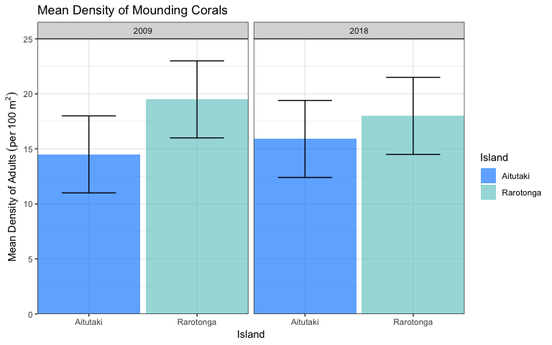

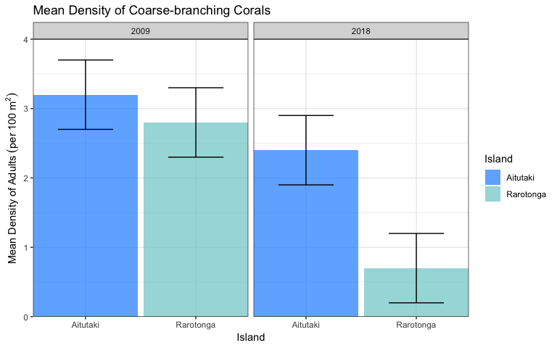

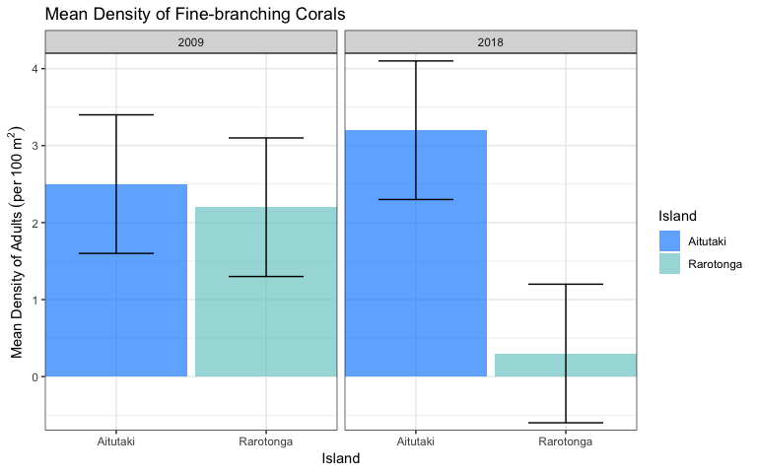

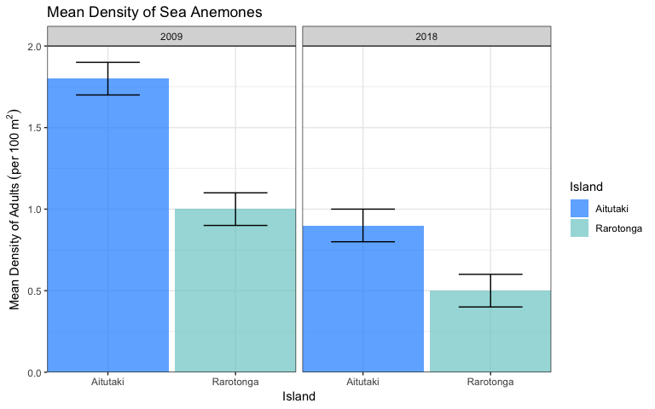

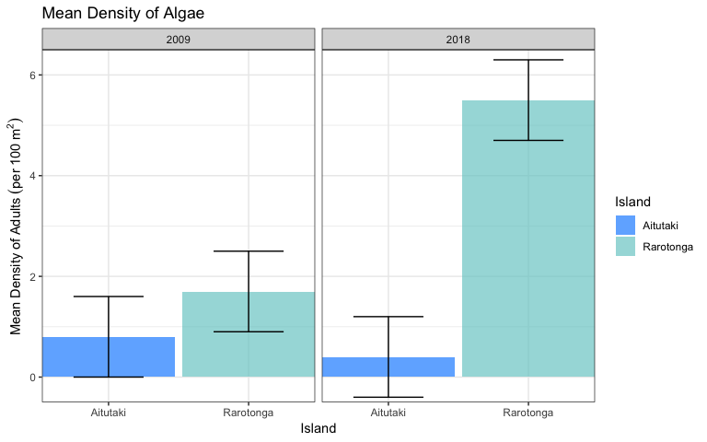

# Question 2

## Change in Density of Recruits

Tasks:  
- Graph recruitment density for each species at each lagoon, separate by years

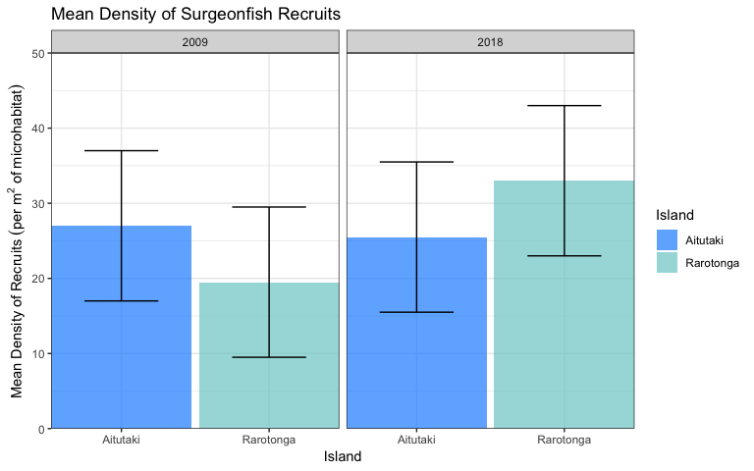

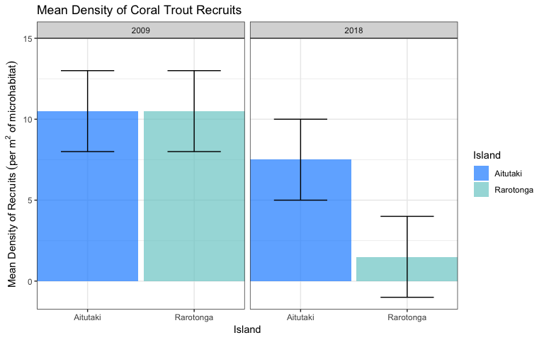

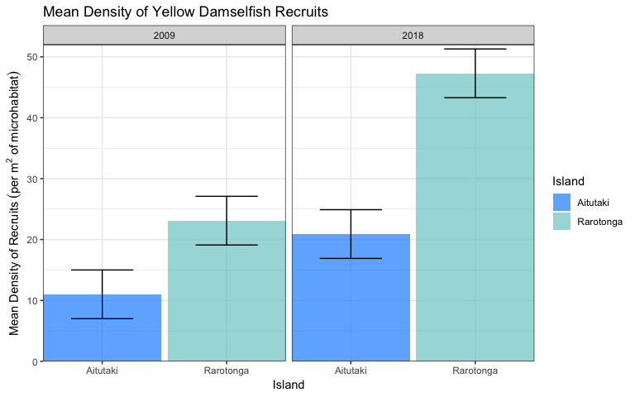

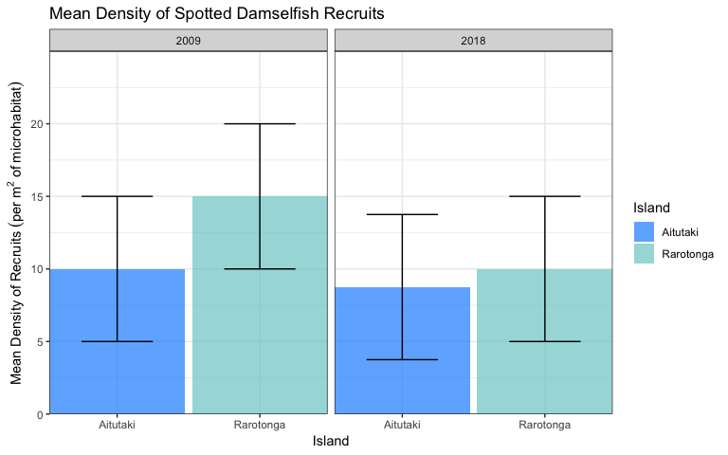

# Question 3

## Density of Recruits by Microhabitat

Tasks:  
- Calculate the density of fish per 100 m2 area of reef  
- Make a scatterplot of relationship between density of recruits and adults

### Calculate the Density

The density data gives the coverage of each microhabitat per 100 m ${}^{2}$ of reef. The recruitment density is per 1 m ${}^{2}$ of microhabitat. To get the density of recruits per 100 m ${}^{2}$ of reef, multiply the number of recruits by the density of the microhabitat.

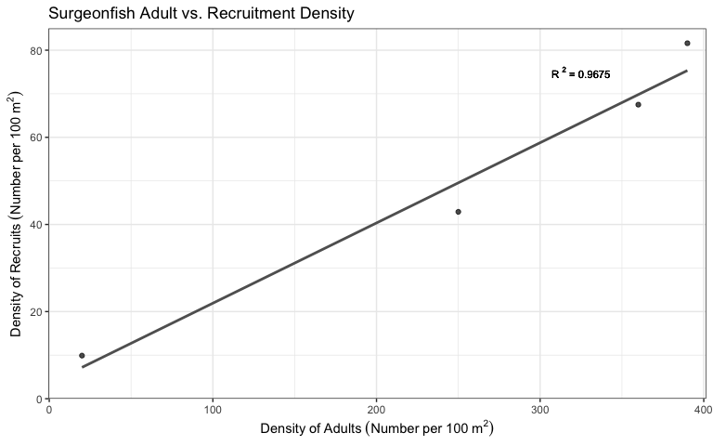

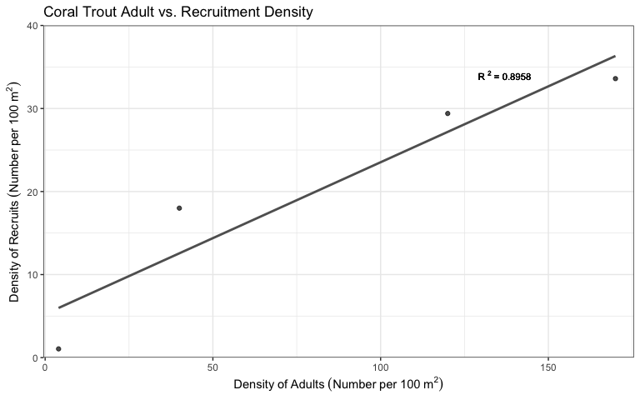

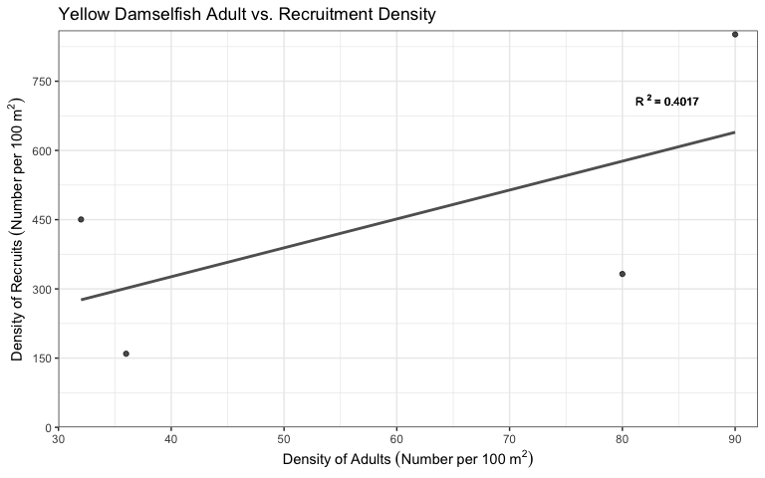

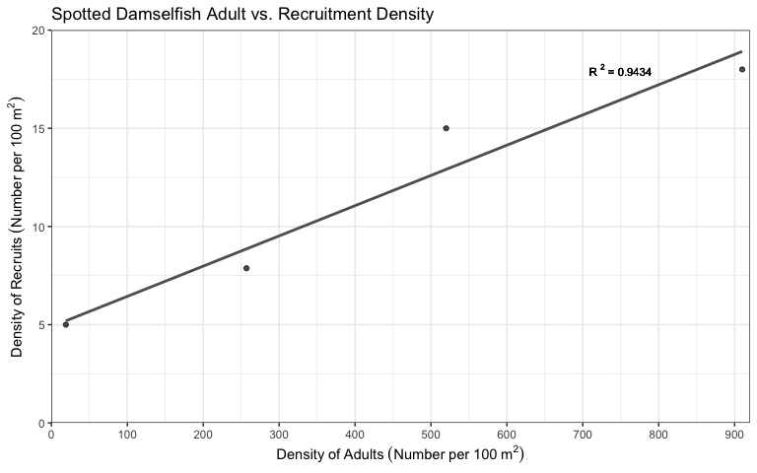

# Question 4

## Adult Density vs. Microhabitat

Tasks:  
- Scatterplots of adult density vs. density of microhabitat used by young

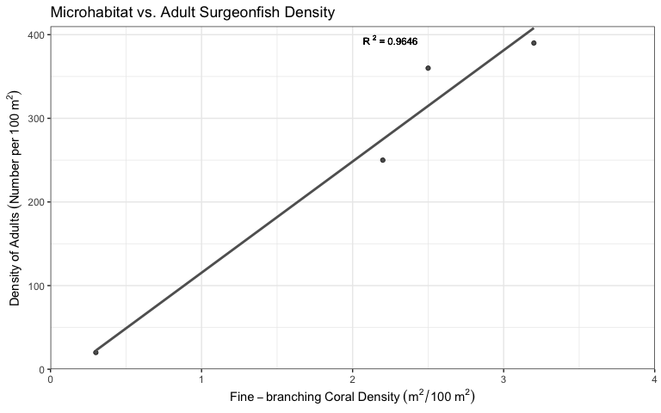

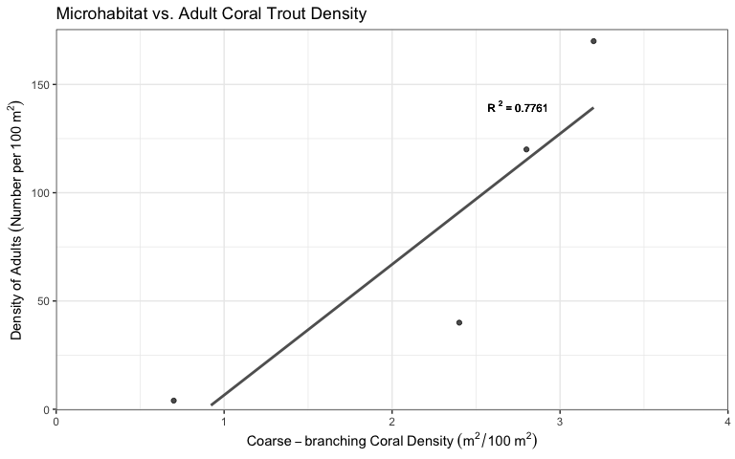

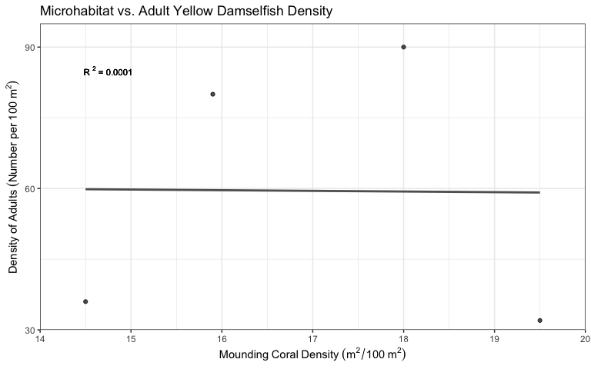

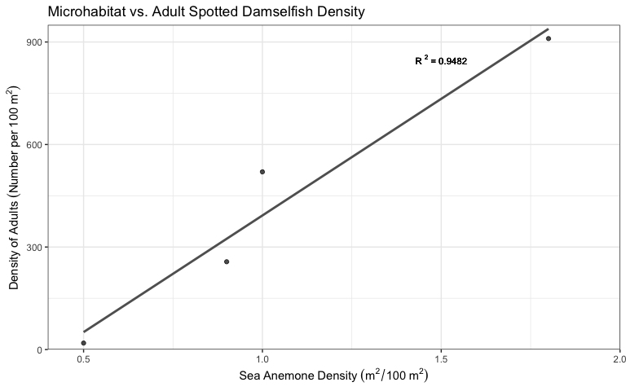

# Question 5

## Adult Density by Juvenile Microhabitat

Tasks:  
- Calculate the density of adults per area of bottom covered by the microhabitat used by the young (for each lagoon and year)  
- Graph them (similar to questions one and two)

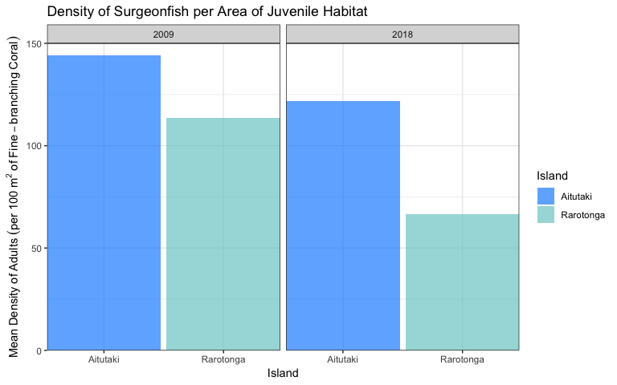

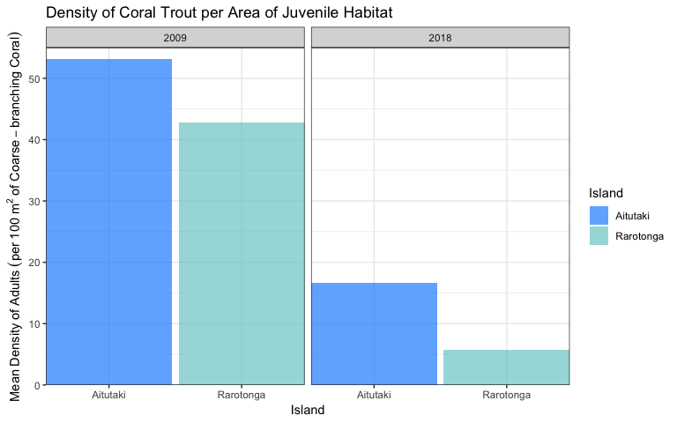

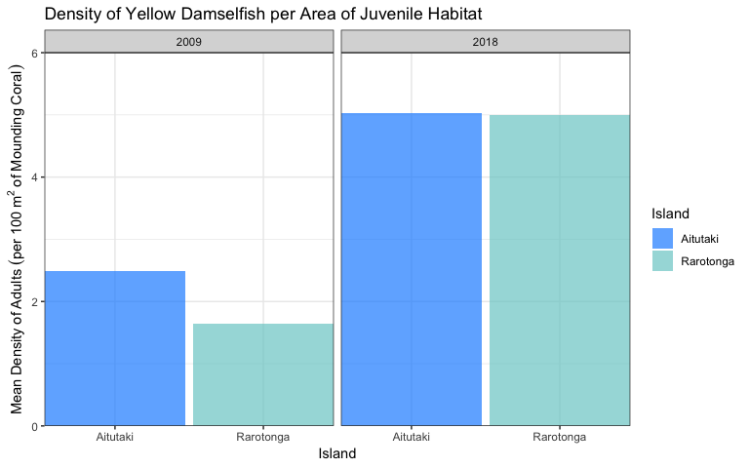

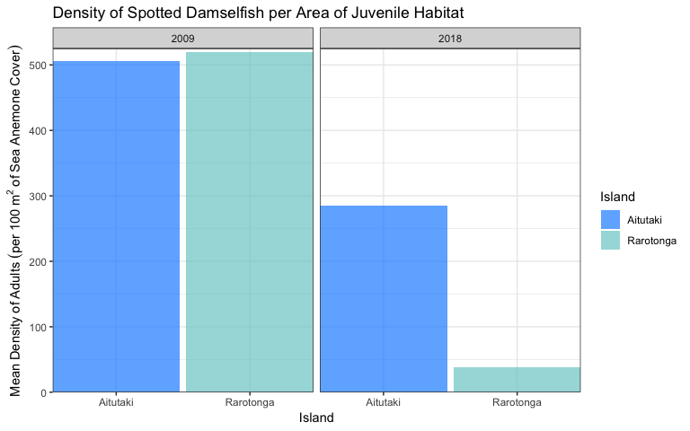

## Question 6

# Adult Density Trends

Tasks:  
- Scatterplots (adult density) with trend line and r-squared value  
- Surgeon vs. Coral Trout  
- Surgeon vs. Yellow Damselfish  
- Surgeon vs. Spotted Damselfish  
- Coral Trout vs. Yellow Damselfish  
- Coral Trout vs. Spotted Damselfish  
- Yellow Damselfish vs. Spotted Damselfish

