Models

# Always Models

Document styles style body section paragraph inline text

On the Insert tab, the galleries include items that are designed to coordinate with the overall look of your document. You can use these galleries to insert tables, headers, footers, lists, cover pages, and other document building blocks. When you create pictures, charts, or diagrams, they also coordinate with your current document look. You can easily change the formatting of selected text in the document text by choosing a look for the selected text from the Quick Styles gallery on the Home tab. You can also format text directly by using the other controls on the Home tab.

Most controls offer a choice of using the look from the current theme or using a format that you specify directly. To change the overall look of your document, choose new Theme elements on the Page Layout tab. To change the looks available in the Quick Style gallery, use the Change Current Quick Style Set command. Both the Themes gallery and the Quick Styles gallery provide reset commands so that you can always restore the look of your document to the original contained in your current template. On the Insert tab, the galleries include items that are designed to coordinate with the overall look of your document.

# Inline (noBreakHyphen SoftHyphen symbol tab hyperlink)

No‑Break‑Hyphen

symbol[♣]

tab[ ].

SoftHyphenaasssssssssssssssssssssssssaaaaaaaaaaaaaaaaaaaaaaaaaaaaaaaaaaaaaaaaa

models.docx anchor link

## Equation

$${\left(x+a\right)}^{n}=\sum_{k=0}^{n}{\left({n \atop k}\right)x^{k}a^{n-k}}$$

# Range (Field Bookmark)

## Field fieldBegin fieldSeparate

## Fieldsimple

28-Apr-15

## Bookmark bookmarStart

On the Insert tab, the galleries include items that are designed to coordinate with the overall look of your document. You can use these galleries to insert tables, headers, footers, lists, cover pages, and other document building blocks. When you create pictures, charts, or diagrams, they also coordinate with your current document look.

# Image

## anchorImage (shape with image filled)

## inlineImage

On the Insert tab, the galleries include items that are designed to coordinate with the overall look of your document. 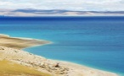You can use these galleries to insert tables, headers, footers, lists, cover pages, and other document building blocks. When you create pictures, charts, or diagrams, they also coordinate with your current document look.

# Clip Art

C:\Program Files (x86)\Microsoft Office\MEDIA\CAGCAT10\j0149627.wmf

# SmartArt

# Chart

# ScreenShot

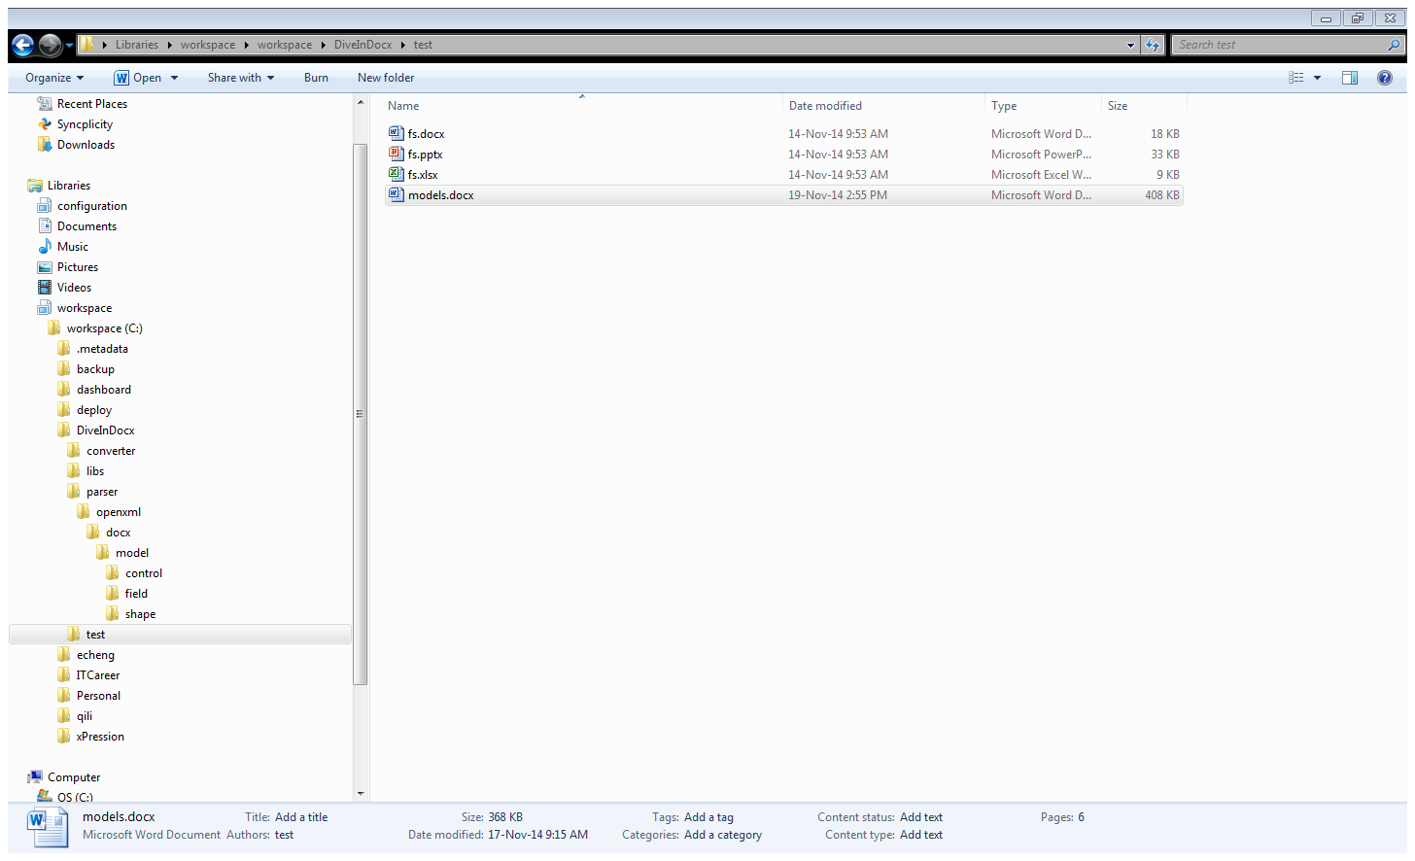

# Shape

## Shape

## Line

## Rect

## RoundRect

## Group

# Heading

## Heading

### On the Insert tab, the galleries include items that are designed to coordinate with the overall look of your document.

## headingChar

On the Insert tab, the galleries include items that are designed to coordinate with the overall look of your document. You can use these galleries to insert tables, headers, footers, lists, cover pages, and other document building blocks. When you create pictures, charts, or diagrams, they also coordinate with your current document look.

## headingCharParagraph

# Table (table row cell)

|  |
| --- |
| hello |

# Others

## textFrame

## SDT

### Rich text

### Text

### Picture



### Building block gallery

Choose a building block.

### Combo box

### Dropdown

### Date

### Checkbox

## hyperlink

click [here](http://office.microsoft.com/) to get word support

## OLE



## Textbox

On the Insert tab, the galleries include items that are designed to coordinate with the overall look of your document.

## Br

On the Insert tab, the galleries include items that are designed to coordinate with the overall look of your document.

You can use these galleries to insert tables, headers, footers, lists, cover pages, and other document building blocks. When you create pictures, charts, or diagrams, they also coordinate with your current document look.

## Cross-Reference

Cross-Reference

## Page Number

8

## WordArt

**Word Art**

## Date & Time

Tuesday, April 28, 2015

## Number

234

## Heading Character

On the Insert tab, the galleries include items that are designed to coordinate with the overall look of your document.