15799
Document Code
00
Revision

Software Architectural Design

Device Name: High Power Laser VL8
Software Safety Class: B
Driver Software Version: 01
GUI Software Version: 7.0.0.7650

Signature | Date of Issue | Approved by | Confirmed by | Prepared by | Issue Details / Rev. No.
 | 03/03/2025 | Beik Y. | Karbasi A. | Bahmaei Sh. | Initial Release / 00

1. Architecture of Software
According to general system architecture, interaction control logic defines the procedures through which the user interacts with the High Power Laser VL8 device. It coordinates with the control software to respond to user inputs and determines the content and timing of information and feedback presented to the user.
Drivers for input devices are responsible for detecting user actions on input devices, such as press/release of buttons and touch events on the touchscreen. The Input interpreter handles complex user input events, such as long-press actions on input widgets, mapping between touchscreen coordinates and input widgets, and continuous user actions such as handswitch actuation. Output render defines how feedback is presented to the user. Drivers for output devices command output devices (e.g., display, speakers) to present feedback to the user.
The High Power Laser VL8 device has two pieces of software. Driver software tasks are to control and adjust the device's output. GUI software provides a Graphical User Interface (GUI) between user and the device. Communication between GUI and Driver software is fulfilled through serial communication protocol (RS-232).
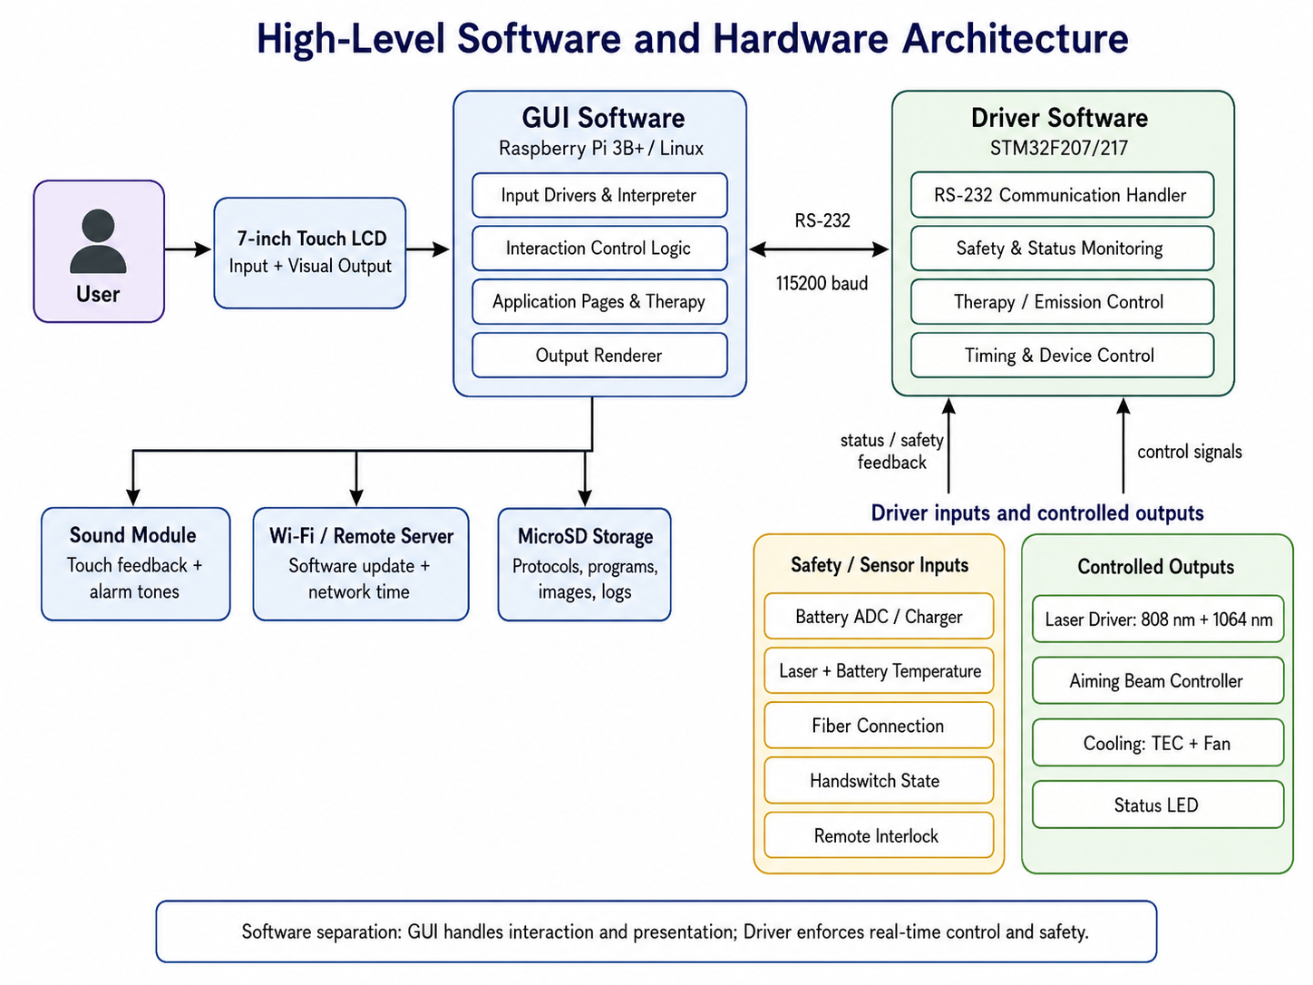
Figure 1. High-Level Software and Hardware Architecture.

Hardware Modules and Software Interaction
1. LCD Module
The GUI software generates the data to be displayed on the 7-inch touch LCD, which can include text, images, icons, and other graphical elements. The user can view and interact with the information presented on the screen. The GUI software receives user input from the integrated touch panel (Vertical ITF In-Cell Touch Framework). It interprets the touch coordinates and performs appropriate actions based on the user's interaction.
2. Sound Module
The GUI software processes user input data to determine the desired volume levels for touch feedback and alarm tones. Once the desired volume levels are determined, the GUI software sends the corresponding data to the sound module of the device. Users can select different alarm tones and adjust alarm volume through the Settings page.
3. Wi-Fi Module
The GUI software communicates with a remote server to determine if any software updates are available for the device. If an update is available, it downloads the update package from the server. Once the user confirms the update, the GUI software initiates the update process and manages the transfer of the update package to the device via the Wi-Fi module. Network time synchronization is also available through this module.
4. Storage Flash Memory
To save therapeutic protocols, user-defined programs, favorites, placement images, error messages and other user settings, a storage flash memory (MicroSD card) is used.
5. Battery
The microcontroller continuously monitors the battery voltage level using the ADC. It compares the voltage against predefined thresholds that indicate the battery's state of charge or health. If the battery voltage drops below a specific threshold (20%), the microcontroller generates a low battery warning visible on the GUI. The microcontroller also implements battery protection mechanisms to safeguard against overcharging or deep discharging. It controls the charging circuits to regulate the charging process and protect the battery's integrity. A visual notification is displayed on the UI when the charger is connected.
6. Temperature Sensor
Temperature sensors with nonlinear (exponential) output characteristics are used. One sensor measures the laser diode temperature and another controls the temperature of the device battery. These measurements are sent to the Driver's Microcontroller to control the fans and output laser. If the laser module exceeds 35°C, an immediate emission interruption is triggered.
7. Fiber Sensor
This sensor is able to recognize if the optic fiber (handpiece fiber cable) is not connected to the device. This data is sent to the Driver's Microcontroller and then to the GUI Module to warn the user, preventing laser emission until the fiber is properly connected.
8. Handswitch
The Microcontroller controls the Handswitch state (pressed or released). If the handswitch is connected, the Microcontroller waits for pressing its switch to start applying the output laser. The sensor also detects if the handswitch is not connected, sending this data to the Driver's Microcontroller and then to the GUI Module to warn the user. The switch mode (Toggle or Momentary) is configurable from the Settings page.
9. LED
The device includes an LED that indicates the status of the laser radiation module. The microcontroller controls the LED, allowing it to change colors to represent four different modes: off, standby, ready, and emitting. A red indicator light is activated when the laser starts running.
10. Cooling System
By controlling the cooling system including TEC and Fan through the microcontroller, the High Power Laser VL8 device effectively regulates its temperature, providing optimal performance and preventing overheating. The microcontroller controls the operation of the Thermoelectric Cooler (TEC) and can adjust the power supplied to regulate device temperature. In addition, the microcontroller controls the fan speed to increase or decrease airflow.
11. Interlock
The driver software constantly monitors the status of the interlock. The interlock is configurable from the Settings > Security page, where the user can enable or disable the requirement of a remote interlock for running output. When active, the device remains locked until the interlock condition is satisfied. The GUI displays a yellow warning indicator when the interlock is not connected.
12. Laser Module
The High Power Laser VL8 device is equipped with a laser driver circuit that provides the necessary electrical power and control signals to the laser module. The device supports two laser diodes operating at 808 nm and 1064 nm wavelengths, each capable of delivering up to 8 watts of peak power. Users can distribute the output power between both wavelengths based on treatment requirements. The laser driver circuit is connected to the microcontroller.
13. Aiming Beam Controller
The aiming beam controller is integrated with the microcontroller. User control is provided through the GUI software, allowing the user to view the active aiming beam status during therapy sessions.
14. Interface between GUI Module and Driver's Microcontroller
There is a serial communication protocol (RS-232) between GUI software and Driver software. The following information is sent from GUI Module to the Driver's Microcontroller (STM32F207):
- Error Commands
- Output Mode selected by user (Continuous Wave / Pulsed)
- Value of output Power (W) for each wavelength (808 nm and 1064 nm), Duty Cycle, Timer, and Wavelength selection
- Value of Frequency selected by user
- Emission mode selected by user (Standby / Ready / Emitting)
The following information is sent from Driver's Microcontroller to GUI Module:
- Error command (e.g., Fiber or Handswitch Disconnection command)
- Handswitch state (Pressed or Released)
- Temperature (laser diode and battery)
- Battery State and charge percentage

A) GUI Software
In this section, GUI software requirements have been transformed into the ARCHITECTURE that describes the software's structure and identifies the SOFTWARE ITEMs. The GUI follows the Portable Series format with a 7-inch touch LCD monitor.
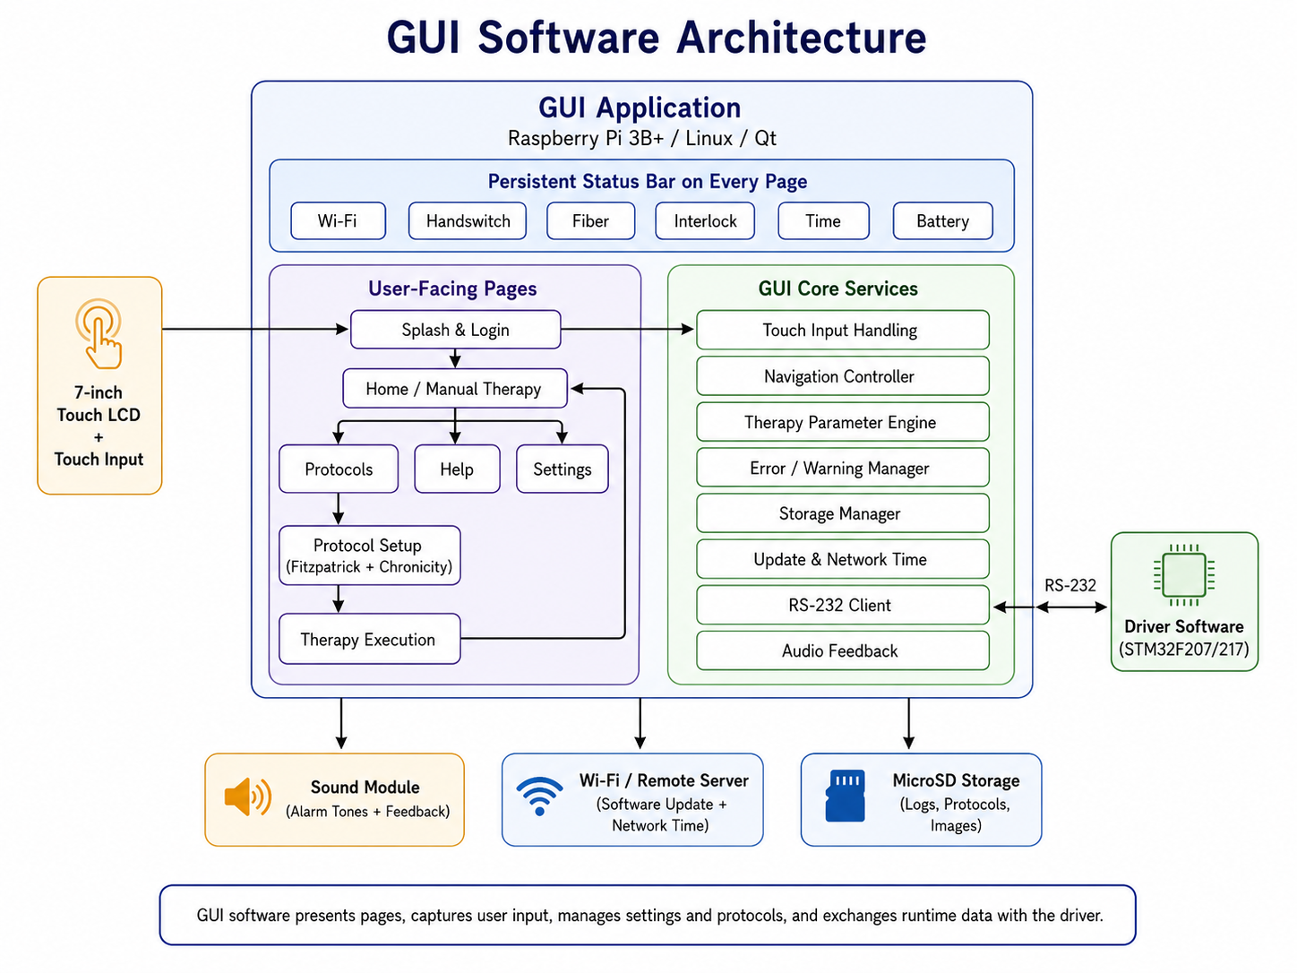
Figure 2. GUI Software Architecture.

1. Splash and Login Page
Once the device is powered on, a splash screen is displayed showing the device name and manufacturer logo. Following this, a screen prompts the user to enter the device password. The default password is '0000' which can be changed after accessing the device. If the device is being turned on for the first time or after a software update, the software prompts the user to set the date and time, as well as the physiotherapist's name.
Status icons are present on every page of the software (including the login page):
- Wi-Fi status (connected or disconnected)
- Handswitch connection (connected or disconnected)
- Fiber connection (connected or disconnected)
- Interlock connection (connected or disconnected)
- Time and battery charge percentage and graphics

2. Home Page (Manual Therapy Page)
After the splash page, the Home page is automatically displayed. It is the central hub of the device, enabling quick and efficient operation. All pages include a header that clearly displays the name of the current page. The Home page includes the following key elements:
2.1. Therapy Parameters
All relevant settings and parameters for the laser therapy session are clearly displayed and easily adjustable on this page.
- Therapy Modes: Five modes are available — Continuous Wave (CW), Pulsed, and others. In CW mode, Frequency and Duty Cycle settings are automatically disabled. Different modes can be set for each wavelength independently.
- Output Mode Options (one selectable at a time):
  - Timer Option: Users manually set the Time parameter; Energy is calculated automatically based on set time.
  - Dose Option: Users set Dose (J/cm²) and Area (cm²); Time (min) and Energy (Joule) are calculated automatically.
- Time: Adjustable from 1 minute to 60 minutes with a step of 1 minute.
- Wavelength Selection and Peak Power:
  - 808 nm: 0 W to 8 W
  - 1064 nm: 0 W to 8 W
  - Combined Mode (Both Wavelengths): 0.1 W to 8 W total power distribution between both sources
- Duty Cycle: Adjustable from 5% to 100% in 5% increments.
- Frequency: Selectable from 1 Hz to 1 kHz (step of 1 for 1–10 Hz, 5 for 10–100 Hz, 50 for 100–1000 Hz).
- Area: Ranges from 1 cm² to 225 cm²; increasing area increases treatment time and total Energy.
- Dose: Ranges from 1 J/cm² to 100 J/cm²; increasing Dose increases treatment time and total Energy.
2.2. Start Treatment Button
A prominent button is available for initiating the laser output directly from the Home page, allowing the user to begin treatment quickly after setting the necessary parameters.
2.3. Navigation Buttons
- Protocol Button: Access to predefined treatment protocols, Favorites, and user-saved protocols.
- Settings Button: Access to the Settings page for further customization.
- Help Button: Help section offering guidance, troubleshooting tips, and detailed instructions.
- Back Button: Present on every page, allowing users to return to the previous screen.
- Home Button: Available on all pages, providing quick access back to the Home page.

3. Protocols Page
The Protocols Page streamlines selection of treatment protocols through two browsing methods: alphabetically or by body part. User-created and saved protocols are also shown here.
- Alphabetical Protocol Selection: Users browse and select protocols listed in alphabetical order.
- Body Part-Based Protocol Selection: Users select protocols by interacting with a human body model displayed on screen. Tapping specific body parts filters and displays relevant protocols for that area.
- Favorites and User-Defined Protocols: Shown in this page; selecting each one displays its contents.
- Protocol Information Display: Once a protocol is selected, detailed information is shown including treatment instructions (step-by-step guidance) and visuals (images indicating the best places to apply the treatment).
3.1. Fitzpatrick Skin Type & Chronicity Selection
After selecting a protocol, users are directed to a page to specify the patient's Fitzpatrick Skin Type (6 levels, I to VI) and Chronicity (3 levels: Acute, Sub-acute, Chronic). Default protocol parameters are set for the acute phase and Fitzpatrick Skin Type I to III.
Effect of Chronicity on Dose:
- Acute: No adjustment to default Dose.
- Sub-Acute: Increases default Dose by 10–15 J/cm² at constant power.
- Chronic: Increases default Dose by 20–30 J/cm² at constant power.
Effect of Fitzpatrick Skin Type on Power and Duty Cycle:
- Skin Types I, II, III: No changes to Power or Duty Cycle.
- Skin Types IV, V: Power increased by 1 W; Duty Cycle reduced by 15–20%; Dose constant.
- Skin Type VI: Power increased by 2 W; Duty Cycle reduced by 30–40%; Dose constant.
3.2. Therapy Execution Page
After confirming the protocol and settings, the user is redirected to the Therapy Page which mirrors the Manual Therapy Page. It includes:
- Header displaying the selected protocol name.
- All standard therapy controls available for adjustment before starting treatment.
- Phase Details: Total number of phases and current phase number displayed.
- Remaining Time per Phase: Remaining time for the current phase displayed.

4. Help Page
The Help Page provides comprehensive support and information:
- Introduction: Overview of the device, main features, basic usage instructions, safety precautions, and a quick-start guide.
- Laser Review: Detailed information about the laser technology, laser types, therapeutic effects, and safety guidelines.
- Anatomy Library: Reference library with detailed anatomical illustrations, descriptions of various body parts, and their relevance to treatment protocols.
- About: Background information about the manufacturer and device, version details, legal disclaimers, and contact information.

5. Settings Page
The Settings Page allows users to customize the device:
5.1. Output
- Switch Mode: Enables users to toggle between different switch modes of operation (Toggle and Momentary).
5.2. Sound
- Touch Sound: Option to enable or disable sounds when interacting with the touchscreen.
- Alarm Tone: Allows users to choose their preferred alarm tone for end of treatment.
- Alarm Volume: Adjustable settings for the volume of alarms.
5.3. Reset
- Default Parameters: Resets therapy parameters to original factory settings.
- Erase Favorites: Clears all saved favorite settings.
- Erase User Programs: Deletes all custom user-defined programs.
- Default Settings: Resets all device settings to factory defaults.
5.4. Service
The Service Page is password-protected, designed exclusively for after-sales use. It includes:
- Calibration of Output: Allows calibration of the device's laser output.
- Work Time: Shows and allows reset/edit of the timer tracking laser diode run time.
- Device Serial Number Entry: Feature to enter or update the device's serial number.
- Remote Software Check: Option to remotely access and verify the device's software.
5.5. Display
- Font, Text size, and theme (light/dark mode) customization options.
5.6. Time and Date
- Manual time and date setting, or synchronization with network time.
5.7. Security
- Password: Options to set, change, or remove the password for accessing the device.
- Interlock: Provides the possibility to remove the requirement of remote interlock for running output.
5.8. Wi-Fi
- Options to connect to, disconnect from, or manage Wi-Fi networks.
5.9. Update
- Options for automatic updates and manual update checks.

6. Errors and Warnings Display
The following table defines alarm and warning conditions, priorities, and required actions:

No. | Priority | Alarm/Warning Condition | Text to be Shown | Indicator Light | Indicator Sound | Required Action
1 | High | Tapping Start Button and Output starts running. | - | Color: Red | Yes | Laser ready for emission.
2 | High | Laser module over temperature (35°C). | Over temperature. |  | Yes | Immediate Laser Emission Interruption.
3 | High | The battery or its circuit is damaged. | Problem in battery or circuit. Contact after-sales service. |  | Yes | No Laser Emission Or Immediate Interruption.
4 | Medium | The interlock is not connected. | The interlock is not connected. | Color: Yellow | Yes | No Laser Emission.
5 | Medium | The handpiece optic fiber cable is not connected. | The handpiece fiber cable is not connected. |  | Yes | No Laser Emission.
6 | Medium | The Handswitch is not connected. | The Handswitch is not connected. |  | Yes | No Laser Emission.
7 | Medium | Start button pressed when laser power is zero. | Laser power must be greater than zero to start treatment. |  | Yes | No Laser Emission.
8 | Medium | Calibration failure (±20% of Preset Value). |  |  |  | No Laser Emission.
9 | Low | The entered password is wrong. | The entered password is wrong. | Color: Designer's choice |  | Sign-in Failure.
10 | Low | A duplicated name typed to save user program. | A duplicated name is typed to save a user program. |  |  | Save Failure.
11 | Low | Battery charge drops below 20%. | Low Battery. |  |  | -
12 | Low | Connecting the charger. | Visual notification on UI showing battery is being charged. |  | Yes | -
13 | Low | High power (more than 5W) in Continuous mode. | The selected power is too high, please be careful. |  |  | -

B) Driver Software
In this section, Driver software requirements have been transformed into the ARCHITECTURE that describes the software's structure and identifies the SOFTWARE ITEMs.
There are several key functions performed by the driver software. At a frequency of 1 ms, the software evaluates all software timers. Every 200 ms, it reads all ADCs (Analog-to-Digital Converters). Additionally, every 300 ms, the software manages all battery processes. It also checks the status of the handswitch, fiber, and interlock. Furthermore, it handles laser emitting processes for wavelengths of 808 nm and 1064 nm, as well as performs the necessary panel control processes. The driver software also controls the device's fan and LED.
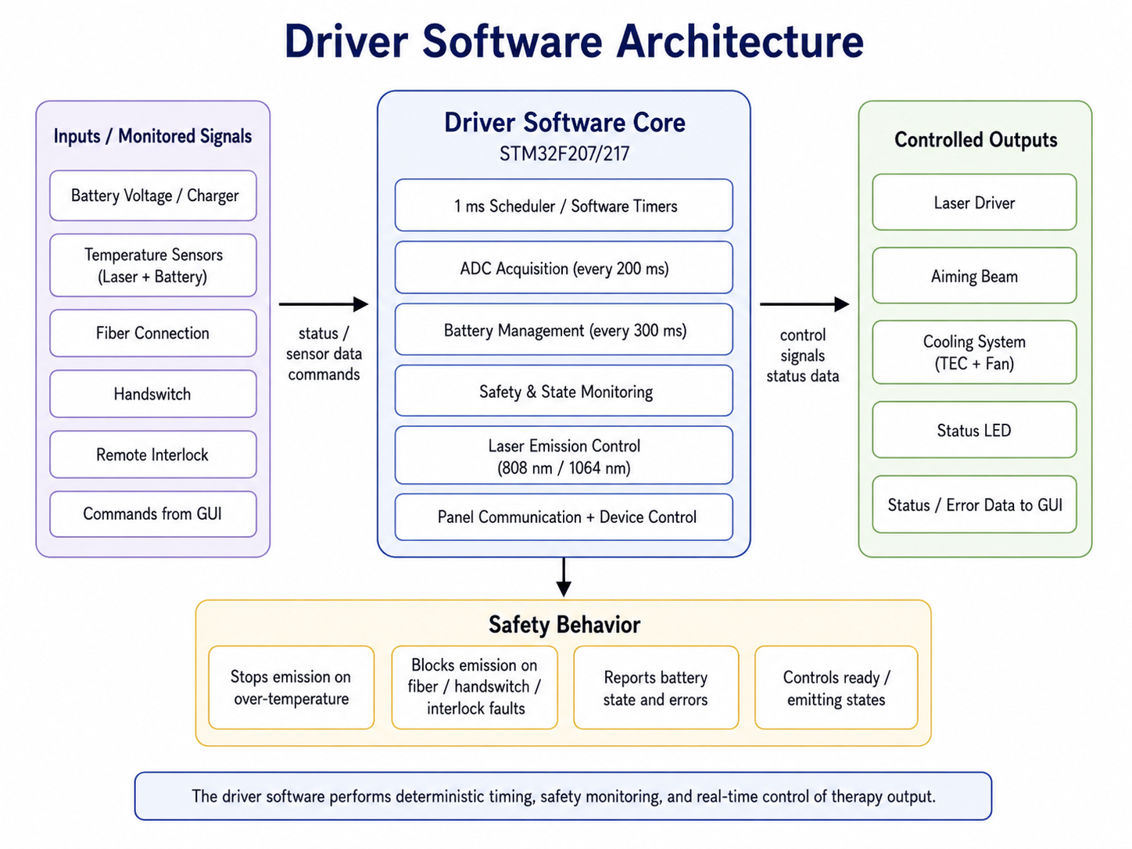
Figure 3. Driver Software Architecture.

2. Architecture of the Interfaces of SOFTWARE ITEMS

Serial Communication between GUI and Driver Software
In serial communication between GUI and Driver software, bytes of data are structured as follows:
General Structure
Byte definitions:
- Ack command byte: 0xaaaa
- Sequence number: number of packets received so far
- Checksum: XOR of 'version', 'data length', 'sequence number', 'command', and 'data' bytes
- Data length: number of bytes from 'data length' to end of packet
- Time interval between sending two packets: more than 10 milliseconds
- All data is Little-endian
- Baudrate = 115200
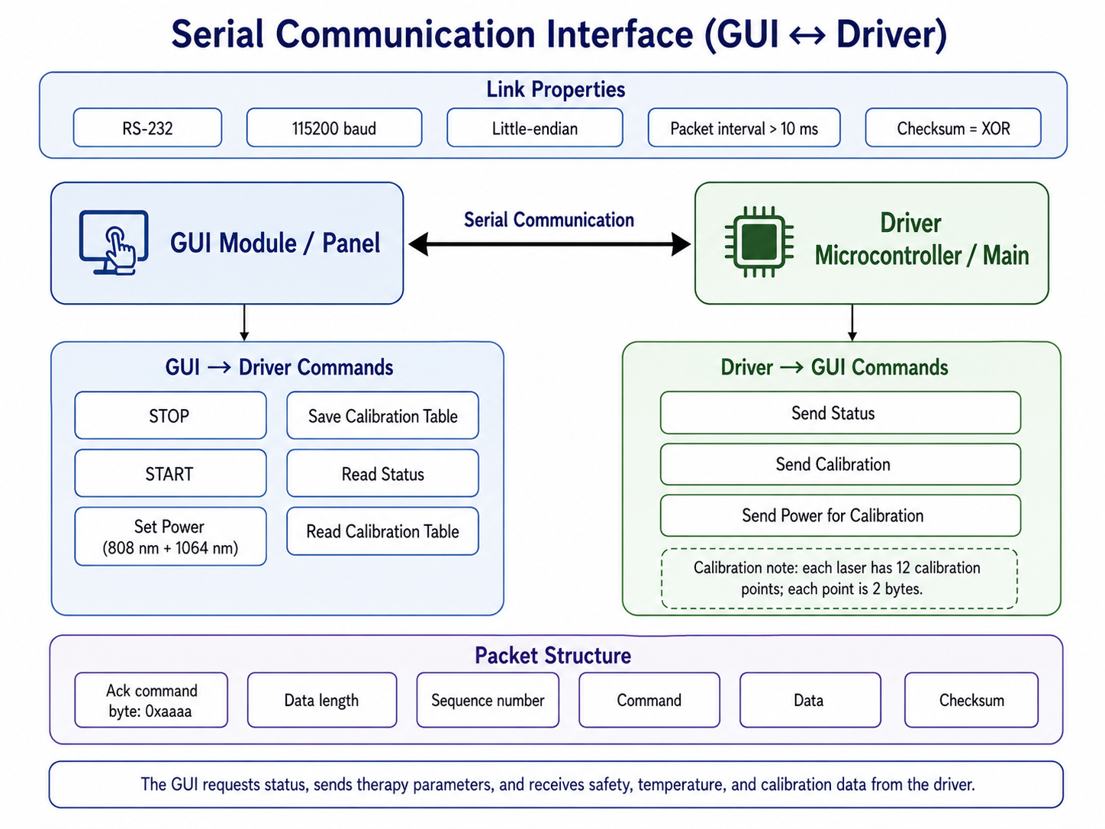
Figure 4. Serial Communication Interface (GUI ↔ Driver).
Commands
Panel to Main — STOP Command
Command | STOP
Direction | GUI (Panel) → Driver (Main)
Description | Stops the laser emission immediately.

Panel to Main — START Command
Command | START
Direction | GUI (Panel) → Driver (Main)
Description | Initiates the laser emission with currently set parameters.

Panel to Main — Set Power Command
Command | Set Power
Direction | GUI (Panel) → Driver (Main)
LaserA | Laser 808 nm
LaserB | Laser 1064 nm
Description | Sets the output power for each wavelength channel independently.

Panel to Main — Save Calibration Table
Command | Save Calibration Table
Direction | GUI (Panel) → Driver (Main)
Caution | ACK response only means data received correctly, not that data is saved in flash successfully.
Calibration Points | Each laser has 12 calibration points. Each point is 2 bytes.

Panel to Main — Read Status
Command | Read Status
Direction | GUI (Panel) → Driver (Main)
Description | Requests the current device status from the Driver microcontroller.

Main to Panel — Send Status
Command | Send Status
Direction | Driver (Main) → GUI (Panel)
Description | Sends current device status including temperature, handswitch state, battery state, and any error conditions.

Panel to Main — Read Calibration Table
Command | Read Calibration Table
Direction | GUI (Panel) → Driver (Main)
Description | Requests the current calibration table from the Driver microcontroller.

Main to Panel — Send Calibration
Command | Send Calibration
Direction | Driver (Main) → GUI (Panel)
Description | Sends the calibration table data to the GUI module.

Main to Panel — Send Power for Calibration
Command | Send Power for Calibration
Direction | Driver (Main) → GUI (Panel)
LaserA | Laser 808 nm
LaserB | Laser 1064 nm
Description | Sends measured laser power values (in mWatts) during calibration procedure. Each laser has 12 calibration points.

3. Software Architecture Verification
The software architecture is not complete unless all software requirements can be implemented by the identified software items mentioned in the previous sections.
Because the design and implementation of the software is dependent on the architecture, the architecture is verified to complete this activity. Verification of the architecture is generally done by technical evaluation.
Software verification has been completed, and the details are documented in the following references: Second Page of 'Software System Testing_High Power Laser VL8 / Verification Sheet', 'GUI Software Testing_High Power Laser VL8', and 'Driver Software Units Testing_High Power Laser VL8'.

4. Segregation Necessary for RISK CONTROL [For Class C]
No specific requirement is needed.

5. Functional and Performance Requirements of SOUP Item

1. GUI Software
In this section, functional and performance requirements for the identified SOUP items are defined. In the case of the High Power Laser VL8 GUI software, these are the Operating System (Linux) and the libraries used.
Operating System (Linux)
Functional Requirements:
- The operating system must support hardware acceleration for graphical operations.
- It should provide necessary system calls for file management, process control, and device I/O.
- Must support multi-threading to allow for responsive user interactions.
- It must be capable of handling serial communication protocols to facilitate communication between the GUI software and the Driver software.
- Audio unit to play feedback sounds and alarm tones.
Performance Requirements:
- The OS must boot within a specified time (≤10 seconds).
- It must ensure that the latency for GUI updates is within acceptable limits (≥30 fps).
- The system should be able to handle a minimum of 10 concurrent user interactions without degradation of performance.
Libraries
Functional Requirements:
- Libraries must include necessary API functions to support OpenGL renderer calls and GPU memory must be preserved to ensure future calls run without issues.
- Each library should facilitate the integration of GUI elements with the underlying hardware.
- Audio software encode/decode support for alarm tones and touch feedback.
Performance Requirements:
- The execution time for library functions should not exceed defined limits (e.g., rendering operations should complete within acceptable milliseconds).
- Resource consumption (CPU and memory usage) must remain below specified thresholds to ensure optimal GUI performance.

2. Driver Software
In the design of the High Power Laser VL8, there are no driver software items classified under the following two categories:
- Software items that are already developed and generally available, which were not specifically created for incorporation into the medical device.
- Software items previously developed for which adequate records of the development processes are unavailable.
As such, this requirement is not applicable to the High Power Laser VL8 driver software.

6. System Hardware and Software Required by SOUP Item

1. GUI Software
This section outlines the hardware and software dependencies necessary for the proper operation of the identified SOUP items.
Hardware Requirements
- Processor: Quad-core 64-bit Broadcom BCM2837 ARM Cortex-A53 SoC processor running at 1.2 GHz.
- Memory: 1 GB Random Access Memory; 250 MB allocated for GPU shared memory.
- Display: 7-inch Vertical ITF (In-Cell Touch Framework) touch-enabled LCD display.
Peripherals:
  - Storage: MicroSD card
  - Network adapter: Ethernet network card
  - USB 2.0 ports: 1
  - 802.11n Wireless LAN (Wi-Fi)
Software Requirements
Operating System:
  - Custom Debian-based OS (Kernel 5.x or higher)
  - VideoCore IV® support
  - EGLFS Support for direct render calls
  - OpenGL 1.3 or higher recommended for smooth performance
Libraries:
  - QtCSV for high-performance file operations based on CSV
  - WiringPi to interact with IO ports
  - LibVLC for audio feedback playback (alarm tones, touch sounds)
  - DBUS
  - QT Framework

2. Driver Software
In the design of the High Power Laser VL8, there are no driver software items classified under the following two categories:
- Software items that are already developed and generally available, which were not specifically created for incorporation into the medical device.
- Software items previously developed for which adequate records of the development processes are unavailable.
As such, this requirement is not applicable to the High Power Laser VL8 driver software.

7. Software Specifications
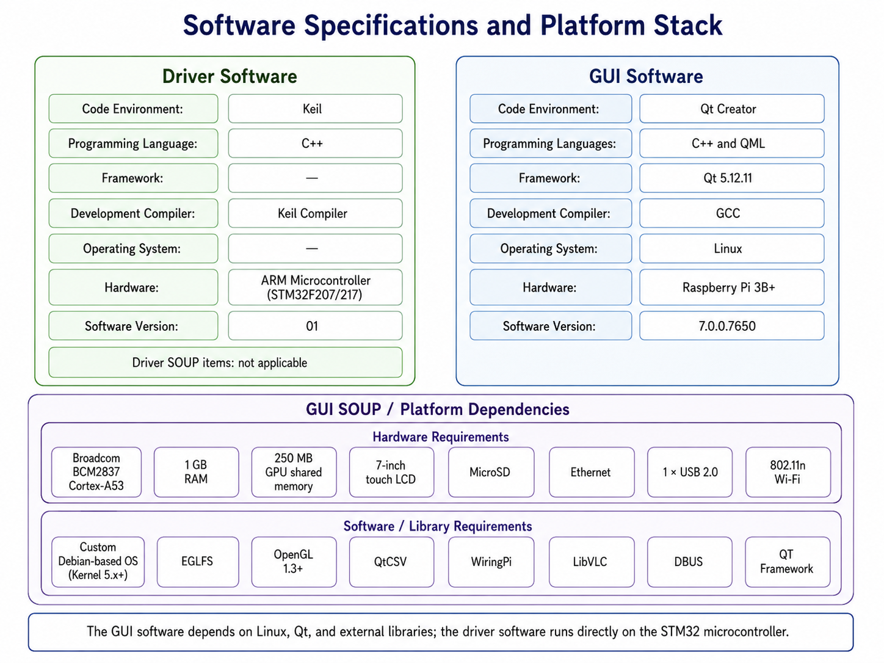
Figure 5. Software Specifications and Platform Stack.

Driver Software | GUI Software
Keil | QT Creator | Code Environment
C++ | C++ and QML | Programming Languages
- | QT 5.12.11 | Framework
Keil Compiler | GCC | Development Compiler
- | Linux | Operating System
ARM Microcontroller (STM32F207/217) | Raspberry Pi 3B+ | Hardware
01 | 7.0.0.7650 | Software Version

8. Reference to Documents
Refer to the following documents for detailed information:
- Software Risk Management Report
- Risk Management File
- Risk Management Plan
- Risk Management Report
- Safety Characteristics
- Software Problem Resolution

