Learned Video Rate Control Under a Bit Budget: How Much Lookahead Does RL Need?
EE599 Project Milestone Report
Aayush Soni, Ahhana Gupta, Atharva Kulkarni, Pavneet Singh Banga, Sara Pirasteh · November 4, 2026

1. Problem statement
A video encoder must decide how many bits each frame gets, so that a group of pictures (GOP) fits a hard bit budget while looking as good as possible. It does this by choosing a quantiser (QP) per frame: a lower QP spends more bits for a sharper frame. We treat this as a reinforcement-learning (RL) problem. The state is the budget left, the recent QPs and bits, and the complexity of the current frame and of the next k frames (the lookahead). The action is the next frame's QP. The reward is picture quality, and the constraint is that the GOP's total bits must not exceed the budget, which is only known once the GOP is coded.
Research question. An offline search that sees the whole GOP and tries many plans can beat the encoder's standard rate control, but it needs hundreds of trial encodes and cannot run inside a live encoder. How much of that search's gain can a policy capture in a single encode, and how does this change with the number of future frames it may see (from k = 0, strictly causal, to the full GOP)? Following the proposal feedback, we frame the contribution as this controlled lookahead–quality trade-off under a fixed GOP budget.

2. Introduction and related work
Rate control is a sequential decision problem with delayed, constrained feedback: overspending early forces crushed quality later, and a frame's cost depends on how well its reference frames were coded, so the problem is neither myopic nor easy to model. Lookahead is the main lever a live encoder has, but every frame of lookahead adds delay. Knowing what each frame of delay buys is useful to encoder designers.
Two closely related works learn rate control from an offline search. Mao et al. (neural rate control via imitation learning) train a controller to imitate per-video search plans and report that imitation alone often misses the bit-rate target, which they fix with auxiliary bit losses, target relabelling and inference-time feedback. MuZero rate control (Mandhane et al.) plans with a learned model of the encoder and a self-competition reward. Both use libvpx (VP9), whole videos and BD-rate, so their numbers are not comparable to ours, and we did not reproduce them. We use them for discussion: our question, how the gain depends on lookahead under a fixed per-GOP budget, is complementary, and the imitation-versus-RL comparison suggested in the feedback is built into our study.

3. What we did

3.1 Setup
- Encoders and episode. Real x265 4.1 and x264 encodes (fast preset). One episode is a 30-frame GOP (an I frame and 29 P frames, no B-frames, adaptive quantisation and cutree off so QPs are obeyed exactly). Every reward comes from a real encode: bits are counted from the bitstream and PSNR from decoding it.
- Action. A per-frame QP offset in −3…+3 around a fixed spend-early pattern (STATIC: I frame −6, P1–9 −3, P10–29 +3) on a base QP.
- Budget and score. The budget is the bits the encoder's own constant-QP mode spends on the same GOP at QP 30 or 38. The score is the % of bits saved at equal PSNR against the encoder's constant-QP curve, minus 2 points per 1 % over budget. We always report the share of GOPs more than 1 % over budget next to it.
- Data. 2,061 GOPs at 320×180 from YouTube UGC, open films and Xiph test sequences, split by source (1,196 train / 386 val / 479 test), plus GOPs spliced from two sources to create known scene cuts. A second, more balanced dataset with human-checked scene labels (v1, 1,042 GOPs) is being prepared.
- Ceiling. A hindsight search per GOP and budget (300 real encodes × 2 seeds). It is the yardstick, and its logged plans (about 1.4 M encodes) are the training data for imitation and offline RL.

3.2 Algorithms
- Imitation: behaviour cloning (BC) of the search's best plans.
- Offline RL on the search logs: CQL and IQL (discrete, γ = 1).
- Online RL from scratch in the real encoder: PPO, A2C and DQN, 60 k real encodes each.
- Offline start + online fine-tuning: CQL → PPO and BC → PPO (the imitation-then-RL comparison suggested in the feedback). CQL → PPO is the learner we sweep over the lookahead k = 0…29.
- Budget-constrained RL: a fixed overshoot penalty (the default reward), a Lagrangian (dual-ascent) constraint and a PID-controlled Lagrangian, all on PPO from the offline start.
- Model-based: a learned per-frame bits/PSNR model with receding-horizon CEM planning (MPC), and PPO pre-trained inside the learned model before real fine-tuning.
- Baselines: constant QP, the STATIC pattern, the encoders' own ABR / two-pass / ABR+VBV rate control, a causal feedback rule and a hand-made lookahead rule that allocates the budget by first-pass cost over the visible window.
Everything runs as SLURM job arrays on the CARC cluster (sharded encodes, one job per learner × k × seed, 3 seeds); all choices are made on the validation split and the numbers below are on the held-out test split.

4. Preliminary results
Results so far use the two budgets (QP 30 and 38) and 479 test GOPs × 2 budgets = 958 cases per encoder, seeds averaged. Table 1 shows a subset of the learners; the full comparison will be in the final report.
Table 1. Score / share of test cases > 1 % over budget (2 budgets, 3 seeds). Single entries do not depend on k.
Method | x265, k = 0 | x265, k = 5 | x264, k = 0 | x264, k = 5
Constant QP (reference) | 0.00 / 0 % |  | 0.00 / 0 %
STATIC pattern | −13.70 / 50 % |  | −15.95 / 56 %
Encoder's own two-pass | −18.75 / 41 % |  | −3.44 / 5 %
Behaviour cloning | 1.68 / 17 % | 3.77 / 9 % | 0.21 / 19 % | 2.65 / 21 %
CQL (offline RL) | −3.42 / 29 % | −1.77 / 26 % | −4.07 / 29 % | −1.23 / 25 %
PPO from scratch | 0.41 / 10 % | 0.32 / 14 % | −0.74 / 15 % | 0.15 / 14 %
CQL → PPO | 0.74 / 22 % | 3.48 / 15 % | −1.17 / 25 % | 0.43 / 24 %
Lagrangian PPO | 4.36 / 1 % | 4.95 / 2 % | 3.90 / 2 % | 4.07 / 6 %
MPC (learned model) | −1.78 / 6 % | −0.43 / 7 % | −3.58 / 10 % | −2.46 / 10 %
Hindsight search (ceiling) | 10.53 / 1 % |  | 9.95 / 1 %

- The search finds about 10 % savings at equal PSNR on both encoders, and it is still improving at 300 encodes, so this is a lower bound on what is attainable.
- Imitation gives a useful start; budget-constrained RL is the best single-pass controller so far. The Lagrangian learner beats BC by +2.7 points on x265 at k = 0 and is within budget on almost every GOP. It captures roughly 40–50 % of the search's gain.
- Lookahead (Fig. 1): going from k = 0 to k = 2–3 is clearly worth it on x265 (+3.4 points for CQL → PPO); beyond that the curve is noisy across seeds. x264 is noisier still.
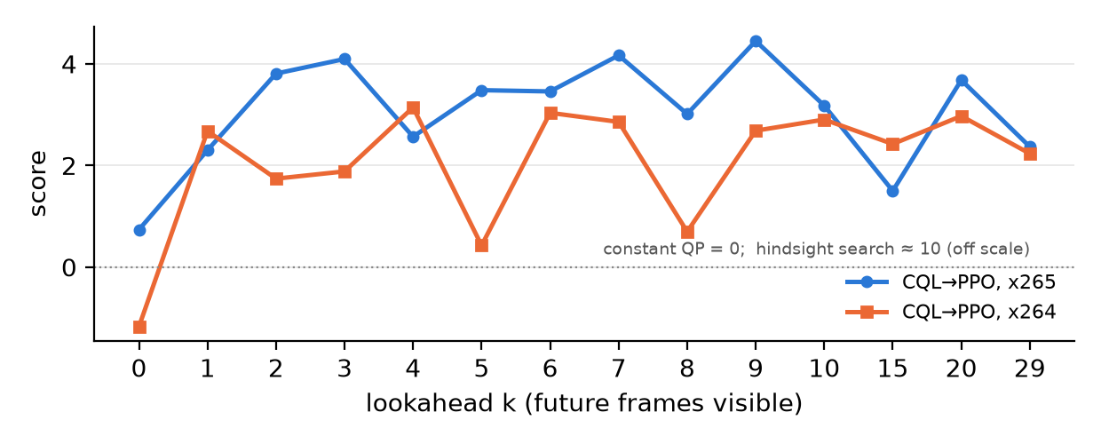
Figure 1. Score of CQL → PPO against lookahead k (test, 2 budgets, mean of 3 seeds).

4.1 What did not work
- Online RL from scratch (PPO, A2C, DQN) stays within ±1.5 points of constant QP with 60 k real encodes. This is partly a compute result: the offline learners start from about 1.4 M search encodes.
- Pure offline RL (CQL, IQL) is worse than plain imitation: it stays close to logged plans that are mostly near STATIC, and overshoots on 10–29 % of cases.
- Model-based RL. MPC exploits its model's errors, and pre-training inside the learned model fails because the model's ≈ 15 % bit error is larger than the effect of a good allocation.
- RL fine-tuning on top of imitation adds little quality. With clip-level confidence intervals, CQL → PPO − BC at k = 5 is −0.28 [−0.94, +0.22] on x265, not significant. RL's measurable contribution so far is budget reliability, not quality.
- More lookahead is not always better. At k = 29 the policy scores 1.7 points below k = 3 (clip-level CI excludes 0). Long windows make learning harder at our data size.
- The encoders' own rate control scores below constant QP in our setting, but that comparison is not fair to the encoder (Section 5), so we do not claim to beat it yet.

5. Holes we found in the problem formulation
A review of the setup found that some of the information the learners get is not available to a real encoder:
- Oracle base QP. Every learner is told the base QP, i.e. the constant QP that exactly meets this GOP's budget. Finding that QP is the hardest part of real rate control, and the encoder gets only a bitrate.
- Budget leak. Because the budget is defined as the GOP's own constant-QP cost, the budget features (budget relative to first-pass cost) reveal the GOP's true cost even at k = 0. So the k = 0 results are likely optimistic, and the lookahead curve may be compressed.
- Scene flags look ahead. The flash and fade detectors use up to 4 later frames. Recomputed causally, 2.4 % of frames get different flags at k = 0.
- Statistics and data. Our confidence intervals were over cases, not clips (the 479 test GOPs come from only 38 source clips plus 60 splices). 60 of the 90 test GOPs with a cut are artificial splices. Re-analysed at clip level, most headline differences still hold, but some small ones do not (e.g. k = 2 → 3).
- Weak baselines. The fixed STATIC pattern is poorly fitted (−13.7 on x265), and the encoders' own rate control is penalised by our oracle-based budget, by 30-frame episodes that are too short for ABR to converge, and by a PSNR score while its defaults target subjective quality.

6. Pivot
- A causal setting. The budget becomes a scaled constant-QP cost with the scale hidden from the controller, the base QP comes from a GOP-level first-pass rate model fitted on training data (as an encoder's lookahead would provide), and scene flags are computed only from visible frames. A first attempt that re-estimated the base QP every frame failed (its first-frame QP was within ±2 of the right value in only 25 % of cases at k = 0), so we moved to the GOP-level model, which we are now testing.
- A fair head-to-head with the encoder's own rate control, where nobody gets an oracle QP: streams of several GOPs under one bitrate, with the encoder given the same lookahead as the learner. Our check shows that the joined stream reproduces the per-GOP encodes bit-exactly on x265.
- A stronger non-RL baseline: imitation plus a simple closed-loop budget correction (in the spirit of Mao et al.'s inference-time feedback). It tests whether RL is really needed for the budget.
- Reframing. The study's claims are about the lookahead–quality trade-off and about budget handling. The main learner moves from the penalty-based CQL → PPO to constrained RL.

7. What is missing and future plan
Not done yet from the proposal: RecurrentPPO (memory-based learner), the safety shield for the budget, the privileged-teacher actor-critic, VMAF as a second quality metric, and the encoder's CRF mode as a baseline.
Table 2. Runs and analyses planned for the final report.
Planned run / analysis | Purpose
Causal rerun of the core learners (CQL → PPO at k = 0, 1, 2, 3, 5; BC, Lagrangian, PID at k = 0, 5; 3 seeds; both encoders) | Lookahead curve and method ranking without the oracle QP and the leak
Encoder's own ABR / two-pass on the same causal budgets and on multi-GOP streams | Fair head-to-head with real rate control
BC + feedback control (tuned on validation) | Is RL needed, or is imitation plus feedback enough?
Wider range of budgets (QP 26 to 42) | Do the conclusions hold from high to low bit rates?
Budget shared across several GOPs | Allocation across GOPs, closer to real streaming
Stable vs scene-cut GOPs; extra lookahead only around cuts | When future information is valuable (feedback suggestions)
Dataset v1 with human-checked scene labels | Natural cuts instead of splices; more balanced content
VMAF, CRF baseline, RecurrentPPO, safety shield | Remaining proposal items

The final report will give results for both encoders with clip-level intervals, the lookahead curve in the causal setting, and a clear statement of what RL adds over imitation, including negative results.

