Basic Headers extraction

Purpose and forensic relevance
This module is designed to systematically parse the essential header fields of an email in order to support forensic assessment of authenticity, origin, and routing. Email headers carry metadata that is critical in investigations, for example: sender and recipient addresses, message identifiers, and timestamp fields.
Recent literature emphasises that header analysis remains a forensic technique for detecting spoofing, phishing, and other forms of email manipulation. For instance, the review by Altulaihan highlights that “the email header contains fields that can be altered by attackers but also leave artefacts interpretable by investigators”(1). Thus, the extraction of basic header fields is not merely preparatory work: it constitutes the first line of forensic evidence gathering, enabling downstream modules to operate effectively.

Extracted Headers
The following headers were targeted:
- From: the author of the message.
- To: the recipient(s) addressed.
- Subject: the summary line, useful for contextualising the message.
- Message-ID: the unique identifier of the email, useful for linking, deduplication or detecting reused IDs.
- Date: the declared sending date/time of the message.
This selection corresponds to best practice in header forensic analysis: the fields From, To, Date, Subject, Message-ID and Received are “key fields” in analysis of email origin and path.

Implementation
The process that headers_simple_module.py and tfm_email_core.py implement are described as follows:
- For each .eml file ingested into Autopsy, the module opens the file, and parses the headers.
- It normalises headers (lower-casing, unfolding line breaks, converting dates) to extract the field values targeted above.
- The extracted fields are then posted into Autopsy’s Artifact system. A TSK_EMAIL_MSG artifact is created and posted to the forensic Blackboard. This indexes the email in the central database, making it searchable and viewable within the analysis interface.

Output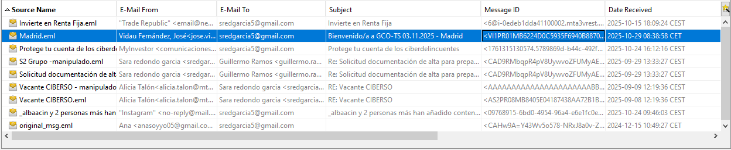

Hashing emails and attachments

Purpose and forensic relevance

Hashing is a foundational procedure in digital forensics, widely recognised in contemporary research as essential for integrity verification, chain-of-custody preservation, and evidential reproducibility. Modern forensic standards emphasise that every artefact extracted during an investigation must be accompanied by a tamper-evident identifier. (2)

For email forensics, this module provides:

Evidence integrity: it verifies that the .eml file ingested by Autopsy has not been modified.

Attachment provenance and traceability: it ensures that the attachments can be matched against external evidence, such as malware repositories, OSINT sources or spam databases.

Implementation

The hashing implementation is processed by the module hash_files_module.py and tfm_email_core.py. For this module, the hashing function chosen is SHA-256 as it ensures robust cryptographic collision resistance compliant with current NIST standards. (3)

On the one hand, the raw bytes of the email are read by Autopsy, stored in the buffer, and hashed using the SHA-256.

On the other hand, as each attachment can constitute independent evidence in email forensics, it is a good practice to hash them. To do this, the module inspects the MIME message to obtain the external files. Then, the payload is extracted and hashed.

Output

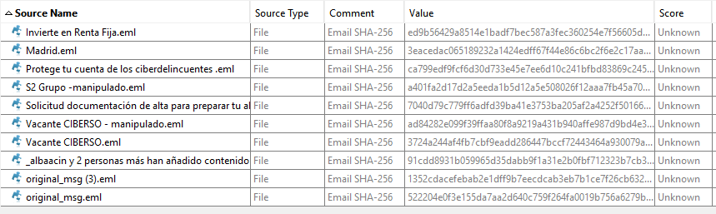

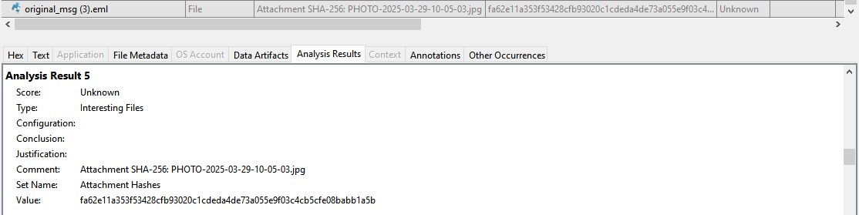

Message-ID

Purpose and forensic relevance

The Message-ID header is a critical component of email architecture, defined by RFC 2822 and RFC 5322 as a globally unique identifier referring to a specific version of a message. According to the standard, the generation of this ID is the responsibility of the host system (Mail Transfer Agent - MTA), which must guarantee its uniqueness in time and space.

Structurally, a valid Message-ID must adhere to the syntax local-part@domain, enclosed in angle brackets (<local-part@domain>). The RFC recommends algorithms that combine date/time stamps, process IDs, and the host's domain name to prevent collisions. Consequently, the presence of a duplicated identifier across distinct messages is a theoretical impossibility in benign environments and serves as a strong indicator of anomaly. (4)

Implementation

The primary objective of analyzing this header is to detect artifacts that deviate from standard generation patterns. The scripts messageID_consistency_module.py and tfm_email_core.py look for the following anomalies:

Missing Message-ID header.

Multiple Message-ID headers within a single email.

Fabricated or suspicious identifiers: It validates the local syntax and calculates Shannon’s entropy for each message-ID.

Duplicated Message-IDs across different emails: It verifies if the ID appears in any other registered email.

Reused Message-IDs across different senders: It will label it as SPOOF_POSSIBLE.

These checks serve as a filter for establishinng evidence authenticity. Since legitímate mail servers rarely produce these anomalies, detecting them allows to look beyond the email’s content and identify the techniques of fabrication or tampering.

Output

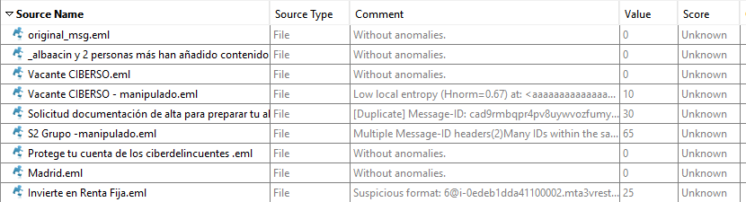

Date coherence

Purpose and forensic relevance

Implementation

Output

X-headers

Purpose and forensic relevance

Implementation

Output

Inconsistent headers

Purpose and forensic relevance

Implementation

Output

DKIM check

Purpose and forensic relevance

Implementation

Output

Authorization policies

Purpose and forensic relevance

Implementation

Output

References:
- Altulaihan, E., Alismail, A., Hafizur Rahman, M. M., & Ibrahim, A. A. (2023). Email Security Issues, Tools, and Techniques Used in Investigation. Sustainability, 15(13), 10612. https://doi.org/10.3390/su151310612 (https://www.mdpi.com/2071-1050/15/13/10612 )
- Eric Conrad, Seth Misenar, Joshua Feldman, Chapter 8 - Domain 7: Security Operations, Editor(s): Eric Conrad, Seth Misenar, Joshua Feldman, CISSP® Study Guide (Fourth Edition), Syngress, 2023,
Pages 361-457, ISBN 9780443187346, https://doi.org/10.1016/B978-0-443-18734-6.00006-4
(https://www.sciencedirect.com/science/article/pii/B9780443187346000064 )
- (https://nvlpubs.nist.gov/nistpubs/Legacy/SP/nistspecialpublication800-107r1.pdf )
- Resnick, P., Ed., "Internet Message Format", RFC 5322, DOI 10.17487/RFC5322, October 2008, <https://www.rfc-editor.org/info/rfc5322>.

THINGS TO ADD:
- Poner in the following modules the email format used is .eml, thus everything will be referencing that specific format.
- Purported – el supuesto
- Explicar que es el MIME

