TasK-🡪

Launch an EC2 instance (Linux and Windows) along with a web server. Then, create an EBS volume of 5 GB, attach it to an EC2 machine (Linux and Windows), and take a snapshot. Finally, create an EBS volume using the taken snapshot.

Linux EC2 EBS attachment of 5 GB:

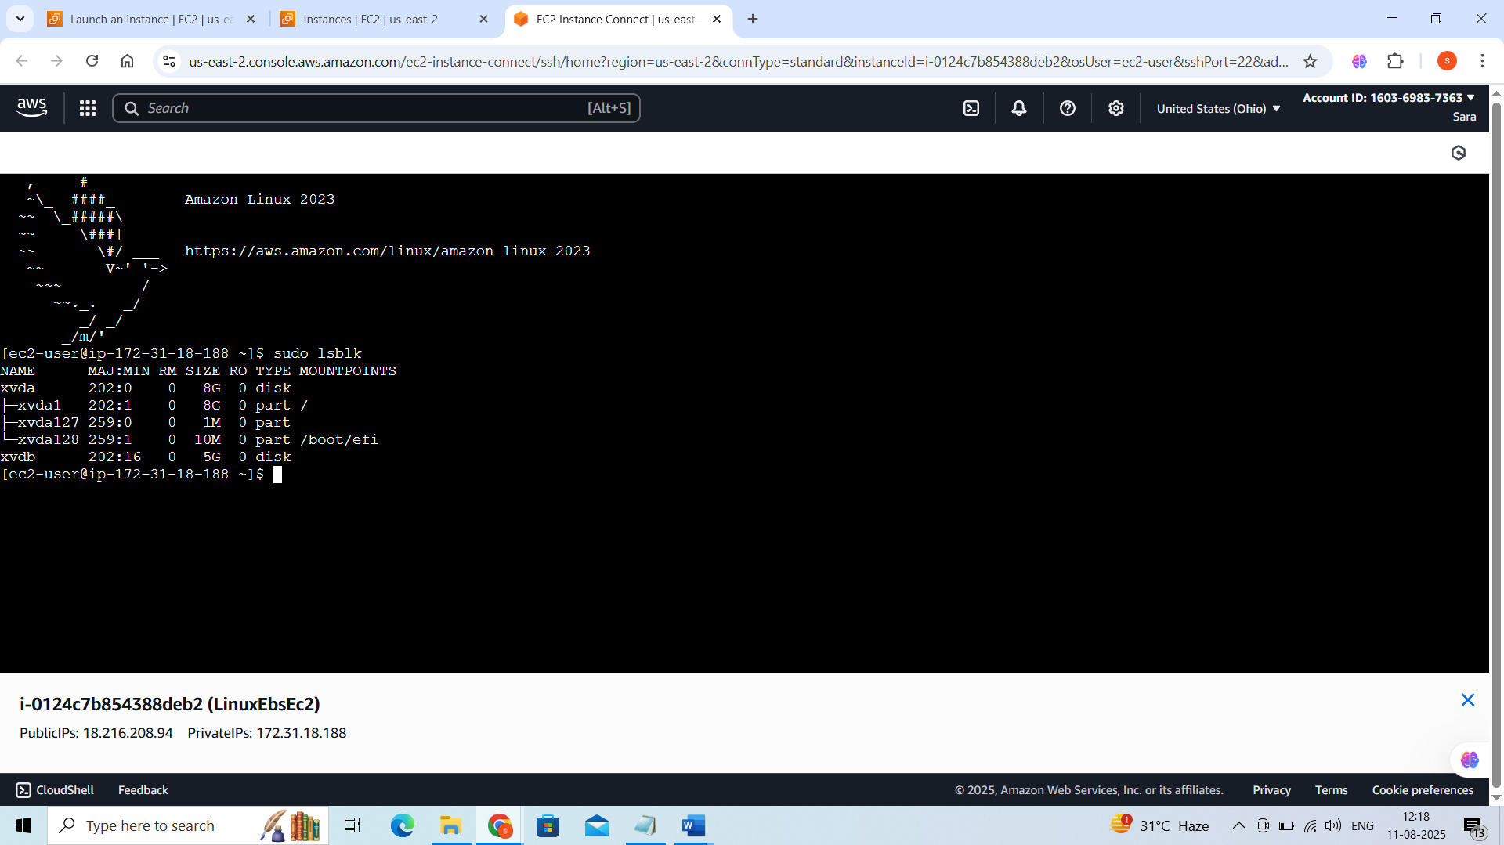

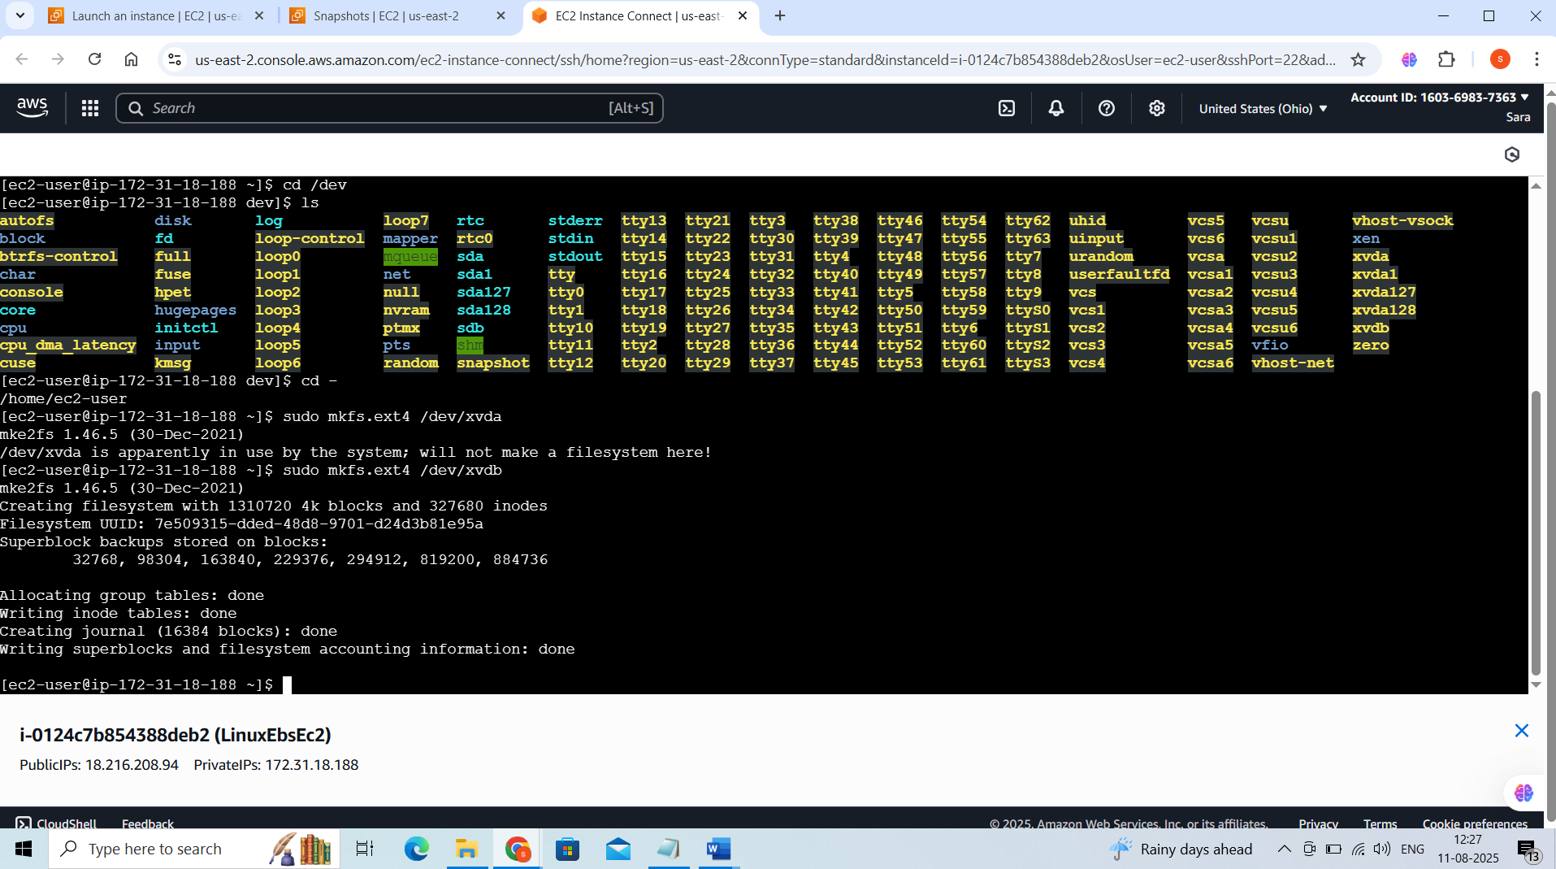

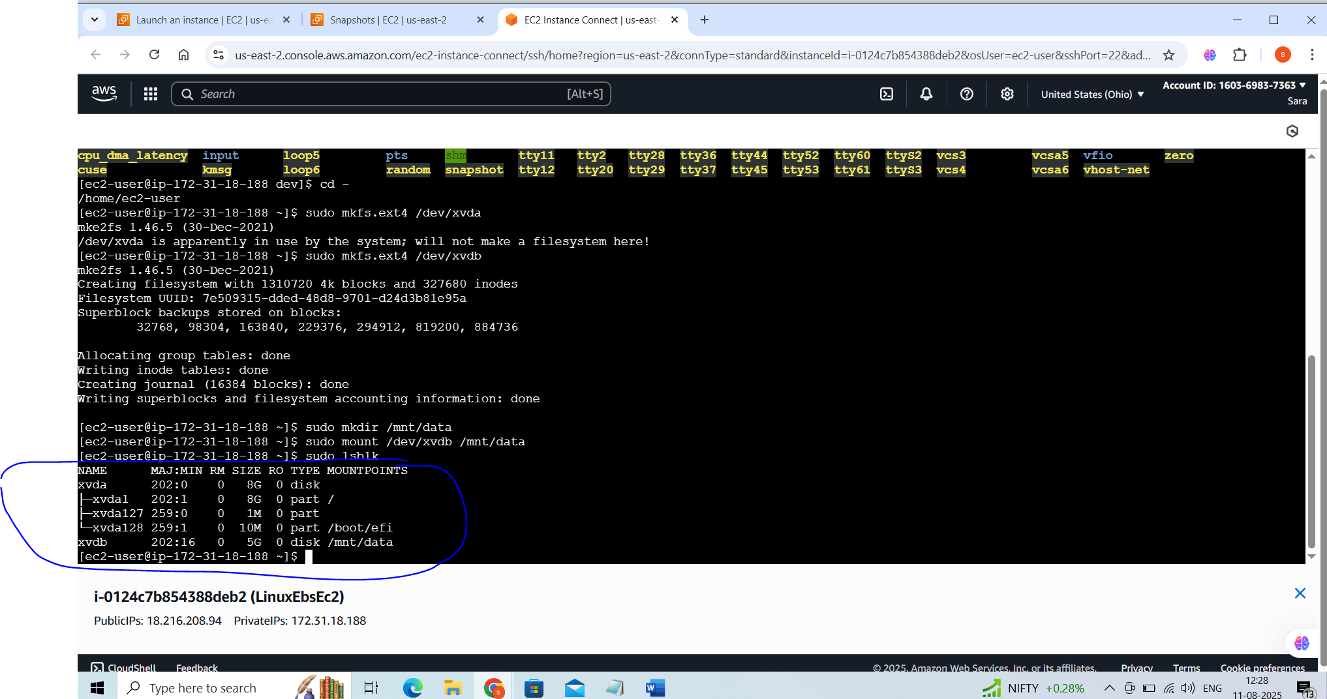

Volumes and snapshots created for the Linux with Webserver:

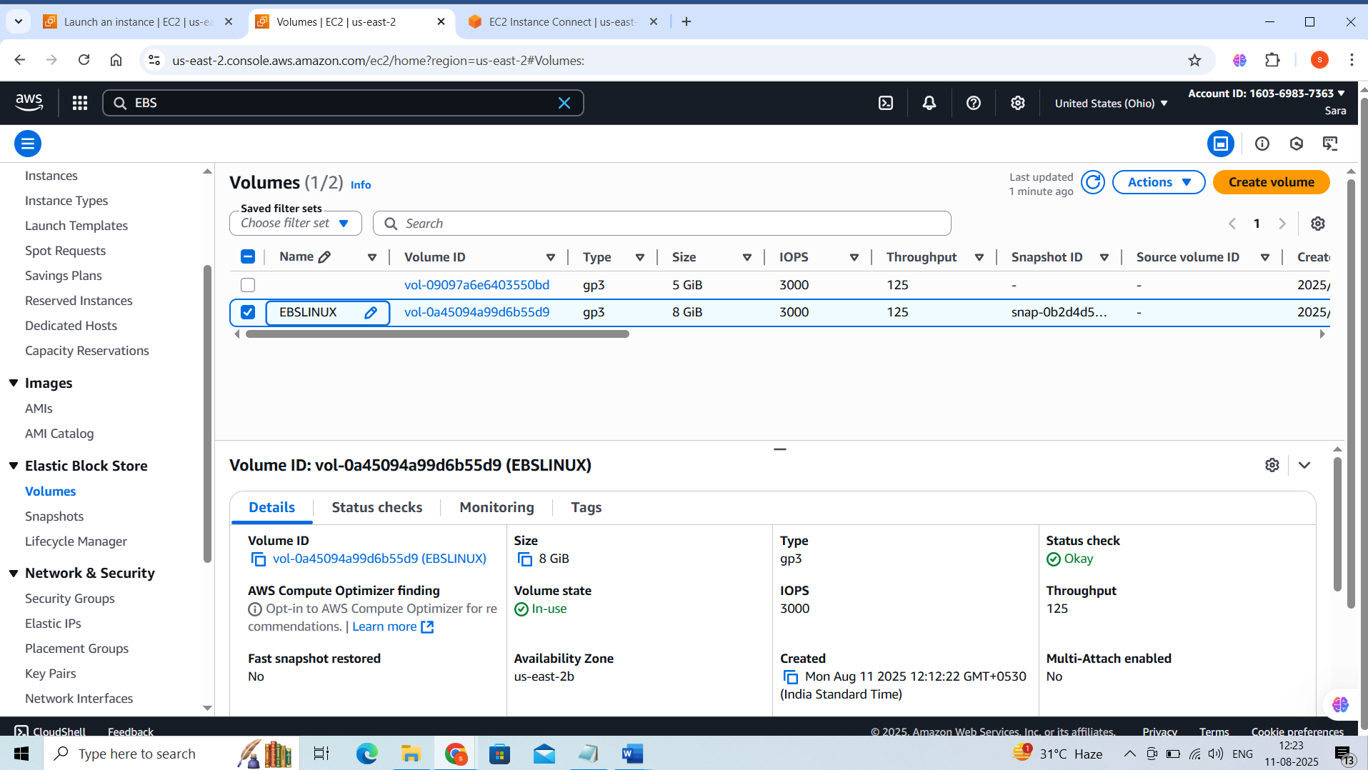

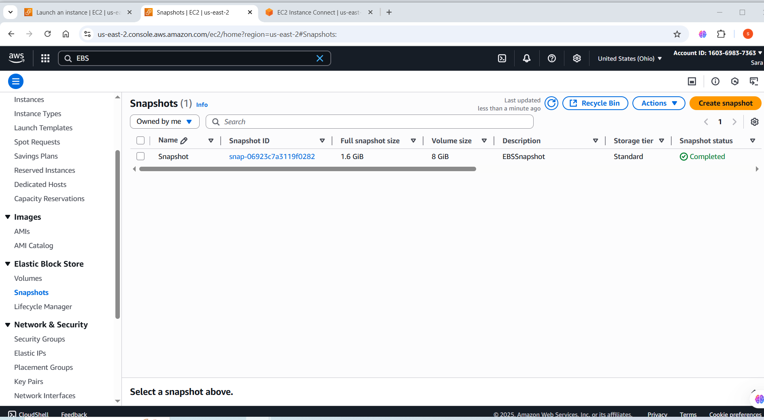

Windows Server Created:

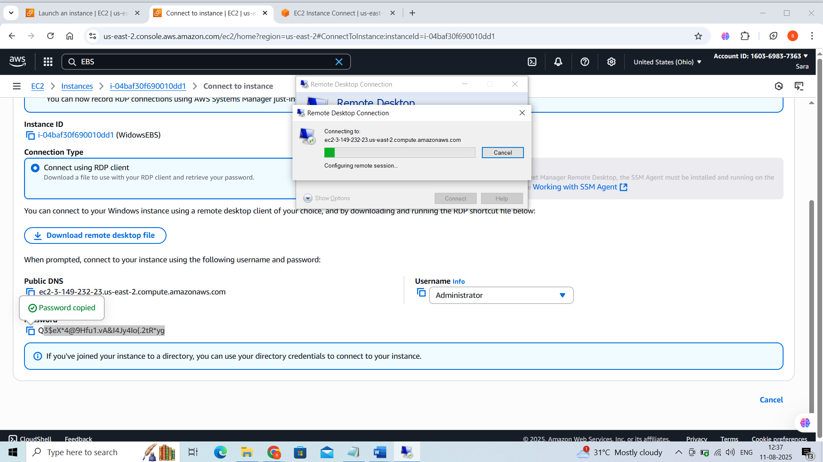

Windows Volume:

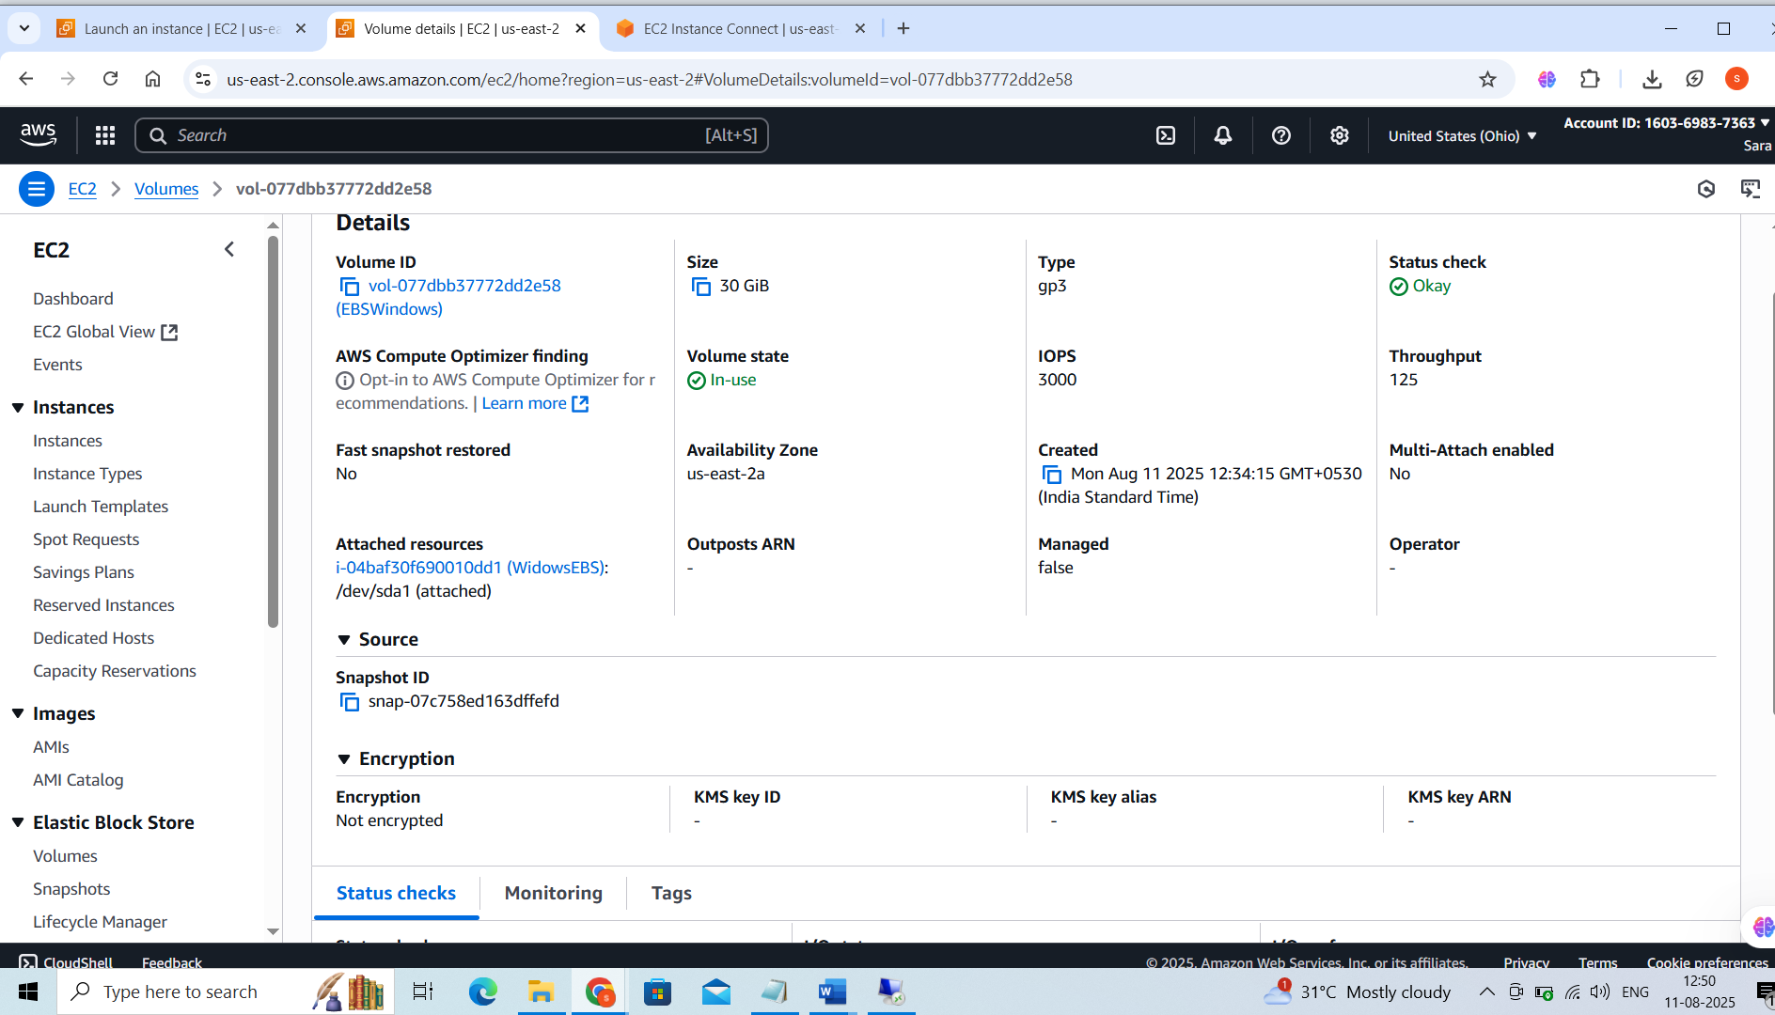

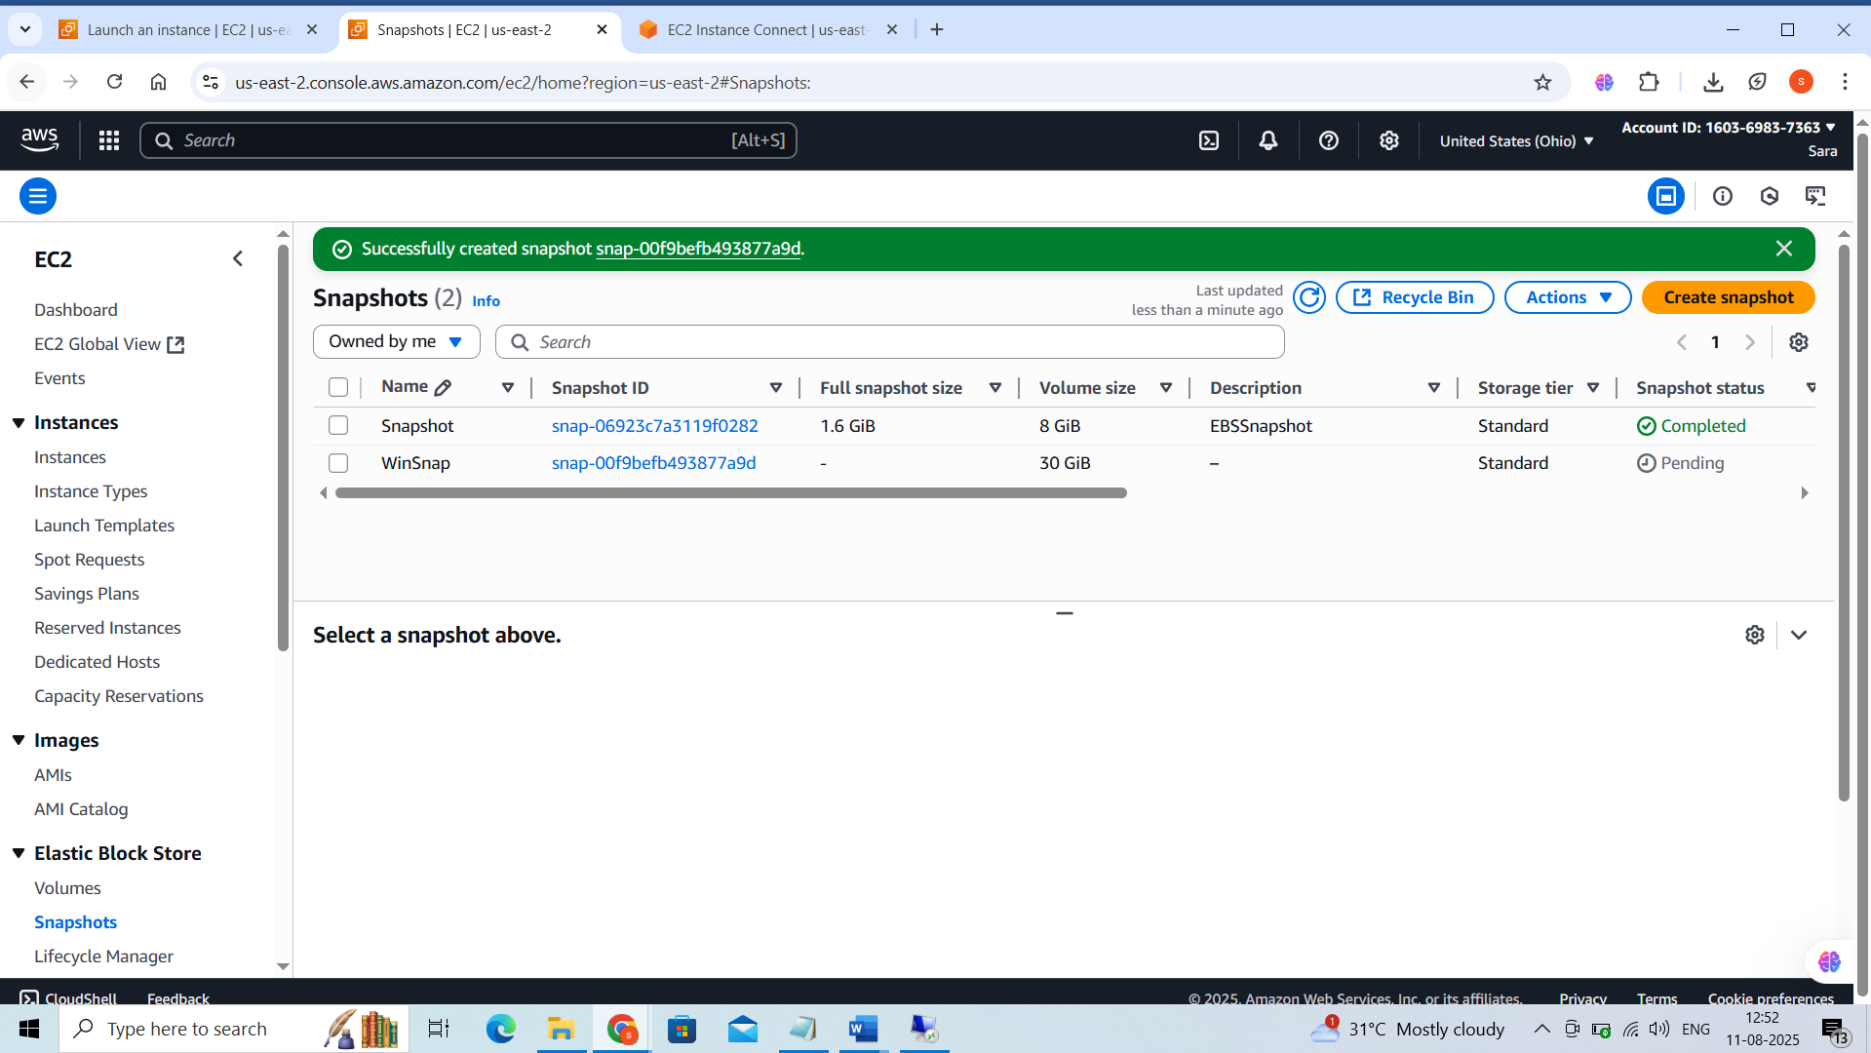

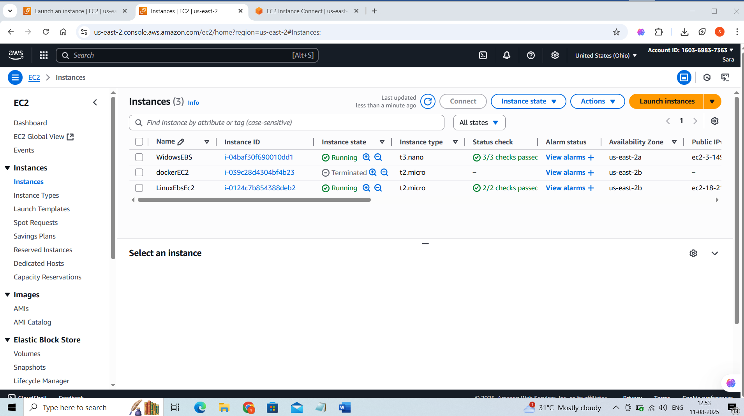

Volume and snapshot created for the Windows:

