Git Initialized:

mkdir my-git-project

cd my-git-project

git init

git add .

git commit -m "Initial commit with main.py and script.sh"

echo "print('Hello from main')" > main.py

echo "# Bash script" > script.sh

chmod +x script.sh

git remote add origin <https://github.com/your-username/my-git-project.git>

git branch -M main

git push -u origin main

git checkout -b feature-branch

echo "print('Feature code')" >> main.py

git add .

git commit -m "Added feature code"

git checkout main

git merge feature-branch

git push origin main

git checkout -b rebase-branch

echo "print('Rebase code')" >> main.py

git add .

git commit -m "Added rebase code"

git checkout main

git pull

git checkout rebase-branch

git rebase main

git checkout main

git merge rebase-branch

git push

echo "# Uncommitted change" >> script.sh

git stash

git status

git stash apply

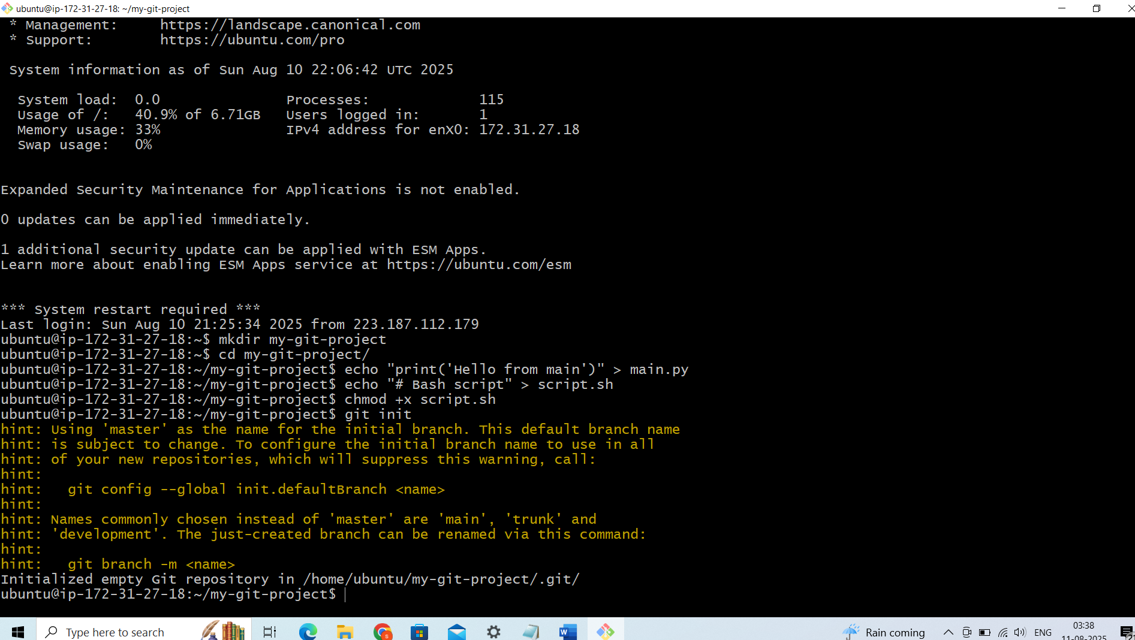

New Repository has been created: https://github.com/saras88-dev/Sara_Repo.git

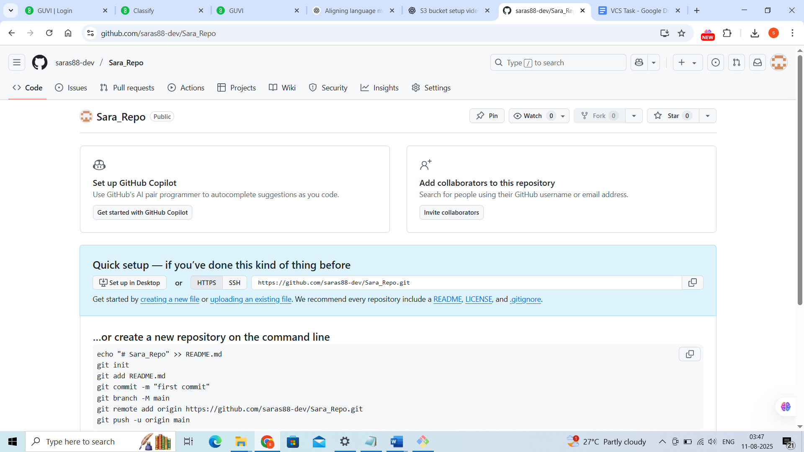

git remote add origin <https://github.com/saras88-dev/Sara_Repo.git>

