**TasK:**

Set up a VPC with an Internet gateway, create a public subnet with 256 IP addresses, a private subnet with 256 IP addresses, make a route table connecting the Internet gateway and the subnets, and launch a Linux EC2 instance by using the above VPC and public subnet.

VPC (MyVPC) Creation with 10.0.0.0/16 IP address:

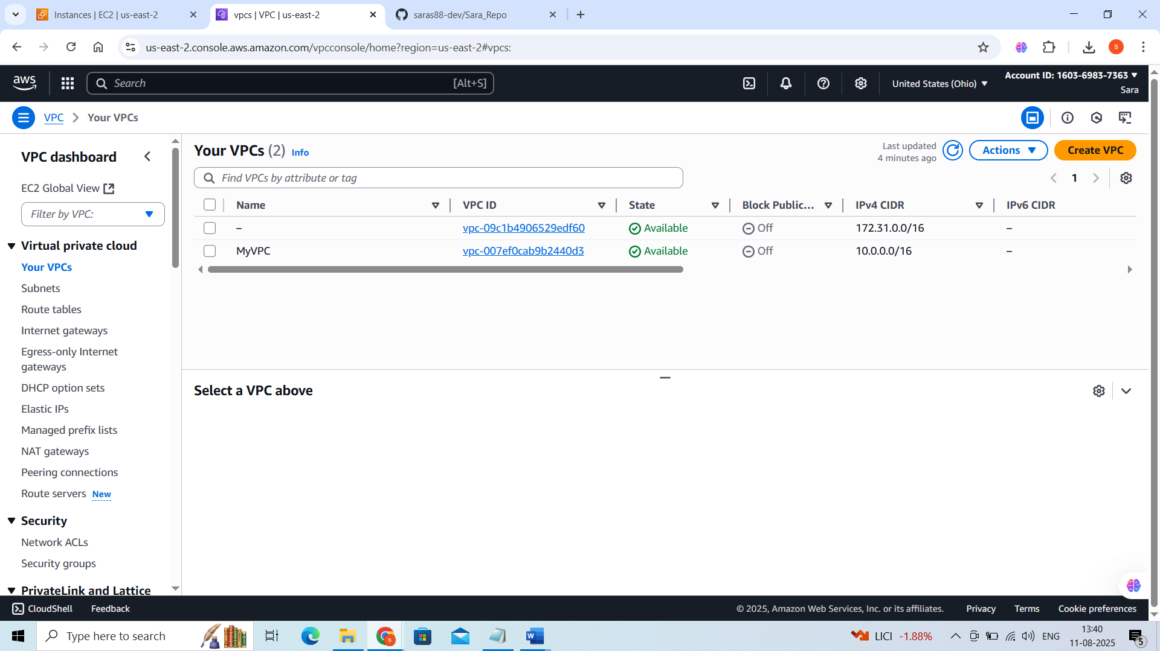

**2 subnets with 256 IP’s (Private and public)**

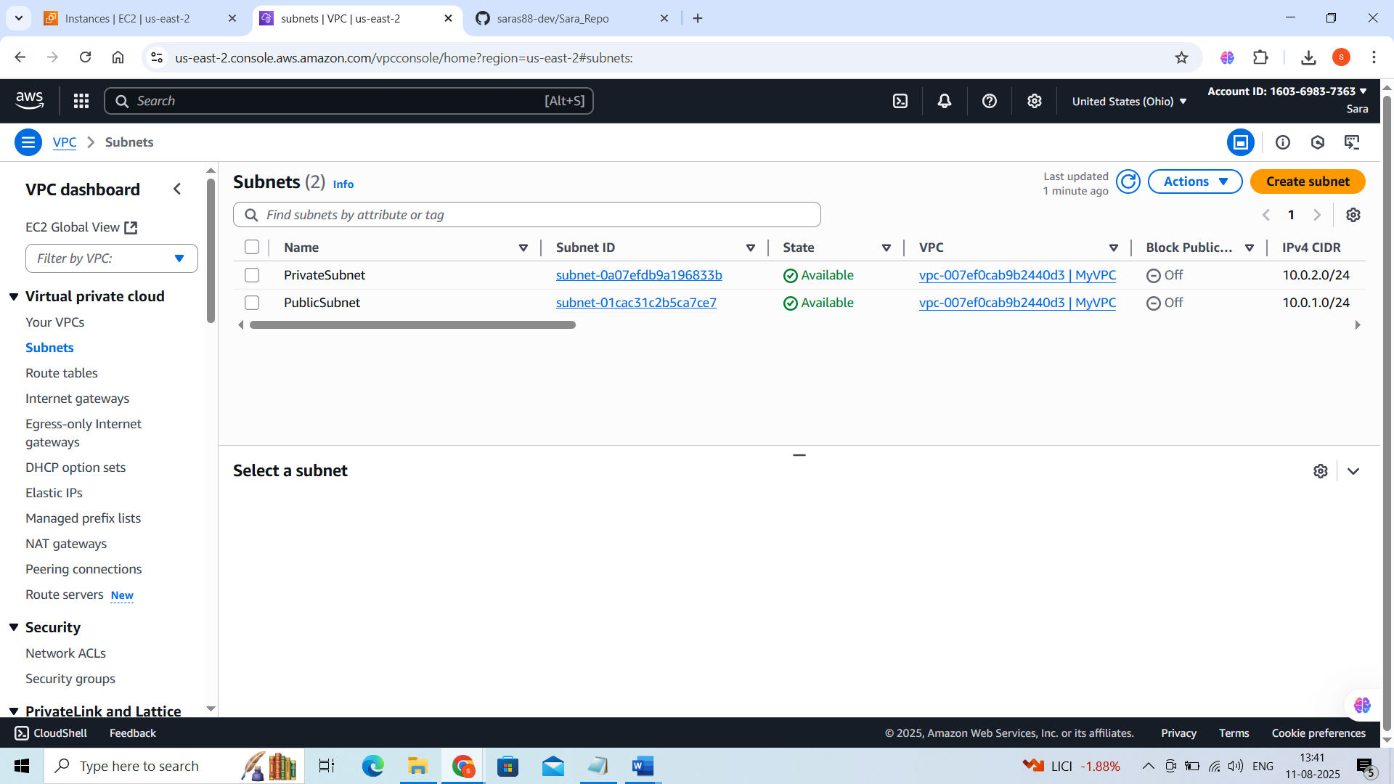

**Internet Gateway:**

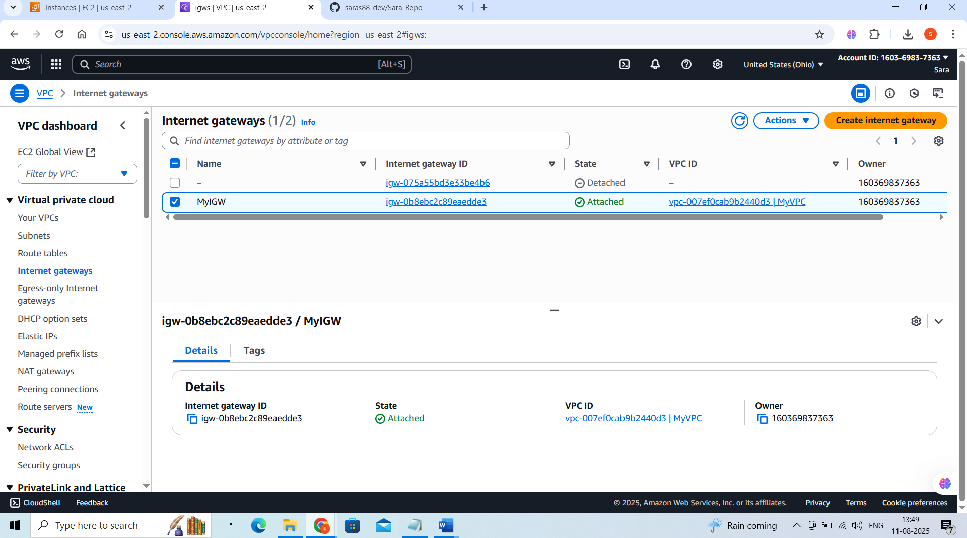

**Launch EC2 in Public Subnet:**

