**Task Description:**

1. Create a S3 bucket, with no public access and upload files to the bucket & view the logs using cloudwatch for the uploaded files.

Step 1:S3 Bucket Creation:

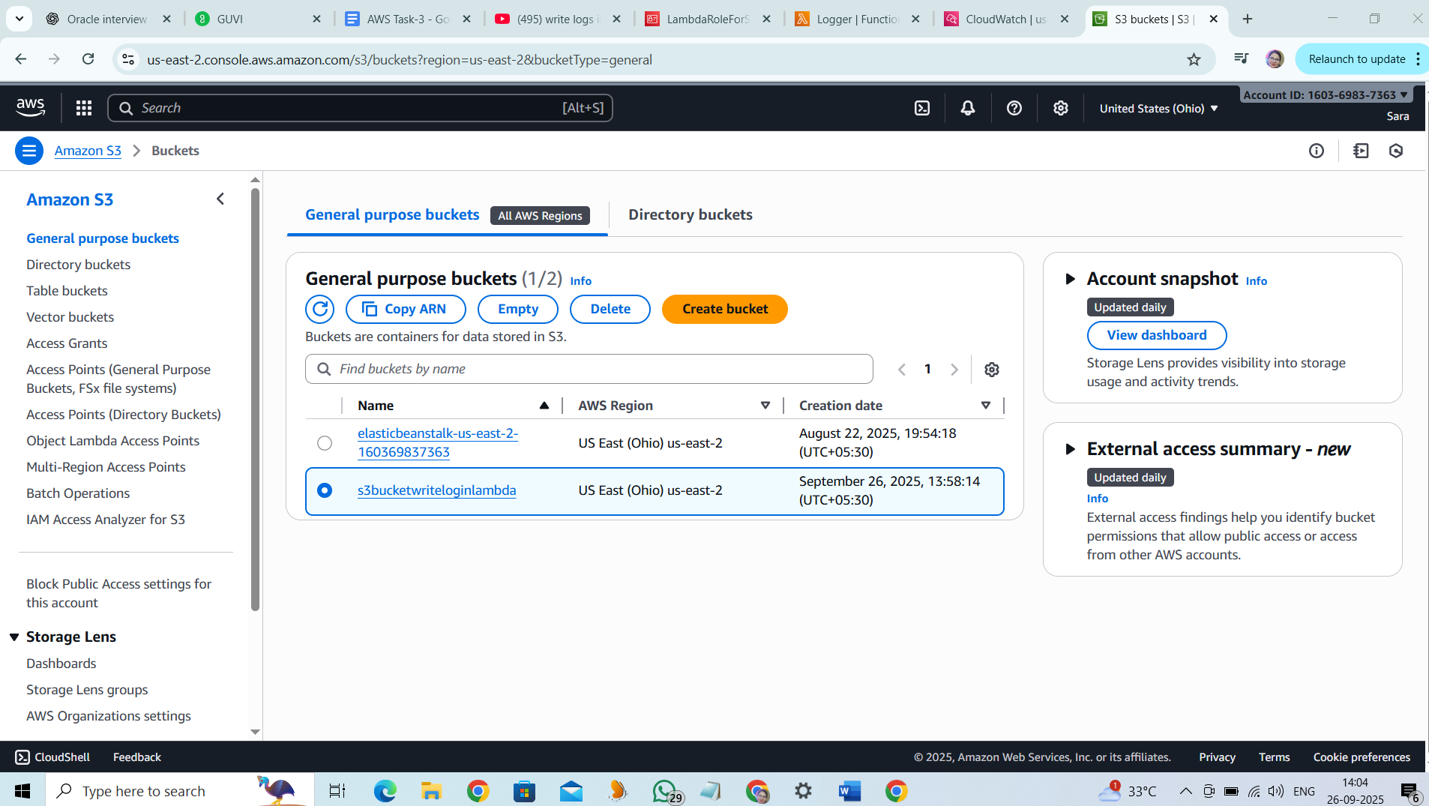

Step 2: Public access blocked:

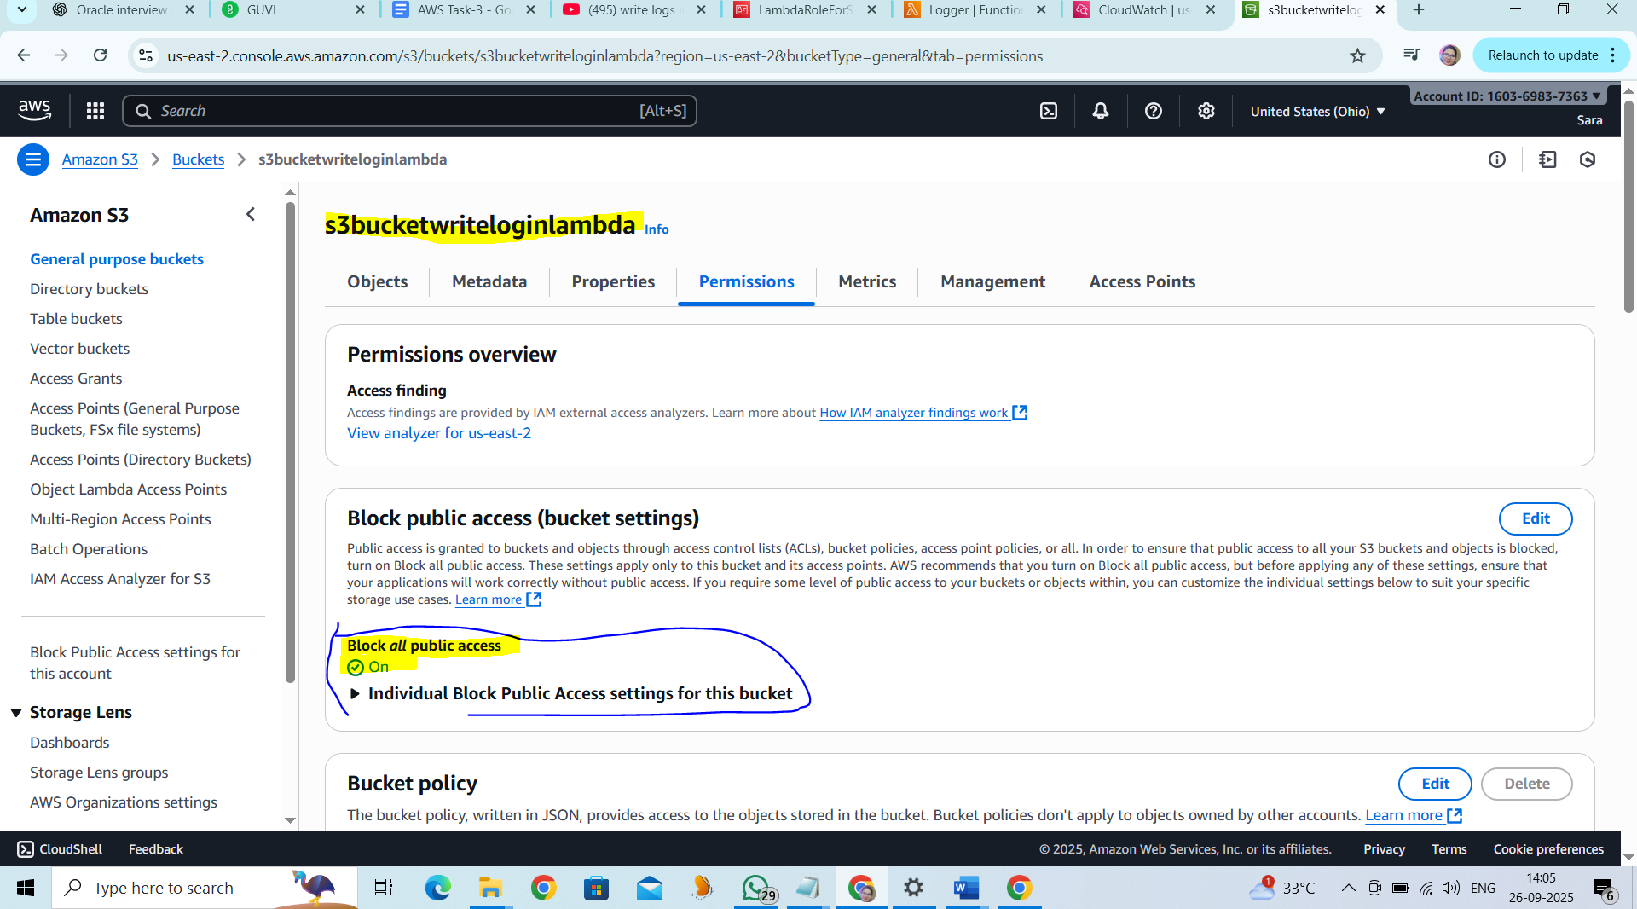

Step 3: Upload the files into the S3 Bucket:

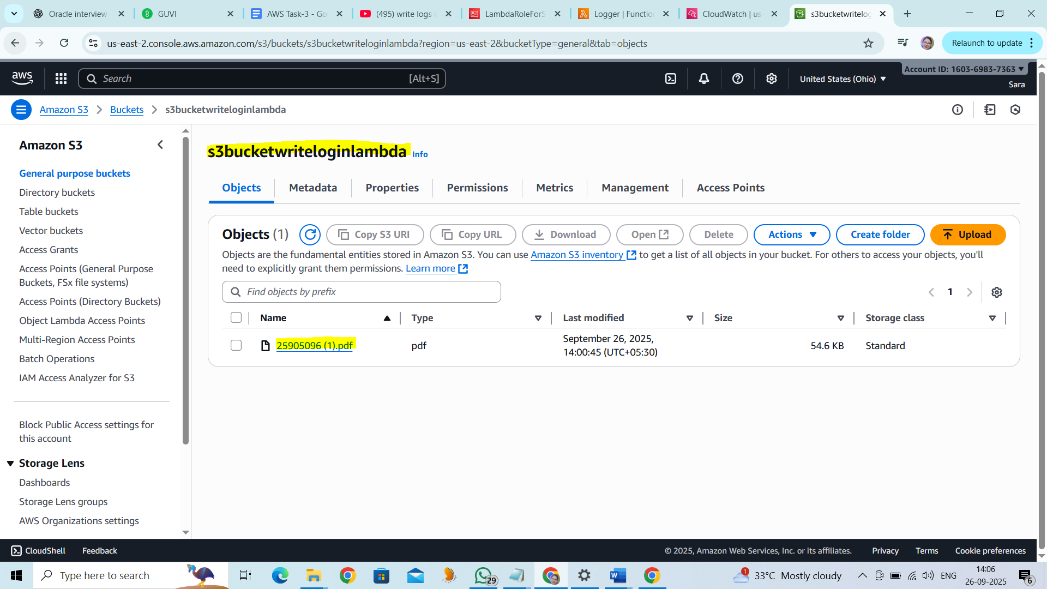

Step 4:Write logs into CloudWatch:

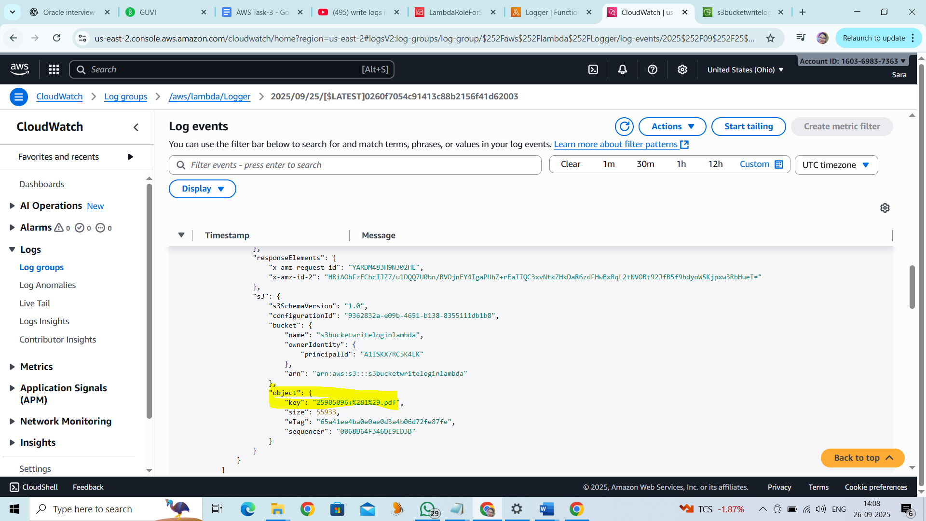

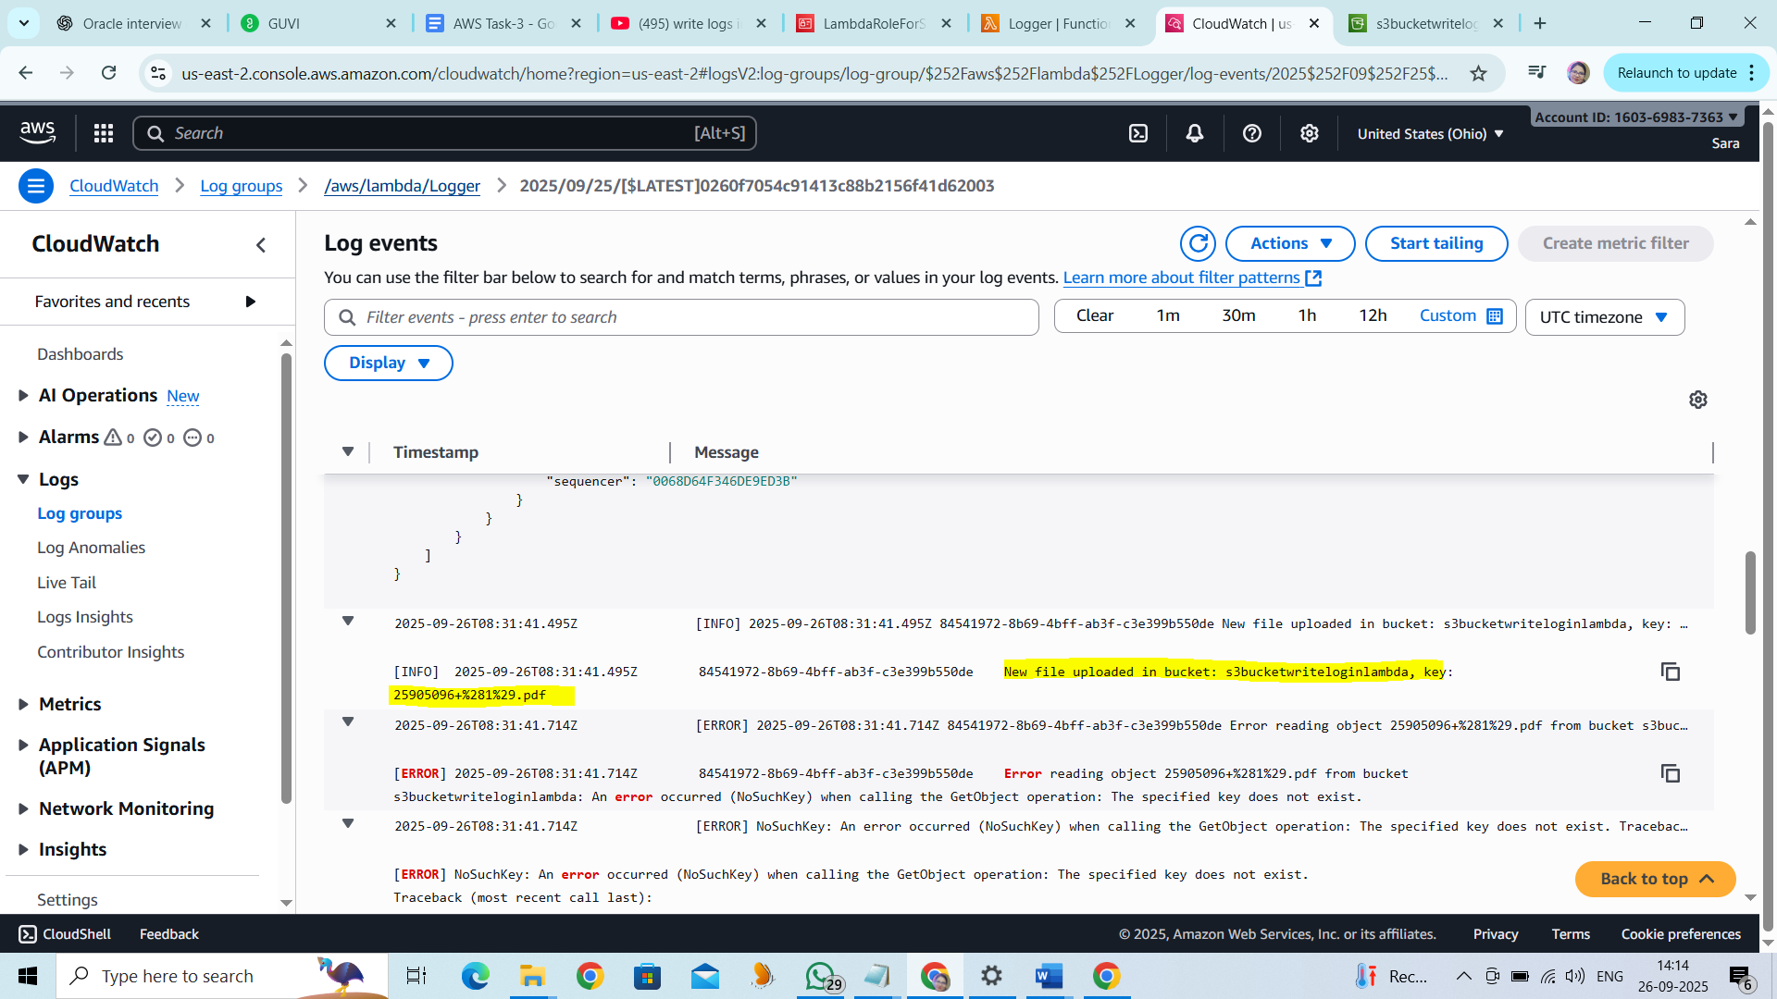

**Task 2:**

Launch two ec2-instances and connect it to a application load balancer, where the output traffic from the server must be an load balancer IP address

Step 1: Target group has been created with the name “lbtg”

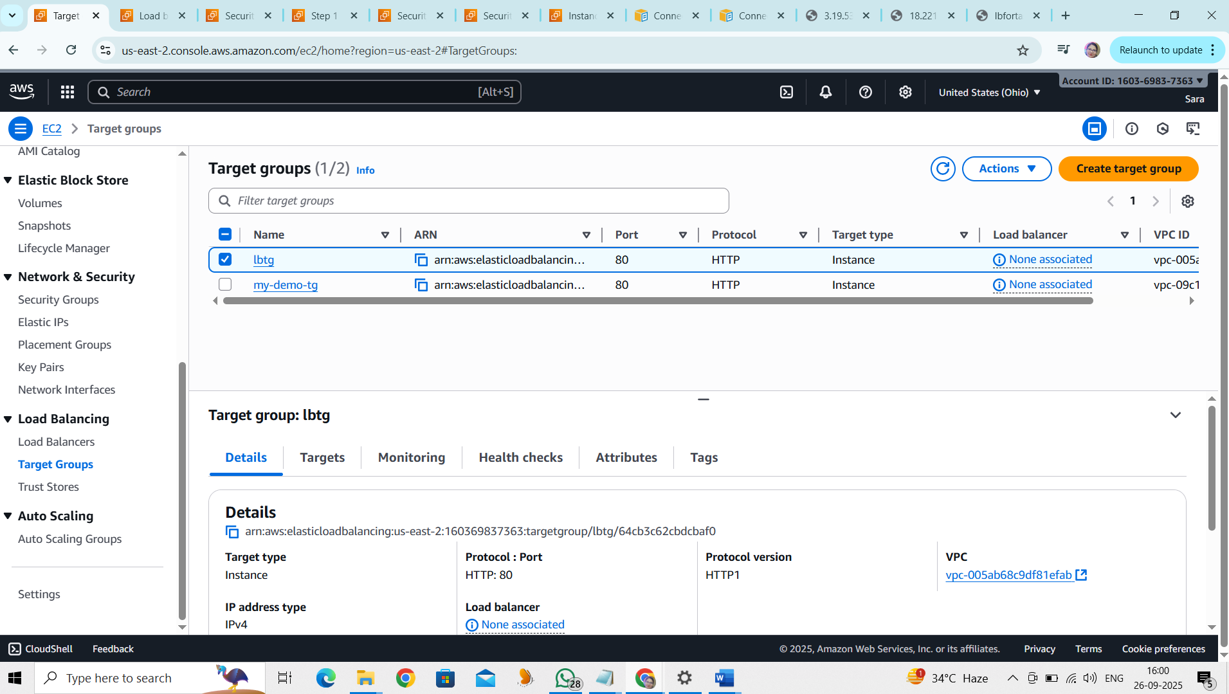

Step 2 :Load Balancer “lbfortask” has been created for the target group “lbtg”

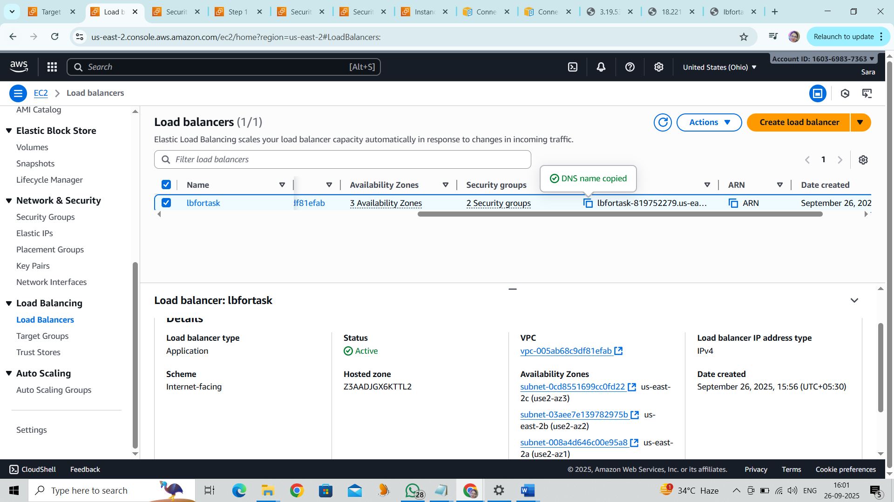

Step 3 :Security Group “sglb” has been created for the Load balancer “lbfortask”

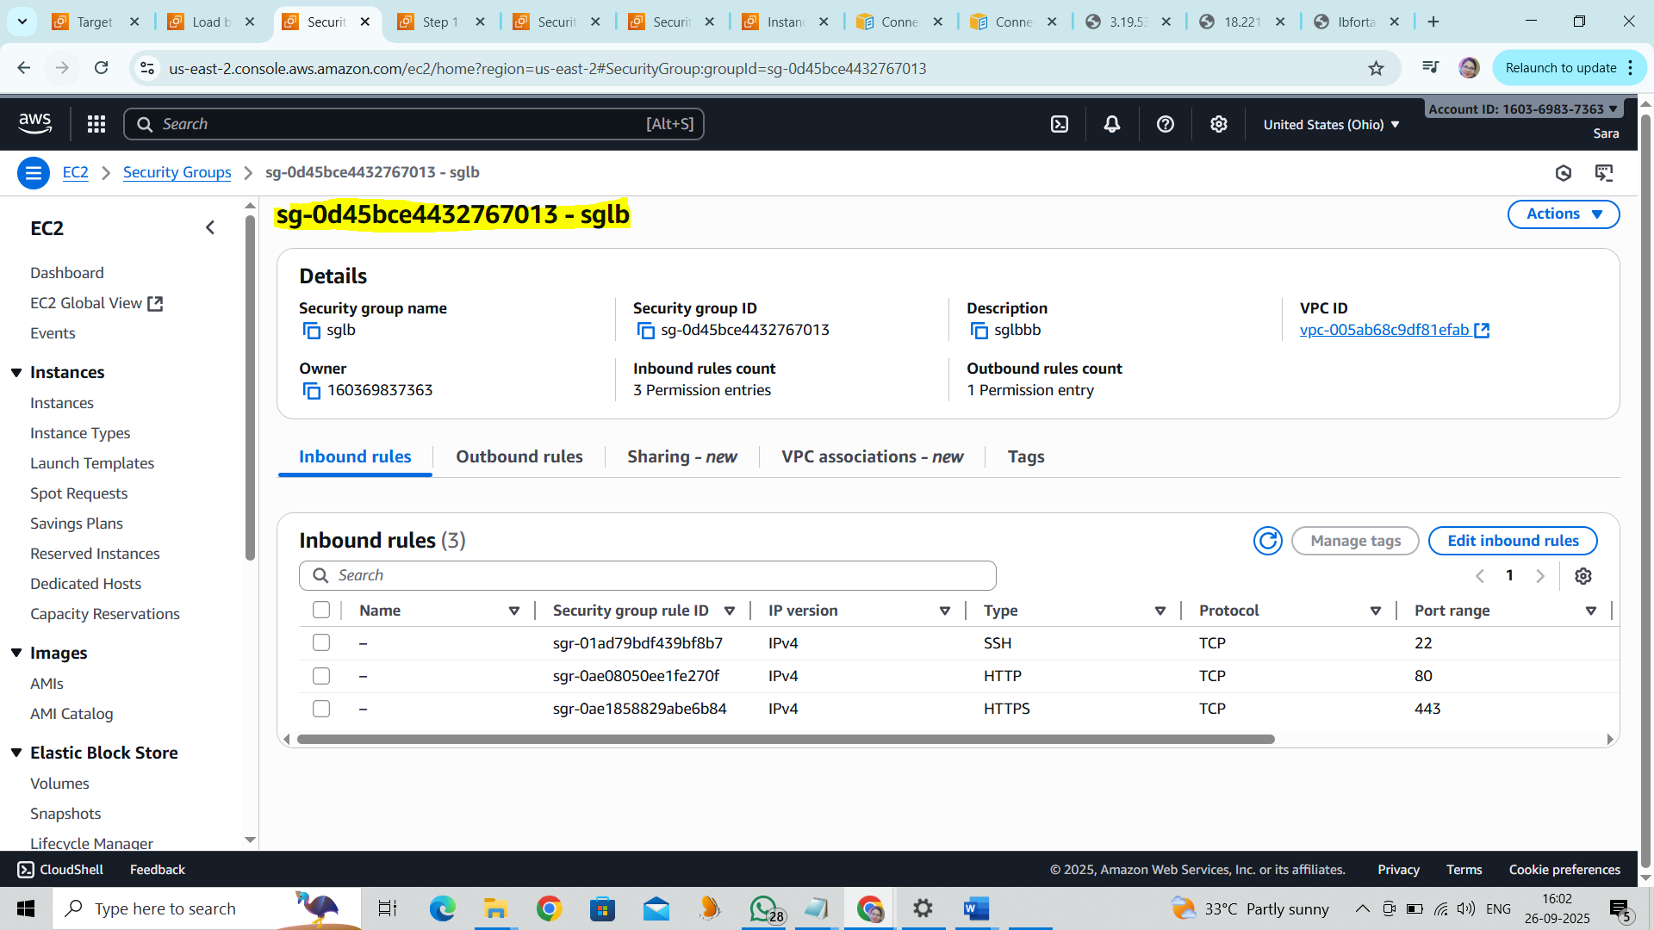

Step 4:Two EC2 instances have been Created to launch Apache :

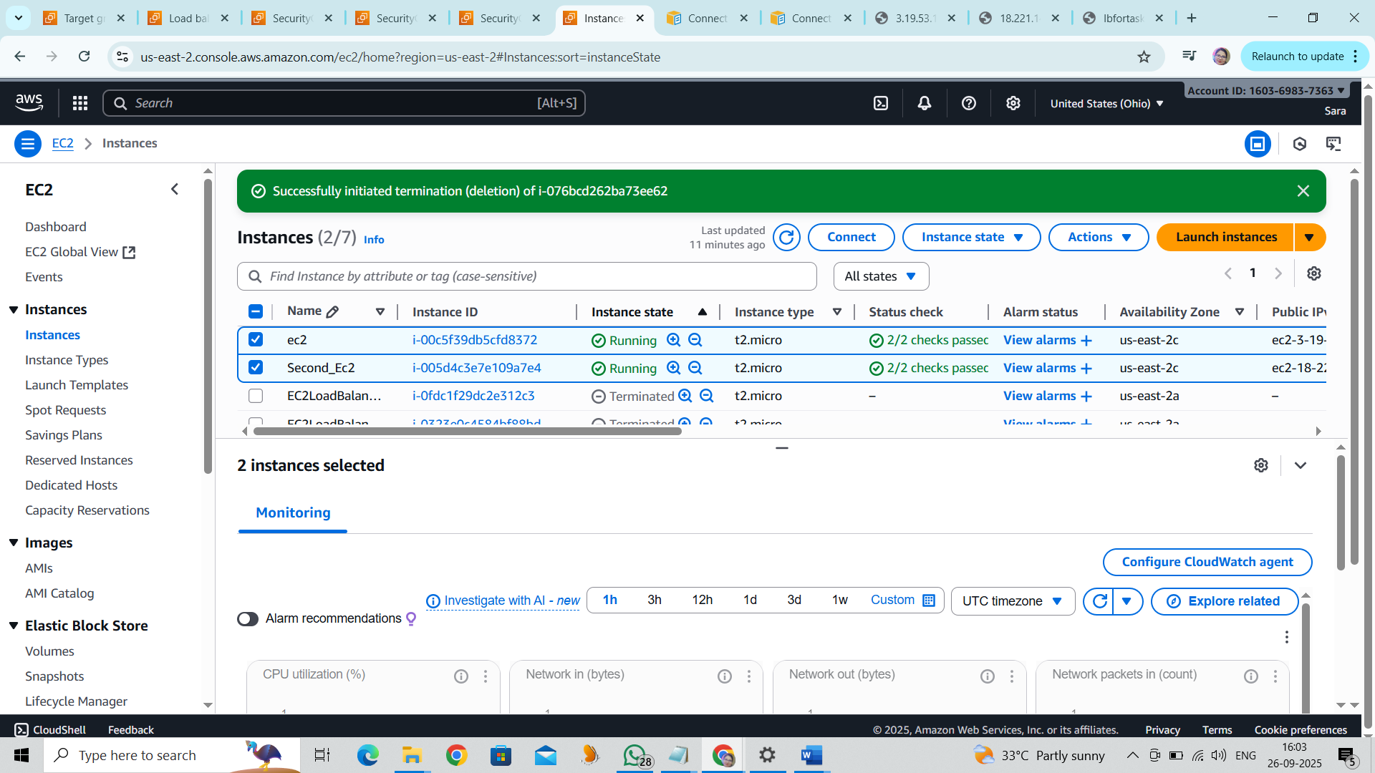

Step 5: Able to launch the first Apache through the EC2 instance Public IP address.

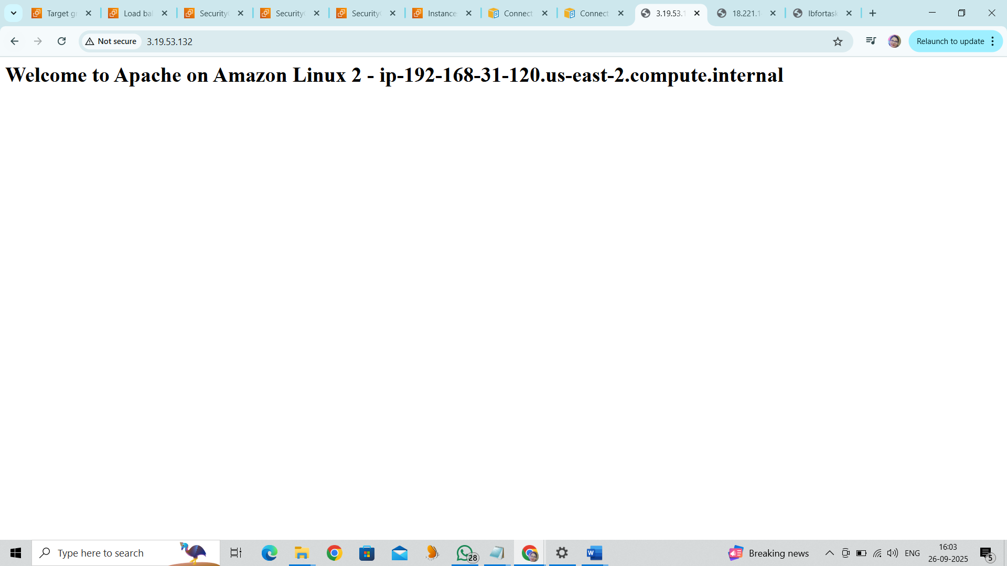

Step 6: Able to launch the second Apache through the EC2 instance Public IP address.

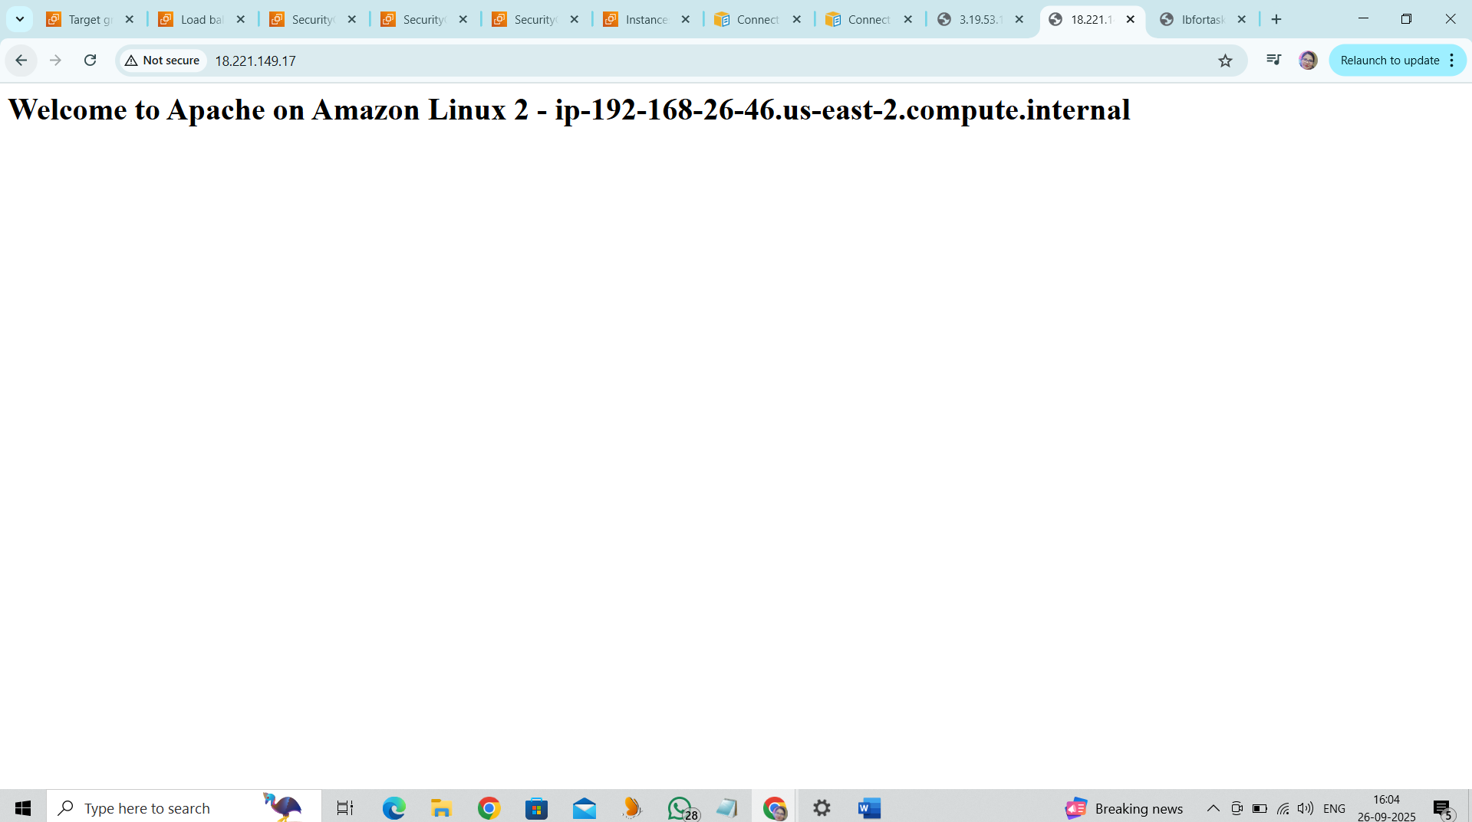

Step 7: LoadBalancer DNS used to validate the balancing the functionality.

**Load balancer DNS:** <http://lbfortask-819752279.us-east-2.elb.amazonaws.com/>

Able to switch between the instances using the load balancer

