Application:
Clone the below mentioned repository and deploy the application (Run application in port 3000).
Repo URL : https://github.com/Vennilavan12/Brain-Tasks-App.gitCommand

Command :
1 mkdir project
2 chmod 777 project/
3 cd project/
4 sudo apt install git-all
5 apt-get install git
6 sudo apt-get install git
7 sudo add-apt-repository ppa:git-core/ppa
8 sudo apt update;sudo apt install git
9 git clone https://github.com/Vennilavan12/Brain-Tasks-App.git
10 ls -lrth
11 cd Brain-Tasks-App/
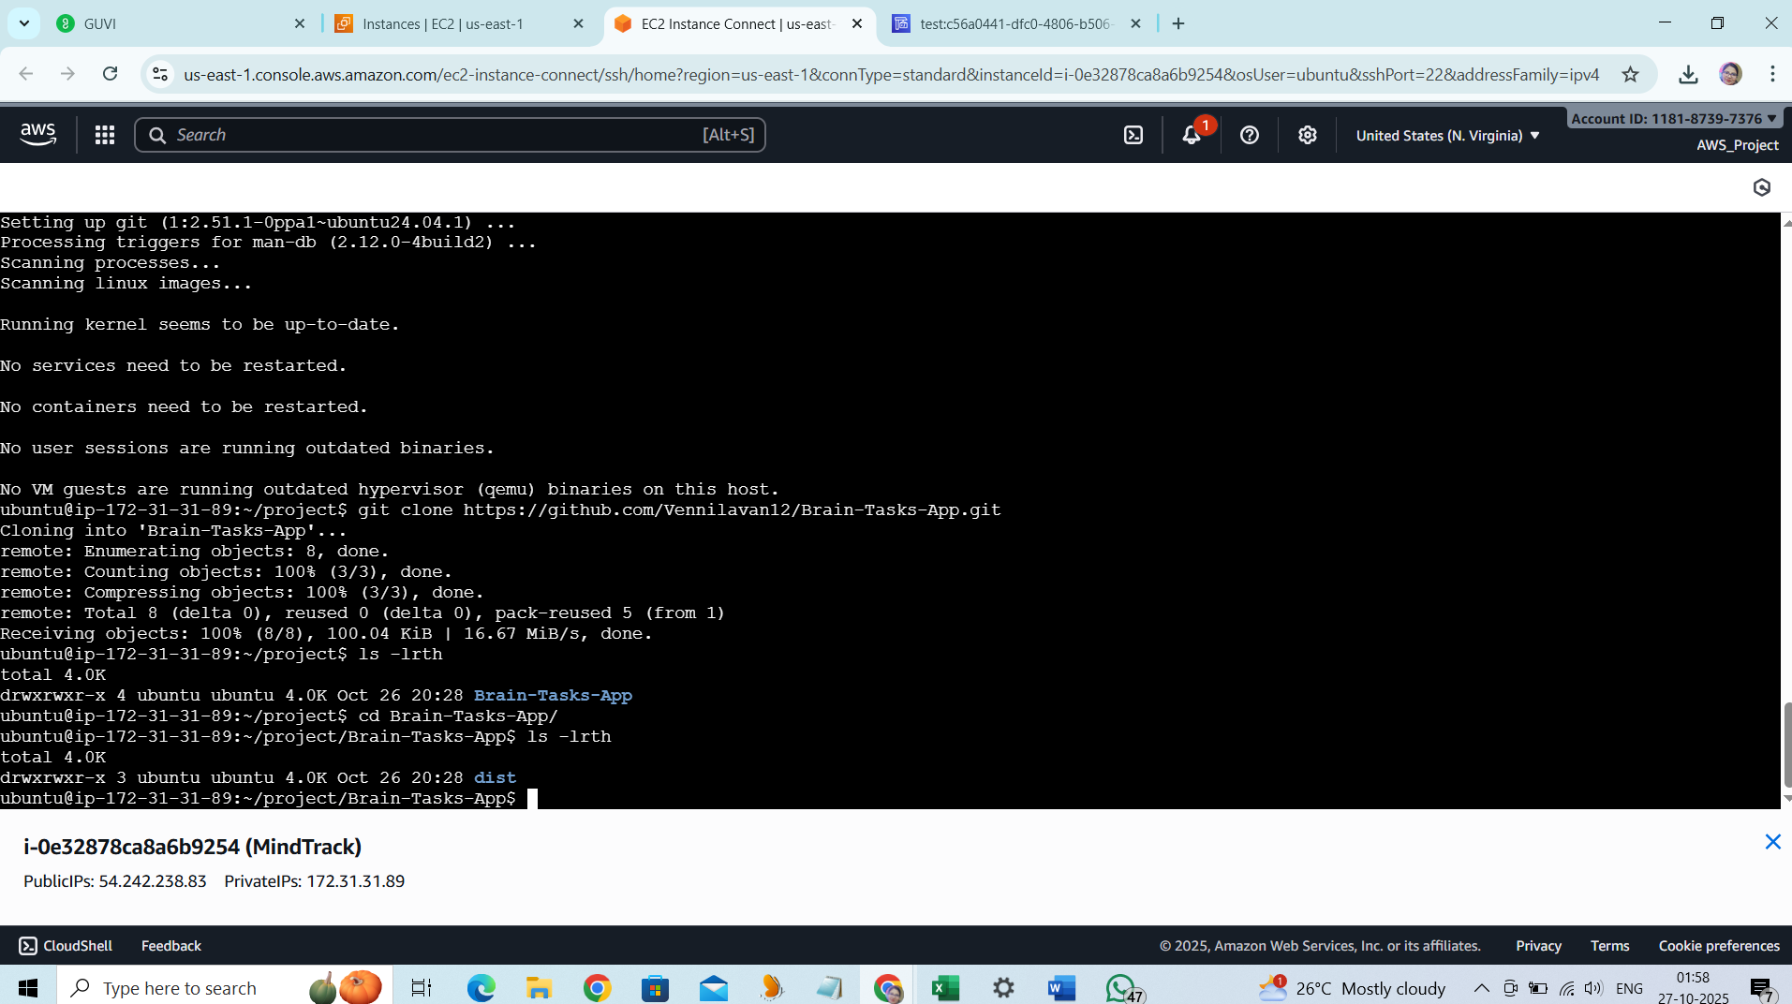

Docker:
- Dockerize the application by creating Dockerfile
- Build an application and check output using docker image.
Action:

- Create the docker image using the dockerfilr for the given application
- Use the ngnix as the base image.

Docker file:

# Use the official Nginx image as the base
FROM nginx:alpine

# Remove the default Nginx static files
RUN rm -rf /usr/share/nginx/html/*

# Copy your built app into the Nginx html folder
COPY . /usr/share/nginx/html

# Expose port 80
EXPOSE 3000

# Start Nginx in the foreground
CMD ["nginx", "-g", "daemon off;"]

Command:

17 vi Dockerfile
18 chmod 777 *
19 docker build -t brain-app .
20 sudo apt-get update
21 sudo apt-get install ca-certificates curl
22 sudo install -m 0755 -d /etc/apt/keyrings
23 sudo curl -fsSL https://download.docker.com/linux/ubuntu/gpg -o /etc/apt/keyrings/docker.asc
24 sudo chmod a+r /etc/apt/keyrings/docker.asc
25 echo "deb [arch=$(dpkg --print-architecture) signed-by=/etc/apt/keyrings/docker.asc] https://download.docker.com/linux/ubuntu \
$(. /etc/os-release && echo "${UBUNTU_CODENAME:-$VERSION_CODENAME}") stable" | sudo tee /etc/apt/sources.list.d/docker.list > /dev/null
26 sudo apt-get update
27 sudo apt-get install docker-ce docker-ce-cli containerd.io docker-buildx-plugin docker-compose-plugin
28 sudo systemctl status docker
29 sudo systemctl start docker
30 sudo docker build -t brain-app:latest .
31 sudo docker images
32 docker run -d -p 3000:80 --name brain-tasks-container brain-app:latest
33 sudo docker run -d -p 3000:80 --name brain-tasks-container brain-app:latest
34 sudo docker ps
35 history

-Created the docker images.

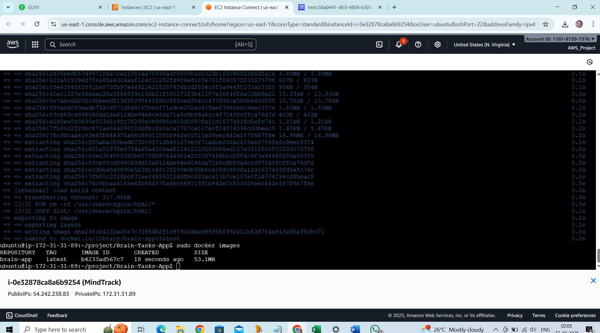

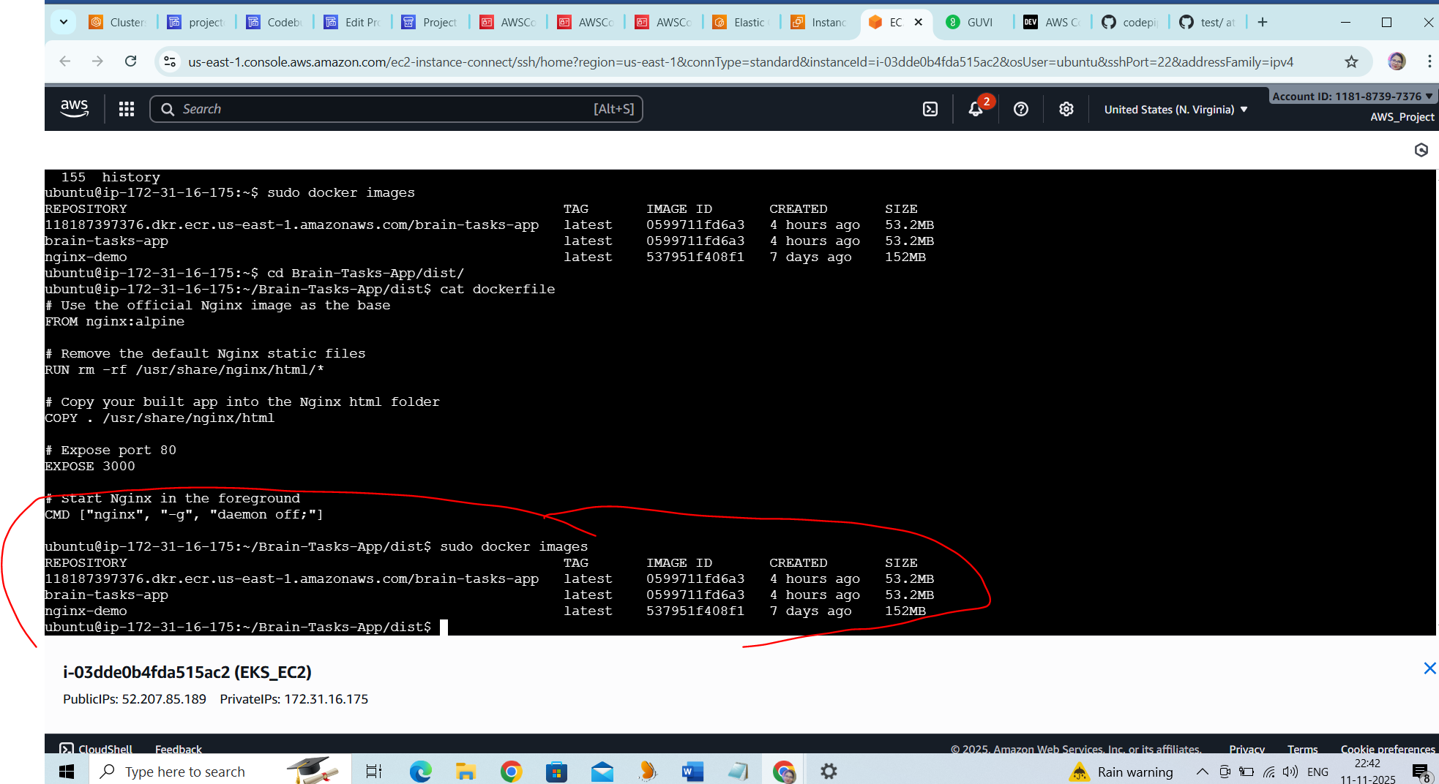

Created the Docker containers and launched the Brain Tasks application as shown in the below snapshot:

Docker Containers :
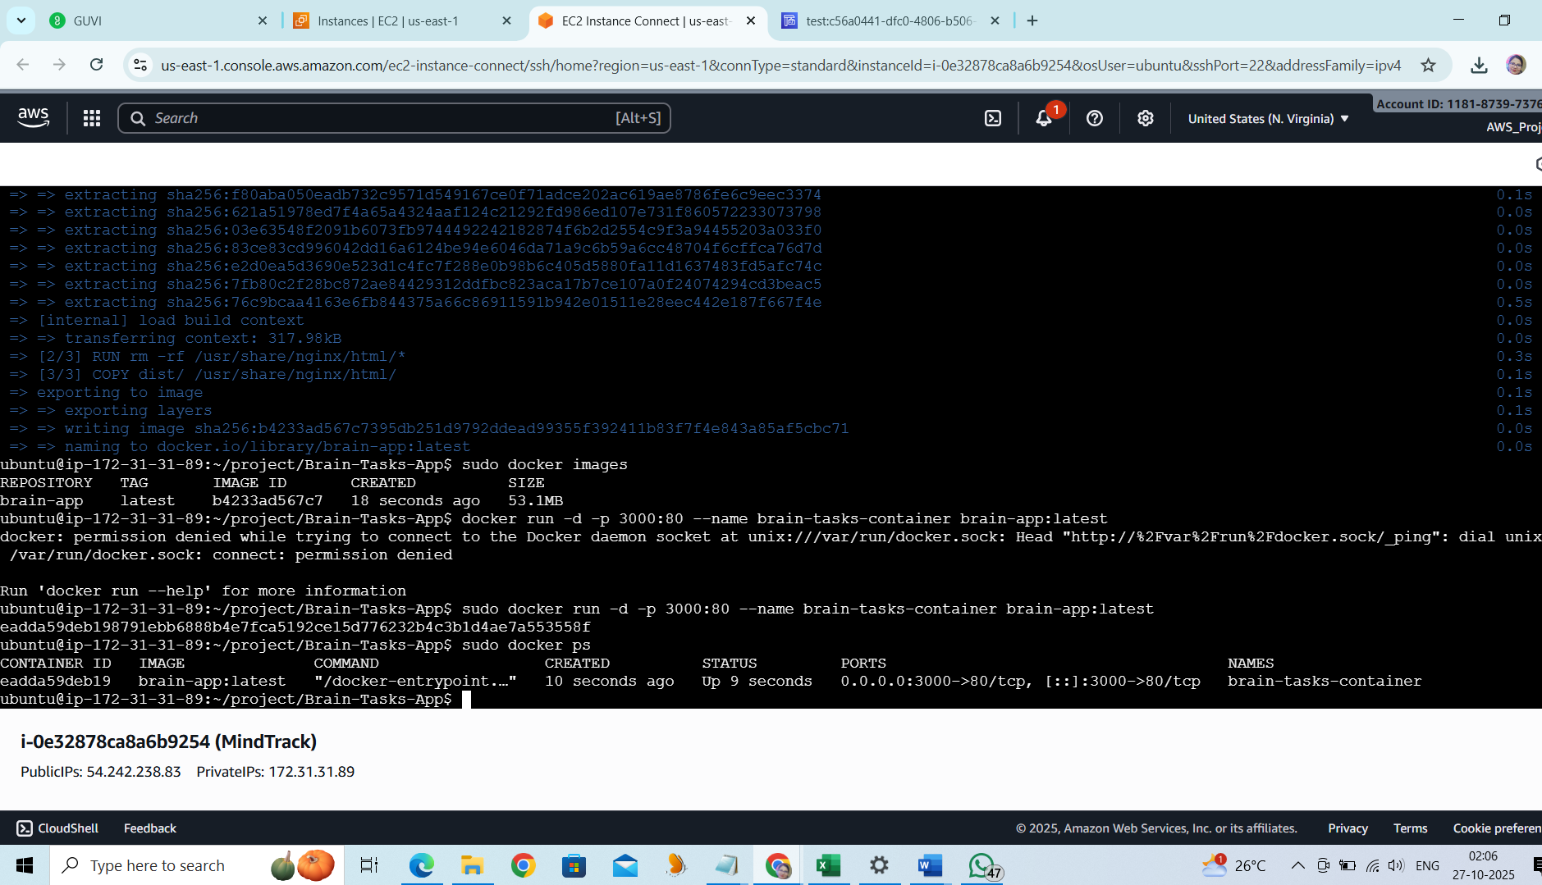

Frontend Application:
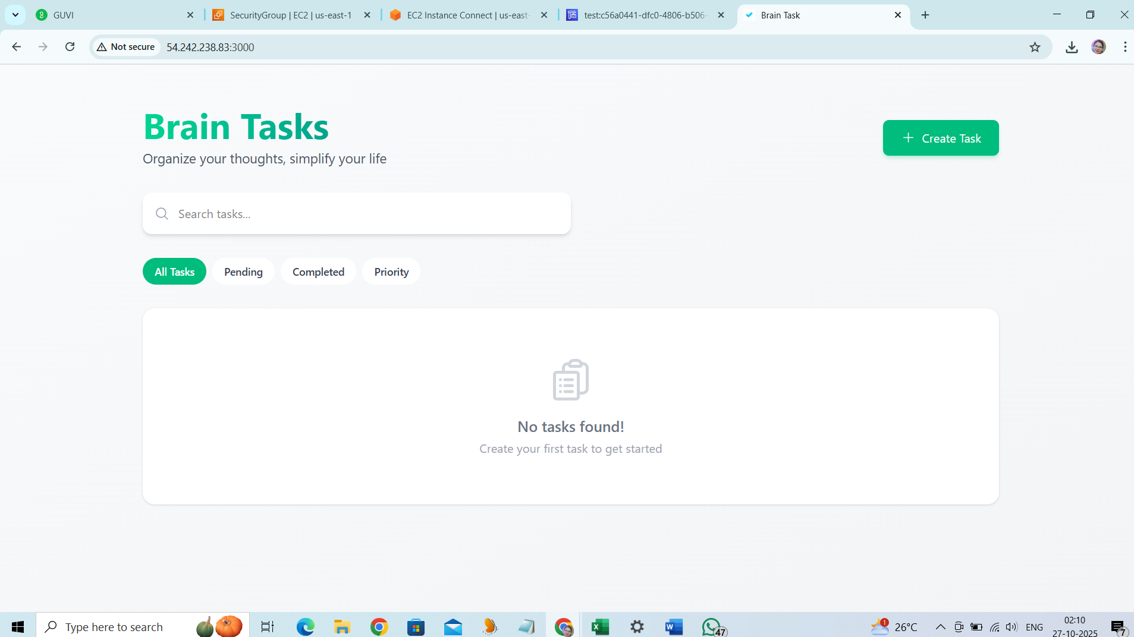
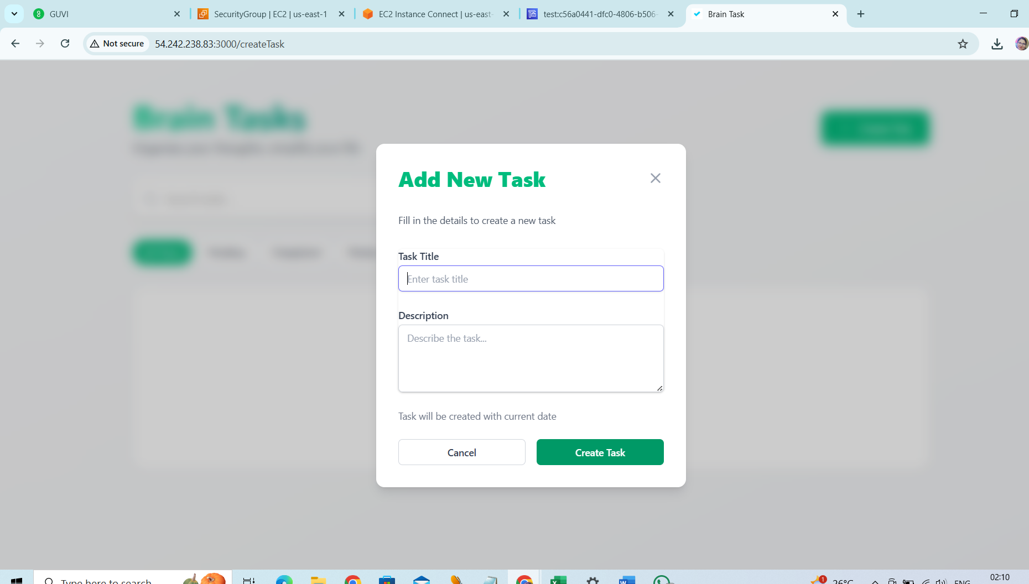

ECR:
- Create an AWS ECR repository for store docker images.

- ECR creation on the AWS private repository.
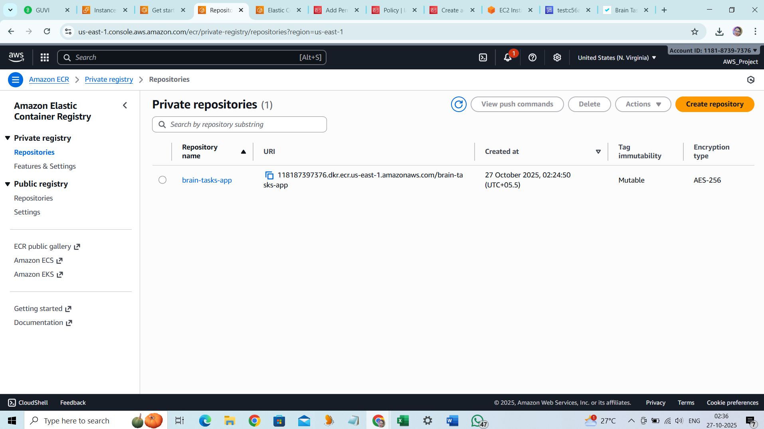

Pushing the images to the ECR Repo:

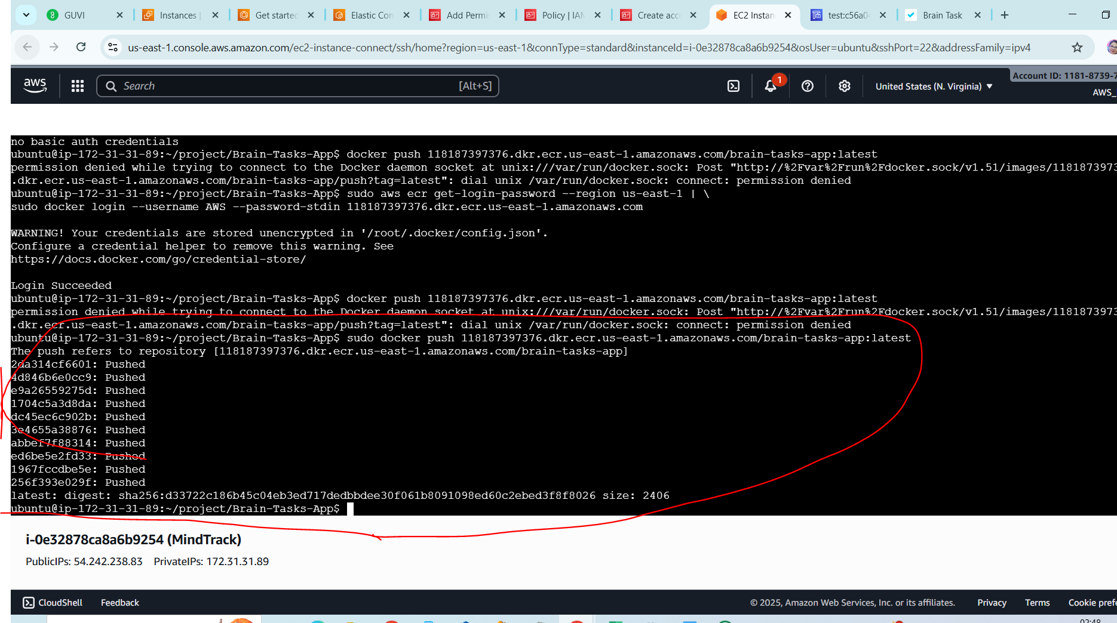

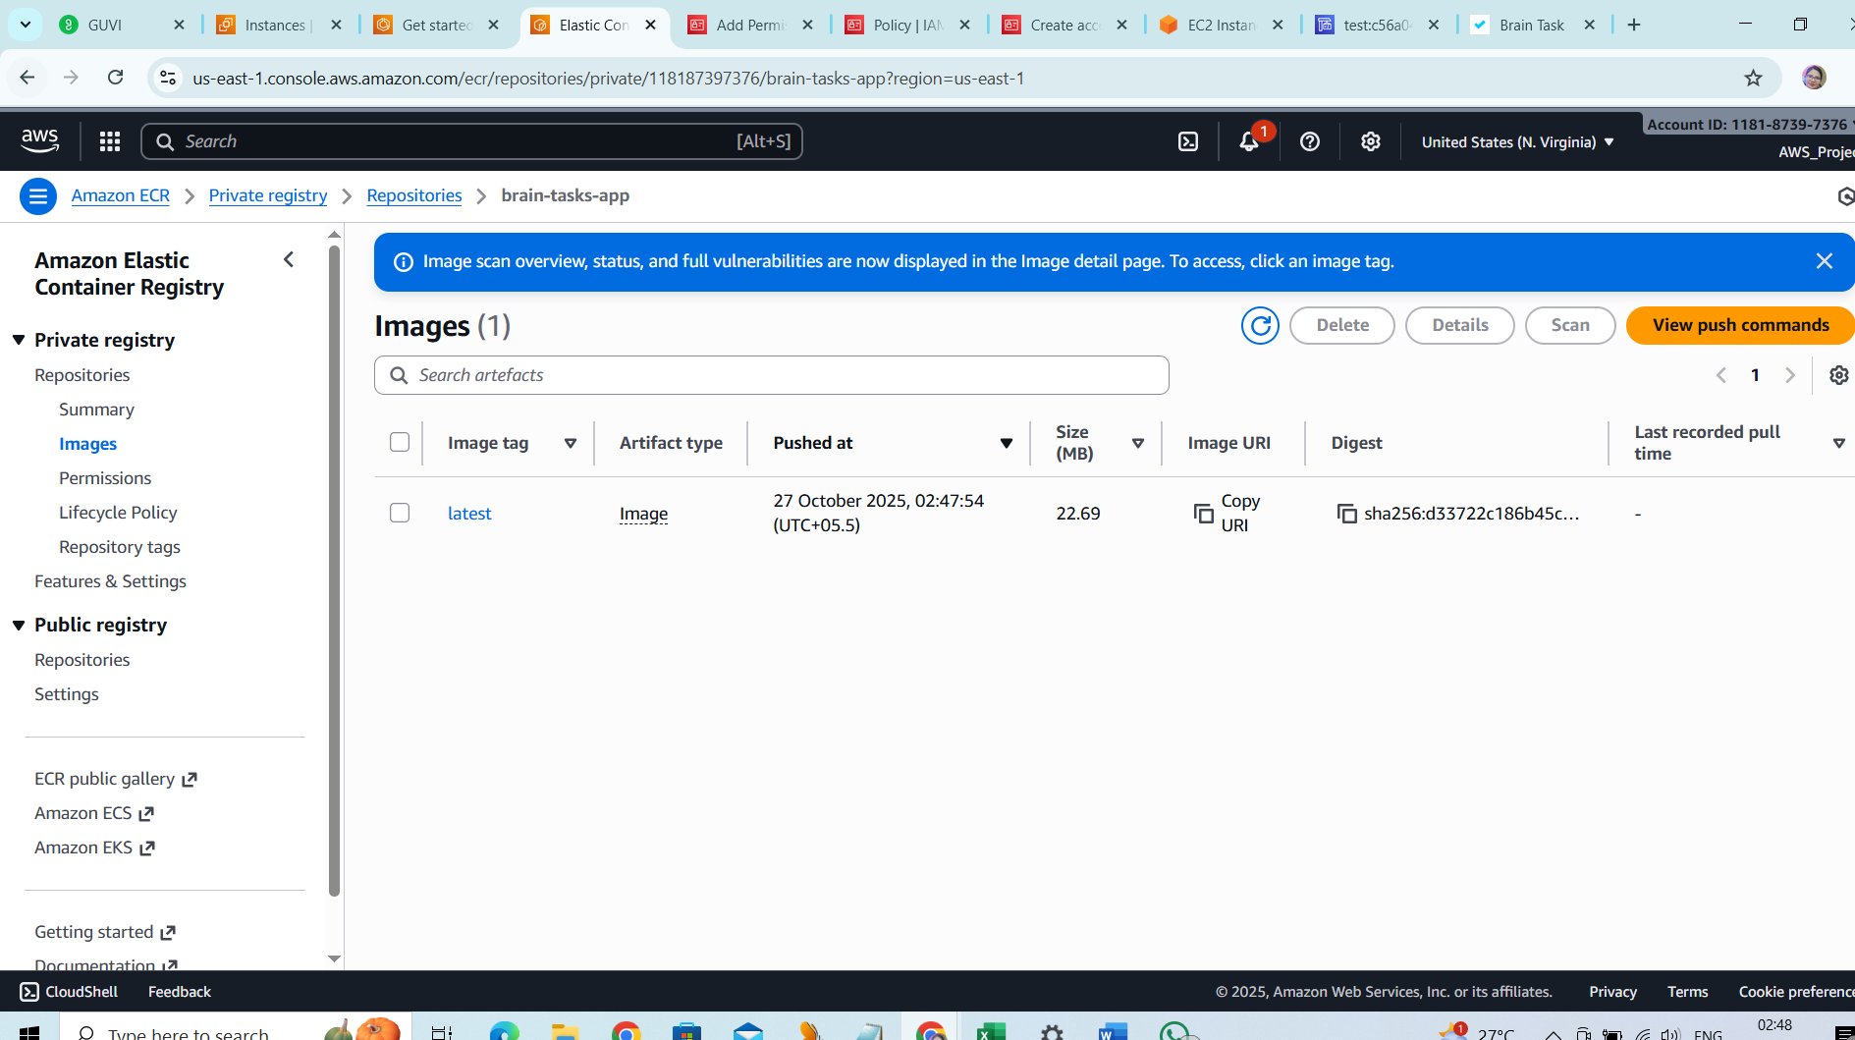

Kubernetes:
- Setup Kubernetes in AWS EKS and Confirm EKS cluster is running.
- Write deployment and service YAML files.
- Deploy using kubectl via Codedeploy.
- Kubectl installation on the EC2machine.
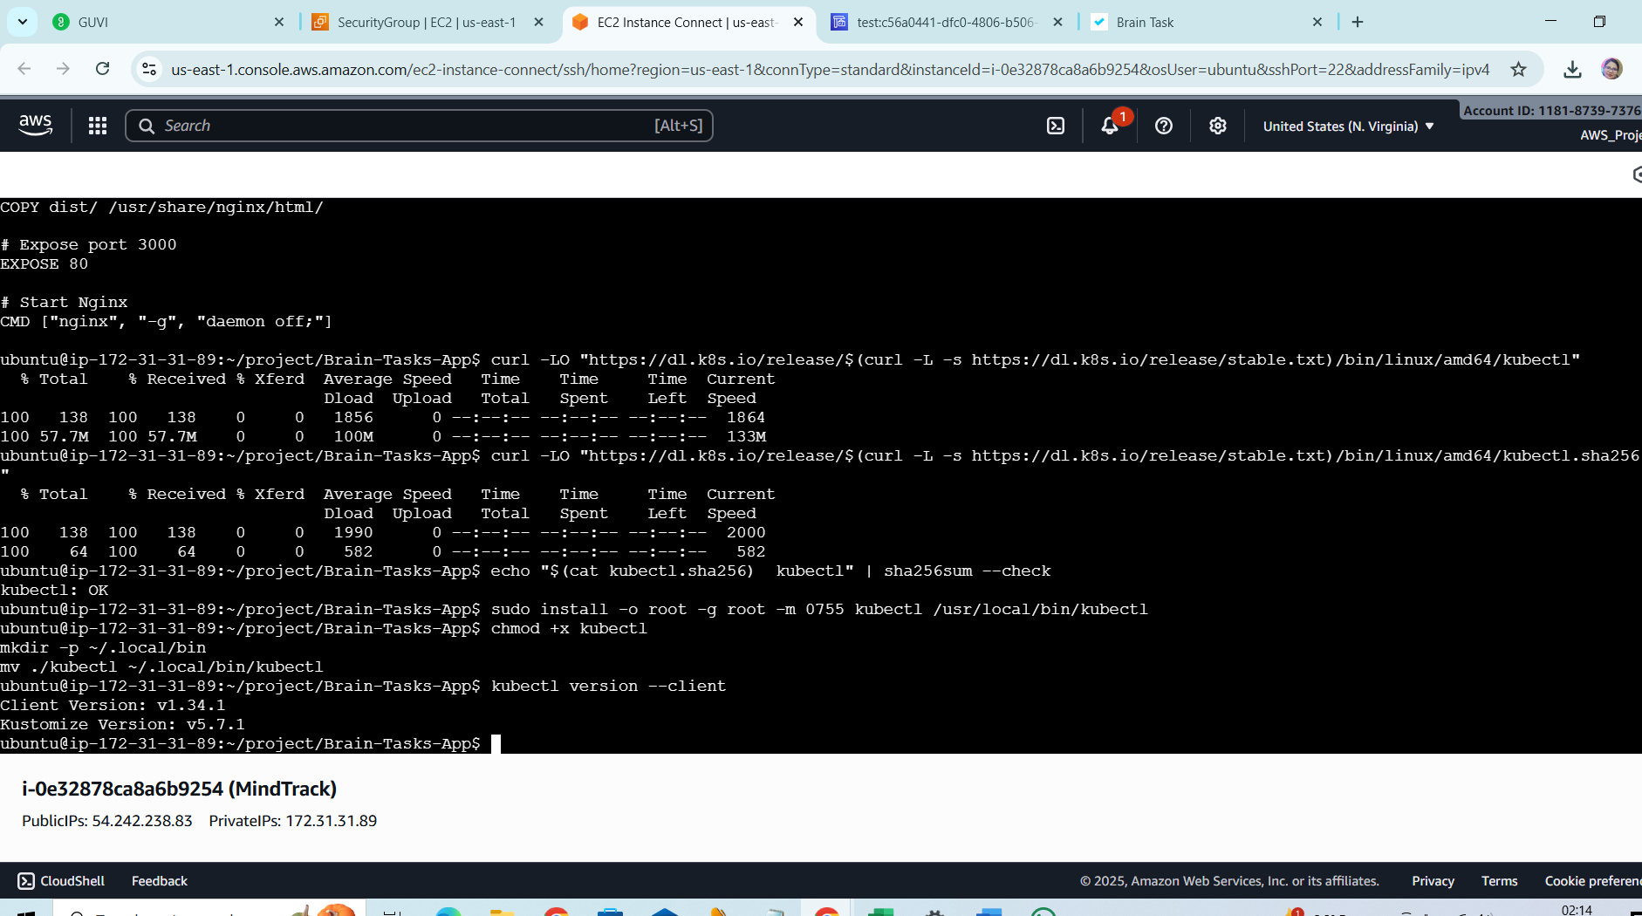
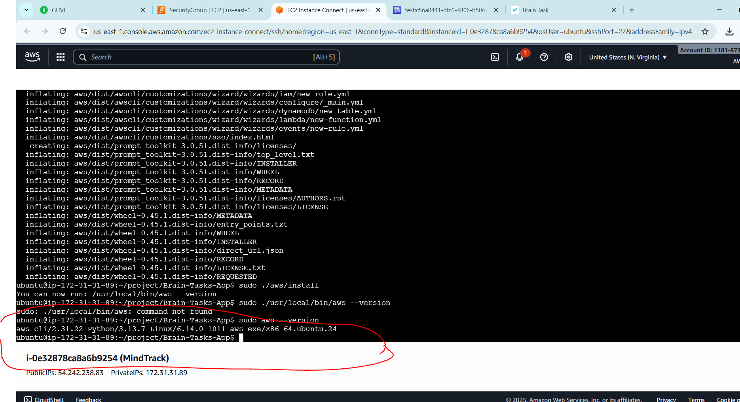

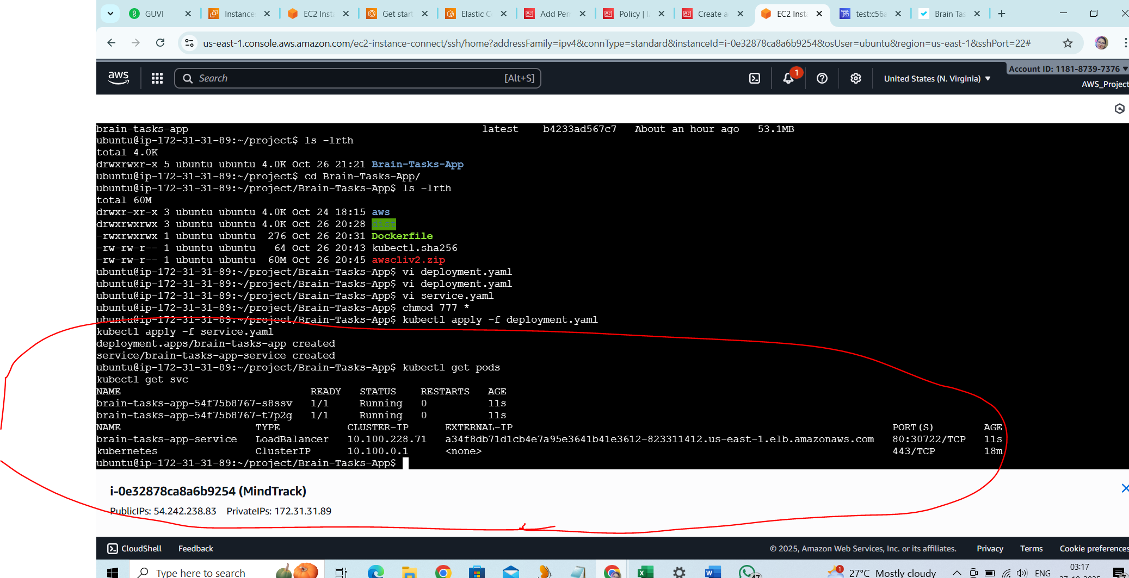
EKS (Elastic Kubernetes Service) :
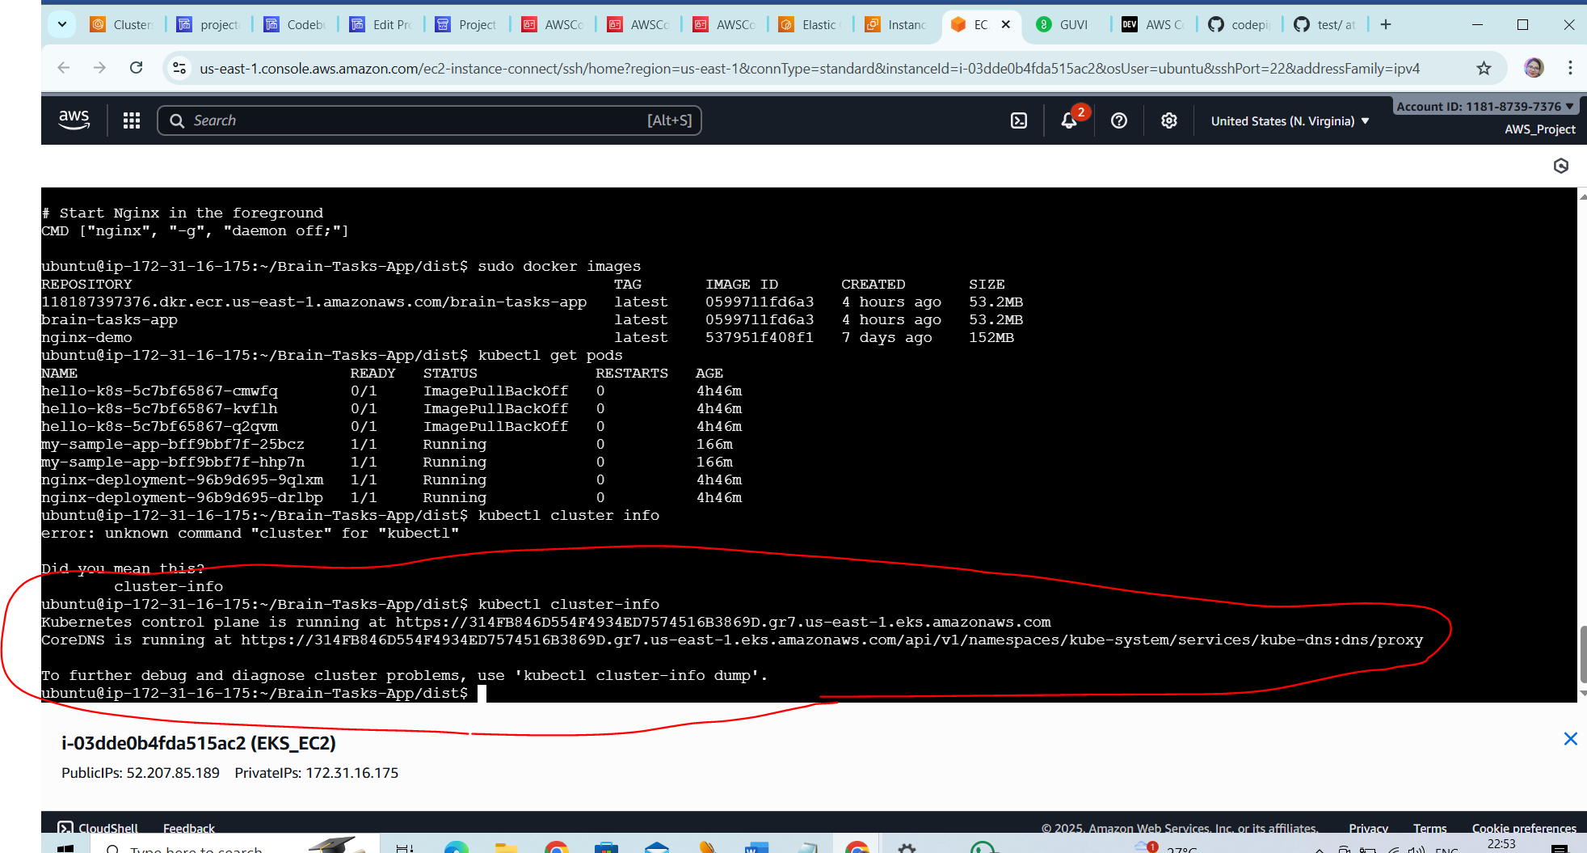

Docker image Latest:

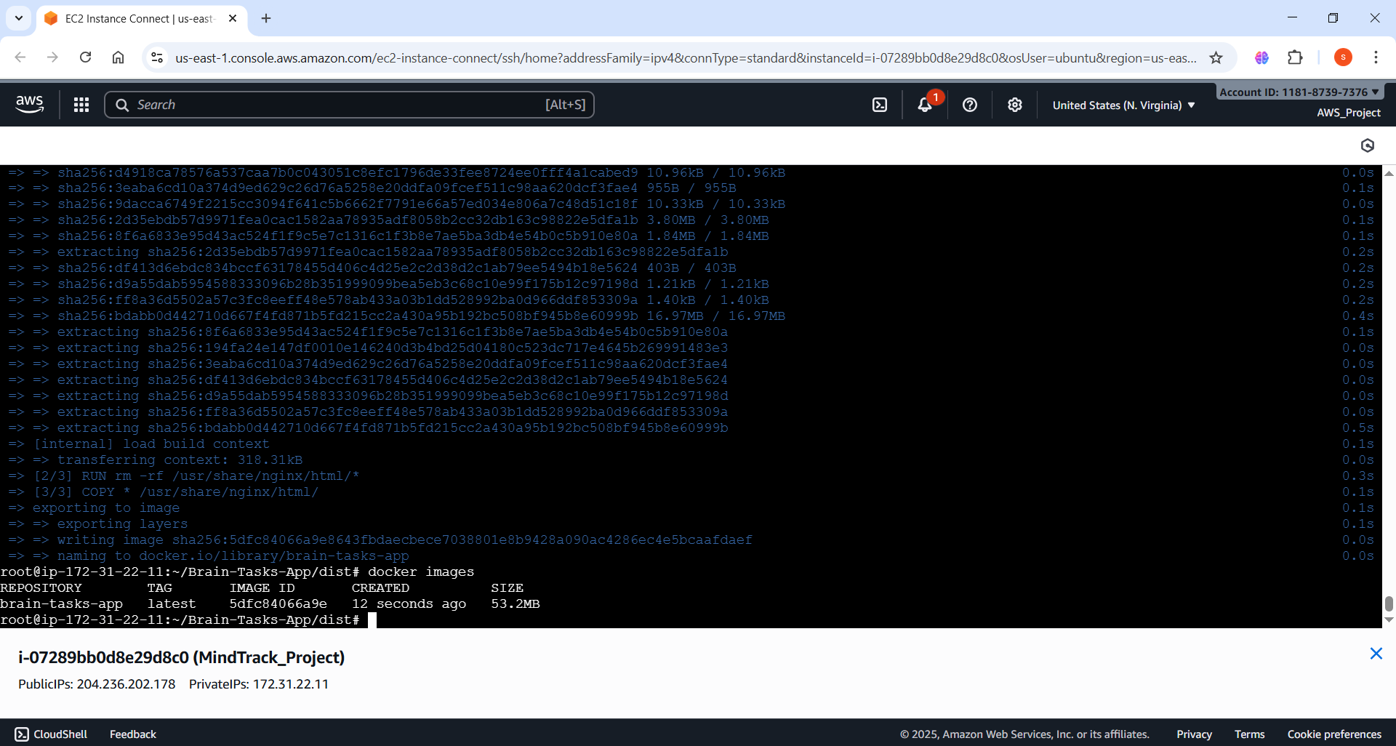

Deploy the kubectl pods/application through the code deploy:
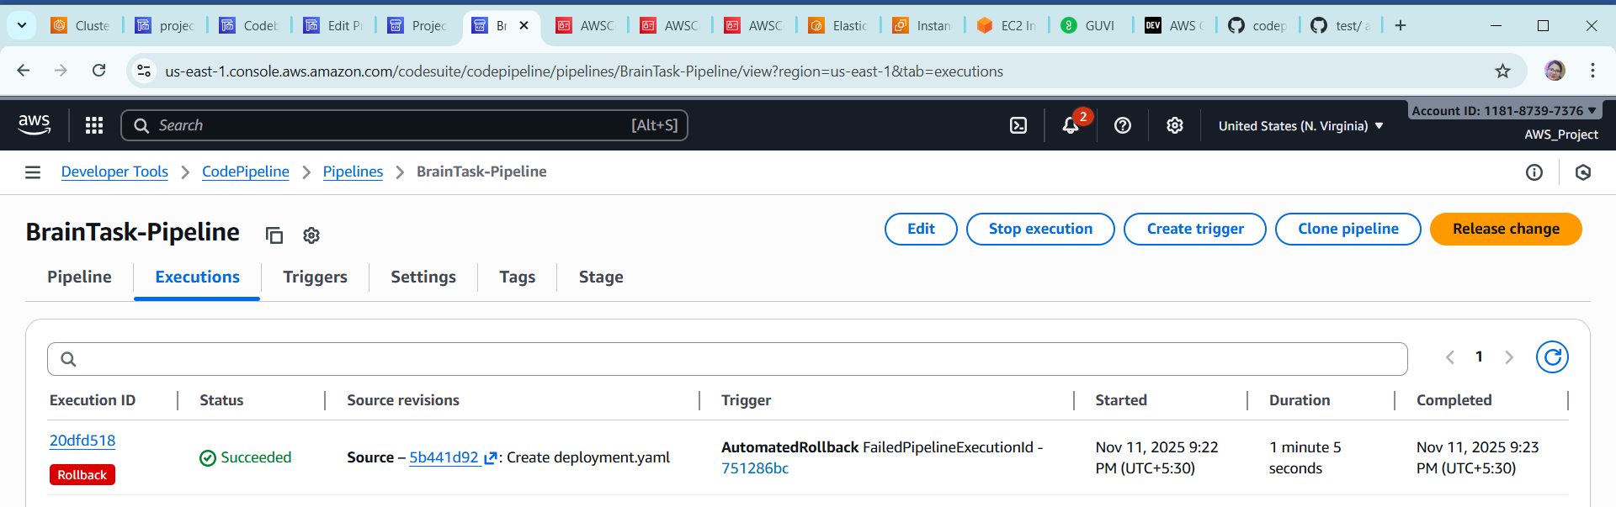
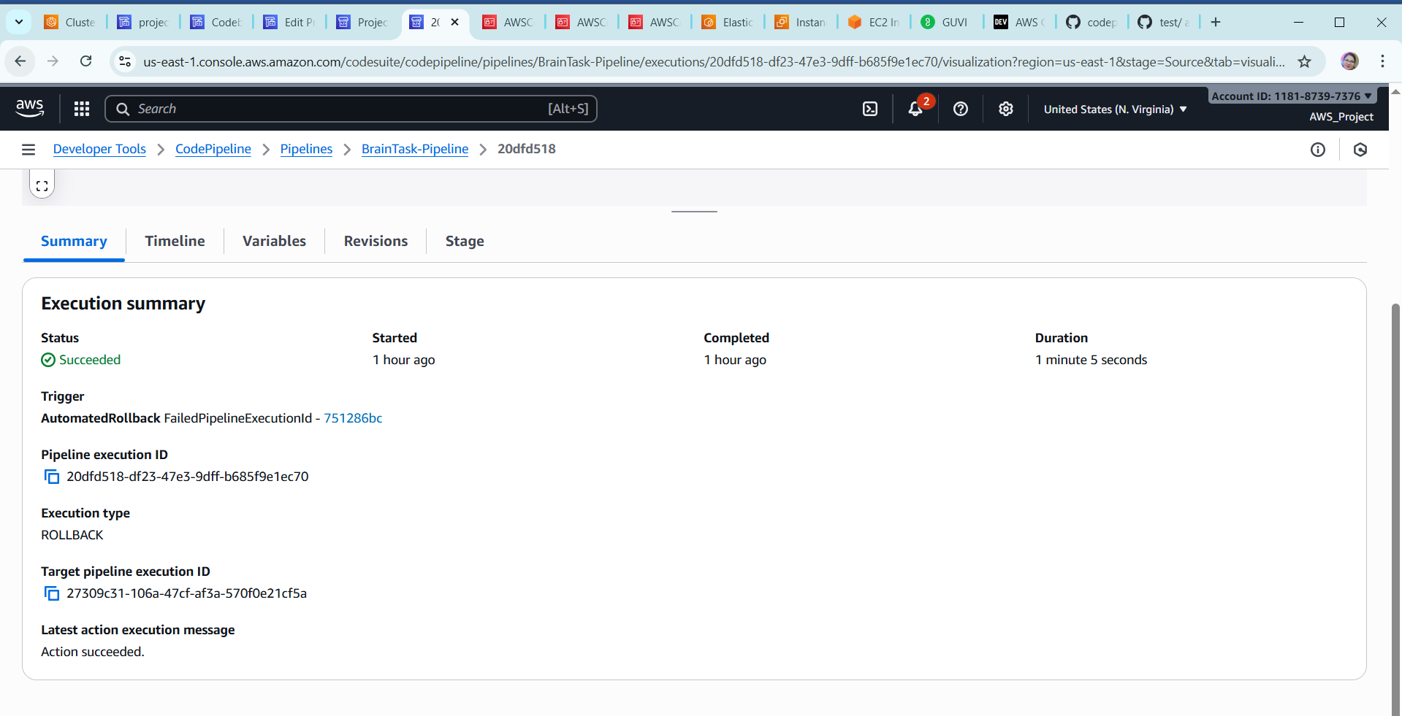
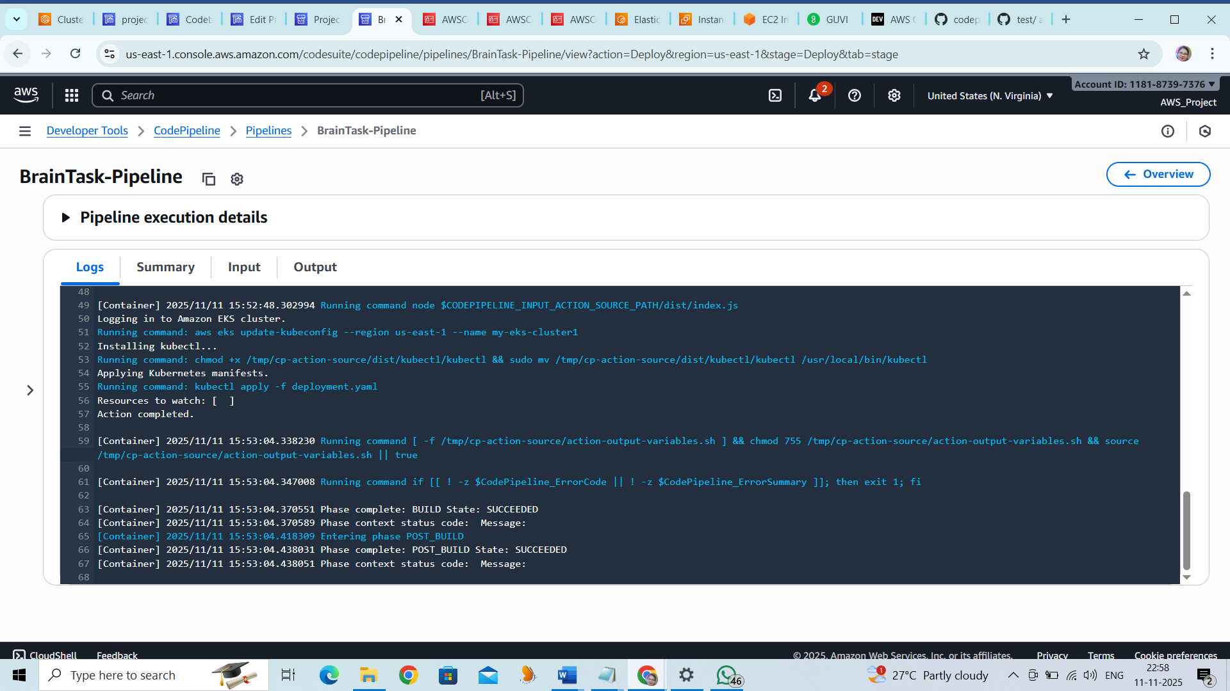
CodeDeploy Log File:

[Container] 2025/11/11 15:52:44.345416 Running on CodeBuild On-demand
[Container] 2025/11/11 15:52:44.345430 Waiting for agent ping
[Container] 2025/11/11 15:52:44.547097 Waiting for DOWNLOAD_SOURCE
[Container] 2025/11/11 15:52:45.493238 Phase is DOWNLOAD_SOURCE
[Container] 2025/11/11 15:52:45.494317 CODEBUILD_SRC_DIR=/codebuild/output/src1516097332/src
[Container] 2025/11/11 15:52:45.494901 YAML location is /codebuild/readonly/buildspec.yml
[Container] 2025/11/11 15:52:45.497563 Setting HTTP client timeout to higher timeout for S3 source
[Container] 2025/11/11 15:52:45.497679 Processing environment variables
[Container] 2025/11/11 15:52:45.747684 No runtime version selected in buildspec.
[Container] 2025/11/11 15:52:45.797126 Moving to directory /codebuild/output/src1516097332/src
[Container] 2025/11/11 15:52:45.797152 Cache is not defined in the buildspec
[Container] 2025/11/11 15:52:45.844485 Skip cache due to: no paths specified to be cached
[Container] 2025/11/11 15:52:45.844904 Registering with agent
[Container] 2025/11/11 15:52:45.902832 Phases found in YAML: 1
[Container] 2025/11/11 15:52:45.902852 BUILD: 7 commands
[Container] 2025/11/11 15:52:45.903204 Phase complete: DOWNLOAD_SOURCE State: SUCCEEDED
[Container] 2025/11/11 15:52:45.903219 Phase context status code: Message:
[Container] 2025/11/11 15:52:46.084531 Entering phase INSTALL
[Container] 2025/11/11 15:52:46.152431 Phase complete: INSTALL State: SUCCEEDED
[Container] 2025/11/11 15:52:46.152449 Phase context status code: Message:
[Container] 2025/11/11 15:52:46.244031 Entering phase PRE_BUILD
[Container] 2025/11/11 15:52:46.262603 Phase complete: PRE_BUILD State: SUCCEEDED
[Container] 2025/11/11 15:52:46.262621 Phase context status code: Message:
[Container] 2025/11/11 15:52:46.315474 Entering phase BUILD
[Container] 2025/11/11 15:52:46.360433 Running command mkdir -p /tmp/cp-action-source
[Container] 2025/11/11 15:52:46.369489 Running command export CODEPIPELINE_INPUT_ACTION_SOURCE_PATH=/tmp/cp-action-source
[Container] 2025/11/11 15:52:46.376852 Running command curl "https://dnii66ogcg9px.cloudfront.net/deploy-eks-aws-1/0.1.0.tgz" -o /tmp/cp-action-source/action-archive.tgz
% Total % Received % Xferd Average Speed Time Time Time Current
Dload Upload Total Spent Left Speed
0 0 0 0 0 0 0 0 --:--:-- --:--:-- --:--:-- 0
100 33.3M 100 33.3M 0 0 190M 0 --:--:-- --:--:-- --:--:-- 190M
[Container] 2025/11/11 15:52:47.481073 Running command tar -xvzf /tmp/cp-action-source/action-archive.tgz --strip-components=1 -C /tmp/cp-action-source
package/dist/helm/helm
package/dist/kubectl/kubectl
package/dist/index.js
package/dist/validationUtils.js
package/package.json
package/dist/index.d.ts.map
package/dist/index.js.map
package/dist/validationUtils.d.ts.map
package/dist/validationUtils.js.map
package/dist/index.d.ts
package/dist/validationUtils.d.ts
[Container] 2025/11/11 15:52:48.302994 Running command node $CODEPIPELINE_INPUT_ACTION_SOURCE_PATH/dist/index.js
Logging in to Amazon EKS cluster.
Running command: aws eks update-kubeconfig --region us-east-1 --name my-eks-cluster1
Installing kubectl...
Running command: chmod +x /tmp/cp-action-source/dist/kubectl/kubectl && sudo mv /tmp/cp-action-source/dist/kubectl/kubectl /usr/local/bin/kubectl
Applying Kubernetes manifests.
Running command: kubectl apply -f deployment.yaml
Resources to watch: [ ]
Action completed.
[Container] 2025/11/11 15:53:04.338230 Running command [ -f /tmp/cp-action-source/action-output-variables.sh ] && chmod 755 /tmp/cp-action-source/action-output-variables.sh && source /tmp/cp-action-source/action-output-variables.sh || true
[Container] 2025/11/11 15:53:04.347008 Running command if [[ ! -z $CodePipeline_ErrorCode || ! -z $CodePipeline_ErrorSummary ]]; then exit 1; fi
[Container] 2025/11/11 15:53:04.370551 Phase complete: BUILD State: SUCCEEDED
[Container] 2025/11/11 15:53:04.370589 Phase context status code: Message:
[Container] 2025/11/11 15:53:04.418309 Entering phase POST_BUILD
[Container] 2025/11/11 15:53:04.438031 Phase complete: POST_BUILD State: SUCCEEDED
[Container] 2025/11/11 15:53:04.438051 Phase context status code: Message:

CodeBuild:
- Create a CodeBuild project:
- Source: Connect to your repository
- Environment: Use managed image (Amazon Linux, Ubuntu)
- Write and define commands in buildspec.yml.

Action:
- Source -cloned the given github repository for the application code.
- Copied the application to the out github Repository “https://github.com/saras88-prod/test.git”
- Connected the Codebuild with the Github for the building the application.
GitHubImage:

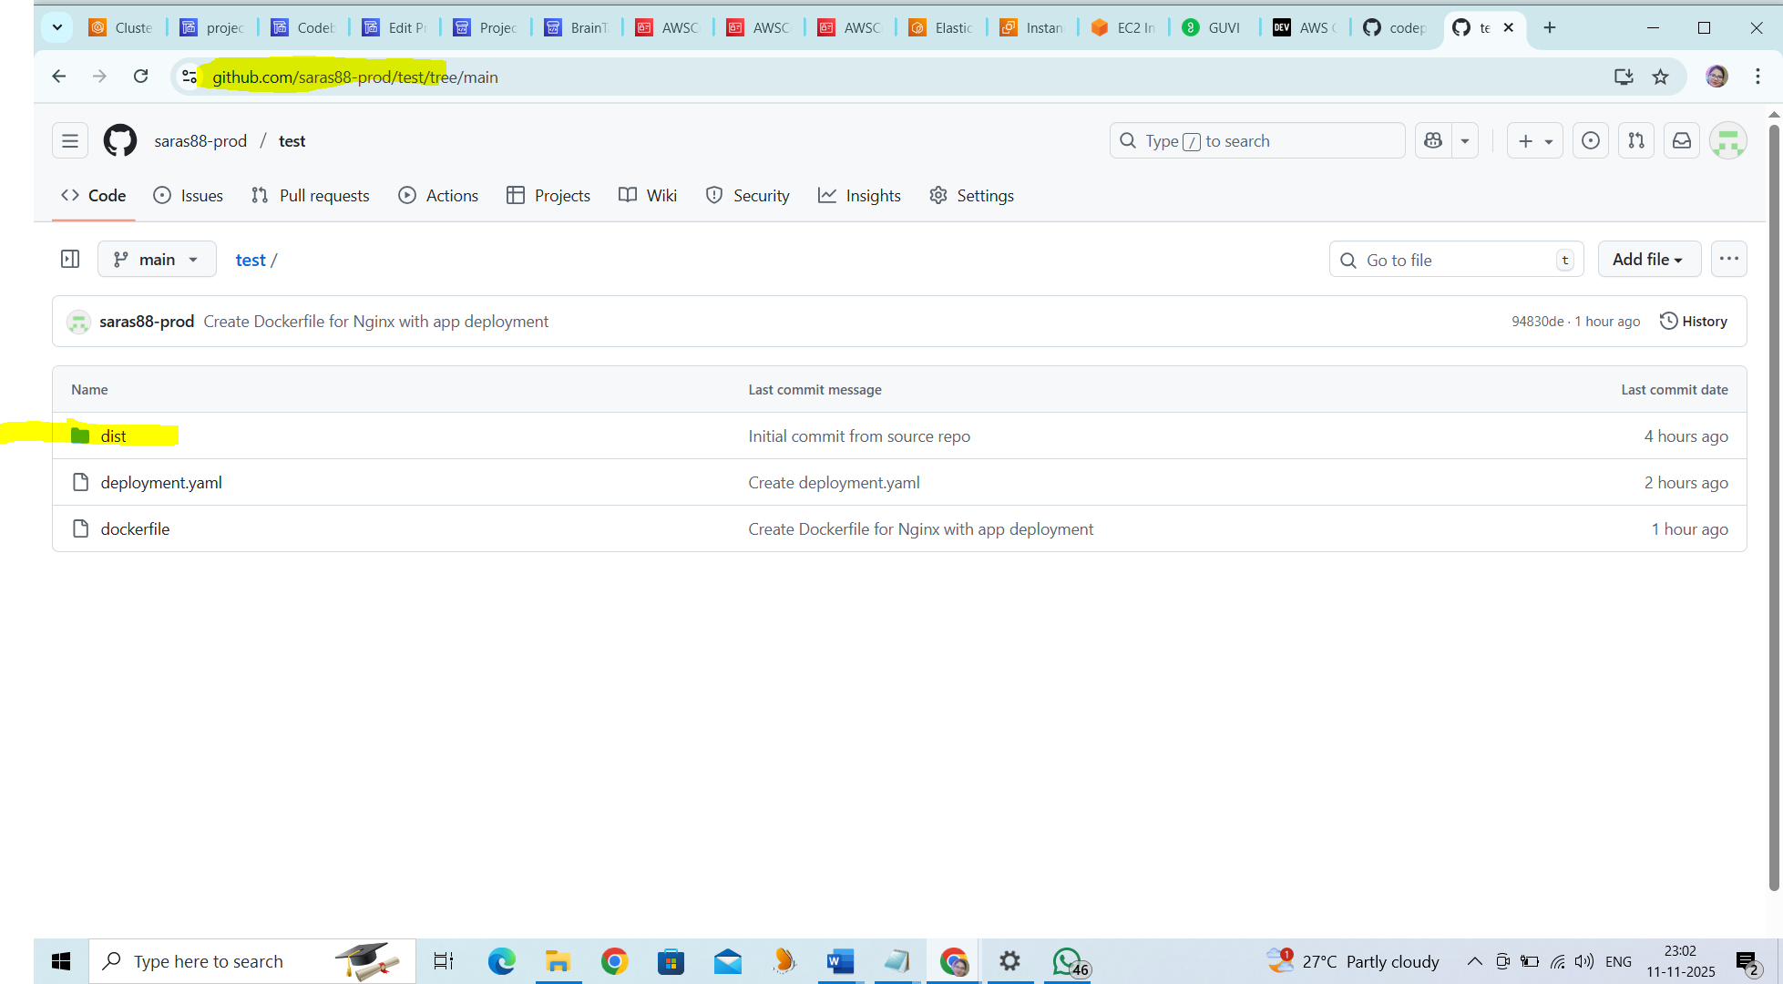

AWS CodeBuild tool :
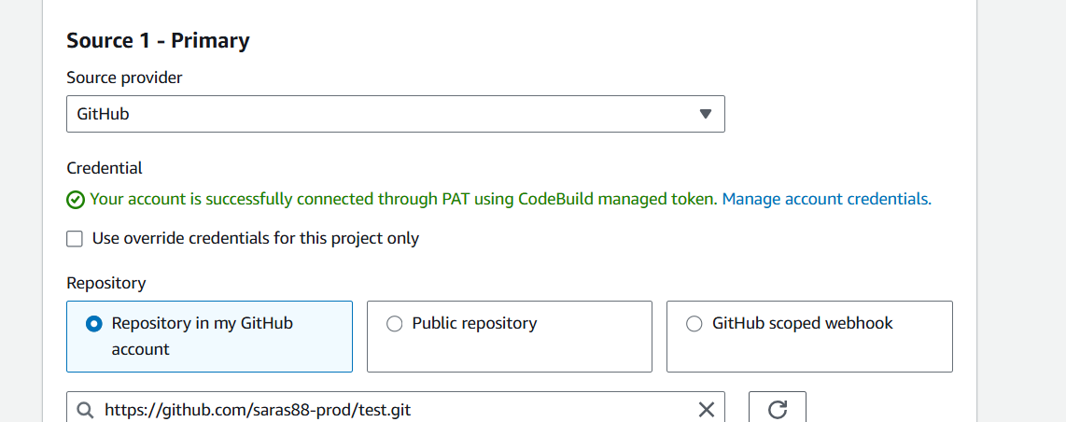
- Created the buildspec to push the docker image of the application to the Elastic private container.
- Create the roles for the necessary permission to the code build to intract with the ECR service.
Buildspec.yaml :
version: 0.2

env:
variables:
# Name of your ECR repository
ECR_REPO_NAME: brain-tasks-app
# AWS region
AWS_DEFAULT_REGION: us-east-1
# Docker image tag
IMAGE_TAG: latest
DOCKERHUB_PASSWORD: dckr_pat_s45MuxORVSJONytj0wvAnREY9ys
DOCKERHUB_USERNAME: saraswathi6

phases:
pre_build:
commands:
- echo Logging in to Amazon ECR...
- aws --version
- echo Logging in to Docker Hub...
- echo $DOCKERHUB_PASSWORD | docker login -u $DOCKERHUB_USERNAME --password-stdin
- aws ecr get-login-password --region $AWS_DEFAULT_REGION | docker login --username AWS --password-stdin 118187397376.dkr.ecr.$AWS_DEFAULT_REGION.amazonaws.com
- echo Build started on `date`
- echo Cloning GitHub repository...
- git clone https://github.com/saras88-prod/test.git app
- cd app
build:
commands:
- echo Building the Docker image...
- docker build -t $ECR_REPO_NAME:$IMAGE_TAG .
- docker tag $ECR_REPO_NAME:$IMAGE_TAG 118187397376.dkr.ecr.$AWS_DEFAULT_REGION.amazonaws.com/$ECR_REPO_NAME:$IMAGE_TAG
post_build:
commands:
- echo Pushing the Docker image to ECR...
- docker push 118187397376.dkr.ecr.$AWS_DEFAULT_REGION.amazonaws.com/$ECR_REPO_NAME:$IMAGE_TAG
- echo Build completed on `date`

artifacts:
files: []
Service.yaml:

apiVersion: v1
kind: Service
metadata:
name: brain-tasks-service
namespace: default
labels:
app: brain-tasks
spec:
selector:
app: brain-tasks
ports:
- protocol: TCP
port: 80
targetPort: 3000
type: LoadBalancer

deploy.sh:
#!/bin/bash
set -e

# Variables
NAMESPACE="default"
CLUSTER_NAME="brain-tasks-clusters"
AWS_REGION="us-east-1"
ECR_REPO="118187397376.dkr.ecr.$AWS_REGION.amazonaws.com/brain-tasks-app"
IMAGE_TAG="latest"

echo "Logging in to EKS cluster..."
aws eks update-kubeconfig --region $AWS_REGION --name $CLUSTER_NAME

echo "Updating deployment image in Kubernetes..."
kubectl set image deployment/brain-tasks-deployment \
brain-tasks-container=$ECR_REPO:$IMAGE_TAG \
-n $NAMESPACE

echo "Applying Kubernetes manifests..."
kubectl apply -f k8s/deployment.yaml -n $NAMESPACE
kubectl apply -f k8s/service.yaml -n $NAMESPACE

echo "Deployment completed successfully!"

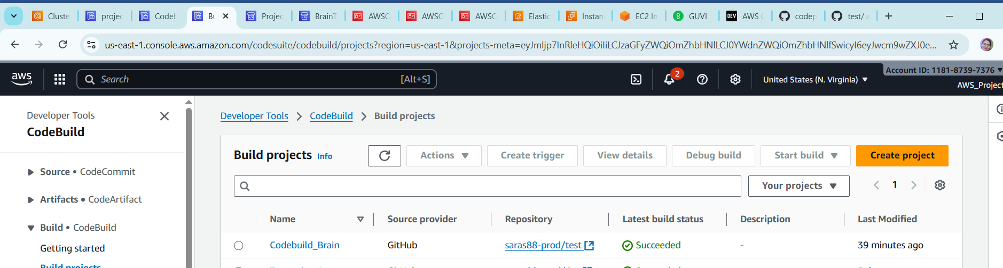

CodeBuild Log:

[Container] 2025/11/11 16:58:56.057103 Running on CodeBuild On-demand
[Container] 2025/11/11 16:58:56.057115 Waiting for agent ping
[Container] 2025/11/11 16:58:56.158560 Waiting for DOWNLOAD_SOURCE
[Container] 2025/11/11 16:58:57.356772 Phase is DOWNLOAD_SOURCE
[Container] 2025/11/11 16:58:57.357965 CODEBUILD_SRC_DIR=/codebuild/output/src2063637085/src
[Container] 2025/11/11 16:58:57.358830 YAML location is /codebuild/readonly/buildspec.yml
[Container] 2025/11/11 16:58:57.362181 Setting HTTP client timeout to higher timeout for S3 source
[Container] 2025/11/11 16:58:57.362275 Processing environment variables
[Container] 2025/11/11 16:58:57.698545 No runtime version selected in buildspec.
[Container] 2025/11/11 16:58:57.769534 Moving to directory /codebuild/output/src2063637085/src
[Container] 2025/11/11 16:58:57.769567 Cache is not defined in the buildspec
[Container] 2025/11/11 16:58:57.815082 Skip cache due to: no paths specified to be cached
[Container] 2025/11/11 16:58:57.815408 Registering with agent
[Container] 2025/11/11 16:58:57.848406 Phases found in YAML: 3
[Container] 2025/11/11 16:58:57.848424 PRE_BUILD: 9 commands
[Container] 2025/11/11 16:58:57.848429 BUILD: 3 commands
[Container] 2025/11/11 16:58:57.848436 POST_BUILD: 3 commands
[Container] 2025/11/11 16:58:57.848782 Phase complete: DOWNLOAD_SOURCE State: SUCCEEDED
[Container] 2025/11/11 16:58:57.848796 Phase context status code: Message:
[Container] 2025/11/11 16:58:57.963454 Entering phase INSTALL
[Container] 2025/11/11 16:58:58.001412 Phase complete: INSTALL State: SUCCEEDED
[Container] 2025/11/11 16:58:58.001431 Phase context status code: Message:
[Container] 2025/11/11 16:58:58.040660 Entering phase PRE_BUILD
[Container] 2025/11/11 16:58:58.073781 Running command echo Logging in to Amazon ECR...
Logging in to Amazon ECR...
[Container] 2025/11/11 16:58:58.080656 Running command aws --version
aws-cli/2.31.30 Python/3.13.9 Linux/4.14.355-280.706.amzn2.x86_64 exec-env/AWS_ECS_EC2 exe/x86_64.amzn.2023
[Container] 2025/11/11 16:59:10.065963 Running command echo Logging in to Docker Hub...
Logging in to Docker Hub...
[Container] 2025/11/11 16:59:10.072713 Running command echo $DOCKERHUB_PASSWORD | docker login -u $DOCKERHUB_USERNAME --password-stdin
WARNING! Your password will be stored unencrypted in /root/.docker/config.json.
Configure a credential helper to remove this warning. See
https://docs.docker.com/engine/reference/commandline/login/#credential-stores
Login Succeeded
[Container] 2025/11/11 16:59:10.137408 Running command aws ecr get-login-password --region $AWS_DEFAULT_REGION | docker login --username AWS --password-stdin 118187397376.dkr.ecr.$AWS_DEFAULT_REGION.amazonaws.com
WARNING! Your password will be stored unencrypted in /root/.docker/config.json.
Configure a credential helper to remove this warning. See
https://docs.docker.com/engine/reference/commandline/login/#credential-stores
Login Succeeded
[Container] 2025/11/11 16:59:11.165685 Running command echo Build started on `date`
Build started on Tue Nov 11 04:59:11 PM UTC 2025
[Container] 2025/11/11 16:59:11.173711 Running command echo Cloning GitHub repository...
Cloning GitHub repository...
[Container] 2025/11/11 16:59:11.179933 Running command git clone https://github.com/saras88-prod/test.git app
Cloning into 'app'...
[Container] 2025/11/11 16:59:12.307514 Running command cd app
[Container] 2025/11/11 16:59:12.313938 Phase complete: PRE_BUILD State: SUCCEEDED
[Container] 2025/11/11 16:59:12.313955 Phase context status code: Message:
[Container] 2025/11/11 16:59:12.352647 Entering phase BUILD
[Container] 2025/11/11 16:59:12.354879 Running command echo Building the Docker image...
Building the Docker image...
[Container] 2025/11/11 16:59:12.361071 Running command docker build -t $ECR_REPO_NAME:$IMAGE_TAG .
#0 building with "default" instance using docker driver
#1 [internal] load build definition from dockerfile
#1 transferring dockerfile: 358B done
#1 DONE 0.0s
#2 [auth] library/nginx:pull token for registry-1.docker.io
#2 DONE 0.0s
#3 [internal] load metadata for docker.io/library/nginx:alpine
#3 DONE 0.3s
#4 [internal] load .dockerignore
#4 transferring context: 2B done
#4 DONE 0.0s
#5 [internal] load build context
#5 transferring context: 317.98kB done
#5 DONE 0.0s
#6 [1/3] FROM docker.io/library/nginx:alpine@sha256:b3c656d55d7ad751196f21b7fd2e8d4da9cb430e32f646adcf92441b72f82b14
#6 resolve docker.io/library/nginx:alpine@sha256:b3c656d55d7ad751196f21b7fd2e8d4da9cb430e32f646adcf92441b72f82b14 0.0s done
#6 sha256:b3c656d55d7ad751196f21b7fd2e8d4da9cb430e32f646adcf92441b72f82b14 10.33kB / 10.33kB done
#6 sha256:667473807103639a0aca5b49534a216d2b64f0fb868aaa801f023da0cdd781c7 2.50kB / 2.50kB done
#6 sha256:d4918ca78576a537caa7b0c043051c8efc1796de33fee8724ee0fff4a1cabed9 10.96kB / 10.96kB done
#6 sha256:3eaba6cd10a374d9ed629c26d76a5258e20ddfa09fcef511c98aa620dcf3fae4 0B / 955B 0.2s
#6 sha256:8f6a6833e95d43ac524f1f9c5e7c1316c1f3b8e7ae5ba3db4e54b0c5b910e80a 0B / 1.84MB 0.2s
#6 sha256:194fa24e147df0010e146240d3b4bd25d04180c523dc717e4645b269991483e3 0B / 628B 0.2s
#6 sha256:3eaba6cd10a374d9ed629c26d76a5258e20ddfa09fcef511c98aa620dcf3fae4 955B / 955B 0.2s done
#6 sha256:8f6a6833e95d43ac524f1f9c5e7c1316c1f3b8e7ae5ba3db4e54b0c5b910e80a 1.84MB / 1.84MB 0.2s done
#6 sha256:194fa24e147df0010e146240d3b4bd25d04180c523dc717e4645b269991483e3 628B / 628B 0.2s done
#6 extracting sha256:8f6a6833e95d43ac524f1f9c5e7c1316c1f3b8e7ae5ba3db4e54b0c5b910e80a
#6 sha256:df413d6ebdc834bccf63178455d406c4d25e2c2d38d2c1ab79ee5494b18e5624 403B / 403B 0.3s done
#6 sha256:d9a55dab5954588333096b28b351999099bea5eb3c68c10e99f175b12c97198d 1.21kB / 1.21kB 0.3s done
#6 sha256:ff8a36d5502a57c3fc8eeff48e578ab433a03b1dd528992ba0d966ddf853309a 1.40kB / 1.40kB 0.3s done
#6 sha256:bdabb0d442710d667f4fd871b5fd215cc2a430a95b192bc508bf945b8e60999b 0B / 16.97MB 0.3s
#6 extracting sha256:8f6a6833e95d43ac524f1f9c5e7c1316c1f3b8e7ae5ba3db4e54b0c5b910e80a 0.2s done
#6 sha256:bdabb0d442710d667f4fd871b5fd215cc2a430a95b192bc508bf945b8e60999b 12.58MB / 16.97MB 0.4s
#6 sha256:bdabb0d442710d667f4fd871b5fd215cc2a430a95b192bc508bf945b8e60999b 16.97MB / 16.97MB 0.5s done
#6 extracting sha256:194fa24e147df0010e146240d3b4bd25d04180c523dc717e4645b269991483e3
#6 extracting sha256:194fa24e147df0010e146240d3b4bd25d04180c523dc717e4645b269991483e3 done
#6 extracting sha256:3eaba6cd10a374d9ed629c26d76a5258e20ddfa09fcef511c98aa620dcf3fae4 done
#6 extracting sha256:df413d6ebdc834bccf63178455d406c4d25e2c2d38d2c1ab79ee5494b18e5624 done
#6 extracting sha256:d9a55dab5954588333096b28b351999099bea5eb3c68c10e99f175b12c97198d
#6 extracting sha256:d9a55dab5954588333096b28b351999099bea5eb3c68c10e99f175b12c97198d done
#6 extracting sha256:ff8a36d5502a57c3fc8eeff48e578ab433a03b1dd528992ba0d966ddf853309a done
#6 extracting sha256:bdabb0d442710d667f4fd871b5fd215cc2a430a95b192bc508bf945b8e60999b 0.1s
#6 extracting sha256:bdabb0d442710d667f4fd871b5fd215cc2a430a95b192bc508bf945b8e60999b 0.4s done
#6 DONE 1.3s
#7 [2/3] RUN rm -rf /usr/share/nginx/html/*
#7 DONE 0.8s
#8 [3/3] COPY dist/* /usr/share/nginx/html
#8 DONE 0.1s
#9 exporting to image
#9 exporting layers 0.0s done
#9 writing image sha256:b510b2fcab82bd8f2eca53356c1b5f37ff5ed81a743b74bf7f516c718fa518df done
#9 naming to docker.io/library/brain-tasks-app:latest done
#9 DONE 0.0s
[Container] 2025/11/11 16:59:15.219157 Running command docker tag $ECR_REPO_NAME:$IMAGE_TAG 118187397376.dkr.ecr.$AWS_DEFAULT_REGION.amazonaws.com/$ECR_REPO_NAME:$IMAGE_TAG
[Container] 2025/11/11 16:59:15.243871 Phase complete: BUILD State: SUCCEEDED
[Container] 2025/11/11 16:59:15.243892 Phase context status code: Message:
[Container] 2025/11/11 16:59:15.328459 Entering phase POST_BUILD
[Container] 2025/11/11 16:59:15.329781 Running command echo Pushing the Docker image to ECR...
Pushing the Docker image to ECR...
[Container] 2025/11/11 16:59:15.337847 Running command docker push 118187397376.dkr.ecr.$AWS_DEFAULT_REGION.amazonaws.com/$ECR_REPO_NAME:$IMAGE_TAG
The push refers to repository [118187397376.dkr.ecr.us-east-1.amazonaws.com/brain-tasks-app]
a6756e2d96be: Preparing
1a27f8ec4359: Preparing
25906c27b84d: Preparing
99ea4bde418d: Preparing
3297b9628ff3: Preparing
b74d92be8225: Preparing
2c79d5d895bb: Preparing
2660a7d4b906: Preparing
50b58ca2a3f5: Preparing
256f393e029f: Preparing
b74d92be8225: Waiting
2c79d5d895bb: Waiting
2660a7d4b906: Waiting
50b58ca2a3f5: Waiting
256f393e029f: Waiting
25906c27b84d: Layer already exists
3297b9628ff3: Layer already exists
99ea4bde418d: Layer already exists
2660a7d4b906: Layer already exists
2c79d5d895bb: Layer already exists
b74d92be8225: Layer already exists
256f393e029f: Layer already exists
50b58ca2a3f5: Layer already exists
1a27f8ec4359: Pushed
a6756e2d96be: Pushed
latest: digest: sha256:f022f4f4b70f968020daf596477a2d6d0e2587f9bd5554a4e20c14af35feb288 size: 2406
[Container] 2025/11/11 16:59:16.871989 Running command echo Build completed on `date`
Build completed on Tue Nov 11 04:59:16 PM UTC 2025
[Container] 2025/11/11 16:59:16.881619 Phase complete: POST_BUILD State: SUCCEEDED
[Container] 2025/11/11 16:59:16.881635 Phase context status code: Message:
[Container] 2025/11/11 16:59:16.956495 Set report auto-discover timeout to 5 seconds
[Container] 2025/11/11 16:59:16.956559 Expanding base directory path: .
[Container] 2025/11/11 16:59:16.960168 Assembling file list
[Container] 2025/11/11 16:59:16.960186 Expanding .
[Container] 2025/11/11 16:59:16.963859 Expanding file paths for base directory .
[Container] 2025/11/11 16:59:16.963877 Assembling file list
[Container] 2025/11/11 16:59:16.963880 Expanding **/*
[Container] 2025/11/11 16:59:16.967940 No matching auto-discover report paths found
[Container] 2025/11/11 16:59:16.967970 Report auto-discover file discovery took 0.011476 seconds
[Container] 2025/11/11 16:59:16.967988 Phase complete: UPLOAD_ARTIFACTS State: SUCCEEDED
[Container] 2025/11/11 16:59:16.967999 Phase context status code: Message:

CodeDeploy:
- Create codedeploy application.
- create appspec.yml file to deploy applications in EKS.

Version Control:
- Push the codebase to a Git provider (GitHub).
- Use CLI commands to push code.

CodePipeline:
- Source: GitHub
- Build: AWS CodeBuild project
- Deploy: AWS CodeDeploy or deploy to EKS via Lambda or custom script.

Action :
Create the CI/CD pipeline for the automatic application deployment
- Created the Source from the github repository
https://github.com/saras88-prod/test.git
- Create the Codebuild service for the application image creation
- Application cloned from the given github and copied to the Ec2 machine.
- Install aws cli to communicate with the AWS services
- Install kubectl to communicate with the elastic Kubernetes cluster(EKS)
- Instal docker latest version
- Create the Docker file and build the images using the file and application code. Expose it to the port 3000
- Create the Elastic container service (ECR) using the command.its a private repository to store the images.
- Push the Docker application image to the ECR in the Codebuild tool.
(10)Using the Codedeloy deploy the images into the Amazon EKS cluster
(11)Create the CD pipeline as a source using the above github and push the all codes into the same hub
(12)create the codebuild yaml file buildspec. And deploy it using the build tool
(13)Use the codebuild of aws and using the codedeploy tool in the pipeline for the deployment of application inside the EKS pods.

Source GitHub:

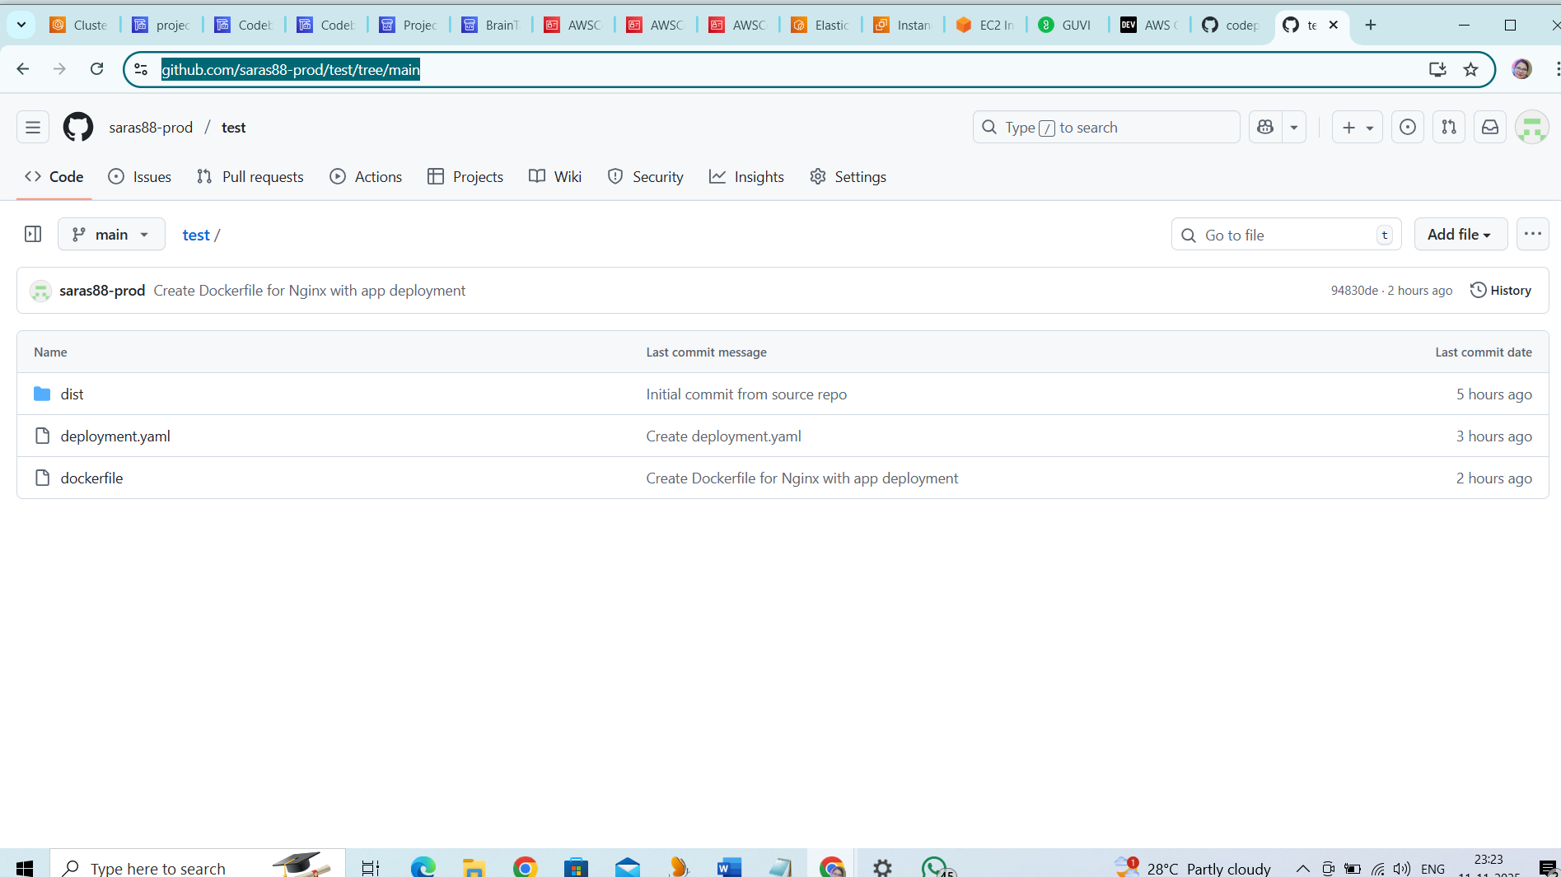
Buildspec:
version: 0.2

env:
variables:
# Name of your ECR repository
ECR_REPO_NAME: brain-tasks-app
# AWS region
AWS_DEFAULT_REGION: us-east-1
# Docker image tag
IMAGE_TAG: latest
DOCKERHUB_PASSWORD: dckr_pat_s45MuxORVSJONytj0wvAnREY9ys
DOCKERHUB_USERNAME: saraswathi6

phases:
pre_build:
commands:
- echo Logging in to Amazon ECR...
- aws --version
- echo Logging in to Docker Hub...
- echo $DOCKERHUB_PASSWORD | docker login -u $DOCKERHUB_USERNAME --password-stdin
- aws ecr get-login-password --region $AWS_DEFAULT_REGION | docker login --username AWS --password-stdin 118187397376.dkr.ecr.$AWS_DEFAULT_REGION.amazonaws.com
- echo Build started on `date`
- echo Cloning GitHub repository...
- git clone https://github.com/saras88-prod/test.git app
- cd app
build:
commands:
- echo Building the Docker image...
- docker build -t $ECR_REPO_NAME:$IMAGE_TAG .
- docker tag $ECR_REPO_NAME:$IMAGE_TAG 118187397376.dkr.ecr.$AWS_DEFAULT_REGION.amazonaws.com/$ECR_REPO_NAME:$IMAGE_TAG
post_build:
commands:
- echo Pushing the Docker image to ECR...
- docker push 118187397376.dkr.ecr.$AWS_DEFAULT_REGION.amazonaws.com/$ECR_REPO_NAME:$IMAGE_TAG
- echo Build completed on `date`

artifacts:
files: []

Log:
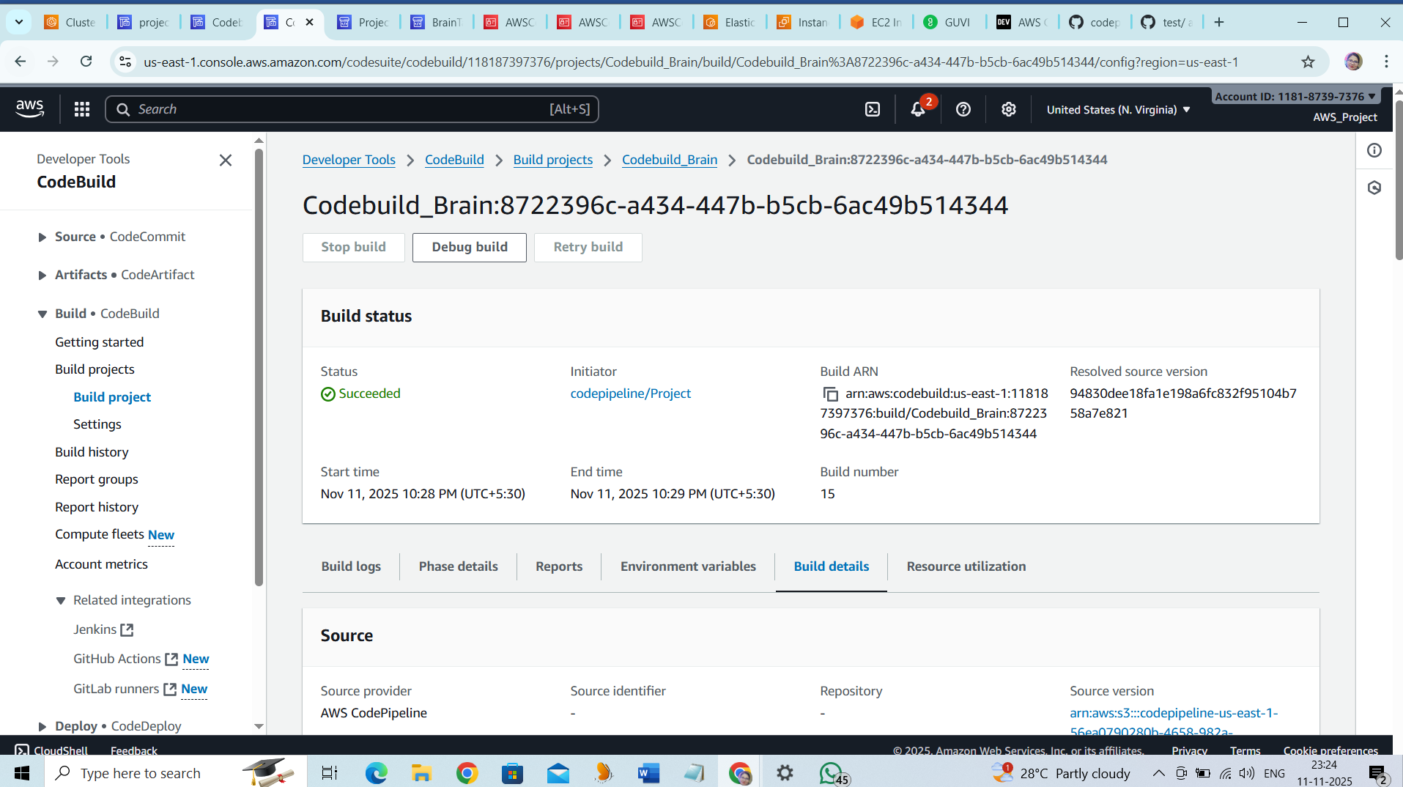
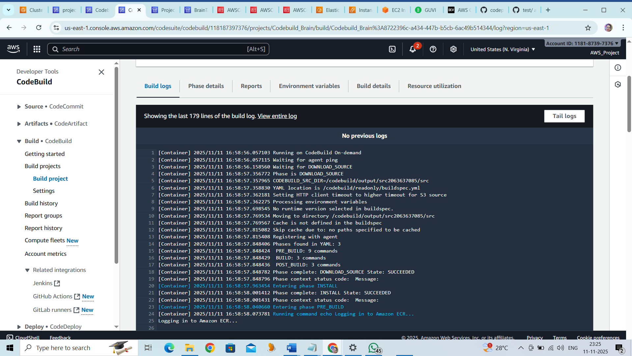
[Container] 2025/11/11 16:58:56.057103 Running on CodeBuild On-demand
[Container] 2025/11/11 16:58:56.057115 Waiting for agent ping
[Container] 2025/11/11 16:58:56.158560 Waiting for DOWNLOAD_SOURCE
[Container] 2025/11/11 16:58:57.356772 Phase is DOWNLOAD_SOURCE
[Container] 2025/11/11 16:58:57.357965 CODEBUILD_SRC_DIR=/codebuild/output/src2063637085/src
[Container] 2025/11/11 16:58:57.358830 YAML location is /codebuild/readonly/buildspec.yml
[Container] 2025/11/11 16:58:57.362181 Setting HTTP client timeout to higher timeout for S3 source
[Container] 2025/11/11 16:58:57.362275 Processing environment variables
[Container] 2025/11/11 16:58:57.698545 No runtime version selected in buildspec.
[Container] 2025/11/11 16:58:57.769534 Moving to directory /codebuild/output/src2063637085/src
[Container] 2025/11/11 16:58:57.769567 Cache is not defined in the buildspec
[Container] 2025/11/11 16:58:57.815082 Skip cache due to: no paths specified to be cached
[Container] 2025/11/11 16:58:57.815408 Registering with agent
[Container] 2025/11/11 16:58:57.848406 Phases found in YAML: 3
[Container] 2025/11/11 16:58:57.848424 PRE_BUILD: 9 commands
[Container] 2025/11/11 16:58:57.848429 BUILD: 3 commands
[Container] 2025/11/11 16:58:57.848436 POST_BUILD: 3 commands
[Container] 2025/11/11 16:58:57.848782 Phase complete: DOWNLOAD_SOURCE State: SUCCEEDED
[Container] 2025/11/11 16:58:57.848796 Phase context status code: Message:
[Container] 2025/11/11 16:58:57.963454 Entering phase INSTALL
[Container] 2025/11/11 16:58:58.001412 Phase complete: INSTALL State: SUCCEEDED
[Container] 2025/11/11 16:58:58.001431 Phase context status code: Message:
[Container] 2025/11/11 16:58:58.040660 Entering phase PRE_BUILD
[Container] 2025/11/11 16:58:58.073781 Running command echo Logging in to Amazon ECR...
Logging in to Amazon ECR...
[Container] 2025/11/11 16:58:58.080656 Running command aws --version
aws-cli/2.31.30 Python/3.13.9 Linux/4.14.355-280.706.amzn2.x86_64 exec-env/AWS_ECS_EC2 exe/x86_64.amzn.2023
[Container] 2025/11/11 16:59:10.065963 Running command echo Logging in to Docker Hub...
Logging in to Docker Hub...
[Container] 2025/11/11 16:59:10.072713 Running command echo $DOCKERHUB_PASSWORD | docker login -u $DOCKERHUB_USERNAME --password-stdin
WARNING! Your password will be stored unencrypted in /root/.docker/config.json.
Configure a credential helper to remove this warning. See
https://docs.docker.com/engine/reference/commandline/login/#credential-stores
Login Succeeded
[Container] 2025/11/11 16:59:10.137408 Running command aws ecr get-login-password --region $AWS_DEFAULT_REGION | docker login --username AWS --password-stdin 118187397376.dkr.ecr.$AWS_DEFAULT_REGION.amazonaws.com
WARNING! Your password will be stored unencrypted in /root/.docker/config.json.
Configure a credential helper to remove this warning. See
https://docs.docker.com/engine/reference/commandline/login/#credential-stores
Login Succeeded
[Container] 2025/11/11 16:59:11.165685 Running command echo Build started on `date`
Build started on Tue Nov 11 04:59:11 PM UTC 2025
[Container] 2025/11/11 16:59:11.173711 Running command echo Cloning GitHub repository...
Cloning GitHub repository...
[Container] 2025/11/11 16:59:11.179933 Running command git clone https://github.com/saras88-prod/test.git app
Cloning into 'app'...
[Container] 2025/11/11 16:59:12.307514 Running command cd app
[Container] 2025/11/11 16:59:12.313938 Phase complete: PRE_BUILD State: SUCCEEDED
[Container] 2025/11/11 16:59:12.313955 Phase context status code: Message:
[Container] 2025/11/11 16:59:12.352647 Entering phase BUILD
[Container] 2025/11/11 16:59:12.354879 Running command echo Building the Docker image...
Building the Docker image...
[Container] 2025/11/11 16:59:12.361071 Running command docker build -t $ECR_REPO_NAME:$IMAGE_TAG .
#0 building with "default" instance using docker driver
#1 [internal] load build definition from dockerfile
#1 transferring dockerfile: 358B done
#1 DONE 0.0s
#2 [auth] library/nginx:pull token for registry-1.docker.io
#2 DONE 0.0s
#3 [internal] load metadata for docker.io/library/nginx:alpine
#3 DONE 0.3s
#4 [internal] load .dockerignore
#4 transferring context: 2B done
#4 DONE 0.0s
#5 [internal] load build context
#5 transferring context: 317.98kB done
#5 DONE 0.0s
#6 [1/3] FROM docker.io/library/nginx:alpine@sha256:b3c656d55d7ad751196f21b7fd2e8d4da9cb430e32f646adcf92441b72f82b14
#6 resolve docker.io/library/nginx:alpine@sha256:b3c656d55d7ad751196f21b7fd2e8d4da9cb430e32f646adcf92441b72f82b14 0.0s done
#6 sha256:b3c656d55d7ad751196f21b7fd2e8d4da9cb430e32f646adcf92441b72f82b14 10.33kB / 10.33kB done
#6 sha256:667473807103639a0aca5b49534a216d2b64f0fb868aaa801f023da0cdd781c7 2.50kB / 2.50kB done
#6 sha256:d4918ca78576a537caa7b0c043051c8efc1796de33fee8724ee0fff4a1cabed9 10.96kB / 10.96kB done
#6 sha256:3eaba6cd10a374d9ed629c26d76a5258e20ddfa09fcef511c98aa620dcf3fae4 0B / 955B 0.2s
#6 sha256:8f6a6833e95d43ac524f1f9c5e7c1316c1f3b8e7ae5ba3db4e54b0c5b910e80a 0B / 1.84MB 0.2s
#6 sha256:194fa24e147df0010e146240d3b4bd25d04180c523dc717e4645b269991483e3 0B / 628B 0.2s
#6 sha256:3eaba6cd10a374d9ed629c26d76a5258e20ddfa09fcef511c98aa620dcf3fae4 955B / 955B 0.2s done
#6 sha256:8f6a6833e95d43ac524f1f9c5e7c1316c1f3b8e7ae5ba3db4e54b0c5b910e80a 1.84MB / 1.84MB 0.2s done
#6 sha256:194fa24e147df0010e146240d3b4bd25d04180c523dc717e4645b269991483e3 628B / 628B 0.2s done
#6 extracting sha256:8f6a6833e95d43ac524f1f9c5e7c1316c1f3b8e7ae5ba3db4e54b0c5b910e80a
#6 sha256:df413d6ebdc834bccf63178455d406c4d25e2c2d38d2c1ab79ee5494b18e5624 403B / 403B 0.3s done
#6 sha256:d9a55dab5954588333096b28b351999099bea5eb3c68c10e99f175b12c97198d 1.21kB / 1.21kB 0.3s done
#6 sha256:ff8a36d5502a57c3fc8eeff48e578ab433a03b1dd528992ba0d966ddf853309a 1.40kB / 1.40kB 0.3s done
#6 sha256:bdabb0d442710d667f4fd871b5fd215cc2a430a95b192bc508bf945b8e60999b 0B / 16.97MB 0.3s
#6 extracting sha256:8f6a6833e95d43ac524f1f9c5e7c1316c1f3b8e7ae5ba3db4e54b0c5b910e80a 0.2s done
#6 sha256:bdabb0d442710d667f4fd871b5fd215cc2a430a95b192bc508bf945b8e60999b 12.58MB / 16.97MB 0.4s
#6 sha256:bdabb0d442710d667f4fd871b5fd215cc2a430a95b192bc508bf945b8e60999b 16.97MB / 16.97MB 0.5s done
#6 extracting sha256:194fa24e147df0010e146240d3b4bd25d04180c523dc717e4645b269991483e3
#6 extracting sha256:194fa24e147df0010e146240d3b4bd25d04180c523dc717e4645b269991483e3 done
#6 extracting sha256:3eaba6cd10a374d9ed629c26d76a5258e20ddfa09fcef511c98aa620dcf3fae4 done
#6 extracting sha256:df413d6ebdc834bccf63178455d406c4d25e2c2d38d2c1ab79ee5494b18e5624 done
#6 extracting sha256:d9a55dab5954588333096b28b351999099bea5eb3c68c10e99f175b12c97198d
#6 extracting sha256:d9a55dab5954588333096b28b351999099bea5eb3c68c10e99f175b12c97198d done
#6 extracting sha256:ff8a36d5502a57c3fc8eeff48e578ab433a03b1dd528992ba0d966ddf853309a done
#6 extracting sha256:bdabb0d442710d667f4fd871b5fd215cc2a430a95b192bc508bf945b8e60999b 0.1s
#6 extracting sha256:bdabb0d442710d667f4fd871b5fd215cc2a430a95b192bc508bf945b8e60999b 0.4s done
#6 DONE 1.3s
#7 [2/3] RUN rm -rf /usr/share/nginx/html/*
#7 DONE 0.8s
#8 [3/3] COPY dist/* /usr/share/nginx/html
#8 DONE 0.1s
#9 exporting to image
#9 exporting layers 0.0s done
#9 writing image sha256:b510b2fcab82bd8f2eca53356c1b5f37ff5ed81a743b74bf7f516c718fa518df done
#9 naming to docker.io/library/brain-tasks-app:latest done
#9 DONE 0.0s
[Container] 2025/11/11 16:59:15.219157 Running command docker tag $ECR_REPO_NAME:$IMAGE_TAG 118187397376.dkr.ecr.$AWS_DEFAULT_REGION.amazonaws.com/$ECR_REPO_NAME:$IMAGE_TAG
[Container] 2025/11/11 16:59:15.243871 Phase complete: BUILD State: SUCCEEDED
[Container] 2025/11/11 16:59:15.243892 Phase context status code: Message:
[Container] 2025/11/11 16:59:15.328459 Entering phase POST_BUILD
[Container] 2025/11/11 16:59:15.329781 Running command echo Pushing the Docker image to ECR...
Pushing the Docker image to ECR...
[Container] 2025/11/11 16:59:15.337847 Running command docker push 118187397376.dkr.ecr.$AWS_DEFAULT_REGION.amazonaws.com/$ECR_REPO_NAME:$IMAGE_TAG
The push refers to repository [118187397376.dkr.ecr.us-east-1.amazonaws.com/brain-tasks-app]
a6756e2d96be: Preparing
1a27f8ec4359: Preparing
25906c27b84d: Preparing
99ea4bde418d: Preparing
3297b9628ff3: Preparing
b74d92be8225: Preparing
2c79d5d895bb: Preparing
2660a7d4b906: Preparing
50b58ca2a3f5: Preparing
256f393e029f: Preparing
b74d92be8225: Waiting
2c79d5d895bb: Waiting
2660a7d4b906: Waiting
50b58ca2a3f5: Waiting
256f393e029f: Waiting
25906c27b84d: Layer already exists
3297b9628ff3: Layer already exists
99ea4bde418d: Layer already exists
2660a7d4b906: Layer already exists
2c79d5d895bb: Layer already exists
b74d92be8225: Layer already exists
256f393e029f: Layer already exists
50b58ca2a3f5: Layer already exists
1a27f8ec4359: Pushed
a6756e2d96be: Pushed
latest: digest: sha256:f022f4f4b70f968020daf596477a2d6d0e2587f9bd5554a4e20c14af35feb288 size: 2406
[Container] 2025/11/11 16:59:16.871989 Running command echo Build completed on `date`
Build completed on Tue Nov 11 04:59:16 PM UTC 2025
[Container] 2025/11/11 16:59:16.881619 Phase complete: POST_BUILD State: SUCCEEDED
[Container] 2025/11/11 16:59:16.881635 Phase context status code: Message:
[Container] 2025/11/11 16:59:16.956495 Set report auto-discover timeout to 5 seconds
[Container] 2025/11/11 16:59:16.956559 Expanding base directory path: .
[Container] 2025/11/11 16:59:16.960168 Assembling file list
[Container] 2025/11/11 16:59:16.960186 Expanding .
[Container] 2025/11/11 16:59:16.963859 Expanding file paths for base directory .
[Container] 2025/11/11 16:59:16.963877 Assembling file list
[Container] 2025/11/11 16:59:16.963880 Expanding **/*
[Container] 2025/11/11 16:59:16.967940 No matching auto-discover report paths found
[Container] 2025/11/11 16:59:16.967970 Report auto-discover file discovery took 0.011476 seconds
[Container] 2025/11/11 16:59:16.967988 Phase complete: UPLOAD_ARTIFACTS State: SUCCEEDED
[Container] 2025/11/11 16:59:16.967999 Phase context status code: Message:

Pipeline:
Action:
All the 3 stages Source,codebuild and codedeploy will run automatically incase any changes in the Github source and commit the changes.

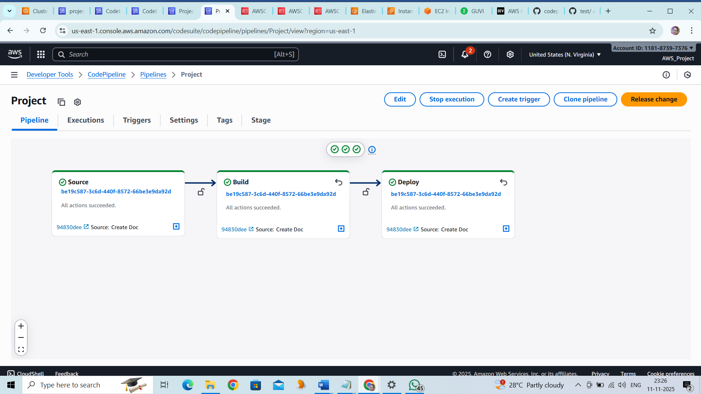

Pipeline Role:

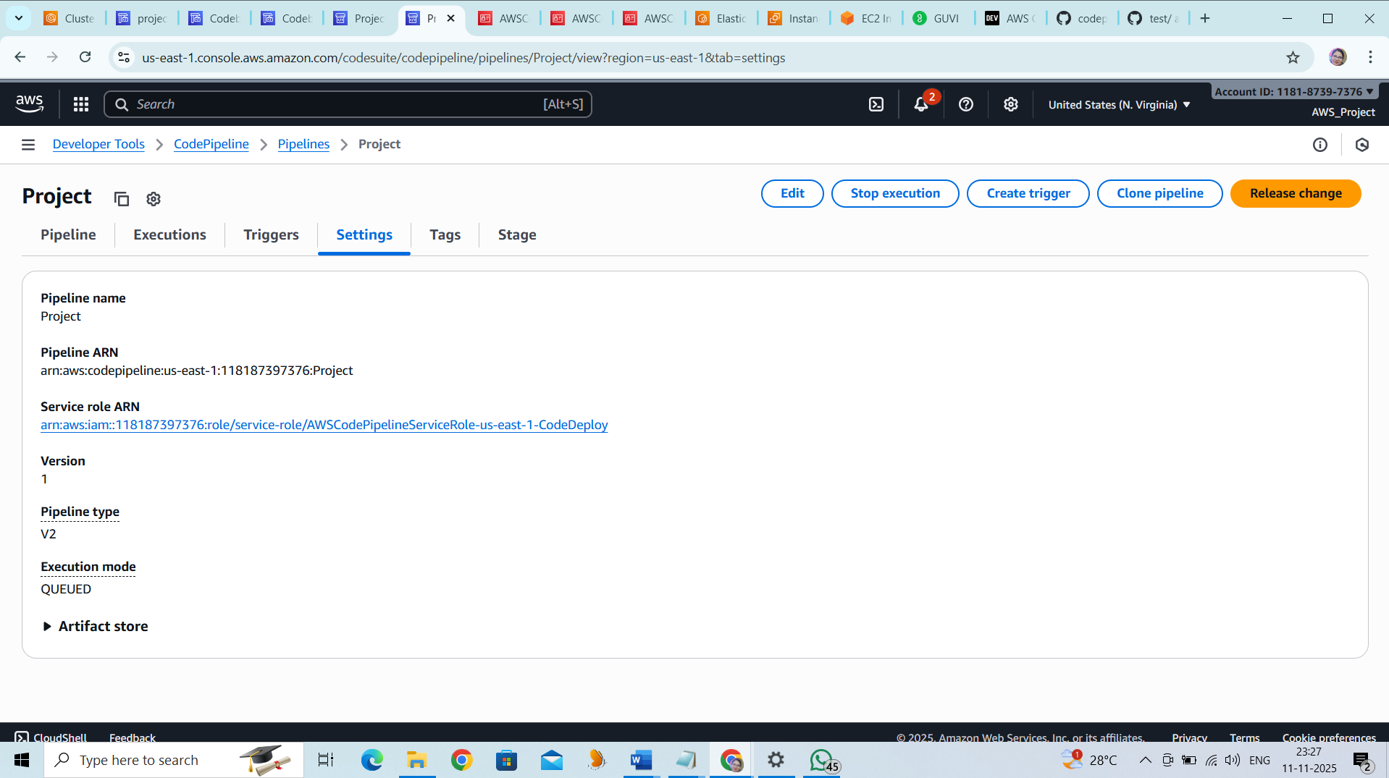

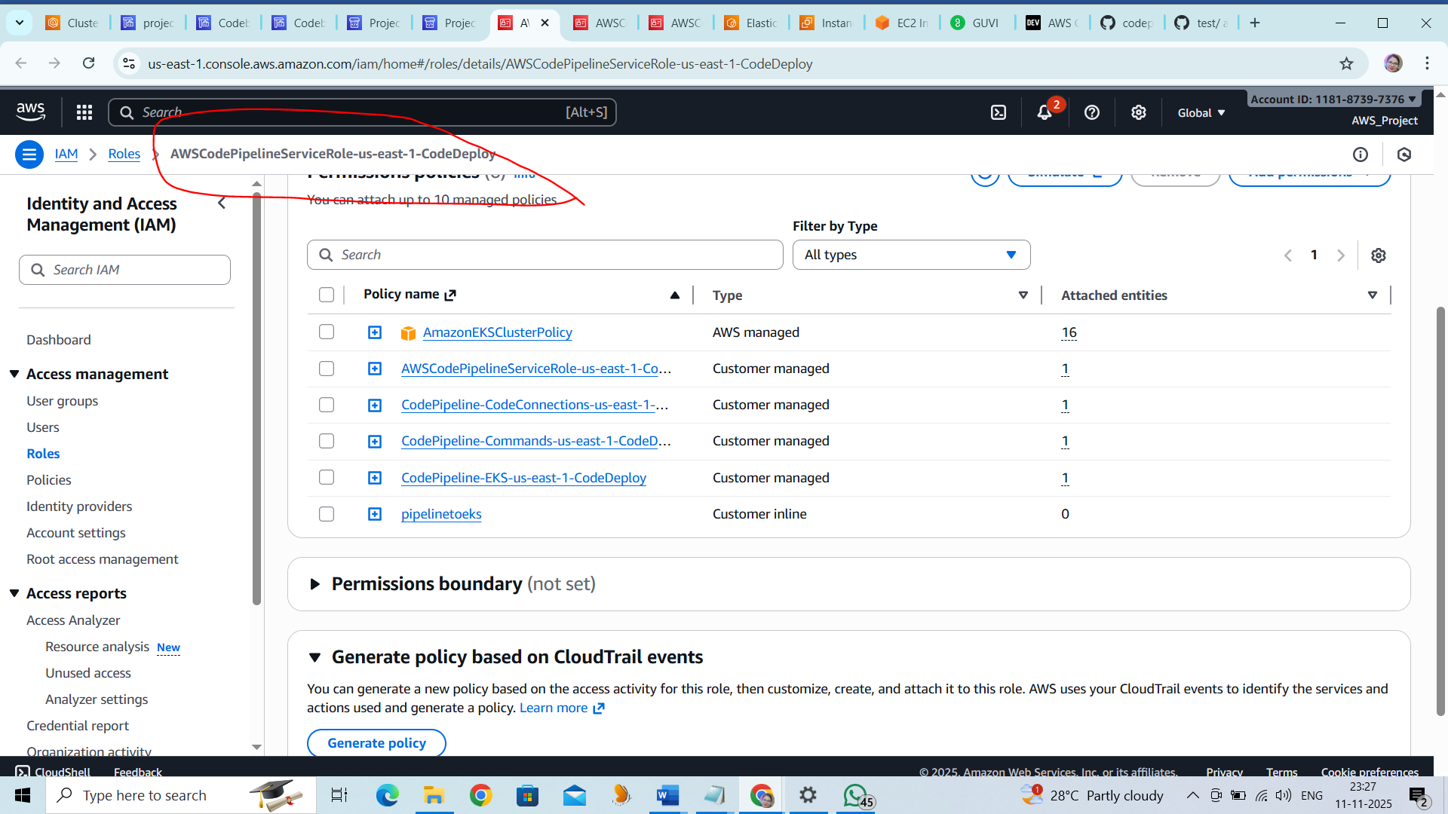
Inline permission manual attachment :

{
"Statement": [
{
"Action": [
"iam:PassRole"
],
"Resource": "*",
"Effect": "Allow",
"Condition": {
"StringEqualsIfExists": {
"iam:PassedToService": [
"cloudformation.amazonaws.com",
"elasticbeanstalk.amazonaws.com",
"ec2.amazonaws.com",
"ecs-tasks.amazonaws.com"
]
}
}
},
{
"Action": [
"codecommit:CancelUploadArchive",
"codecommit:GetBranch",
"codecommit:GetCommit",
"codecommit:GetRepository",
"codecommit:GetUploadArchiveStatus",
"codecommit:UploadArchive"
],
"Resource": "*",
"Effect": "Allow"
},
{
"Action": [
"codedeploy:CreateDeployment",
"codedeploy:GetApplication",
"codedeploy:GetApplicationRevision",
"codedeploy:GetDeployment",
"codedeploy:GetDeploymentConfig",
"codedeploy:RegisterApplicationRevision"
],
"Resource": "*",
"Effect": "Allow"
},
{
"Action": [
"codestar-connections:UseConnection"
],
"Resource": "*",
"Effect": "Allow"
},
{
"Action": [
"elasticbeanstalk:*",
"ec2:*",
"elasticloadbalancing:*",
"autoscaling:*",
"cloudwatch:*",
"s3:*",
"sns:*",
"cloudformation:*",
"rds:*",
"sqs:*",
"ecs:*",
"logs:CreateLogGroup",
"logs:CreateLogStream",
"logs:PutLogEvents"
],
"Resource": "*",
"Effect": "Allow"
},
{
"Action": [
"lambda:InvokeFunction",
"lambda:ListFunctions"
],
"Resource": "*",
"Effect": "Allow"
},
{
"Action": [
"opsworks:CreateDeployment",
"opsworks:DescribeApps",
"opsworks:DescribeCommands",
"opsworks:DescribeDeployments",
"opsworks:DescribeInstances",
"opsworks:DescribeStacks",
"opsworks:UpdateApp",
"opsworks:UpdateStack"
],
"Resource": "*",
"Effect": "Allow"
},
{
"Action": [
"cloudformation:CreateStack",
"cloudformation:DeleteStack",
"cloudformation:DescribeStacks",
"cloudformation:UpdateStack",
"cloudformation:CreateChangeSet",
"cloudformation:DeleteChangeSet",
"cloudformation:DescribeChangeSet",
"cloudformation:ExecuteChangeSet",
"cloudformation:SetStackPolicy",
"cloudformation:ValidateTemplate"
],
"Resource": "*",
"Effect": "Allow"
},
{
"Action": [
"codebuild:BatchGetBuilds",
"codebuild:StartBuild",
"codebuild:BatchGetBuildBatches",
"codebuild:StartBuildBatch"
],
"Resource": "*",
"Effect": "Allow"
},
{
"Effect": "Allow",
"Action": [
"devicefarm:ListProjects",
"devicefarm:ListDevicePools",
"devicefarm:GetRun",
"devicefarm:GetUpload",
"devicefarm:CreateUpload",
"devicefarm:ScheduleRun"
],
"Resource": "*"
},
{
"Effect": "Allow",
"Action": [
"servicecatalog:ListProvisioningArtifacts",
"servicecatalog:CreateProvisioningArtifact",
"servicecatalog:DescribeProvisioningArtifact",
"servicecatalog:DeleteProvisioningArtifact",
"servicecatalog:UpdateProduct"
],
"Resource": "*"
},
{
"Effect": "Allow",
"Action": [
"cloudformation:ValidateTemplate"
],
"Resource": "*"
},
{
"Effect": "Allow",
"Action": [
"ecr:DescribeImages"
],
"Resource": "*"
},
{
"Effect": "Allow",
"Action": [
"states:DescribeExecution",
"states:DescribeStateMachine",
"states:StartExecution"
],
"Resource": "*"
},
{
"Effect": "Allow",
"Action": [
"appconfig:StartDeployment",
"appconfig:StopDeployment",
"appconfig:GetDeployment"
],
"Resource": "*"
},
{
"Effect": "Allow",
"Action": [
"logs:CreateLogGroup",
"logs:CreateLogStream",
"logs:PutLogEvents"
],
"Resource": [
"arn:aws:logs:us-east-1:118187397376:log-group:/aws/codepipeline/eks-deploy-codepipeline",
"arn:aws:logs:us-east-1:118187397376:log-group:/aws/codepipeline/eks-deploy-codepipeline:log-stream:*"
]
},
{
"Sid": "EksClusterPolicy",
"Effect": "Allow",
"Action": "eks:DescribeCluster",
"Resource": [
"*"
]
},
{
"Sid": "EksVpcClusterPolicy",
"Effect": "Allow",
"Action": [
"ec2:DescribeDhcpOptions",
"ec2:DescribeNetworkInterfaces",
"ec2:DescribeRouteTables",
"ec2:DescribeSubnets",
"ec2:DescribeSecurityGroups",
"ec2:DescribeVpcs"
],
"Resource": [
"*"
]
},
{
"Effect": "Allow",
"Action": "ec2:CreateNetworkInterface",
"Resource": "*",
"Condition": {
"StringEqualsIfExists": {
"ec2:Subnet": [
"arn:aws:ec2:us-east-1:292170836962:subnet/subnet-example1",
"arn:aws:ec2:us-east-1:292170836962:subnet/subnet-example2"
]
}
}
},
{
"Effect": "Allow",
"Action": "ec2:CreateNetworkInterfacePermission",
"Resource": "*",
"Condition": {
"ArnEquals": {
"ec2:Subnet": [
"arn:aws:ec2:us-east-1:118187397376:subnet/subnet-example1",
"arn:aws:ec2:us-east-1:118187397376:subnet/subnet-example2"
]
}
}
},
{
"Effect": "Allow",
"Action": "ec2:DeleteNetworkInterface",
"Resource": "*",
"Condition": {
"StringEqualsIfExists": {
"ec2:Subnet": [
"arn:aws:ec2:us-east-1:xxxxx:subnet/subnet-example1",
"arn:aws:ec2:us-east-1:xxxx:subnet/subnet-example2"
]
}
}
}
],
"Version": "2012-10-17"
}

Pod Deployment:

[Container] 2025/11/04 07:48:52.262943 Running on CodeBuild On-demand
[Container] 2025/11/04 07:48:52.262954 Waiting for agent ping
[Container] 2025/11/04 07:48:52.365656 Waiting for DOWNLOAD_SOURCE
[Container] 2025/11/04 07:48:55.189053 Phase is DOWNLOAD_SOURCE
[Container] 2025/11/04 07:48:55.191297 CODEBUILD_SRC_DIR=/codebuild/output/src3088391916/src/github.com/saras88-prod/BrainTask
[Container] 2025/11/04 07:48:55.191943 YAML location is /codebuild/readonly/buildspec.yml
[Container] 2025/11/04 07:48:55.195204 Setting HTTP client timeout to higher timeout for Github and GitHub Enterprise sources
[Container] 2025/11/04 07:48:55.195341 Processing environment variables
[Container] 2025/11/04 07:48:55.372561 No runtime version selected in buildspec.
[Container] 2025/11/04 07:48:55.392464 Moving to directory /codebuild/output/src3088391916/src/github.com/saras88-prod/BrainTask
[Container] 2025/11/04 07:48:55.392583 Cache is not defined in the buildspec
[Container] 2025/11/04 07:48:55.428960 Skip cache due to: no paths specified to be cached
[Container] 2025/11/04 07:48:55.429266 Registering with agent
[Container] 2025/11/04 07:48:55.462852 Phases found in YAML: 3
[Container] 2025/11/04 07:48:55.462872 BUILD: 3 commands
[Container] 2025/11/04 07:48:55.462878 POST_BUILD: 12 commands
[Container] 2025/11/04 07:48:55.462883 PRE_BUILD: 9 commands
[Container] 2025/11/04 07:48:55.463210 Phase complete: DOWNLOAD_SOURCE State: SUCCEEDED
[Container] 2025/11/04 07:48:55.463225 Phase context status code: Message:
[Container] 2025/11/04 07:48:55.570283 Entering phase INSTALL
[Container] 2025/11/04 07:48:55.605859 Phase complete: INSTALL State: SUCCEEDED
[Container] 2025/11/04 07:48:55.605887 Phase context status code: Message:
[Container] 2025/11/04 07:48:55.636229 Entering phase PRE_BUILD
[Container] 2025/11/04 07:48:55.668773 Running command echo Logging in to Amazon ECR...
Logging in to Amazon ECR...
[Container] 2025/11/04 07:48:55.672805 Running command aws --version
aws-cli/2.31.1 Python/3.13.7 Linux/4.14.355-280.684.amzn2.x86_64 exec-env/AWS_ECS_EC2 exe/x86_64.ubuntu.22
[Container] 2025/11/04 07:49:07.415874 Running command echo Logging in to Docker Hub...
Logging in to Docker Hub...
[Container] 2025/11/04 07:49:07.419760 Running command echo $DOCKERHUB_PASSWORD | docker login -u $DOCKERHUB_USERNAME --password-stdin
WARNING! Your password will be stored unencrypted in /root/.docker/config.json.
Configure a credential helper to remove this warning. See
https://docs.docker.com/engine/reference/commandline/login/#credential-stores
Login Succeeded
[Container] 2025/11/04 07:49:07.479331 Running command aws ecr get-login-password --region $AWS_DEFAULT_REGION | docker login --username AWS --password-stdin 118187397376.dkr.ecr.$AWS_DEFAULT_REGION.amazonaws.com
WARNING! Your password will be stored unencrypted in /root/.docker/config.json.
Configure a credential helper to remove this warning. See
https://docs.docker.com/engine/reference/commandline/login/#credential-stores
Login Succeeded
[Container] 2025/11/04 07:49:08.605023 Running command echo Build started on `date`
Build started on Tue Nov 4 07:49:08 UTC 2025
[Container] 2025/11/04 07:49:08.614220 Running command echo Cloning GitHub repository...
Cloning GitHub repository...
[Container] 2025/11/04 07:49:08.618763 Running command git clone https://github.com/saras88-prod/BrainTask.git app
Cloning into 'app'...
[Container] 2025/11/04 07:49:08.787022 Running command cd app
[Container] 2025/11/04 07:49:08.790988 Phase complete: PRE_BUILD State: SUCCEEDED
[Container] 2025/11/04 07:49:08.791006 Phase context status code: Message:
[Container] 2025/11/04 07:49:08.834093 Entering phase BUILD
[Container] 2025/11/04 07:49:08.835525 Running command echo Building the Docker image...
Building the Docker image...
[Container] 2025/11/04 07:49:08.839179 Running command docker build -t $ECR_REPO_NAME:$IMAGE_TAG .
#0 building with "default" instance using docker driver
#1 [internal] load build definition from dockerfile
#1 transferring dockerfile: 408B done
#1 DONE 0.0s
#2 [auth] library/nginx:pull token for registry-1.docker.io
#2 DONE 0.0s
#3 [internal] load metadata for docker.io/library/nginx:alpine
#3 DONE 0.4s
#4 [internal] load .dockerignore
#4 transferring context: 2B done
#4 DONE 0.0s
#5 [internal] load build context
#5 transferring context: 317.98kB done
#5 DONE 0.0s
#6 [1/2] FROM docker.io/library/nginx:alpine@sha256:b3c656d55d7ad751196f21b7fd2e8d4da9cb430e32f646adcf92441b72f82b14
#6 resolve docker.io/library/nginx:alpine@sha256:b3c656d55d7ad751196f21b7fd2e8d4da9cb430e32f646adcf92441b72f82b14 0.0s done
#6 sha256:3eaba6cd10a374d9ed629c26d76a5258e20ddfa09fcef511c98aa620dcf3fae4 0B / 955B 0.1s
#6 sha256:667473807103639a0aca5b49534a216d2b64f0fb868aaa801f023da0cdd781c7 2.50kB / 2.50kB done
#6 sha256:8f6a6833e95d43ac524f1f9c5e7c1316c1f3b8e7ae5ba3db4e54b0c5b910e80a 1.84MB / 1.84MB 0.1s done
#6 sha256:194fa24e147df0010e146240d3b4bd25d04180c523dc717e4645b269991483e3 628B / 628B 0.1s
#6 sha256:df413d6ebdc834bccf63178455d406c4d25e2c2d38d2c1ab79ee5494b18e5624 0B / 403B 0.1s
#6 sha256:b3c656d55d7ad751196f21b7fd2e8d4da9cb430e32f646adcf92441b72f82b14 10.33kB / 10.33kB done
#6 sha256:d4918ca78576a537caa7b0c043051c8efc1796de33fee8724ee0fff4a1cabed9 10.96kB / 10.96kB done
#6 sha256:2d35ebdb57d9971fea0cac1582aa78935adf8058b2cc32db163c98822e5dfa1b 3.80MB / 3.80MB 0.1s done
#6 sha256:3eaba6cd10a374d9ed629c26d76a5258e20ddfa09fcef511c98aa620dcf3fae4 955B / 955B 0.1s done
#6 sha256:194fa24e147df0010e146240d3b4bd25d04180c523dc717e4645b269991483e3 628B / 628B 0.1s done
#6 sha256:df413d6ebdc834bccf63178455d406c4d25e2c2d38d2c1ab79ee5494b18e5624 403B / 403B 0.1s done
#6 extracting sha256:2d35ebdb57d9971fea0cac1582aa78935adf8058b2cc32db163c98822e5dfa1b 0.1s
#6 sha256:ff8a36d5502a57c3fc8eeff48e578ab433a03b1dd528992ba0d966ddf853309a 1.40kB / 1.40kB 0.2s done
#6 sha256:d9a55dab5954588333096b28b351999099bea5eb3c68c10e99f175b12c97198d 1.21kB / 1.21kB 0.1s done
#6 sha256:bdabb0d442710d667f4fd871b5fd215cc2a430a95b192bc508bf945b8e60999b 1.05MB / 16.97MB 0.2s
#6 extracting sha256:2d35ebdb57d9971fea0cac1582aa78935adf8058b2cc32db163c98822e5dfa1b 0.2s done
#6 sha256:bdabb0d442710d667f4fd871b5fd215cc2a430a95b192bc508bf945b8e60999b 16.97MB / 16.97MB 0.4s done
#6 extracting sha256:8f6a6833e95d43ac524f1f9c5e7c1316c1f3b8e7ae5ba3db4e54b0c5b910e80a
#6 extracting sha256:8f6a6833e95d43ac524f1f9c5e7c1316c1f3b8e7ae5ba3db4e54b0c5b910e80a 0.1s done
#6 extracting sha256:194fa24e147df0010e146240d3b4bd25d04180c523dc717e4645b269991483e3
#6 extracting sha256:194fa24e147df0010e146240d3b4bd25d04180c523dc717e4645b269991483e3 done
#6 extracting sha256:3eaba6cd10a374d9ed629c26d76a5258e20ddfa09fcef511c98aa620dcf3fae4 done
#6 extracting sha256:df413d6ebdc834bccf63178455d406c4d25e2c2d38d2c1ab79ee5494b18e5624 done
#6 extracting sha256:d9a55dab5954588333096b28b351999099bea5eb3c68c10e99f175b12c97198d
#6 extracting sha256:d9a55dab5954588333096b28b351999099bea5eb3c68c10e99f175b12c97198d done
#6 extracting sha256:ff8a36d5502a57c3fc8eeff48e578ab433a03b1dd528992ba0d966ddf853309a done
#6 extracting sha256:bdabb0d442710d667f4fd871b5fd215cc2a430a95b192bc508bf945b8e60999b
#6 extracting sha256:bdabb0d442710d667f4fd871b5fd215cc2a430a95b192bc508bf945b8e60999b 0.4s done
#6 DONE 1.7s
#7 [2/2] COPY dist/ /usr/share/nginx/html
#7 DONE 0.4s
#8 exporting to image
#8 exporting layers 0.0s done
#8 writing image sha256:c9d10026a33e9b017c9979053108c803f1262a856bcfb5e309d9259279809320 done
#8 naming to docker.io/library/brain-tasks-app:latest done
#8 DONE 0.0s
[Container] 2025/11/04 07:49:11.581093 Running command docker tag $ECR_REPO_NAME:$IMAGE_TAG 118187397376.dkr.ecr.$AWS_DEFAULT_REGION.amazonaws.com/$ECR_REPO_NAME:$IMAGE_TAG
[Container] 2025/11/04 07:49:11.613981 Phase complete: BUILD State: SUCCEEDED
[Container] 2025/11/04 07:49:11.614003 Phase context status code: Message:
[Container] 2025/11/04 07:49:11.652074 Entering phase POST_BUILD
[Container] 2025/11/04 07:49:11.654116 Running command echo Pushing the Docker image to ECR...
Pushing the Docker image to ECR...
[Container] 2025/11/04 07:49:11.669260 Running command docker push 118187397376.dkr.ecr.$AWS_DEFAULT_REGION.amazonaws.com/$ECR_REPO_NAME:$IMAGE_TAG
The push refers to repository [118187397376.dkr.ecr.us-east-1.amazonaws.com/brain-tasks-app]
1c4a6313bfc7: Preparing
25906c27b84d: Preparing
99ea4bde418d: Preparing
3297b9628ff3: Preparing
b74d92be8225: Preparing
2c79d5d895bb: Preparing
2660a7d4b906: Preparing
50b58ca2a3f5: Preparing
256f393e029f: Preparing
2660a7d4b906: Waiting
50b58ca2a3f5: Waiting
256f393e029f: Waiting
2c79d5d895bb: Waiting
b74d92be8225: Layer already exists
25906c27b84d: Layer already exists
99ea4bde418d: Layer already exists
3297b9628ff3: Layer already exists
2c79d5d895bb: Layer already exists
256f393e029f: Layer already exists
50b58ca2a3f5: Layer already exists
2660a7d4b906: Layer already exists
1c4a6313bfc7: Pushed
latest: digest: sha256:729dd9b4b263944f33f6f6caf622d9163ba521cf40ba7b802f1c7043d9ae8816 size: 2199
[Container] 2025/11/04 07:49:13.254567 Running command echo Build completed on `date`
Build completed on Tue Nov 4 07:49:13 UTC 2025
[Container] 2025/11/04 07:49:13.261196 Running command echo Updating kubeconfig for EKS cluster...
Updating kubeconfig for EKS cluster...
[Container] 2025/11/04 07:49:13.266751 Running command aws eks update-kubeconfig --region us-east-1 --name brain-tasks-clusters
Added new context arn:aws:eks:us-east-1:118187397376:cluster/brain-tasks-clusters to /root/.kube/config
[Container] 2025/11/04 07:49:14.287873 Running command echo Applying Kubernetes deployment...
Applying Kubernetes deployment...
[Container] 2025/11/04 07:49:14.294085 Running command kubectl apply -f k8s/deployment.yaml -n default
deployment.apps/brain-tasks-deployment unchanged
[Container] 2025/11/04 07:49:18.824291 Running command echo Updating Kubernetes deployment with new image...
Updating Kubernetes deployment with new image...
[Container] 2025/11/04 07:49:18.830420 Running command kubectl set image deployment/brain-tasks-deployment brain-tasks-container=118187397376.dkr.ecr.$AWS_DEFAULT_REGION.amazonaws.com/$ECR_REPO_NAME:$IMAGE_TAG -n default
[Container] 2025/11/04 07:49:19.704202 Running command echo Applying service manifest
Applying service manifest
[Container] 2025/11/04 07:49:19.710306 Running command kubectl apply -f k8s/service.yaml -n default
service/brain-tasks-service created
[Container] 2025/11/04 07:49:20.613730 Running command echo Deployment to EKS completed successfully!
Deployment to EKS completed successfully!
[Container] 2025/11/04 07:49:20.620122 Phase complete: POST_BUILD State: SUCCEEDED
[Container] 2025/11/04 07:49:20.620142 Phase context status code: Message:
[Container] 2025/11/04 07:49:20.661634 Set report auto-discover timeout to 5 seconds
[Container] 2025/11/04 07:49:20.661761 Expanding base directory path: .
[Container] 2025/11/04 07:49:20.663329 Assembling file list
[Container] 2025/11/04 07:49:20.663342 Expanding .
[Container] 2025/11/04 07:49:20.664950 Expanding file paths for base directory .
[Container] 2025/11/04 07:49:20.664962 Assembling file list
[Container] 2025/11/04 07:49:20.664965 Expanding **/*
[Container] 2025/11/04 07:49:20.667608 No matching auto-discover report paths found
[Container] 2025/11/04 07:49:20.667836 Report auto-discover file discovery took 0.006202 seconds
[Container] 2025/11/04 07:49:20.667852 Phase complete: UPLOAD_ARTIFACTS State: SUCCEEDED
[Container] 2025/11/04 07:49:20.667858 Phase context status code: Message:

EKS Cluster Node :
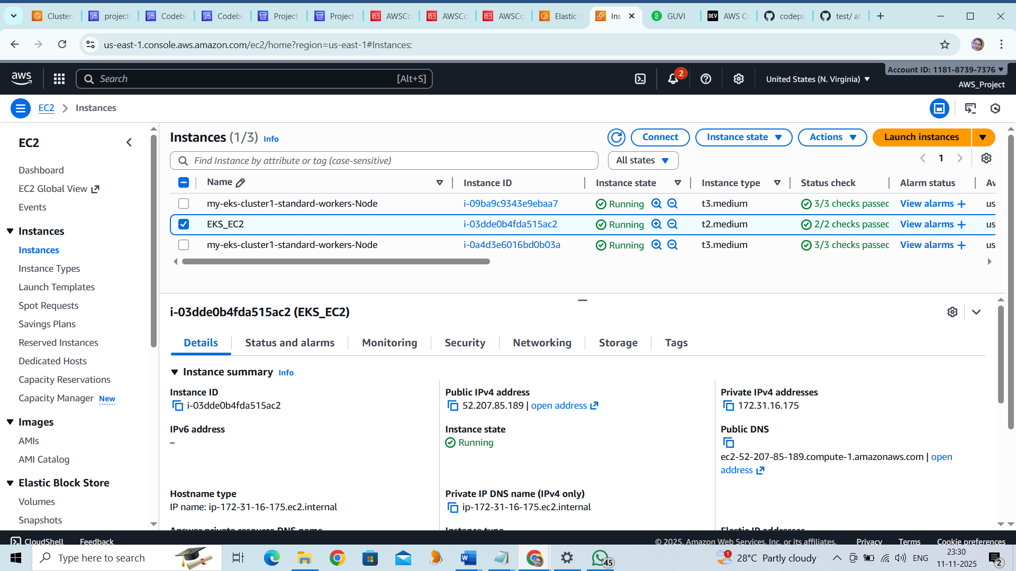

EKS cluster:
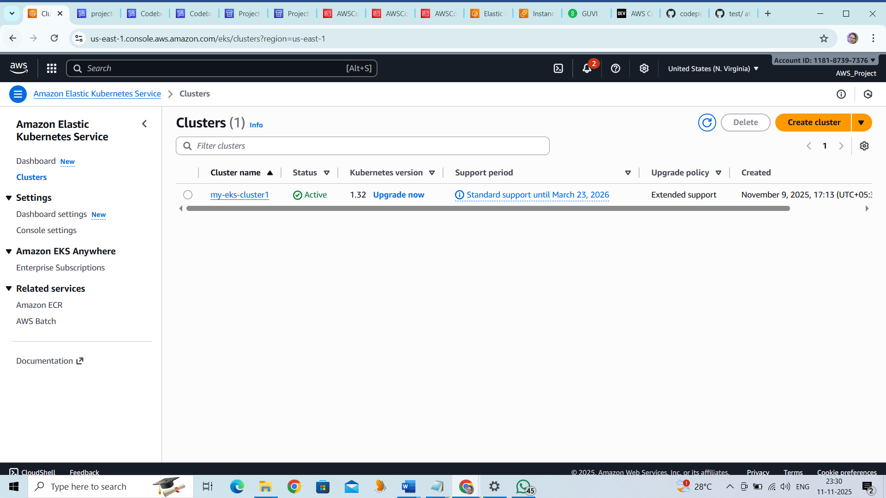

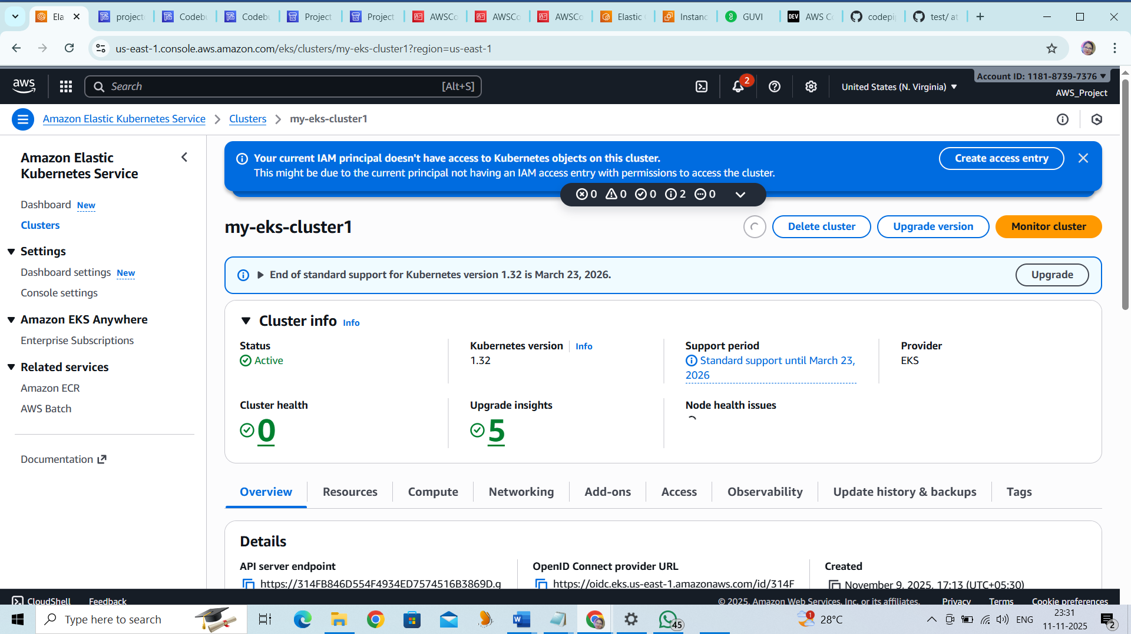

Cluster Nodes and services:

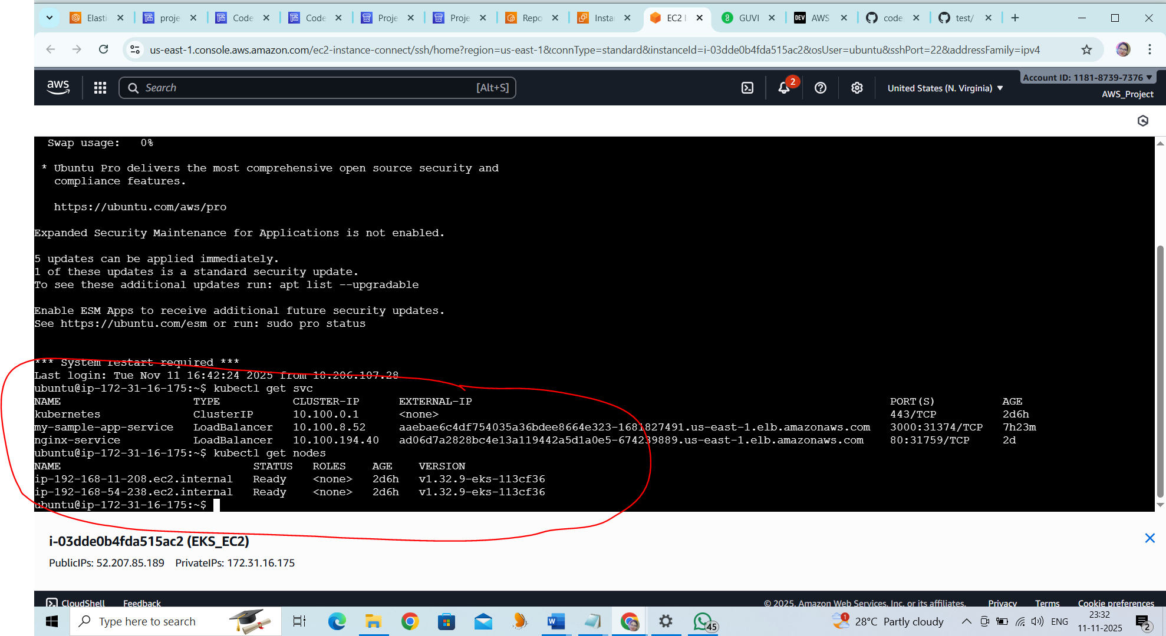

Cluster Pods created with application details:

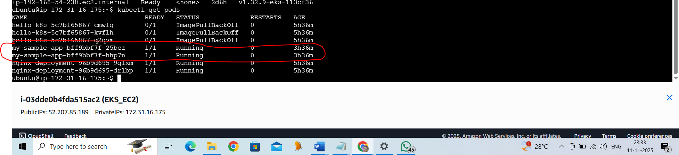

Application deployed inside the pods:

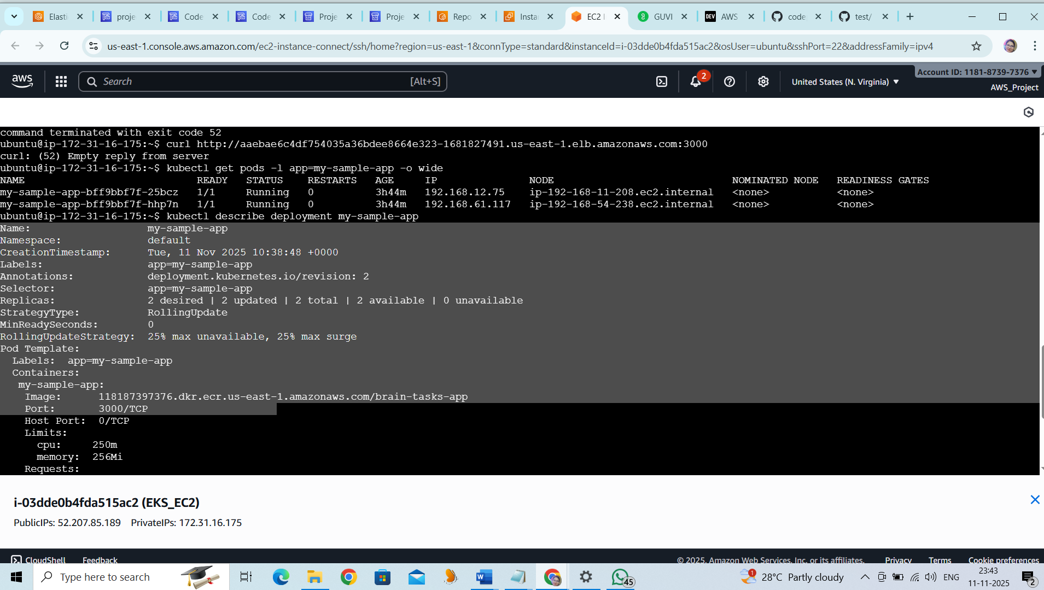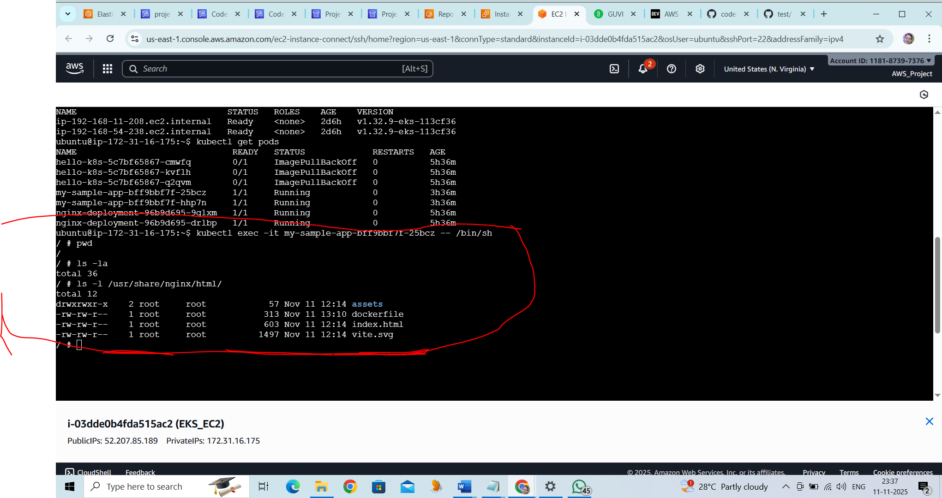

kubectl describe svc my-sample-app-service
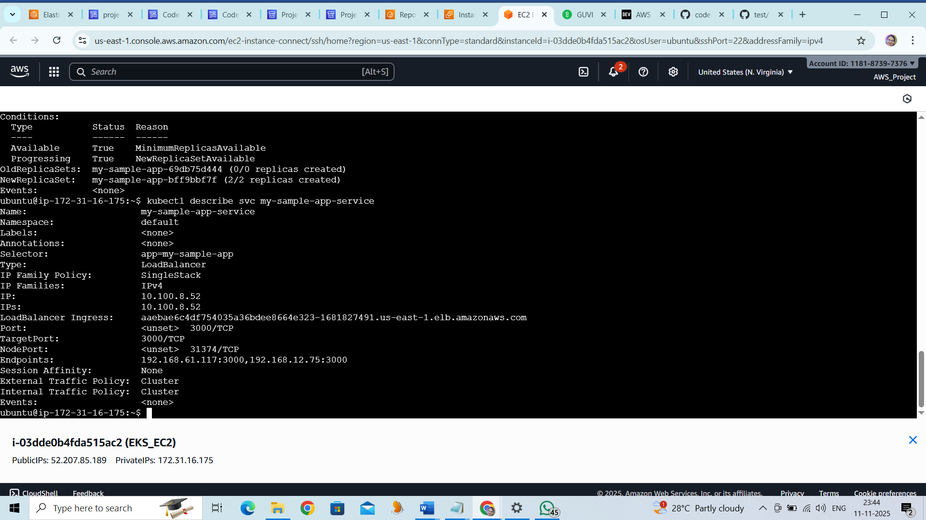

Codebuild yml:
version: 0.2

env:
variables:
# Name of your ECR repository
ECR_REPO_NAME: brain-tasks-app
# AWS region
AWS_DEFAULT_REGION: us-east-1
# Docker image tag
IMAGE_TAG: latest
DOCKERHUB_PASSWORD: dckr_pat_s45MuxORVSJONytj0wvAnREY9ys
DOCKERHUB_USERNAME: saraswathi6

phases:
pre_build:
commands:
- echo Logging in to Amazon ECR...
- aws --version
- echo Logging in to Docker Hub...
- echo $DOCKERHUB_PASSWORD | docker login -u $DOCKERHUB_USERNAME --password-stdin
- aws ecr get-login-password --region $AWS_DEFAULT_REGION | docker login --username AWS --password-stdin 118187397376.dkr.ecr.$AWS_DEFAULT_REGION.amazonaws.com
- echo Build started on `date`
- echo Cloning GitHub repository...
- git clone https://github.com/saras88-prod/test.git app
- cd app
build:
commands:
- echo Building the Docker image...
- docker build -t $ECR_REPO_NAME:$IMAGE_TAG .
- docker tag $ECR_REPO_NAME:$IMAGE_TAG 118187397376.dkr.ecr.$AWS_DEFAULT_REGION.amazonaws.com/$ECR_REPO_NAME:$IMAGE_TAG
post_build:
commands:
- echo Pushing the Docker image to ECR...
- docker push 118187397376.dkr.ecr.$AWS_DEFAULT_REGION.amazonaws.com/$ECR_REPO_NAME:$IMAGE_TAG
- echo Build completed on `date`

artifacts:
files: []

CodeDeploy:

Log:
[Container] 2025/11/11 16:59:49.784673 Running on CodeBuild On-demand
[Container] 2025/11/11 16:59:49.784684 Waiting for agent ping
[Container] 2025/11/11 16:59:49.986051 Waiting for DOWNLOAD_SOURCE
[Container] 2025/11/11 16:59:51.251210 Phase is DOWNLOAD_SOURCE
[Container] 2025/11/11 16:59:51.252187 CODEBUILD_SRC_DIR=/codebuild/output/src1491147807/src
[Container] 2025/11/11 16:59:51.252692 YAML location is /codebuild/readonly/buildspec.yml
[Container] 2025/11/11 16:59:51.256153 Setting HTTP client timeout to higher timeout for S3 source
[Container] 2025/11/11 16:59:51.256239 Processing environment variables
[Container] 2025/11/11 16:59:51.481137 No runtime version selected in buildspec.
[Container] 2025/11/11 16:59:51.528546 Moving to directory /codebuild/output/src1491147807/src
[Container] 2025/11/11 16:59:51.528571 Cache is not defined in the buildspec
[Container] 2025/11/11 16:59:51.576474 Skip cache due to: no paths specified to be cached
[Container] 2025/11/11 16:59:51.576888 Registering with agent
[Container] 2025/11/11 16:59:51.619863 Phases found in YAML: 1
[Container] 2025/11/11 16:59:51.619880 BUILD: 7 commands
[Container] 2025/11/11 16:59:51.620250 Phase complete: DOWNLOAD_SOURCE State: SUCCEEDED
[Container] 2025/11/11 16:59:51.620265 Phase context status code: Message:
[Container] 2025/11/11 16:59:51.770952 Entering phase INSTALL
[Container] 2025/11/11 16:59:51.835771 Phase complete: INSTALL State: SUCCEEDED
[Container] 2025/11/11 16:59:51.835788 Phase context status code: Message:
[Container] 2025/11/11 16:59:51.929043 Entering phase PRE_BUILD
[Container] 2025/11/11 16:59:51.947829 Phase complete: PRE_BUILD State: SUCCEEDED
[Container] 2025/11/11 16:59:51.947849 Phase context status code: Message:
[Container] 2025/11/11 16:59:52.036847 Entering phase BUILD
[Container] 2025/11/11 16:59:52.083086 Running command mkdir -p /tmp/cp-action-source
[Container] 2025/11/11 16:59:52.092065 Running command export CODEPIPELINE_INPUT_ACTION_SOURCE_PATH=/tmp/cp-action-source
[Container] 2025/11/11 16:59:52.099346 Running command curl "https://dnii66ogcg9px.cloudfront.net/deploy-eks-aws-1/0.1.0.tgz" -o /tmp/cp-action-source/action-archive.tgz
% Total % Received % Xferd Average Speed Time Time Time Current
Dload Upload Total Spent Left Speed
0 0 0 0 0 0 0 0 --:--:-- --:--:-- --:--:-- 0
100 33.3M 100 33.3M 0 0 261M 0 --:--:-- --:--:-- --:--:-- 262M
[Container] 2025/11/11 16:59:52.793192 Running command tar -xvzf /tmp/cp-action-source/action-archive.tgz --strip-components=1 -C /tmp/cp-action-source
package/dist/helm/helm
package/dist/kubectl/kubectl
package/dist/index.js
package/dist/validationUtils.js
package/package.json
package/dist/index.d.ts.map
package/dist/index.js.map
package/dist/validationUtils.d.ts.map
package/dist/validationUtils.js.map
package/dist/index.d.ts
package/dist/validationUtils.d.ts
[Container] 2025/11/11 16:59:53.653981 Running command node $CODEPIPELINE_INPUT_ACTION_SOURCE_PATH/dist/index.js
Logging in to Amazon EKS cluster.
Running command: aws eks update-kubeconfig --region us-east-1 --name my-eks-cluster1
Installing kubectl...
Running command: chmod +x /tmp/cp-action-source/dist/kubectl/kubectl && sudo mv /tmp/cp-action-source/dist/kubectl/kubectl /usr/local/bin/kubectl
Applying Kubernetes manifests.
Running command: kubectl apply -f deployment.yaml
Resources to watch: [ ]
Action completed.
[Container] 2025/11/11 17:00:07.648543 Running command [ -f /tmp/cp-action-source/action-output-variables.sh ] && chmod 755 /tmp/cp-action-source/action-output-variables.sh && source /tmp/cp-action-source/action-output-variables.sh || true
[Container] 2025/11/11 17:00:07.656929 Running command if [[ ! -z $CodePipeline_ErrorCode || ! -z $CodePipeline_ErrorSummary ]]; then exit 1; fi
[Container] 2025/11/11 17:00:07.680062 Phase complete: BUILD State: SUCCEEDED
[Container] 2025/11/11 17:00:07.680078 Phase context status code: Message:
[Container] 2025/11/11 17:00:07.740872 Entering phase POST_BUILD
[Container] 2025/11/11 17:00:07.763040 Phase complete: POST_BUILD State: SUCCEEDED
[Container] 2025/11/11 17:00:07.763060 Phase context status code: Message:

Deployment.yaml:
apiVersion: apps/v1
kind: Deployment
metadata:
name: my-sample-app
namespace: default
labels:
app: my-sample-app
spec:
replicas: 2
selector:
matchLabels:
app: my-sample-app
template:
metadata:
labels:
app: my-sample-app
spec:
containers:
- name: my-sample-app
image: 118187397376.dkr.ecr.us-east-1.amazonaws.com/brain-tasks-app
imagePullPolicy: Always
ports:
- containerPort: 3000
resources:
requests:
cpu: "100m"
memory: "128Mi"
limits:
cpu: "250m"
memory: "256Mi"
env:
- name: ENVIRONMENT
value: "production"
---
apiVersion: v1
kind: Service
metadata:
name: my-sample-app-service
namespace: default
spec:
type: LoadBalancer # Use ClusterIP for internal-only
selector:
app: my-sample-app
ports:
- protocol: TCP
port: 3000
targetPort: 3000

Cloudwatch monitor:

Pod LoadBalancer ARN:

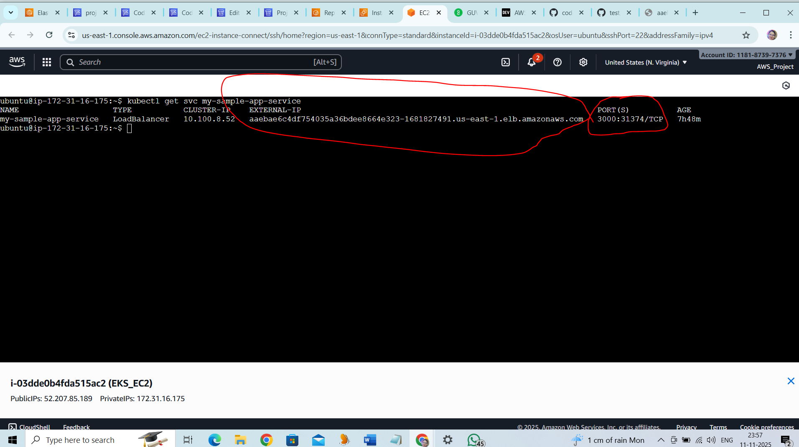

CloudWatch Logs to monitor the application:
Monitoring:
- Use CloudWatch Logs to track build, deploy, and application logs.

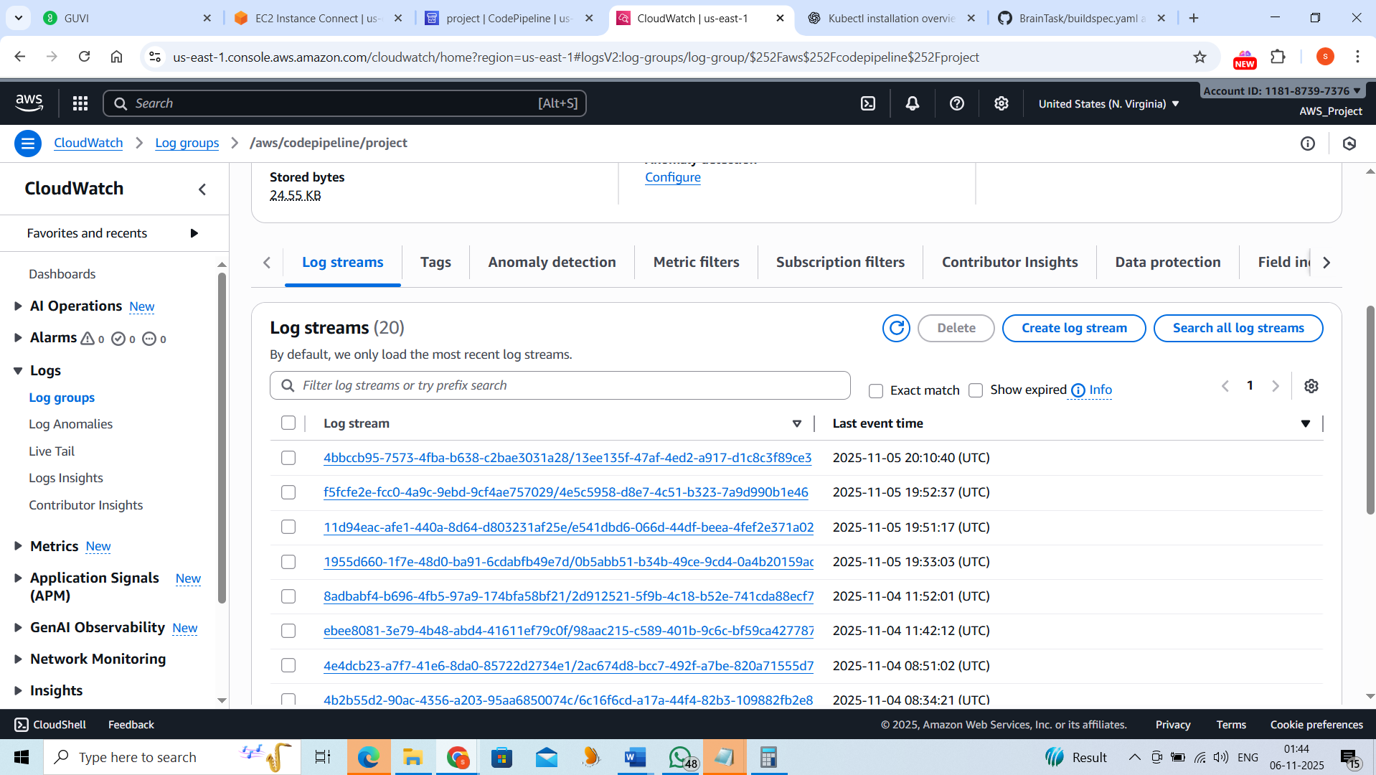

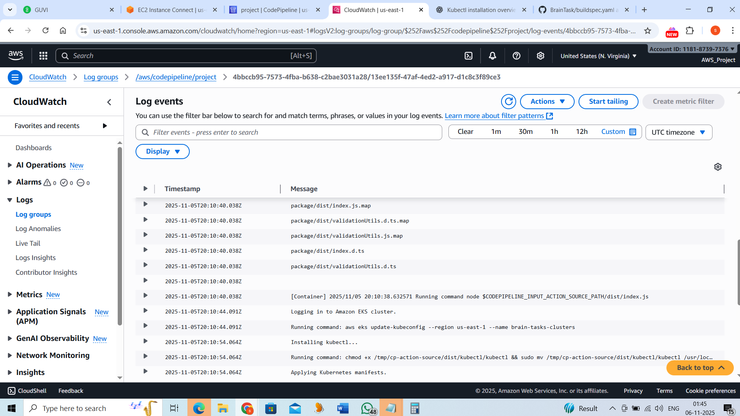

Pods Deployment:
Application deployed into the EKS pods using the code deploy kubectl concept.
Step 1:
Source formation by connecting the Pipeline with the Github public repository “test” .
Below log stats that application image from the ECR private repository has been successfully deployed into the EKS cluster successfully.
ECR Image :
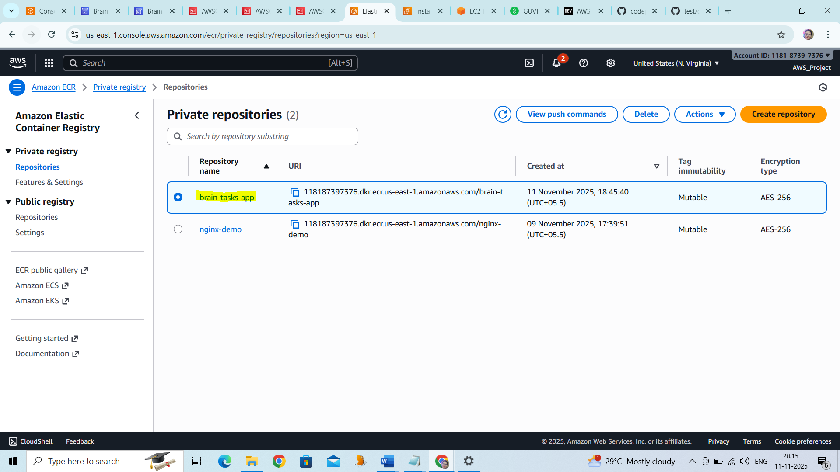

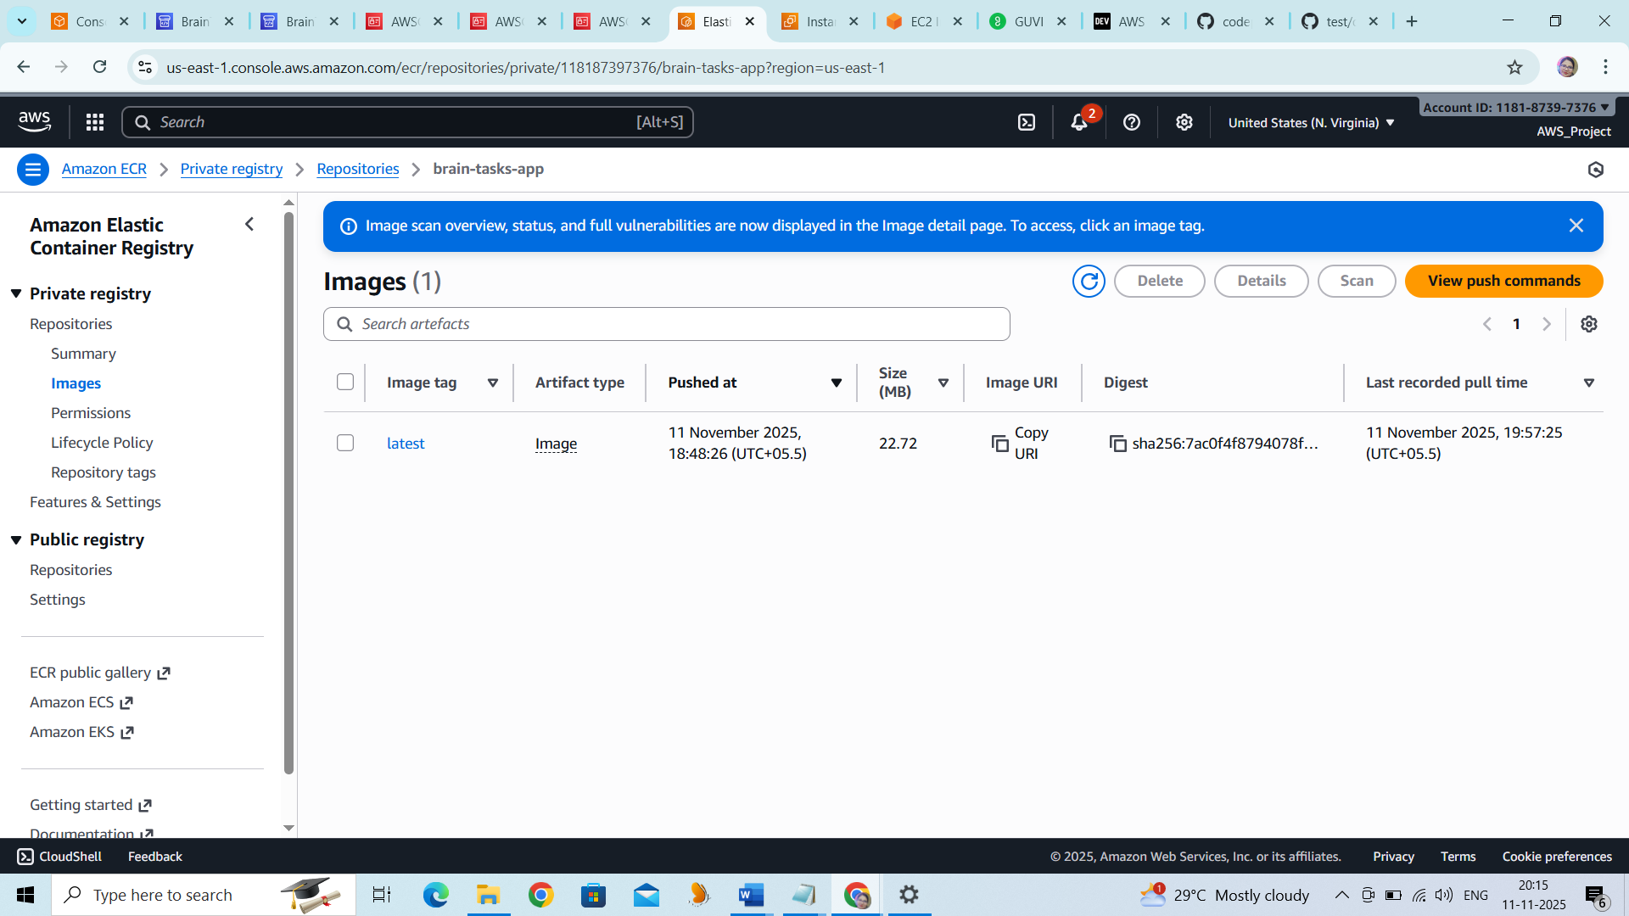
Pipeline Service Role : arn:aws:iam::118187397376:role/service-role/AWSCodePipelineServiceRole-us-east-1-CodeDeploy

CodeDeploy Yaml file :
apiVersion: apps/v1
kind: Deployment
metadata:
name: my-sample-app
namespace: default
labels:
app: my-sample-app
spec:
replicas: 2
selector:
matchLabels:
app: my-sample-app
template:
metadata:
labels:
app: my-sample-app
spec:
containers:
- name: my-sample-app
image: 118187397376.dkr.ecr.us-east-1.amazonaws.com/brain-tasks-app
imagePullPolicy: Always
ports:
- containerPort: 3000
resources:
requests:
cpu: "100m"
memory: "128Mi"
limits:
cpu: "250m"
memory: "256Mi"
env:
- name: ENVIRONMENT
value: "production"
---
apiVersion: v1
kind: Service
metadata:
name: my-sample-app-service
namespace: default
spec:
type: LoadBalancer # Use ClusterIP for internal-only
selector:
app: my-sample-app
ports:
- protocol: TCP
port: 3000
targetPort: 3000

Log File :
[Container] 2025/11/11 14:27:04.022807 Running on CodeBuild On-demand
[Container] 2025/11/11 14:27:04.022827 Waiting for agent ping
[Container] 2025/11/11 14:27:04.224481 Waiting for DOWNLOAD_SOURCE
[Container] 2025/11/11 14:27:05.351980 Phase is DOWNLOAD_SOURCE
[Container] 2025/11/11 14:27:05.353275 CODEBUILD_SRC_DIR=/codebuild/output/src3342698241/src
[Container] 2025/11/11 14:27:05.353891 YAML location is /codebuild/readonly/buildspec.yml
[Container] 2025/11/11 14:27:05.356312 Setting HTTP client timeout to higher timeout for S3 source
[Container] 2025/11/11 14:27:05.356799 Processing environment variables
[Container] 2025/11/11 14:27:05.642423 No runtime version selected in buildspec.
[Container] 2025/11/11 14:27:05.691138 Moving to directory /codebuild/output/src3342698241/src
[Container] 2025/11/11 14:27:05.691168 Cache is not defined in the buildspec
[Container] 2025/11/11 14:27:05.745420 Skip cache due to: no paths specified to be cached
[Container] 2025/11/11 14:27:05.745684 Registering with agent
[Container] 2025/11/11 14:27:05.803673 Phases found in YAML: 1
[Container] 2025/11/11 14:27:05.803693 BUILD: 7 commands
[Container] 2025/11/11 14:27:05.804026 Phase complete: DOWNLOAD_SOURCE State: SUCCEEDED
[Container] 2025/11/11 14:27:05.804039 Phase context status code: Message:
[Container] 2025/11/11 14:27:05.970913 Entering phase INSTALL
[Container] 2025/11/11 14:27:06.056628 Phase complete: INSTALL State: SUCCEEDED
[Container] 2025/11/11 14:27:06.056649 Phase context status code: Message:
[Container] 2025/11/11 14:27:06.106438 Entering phase PRE_BUILD
[Container] 2025/11/11 14:27:06.125187 Phase complete: PRE_BUILD State: SUCCEEDED
[Container] 2025/11/11 14:27:06.125208 Phase context status code: Message:
[Container] 2025/11/11 14:27:06.186312 Entering phase BUILD
[Container] 2025/11/11 14:27:06.245888 Running command mkdir -p /tmp/cp-action-source
[Container] 2025/11/11 14:27:06.254387 Running command export CODEPIPELINE_INPUT_ACTION_SOURCE_PATH=/tmp/cp-action-source
[Container] 2025/11/11 14:27:06.261724 Running command curl "https://dnii66ogcg9px.cloudfront.net/deploy-eks-aws-1/0.1.0.tgz" -o /tmp/cp-action-source/action-archive.tgz
% Total % Received % Xferd Average Speed Time Time Time Current
Dload Upload Total Spent Left Speed
0 0 0 0 0 0 0 0 --:--:-- --:--:-- --:--:-- 0
100 33.3M 100 33.3M 0 0 269M 0 --:--:-- --:--:-- --:--:-- 271M
[Container] 2025/11/11 14:27:07.225718 Running command tar -xvzf /tmp/cp-action-source/action-archive.tgz --strip-components=1 -C /tmp/cp-action-source
package/dist/helm/helm
package/dist/kubectl/kubectl
package/dist/index.js
package/dist/validationUtils.js
package/package.json
package/dist/index.d.ts.map
package/dist/index.js.map
package/dist/validationUtils.d.ts.map
package/dist/validationUtils.js.map
package/dist/index.d.ts
package/dist/validationUtils.d.ts
[Container] 2025/11/11 14:27:08.018789 Running command node $CODEPIPELINE_INPUT_ACTION_SOURCE_PATH/dist/index.js
Logging in to Amazon EKS cluster.
Running command: aws eks update-kubeconfig --region us-east-1 --name my-eks-cluster1
Installing kubectl...
Running command: chmod +x /tmp/cp-action-source/dist/kubectl/kubectl && sudo mv /tmp/cp-action-source/dist/kubectl/kubectl /usr/local/bin/kubectl
Applying Kubernetes manifests.
Running command: kubectl apply -f deployment.yaml
Resources to watch: [ my-sample-app ]
Running command: kubectl rollout status -w deployment.apps/my-sample-app
deployment.apps my-sample-app finished with message: Waiting for deployment "my-sample-app" rollout to finish: 1 out of 2 new replicas have been updated...
Waiting for deployment "my-sample-app" rollout to finish: 1 out of 2 new replicas have been updated...
Waiting for deployment "my-sample-app" rollout to finish: 1 out of 2 new replicas have been updated...
Waiting for deployment "my-sample-app" rollout to finish: 1 old replicas are pending termination...
Waiting for deployment "my-sample-app" rollout to finish: 1 old replicas are pending termination...
Waiting for deployment "my-sample-app" rollout to finish: 1 old replicas are pending termination...
deployment "my-sample-app" successfully rolled out
Action completed.
[Container] 2025/11/11 14:27:30.789261 Running command [ -f /tmp/cp-action-source/action-output-variables.sh ] && chmod 755 /tmp/cp-action-source/action-output-variables.sh && source /tmp/cp-action-source/action-output-variables.sh || true
[Container] 2025/11/11 14:27:30.798276 Running command if [[ ! -z $CodePipeline_ErrorCode || ! -z $CodePipeline_ErrorSummary ]]; then exit 1; fi
[Container] 2025/11/11 14:27:30.823352 Phase complete: BUILD State: SUCCEEDED
[Container] 2025/11/11 14:27:30.823372 Phase context status code: Message:
[Container] 2025/11/11 14:27:30.878300 Entering phase POST_BUILD
[Container] 2025/11/11 14:27:30.898642 Phase complete: POST_BUILD State: SUCCEEDED
[Container] 2025/11/11 14:27:30.898664 Phase context status code: Message:

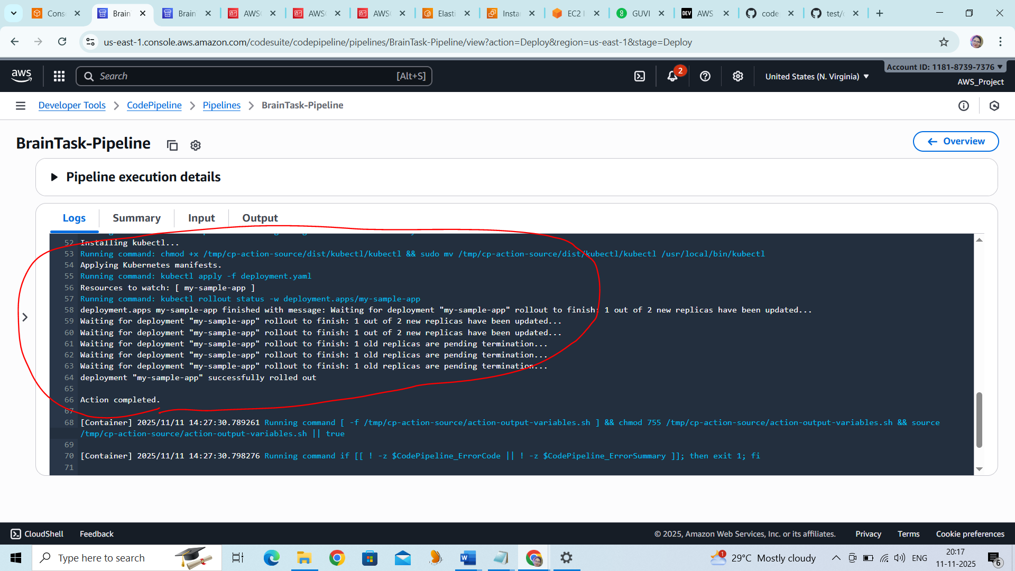

Pipeline :
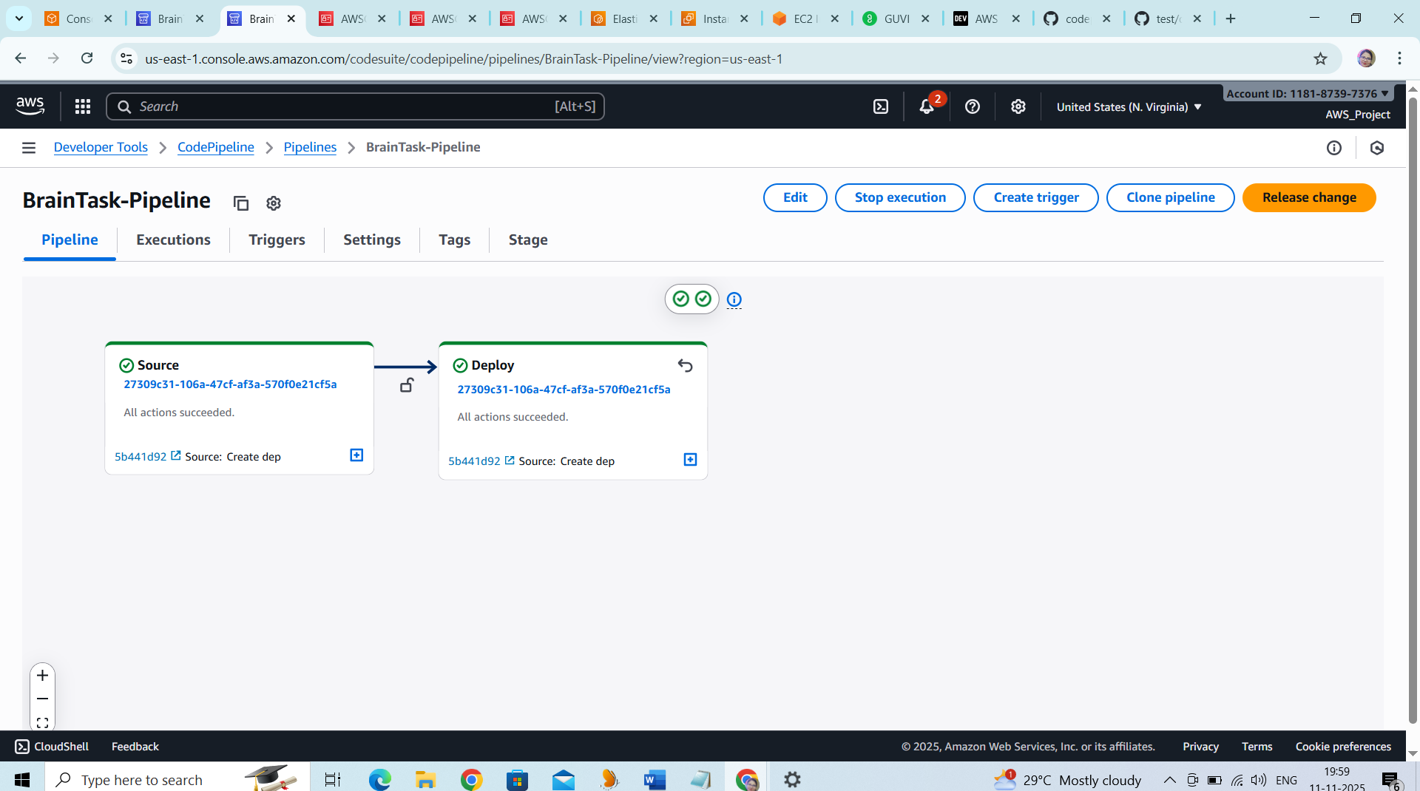
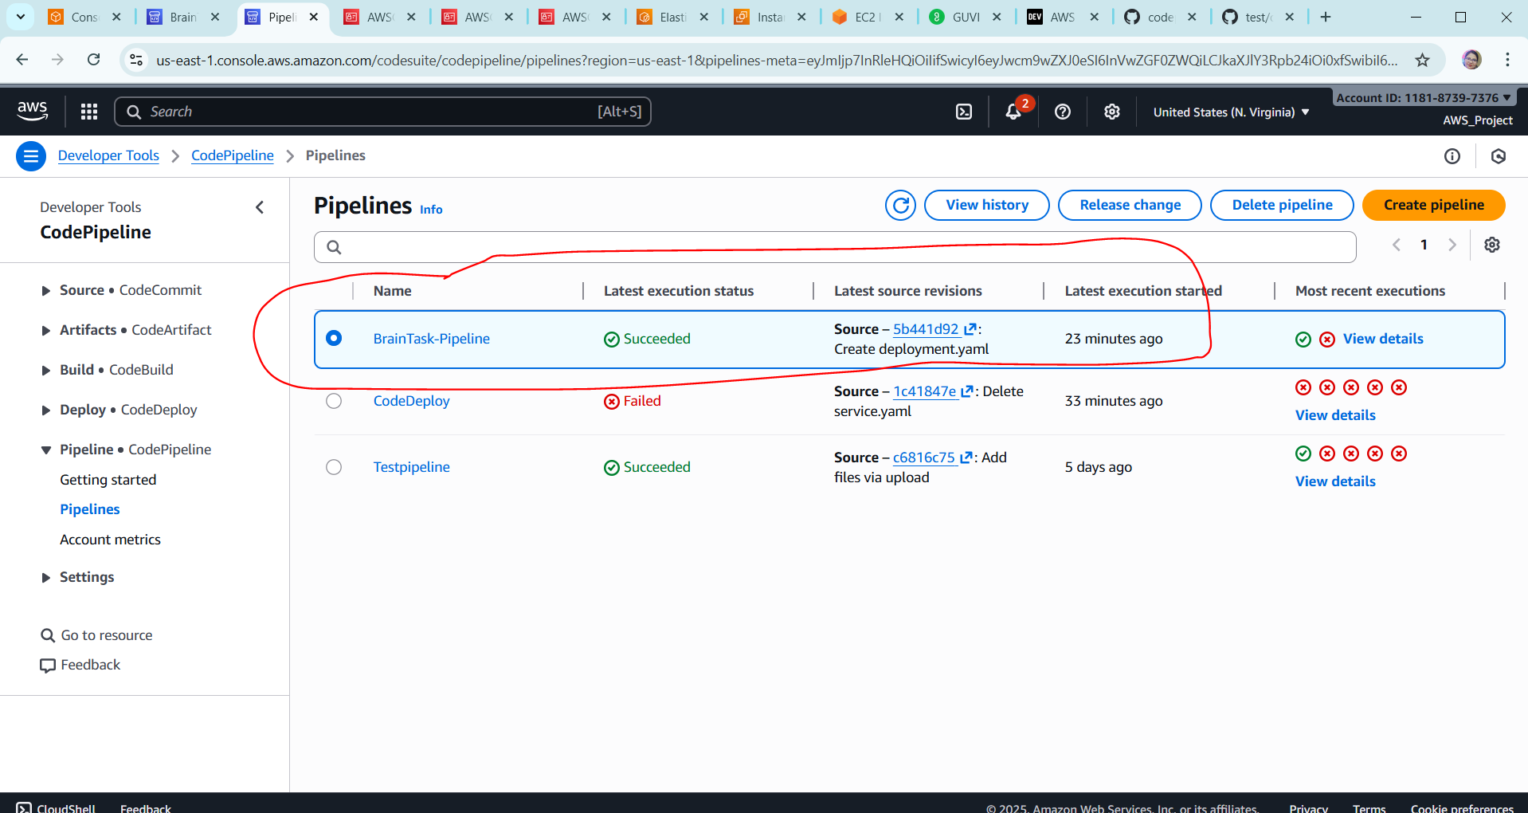

GitHub, CodeBuild and code Deploy:

