Lab # 03
OPERATING SYSTEM
Submitted by:
sara saqib
Submitted to:
sir Ihtasham Asif
Program:
Software Engineering 5C
Task 1: pwd
Purpose: To display the current working directory.
Explanation: This command tells us where we are currently working in the Linux file system.
Task 2: cd /etc
Purpose: To change the current directory.
Explanation: This command moves us into the /etc directory, which contains system configuration files and settings.
Task 3: cd ..
Purpose: To move to the parent directory.

Explanation: This command takes us one level up from our current directory.
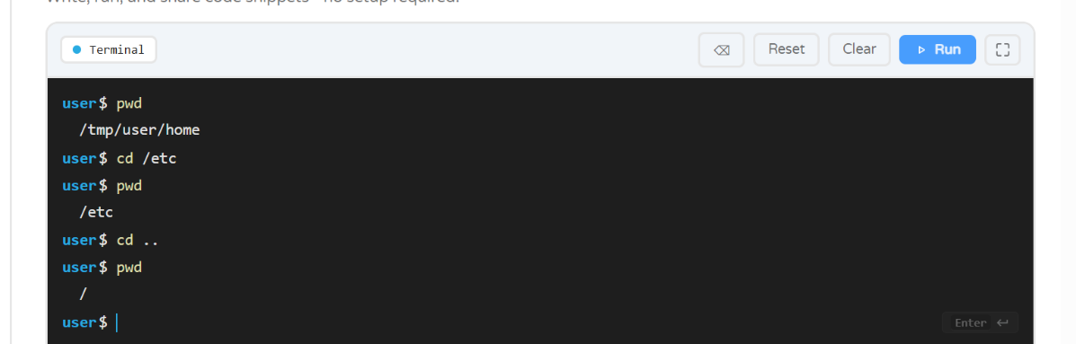
Task 4: cd /
Purpose: To move to the root directory.
Explanation: This command takes us to /, the starting point of the Linux file system.
Task 5: ls /
Purpose: To list the contents of the root directory.
Explanation: This command displays the files and directories located in the root directory without moving us there.
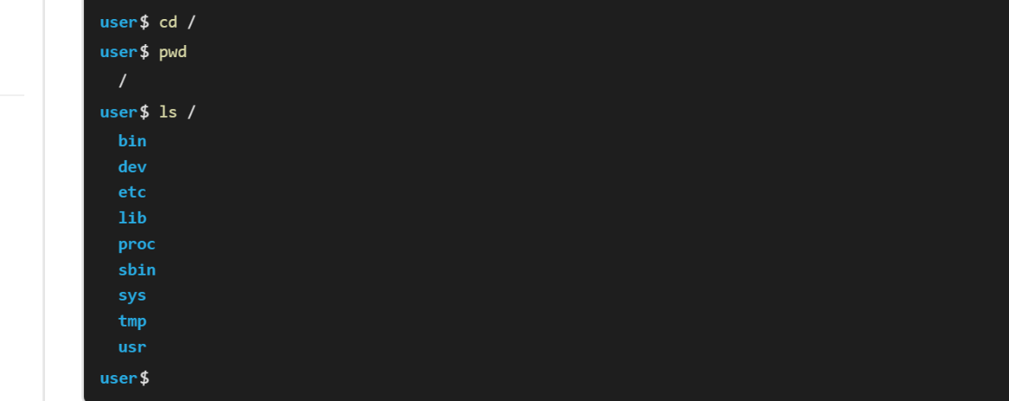
Task 6: ls -l /
Purpose: To display detailed information about the root directory's contents.
Explanation: This command shows details such as permissions, file owners, sizes, and modification dates.
Task 7: ls /etc
Purpose: To list the contents of the /etc directory.
Explanation: This command displays the files and directories inside /etc without changing our current location.
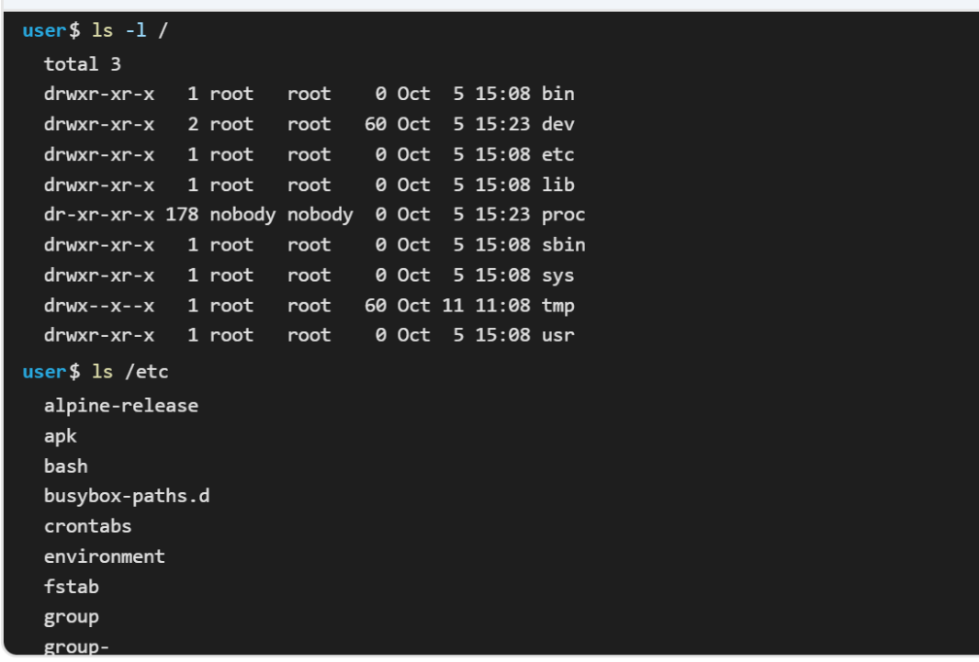
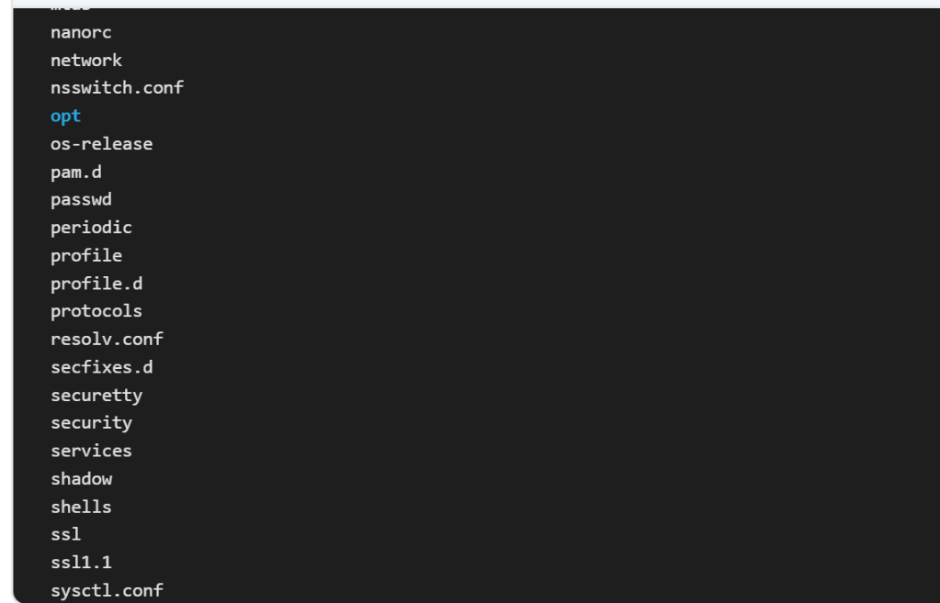
Task 8: ls /bin /sbin
Purpose: To list the contents of /bin and /sbin.
Explanation: This command displays the commands and programs stored in both directories without moving into them.
Task 9: ls ~
Purpose: To list the contents of the home directory.
Explanation: The ~ symbol represents the current user's home directory. This command displays its contents.
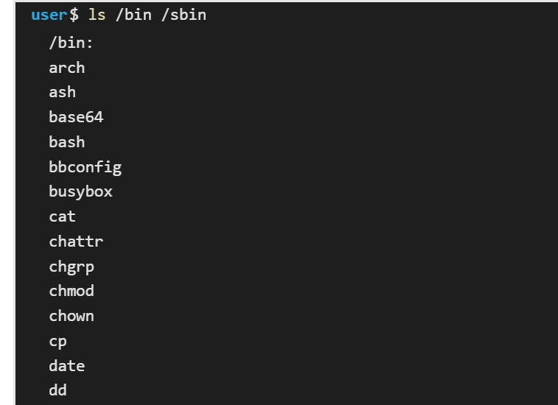
Task 10: ls -a ~
Purpose: To display all contents of the home directory, including hidden files.
Explanation: The -a option shows hidden files and directories, whose names usually begin with a dot (.).
Task 11: ls -lh /boot
Purpose: To display detailed information about files in the /boot directory.
Explanation: This command shows file details, including file sizes in an easy-to-read format. The /boot directory contains files needed to start Linux.
