22373 [ Website Chatbot with RAG - Nomic Embedding - 7 ]
Contents
Test the Nomic embedding model 1
Test Arabic embeddings 8

Test the Nomic embedding model

Privacy & Deployment Considerations
1. Nomic Embedding Models (Ollama Local)
No text or embeddings are sent to any external API or cloud service. This satisfies our privacy requirement. (Ollama)
Note: Some users report that default local Nomic embeddings may run slowly or produce weaker results compared with cloud alternatives; optimizing your embedding pipeline (batching, quantization, GPU acceleration) can help. (Reddit)

2. EmbeddingGemma (Hugging Face Local)
EmbeddingGemma is a 300M-parameter multilingual embedding model from Google DeepMind that is ideally suited to on-device or local deployments.
Important: You must accept the Gemma Terms of Use on Hugging Face before downloading and hosting the model — this is a licensing requirement, not a privacy risk.

Comparison Summary for Deployment
Criterion | Nomic (Ollama Local) | EmbeddingGemma (Local Hugging Face)
Privacy / Data Residency | Fully local, no cloud components needed | Also fully local when downloaded and deployed
Performance Quality | Good on long contexts and varied data | High quality for smaller/typical contexts and multilingual use
Token Context | Large (up to 8 192 tokens) | Up to ~2048 tokens

Recommendation for Production
Use both models locally, but choose the one that gives better retrieval results in the RAG pipeline after benchmarking.
- If EmbeddingGemma gives significantly better embedding quality for queries, it’s a strong choice because it’s compact and designed for offline embedding workloads
- If Nomic embeddings perform better on our corpus (especially for longer contexts), stick with them because both run locally without external exposure.

Manual testing on our dataset:
Nomic model was integrated to the Website Chatbot via Ollama.
The same existing database that was before embedded using embeddinggemma-300m was now embedded again using nomic-embed-text model.
Embedded vectors were added to a new Qdrant collection.
The Nomic-based chatbot instance was deployed on a separate port to allow parallel comparison.
Chatbot answers comparison between these two models is shown below:
The same question was sent to both models.
Specific question: “where is the company located?”
Nomic embedding model retrieved chunks and response are presented below:
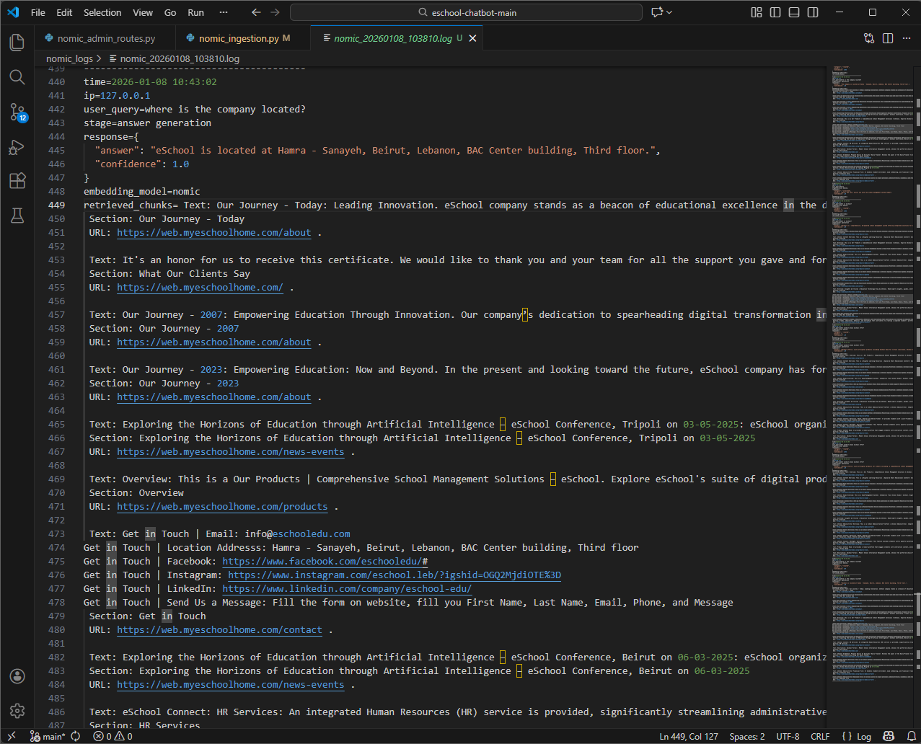

Emeddinggemma retrieved chunks and response:
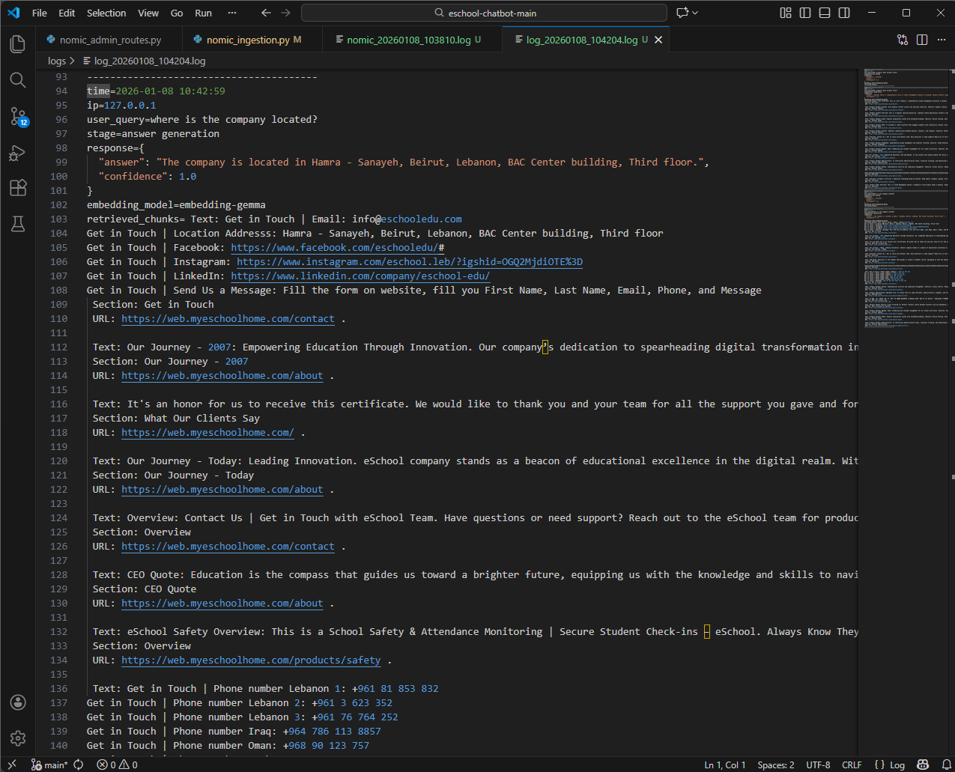

When number of retrieved chunks was reduced from 15 to 3, the chatbot using nomic model didn’t have an answer:
Nomic model retrieved chunks and response:
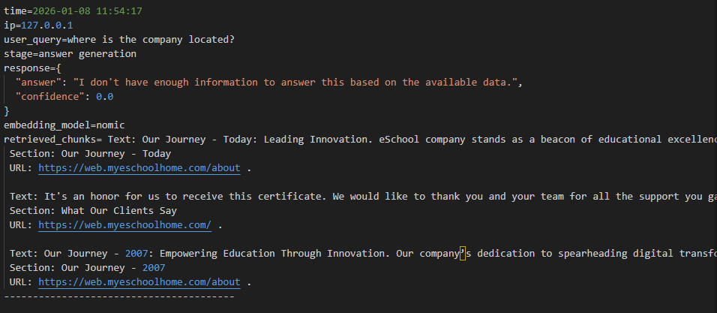

Embeddinggemma model retrieved chunks and response:
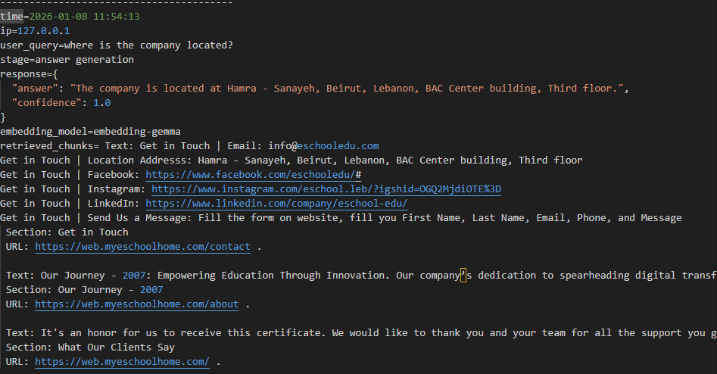

General question: “What is eschool room used for?”
Nomic results
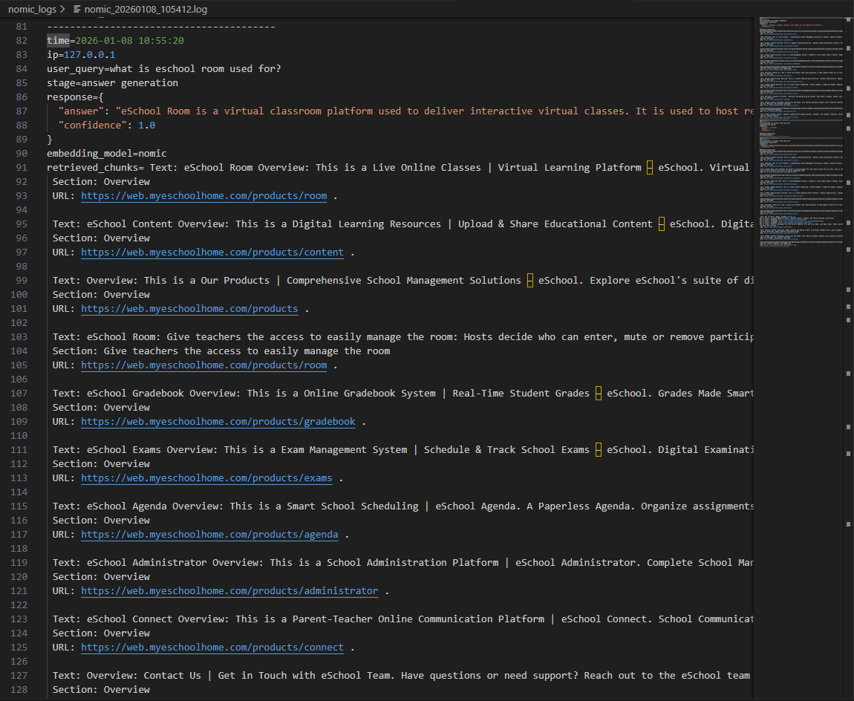

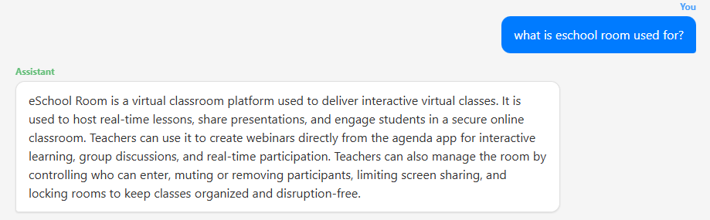

Embeddinggemma results:
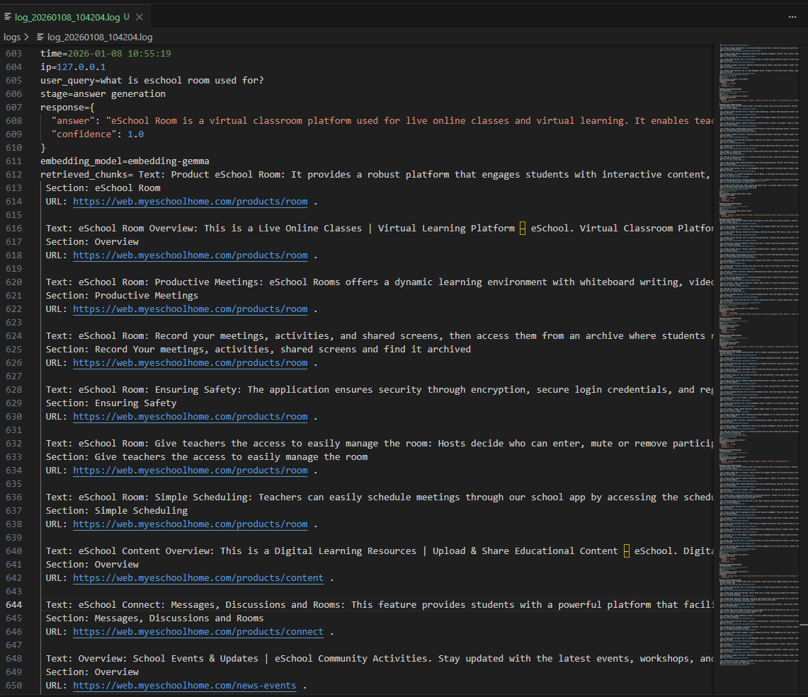

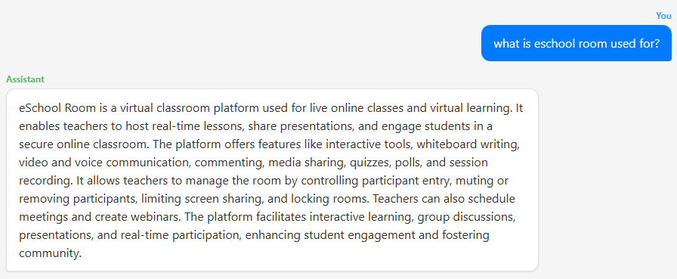
Conclusion: embeddinggemma is better in ranking related chunks which results in richer and more contextually complete answers.

While testing queries, time was also taken into consideration.
This info is for the same queries, sent at the same time.
First image is for nomic, the second is for Embeddinggemma.
Observed end-to-end response time (embedding + retrieval + generation) was consistently lower for EmbeddingGemma under identical query conditions.

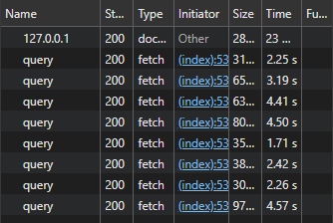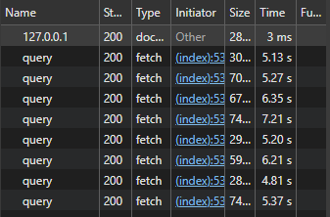

Test Arabic embeddings

Top rated Arabic finetuned embedding models were tested in comparison with embeddinggemma-300m and the results are presented below.
The same previous dataset was translated to Arabic using the following prompt and was sent to deepseek via ollama:
Translate the following text into clear, accurate Modern Standard Arabic without any harakat (diacritics). Preserve the full meaning exactly, maintain consistent terminology, and do not add or omit information. All technical terms, proper nouns, and key domain-specific keywords must be translated into Arabic and also retained in English in parentheses every time they appear. Use neutral, formal MSA suitable for knowledge-base embeddings. Output only the Arabic text with no explanations, no headings, and no extra formatting.

Each model was downloaded and then used to embed the translated text and inserting it to a new separate collection.
The chatbot was then tested with the same questions using three different embedding models.
The number of retrieved chunks was increased from 15 to 20 to capture more meaning from more chunks.

Embeddinggemma results:
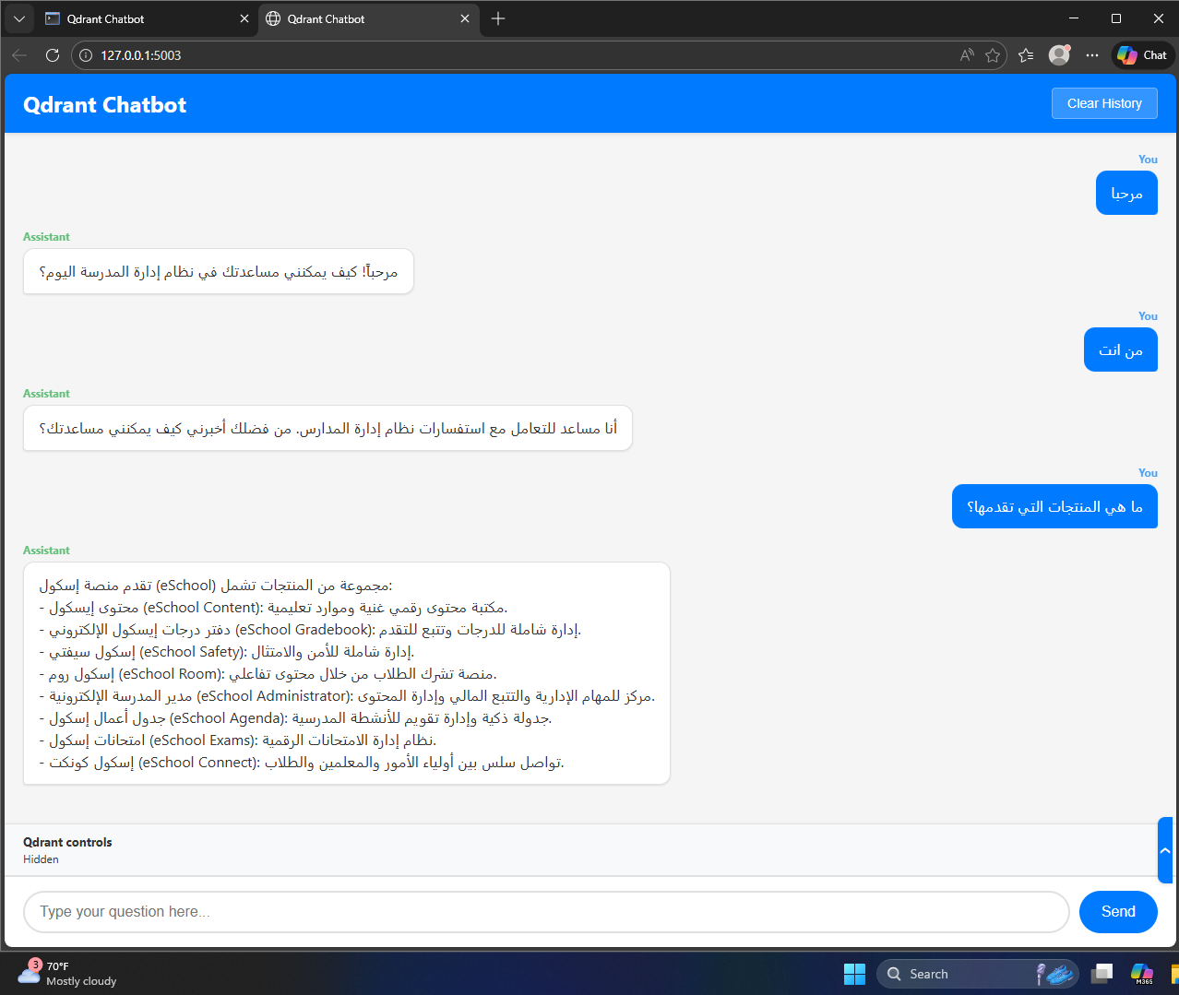

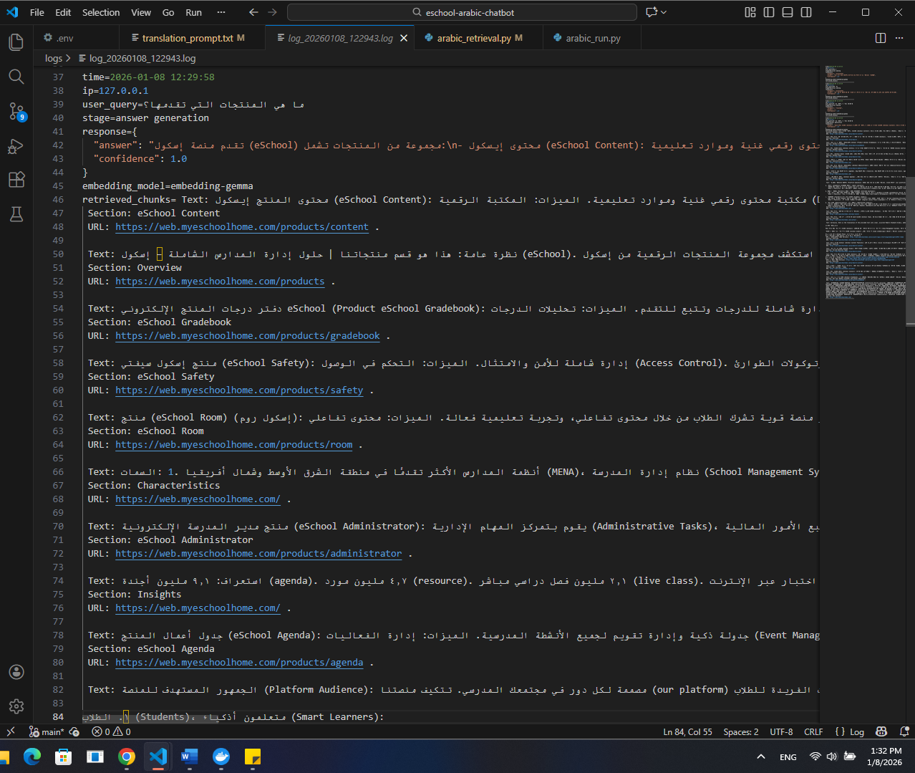

LaBSE:
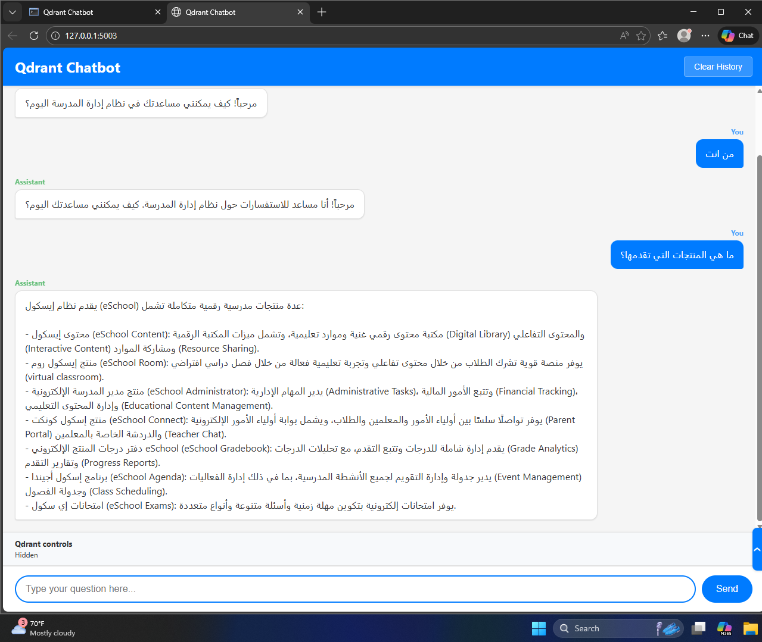

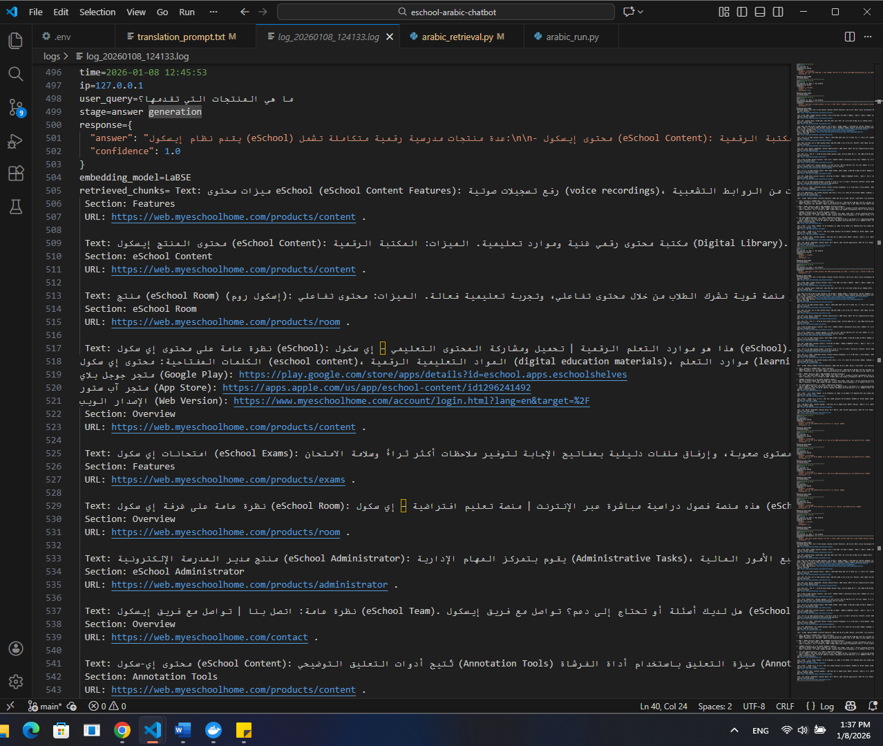
Arabic-Triplet-Matryoshka-V2:
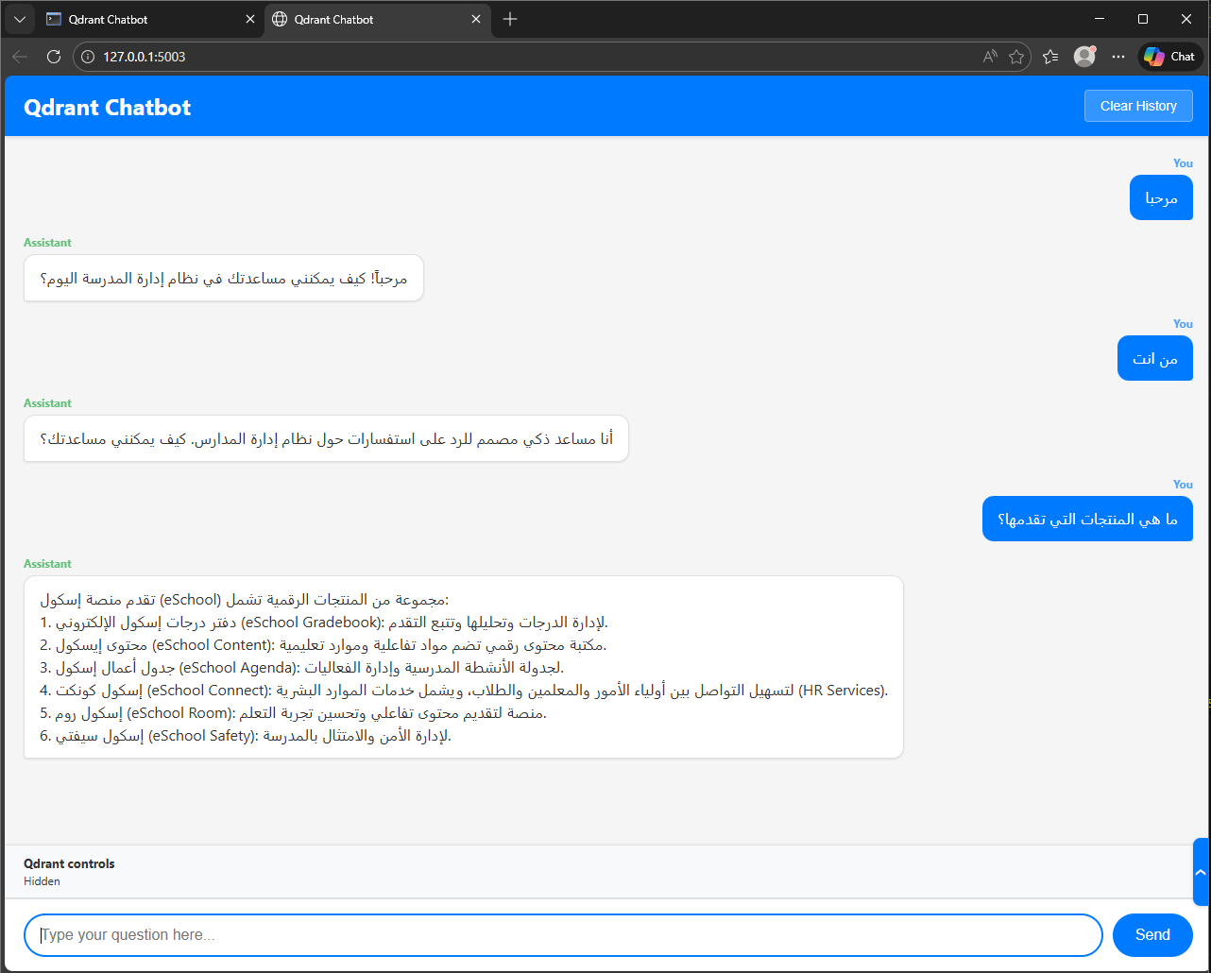

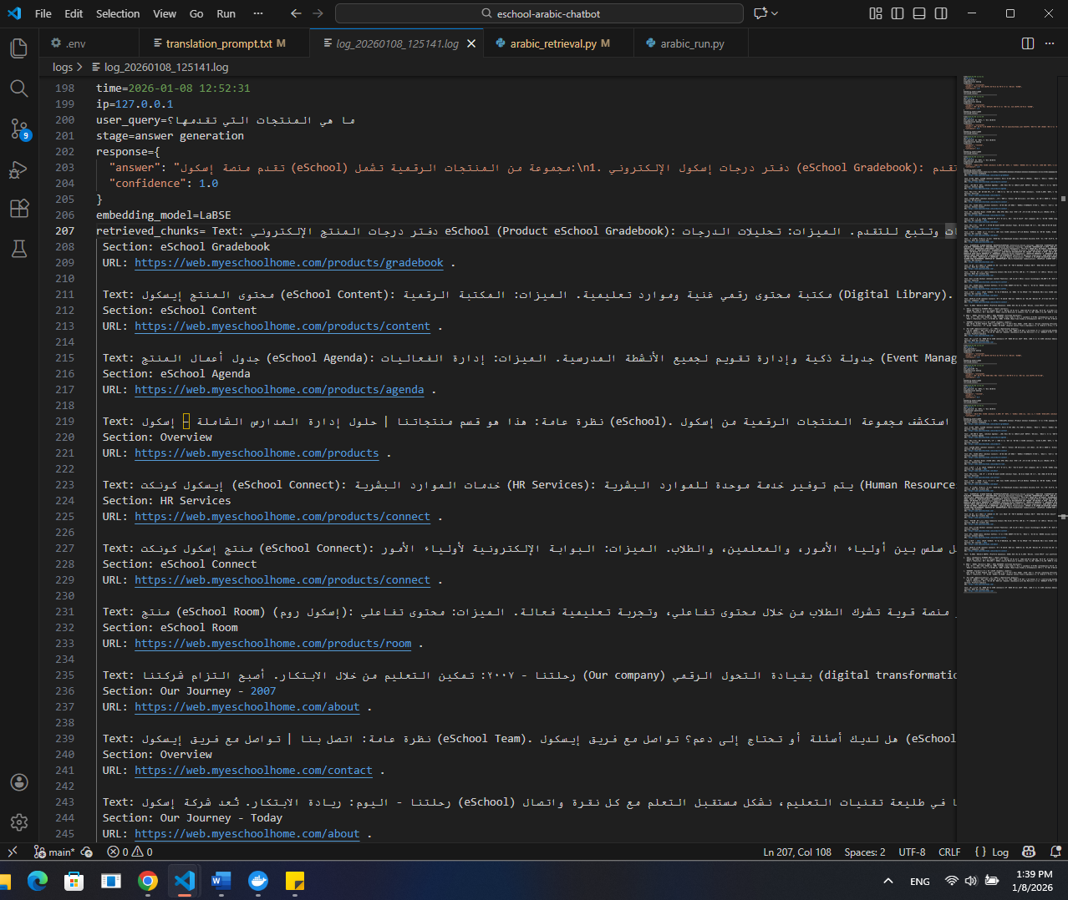
Conclusion:
All three Arabic embedding models showed comparable results on our translated dataset. EmbeddingGemma remains competitive, but additional testing on a larger Arabic corpus is recommended before production deployment.

