Ex 6 REPOSITORY IN GITHUB

**Date: 25.08.20**

# Aim:

To study and implement the git and git repository.

# Description:

## The Linux Kernel :

**GitHub** is a Git repository hosting service, but it adds many of its own features. While Git is a command line tool, **GitHub** provides a Web-based graphical interface. It also provides access control and several collaboration features, such as a wikis and basic task management tools for every project.

**GitHub** is a website for developers and programmers to collaboratively work on code. The primary benefit of **GitHub** is its version control system, which allows for seamless collaboration without compromising the integrity of the original project.

# COMMANDS:

|  |  |  |
| --- | --- | --- |
| **Sl. No.** | **COMMAND** | **DESCRIPTION** |
| **1.** | git init | Initialize git repository |
| **2.** | git add filename | To add individual files |
| **3.** | git add * | T o add all files |
| **4.** | git status | To see the added files status |
| **5.** | git commit -m “text” | A dded text note with added file |
| **6.** | git remote add origin path | To link the files to the github repository |
| **7.** | git push -u origin master | To push files into the repository |

**Exercise**

**Create repository and uploading files in github**

## Step 1 :

Installing git

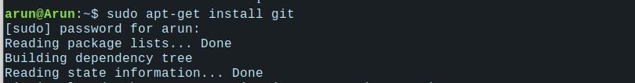

## Step 2 :

Check version

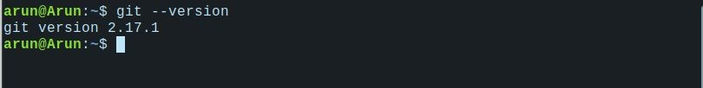

## Step 3 :

Initializing git



## Step 4 :

Adding files and checking status

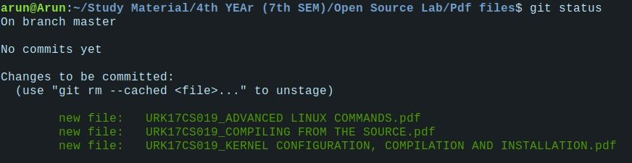



## Step 5 :

Uploading the files

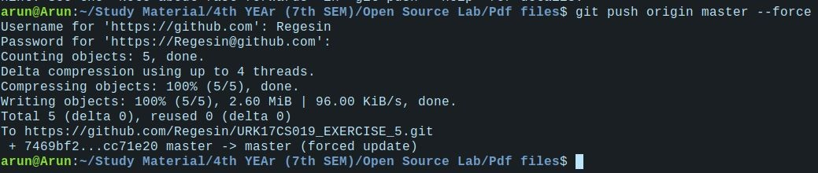

## Step 6 :

Checking repository

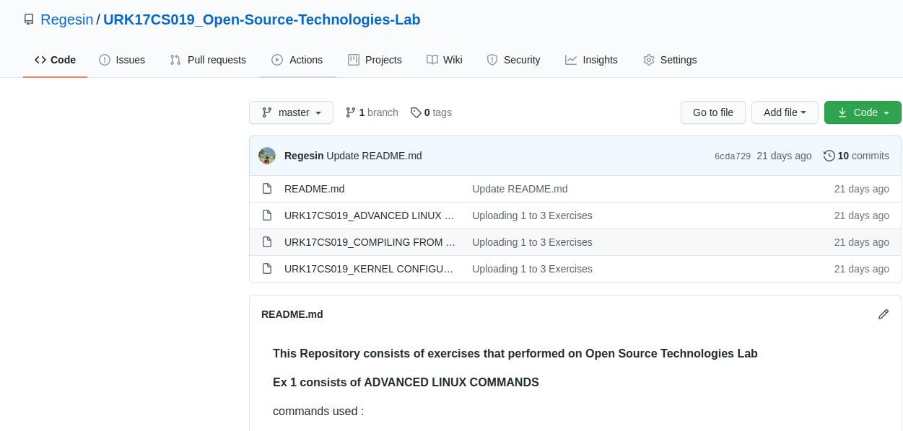

# Github link :

h [ttps://github.com/sarasumanth/URK17CS037_EXERCISE_5](https://github.com/sarasumanth/URK17CS037_EXERCISE_5)

# Results:

The study and implementation of the git and git repository is studied and executed.

**Video link :** [**https://drive.google.com/file/d/1YY0L5K69Gd422gpJWYQSRxtIcfBs5uUP**](https://drive.google.com/file/d/1YY0L5K69Gd422gpJWYQSRxtIcfBs5uUP/view?usp=drivesdk)

[**/view?usp=drivesdk**](https://drive.google.com/file/d/1YY0L5K69Gd422gpJWYQSRxtIcfBs5uUP/view?usp=drivesdk)