# Ex 7 Basic Python Programming

**Date: 06.10.2020**

## Aim:

To study and implement the basic python programming.

## Exercise

1. **Design and implement a basic calculator.**

**Source Code :**

a = int(input("enter the first number :"))

b = int(input("enter the second number :"))

c = int(input("enter the operation you want :\n 1.Add \n 2.Sub \n 3.Mul \n 4.Div \n")) if c==1:

print(a+b) elif c==2:

print(a-b) elif c==3:

print(a*b) elif c==4:

print(a/b)

else:

print("choose the correct operation _ ")

## Output :

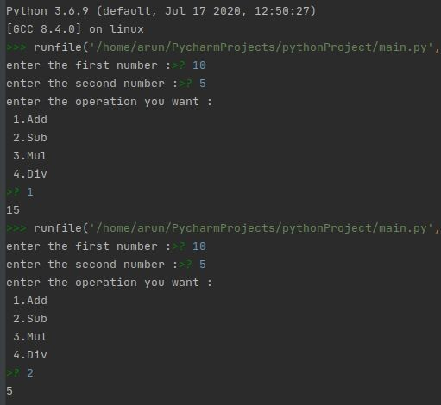

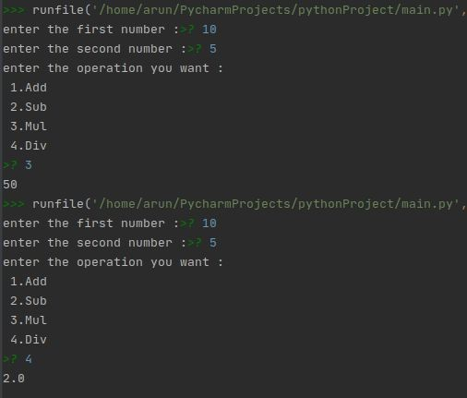

1. **Find whether the given number is perfect or not.**

**Source Code :**

Number = int(input(" Please Enter any Number: "))

Sum = 0

for i in range(1, Number): if(Number % i == 0):

Sum = Sum + i if (Sum == Number):

print(" %d is a Perfect Number" %Number)

else:

print(" %d is not a Perfect Number" %Number)

## Output :

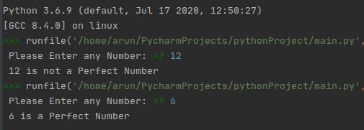

1. **Find whether the given number is Adam’s number or not.**

**Source Code :**

def isAdam(num):

n = num rev = 0

while n != 0:

rev = rev * 10 + n % 10 n = n // 10

sn = num ** 2 sr = rev ** 2 n = sr

rev = 0 while n != 0:

rev = rev * 10 + n % 10 n = n // 10

return sn == rev

num = int(input("Enter the number: ")) if isAdam(num):

print(str(num) + " is an Adam Number.")

else:

print(str(num) + " is NOT an Adam Number.")

## Output :

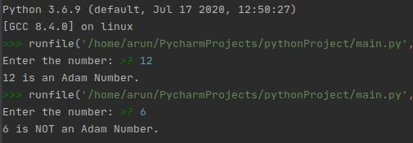

1. **Write a program to check whether the given number is Armstrong or not.**

**Source Code :**

num = int(input("Enter a number: ")) sum = 0

temp = num

while temp > 0:

digit = temp % 10 sum += digit ** 3 temp //= 10

if num == sum:

print(num,"is an Armstrong number") else:

print(num,"is not an Armstrong number")

## Output :

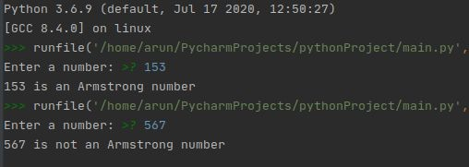

**Results:**

The study and implementation of the basic python programming are studied and executed.

## Video :

[**https://drive.google.com/file/d/1YY0L5K69Gd422gpJWYQSRxtIcfBs5uUP**](https://drive.google.com/file/d/1YY0L5K69Gd422gpJWYQSRxtIcfBs5uUP/view?usp=drivesdk)

[**/view?usp=drivesdk**](https://drive.google.com/file/d/1YY0L5K69Gd422gpJWYQSRxtIcfBs5uUP/view?usp=drivesdk)