**Experiment-14**

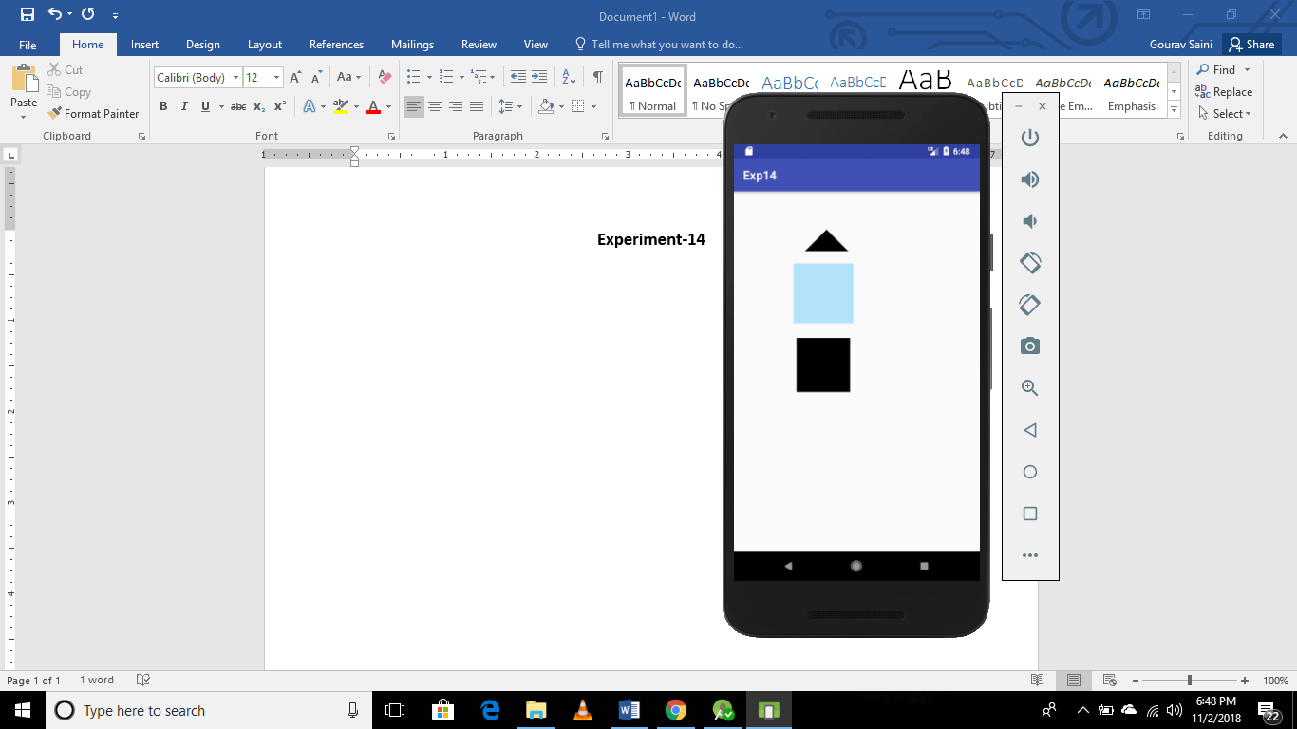

***Activity.xml***

*<?***xml version="1.0" encoding="utf-8"***?>*<**RelativeLayoutxmlns:android="http://schemas.android.com/apk/res/android"  
xmlns:app="http://schemas.android.com/apk/res-auto"  
xmlns:tools="http://schemas.android.com/tools"  
android:layout_width="match_parent"  
android:layout_height="match_parent"  
tools:context=".MainActivity"**>  
<**RelativeLayout  
android:id="@+id/triangle"  
android:layout_width="100dp"  
android:layout_height="100dp"  
android:background="@drawable/triangle"  
android:layout_marginLeft="100dp"**>  
</**RelativeLayout**>  
  
<**RelativeLayout  
android:id="@+id/rectangle"  
android:layout_width="100dp"  
android:layout_height="100dp"  
android:layout_below="@+id/triangle"  
android:layout_marginLeft="100dp"  
android:layout_marginTop="20dp"  
android:background="@drawable/rectangle"**>  
  
</**RelativeLayout**>  
  
  
<**RelativeLayout  
android:layout_width="100dp"  
android:layout_height="100dp"  
android:layout_below="@+id/rectangle"  
android:layout_marginLeft="100dp"  
android:layout_marginTop="20dp"  
android:background="@drawable/squar"**>  
  
</**RelativeLayout**>  
  
  
  
</**RelativeLayout**>

**Triangle.xml**

*<?***xml version="1.0" encoding="utf-8"***?>*<**layer-list xmlns:android="http://schemas.android.com/apk/res/android"** >  
<**item** >  
<**rotate  
android:fromDegrees="45"  
android:toDegrees="45"  
android:pivotX="-40%"  
android:pivotY="95%"** >  
<**shape  
android:shape="rectangle"** >  
<**stroke  
android:color="@android:color/transparent"  
android:width="10dp"**/>  
<**solid  
android:color="#000000"** />  
</**shape**>  
</**rotate**>  
</**item**>  
</**layer-list**>

**Rectangle.xml**

*<?***xml version="1.0" encoding="utf-8"***?>*<**layer-list xmlns:android="http://schemas.android.com/apk/res/android"** >  
<**item**>  
<**shape android:shape="rectangle"**>  
<**solid android:color="#B2E3FA"** />  
</**shape**>  
</**item**>  
</**layer-list**>

**Square.xml**

*<?***xml version="1.0" encoding="utf-8"***?>*<**layer-list xmlns:android="http://schemas.android.com/apk/res/android"** >  
<**item** >  
<**rotate  
android:fromDegrees="0"  
android:toDegrees="12"  
android:pivotX="-40%"  
android:pivotY="50%"** >  
<**shape  
android:shape="rectangle"** >  
<**stroke  
android:color="@android:color/transparent"  
android:width="10dp"**/>  
<**solid  
android:color="#000000"** />  
</**shape**>  
</**rotate**>  
</**item**>  
</**layer-list**>