**Experiment-7**

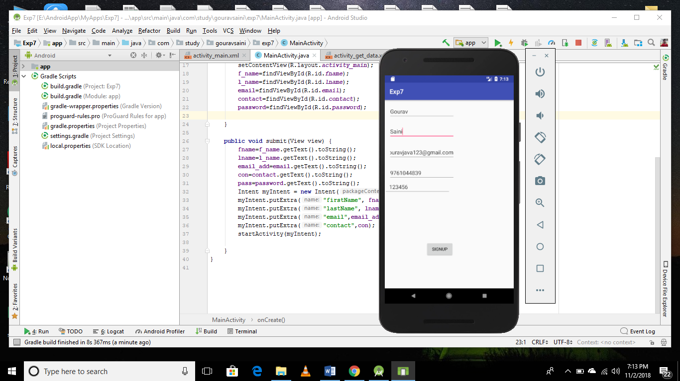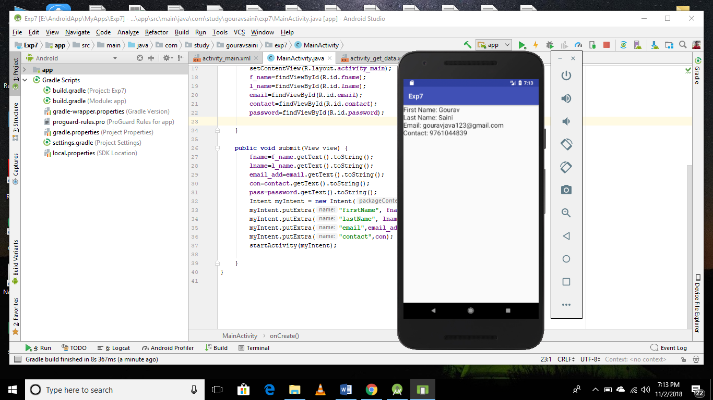

**MainActivity.java**

**public class** MainActivity**extends** AppCompatActivity {  
EditText**f_name**,**l_name**,**email**,**contact**,**password**;  
String **fname**,**lname**,**email_add**,**con**,**pass**;  
  
  
@Override  
**protected void** onCreate(Bundle savedInstanceState) {  
**super**.onCreate(savedInstanceState);  
setContentView(R.layout.***activity_main***);  
**f_name**=findViewById(R.id.***fname***);  
**l_name**=findViewById(R.id.***lname***);  
**email**=findViewById(R.id.***email***);  
**contact**=findViewById(R.id.***contact***);  
**password**=findViewById(R.id.***password***);  
  
 }  
  
**public void** submit(View view) {  
**fname**=**f_name**.getText().toString();  
**lname**=**l_name**.getText().toString();  
**email_add**=**email**.getText().toString();  
**con**=**contact**.getText().toString();  
**pass**=**password**.getText().toString();  
 Intent myIntent = **new** Intent(**this**, GetData.**class**);  
myIntent.putExtra(**"firstName"**, **fname**);  
myIntent.putExtra(**"lastName"**, **lname**);  
myIntent.putExtra(**"email"**,**email_add**);  
myIntent.putExtra(**"contact"**,**con**);  
startActivity(myIntent);  
  
 }  
}

**SecondActivity.java**

**public class SecondActivityextends** AppCompatActivity {  
TextView**txt**;  
  
@Override  
**protected void** onCreate(Bundle savedInstanceState) {  
**super**.onCreate(savedInstanceState);  
setContentView(R.layout.***activity_get_data***);  
**txt**=findViewById(R.id.***text***);  
 Intent intent = getIntent();  
  
 String fName = intent.getStringExtra(**"firstName"**);  
 String lName = intent.getStringExtra(**"lastName"**);  
 String email=intent.getStringExtra(**"email"**);  
 String contact=intent.getStringExtra(**"contact"**);  
  
**txt**.setText(**"First Name: "**+fName+**"\nLast Name: "**+lName+**"\nEmail: "**+email+**"\nContact: "**+contact);  
  
 }  
}