SaraResume

# Introduction

The web application name is saraResume. Objective of the website is to display the qualification, skills and experience of the job seeker. This website will help the viewers to understand the job-seeker skills in an easier view rather than going through the resume document.

* Benefits: Having a personal website makes job seeker more findable and stands out among the competitors. This is a key for establishing your personal brand and for highlighting your accomplishments.
* I believe the website created by me will add value to my resume and helps to create a confidence over me to the recruiters.

# Design and Implementation

The website have 4 pages/modules and a navigation bar in the top to navigate through the pages.

1. About Me : The page displays a brief introduction about the job seeker.
2. Portfolio: The page displays the career experience and skills of the job seeker.
3. Resume: The page displays the resume in PDF format with an download option.
4. Contact Me: The page displays the social media links of the jobseeker and a form to post feedback or message as an email to the jobseeker.

**Implementation:**

The website is created with

* The application have 4 components for the appropriate pages, About.component, portfolio.component, resume.component, contact.component
* Added 2 more components for header and footer, Header.componet and footer.component
* Routes.ts file which handles the routing in the navigation bar(header component)
* Content for the about page and portfolio page is rendered from the typescript file using a service at client side angular application.
* Email function for contact page is done with node.js API which runs in the express server. The API is called through an service from the client side angular application.
* The application made as responsive website which fits in different width devices from mobile to large desktop.
* The client side angular application is build and the static files are included to the node.js express server. The final application is rendered through the express server.

**Libraries and Modules Used in the application:**

Apart from common modules in the application like Browsermodule, ngmodule, flexlayout I have given description for few modules which I find it unique,

1. *Material tool bar* Module : This module is used for setting up the navigation links in the header.
2. *PDF viewer* Module : This module is used for displaying the resume in PDF format.
3. *Material Expansion* Module: This module is used in the portfolio page for displaying the project works with panel view.
4. *Material Forms and Reactive forms* Module: This module is used in the contact page Email sending form.
5. *Material Spinner* Module: This is used to display the mail sending message to the user when the email submit button is clicked.
6. *Material Tabs* Module: This module is used in the contact page to display the email and social media links separately. (just used for an attraction)
7. *Application Routing* Module*:* This module is used to handle the page routes in the navigation link.
8. *Nodemailer* Module: This module is added at the node.js api for sending email.
9. *Node-static* Module: This module is used to render the angular static page from the node.js.
10. *ng2-pdf-viewer* for displaying the resume in pdf format.
11. Rxjs library for using observables during asynchronous function calls

**Website link:** <https://sararesume.azurewebsites.net/about>

Screenshot:1

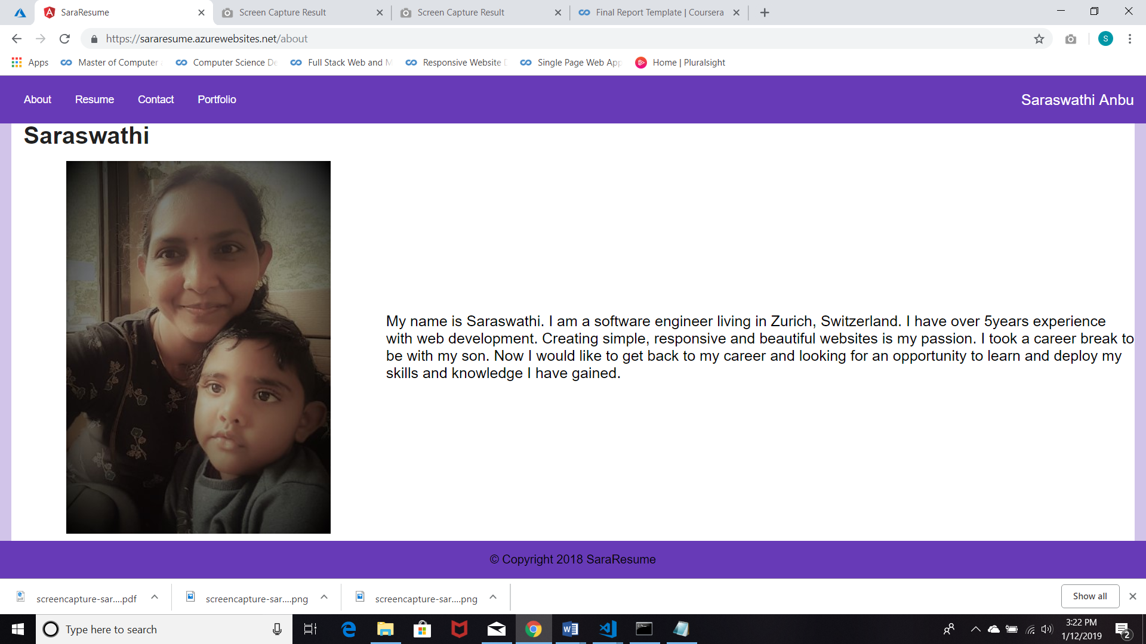

Screenshot:2

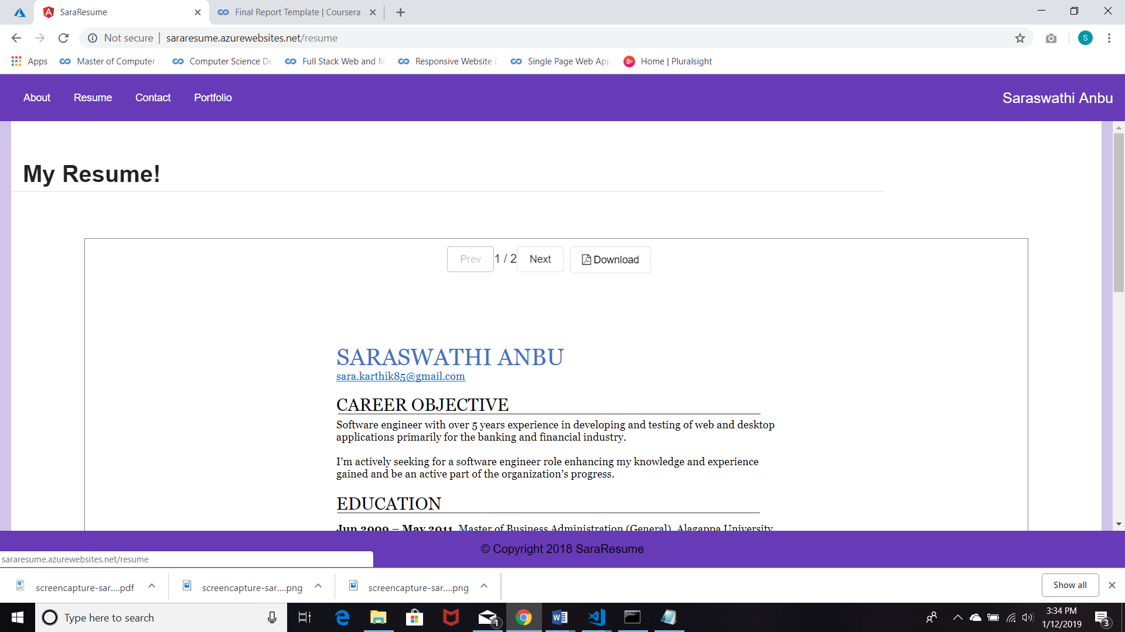

Screenshot:3

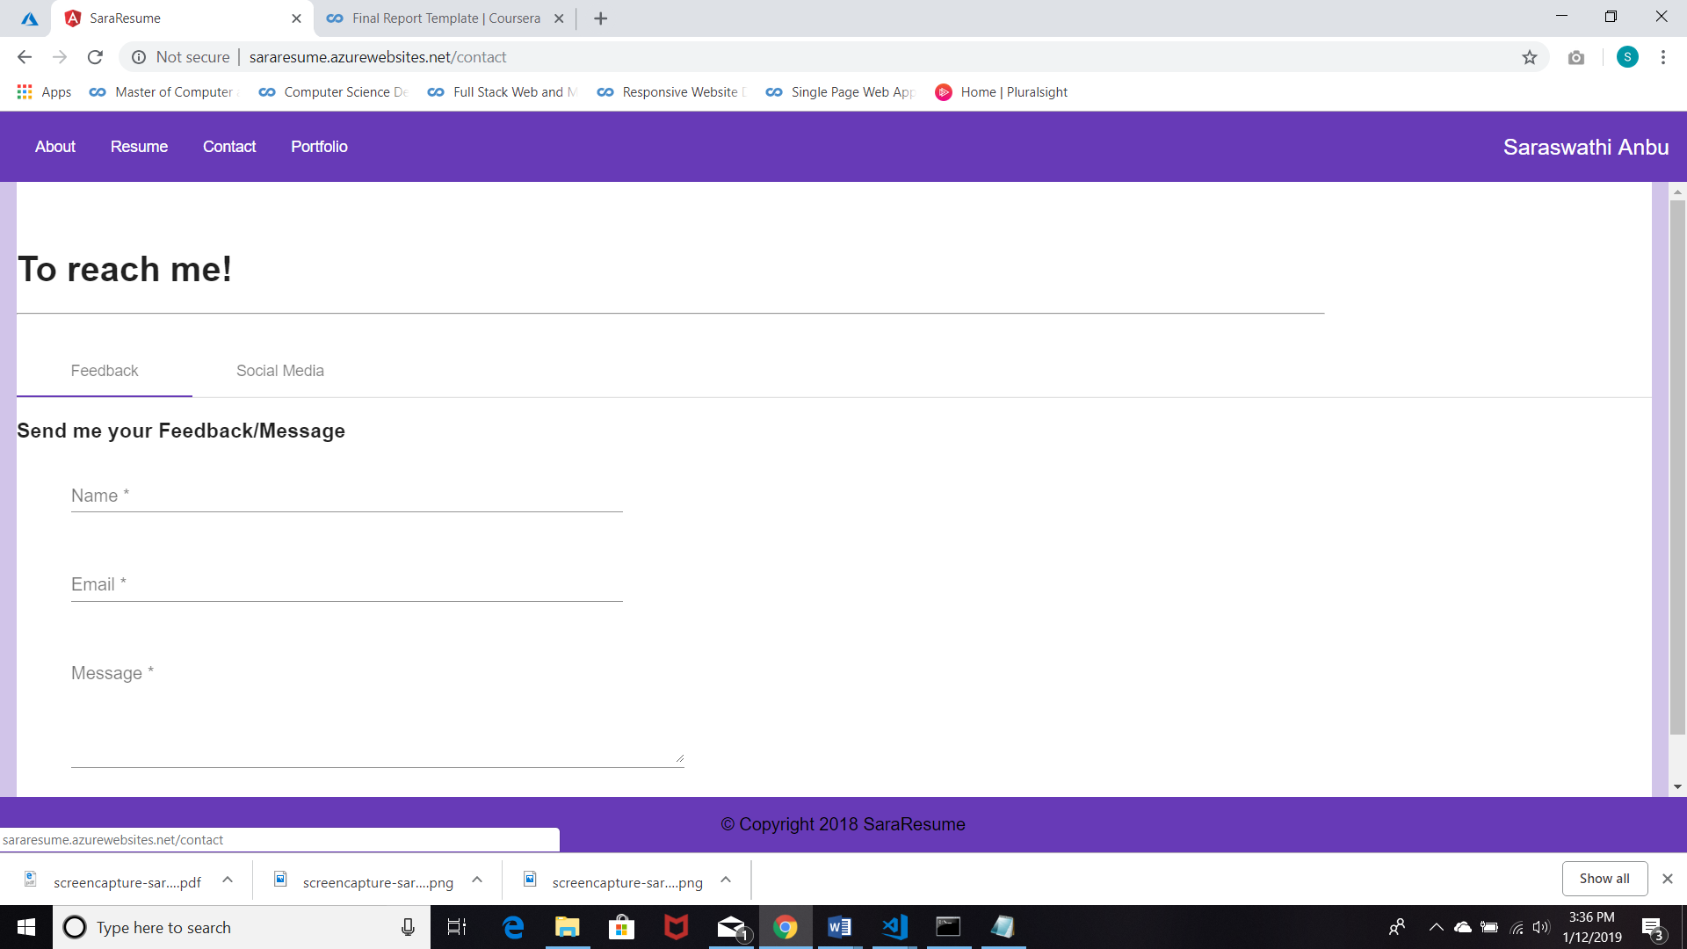

Screenshot:4

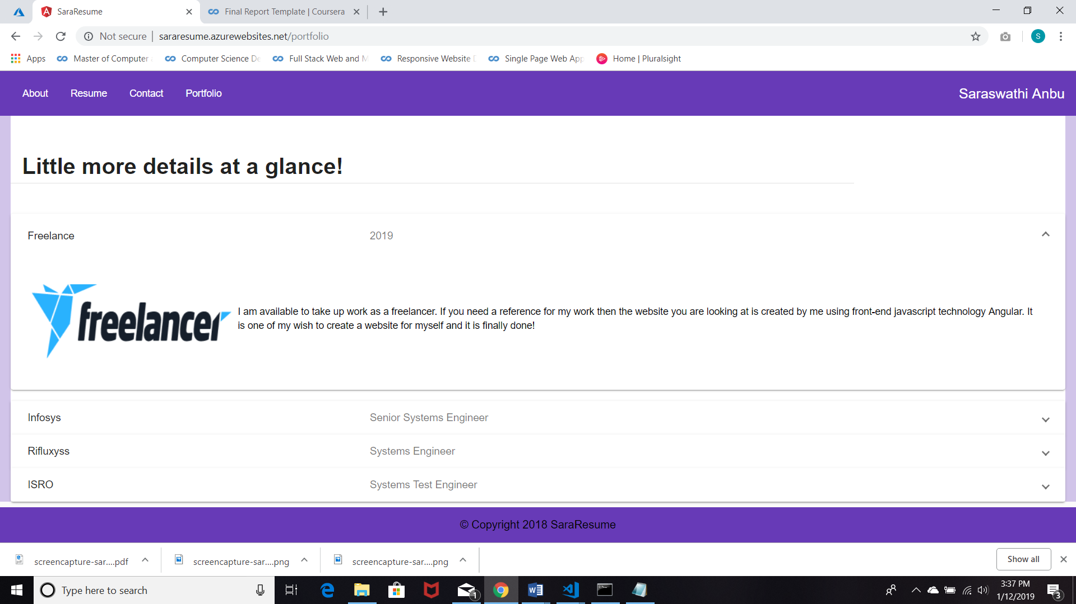

# Conclusion

**Result**:

Created a final project “SaraResume” which displays the job seeker professional skills and experience. The website is deployed and hosted in azure platform.

Creating the project helped in recollecting what we studied during the angular course. The project helped to learn about new technologies and methods. Gained knowledge in build and deployment in azure and little knowledge about node.js express server application.

**Features and shortcomings of the project**

I would like to integrate a database to this project to store data of the about and portfolio page. So that I could able to create an admin end and modify the data of about/portfolio page. This helps me to easily update the content of the page instead of changing the code and deploying.

I tried to create a database with Json-server but I could not able create json-server in azure environment so happened to choose typescript file to store the data and retrieve through service.

**References:**

<https://malcoded.com/posts/angular-backend-express>

<https://nodemailer.com/about/>

<https://puppet.com/docs/pipelines-for-apps/team/application-nodejs.html>

<https://developer.mozilla.org/en-US/docs/Learn/Server-side/Express_Nodejs/deployment>

<https://expressjs.com/en/advanced/best-practice-performance.html>