BDA400 – Data Science Tools and Techniques
Assignment 2 – Technical Analysis using R, Preliminary Stage
Student Name: Saraswathi Ramagiri
Assignment: Assignment 2
GitHub Repository: TechnicalAnalysis
1. GitHub Account and Repository Setup
A GitHub repository named TechnicalAnalysis was created to store the files and documentation for the technical analysis assignments.
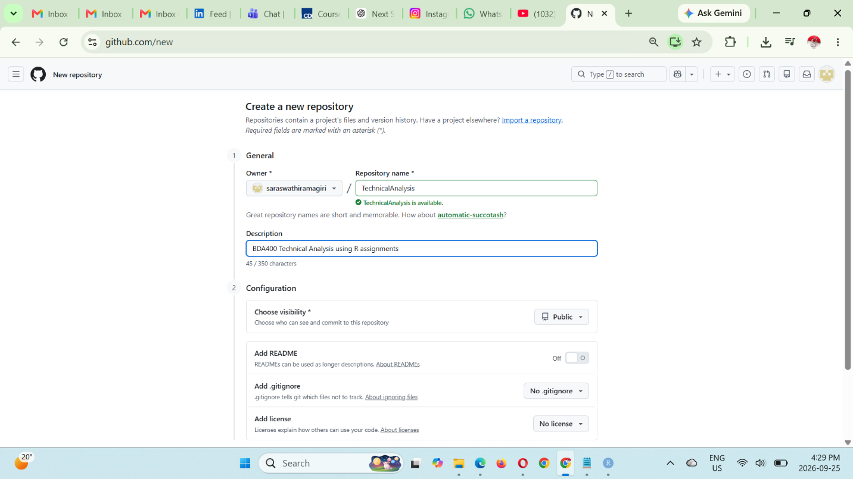
2. Required R Packages
The quantmod and TTR packages were installed and loaded in RStudio. These packages provide functions for retrieving stock market data and performing technical analysis.
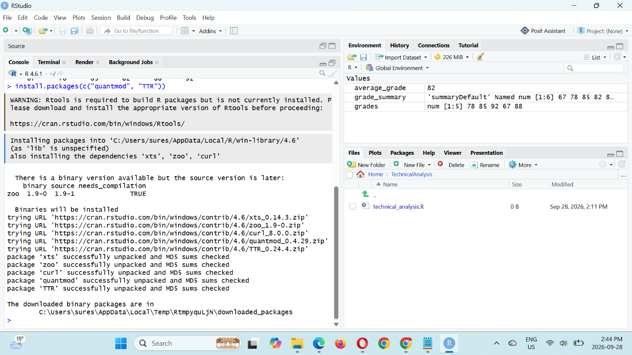
3. Portfolio File
A text file named portfolio.txt was created to store the stock symbols used for the analysis. The portfolio contains five stocks:
AAPL, MSFT, GOOG, AMZN, and TSLA
The R program reads these symbols from the text file and uses them to retrieve the corresponding stock data.
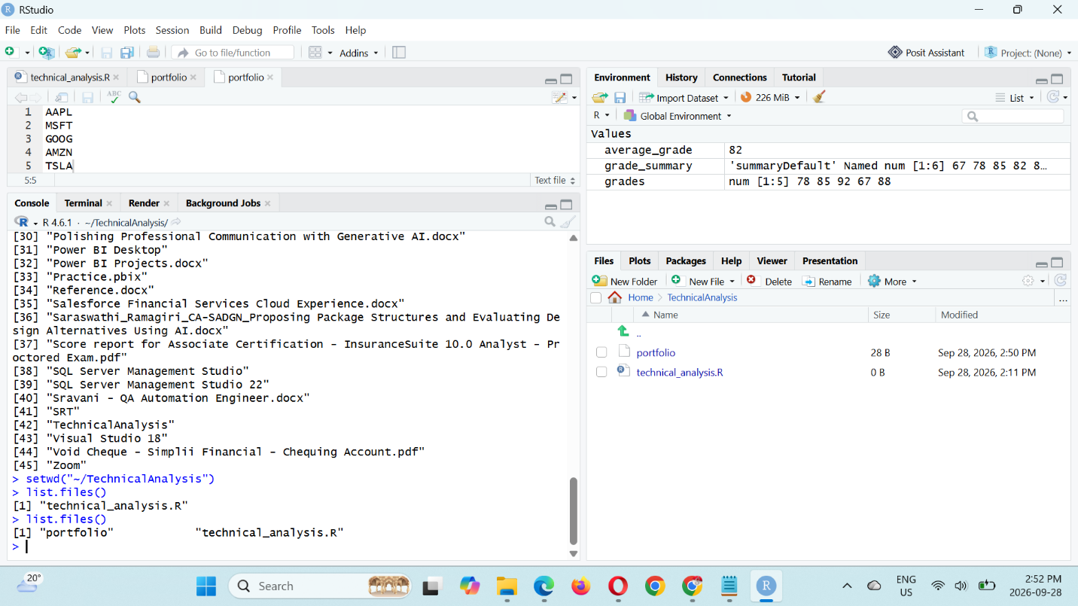
4. Loading Stock Data
A custom R function was created to read the stock symbols from portfolio.txt and retrieve historical market data using the quantmod package. The downloaded stock data was stored in a list so that each stock could be analyzed separately.
The program successfully loaded data for AAPL, MSFT, GOOG, AMZN, and TSLA.
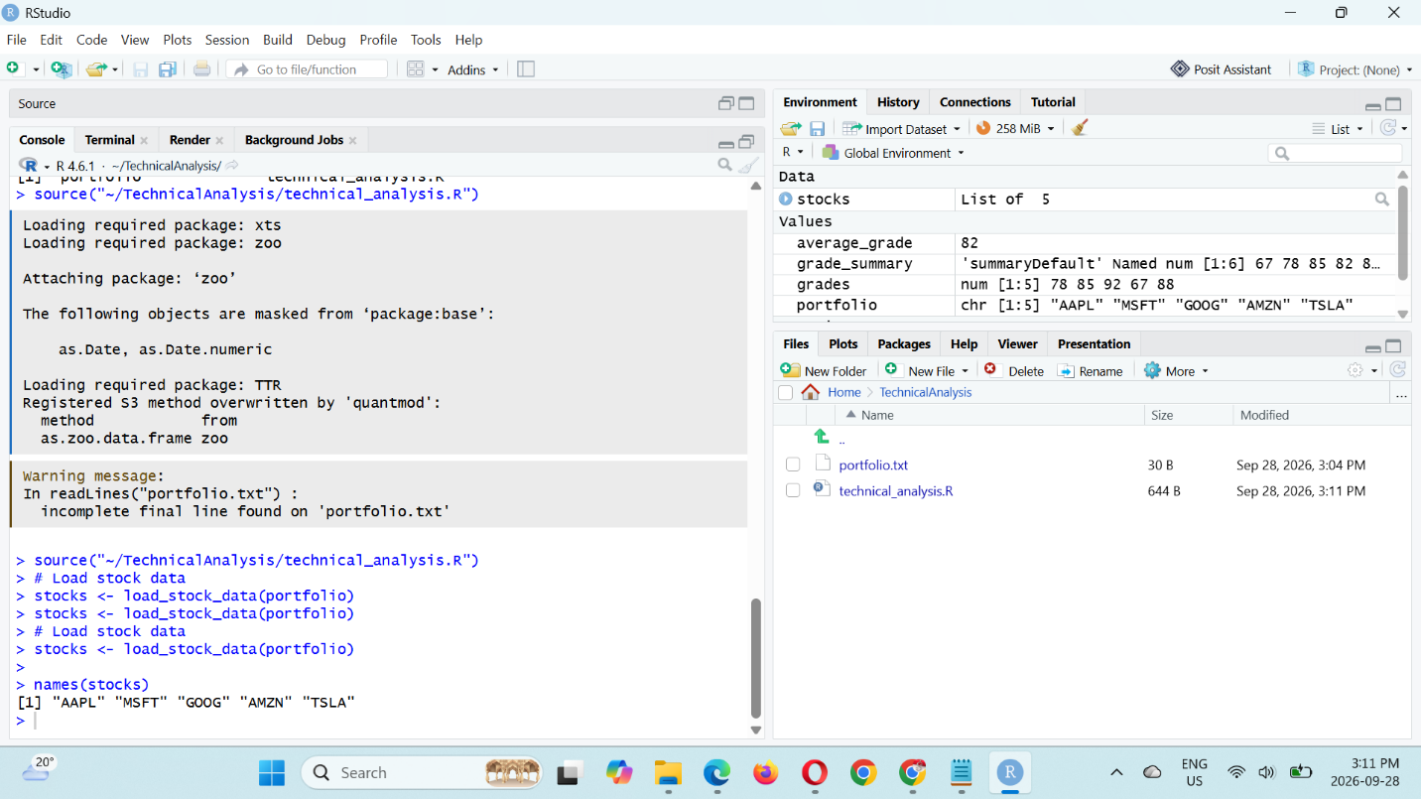`5. Statistical Analysis
A calculate_statistics() function was created to calculate statistical measures for each stock in the portfolio. The calculated measures include:
- Moving Average
- Mean
- Mode
- Median
- Standard Deviation
The results were stored in a structured list and displayed for each stock.

