Practice Project 2

**Create an MVC Application to Manage Data for School Application**

**Output Screen**

**Classes/Index:**

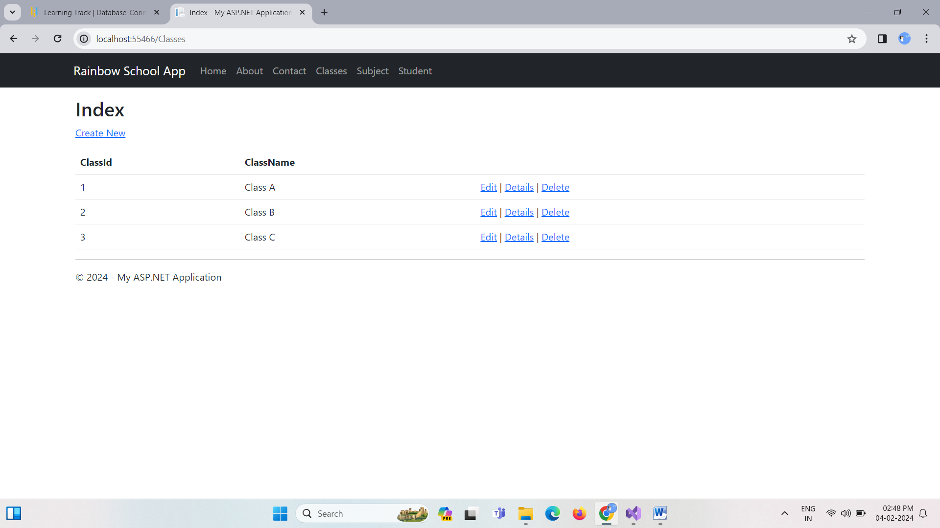

**Subjects/Index:**

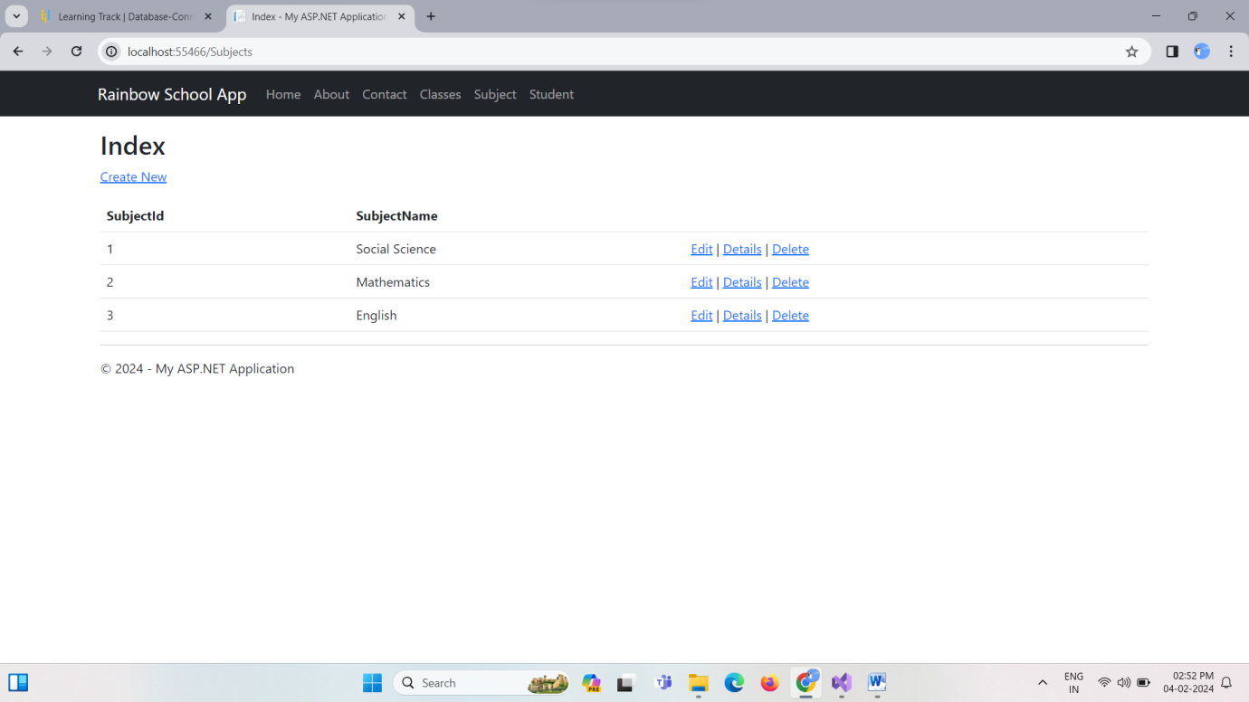

**Students/Index:**

