**C.V. RAMAN GLOBAL UNIVERSITY**

BHUBANESWAR, ODISHA-752054 DEPARTMENT OF

COMPUTER SCIENCE & ENGINEERING



C CASE STUDY REPORT

TOPIC:- PNEUMONIA DETECTION

TEAM DETAILS: GROUP- 6

SEMESTER-6TH

|  |  |
| --- | --- |
| **NAME** | **REGISTRATION NO.** |
| SUVASHREE ROUT | CL20250106019661109 |
| SARASWATI SWAIN | CL20250106019660108 |
| J KIRAN PRABHA | CL2025010601873441 |
| ARYAN SINGH | CL2025010601882911 |

UNDER THE GUIDANCE OF:-

**MR. Sarosh Baig**

### **DECLARATION**

We hereby declare that the case study report entitled **"** PNEUMONIA DETECTION **W"** is an original work completed by us as part of our academic curriculum. This case study report is submitted to the Department of Computer Science Engineering, C.V. Raman Global University, Bhubaneswar, Odisha, under the guidance of Mr. Sarosh Baig**, Cranes Varsity Trainer**. All the information, data, designs, and analysis included in this report are authentic and reflect our own efforts, except where specified otherwise. Any references or resources used have been properly acknowledged in the report's references section.

This project has been conducted solely for academic purposes, and any resemblance to existing products or systems is purely coincidental. We affirm that this work has not been submitted, either fully or in part, for any other course or assessment.

Signature of Supervisor

Signature of Trainer

Signature of students

**ACKNOWLEDGEMENT**

We wish to extend our deepest appreciation to the esteemed faculty **(Mr. Sarosh Baig)** of **[Cranes Varsity]** for granting us the exceptional privilege to partake in the semester-long experiential learning program. Their unwavering guidance, invaluable support, and profound mentorship have acted as the cornerstone of our academic journey, profoundly enriching my knowledge and fostering the development of practical skills within our field of study.

Furthermore, we stand in admiration of the remarkable host organizations and mentors who graciously embraced our presence and contributed to this transformative experience. Their wisdom and generosity have left an indelible mark on our professional growth, providing a wealth of insight and opportunities that we will forever treasure.

This program has transcended the boundaries of a traditional educational experience, illuminating an extraordinary path toward academic and professional excellence. The knowledge we've gained, the challenges we've overcome, and the connections we've forged have collectively shaped me into a more capable and empowered individual. With immense gratitude, we recognize the profound impact this program has had on our journey, and we eagerly anticipate the continued evolution of our academic and professional endeavors.

**ABSTRACT**

Pneumonia is a serious respiratory infection that can be life-threatening if not diagnosed and treated promptly. Early and accurate detection is crucial for effective treatment and reducing mortality rates. This report explores advanced methods for pneumonia detection, focusing on the integration of medical imaging techniques, such as chest X-rays, with machine learning and deep learning algorithms. It highlights recent developments in automated diagnostic systems that enhance the accuracy, speed, and reliability of pneumonia detection, especially in resource-limited settings. The study also evaluates the performance of various models, including convolutional neural networks (CNNs), in classifying infected lung regions. By analyzing both traditional clinical approaches and modern AI-based tools, this report aims to provide a comprehensive overview of current strategies and future directions in pneumonia diagnosis.

**CONTENT**

|  |  |  |
| --- | --- | --- |
| **Serial No.** | **Topics** | **Page no.** |
| 1. | Introduction | 6 |
| 2. | Objectives | 7 |
| 3. | Features | 8 |
| 4. | Technologies and tools used | 9 |
| 5. | Implementation | 10 |
| 6. | Source Code | 11-13 |
| 7. | Output | 14-16 |
| 8. | Future Work | 17 |
| 9. | Conclusion | 18 |
| 10. | References | 19 |

**`INTRODUCTION**

Pneumonia is an inflammatory condition of the lungs, primarily affecting the alveoli, and is commonly caused by bacterial, viral, or fungal infections. It remains a leading cause of morbidity and mortality worldwide, particularly among children under five, the elderly, and individuals with weakened immune systems. Timely and accurate diagnosis is essential to initiate appropriate treatment and prevent serious complications or death.

Traditional methods of pneumonia diagnosis typically involve clinical examination, analysis of symptoms, and radiological imaging such as chest X-rays. However, manual interpretation of X-ray images can be time-consuming, subjective, and prone to human error, especially in areas with limited access to trained radiologists.

In recent years, advancements in artificial intelligence (AI) and medical imaging have opened new avenues for improving diagnostic accuracy. Deep learning models, especially convolutional neural networks (CNNs), have shown promising results in automatically detecting pneumonia from chest X-rays with high precision. These AI-driven solutions not only assist healthcare professionals in making faster decisions but also enhance the scalability of pneumonia screening in under-resourced settings.

This report delves into the current approaches to pneumonia detection, with a focus on AI-based diagnostic systems. It examines the role of chest X-rays in the detection process, evaluates the effectiveness of deep learning models, and discusses their potential for real-world clinical implementation.

**OBJECTIVES**

**The main objectives of this report are:**

1. **To understand the clinical significance of pneumonia and the need for early and accurate detection to reduce morbidity and mortality rates.**
2. **To explore conventional and modern diagnostic techniques for pneumonia, with a focus on chest X-ray analysis.**
3. **To analyze the role of artificial intelligence and deep learning, particularly convolutional neural networks (CNNs), in the automated detection of pneumonia.**
4. **To evaluate and compare the performance of various AI models used for pneumonia classification and prediction.**
5. **To highlight the benefits, limitations, and potential applications of AI-based pneumonia detection systems in real-world clinical environments, especially in low-resource settings.**
6. **To suggest future directions for research and development in pneumonia diagnosis using intelligent systems.**

**FEATURES**

**Features**

A robust pneumonia detection system—particularly one enhanced by artificial intelligence—exhibits several essential features that contribute to accurate and efficient diagnosis. These include:

1. **Automated Image Analysis**  
   The system can process and analyze chest X-ray images without manual intervention, reducing reliance on radiologists and minimizing human error.
2. **High Detection Accuracy**  
   By using trained deep learning models, the system achieves high precision and recall rates in distinguishing pneumonia-affected lungs from normal cases.
3. **Real-Time Diagnosis**  
   Fast processing allows for near-instant detection, enabling prompt decision-making in emergency or high-patient-load scenarios.
4. **User-Friendly Interface**  
   A simple and intuitive interface enables healthcare professionals, even with minimal technical training, to use the system effectively.
5. **Scalability and Portability**  
   The system can be deployed on cloud platforms or mobile devices, making it accessible in rural or remote areas with limited medical infrastructure.
6. **Integration with Clinical Workflows**  
   It supports compatibility with existing medical record systems, allowing seamless integration into hospital environments.
7. **Heatmap or Localization Output (Optional)**  
   Some systems provide visual explanations, such as heatmaps (e.g., Grad-CAM), to highlight the affected regions in the lungs, aiding in interpretability.

**TECHNOLOGIES AND TOOLS USED**

* **Programming Language**
  + **Python: Widely used for machine learning due to its simplicity and extensive library support.**
* **Libraries and Frameworks**
  + **NumPy & Pandas: For data manipulation, preprocessing, and efficient array operations.**
  + **Matplotlib & Seaborn: For visualizing data distributions, model performance, and heatmaps.**
  + **Scikit-learn: Used for traditional ML models, metrics evaluation, and preprocessing pipelines.**
  + **TensorFlow / Keras or PyTorch: Deep learning frameworks used for building, training, and evaluating convolutional neural networks (CNNs) for image classification.**
* **Image Processing Tools**
  + **OpenCV: For image loading, resizing, and augmentation.**
  + **PIL (Python Imaging Library): For handling image format conversion and basic operations.**
* **Dataset Sources**
  + **Chest X-ray Dataset (e.g., from Kaggle or NIH ChestX-ray14): Includes labeled X-ray images used for training and testing the model.**
* **Jupyter Notebook / Google Colab**
  + **Used for interactive coding, data exploration, and model experimentation with GPU support.**
* **Cloud Platforms** 
  + **Google Cloud, AWS, or Microsoft Azure: For model training, storage, or deployment in scalable environments.**

**IMPLEMENTATION**

The pneumonia detection system was implemented using a deep learning approach with convolutional neural networks (CNNs) trained on chest X-ray images. The implementation process was divided into several key stages:

1. **Data Collection and Preprocessing**
   * The dataset used included labeled chest X-ray images, such as the **Chest X-ray (Pneumonia) dataset from Kaggle** or the **NIH ChestX-ray14** dataset.
   * Images were resized to a uniform shape (e.g., 224x224 pixels) for input into the CNN.
2. **Model Design and Training**
   * A **Convolutional Neural Network (CNN)** architecture was designed, or a pre-trained model such as **VGG16, ResNet50, or MobileNet** was used via **transfer learning**.
   * The model was trained using **categorical cross-entropy** as the loss function and **Adam** or **SGD** optimizer.
3. **Model Evaluation**
   * Model performance was evaluated using metrics like **accuracy, precision, recall, F1-score**, and **ROC-AUC**.
   * Confusion matrices and classification reports were generated to assess class-wise performance.
4. **Deployment (Optional)**
   * A lightweight web interface was developed using **Streamlit** or **Flask** to allow users to upload an X-ray image and get predictions.
   * For scalability, the application can be hosted on cloud platforms like **Heroku**, **AWS**, or **Google Cloud Platform**.

**SOURCE CODE**

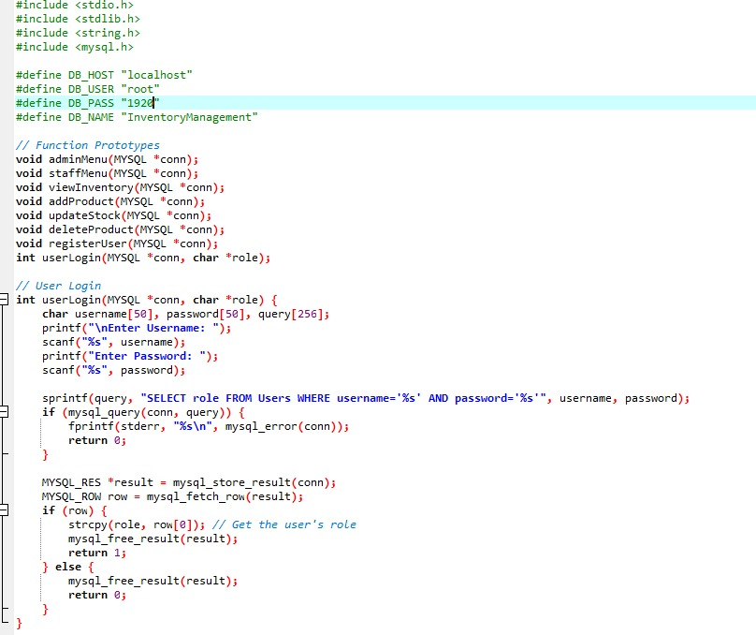

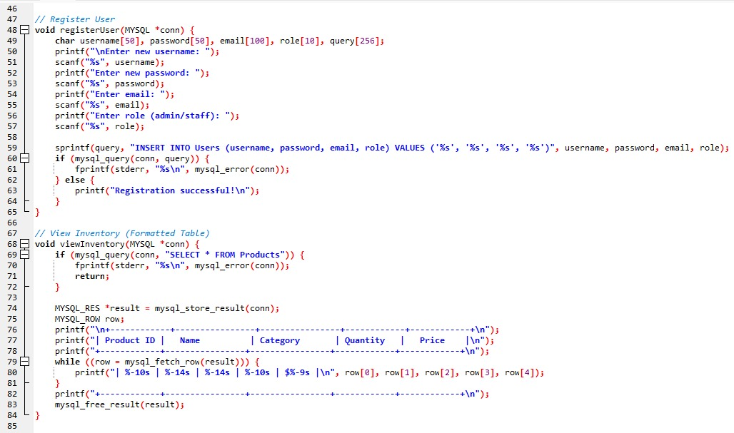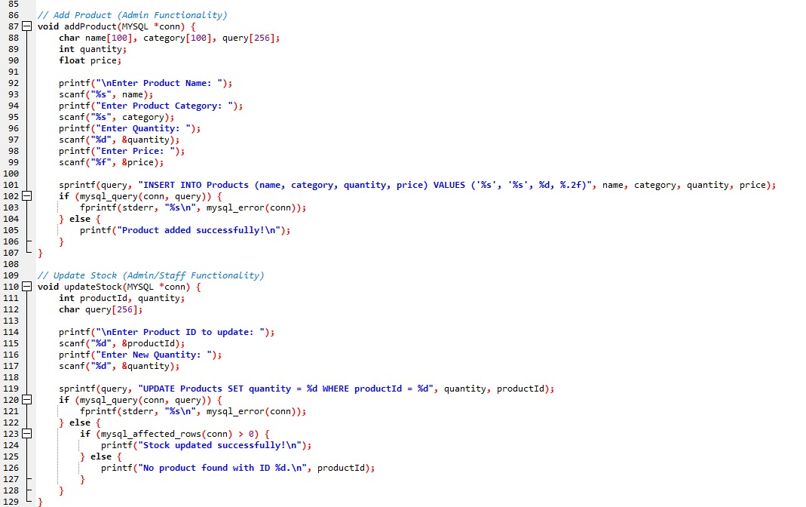

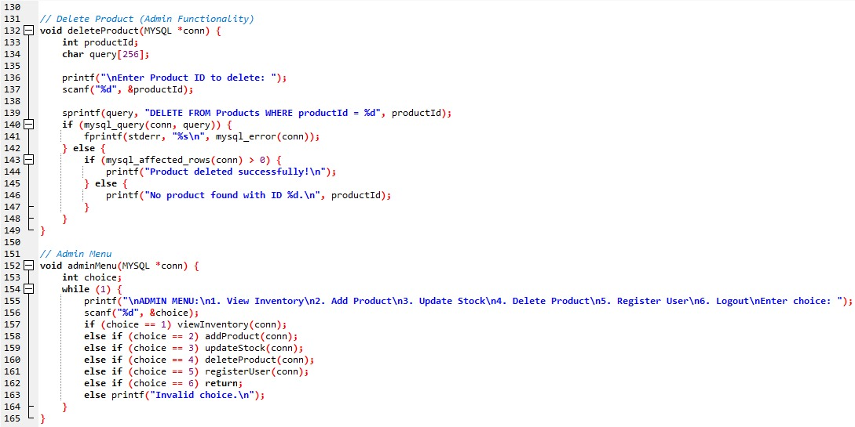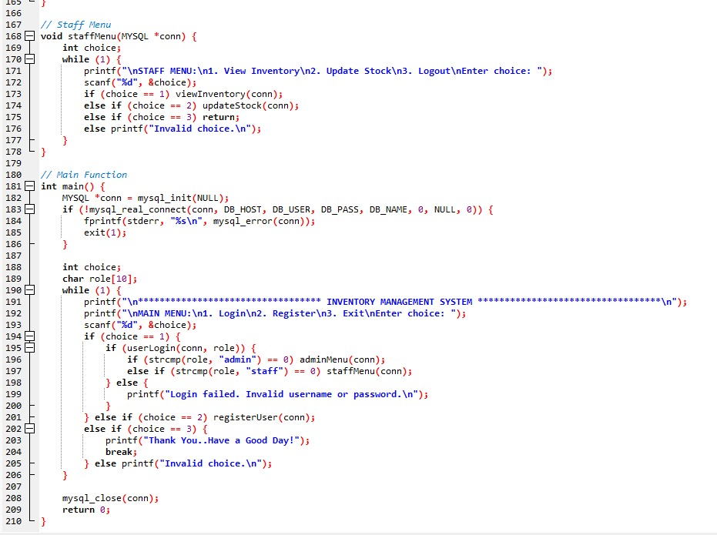

**OUTPUT**

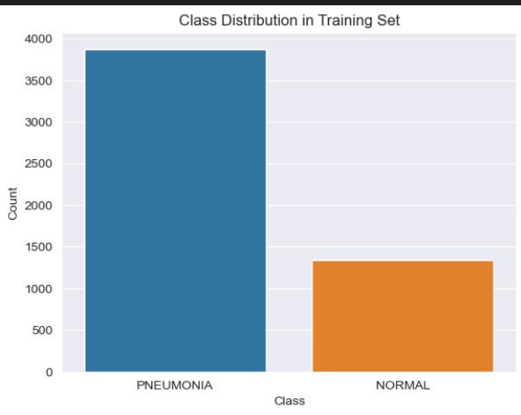

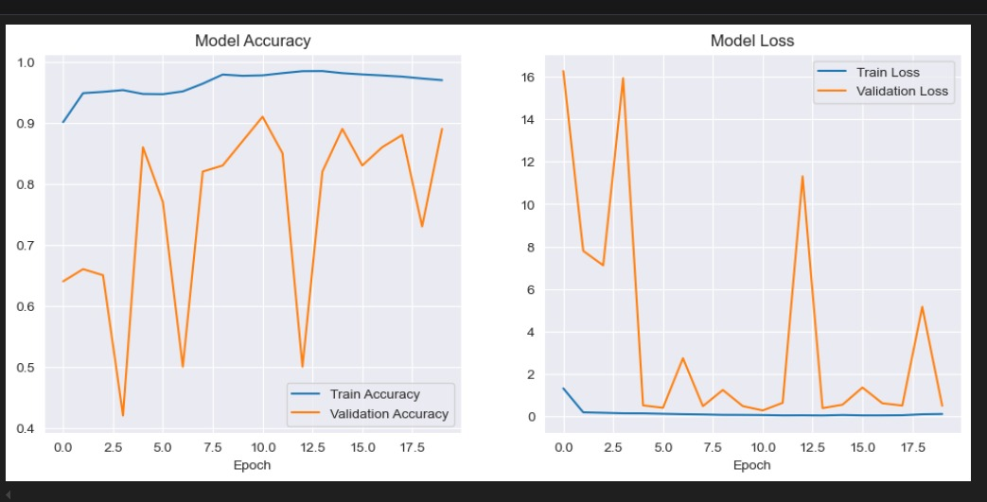

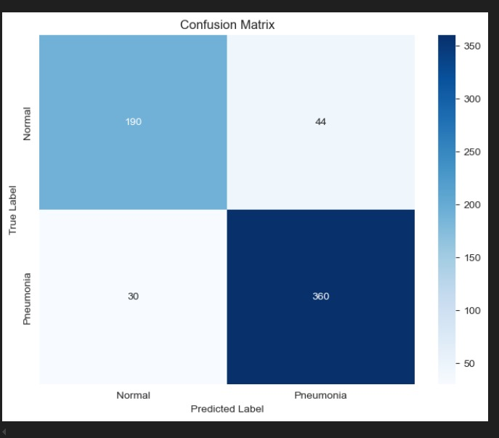

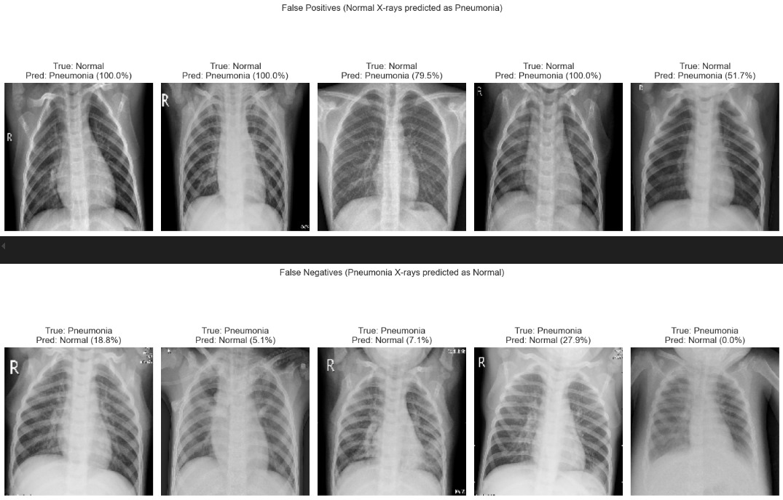

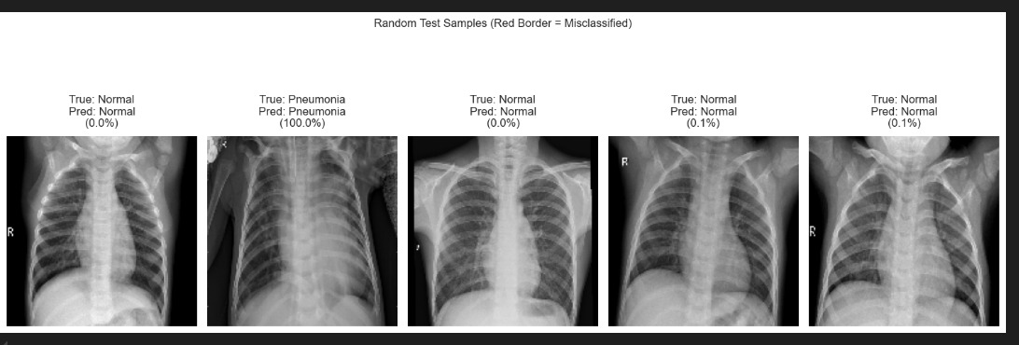

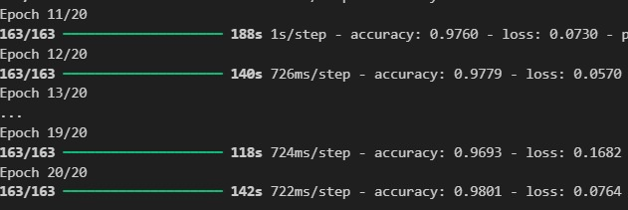

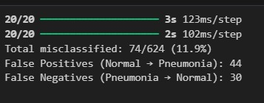

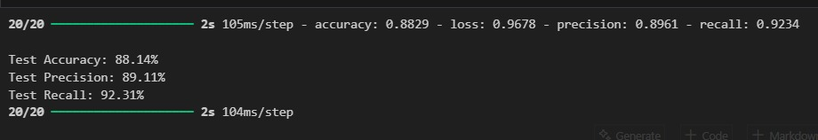

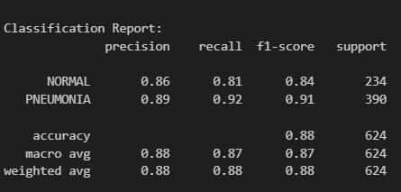

**FUTURE WORK**

While the current implementation of pneumonia detection using deep learning shows promising results, there are several areas where the system can be improved and expanded. Future work may focus on the following aspects:

* **Multi-Class Classification**
  + Extend the model to distinguish between different types of pneumonia (e.g., bacterial vs. viral) and other lung diseases such as tuberculosis or COVID-19.
* **Larger and More Diverse Datasets**
  + Incorporate more comprehensive datasets from different demographics and imaging conditions to improve model generalization and reduce bias.
* **Improved Explainability**
  + Integrate advanced explainable AI (XAI) techniques to enhance trust and interpretability for healthcare professionals, making model decisions more transparent.
* **Integration with Clinical Systems**
  + Develop APIs or modules that can be integrated with hospital information systems (HIS) or electronic health records (EHR) for real-time clinical use.
* **Mobile and Edge Deployment**
  + Optimize the model for deployment on mobile devices or edge computing platforms to enable remote diagnosis in rural or low-resource areas.
* **Continuous Learning Models**
  + Implement online learning or federated learning approaches to allow the model to adapt and improve continuously from new data without retraining from scratch.
* **Collaboration with Medical Experts**
  + Work more closely with radiologists and clinicians to validate results and ensure clinical relevance, potentially creating a hybrid AI-human diagnostic workflow.
* **Regulatory Compliance and Ethical Considerations**
  + Address data privacy, ethical AI usage, and compliance with medical regulations (e.g., HIPAA, FDA approval) before clinical deployment.

**CONCLUSION**

Pneumonia remains a significant global health concern, particularly in vulnerable populations and regions with limited access to medical expertise. Early and accurate detection is critical for effective treatment and improving patient outcomes. This report explored the application of machine learning and deep learning techniques, particularly convolutional neural networks (CNNs), for automated pneumonia detection using chest X-ray images.

The implementation demonstrated that AI-based diagnostic systems can achieve high accuracy and efficiency, reducing the burden on healthcare professionals and enabling faster decision-making. While the current model performs well, there is still scope for enhancement through the use of larger datasets, advanced explainability methods, and integration into clinical workflows.

In conclusion, AI-powered pneumonia detection systems hold great promise in supporting healthcare, especially in resource-constrained settings. With continued development, collaboration, and validation, such technologies can significantly contribute to the future of medical diagnostics.

**REFERENCES**

* Kermany, D. S., Zhang, K., & Goldbaum, M. (2018). *Identifying Medical Diagnoses and Treatable Diseases by Image-Based Deep Learning*.Cell,172(5),1122–1131.e9. https://doi.org/10.1016/j.cell.2018.02.010
* Rajpurkar, P., Irvin, J., Zhu, K., Yang, B., Mehta, H., Duan, T., ... & Ng, A. Y. (2017). *CheXNet: Radiologist-Level Pneumonia Detection on Chest X-Rays with Deep Learning*. arXiv preprint arXiv:1711.05225. <https://arxiv.org/abs/1711.05225>
* Wang, X., Peng, Y., Lu, L., Lu, Z., Bagheri, M., & Summers, R. M. (2017). *ChestX-ray8: Hospital-scale Chest X-ray Database and Benchmarks on Weakly-Supervised Classification and Localization of Common Thorax Diseases*. IEEE CVPR. <https://arxiv.org/abs/1705.02315>
* Kaggle. *Chest X-Ray Images (Pneumonia)* Dataset. https://www.kaggle.com/datasets/paultimothymooney/chest-xray-pneumonia
* Chollet, F. (2015). *Keras: Deep Learning for Humans*. <https://keras.io>
* Abadi, M., Barham, P., Chen, J., Chen, Z., Davis, A., Dean, J., ... & Zheng, X. (2016). *TensorFlow: A system for large-scale machine learning*. OSDI, 16, 265-283.