DATABRICKS SQL PROJECT
Dataset: Sample bakehouse(franchise sales)
Data used:
Franchise dataset,listing details like franchiseid,state,district,zipcode,latitude,longitude
Schema used:
Catalog: Workspace ,scheme : default ,table : dataset from franchise bake house.

DML(DATA MANIPULATION LANGUAGE):
SELECT city, district
FROM samples.bakehouse.sales_franchises
WHERE size = 'L'
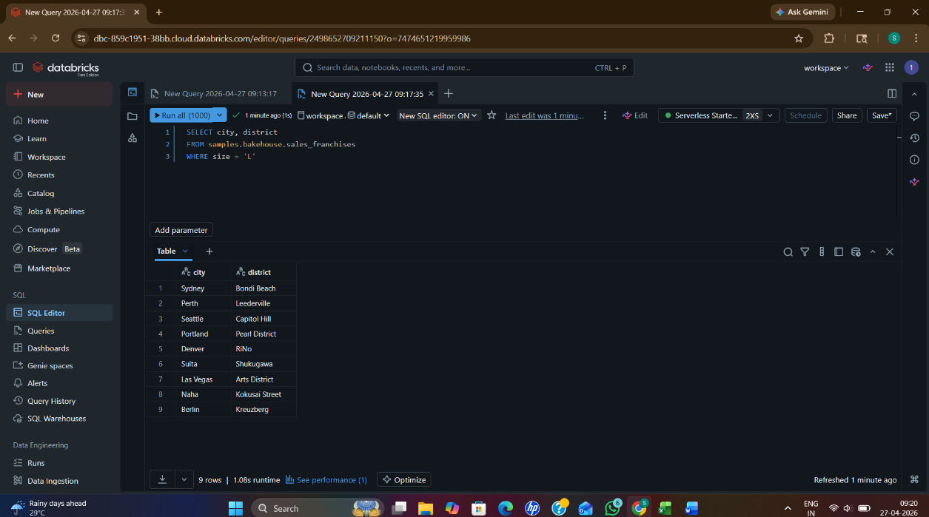

2] SELECT franchiseId, name
FROM samples.bakehouse.sales_franchises
3]Select * from franchiseid
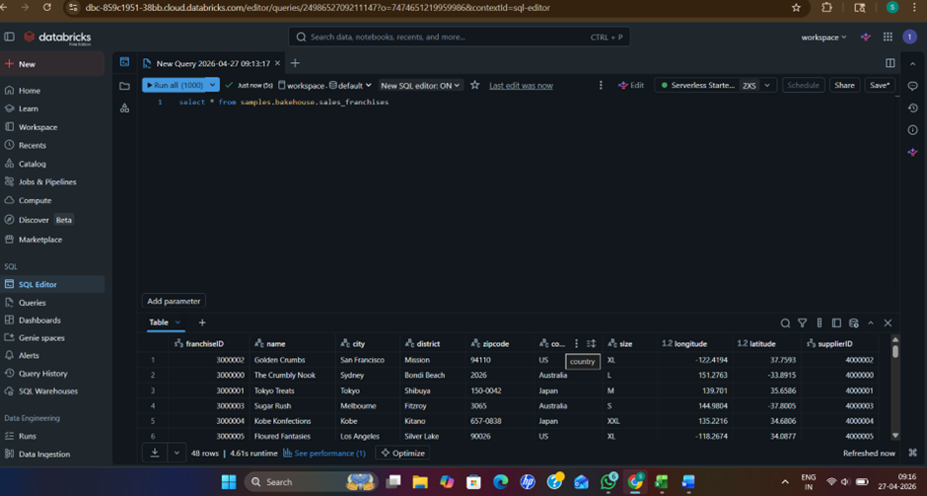
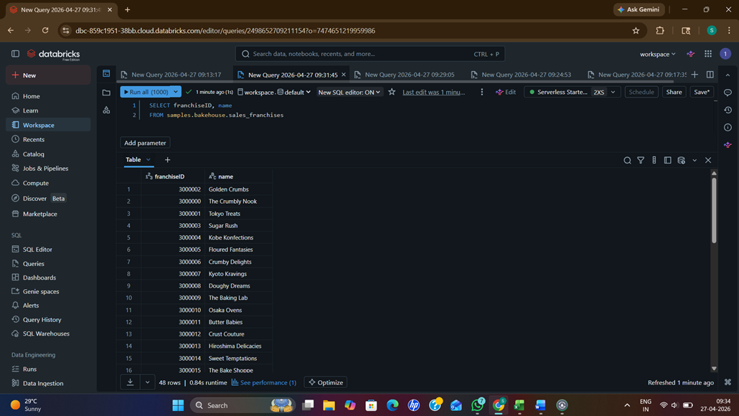
4]SELECT name, country
FROM samples.bakehouse.sales_franchises
WHERE country = 'Japan';
5] latitude, longitude
FROM samples.bakehouse.sales_franchises

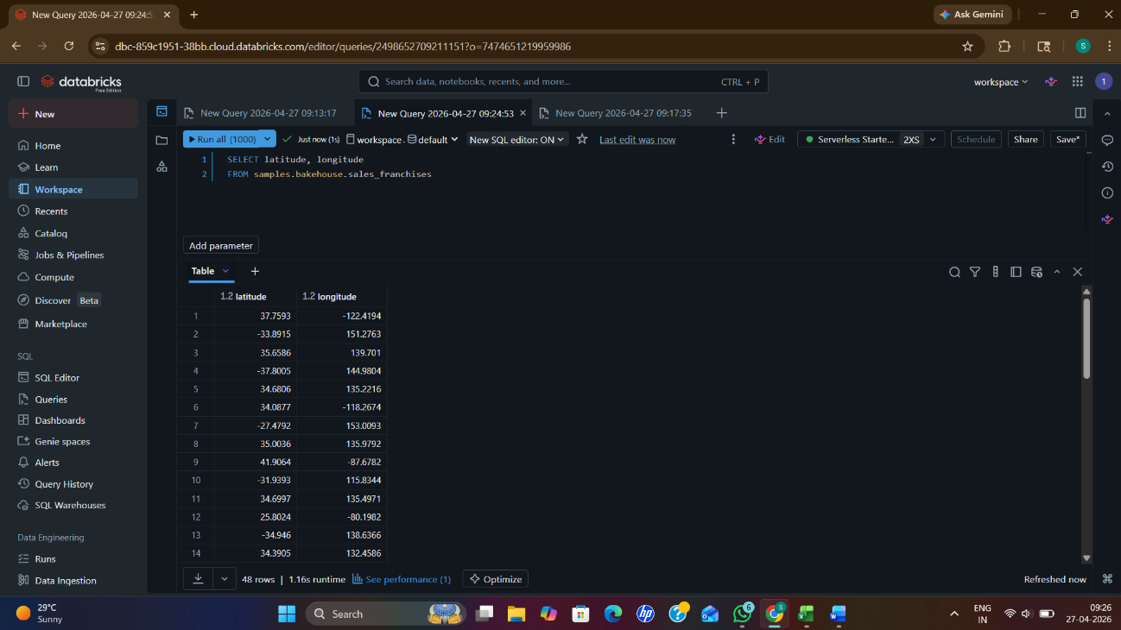
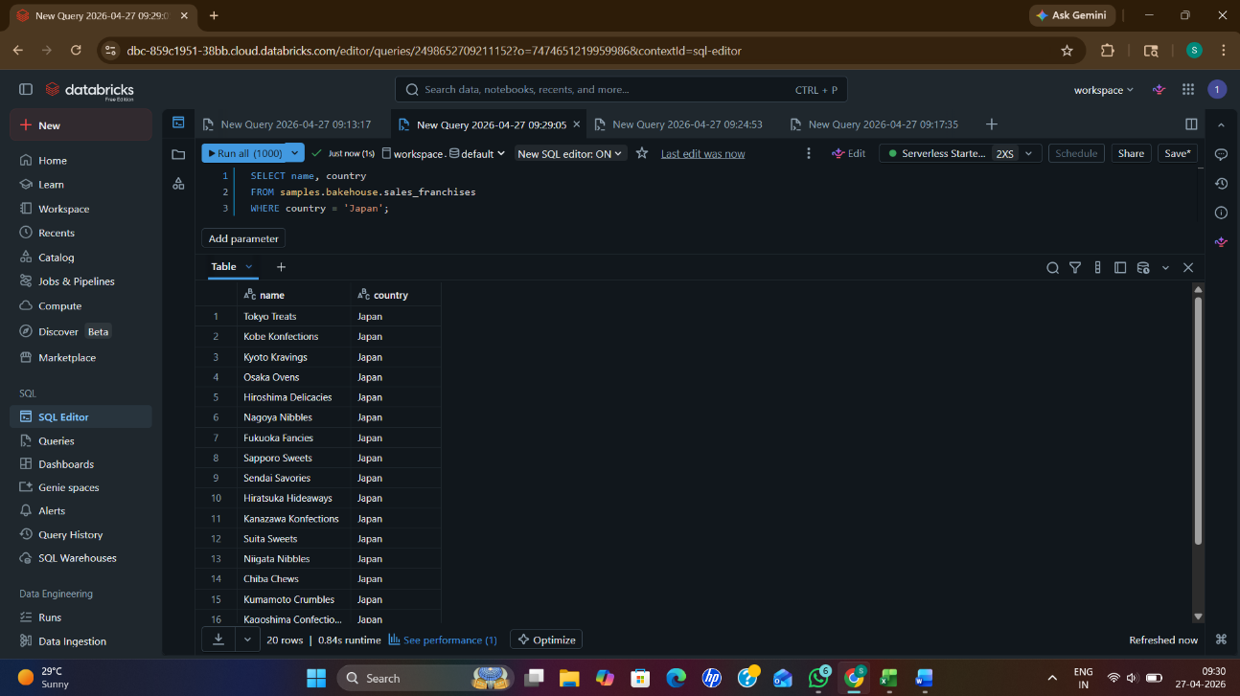
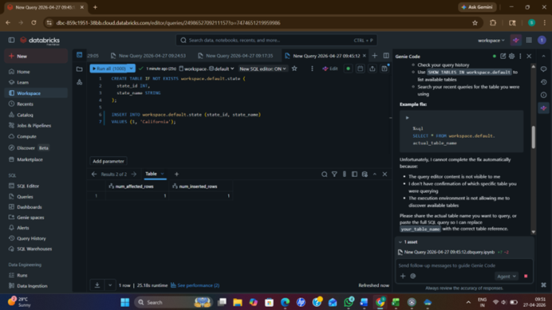
6] CREATE TABLE IF NOT EXISTS workspace.default.state (
state_id INT,
state_name STRING
);
INSERT INTO workspace.default.state (state_id, state_name)
VALUES (1, 'California');

DDL(DATA DEFINATION LANGUAGE):
1]select supplierID, ingredient, continent, city, district, size, longitude, latitude, approved
from `samples`.`bakehouse`.`sales_suppliers`
limit 100;

2]select transactionID, customerID, franchiseID, dateTime, quantity, unitPrice, totalPrice, paymentMethod, cardNumber
from `samples`.`bakehouse`.`sales_transactions`
limit 100;
