**Image Classification**

Identifying different ethnicities

**4 classes** – Asian, Black, Indian, White

**Train/ Test split** – 80:20

1.

Base model: VGG 16 on imagenet (Not trainable)

Top layer: Dense layer 1024 nodes  
 Dense layer 512 nodes  
  
Activation: ReLU

Optimization: ADAM (Learning Rate - 0.00001)

Epochs: 100

Results:

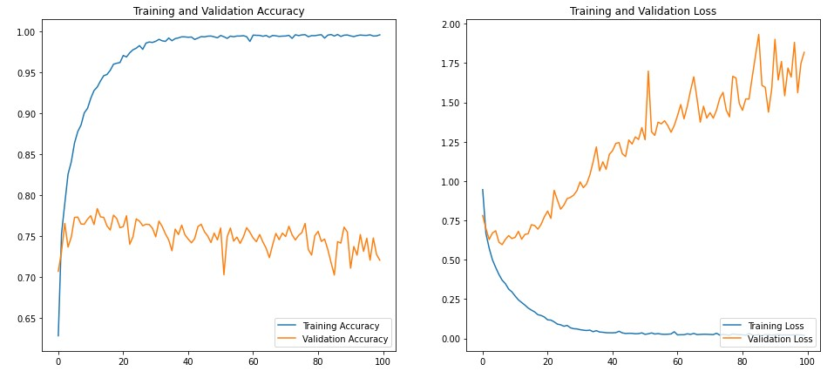

Training accuracy got close to 100% but validation accuracy peaked at 78% and slowly started dropping down to 72.5%

Training loss decreased constantly and stabilized at 0 while validation loss kept increasing and fluctuating and peaked at 1.9.

Clearly overfitting.

2.

Added dropout layers to reduce overfitting.

Base model: VGG 16 on imagenet (Not trainable)

Top layer: Dense layer – 1024 nodes  
 Dropout – 0.5  
 Dense layer – 512 nodes  
 Dropout – 0.5

Activation: ReLU

Optimization: RMSprop (Learning Rate - 0.0001)

Epochs: 50

Results:

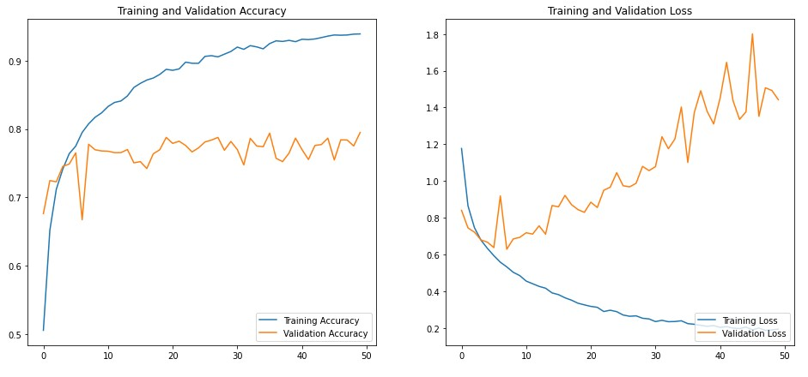

Training accuracy came down from 100% to about 95% and validation accuracy stayed above 75%

Training loss dropped to 0.2 and validation loss didn’t go above 1.8.

Still overfitting but slightly better than before. Dropout layers helped.

3.

Used L2 regularization along with dropout layers.

After training the top dense layers for 50 epochs the base VGG model was made trainable and the entire NN was trained at a slow learning rate for another 50 epochs

Base model: VGG 16 on imagenet (Not trainable)

Top layer: Dense layer – 1024 nodes  
 Dropout – 0.5  
 Dense layer – 512 nodes  
 Dropout – 0.5

Activation: ReLU

Optimization: RMSprop  
 Learning rate 0.0001 for initial training and 0.00001 for fine  
 tuning.

Epochs: 50 + 50

Results:

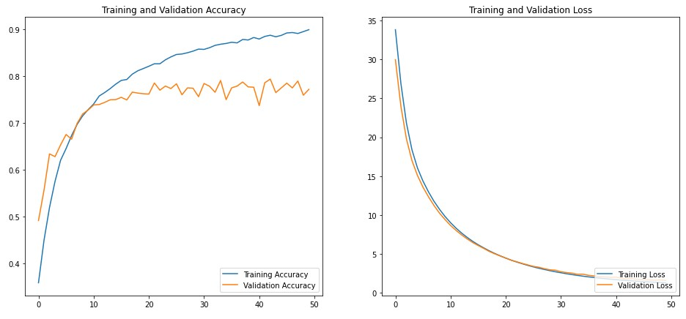

The regularization made a lot of difference. The training and validation accuracies are closer now and the fluctuations are also reduced.

The training and validation losses are very similar now compared to the previous runs.

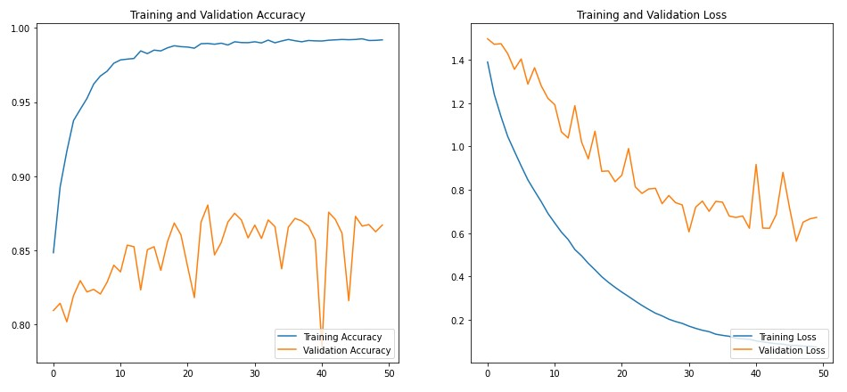

The first fine tuning attempt was not great. Although the validation accuracy crossed 85% (with huge fluctuations) the training accuracy went back up to almost 100%.

Even the training and validation losses showed a significant difference.

Back to overfitting

4.

For the final run the top dense layers were made much smaller with 512 nodes and going down to 256 and then 128 nodes. Even the dropout probability was reduced for every layer. Maybe the previous models were over fitting because there were too many millions of parameters.

Base model: VGG 16 on imagenet (Not trainable)

Top layer: Dense layer – 512 nodes  
 Dropout – 0.5  
 Dense layer – 256 nodes  
 Dropout – 0.4  
 Dense layer – 128 nodes  
 Dropout – 0.2

Activation: ReLU

Optimization: RMSprop  
 Learning rate 0.00001 for both runs.

Epochs: 30 + 30

Results:

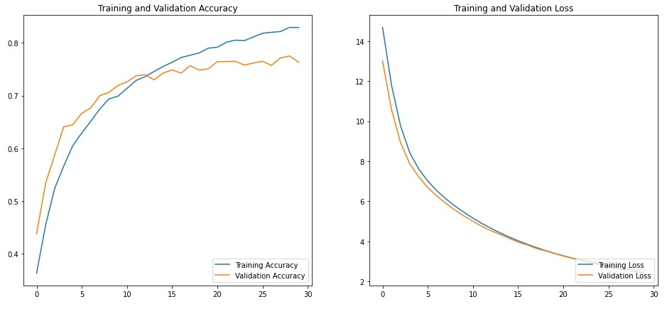

The training and validation accuracies are much closer this time. Around 83% to 76%.

Both losses are also very close.

Smaller NN layers are much better. Should explore further.

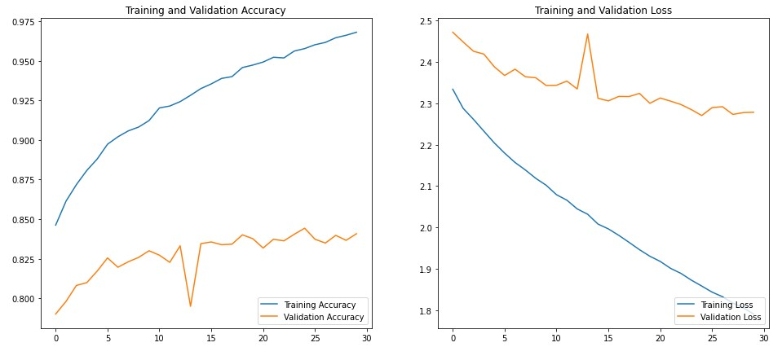

The fine-tuning attempt was better than before. Although the model is still overfitting, the validation accuracy is consistently above 82.5% with very little fluctuation.