Environmental health checkup
Account Closure status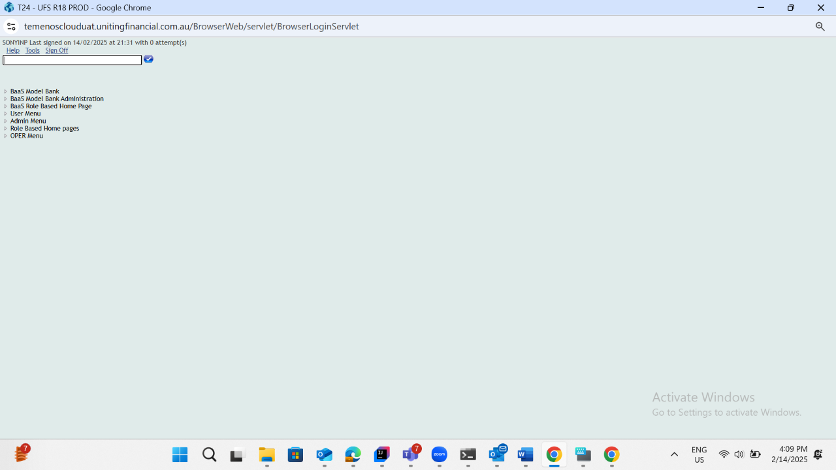
Deposit Closure status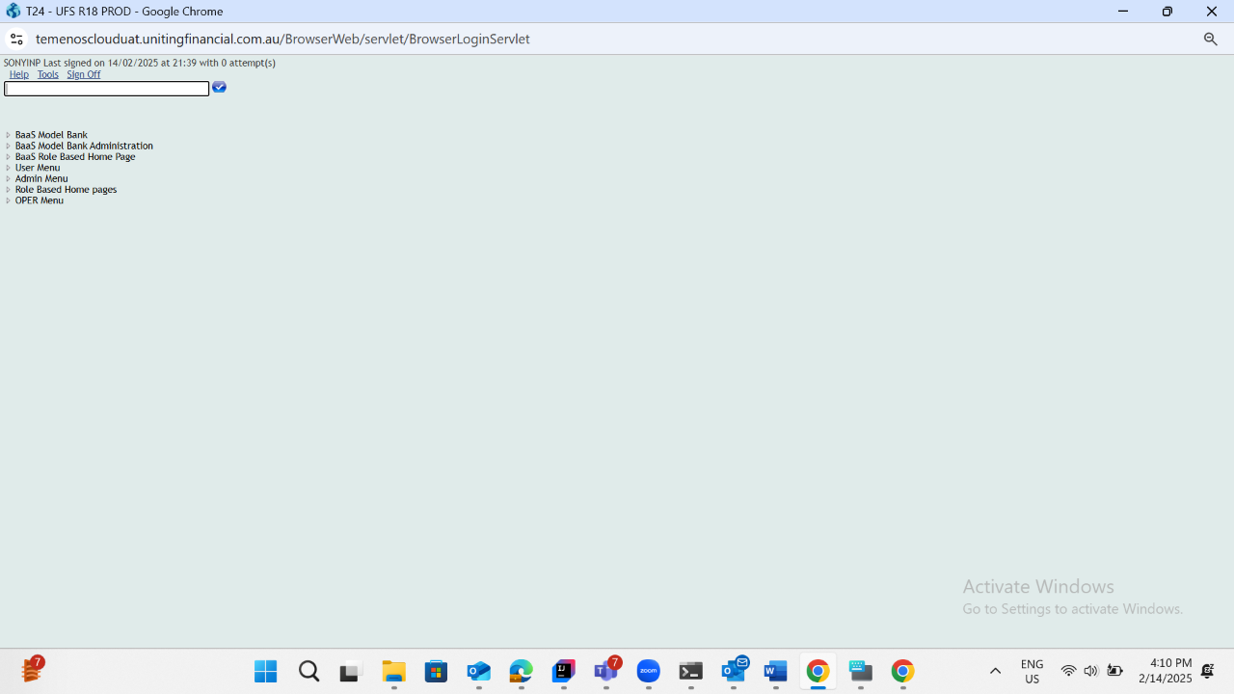
Loan Closure status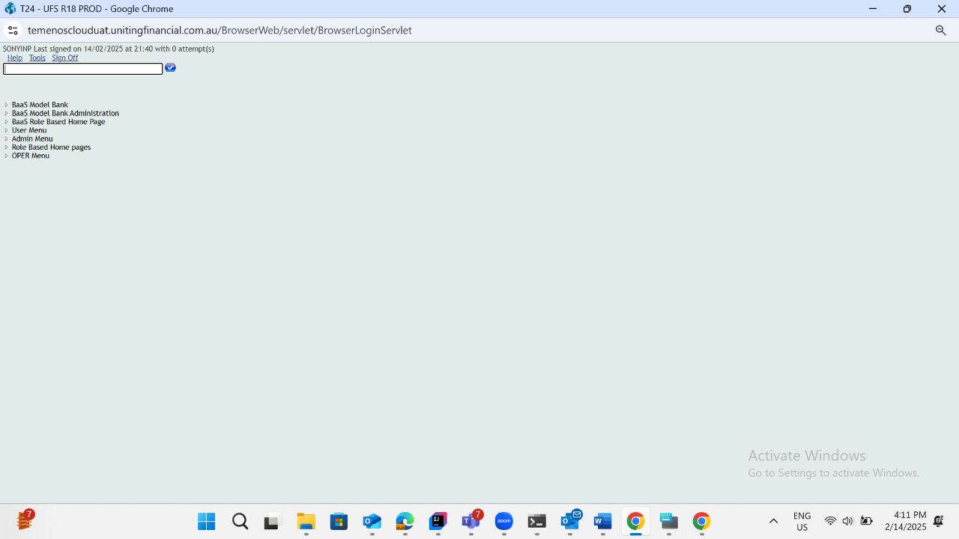
Balance Maintanance sweep transfer Narrative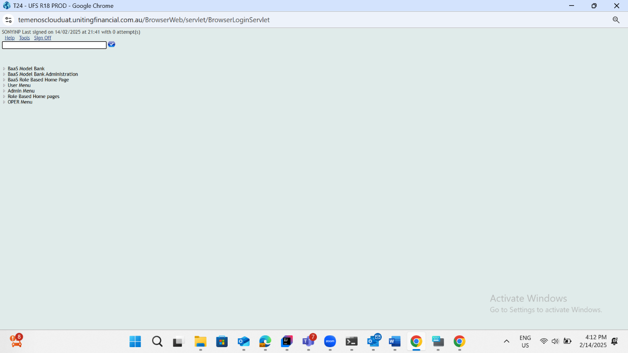
Surplus sweep transfer Narrative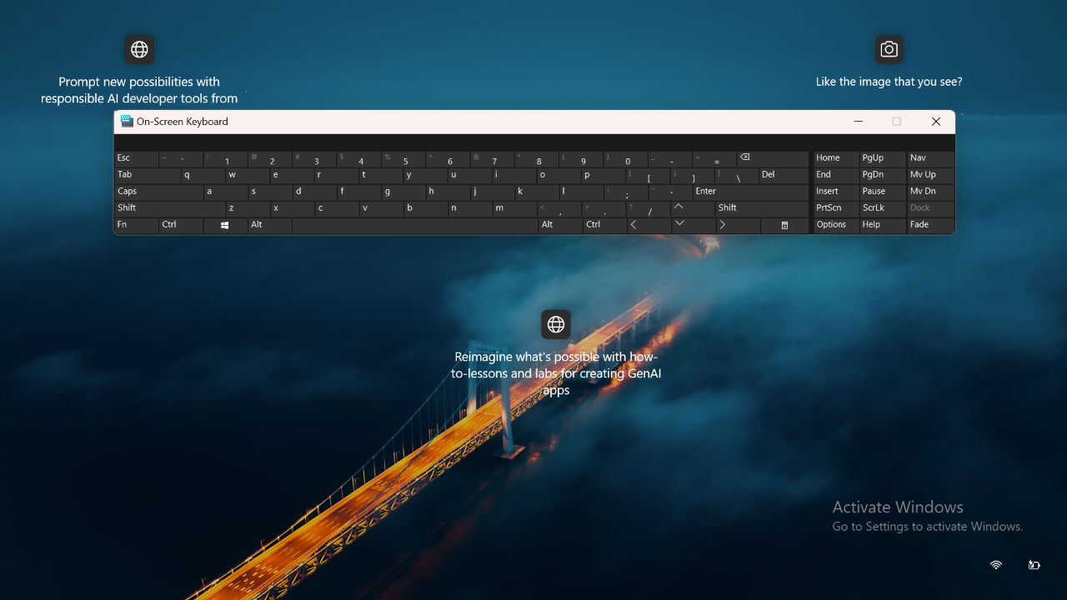
Two way sweep transfer Surplus Narrative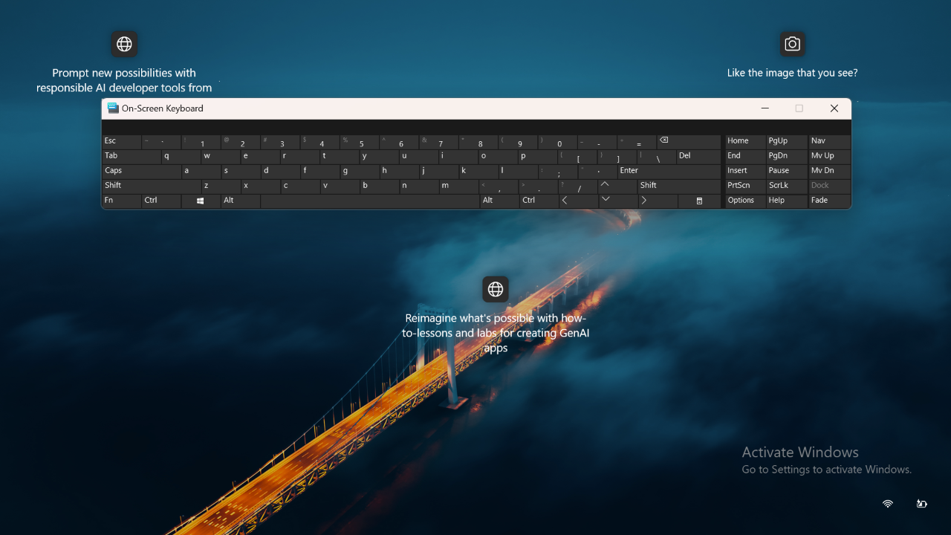
Two way sweep transfer Balance maintenance Narrative
Direct Debit Narrative

