Environmental health checkup
Perform Internal Transfer IB Now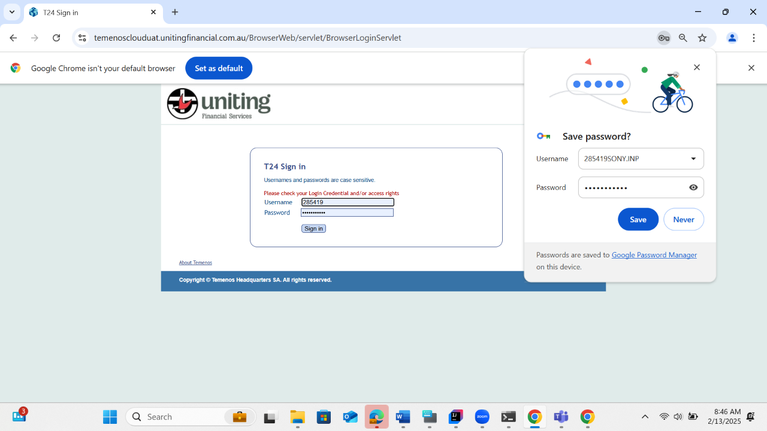
Perform External Transfer IB new contact now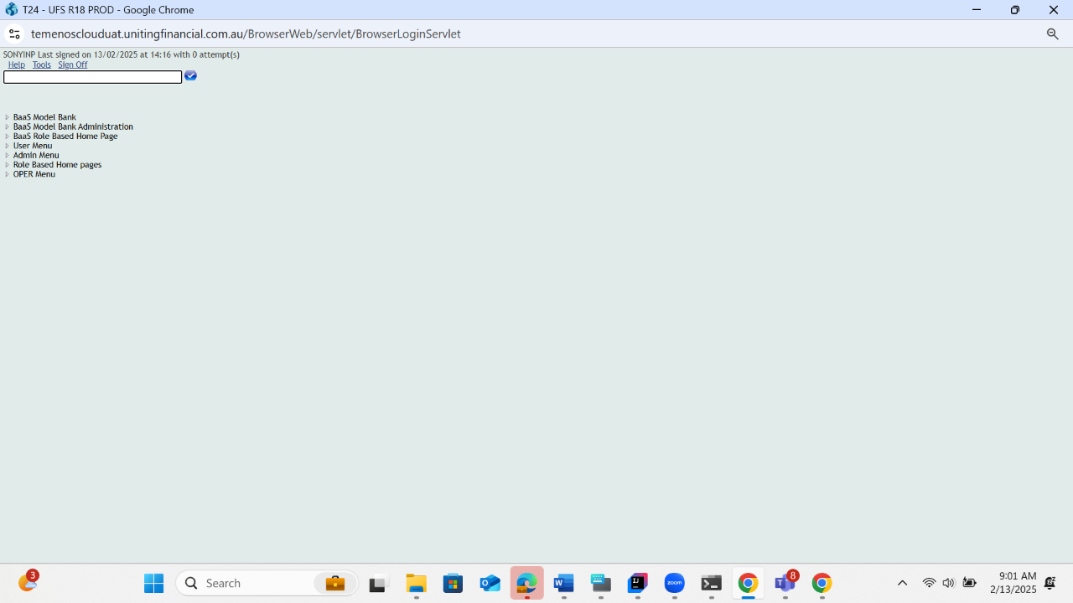
Bpay now saved contact