Steps to run the application:

1. Download Project from git.

git clone https://github.com/jayagopi1993/Assignment.git

2. Run maven command to install jars.

3. This Web service application have one active service to process Csv/Xml files. please find service url below,

http://localhost:8080/rabobank/statment

4. Upload input csv/xml file in the service using postman client.

5. The input file will be validated based on two conduction mentioned in the problem statment.(validation condition mentioned in expected output section)

\* Duplicate Transaction key check,

\* End balance calculation check. (endbalance = startbalance – mutation)

6. Finally invalid records will be getting as webservice response with status code.

Screenshots:

1. Invalid records from csv/xml

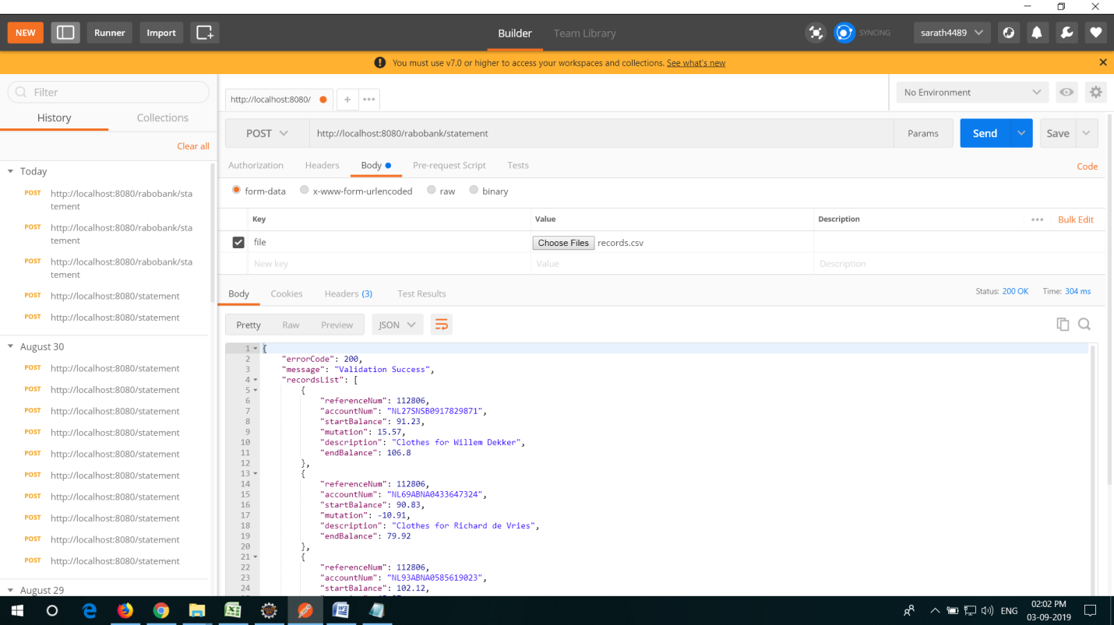

1. Upload from UI .

