Assignment1

Sarath. M (DS3)

1.What is the basic difference and similarity between a vector and a matrix?

Ans:

Similarity:

1. Both Vector and Matrix have collection of elements of same Datatype.

Difference:

1. Vector is dimensionless whereas matrix is 2D.

2.What is the basic difference and similarity between a data frame and a matrix?

Ans:

Similarity:

1. Both Data Frame and Matrix are 2D.

Difference:

1. Data Frame is used for different type of variable whereas Matrix is used for same type of variable.
2. Data Frames contains components of equal lengths whereas Matrix contains has integer vector of length 2.

3.Create a vector using (15, TRUE, “World”). What happened to your result?

Ans: Input:

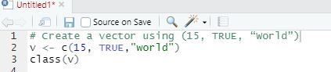

Output:



As the data for vector is not of same data type it is automatically considered whole of vector as character.

1. John’s scores in the final semester for the three subjects are 95, 91, and 88. The subjects are Statistics, Linear Algebra, and Calculus. Using these create a vector and give names to all elements of the vector based on their subjects.

Ans: Input:

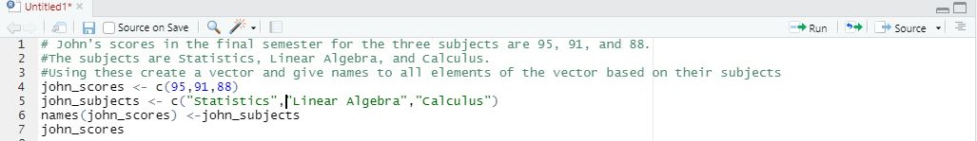

Output:



1. Please check the types (character or numeric) of the vector you created.

Ans:



1. You have three students in your class (choose any name you want). You must create a matrix using their score in the above mentioned subjects (question 4) Student 1 (95, 91, and 88), Student 2(96, 94, and 97), Student 3(88, 98, and 85). Create a matrix and label column and row names.

Ans:input:

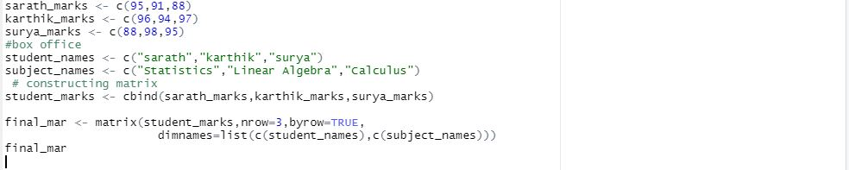

Output:



1. Convert the created matrix into a data frame

Ans: input



Output:

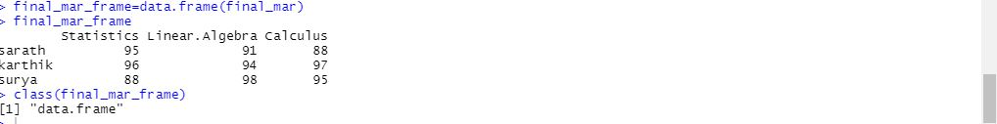

1. Create three vectors using five countries (your choice) from the following website. The first vector should be country names, the second vector should be the total number of cases, and the third vector should contain the total number of deaths. Create a data frame using these vectors.   
   <https://www.worldometers.info/coronavirus/>

Ans:Input:

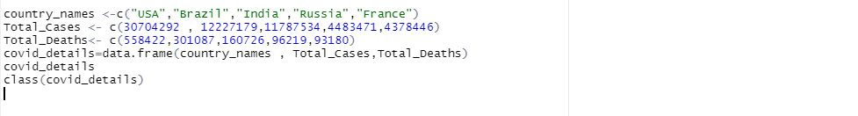

Output:

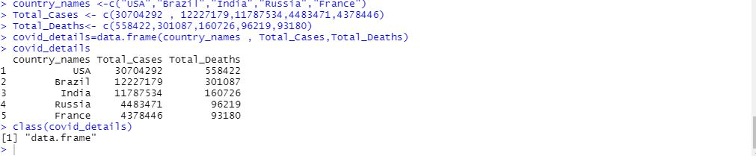

1. Please read the mtcars data set from R. It is an built-in data set. Please check the structure of the data set. If required, please convert the data into their appropriate data types (character, logical, factor, etc). Save your results as a new data frame using a new name.

Ans:

Input:

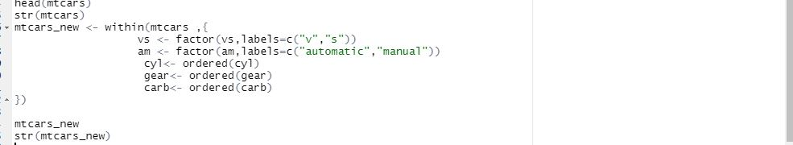

Output:

