Assignment 2

1. The final score of the World Cup finals of football is France  4 and Croatia 2. Please use a control structure to print the results as Team ---- Wins -----.

Ans:

1. The mtcars data set has several factor variables. However, R is reading them as numeric. Please convert them into factors using a for loop. Please use column 8 to 11 for the loop

Ans:

Input:

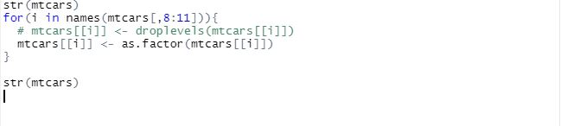

Output:

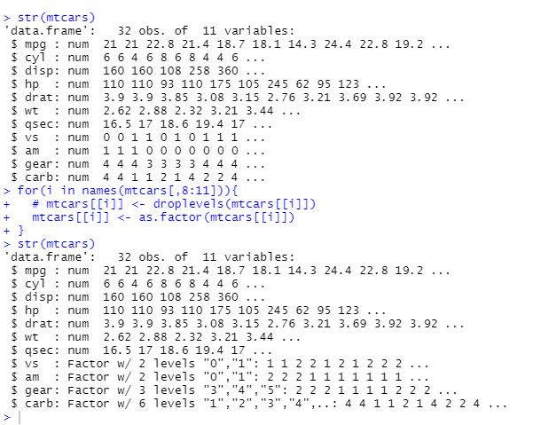

1. Write a function to get the percentage of NAs in each column

Ans: