**Task - Day 3 - LINUX - Network Basic**

**Create a shell script to print the HTTP error code of guvi.in & print, the success/failure message based on the error code response Given a file, replace all occurrence of the word ""give"" with ""learning"" from the 5th line till the end in only those lines that contain the word "welcome"**

1. **Get me IP address of particular domain (guvi.in) ?**

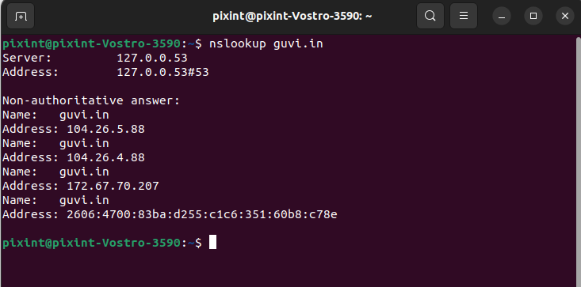

The IP address is 104.26.5.88

**2. How do I find my CPU/memory usage of my server?**

Using the top command we can find the CPU/memory usage

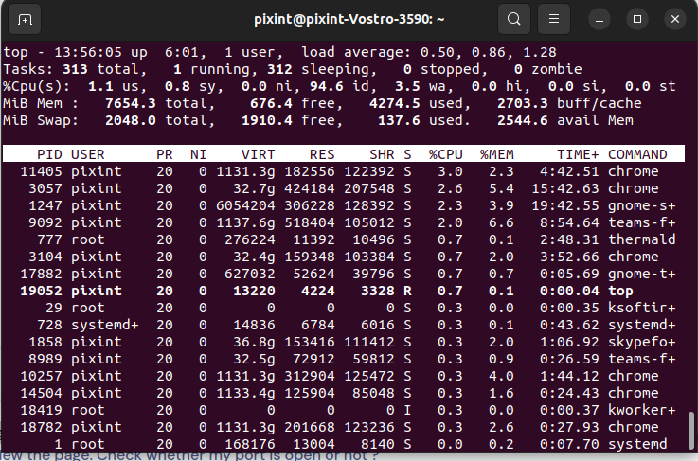

**3. Test the connectivity between 2 nodes?**

Using ping command we can test the 2 nodes.

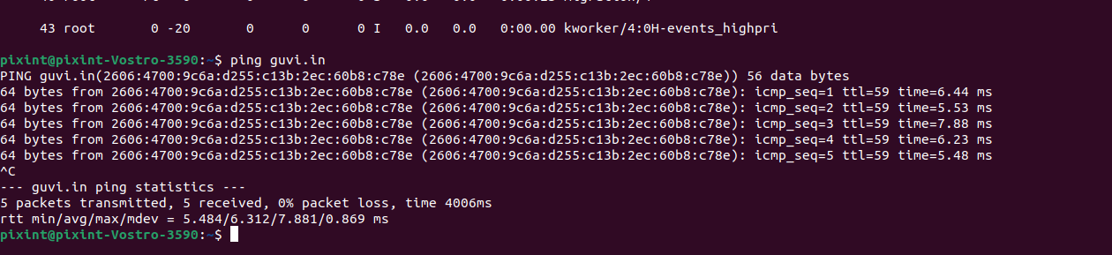

**4. I have deployed an application in guvi.com:9000, and logs shows my app is running, but I’m unable to view the page. Check whether my port is open or not ?**

Deployed application is not running in port 9000. It is running in port 443.

