**RAJAGIRI COLLEGE OF SOCIAL SCIENCES**

**(Autonomous)**

**KALAMASSERY - KOCHI - 683104**



**MASTER OF COMPUTER APPLICATIONS**

**ANDROID (LAB ASSIGNMENT)  
MCA307**

**NAME : Sarath Chandran M**

**ROLL NO: 51**

**1. Create an app that illustrates the following layouts of the android studio.**

**● Constraint Layout**

**● Linear Layout**

**● Relative Layout**

**● Frame Layout**

**● Table Layout**

**MainActivity.java**

package com.example.layoutdemo;  
  
import android.os.Bundle;  
import android.view.LayoutInflater;  
import android.view.View;  
import android.widget.Button;  
import android.widget.FrameLayout;  
import androidx.appcompat.app.AppCompatActivity;  
import androidx.constraintlayout.widget.ConstraintLayout;  
  
public class MainActivity extends AppCompatActivity {  
  
 private FrameLayout frameLayout;  
 private Button changeLayoutButton;  
 private int currentLayoutIndex = 0;  
 private int[] layouts = {  
 R.layout.*layout_constraint*,  
 R.layout.*layout_linear*,  
 R.layout.*layout_relative*,  
 R.layout.*layout_frame*,  
 R.layout.*layout_table* };  
  
 @Override  
 protected void onCreate(Bundle savedInstanceState) {  
 super.onCreate(savedInstanceState);  
 setContentView(R.layout.*activity_main*);  
  
 // Initialize views  
 frameLayout = findViewById(R.id.*frameLayout*);  
 changeLayoutButton = findViewById(R.id.*changeLayoutButton*);  
  
 // Set initial layout  
 showLayout(layouts[currentLayoutIndex]);  
  
 // Button click listener to cycle through layouts  
 changeLayoutButton.setOnClickListener(new View.OnClickListener() {  
 @Override  
 public void onClick(View v) {  
 currentLayoutIndex = (currentLayoutIndex + 1) % layouts.length;  
 showLayout(layouts[currentLayoutIndex]);  
 }  
 });  
 }  
  
 private void showLayout(int layoutResID) {  
 frameLayout.removeAllViews();  
 View view = LayoutInflater.*from*(this).inflate(layoutResID, frameLayout, false);  
 frameLayout.addView(view);  
 }  
}

**activity_main.xml**

<?xml version="1.0" encoding="utf-8"?>  
<RelativeLayout xmlns:android="http://schemas.android.com/apk/res/android"  
 android:layout_width="match_parent"  
 android:layout_height="match_parent">  
  
 <FrameLayout  
 android:id="@+id/frameLayout"  
 android:layout_width="match_parent"  
 android:layout_height="match_parent"  
 android:layout_above="@+id/changeLayoutButton" />  
  
 <Button  
 android:id="@+id/changeLayoutButton"  
 android:layout_width="wrap_content"  
 android:layout_height="wrap_content"  
 android:layout_alignParentBottom="true"  
 android:layout_centerHorizontal="true"  
 android:text="Change Layout" />  
  
</RelativeLayout>

**Layout_linera.xml**

<LinearLayout  
 android:layout_width="match_parent"  
 android:layout_height="wrap_content"  
 android:orientation="horizontal"  
 android:gravity="center"  
 android:layout_marginTop="16dp">  
  
 <Button  
 android:id="@+id/button"  
 android:layout_width="wrap_content"  
 android:layout_height="wrap_content"  
 android:text="Click Me"  
 android:layout_margin="8dp" />  
  
 <EditText  
 android:id="@+id/editText"  
 android:layout_width="0dp"  
 android:layout_height="wrap_content"  
 android:layout_margin="8dp"  
 android:layout_weight="1"  
 android:hint="Enter text"  
 android:minHeight="48dp" />  
</LinearLayout>

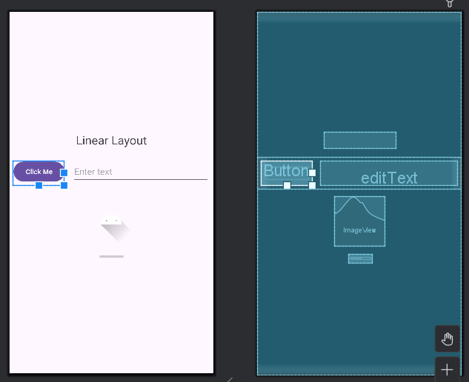

**Layout_constraint.xml**

<TextView  
 android:id="@+id/textView"  
 android:layout_width="wrap_content"  
 android:layout_height="wrap_content"  
 android:text="Constraint Layout"  
 android:textSize="24sp"  
 android:layout_marginTop="16dp"  
 app:layout_constraintTop_toTopOf="parent"  
 app:layout_constraintStart_toStartOf="parent"  
 app:layout_constraintEnd_toEndOf="parent" />  
  
<Button  
 android:id="@+id/button"  
 android:layout_width="wrap_content"  
 android:layout_height="wrap_content"  
 android:text="Click Me"  
 app:layout_constraintTop_toBottomOf="@id/textView"  
 app:layout_constraintStart_toStartOf="parent"  
 app:layout_constraintEnd_toEndOf="parent"  
 android:layout_marginTop="16dp" />  
  
<ImageView  
 android:id="@+id/imageView"  
 android:layout_width="100dp"  
 android:layout_height="100dp"  
 android:src="@drawable/ic_launcher_foreground"  
 app:layout_constraintTop_toBottomOf="@id/button"  
 app:layout_constraintStart_toStartOf="parent"  
 app:layout_constraintEnd_toEndOf="parent"  
 android:layout_marginTop="16dp" />  
  
<EditText  
 android:id="@+id/editText"  
 android:layout_width="0dp"  
 android:layout_height="wrap_content"  
 android:layout_marginStart="16dp"  
 android:layout_marginTop="16dp"  
 android:layout_marginEnd="16dp"  
 android:hint="Enter text"  
 android:minHeight="48dp"  
 app:layout_constraintEnd_toEndOf="parent"  
 app:layout_constraintStart_toStartOf="parent"  
 app:layout_constraintTop_toBottomOf="@id/imageView" />

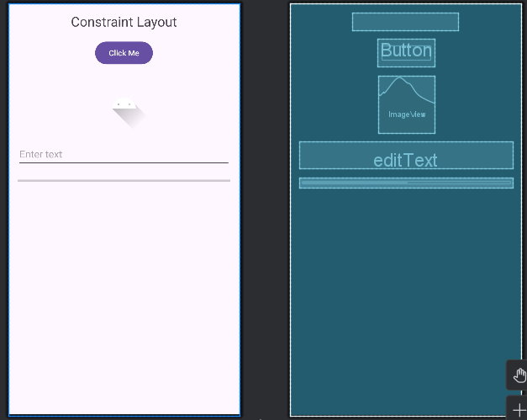

**Layout_frame.xml**

<TextView  
 android:id="@+id/textView"  
 android:layout_width="wrap_content"  
 android:layout_height="wrap_content"  
 android:text="Frame Layout"  
 android:textSize="24sp"  
 android:layout_gravity="center" />  
  
<Button  
 android:id="@+id/button"  
 android:layout_width="wrap_content"  
 android:layout_height="wrap_content"  
 android:text="Click Me"  
 android:layout_gravity="bottom|center_horizontal"  
 android:layout_marginBottom="16dp" />  
  
<ImageView  
 android:id="@+id/imageView"  
 android:layout_width="100dp"  
 android:layout_height="100dp"  
 android:src="@drawable/ic_launcher_foreground"  
 android:layout_gravity="top|center_horizontal"  
 android:layout_marginTop="16dp" />

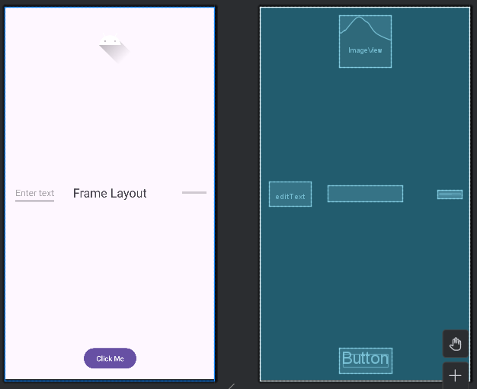

**Layout_relative.xml**

<RelativeLayout xmlns:android="http://schemas.android.com/apk/res/android"  
 android:layout_width="match_parent"  
 android:layout_height="match_parent">  
  
 <TextView  
 android:id="@+id/textView"  
 android:layout_width="wrap_content"  
 android:layout_height="wrap_content"  
 android:text="Relative Layout"  
 android:textSize="24sp"  
 android:layout_centerInParent="true"  
 android:layout_marginTop="16dp" />  
  
 <Button  
 android:id="@+id/button"  
 android:layout_width="wrap_content"  
 android:layout_height="wrap_content"  
 android:text="Click Me"  
 android:layout_below="@id/textView"  
 android:layout_centerHorizontal="true"  
 android:layout_marginTop="16dp" />  
  
 <ImageView  
 android:id="@+id/imageView"  
 android:layout_width="100dp"  
 android:layout_height="100dp"  
 android:src="@drawable/ic_launcher_foreground"  
 android:layout_above="@id/textView"  
 android:layout_centerHorizontal="true"  
 android:layout_marginBottom="16dp" />

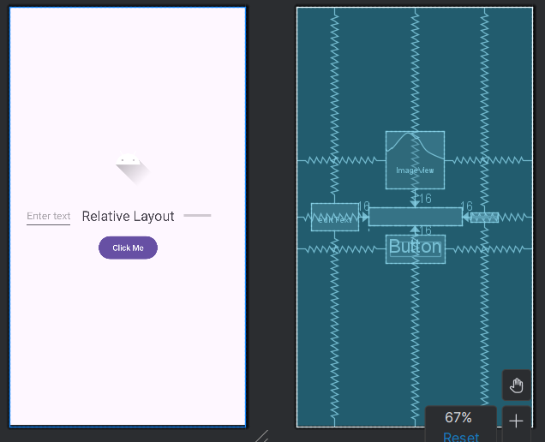

**Layout_table.xml**

<TableLayout xmlns:android="http://schemas.android.com/apk/res/android"  
 android:layout_width="match_parent"  
 android:layout_height="match_parent">  
  
 <TableRow  
 android:layout_width="match_parent"  
 android:layout_height="wrap_content">  
  
 <TextView  
 android:id="@+id/textView2"  
 android:layout_width="wrap_content"  
 android:layout_height="wrap_content"  
 android:text="TextView 2"  
 android:textSize="24sp"  
 android:padding="8dp" />  
  
 <Button  
 android:id="@+id/button1"  
 android:layout_width="wrap_content"  
 android:layout_height="wrap_content"  
 android:text="Button 1"  
 android:padding="8dp" />  
  
 <ImageView  
 android:id="@+id/imageView1"  
 android:layout_width="50dp"  
 android:layout_height="50dp"  
 android:src="@drawable/cat"  
 android:scaleType="fitCenter"  
 android:padding="8dp" />  
  
  
  
 </TableRow>

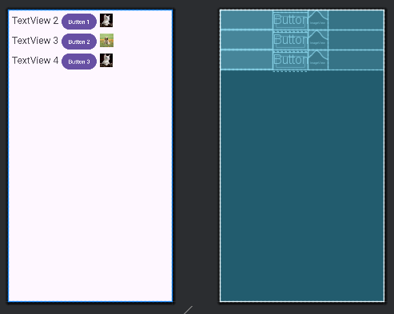

**OUTPUT:**

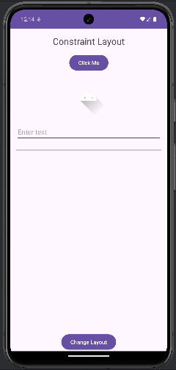 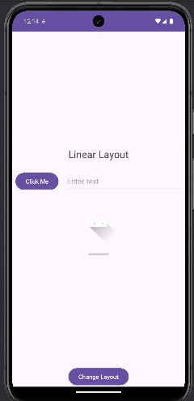 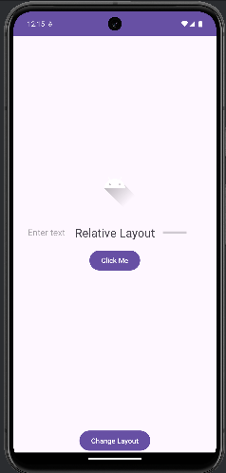 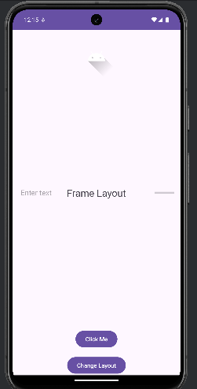

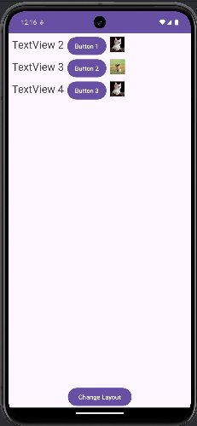

**2. Create an app that demonstrates Tab Layout and Grid View**

**MainActivity.java**

package com.example.tablayout;  
  
import android.os.Bundle;  
  
import androidx.activity.EdgeToEdge;  
import androidx.appcompat.app.AppCompatActivity;  
import androidx.core.graphics.Insets;  
import androidx.core.view.ViewCompat;  
import androidx.core.view.WindowInsetsCompat;  
import androidx.viewpager2.widget.ViewPager2;  
  
import com.google.android.material.tabs.TabLayout;  
  
public class MainActivity extends AppCompatActivity {  
 TabLayout tabLayout;  
 ViewPager2 viewPager2;  
 ViewPagerAdapter viewPagerAdapter;  
  
 @Override  
 protected void onCreate(Bundle savedInstanceState) {  
 super.onCreate(savedInstanceState);  
 EdgeToEdge.*enable*(this);  
 setContentView(R.layout.*activity_main*);  
 tabLayout=findViewById(R.id.*tabLayout*);  
 viewPager2=findViewById(R.id.*viewpager*);  
 viewPagerAdapter=new ViewPagerAdapter(this);  
 viewPager2.setAdapter(viewPagerAdapter);  
 tabLayout.addOnTabSelectedListener(new TabLayout.OnTabSelectedListener() {  
 @Override  
 public void onTabSelected(TabLayout.Tab tab) {  
 viewPager2.setCurrentItem(tab.getPosition());  
 }  
  
 @Override  
 public void onTabUnselected(TabLayout.Tab tab) {  
  
 }  
  
 @Override  
 public void onTabReselected(TabLayout.Tab tab) {  
  
 }  
 });  
 viewPager2.registerOnPageChangeCallback(new ViewPager2.OnPageChangeCallback() {  
 @Override  
 public void onPageSelected(int position) {  
 super.onPageSelected(position);  
 tabLayout.getTabAt(position).select();  
  
 }  
 });  
 ViewCompat.*setOnApplyWindowInsetsListener*(findViewById(R.id.*main*), (v, insets) -> {  
 Insets systemBars = insets.getInsets(WindowInsetsCompat.Type.*systemBars*());  
 v.setPadding(systemBars.left, systemBars.top, systemBars.right, systemBars.bottom);  
 return insets;  
 });  
 }  
}

**activity_main.xml**

<?xml version="1.0" encoding="utf-8"?>  
<LinearLayout xmlns:android="http://schemas.android.com/apk/res/android"  
 xmlns:app="http://schemas.android.com/apk/res-auto"  
 xmlns:tools="http://schemas.android.com/tools"  
 android:id="@+id/main"  
 android:layout_width="match_parent"  
 android:layout_height="match_parent"  
 android:orientation="vertical"  
 tools:context=".MainActivity">  
<com.google.android.material.tabs.TabLayout  
 android:id= "@+id/tabLayout"  
 android:layout_width="match_parent"  
 android:layout_height="wrap_content">  
 <com.google.android.material.tabs.TabItem  
 android:text = "TAB1"  
 android:layout_width="wrap_content"  
 android:layout_height="wrap_content"/>  
  
 <com.google.android.material.tabs.TabItem  
 android:text = "TAB2"  
 android:layout_width="wrap_content"  
 android:layout_height="wrap_content"/>  
  
<com.google.android.material.tabs.TabItem  
android:text = "TAB3"  
android:layout_width="wrap_content"  
android:layout_height="wrap_content"/>  
 </com.google.android.material.tabs.TabLayout>  
 <androidx.viewpager2.widget.ViewPager2  
 android:id="@+id/viewpager"  
 android:layout_width="match_parent"  
 android:layout_height="match_parent"/>  
  
 </LinearLayout>

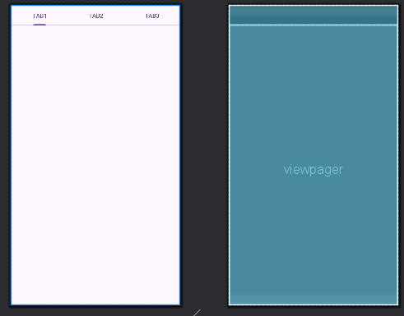

**Fragment_tab1.xml**

<GridLayout  
 android:layout_width="match_parent"  
 android:layout_height="match_parent"  
 android:layout_margin="10sp"  
 android:rowCount="5"  
 android:columnCount="2">  
  
 <Button  
 android:id="@+id/button1"  
 android:layout_width="wrap_content"  
 android:layout_height="wrap_content"  
 android:layout_rowWeight="1"  
 android:layout_columnWeight="1"  
 android:layout_gravity="fill"  
 android:layout_margin="5sp"  
 android:background="#FFFDFD"  
 android:text="Button"  
 android:textColor="#757575"  
 android:textSize="18sp" />  
 <Button  
 android:id="@+id/button2"  
 android:layout_width="wrap_content"  
 android:layout_height="wrap_content"  
 android:background="#FFFF"  
 android:layout_gravity="fill"  
 android:textSize="18sp"  
 android:text="Button"  
 android:layout_rowWeight="1"  
 android:layout_columnWeight="1"  
 android:layout_margin="5sp"  
 android:textColor="#757575" />

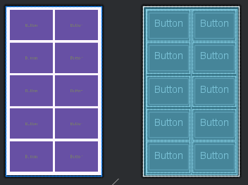

**Fragment_tab2.xml**

<FrameLayout xmlns:android="http://schemas.android.com/apk/res/android"  
 xmlns:tools="http://schemas.android.com/tools"  
 android:layout_width="match_parent"  
 android:layout_height="match_parent"  
 tools:context=".Tab2">  
  
 <!-- *TODO: Update blank fragment layout* -->  
 <TextView  
 android:layout_width="match_parent"  
 android:layout_height="match_parent"  
 android:textSize="30sp"  
 android:text="fragmentTwo" />  
  
</FrameLayout>

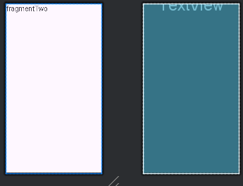

**Fragment_tab3.xml**

<FrameLayout xmlns:android="http://schemas.android.com/apk/res/android"  
 xmlns:tools="http://schemas.android.com/tools"  
 android:layout_width="match_parent"  
 android:layout_height="match_parent"  
 tools:context=".Tab3">  
  
 <!-- *TODO: Update blank fragment layout* -->  
 <TextView  
 android:layout_width="match_parent"  
 android:layout_height="match_parent"  
 android:textSize="30sp"  
 android:text="fragment three" />  
  
</FrameLayout>

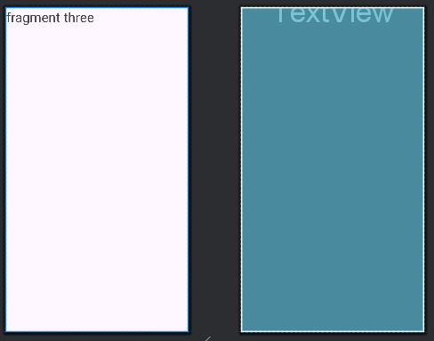

**OUTPUT:**

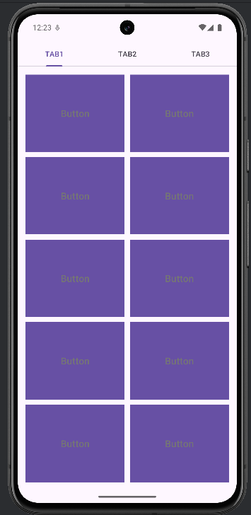 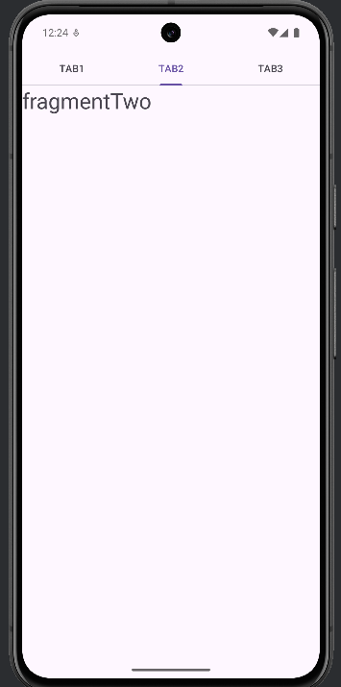 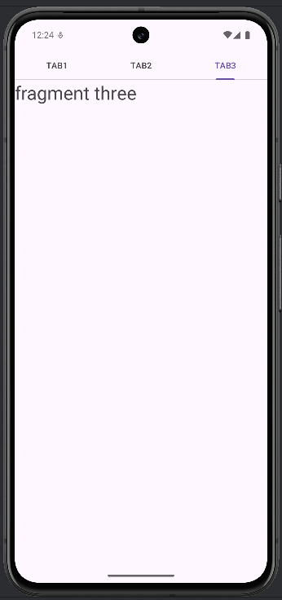

**3. Develop a calculator app using appropriate layouts.**

**MainActivity.java**

package com.example.simplecalculator;  
  
import androidx.appcompat.app.AppCompatActivity;  
  
import android.os.Bundle;  
import android.view.View;  
import android.widget.Button;  
import android.widget.TextView;  
  
public class MainActivity extends AppCompatActivity {  
  
 TextView text;  
 Button btn;  
  
 double operand1, operand2, add = 0, subtract = 0, multiply = 0, divide = 0, result = 0;  
  
 @Override  
 protected void onCreate(Bundle savedInstanceState) {  
 super.onCreate(savedInstanceState);  
 setContentView(R.layout.*activity_main*);  
 }  
  
 public void digit(View view) {  
  
 text = (TextView)findViewById(R.id.*view*);  
 String currentText = text.getText().toString();  
  
 btn = (Button)view;  
 String btnValue = btn.getText().toString();  
  
 if (currentText != "" && currentText.length() < 12)  
 {  
 if (Double.*parseDouble*(currentText) != 0)  
 {  
 text.setText(currentText + btnValue);  
 }  
 else  
 {  
 text.setText(btnValue);  
 }  
  
 }  
 else if(currentText.length() != 12)  
 {  
 text.setText(btnValue);  
 }  
  
  
 }  
  
 public void clear(View view) {  
 operand1 = operand2 = add = subtract = multiply = divide = 0;  
 text = (TextView)findViewById(R.id.*view*);  
 text.setText("");  
 }  
  
 public void operator(View view)  
 {  
 text = (TextView)findViewById(R.id.*view*);  
 String currentText = text.getText().toString();  
  
 if (currentText != "")  
 {  
 if (view.getId() == R.id.*add*)  
 {  
 if (add == 0)  
 {  
 operand1 = Double.*parseDouble*(currentText);  
 text.setText("");  
 add = 1;  
 }  
  
 }  
  
 if (view.getId() == R.id.*subtract*)  
 {  
 if (subtract == 0)  
 {  
 operand1 = Double.*parseDouble*(currentText);  
 text.setText("");  
 subtract = 1;  
 }  
  
 }  
  
 if (view.getId() == R.id.*multiply*)  
 {  
 if (multiply == 0)  
 {  
 operand1 = Double.*parseDouble*(currentText);  
 text.setText("");  
 multiply = 1;  
 }  
  
 }  
  
 if (view.getId() == R.id.*divide*)  
 {  
 if (divide == 0)  
 {  
 operand1 = Double.*parseDouble*(currentText);  
 text.setText("");  
 divide = 1;  
 }  
  
 }  
 }  
  
  
  
  
 if (view.getId() == R.id.*equals* && currentText != "")  
 {  
 if (add == 1)  
 {  
 operand2 = Double.*parseDouble*(currentText);  
 result = operand1 + operand2;  
 text.setText(result <=999999999999.0 ? String.*format*("%.2f", result) : "Error");  
 }  
 else if (subtract == 1)  
 {  
 operand2 = Double.*parseDouble*(currentText);  
 result = operand1 - operand2;  
 text.setText(result <=999999999999.0 ? String.*format*("%.2f", result) : "Error");  
 }  
 else if (multiply == 1)  
 {  
 operand2 = Double.*parseDouble*(currentText);  
 result = operand1 * operand2;  
 text.setText(result <=999999999999.0 ? String.*format*("%.2f", result) : "Error");  
 }  
 else if (divide == 1)  
 {  
 operand2 = Double.*parseDouble*(currentText);  
 result = operand1 / operand2;  
 text.setText(result <=999999999999.0 ? String.*format*("%.2f", result) : "Error");  
 }  
 operand1 = operand2 = add = subtract = multiply = divide = 0;  
 }  
 }  
}

**Activity_main.xml**

<?xml version="1.0" encoding="utf-8"?>  
<LinearLayout xmlns:android="http://schemas.android.com/apk/res/android"  
 xmlns:app="http://schemas.android.com/apk/res-auto"  
 xmlns:tools="http://schemas.android.com/tools"  
 android:layout_width="match_parent"  
 android:layout_height="match_parent"  
 tools:context=".MainActivity"  
 android:orientation="vertical">  
  
 <TextView  
 android:id="@+id/view"  
 android:layout_width="match_parent"  
 android:layout_height="195dp"  
 android:gravity="right|center"  
 android:hint="0"  
 android:textSize="35dp" />  
  
 <LinearLayout  
 android:layout_width="match_parent"  
 android:layout_height="match_parent"  
 android:orientation="vertical"  
 >  
  
 <LinearLayout  
 android:layout_width="match_parent"  
 android:layout_height="wrap_content"  
 android:layout_weight="1"  
 >  
  
 <Button  
 android:onClick="clear"  
 android:id="@+id/clear"  
 android:layout_width="wrap_content"  
 android:layout_height="match_parent"  
 android:text="C"  
 android:textSize="30dp"  
 android:textStyle="bold"  
 android:background="#181a14"  
 android:textColor="#fff"  
 android:layout_weight="1"  
 android:layout_margin="1dp"  
 />  
  
 <Button  
 android:layout_width="wrap_content"  
 android:layout_height="match_parent"  
 android:text="+/-"  
 android:textSize="30dp"  
 android:textStyle="bold"  
 android:background="#181a14"  
 android:textColor="#fff"  
 android:layout_weight="1"  
 android:layout_margin="1dp"  
 />  
  
 <Button  
 android:id="@+id/percent"  
 android:layout_width="wrap_content"  
 android:layout_height="match_parent"  
 android:text="%"  
 android:textSize="30dp"  
 android:textStyle="bold"  
 android:background="#181a14"  
 android:textColor="#fff"  
 android:layout_weight="1"  
 android:layout_margin="1dp"  
 />  
  
 <Button  
 android:onClick="operator"  
 android:id="@+id/divide"  
 android:layout_width="wrap_content"  
 android:layout_height="match_parent"  
 android:text="÷"  
 android:textSize="30dp"  
 android:textStyle="bold"  
 android:background="#a79300"  
 android:textColor="#fff"  
 android:layout_weight="1"  
 android:layout_margin="1dp"  
 />  
  
 </LinearLayout>  
  
  
  
 <LinearLayout  
 android:layout_width="match_parent"  
 android:layout_height="wrap_content"  
 android:layout_weight="1"  
 >  
  
 <Button  
 android:onClick="digit"  
 android:id="@+id/seven"  
 android:layout_width="wrap_content"  
 android:layout_height="match_parent"  
 android:text="7"  
 android:textSize="30dp"  
 android:textStyle="bold"  
 android:background="#181a14"  
 android:textColor="#fff"  
 android:layout_weight="1"  
 android:layout_margin="1dp"  
 />  
  
 <Button  
 android:onClick="digit"  
 android:id="@+id/eight"  
 android:layout_width="wrap_content"  
 android:layout_height="match_parent"  
 android:text="8"  
 android:textSize="30dp"  
 android:textStyle="bold"  
 android:background="#181a14"  
 android:textColor="#fff"  
 android:layout_weight="1"  
 android:layout_margin="1dp"  
 />  
  
 <Button  
 android:onClick="digit"  
 android:id="@+id/nine"  
 android:layout_width="wrap_content"  
 android:layout_height="match_parent"  
 android:text="9"  
 android:textSize="30dp"  
 android:textStyle="bold"  
 android:background="#181a14"  
 android:textColor="#fff"  
 android:layout_weight="1"  
 android:layout_margin="1dp"  
 />  
  
 <Button  
 android:onClick="operator"  
 android:id="@+id/multiply"  
 android:layout_width="wrap_content"  
 android:layout_height="match_parent"  
 android:text="×"  
 android:textSize="30dp"  
 android:textStyle="bold"  
 android:background="#a79300"  
 android:textColor="#fff"  
 android:layout_weight="1"  
 android:layout_margin="1dp"  
 />  
  
 </LinearLayout>  
  
 <LinearLayout  
 android:layout_width="match_parent"  
 android:layout_height="wrap_content"  
 android:layout_weight="1"  
 >  
  
 <Button  
 android:onClick="digit"  
 android:id="@+id/four"  
 android:layout_width="wrap_content"  
 android:layout_height="match_parent"  
 android:text="4"  
 android:textSize="30dp"  
 android:textStyle="bold"  
 android:background="#181a14"  
 android:textColor="#fff"  
 android:layout_weight="1"  
 android:layout_margin="1dp"  
 />  
  
 <Button  
 android:onClick="digit"  
 android:id="@+id/five"  
 android:layout_width="wrap_content"  
 android:layout_height="match_parent"  
 android:text="5"  
 android:textSize="30dp"  
 android:textStyle="bold"  
 android:background="#181a14"  
 android:textColor="#fff"  
 android:layout_weight="1"  
 android:layout_margin="1dp"  
 />  
  
 <Button  
 android:onClick="digit"  
 android:id="@+id/six"  
 android:layout_width="wrap_content"  
 android:layout_height="match_parent"  
 android:text="6"  
 android:textSize="30dp"  
 android:textStyle="bold"  
 android:background="#181a14"  
 android:textColor="#fff"  
 android:layout_weight="1"  
 android:layout_margin="1dp"  
  
 />  
  
 <Button  
 android:onClick="operator"  
 android:id="@+id/subtract"  
 android:layout_width="wrap_content"  
 android:layout_height="match_parent"  
 android:text="−"  
 android:textSize="30dp"  
 android:textStyle="bold"  
 android:background="#a79300"  
 android:textColor="#fff"  
 android:layout_weight="1"  
 android:layout_margin="1dp"  
 />  
  
 </LinearLayout>  
  
 <LinearLayout  
 android:layout_width="match_parent"  
 android:layout_height="wrap_content"  
 android:layout_weight="1"  
 >  
  
 <Button  
 android:onClick="digit"  
 android:id="@+id/one"  
 android:layout_width="wrap_content"  
 android:layout_height="match_parent"  
 android:text="1"  
 android:textSize="30dp"  
 android:textStyle="bold"  
 android:background="#181a14"  
 android:textColor="#fff"  
 android:layout_weight="1"  
 android:layout_margin="1dp"  
 />  
  
 <Button  
 android:onClick="digit"  
 android:id="@+id/two"  
 android:layout_width="wrap_content"  
 android:layout_height="match_parent"  
 android:text="2"  
 android:textSize="30dp"  
 android:textStyle="bold"  
 android:background="#181a14"  
 android:textColor="#fff"  
 android:layout_weight="1"  
 android:layout_margin="1dp"  
 />  
  
 <Button  
 android:onClick="digit"  
 android:id="@+id/three"  
 android:layout_width="wrap_content"  
 android:layout_height="match_parent"  
 android:text="3"  
 android:textSize="30dp"  
 android:textStyle="bold"  
 android:background="#181a14"  
 android:textColor="#fff"  
 android:layout_weight="1"  
 android:layout_margin="1dp"  
 />  
  
 <Button  
 android:onClick="operator"  
 android:id="@+id/add"  
 android:layout_width="wrap_content"  
 android:layout_height="match_parent"  
 android:text="+"  
 android:textSize="30dp"  
 android:textStyle="bold"  
 android:background="#a79300"  
 android:textColor="#fff"  
 android:layout_weight="1"  
 android:layout_margin="1dp"  
 />  
  
 </LinearLayout>  
  
 <LinearLayout  
 android:layout_width="match_parent"  
 android:layout_height="wrap_content"  
 android:layout_weight="1"  
 >  
  
 <Button  
 android:onClick="digit"  
 android:id="@+id/zero"  
 android:layout_width="wrap_content"  
 android:layout_height="match_parent"  
 android:text="0"  
 android:textSize="30dp"  
 android:textStyle="bold"  
 android:background="#181a14"  
 android:textColor="#fff"  
 android:layout_weight="1"  
 android:layout_margin="1dp"  
 />  
  
 <Button  
 android:id="@+id/point"  
 android:layout_width="wrap_content"  
 android:layout_height="match_parent"  
 android:text="."  
 android:textSize="30dp"  
 android:textStyle="bold"  
 android:background="#181a14"  
 android:textColor="#fff"  
 android:layout_weight="1"  
 android:layout_margin="1dp"  
 />  
  
 <Button  
 android:id="@+id/del"  
 android:layout_width="wrap_content"  
 android:layout_height="match_parent"  
 android:text="del"  
 android:textSize="30dp"  
 android:textStyle="bold"  
 android:background="#181a14"  
 android:textColor="#fff"  
 android:layout_weight="1"  
 android:layout_margin="1dp"  
 />  
  
 <Button  
 android:onClick="operator"  
 android:id="@+id/equals"  
 android:layout_width="wrap_content"  
 android:layout_height="match_parent"  
 android:text="="  
 android:textSize="30dp"  
 android:textStyle="bold"  
 android:background="#236e22"  
 android:textColor="#fff"  
 android:layout_weight="1"  
 android:layout_margin="1dp"  
 />  
  
 </LinearLayout>  
  
 </LinearLayout>  
  
</LinearLayout>

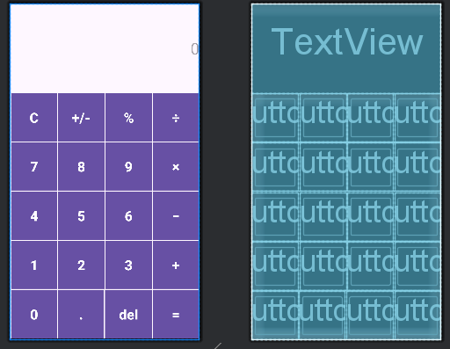

**OUTPUT:  
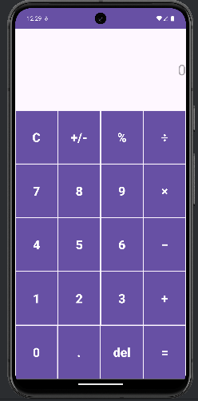**

**4. Create an android application that displays a contact list using List View.**

**MainActivity.java**

package com.example.contactlistview;  
  
import android.os.Bundle;  
import android.widget.ArrayAdapter;  
import android.widget.ListView;  
import androidx.appcompat.app.AppCompatActivity;  
  
public class MainActivity extends AppCompatActivity {  
  
 @Override  
 protected void onCreate(Bundle savedInstanceState) {  
 super.onCreate(savedInstanceState);  
 setContentView(R.layout.*activity_main*);  
  
 // Create a list of contacts  
 String[] contacts = {"John Doe", "Jane Smith", "Robert Johnson", "Emily Davis", "Michael Brown"};  
  
 // Find the ListView in the layout  
 ListView contactListView = findViewById(R.id.*contactListView*);  
  
 // Create an ArrayAdapter to bind the contacts array to the ListView  
 ArrayAdapter<String> adapter = new ArrayAdapter<>(this,  
 android.R.layout.*simple_list_item_1*, contacts);  
  
 // Set the adapter on the ListView  
 contactListView.setAdapter(adapter);  
 }  
}

**activity_mani.xml**

<?xml version="1.0" encoding="utf-8"?>  
<LinearLayout xmlns:android="http://schemas.android.com/apk/res/android"  
 android:layout_width="match_parent"  
 android:layout_height="match_parent"  
 android:orientation="vertical"  
 android:padding="16dp">  
  
 <!-- Heading TextView -->  
 <TextView  
 android:id="@+id/headingTextView"  
 android:layout_width="wrap_content"  
 android:layout_height="wrap_content"  
 android:text="Contacts"  
 android:textSize="24sp"  
 android:textStyle="bold"  
 android:layout_gravity="center"  
 android:paddingBottom="16dp"/>  
  
 <!-- ListView for contacts -->  
 <ListView  
 android:id="@+id/contactListView"  
 android:layout_width="match_parent"  
 android:layout_height="match_parent"/>  
</LinearLayout>

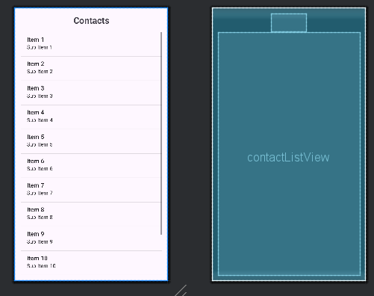

OUTPUT:

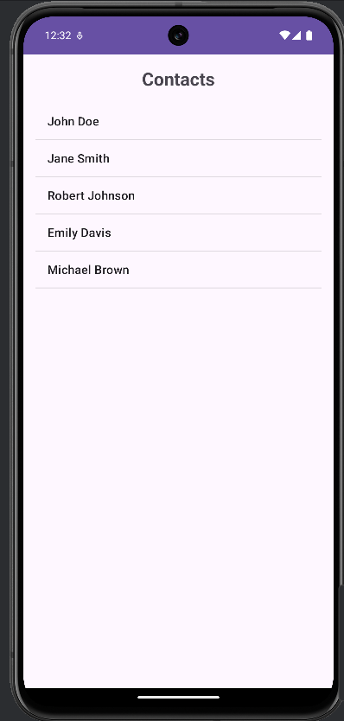

**5. Design the user interface of an online food delivery app using Custom List View that displays different items available for the day along with its details.**

**MainActivity.java**

package com.example.fooddelivery;  
import android.os.Bundle;  
import android.widget.ListView;  
import androidx.appcompat.app.AppCompatActivity;  
import java.util.ArrayList;  
import java.util.List;  
  
public class MainActivity extends AppCompatActivity {  
  
 private ListView foodListView;  
 private FoodItemAdapter foodItemAdapter;  
 private List<FoodItem> foodItemList;  
  
 @Override  
 protected void onCreate(Bundle savedInstanceState) {  
 super.onCreate(savedInstanceState);  
 setContentView(R.layout.*activity_main*);  
  
 foodListView = findViewById(R.id.*food_list_view*);  
  
 foodItemList = new ArrayList<>();  
 foodItemList.add(new FoodItem("Pizza", "Delicious cheese pizza with fresh toppings", 9.99, R.drawable.*pizza*));  
 foodItemList.add(new FoodItem("Burger", "Juicy beef burger with lettuce, tomato, and cheese", 7.99, R.drawable.*burger*));  
 foodItemList.add(new FoodItem("Sushi", "Fresh sushi with salmon and avocado", 12.99, R.drawable.*sushi*));  
 foodItemList.add(new FoodItem("Pasta", "Creamy Alfredo pasta with chicken", 10.99, R.drawable.*pasta*));  
 foodItemList.add(new FoodItem("Salad", "Healthy green salad with a variety of vegetables", 6.99, R.drawable.*salad*));  
  
 foodItemAdapter = new FoodItemAdapter(this, foodItemList);  
 foodListView.setAdapter(foodItemAdapter);  
 }  
}

**activity_main.xml**

<LinearLayout xmlns:android="http://schemas.android.com/apk/res/android"  
 xmlns:tools="http://schemas.android.com/tools"  
 android:layout_width="match_parent"  
 android:layout_height="match_parent"  
 android:orientation="vertical"  
 tools:context=".MainActivity">  
  
 <ListView  
 android:id="@+id/food_list_view"  
 android:layout_width="match_parent"  
 android:layout_height="match_parent"/>  
</LinearLayout>

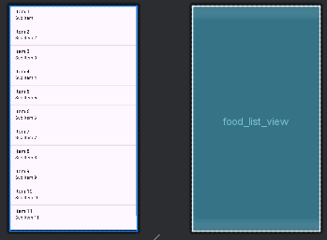

**List_item_food.xml**

<LinearLayout  
 android:layout_width="0dp"  
 android:layout_height="wrap_content"  
 android:layout_weight="1"  
 android:orientation="vertical">  
  
 <TextView  
 android:id="@+id/food_name"  
 android:layout_width="match_parent"  
 android:layout_height="wrap_content"  
 android:textSize="18sp"  
 android:textStyle="bold" />  
  
 <TextView  
 android:id="@+id/food_description"  
 android:layout_width="match_parent"  
 android:layout_height="wrap_content"  
 android:textSize="14sp" />  
  
 <TextView  
 android:id="@+id/food_price"  
 android:layout_width="match_parent"  
 android:layout_height="wrap_content"  
 android:textSize="16sp"  
 android:textStyle="italic"  
 android:textColor="@android:color/holo_red_dark" />  
</LinearLayout>

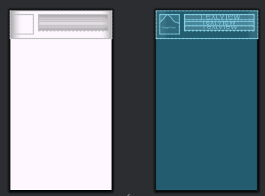

**OUTPUT:**

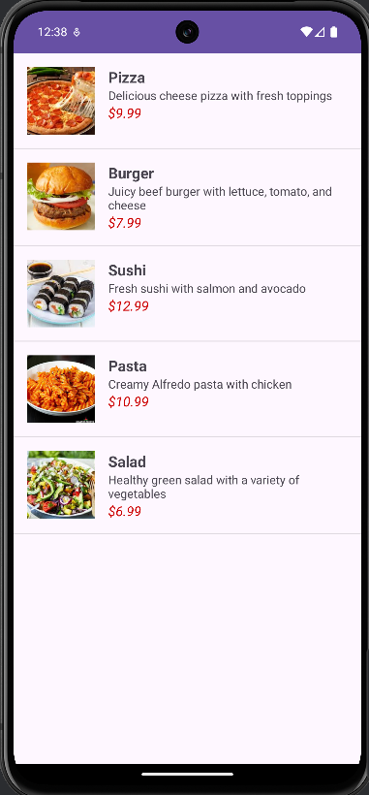

**6. Create suitable apps to demonstrate following menus in android**

**● Options Menu**

**MainActivity.java**

public class MainActivity extends AppCompatActivity {  
  
 @Override  
 protected void onCreate(Bundle savedInstanceState) {  
 super.onCreate(savedInstanceState);  
 EdgeToEdge.*enable*(this);  
 setContentView(R.layout.*activity_main*);  
 Toolbar toolbar = findViewById(R.id.*toolbar*);  
 setSupportActionBar(toolbar);  
  
 }  
  
 @Override  
 public boolean onCreateOptionsMenu(Menu menu) {  
 MenuInflater menuInflater= new MenuInflater(this);  
 menuInflater.inflate(R.menu.*option_menu*,menu);  
 return true;  
 }  
}

**activit_main.xml**

<androidx.appcompat.widget.Toolbar  
 android:id="@+id/toolbar"  
 android:layout_width="0dp"  
 android:layout_height="wrap_content"  
 android:layout_marginTop="64dp"  
 android:background="#4161FF"  
 app:layout_constraintEnd_toEndOf="parent"  
 app:layout_constraintHorizontal_bias="0.0"  
 app:layout_constraintStart_toStartOf="parent"  
 app:layout_constraintTop_toTopOf="parent" />  
  
</androidx.constraintlayout.widget.ConstraintLayout>

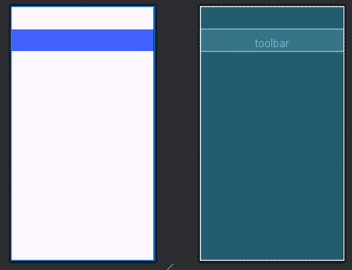

**OUTPUT:**

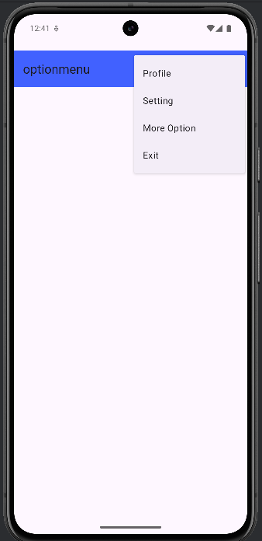

**● Context Menu**

**MainActivity.java**

public class MainActivity extends AppCompatActivity {  
  
 ListView listView;  
 String[] items = {"Item 1", "Item 2", "Item 3", "Item 4"};  
  
 @Override  
 protected void onCreate(Bundle savedInstanceState) {  
 super.onCreate(savedInstanceState);  
 EdgeToEdge.*enable*(this);  
 setContentView(R.layout.*activity_main*);  
  
 ViewCompat.*setOnApplyWindowInsetsListener*(findViewById(R.id.*main*), (v, insets) -> {  
 Insets systemBars = insets.getInsets(WindowInsetsCompat.Type.*systemBars*());  
 v.setPadding(systemBars.left, systemBars.top, systemBars.right, systemBars.bottom);  
 return insets;  
 });  
  
 listView = findViewById(R.id.*listView*);  
 ArrayAdapter<String> adapter = new ArrayAdapter<>(this, android.R.layout.*simple_list_item_1*, items);  
 listView.setAdapter(adapter);  
  
 // Register the ListView for the context menu  
 registerForContextMenu(listView);  
 }  
  
 @Override  
 public void onCreateContextMenu(ContextMenu menu, View v, ContextMenu.ContextMenuInfo menuInfo) {  
 super.onCreateContextMenu(menu, v, menuInfo);  
 getMenuInflater().inflate(R.menu.*context_menu*, menu);  
 }  
  
 @Override  
 public boolean onContextItemSelected(@NonNull MenuItem item) {  
 AdapterView.AdapterContextMenuInfo info = (AdapterView.AdapterContextMenuInfo) item.getMenuInfo();  
  
 // Check which item was selected based on its ID  
 if (item.getItemId() == R.id.*edit*) {  
 Toast.*makeText*(this, "Edit item: " + items[info.position], Toast.*LENGTH_SHORT*).show();  
 return true;  
 } else if (item.getItemId() == R.id.*delete*) {  
 Toast.*makeText*(this, "Delete item: " + items[info.position], Toast.*LENGTH_SHORT*).show();  
 return true;  
 }  
  
 return super.onContextItemSelected(item);  
 }

**activity_main.xml**

<?xml version="1.0" encoding="utf-8"?>  
<androidx.constraintlayout.widget.ConstraintLayout xmlns:android="http://schemas.android.com/apk/res/android"  
 xmlns:app="http://schemas.android.com/apk/res-auto"  
 xmlns:tools="http://schemas.android.com/tools"  
 android:id="@+id/main"  
 android:layout_width="match_parent"  
 android:layout_height="match_parent"  
 tools:context=".MainActivity">  
  
 <ListView  
 android:id="@+id/listView"  
 android:layout_width="0dp"  
 android:layout_height="0dp"  
 app:layout_constraintTop_toTopOf="parent"  
 app:layout_constraintBottom_toBottomOf="parent"  
 app:layout_constraintStart_toStartOf="parent"  
 app:layout_constraintEnd_toEndOf="parent"  
 android:divider="@android:color/darker_gray"  
 android:dividerHeight="1dp"/>  
</androidx.constraintlayout.widget.ConstraintLayout>

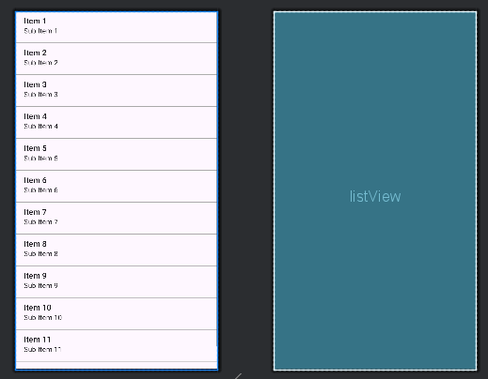

OUTPUT:

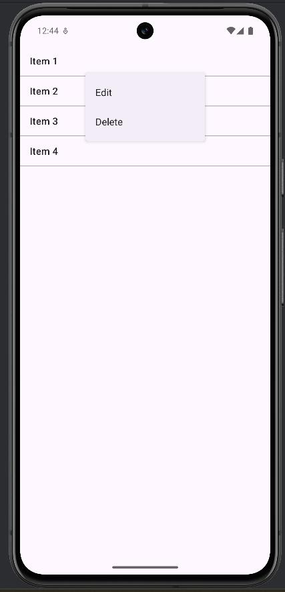

**● Pop Up Menu**

**MainActivity.java**

private void showPopupMenu(View view) {  
 PopupMenu popupMenu = new PopupMenu(this, view);  
 popupMenu.getMenuInflater().inflate(R.menu.*popup_menu*, popupMenu.getMenu());  
 popupMenu.setOnMenuItemClickListener(new PopupMenu.OnMenuItemClickListener() {  
 @Override  
 public boolean onMenuItemClick(MenuItem item) {  
 return handleMenuItemClick(item);  
 }  
 });  
 popupMenu.show();  
}  
  
// Method to handle menu item clicks  
private boolean handleMenuItemClick(MenuItem item) {  
 int itemId = item.getItemId();  
  
 if (itemId == R.id.*action_edit*) {  
 Toast.*makeText*(MainActivity.this, "Edit selected", Toast.*LENGTH_SHORT*).show();  
 return true;  
 } else if (itemId == R.id.*action_delete*) {  
 Toast.*makeText*(MainActivity.this, "Delete selected", Toast.*LENGTH_SHORT*).show();  
 return true;  
 } else if (itemId == R.id.*action_share*) {  
 Toast.*makeText*(MainActivity.this, "Share selected", Toast.*LENGTH_SHORT*).show();  
 return true;  
 } else {  
 return false;  
 }  
}

**activity_main.xml**

<TextView  
 android:id="@+id/textView"  
 android:layout_width="wrap_content"  
 android:layout_height="wrap_content"  
 android:text="Hello World!"  
 app:layout_constraintBottom_toTopOf="@+id/button_show_menu"  
 app:layout_constraintEnd_toEndOf="parent"  
 app:layout_constraintStart_toStartOf="parent"  
 app:layout_constraintTop_toTopOf="parent" />  
  
<Button  
 android:id="@+id/button_show_menu"  
 android:layout_width="wrap_content"  
 android:layout_height="wrap_content"  
 android:text="Show Popup Menu"  
 app:layout_constraintTop_toBottomOf="@id/textView"  
 app:layout_constraintStart_toStartOf="parent"  
 app:layout_constraintEnd_toEndOf="parent"  
 app:layout_constraintBottom_toBottomOf="parent"  
 android:layout_marginTop="20dp"/>

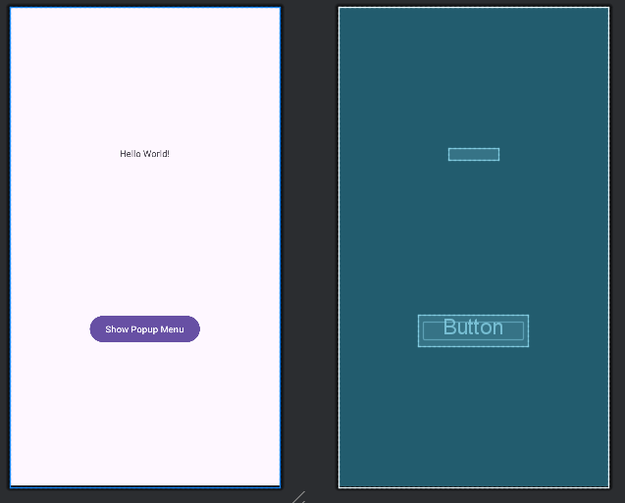

**OUTPUT:  
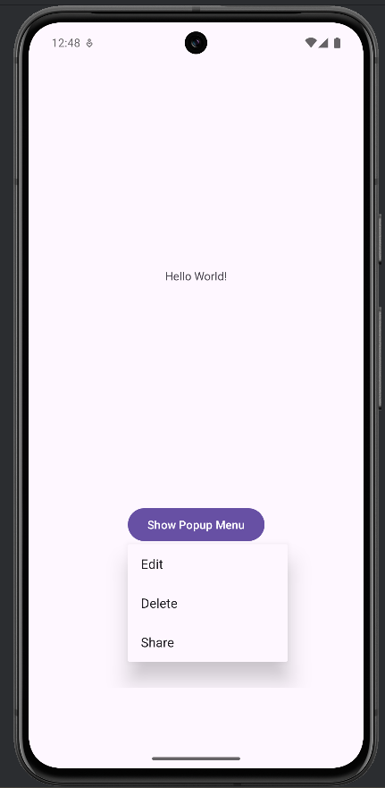**

**7. Create suitable apps to demonstrate the following**

**● Action Bar**

**● Action Bar & Tabs**

**● View Pager**

**● Action Bar & View Pager**

**MainActivity.java**

public class MainActivity extends AppCompatActivity {  
  
 private Toolbar toolbar;  
 private TabLayout tabLayout;  
 private ViewPager viewPager;  
 private ViewPagerAdapter adapter;  
  
 @Override  
 protected void onCreate(Bundle savedInstanceState) {  
 super.onCreate(savedInstanceState);  
 setContentView(R.layout.*activity_main*);  
  
 toolbar = findViewById(R.id.*toolbar*);  
 setSupportActionBar(toolbar);  
  
 tabLayout = findViewById(R.id.*tab_layout*);  
 viewPager = findViewById(R.id.*view_pager*);  
  
 adapter = new ViewPagerAdapter(getSupportFragmentManager());  
 viewPager.setAdapter(adapter);  
  
 tabLayout.setupWithViewPager(viewPager);  
 }  
  
 @Override  
 public boolean onCreateOptionsMenu(Menu menu) {  
 MenuInflater inflater = getMenuInflater();  
 inflater.inflate(R.menu.*menu_main*, menu);  
 return true;  
 }  
}

**activity_main.xml**

<?xml version="1.0" encoding="utf-8"?>  
<RelativeLayout xmlns:android="http://schemas.android.com/apk/res/android"  
 xmlns:app="http://schemas.android.com/apk/res-auto"  
 android:layout_width="match_parent"  
 android:layout_height="match_parent">  
  
 <androidx.appcompat.widget.Toolbar  
 android:id="@+id/toolbar"  
 android:layout_width="match_parent"  
 android:layout_height="?attr/actionBarSize"  
 android:background="?attr/colorPrimary"  
 android:elevation="4dp"  
 android:theme="@style/ThemeOverlay.AppCompat.ActionBar"  
 android:popupTheme="@style/ThemeOverlay.AppCompat.Light" />  
  
 <com.google.android.material.tabs.TabLayout  
 android:id="@+id/tab_layout"  
 android:layout_width="match_parent"  
 android:layout_height="wrap_content"  
 android:layout_below="@id/toolbar"  
 app:tabMode="fixed"  
 app:tabGravity="fill"  
 app:tabIndicatorColor="@android:color/white"  
 app:tabSelectedTextColor="@android:color/white" />  
  
 <androidx.viewpager.widget.ViewPager  
 android:id="@+id/view_pager"  
 android:layout_width="match_parent"  
 android:layout_height="match_parent"  
 android:layout_below="@id/tab_layout" />  
  
</RelativeLayout>

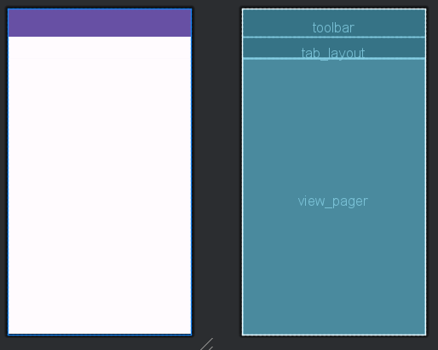

**Fragment_tab.xml**

<RelativeLayout xmlns:android="http://schemas.android.com/apk/res/android"  
 android:layout_width="match_parent"  
 android:layout_height="match_parent"  
 android:padding="16dp">  
  
 <TextView  
 android:id="@+id/tab_text"  
 android:layout_width="wrap_content"  
 android:layout_height="wrap_content"  
 android:layout_centerInParent="true"  
 android:textSize="24sp"  
 android:textColor="@android:color/black" />  
  
 <ImageView  
 android:id="@+id/tab_image"  
 android:layout_width="wrap_content"  
 android:layout_height="wrap_content"  
 android:layout_below="@id/tab_text"  
 android:layout_centerHorizontal="true"  
 android:layout_marginTop="16dp"  
 android:src="@android:drawable/ic_menu_gallery" />  
  
</RelativeLayout>

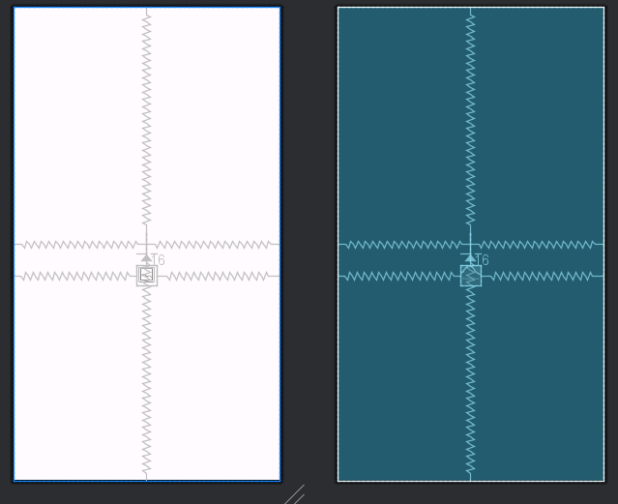

**OUTPUT:**

