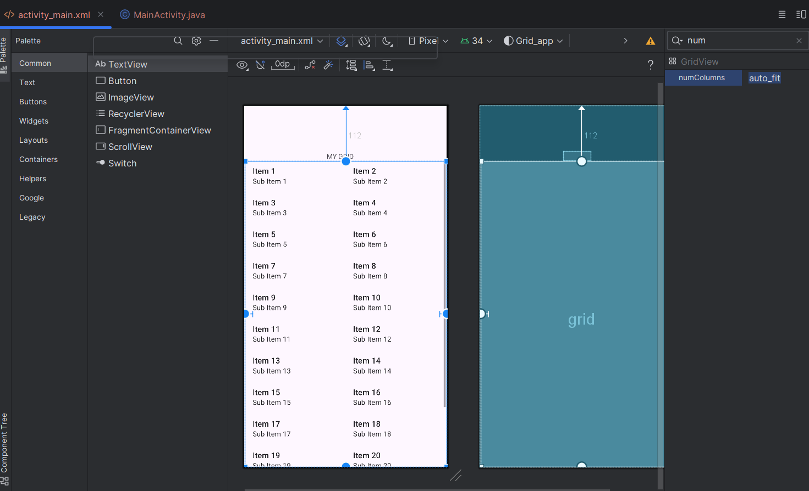

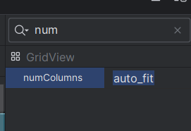This is to make the list like Grid

import android.view.View;  
import android.widget.GridView;  
import android.widget.Toast;  
import android.widget.ArrayAdapter;//class required to adapt the view  
import android.widget.ArrayAdapter;

protected void onCreate(Bundle savedInstanceState) {  
 super.onCreate(savedInstanceState);  
 EdgeToEdge.*enable*(this);  
 setContentView(R.layout.*activity_main*);  
 ViewCompat.*setOnApplyWindowInsetsListener*(findViewById(R.id.*main*), (v, insets) -> {  
 Insets systemBars = insets.getInsets(WindowInsetsCompat.Type.*systemBars*());  
 v.setPadding(systemBars.left, systemBars.top, systemBars.right, systemBars.bottom);  
 GridView grid=findViewById(R.id.*grid*);  
 //create an array that contains the item to be displayed  
 String [] item={"Java","Python","R","Android"};  
  
 //CREATE AN ARRAY ADAPTER  
 ArrayAdapter<String> adapter=new ArrayAdapter<>(this, android.R.layout.*simple_list_item_1*,item);  
 //bind adapter to gridview  
 grid.setAdapter(adapter);  
  
 grid.setOnItemClickListener(new AdapterView.OnItemClickListener() {  
 @Override  
 public void onItemClick(AdapterView<?> adapterView, View view, int i, long l) {  
 String item=adapter.getItem(i);  
 Toast.*makeText*(MainActivity.this,"you Selected :"+item,Toast.*LENGTH_SHORT*).show();  
 }  
 });  
 return insets;  
 });  
 }  
}