* Platform independent
* Object oriented programming
* Language independent-(it supports 60 + languages)
* Better Support for dynamic web pages
* Zero impact installation

.NET FRAME WORK ARCHITECTURE

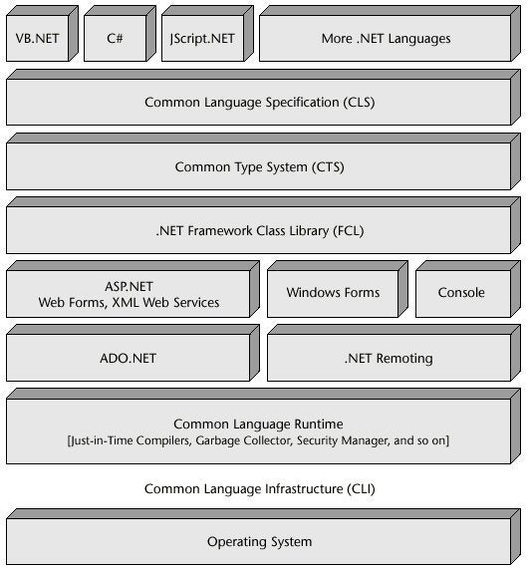

COMPONENTS

CTS_(COMMON TYPE SYSTEM)

Standard that represents what type of values can be definined and managed in computer memory.

CLS_(COMMON LANGUGAE SPECIFICATION)

-subset of cts

FCL(FRAME WORK CLASS LIBRARY)_

FCL provides system sunctionality in the .Net Frame work as it has various classes,datatypes,interfacecs,etc

IL/MIL/CIL(INTERMEDIATE LANGUAGE,MICROSOFT INTDT LANG,COMMON INTRMT LANG)

CLR(COMMON LANGUAGE RUNTIME)

JIT-(JUST IN TIME COMPILER)

Part of clr,convert intermediate language to machine language

ADO.NET –(ACTIVEX DAATA OBJECTS)

Providing access to relational,XML and application data

ASP>NET-

To develop or design Websites