**TENANT**

1. **Self-shipped**

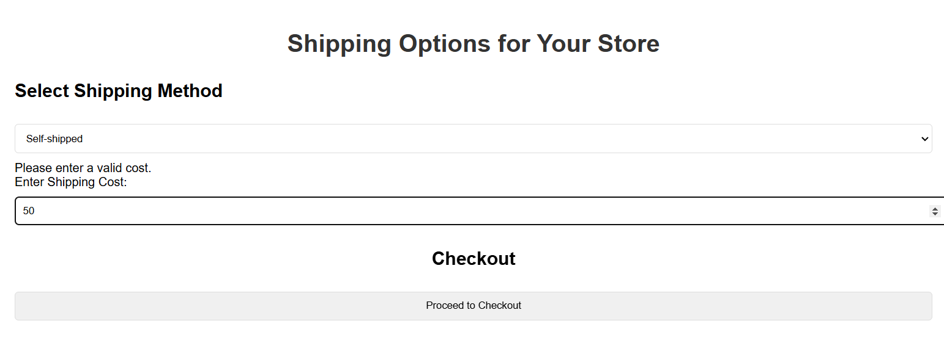

1. **Auto-Shipped(Courier)**

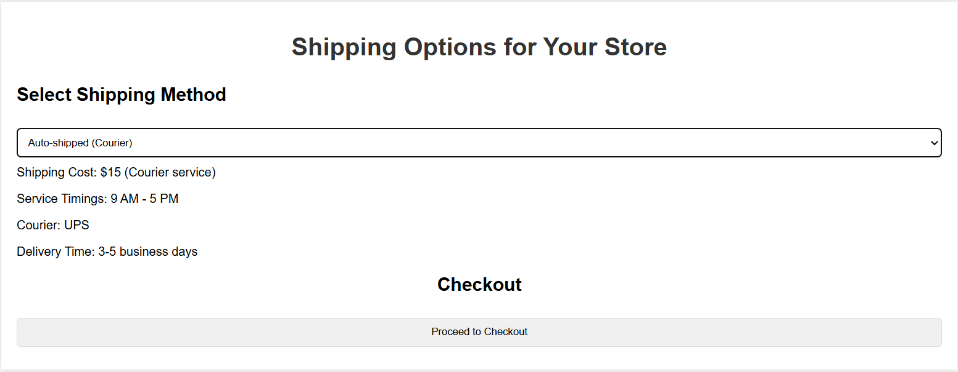

1. **Hyper-local Delivery**

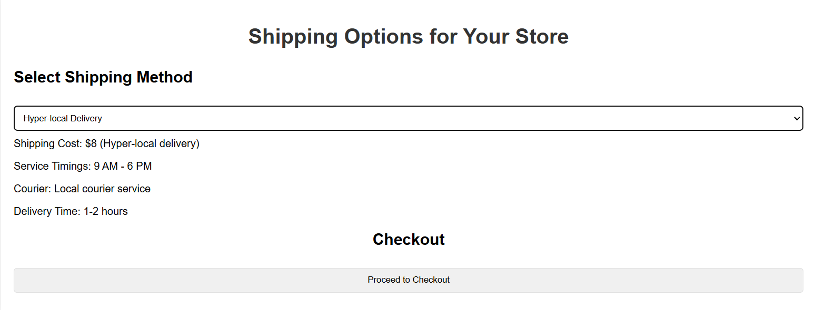

**ADMIN USER**

