Let's start from zero knowledge and build a very simple end-to-end MCP example in Python.
Goal
We will create:
User
|
v
MCP Client
|
v
MCP Server
|
v
Calculator Tool
User asks:
What is 10 + 20?
The MCP client will call a tool on the MCP server, and the server will return 30.

Step 1: Install uv
On Windows:
pip install uv
Verify:
uv --version

Step 2: Create Project
mkdir mcp-demo
cd mcp-demo
Initialize project:
uv init
This creates:
mcp-demo/
├── pyproject.toml
├── hello.py

Step 3: Install MCP Library
uv add mcp
This updates pyproject.toml automatically.

Step 4: Create MCP Server
Create file:
server.py
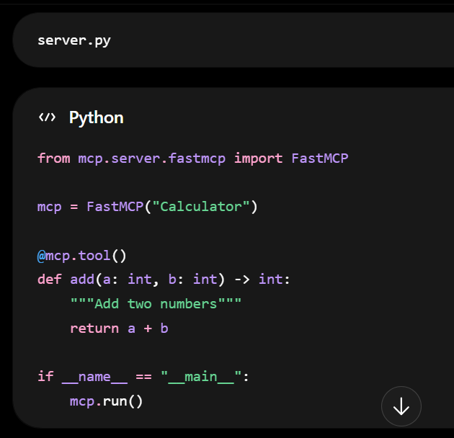

What this does:
This is your MCP Server (server.py). It creates a calculator server and exposes an add() tool that clients can call.
Let's go through it line by line.

Line 1
from mcp.server.fastmcp import FastMCP
What it does
Imports the FastMCP class from the MCP SDK.
Think of FastMCP as a framework that helps you create an MCP server easily, similar to:
from flask import Flask
for web applications.
Without FastMCP, you would have to manually:
- Handle JSON-RPC messages
- Register tools
- Process requests
- Return responses
FastMCP does all of that for you.

Line 3
mcp = FastMCP("Calculator")
What it does
Creates a new MCP server instance.
mcp = FastMCP("Calculator")
Here:
Calculator
is the name of the MCP server.
Think of it as:
Server Name: Calculator

Internally:
┌─────────────────┐
│ MCP Server │
│ Name=Calculator │
└─────────────────┘
This object (mcp) will:
- Store registered tools
- Handle requests
- Start the server

Line 5
@mcp.tool()
This is called a decorator.
Decorators in Python modify or register functions.

Without decorator
def add(a, b):
return a + b
This is just a normal Python function.
Nobody outside Python knows it exists.

With decorator
@mcp.tool()
def add(a, b):
return a + b
Now FastMCP knows:
Register add() as an MCP Tool
Internally it becomes:
Available Tools:
--------------
add

Equivalent idea:
mcp.register_tool(add)
The decorator is just a cleaner syntax.

Line 6
def add(a: int, b: int) -> int:
Defines a Python function.
Parameters:
a: int
b: int
meaning:
a must be integer
b must be integer
Return type:
-> int
means:
returns integer

Example:
add(10,20)
returns:
30

Line 7
"""Add two numbers"""
This is called a docstring.

Purpose:
Provides a description of the tool.
When the client asks:
await session.list_tools()
the MCP server can return:
{
"name":"add",
"description":"Add two numbers"
}

Think of it as:
Tool Name: add
Description: Add two numbers

Line 8
return a + b
Actual business logic.
If:
a = 10
b = 20
Then:
return 10 + 20
returns:
30

Line 10
if __name__ == "__main__":
A standard Python construct.

What is __name__?
When a Python file is run directly:
python server.py
then:
__name__
becomes:
"__main__"

When imported:
import server
then:
__name__
becomes:
"server"

This ensures:
mcp.run()
runs only when the file is executed directly.

Line 11
mcp.run()
Starts the MCP server.

Internally it:
1. Discovers tools
Finds:
@mcp.tool()
def add(...)
and registers it.

2. Opens communication channel
Listens for requests from:
client.py

3. Waits forever
Like:
while True:
wait_for_request()

4. Executes tools
When client sends:
{
"tool":"add",
"arguments":{
"a":10,
"b":20
}
}
Server runs:
add(10,20)
returns:
30

Complete Flow
When you run:
python server.py
Flow:
Start Server
|
v
Create FastMCP("Calculator")
|
v
Register Tool "add"
|
v
mcp.run()
|
v
Wait For Client Requests

How Client and Server Work Together
Client
await session.call_tool(
"add",
{
"a":10,
"b":20
}
)
sends:
Call tool add

Server
Receives:
Tool: add
a=10
b=20
Executes:
return a + b

Returns:
30

Client Output
Available Tools:
add
Result:
30
Overall Architecture
client.py
|
| call_tool("add")
v
-------------------------
| MCP Protocol |
-------------------------
|
v
server.py
@mcp.tool()
def add(a,b):
return a+b
|
v
30
|
v
client.py
This is the simplest MCP example: one server exposing one tool (add) and one client discovering and invoking that tool.

Step 5: Create MCP Client
Create:
client.py
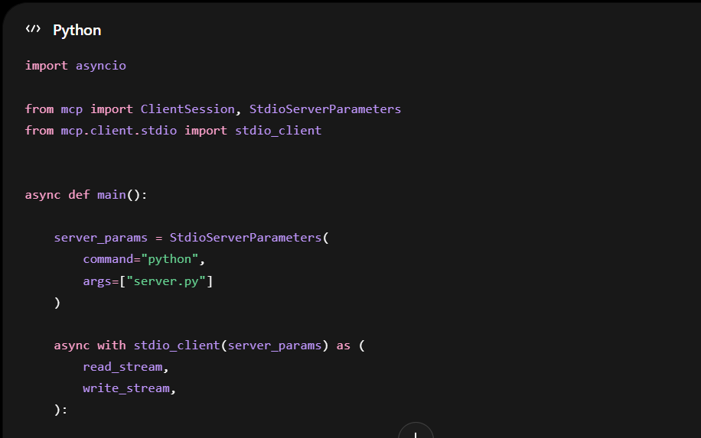
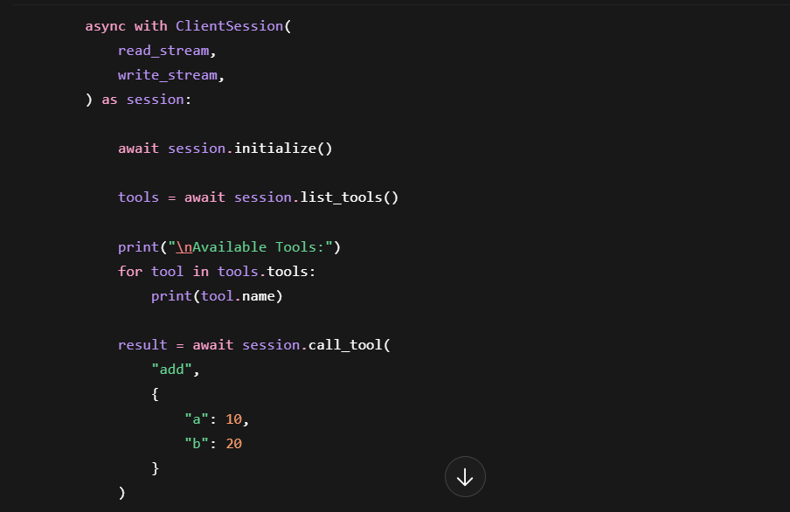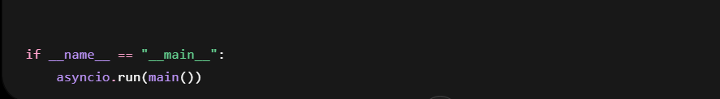

Step 6: Run Client
Execute:
uv run client.py
This client.py is a simple MCP (Model Context Protocol) client that starts an MCP server (server.py), connects to it, discovers available tools, and calls the add tool.
Let's go through it line by line.

1. Import Statements
import asyncio
Python's asynchronous programming library.
MCP communication is asynchronous because the client and server exchange messages over streams.

from mcp import ClientSession, StdioServerParameters
ClientSession
Represents a connection/session with an MCP server.
Used to:
- Initialize the connection
- Discover tools
- Call tools
- Receive responses

StdioServerParameters
Defines how to start the MCP server.
Think of it as:
How should I launch the server?

from mcp.client.stdio import stdio_client
Creates a communication channel using:
stdin
stdout
between:
client.py <-----> server.py

2. Main Function
async def main():
An asynchronous function.
All MCP operations are async because they involve waiting for responses.

3. Server Configuration
server_params = StdioServerParameters(
command="python",
args=["server.py"]
)
This tells MCP:
Start a process:
python server.py
Equivalent to running:
python server.py
from the terminal.

What happens internally?
client.py
|
+---- starts ----> python server.py
Now both processes are running.

4. Create Communication Channel
async with stdio_client(server_params) as (
read_stream,
write_stream,
):
This launches the server and creates two streams.

read_stream
Used by the client to receive messages.
Server -----> Client

write_stream
Used by the client to send messages.
Client -----> Server

Visual:
read_stream
Server --------------------> Client
write_stream
Client --------------------> Server

5. Create MCP Session
async with ClientSession(
read_stream,
write_stream,
) as session:
Creates a protocol session over those streams.
Think of it as:
TCP Connection
+
MCP Protocol
=
ClientSession
All MCP requests will use this session.

6. Initialize Session
await session.initialize()
Very important.
This performs the MCP handshake.

Internally:
Client -----------------> Initialize Request
Server -----------------> Initialize Response
The server responds with:
- Protocol version
- Supported capabilities
- Available resources
Without this step:
session.list_tools()
would fail.

7. Get Available Tools
tools = await session.list_tools()
Client sends:
List all tools available
to the server.

Suppose your server.py contains:
@mcp.tool()
def add(a: int, b: int):
The server replies:
{
"tools": [
{
"name": "add"
}
]
}

8. Print Tool Names
print("\nAvailable Tools:")
Output:
Available Tools:

for tool in tools.tools:
print(tool.name)
If server exposes:
add
subtract
multiply
Output:
Available Tools:
add
subtract
multiply

9. Call a Tool
result = await session.call_tool(
"add",
{
"a": 10,
"b": 20
}
)
This is the most important part.

The client sends:
{
"tool": "add",
"arguments": {
"a": 10,
"b": 20
}
}
to the server.

Server executes:
def add(a, b):
return a + b
Result:
30

Server sends back:
{
"result": 30
}

10. Print Result
print("\nResult:")
print(result)
Output:
Result:
30
(or an MCP response object containing 30)

Complete Flow Diagram
┌────────────┐
│ client.py │
└─────┬──────┘
│
│ Start
▼
python server.py
│
▼
┌────────────┐
│ server.py │
└─────┬──────┘
│
│ initialize()
▼
Handshake
│
│ list_tools()
▼
Returns:
add
│
│ call_tool("add")
▼
add(10,20)
│
▼
30
│
▼
Client prints:
30
What Happens When You Run It
Command:
uv run client.py
Execution sequence:
1. client.py starts
2. Starts server.py
3. Creates stdin/stdout pipes
4. Creates MCP session
5. Initializes connection
6. Lists tools
7. Calls add(10,20)
8. Server returns 30
9. Prints result
Expected output:
Available Tools:
add
Result:
30
If you share your server.py as well, I can explain how the @tool() registration works and show exactly how the add request travels from the client to the server and back.

Real-World Example
Instead of:
def add(a,b):
you might have:
@mcp.tool()
def get_wps_violations(months):
Inside:
requests.get(
"https://lmra-api/wps/violations"
)
Then your AI agent can call:
get_wps_violations(3)
without knowing:
- API URLs
- Authentication
- Database details
This is exactly how MCP is used with AI agents.

The One Thing to Remember
An MCP Server is just a Python program that exposes functions as tools:
@mcp.tool()
def some_function():
...
An MCP Client discovers those tools and calls them:
await session.call_tool(...)
Everything else (AI agents, Bedrock AgentCore, Claude, Gateway) is built on top of this simple concept.

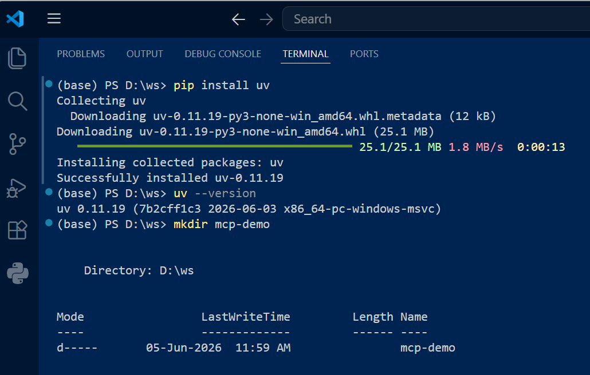
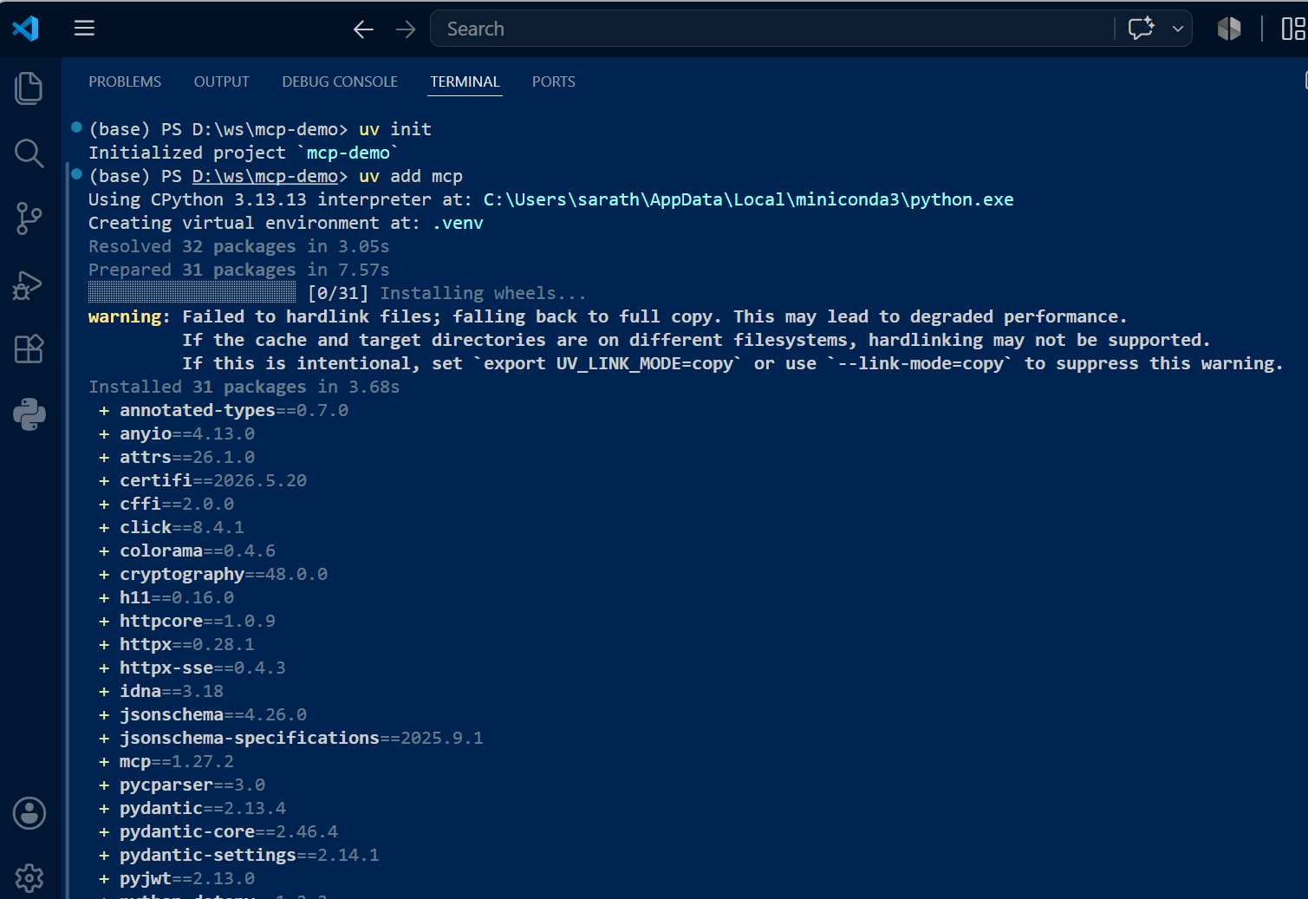

Server.py
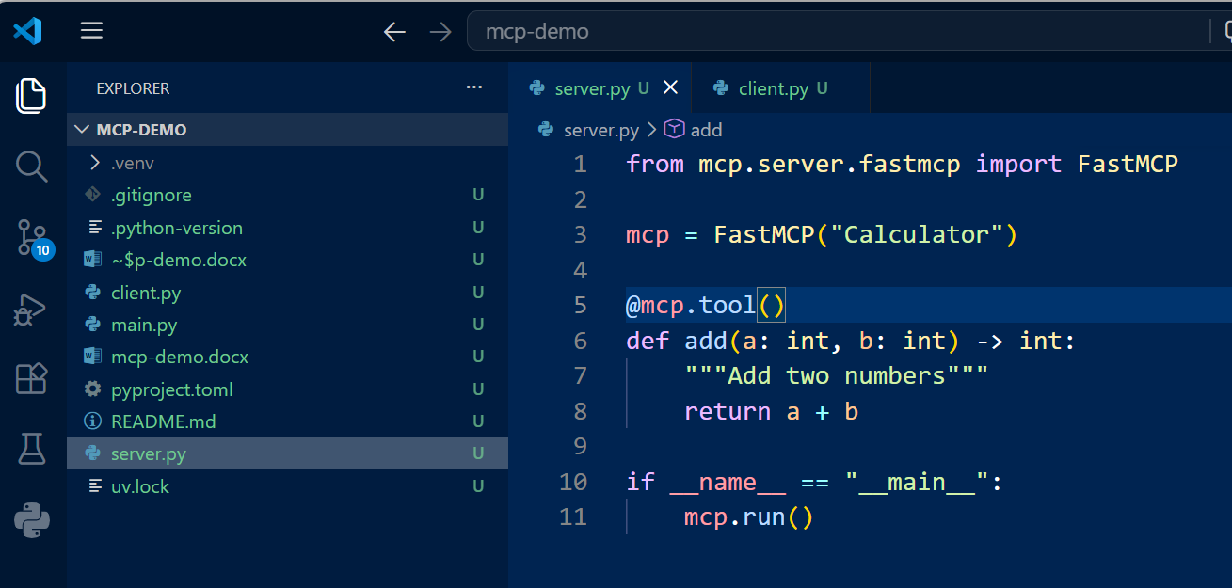
Client.py

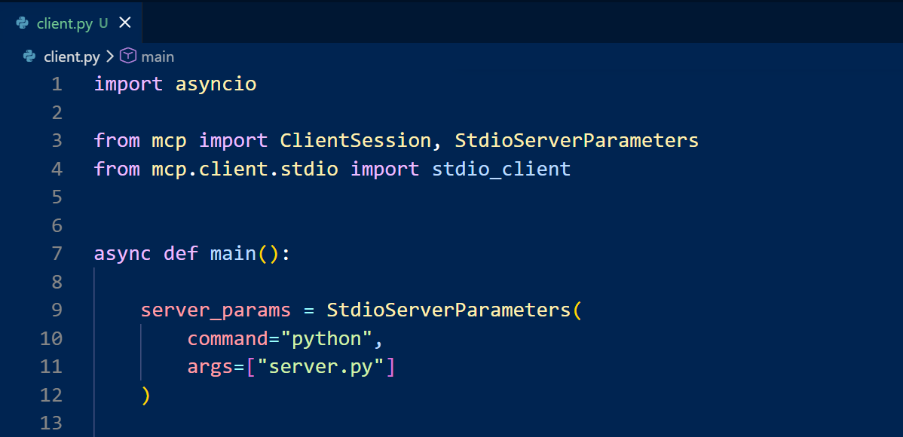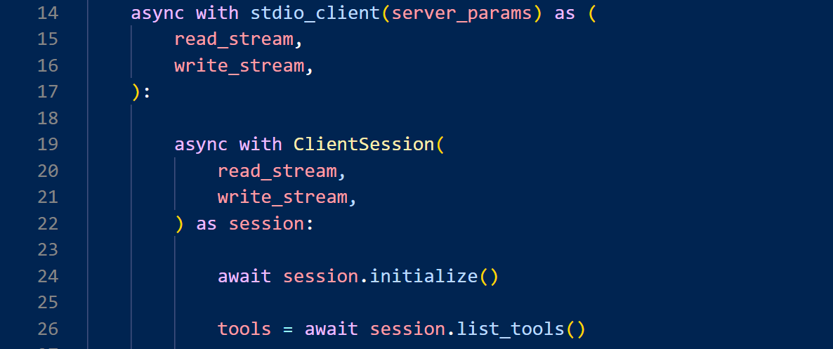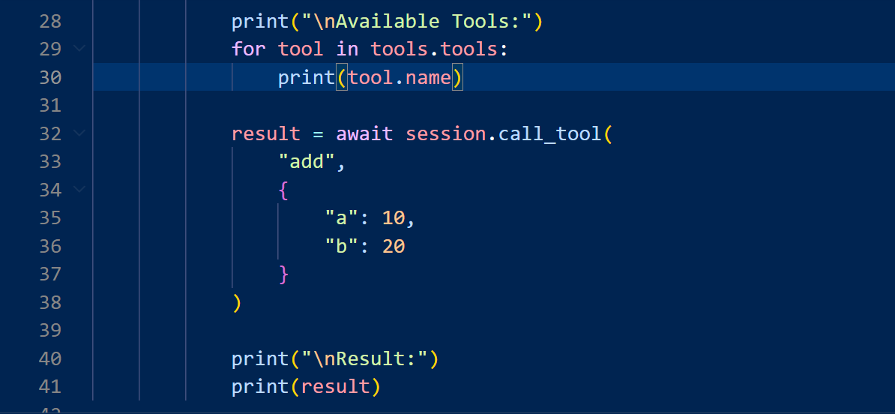


If you want to use Strands Agents with your MCP server, the architecture changes slightly.
Currently:
client.py
|
| MCP
v
server.py
|
+--> add()
With Strands:
User
|
v
Strands Agent
|
+---- MCP Tool: add
|
+---- LLM
The agent decides when to call the MCP tool.

Existing MCP Server (No Changes)
Keep your server.py exactly as it is:
from mcp.server.fastmcp import FastMCP
mcp = FastMCP("Calculator")
@mcp.tool()
def add(a: int, b: int) -> int:
"""Add two numbers"""
return a + b
if __name__ == "__main__":
mcp.run()

Install
pip install strands-agents
pip install mcp

Strands Agent Client
Replace your old client.py with:
import asyncio
from strands import Agent
from strands.tools.mcp import MCPClient
from mcp import StdioServerParameters
async def main():
server_params = StdioServerParameters(
command="python",
args=["server.py"]
)
async with MCPClient(server_params) as mcp_client:
tools = await mcp_client.list_tools()
agent = Agent(
tools=tools
)
response = await agent.run(
"What is 10 plus 20?"
)
print(response)
if __name__ == "__main__":
asyncio.run(main())

What Happens?
Step 1
User asks:
What is 10 plus 20?

Step 2
Agent receives prompt
Agent:
I have an MCP tool called add

Step 3
Agent decides:
Need tool invocation

Step 4
Agent calls MCP tool
{
"tool":"add",
"arguments":{
"a":10,
"b":20
}
}

Step 5
MCP Server executes
add(10,20)
returns
30

Step 6
Agent receives result
30

Step 7
Agent generates response
10 plus 20 equals 30.

More Interesting Example
Add another tool:
from mcp.server.fastmcp import FastMCP
mcp = FastMCP("Calculator")
@mcp.tool()
def add(a: int, b: int) -> int:
return a + b
@mcp.tool()
def multiply(a: int, b: int) -> int:
return a * b
if __name__ == "__main__":
mcp.run()
Then:
response = await agent.run(
"Multiply 5 by 8 and then add 10"
)
Agent may automatically perform:
multiply(5,8)
↓
40
add(40,10)
↓
50
and respond:
The answer is 50.

Using the Current Strands MCP Pattern
A more common pattern today is:
import asyncio
from strands import Agent
from strands.tools.mcp import MCPClient
from mcp import StdioServerParameters
async def main():
async with MCPClient(
StdioServerParameters(
command="python",
args=["server.py"]
)
) as client:
agent = Agent(
tools=await client.list_tools()
)
result = await agent.run(
"Add 100 and 250"
)
print(result)
asyncio.run(main())

End-to-End Flow
User
|
| "Add 100 and 250"
v
Strands Agent
|
| discovers MCP tools
|
+---- add(a,b)
|
v
MCP Server
|
+---- add(100,250)
|
v
350
|
v
Agent
|
v
"The answer is 350."
This is the simplest example of integrating an MCP server with a Strands agent, and it demonstrates the key idea: the agent no longer directly calls session.call_tool(). Instead, the LLM-powered agent chooses when and how to invoke MCP tools.
