SOME PERFORMANCE ASPECTS AND PRACTICAL CONSIDERATIONS OF
AN AGENTIC AI-BASED DATA ANALYSIS AND MACHINE LEARNING ASSISTANT

FULL SEMESTER INTERNSHIP REPORT

Submitted by

DUNNAPAPAGARI SARATHKUMAR
(25341D5803)

in partial fulfillment for the award of the degree
of

MASTER OF TECHNOLOGY
in
COMPUTER SCIENCE AND ENGINEERING

GMRIT DEEMED TO BE UNIVERSITY, RAJAM
Andhra Pradesh, India

SEPTEMBER 2026

DATA ANALYST + ML AGENT
AN AGENTIC AI-BASED DATA ANALYSIS AND MACHINE LEARNING ASSISTANT

Internship carried out at
RECRUITWIRE SERVICES

Report Submitted by

DUNNAPAPAGARI SARATHKUMAR
(25341D5803)

in partial fulfillment for the award of the degree
of

MASTER OF TECHNOLOGY
in
COMPUTER SCIENCE AND ENGINEERING

GMRIT DEEMED TO BE UNIVERSITY, RAJAM
Andhra Pradesh, India

SEPTEMBER 2026

BONAFIDE CERTIFICATE
Certified that this internship report titled “Data Analyst + ML Agent — An Agentic AI-Based Data Analysis and Machine Learning Assistant” is the bonafide work of Dunnapapagari Sarathkumar (25341D5803), who carried out the full semester internship under our supervision at M/S Recruitwire Services.

________________________________  Signature of the Faculty Supervisor | ________________________________  Signature of the Industry Supervisor
S. Ravi Shankar  Assistant Professor, Dept. of CSE  GMRIT Deemed to be University, Rajam | M Vyshnavi  Program Manager  Recruitwire Services

________________________________
Signature of the Head of the Department

Dr. K. Lakshman Rao
Head of the Department, CSE
GMRIT Deemed to be University, Rajam

INTERNSHIP CERTIFICATE
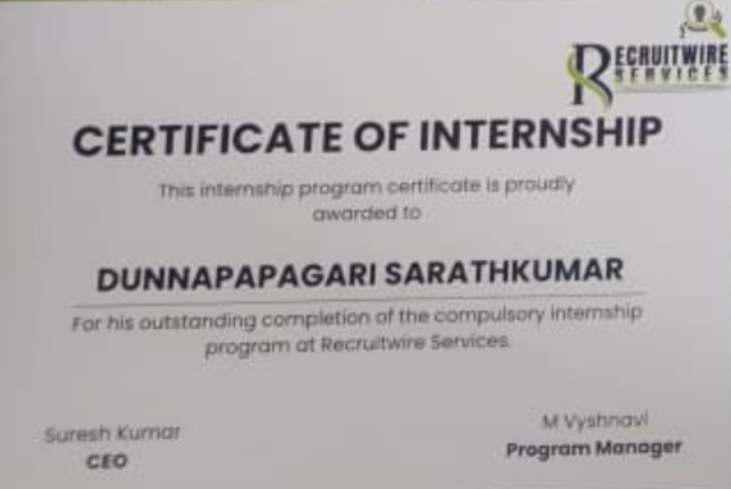
Certificate of Internship awarded by Recruitwire Services to Dunnapapagari Sarathkumar

ACKNOWLEDGEMENT
I would like to express my sincere gratitude to everyone who supported me during my full semester internship. I thank the Principal and Vice Principal of GMRIT Deemed to be University, Rajam, for providing the opportunity to undertake this internship as part of the curriculum.
I am deeply grateful to Dr. K. Lakshman Rao, Head of the Department, Computer Science and Engineering, for his constant encouragement and support throughout the internship period.
I sincerely thank the Full Semester Internship (FSI) coordinator and department coordinator for their guidance in organizing and facilitating this internship.
I would like to express my heartfelt thanks to my industry supervisor, M Vyshnavi, Program Manager at Recruitwire Services, and to Suresh Kumar, CEO, for their valuable guidance, feedback and the opportunity to work on a real-world project during the internship.
I am extremely thankful to my faculty supervisor, S. Ravi Shankar, Department of CSE, for his continuous guidance, timely suggestions and support in the successful completion of this internship report.
Finally, I thank my family and friends for their constant encouragement and support throughout this internship.

Dunnapapagari Sarathkumar

ABSTRACT
Most individuals and small organizations that hold a dataset cannot act on it, because turning raw data into a decision requires SQL, statistics and machine learning skills that most users do not possess. This report documents the design and development of “Data Analyst + ML Agent,” an agentic, AI-assisted web application built during a full semester internship at Recruitwire Services, which closes this gap for non-technical users.
The system allows a user to upload a CSV or Excel dataset and, without writing a single line of code, automatically profile the data, clean it, generate exploratory visualizations, ask questions about it in plain English, generate and safely execute analytical SQL queries, receive a recommended machine learning problem type and algorithms, train and compare multiple models, inspect feature importance, generate predictions, and download a complete report — all explained in beginner-friendly language.
The system follows a strict engineering principle: every numeric computation — a mean, a correlation, a model metric — is produced deterministically using Pandas, NumPy and scikit-learn. A large language model (the Claude API) is used only to translate natural-language questions into SQL and to turn already-computed results into natural-language explanations; it is never used to generate or guess numeric values. As a result, the application remains fully functional even when no AI API key is configured.
The backend was implemented using FastAPI with a modular, agent-based architecture comprising twenty-one functional modules, and the frontend was implemented using React, TypeScript and Tailwind CSS across twelve pages. The system was verified through twenty-five automated backend tests, a clean TypeScript build, and an end-to-end manual walkthrough covering upload, profiling, cleaning, exploratory analysis, natural-language querying, guarded SQL execution, model training, model comparison, explainability, prediction and report generation. On a representative customer-churn dataset, a Logistic Regression model trained through the system achieved 74% accuracy and a ROC-AUC of 0.83, outperforming Gradient Boosting, KNN, Decision Tree and Random Forest baselines trained under identical conditions.
This internship provided hands-on experience in full-stack software engineering, applied machine learning, API design, and the responsible integration of large language models into a data application where correctness of numeric output must never depend on the language model.

TABLE OF CONTENTS
CHAPTER 1 1
INTRODUCTION 1
1.1 About the Full Semester Internship Programme 1
1.2 About the Internship 1
1.3 Motivation for the Project 1
1.4 Organization of the Report 2
CHAPTER 2 3
PROFILE OF THE COMPANY 3
2.1 Overview 3
2.2 Governance and Structure 3
2.3 Nature of Engagements 3
2.4 Technologies and Tools in Use 3
2.5 Relevance to Academic Training 4
CHAPTER 3 5
TASKS TAKEN UP AND PROBLEM DEFINITION 5
3.1 Problem Definition 5
3.2 Scope of Work 5
3.3 Department / Section 6
3.4 Technologies Put into Practice 6
3.5 Constraints 6
CHAPTER 4 8
METHODOLOGY AND LEARNING 8
4.1 System Architecture 8
4.2 Design Flow 9
4.3 A Core Engineering Principle: Deterministic Computation, AI for Language Only 9
4.4 Preprocessing Pipeline 9
4.5 Machine Learning Problem Identification and Algorithm Selection 10
4.6 Model Training, Tuning and Evaluation 10
4.7 Explainability 11
4.8 Natural-Language Querying and Guarded SQL 11
4.9 Verification and Results 11
4.10 Key Learning Outcomes 13
CHAPTER 5 14
CONCLUSIONS AND SUGGESTIONS 14
5.1 Conclusions 14
5.2 Suggestions 14
APPENDICES 16
Appendix A — Sample Datasets 16
Appendix B — API Endpoints (Representative) 16
Appendix C — Format for No Dues Certificate 16
REFERENCES 17

LIST OF TABLES
Table 4.1 Algorithms implemented, by problem type 10
Table 4.2 Classification and regression evaluation metrics 11
Table 4.3 Model comparison results on the sample customer-churn dataset 12

LIST OF FIGURES
Figure 4.1 System architecture (three-layer block diagram) 8
Figure 4.2 Application workflow / design flow 9

CHAPTER 1

INTRODUCTION

1.1 About the Full Semester Internship Programme
The Full Semester Internship (FSI) is a curriculum component designed to bridge the gap between academic learning and industry practice. It gives students the opportunity to work on real, industry-relevant problems under the joint guidance of an industry supervisor and a faculty supervisor, and to be evaluated on the basis of the work actually carried out rather than on classroom examinations alone. This internship report has been prepared in accordance with the FSI report guidelines issued by GMRIT Deemed to be University, Rajam.

1.2 About the Internship
This internship was carried out at Recruitwire Services from 10 August 2026 to 3 September 2026, under the industry supervision of M Vyshnavi, Program Manager, and the faculty supervision of S. Ravi Shankar, Department of Computer Science and Engineering. The task assigned was to design, build and deliver a complete, working software application — “Data Analyst + ML Agent” — that allows a non-technical user to go from a raw dataset to a trained, explained machine learning model without writing code.

1.3 Motivation for the Project
Organizations and individuals routinely collect data — customer records, sales logs, survey responses — but most people who hold this data lack the SQL, statistics, or machine learning background needed to extract value from it. Existing business-intelligence tools typically stop at charts and dashboards; they do not clean data, explain results in plain language, or train and compare machine learning models. This gap motivated the internship task: build one integrated system that carries a user through the entire data-to-decision pipeline.

1.4 Organization of the Report
Chapter 2 profiles Recruitwire Services, the organization at which the internship was carried out. Chapter 3 describes the specific task assigned and the problem definition. Chapter 4 explains the methodology, system design and the technical learning gained during the internship. Chapter 5 presents the conclusions drawn from the internship and suggestions for future work.

CHAPTER 2

PROFILE OF THE COMPANY

2.1 Overview
Recruitwire Services is the organization at which this full semester internship was carried out. The organization runs a structured internship program that places students on live, outcome-based projects under the mentorship of an assigned Program Manager, giving interns direct exposure to real software delivery practices rather than simulated coursework.

2.2 Governance and Structure
The internship program at Recruitwire Services is led by Suresh Kumar (CEO) and administered by the Program Management team, headed in this internship's case by M Vyshnavi, Program Manager, who served as the industry supervisor for this project and was responsible for scoping the task, reviewing progress, and validating the final deliverable.

2.3 Nature of Engagements
Recruitwire Services engages interns on applied software and data-related assignments spanning full-stack web development, data analysis, and applied machine learning. Interns are expected to independently research, design, build and deliver a working system within the engagement window, with periodic checkpoints against the Program Manager.

2.4 Technologies and Tools in Use
The technology stack commonly used across engagements at Recruitwire Services includes modern web frameworks (such as React on the frontend and Python-based frameworks such as FastAPI on the backend), relational and embedded analytical databases, cloud-hosted large language model APIs for AI-assisted features, and standard version-control and deployment tooling. The project assigned for this internship, described in Chapter 3, was built using this class of technologies.

2.5 Relevance to Academic Training
The internship assignment at Recruitwire Services closely mirrored the FSI program's objective of bridging academic learning and industry practice: the intern was expected to independently translate an open-ended business problem (helping non-technical users work with data) into a scoped, engineered, tested and documented software deliverable, applying skills from data structures, databases, software engineering and machine learning courses in a single integrated project.

CHAPTER 3

TASKS TAKEN UP AND PROBLEM DEFINITION

3.1 Problem Definition
The task entrusted during this internship was to design and build “Data Analyst + ML Agent”, a full-stack web application that enables a user with no SQL, Python, statistics or machine learning background to take a raw dataset through the complete analytics and machine learning lifecycle — from upload to a trained, explained, predictive model — using natural language and guided workflows instead of code.

3.2 Scope of Work
The scope of the assigned task, confirmed with the industry supervisor at the start of the internship, covered the following functional areas:
- Dataset ingestion (CSV / Excel) with validation, safe storage and metadata extraction
- Automated data profiling: column types, missing values, duplicates, class imbalance, target-column suggestions
- Non-destructive data cleaning: missing-value handling, duplicate removal, outlier detection, with a full cleaning log
- Exploratory Data Analysis: summary statistics, distributions, correlations, categorical frequencies
- Chart generation (bar, line, scatter, histogram, box, heatmap, pie, count) with AI-assisted interpretation
- A natural-language “Ask Data” assistant that answers questions over the dataset
- A guarded, read-only SQL agent that converts natural language to SQL and blocks destructive statements
- A Pandas agent exposing a fixed set of safe analytical operations (groupby, pivot, filter, aggregate)
- Automatic ML problem-type detection (classification / regression / clustering) and algorithm recommendation
- Model training, hyperparameter tuning, multi-model comparison and evaluation
- Model explainability (feature importance / coefficients / permutation importance)
- Single-record and batch prediction
- A BI-style dashboard, a RAG-based knowledge assistant, and a downloadable PDF report

3.3 Department / Section
The work was carried out under the Program Management vertical of Recruitwire Services, reporting to M Vyshnavi (Program Manager), with weekly review checkpoints against the agreed scope and milestones.

3.4 Technologies Put into Practice
The project required practical application of the following technologies and concepts, several of which were learned or deepened specifically during this internship: Python, FastAPI, Pydantic, Pandas, NumPy, scikit-learn (Pipelines and ColumnTransformer), DuckDB, SQLite, joblib, React, TypeScript, Vite, Tailwind CSS, Recharts, REST API design, CORS configuration, prompt-based LLM integration via the Claude API, automated testing with pytest, and version-controlled, documented software delivery.

3.5 Constraints
The task was time-boxed to the internship duration (10 August – 3 September 2026) and was required to run entirely on commodity hardware without specialized infrastructure, to remain fully functional without any paid AI API key, and to never execute unrestricted, AI-generated code or destructive SQL against the user's data — a non-negotiable safety constraint set at the start of the engagement.

CHAPTER 4

METHODOLOGY AND LEARNING

4.1 System Architecture
The application follows a three-layer architecture (Figure 4.1). The presentation layer is a React, TypeScript and Tailwind CSS single-page application that communicates with the backend exclusively over a JSON REST API. The application layer is a FastAPI backend organized into independent modules (“agents”), each responsible for one stage of the data pipeline — upload, profiling, cleaning, EDA, visualization, natural-language querying, SQL generation and guarding, Pandas operations, ML training, tuning, explainability, prediction, the RAG knowledge assistant, and report generation. The data layer consists of SQLite for application metadata, DuckDB as an embedded analytical SQL engine for querying uploaded datasets, and joblib-serialized files for trained model pipelines.
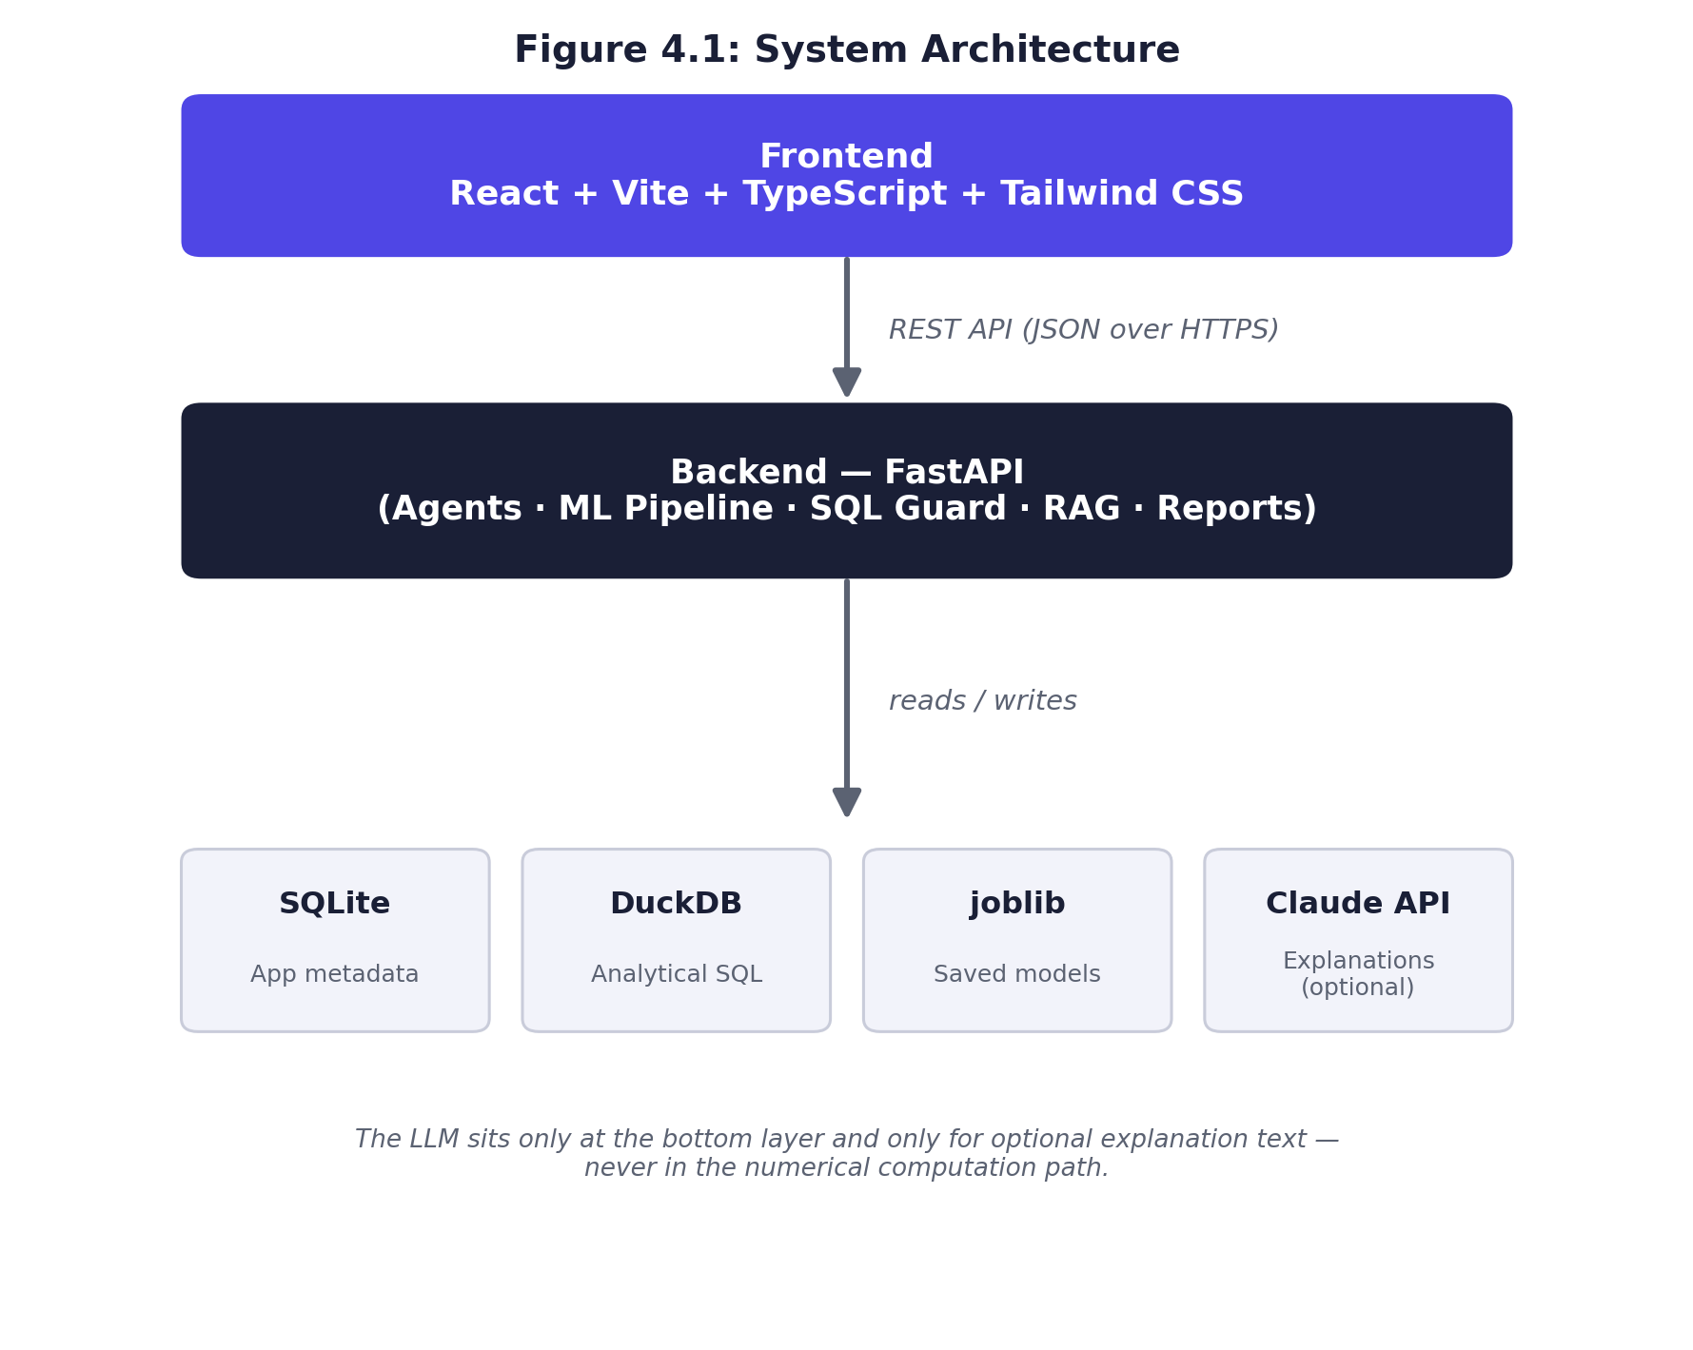
Figure 4.1: System Architecture — Frontend → REST API → Backend → SQLite / DuckDB / joblib / Claude API

4.2 Design Flow
A dataset moves through seven pipeline stages (Figure 4.2): Upload → Profile → Clean → Explore and Ask → Train ML → Compare and Explain → Predict and Report. The system always keeps the original uploaded dataset separate from the working (cleaned) dataset, so a user can revisit an earlier stage — for example, re-cleaning with different settings — without losing downstream analysis or trained models.
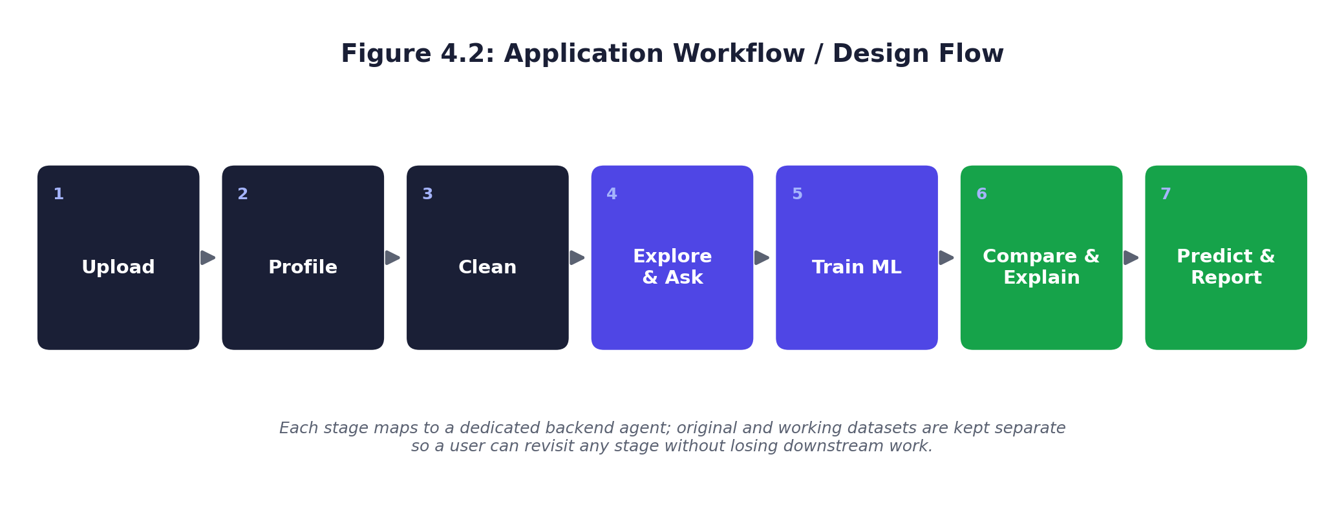
Figure 4.2: Upload → Profile → Clean → Explore & Ask → Train ML → Compare & Explain → Predict & Report

4.3 A Core Engineering Principle: Deterministic Computation, AI for Language Only
A deliberate design rule was applied throughout the project: every numeric value shown to the user — a mean, a correlation coefficient, a missing-value percentage, a model accuracy score — is computed deterministically using Pandas, NumPy or scikit-learn. The large language model (accessed via the Claude API) is used only for two purposes: translating a natural-language question into an SQL query or an analytical operation, and turning already-computed numeric results into a natural-language explanation. The model is never asked to produce or guess a number. This was validated by designing the system so that every AI-dependent feature degrades gracefully to a clear “AI explanation unavailable” message, while every core analytical and ML feature continues to function normally, when no API key is configured.

4.4 Preprocessing Pipeline
Feature preprocessing was implemented using scikit-learn's ColumnTransformer and Pipeline primitives. Numeric columns are median-imputed and scaled; categorical columns are mode-imputed and one-hot encoded. Critically, the preprocessing pipeline is fit only on the training split of the data and then applied to the test split, which prevents information from the test set from leaking into model training — a common correctness pitfall in applied machine learning that this internship required understanding and avoiding in practice.

4.5 Machine Learning Problem Identification and Algorithm Selection
When a user selects a target column, the system inspects its data type and the number of unique values to decide whether the task is classification or regression; if no target is selected, the task is routed to clustering. Based on this decision, the system recommends a shortlist of algorithms, along with their assumptions, advantages and disadvantages, rather than silently picking one “best” algorithm. Table 4.1 lists the algorithms implemented for each problem type.

Problem Type | Algorithms Implemented
Classification | Logistic Regression, Decision Tree, Random Forest, Gradient Boosting, K-Nearest Neighbours
Regression | Linear Regression, Ridge, Lasso, Decision Tree Regressor, Random Forest Regressor, Gradient Boosting Regressor
Clustering | K-Means

Table 4.1: Algorithms implemented, by problem type.

4.6 Model Training, Tuning and Evaluation
Training is performed through a dedicated API endpoint that accepts the dataset, target column, feature columns, problem type, algorithm, test-set proportion and random seed, and returns the fitted pipeline's evaluation metrics. Lightweight hyperparameter tuning is available via RandomizedSearchCV / GridSearchCV over deliberately small search spaces, with before-and-after metrics shown to the user so the effect of tuning is transparent rather than hidden. Table 4.2 lists the evaluation metrics implemented for each problem type, each of which the system also explains in plain language in the user interface.

Problem Type | Metrics Implemented
Classification | Accuracy, Precision, Recall, F1 Score, ROC-AUC, Confusion Matrix
Regression | Mean Absolute Error (MAE), Mean Squared Error (MSE), Root Mean Squared Error (RMSE), R²

Table 4.2: Classification and regression evaluation metrics.

4.7 Explainability
For models that expose them, the system surfaces feature_importances_ (tree-based models) or coefficient magnitudes (linear models); where neither is available, it falls back to model-agnostic permutation importance. These values are translated into plain-English statements about which input features most influenced the model's predictions, rather than being shown as raw numbers alone.

4.8 Natural-Language Querying and Guarded SQL
The “Ask Data” assistant routes a user's natural-language question to either a DuckDB SQL query or a predetermined Pandas operation. For SQL, the system enforces a strict read-only allowlist before execution: statements such as DROP, DELETE, UPDATE, INSERT, ALTER, TRUNCATE, ATTACH and COPY are rejected outright, regardless of how the query was generated. This guard was implemented and unit-tested against all of the statement types listed above, so that natural-language access to the dataset can never be used to modify or destroy it.

4.9 Verification and Results
The system was verified in two ways. First, through twenty-five automated backend tests (pytest) covering dataset parsing, profiling, cleaning, SQL-safety enforcement, and ML training and evaluation — all twenty-five passed in the final build, and the frontend TypeScript build completed with zero errors. Second, through an end-to-end manual walkthrough on the bundled sample customer dataset, exercising every stage of the pipeline from upload through report generation.
As a concrete result from this verification, Table 4.3 shows the comparison of five classification algorithms trained through the system on the sample customer-churn dataset (250 rows, 80/20 train-test split, fixed random seed for reproducibility), predicting customer churn from features such as contract type, tenure, monthly charges and support-call history.

Algorithm | Accuracy | Precision | Recall | F1 | ROC-AUC
Logistic Regression | 0.74 | 0.78 | 0.74 | 0.74 | 0.83
Gradient Boosting | 0.64 | 0.67 | 0.64 | 0.65 | 0.70
K-Nearest Neighbours | 0.62 | 0.62 | 0.62 | 0.62 | 0.59
Decision Tree | 0.58 | 0.63 | 0.58 | 0.58 | 0.60
Random Forest | 0.58 | 0.60 | 0.58 | 0.59 | 0.73

Table 4.3: Model comparison results on the sample customer-churn dataset.
Logistic Regression achieved the best overall performance (74% accuracy, ROC-AUC 0.83). The feature-importance output identified contract type (month-to-month) as the strongest predictor of churn, followed by payment method and internet service type — a result consistent with general domain intuition that customers without a long-term contract are more likely to churn, and one that the system was able to state in plain language rather than as raw coefficients alone.

4.10 Key Learning Outcomes
- Practical experience designing and building a modular REST API backend with FastAPI and Pydantic
- Hands-on application of scikit-learn Pipelines and ColumnTransformer to avoid data leakage
- Understanding of classification and regression evaluation metrics and how to explain them to a non-technical audience
- Experience building a production-style React + TypeScript frontend consuming a typed REST API
- Practical understanding of the risks of integrating large language models into a data application, and of the guardrails (read-only SQL enforcement, no arbitrary code execution, deterministic numeric computation) needed to use them safely
- Experience with embedded analytical databases (DuckDB) and lightweight retrieval-augmented generation (RAG) for a knowledge assistant
- End-to-end software delivery discipline: automated testing, documentation, and local-to-deployment readiness (Docker and cloud hosting configuration)

CHAPTER 5

CONCLUSIONS AND SUGGESTIONS

5.1 Conclusions
This internship successfully delivered a complete, working, tested web application — Data Analyst + ML Agent — that carries a non-technical user through the full data lifecycle: upload, automatic profiling, non-destructive cleaning, exploratory data analysis, natural-language querying, guarded SQL execution, machine learning model training and comparison, explainability, prediction, and automated report generation. The system was built and verified end to end, with twenty-five automated backend tests passing, a clean TypeScript build on the frontend, and a documented, repeatable demo covering every module.
The most important engineering outcome of this internship was establishing and enforcing a clear boundary between deterministic computation and AI-generated language: every numeric result in the system is produced by Pandas, NumPy or scikit-learn, while the large language model is confined to translating natural language into SQL and turning computed results into explanations. This discipline ensured the system remains trustworthy and fully usable even without any AI configuration, and is the single most transferable lesson from this internship for any future work that combines classical data processing with large language models.
On the applied machine learning side, the internship provided direct, hands-on experience with the complete model-development lifecycle — preprocessing without data leakage, algorithm selection appropriate to the problem type, training, hyperparameter tuning, multi-model comparison, and explainability — validated concretely on a sample customer-churn dataset, where a Logistic Regression model achieved 74% accuracy and a ROC-AUC of 0.83, outperforming four other baseline algorithms trained under identical conditions.

5.2 Suggestions
- Extend model explainability with SHAP values for richer, per-prediction feature-impact analysis, particularly for tree-based ensembles
- Add multi-user accounts and role-based access so the application can be used by teams rather than a single user per session
- Support streaming or chunked ingestion so the system can handle datasets larger than the current in-memory limit
- Extend algorithm support to deep learning models for unstructured or high-dimensional data
- Introduce automated UI testing (in addition to the existing backend test suite) to further strengthen regression safety as the frontend grows
For the FSI program itself, it is suggested that future industry-mentored projects of this kind continue to require an explicit, demonstrable boundary between AI-assisted and deterministic components wherever an LLM is used, since this proved to be both a strong engineering discipline and a valuable, explainable learning outcome for the viva and the final report.

APPENDICES

Appendix A — Sample Datasets
Two bundled sample datasets were used to demonstrate and verify the system without requiring personal or proprietary data: customer_churn_sample.csv (250 rows, 11 columns, used for the classification results in Chapter 4) and sales_sample.csv, a smaller dataset used to demonstrate regression and time-based analysis.

Appendix B — API Endpoints (Representative)
GET /api/health — POST /api/datasets/upload — GET /api/datasets/{id}/profile — POST /api/datasets/{id}/clean — GET /api/datasets/{id}/eda — POST /api/datasets/{id}/ask — POST /api/datasets/{id}/sql — POST /api/ml/train — GET /api/ml/models/{id}/importance — POST /api/ml/models/{id}/predict — POST /api/reports/generate — POST /api/knowledge/ask.

Appendix C — Format for No Dues Certificate
FSI station: Recruitwire Services Date: 3 September 2026
Name: Dunnapapagari Sarathkumar ID No.: 25341D5803, completing the FSI Program on 3 September 2026. In case of any dues, the same is reported below against the respective section; where there are no dues, the section is marked “NO DUES” and signed.
Organization Supervisor: ______________________ Faculty Supervisor: ______________________
Librarian: ______________________ Accounts Section: ______________________
FSI Coordinator: ______________________ Hostels: ______________________

REFERENCES
[1] F. Pedregosa et al., “Scikit-learn: Machine Learning in Python,” Journal of Machine Learning Research, vol. 12, pp. 2825–2830, 2011.
[2] W. McKinney, “Data Structures for Statistical Computing in Python,” in Proc. 9th Python in Science Conf. (SciPy), 2010, pp. 56–61.
[3] S. M. Lundberg and S.-I. Lee, “A Unified Approach to Interpreting Model Predictions,” in Advances in Neural Information Processing Systems (NeurIPS), vol. 30, 2017.
[4] FastAPI Documentation, Sebastián Ramírez. [Online]. Available: https://fastapi.tiangolo.com. [Accessed: Sept. 2026].
[5] DuckDB Labs, “DuckDB: An Embeddable Analytical Database.” [Online]. Available: https://duckdb.org. [Accessed: Sept. 2026].
[6] React Documentation, Meta Open Source. [Online]. Available: https://react.dev. [Accessed: Sept. 2026].
[7] Anthropic, “Claude API Documentation.” [Online]. Available: https://docs.anthropic.com. [Accessed: Sept. 2026].
[8] scikit-learn Developers, “Pipelines and Composite Estimators.” [Online]. Available: https://scikit-learn.org/stable/modules/compose.html. [Accessed: Sept. 2026].

