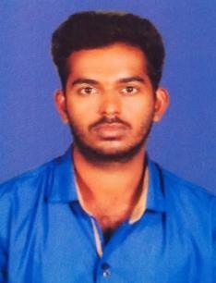

**SARATH GANESAN**

**Email**[**: sarathganesan8@gmail.com**](mailto:ganesansarath481@gmail.com)

**PHONE: +919344326782**

**FULL STACK DEVELOPER**

**PROFESSIONAL OBJECTIVE**

To work in a challenging atmosphere where I can improve my technical skills in the area of Coordinating, Full Stack Developer thereby improving quality standards of the organization in achieving the objectives and in turn lead me for an enhanced growth that reflects a solid background of  Coordinating Full Stack Developer

**EDUCATIONAL QUALIFICATION**

* SSLC
* Plus two

**TECHNICAL QUALIFICATION**

* + BTECH CSE

**KEY SKILLS**

* + **HTML 5**
  + **CSS 3**
  + **JAVA SCRIPT**
  + **BOOTSTRAP**
  + **MONGO DB**
  + **NODE JS**
  + **EXPRESS JS**
  + **REACT JS**
  + **GIT**

**SUMMARY**

Highly skilled and innovactive web development professional .Focused and efficient learner with practical expertise in automated testing .seeking a full stack developer position

**Work Experience:**

**null**

**Duties and Responsibilities handled as Full Stack Developer:**

* Developing front end and back end website architecture
* Designing user interaction on web pages
* Developing back-end website applications.
* Creating servers and databases for functionality
* Ensuring responsiveness of applications.
* Designing and developing APIs
* Meeting both technical and consumer needs
* Ensuring responsiveness of applications
* Working alongside graphic designers for web design feactures
* Seeing through a project from conception to finished product
* Staying abreast of developments in web applications and programming languages.

**Strength**

* Time and Team management.
* Quick adaptation to change.
* Positive Attitude.
* Result Oriented.
* Planned Execution.

**Personal Details:**

|  |  |
| --- | --- |
| Sex | : Male |
| Marital Status | : Single |
| Nationality | : Indian |
| Religion | : Hindu |
| Languages Known | : English, Malayalam, Hindi & Tamil |

**Declaration**

I hereby declare that all the credentials given above are true and to the best of my knowledge and belief.

**SARATH GANESAN**